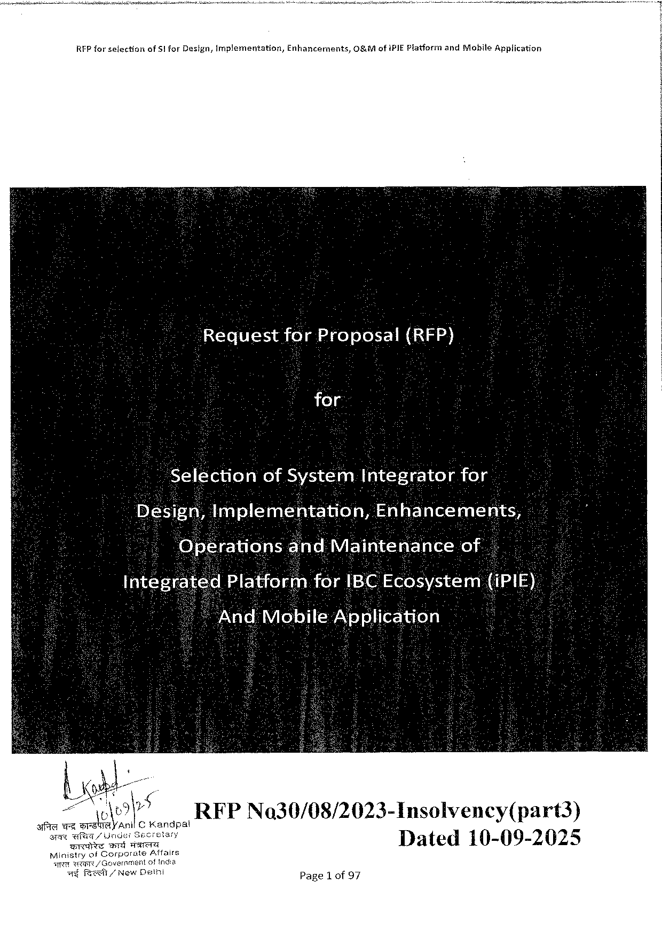

|  |  |  |  |
| --- | --- | --- | --- |
| RFP forselection | of S| for Design, Implementation, | Enhancernents, | 0&Mofi PIE Platformand Mobile Application |

for:

electionof Sy Stém Integratorfor

RFPN o 30/08/2023-Insolvency(part 3)

Dated 10-09-2025

Page 1 of 97

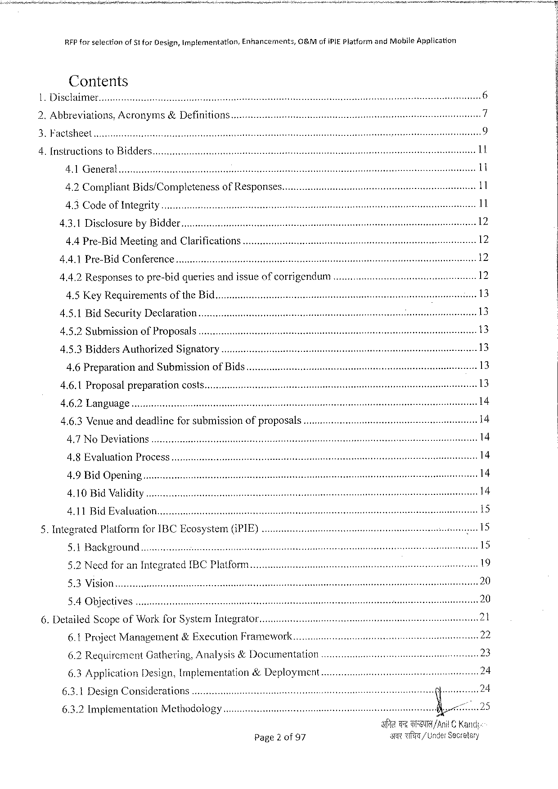

|  |  |  |  |
| --- | --- | --- | --- |
| RFP forselection | of 51 for Design, Implemantation, | Enhancements, | OBM ofi PIEP latformand Mobile Application |

Contents   
Disclaimer..

|  |  |  |  |  |  |  |  |  |  |  |  |  |  |  |  |  |  |  |  |  |  |
| --- | --- | --- | --- | --- | --- | --- | --- | --- | --- | --- | --- | --- | --- | --- | --- | --- | --- | --- | --- | --- | --- |
| b | Abbreviations, Acronyms&Definition | | | | | | | | | 5585 VS T | | | S | | e | g | e | A | 1 | | 9 |
| AU | Brorvarrsrssrsmeamessversmsey | | | | or T e¥3 | | S | |
| bbb | | | | | | | s 11 | | |
| [NSEUCHIONS 10 BIAAEIS..... voviveveeerecerinet | | | | | | | | |
| s | enss peassies 11 | |
| A 1} BT | | bz | rmmemsrsremmmresem o | | | e | o | FT | TS | T | | S As | | se | |
| es | e | S | | sss | | | 11 | | |
| 4.2 Compliant Bids/Completeness 0 f RESPONSES... uv. i | | | | | | | | |
| AWCOAETOTR NG | | | | ressevwvrosssvemrremmevessves | | | sovsi 7 omsssy | | enas absns 11 | | |

4.3.1 Disclosureby Bidder

4.4 Pre-Bid Meetingand Clarifications

4.4.1 Pre-Bid Conference.......... cocovviivinnniiimnsnninenns

4.4.2 Responsestopre-bidqueriesandissueofcorrigendum

4.5 Key Requirementsofthe Bid.

4.5.1 Bid Security Declaration....

|  |  |  |  |  |  |
| --- | --- | --- | --- | --- | --- |
| 4.5.2 Submis Sion 0 f Pr OPOSALS.. ot | | s | i | s | 13 |
| 4.5.3 Bidders Authorized | SIZRA t OTY..... covviiviiiesesice | 13 |
| 4.6 Preparationand Submissionof Bids... t | | 13 |
| 13 |
| 4.6.1 Proposal Preparation | COSES ... ttt |

4.6.2 Language

4,6.3 Venue anddeadlinefor submissionofproposals

4.7 No Deviations....... cooveinriviinnnisninnns

4.8 Evaluation Process

4.9 Bid Opening

4.10 Bid Validity

4.11 Bid Evaluation.

|  |  |  |  |  |  |  |  |  |  |  |  |  |  |  |  |  |
| --- | --- | --- | --- | --- | --- | --- | --- | --- | --- | --- | --- | --- | --- | --- | --- | --- |
| 5. | Integrated Platformfor IBCE cosystem((PIE).. o | | | | | | | | | | | RSSOSRSS Ne S s | e | s | 15 | 15 |
| 5.1 BACKETOUNA.. o | | | | v | | | | s | | |
| 6. | 5.2 Needfor an Integrated IBCPI atform ... | | | | | | | | | | | Sng | 19 |
| S BV | S G | szrmsmrssmesressoo | | | | e | TS | TS | | T | 20 |
| 5.4 OBJECLIVES | | | .. reeververiescoreaemeeseemeeiesee | | | | | st | bbbb | | 20 |
| Detailed Scopeof Work for System Integrator | | | | | | | | | | |
| 6.1 Project Management | | | | | &Execution Framework....... | | | | | |

6.2 Requirement Gathering, Analysis&Documentation

|  |  |  |  |  |  |  |  |  |  |
| --- | --- | --- | --- | --- | --- | --- | --- | --- | --- |
| 6.3 Application | Design, lmplementation&Deployment | | | | s | e | R | ! | |
| 6.3.1 Design Considerations | | ........ ccuiorrirociire | | i |
| 6.3.2 Implementation Methodology | | | ooovvvvieinreimieer | |
| Page 2 of 97 | | | | | TT | /Anil© Kand |
| T/Under Seveatsry | |

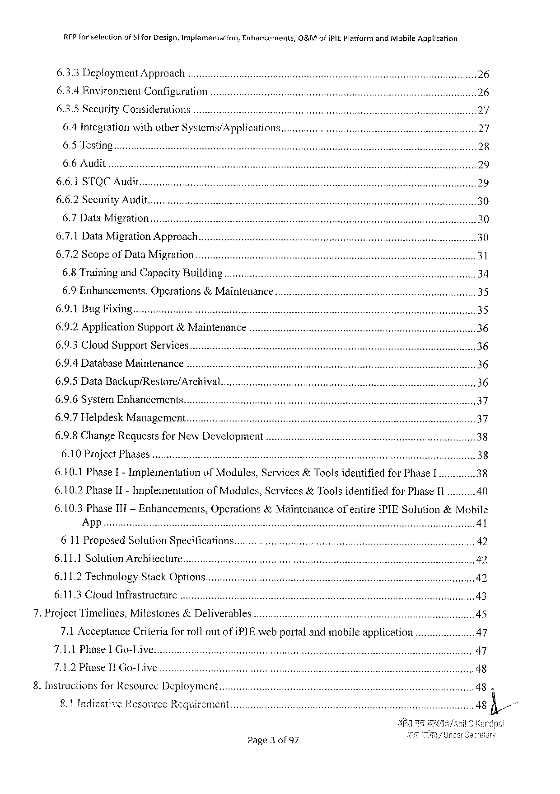

RFP for selectionof Si for Design, Implementation, Enhancements,&Mofi PIEP latformand Mobile Application

|  |  |  |  |
| --- | --- | --- | --- |
| 6.3.3 Deployment APPIO a Ch.. ....... oo. uicericionicnccceenie | e | ssars e | 26 |
| 6.3.4 Environment Conf Iguration .. o | 26 |

6.3.5 Security Considerations

6.4 Integrationwithother Systems/APPHCA t ONS...... ovvvvrorriernrornerienrareesoreesr s 27

6.5 Testing

6.6 Audit

6.6.1 STQCA ud

6.6.2 Security Audit.

6.7 Data MIIATON.. v. evorveecreicis ot ssns eav s st st 30

6.7.1 Data Migration APP roach............. cc. cccumieriinciicnececneecr e sssessssnsesssss 30

6.7.2 Scopeof Data MIIAION......... c. iuiierieriecteciccenees e ss s 31

6.8 Trainingand Capacity BUI lding........ cccocooerimcriininiinie i 34

6.9 Enhancements, Operations&Ma INTEN a NC e......... ovvreevernrenreiiossassreseenems s s ssnenn 35

6.9.2 Application Support&Maintenan

6.9.3 Cloud Support Services

6.9.4 Database Maintenance .

6.9.5 Data Backup/Restore/Archival

6.9.6 System Enhancements

6.9.7 Helpdesk Managemient........... ccoouccvivnrnireroesserienn s cessesmssssssssssssssssessneeens 37

6.9.8 Change Requests for New Development ....... iierieneeernssmssonsinesones 38

6.10 Project PRASES ..... c. ooriec ittt s 38

6.10.1 Phase I-Implementation 6.10.2 Phase II-Implementation

of Modules, Services&Toolsidentifiedfor Phase I .............38 of Modules, Services&Toolsidentifiedfor Phase II..........40

|  |  |  |
| --- | --- | --- |
| 6.10.3 Phase III-Enhancements, | Operations&Maintenance | ofentirei PIES olution&Mobile |

App

|  |  |  |  |  |  |  |  |  |
| --- | --- | --- | --- | --- | --- | --- | --- | --- |
| 6.11 Proposed Solution SP ecifications....... | | | e | emsssesse e | | | | 42 |
| 6.11.1 Solution ATCAIIECIUTE.... ttt | | |
| 42 | | | | |
| 6.11.2 Technology Stack OPONS........... ccrwuiveiiiiicricie | | |
| eessesssessesessssesesessssos es | | | ssnns 42 | |
| 6.11.3 CL o UGINFTASIIUCIUIE... o.. eoiees | e | eve |
| sases st | et | rs e | sssenes | |

7. Project Timelines, Milestones&Deliverables   
 7.1 Acceptance Criteriaforrolloutofi PIE webportalandmobileapplication .......... cc.........47 7.1.1 Phase IG o-Live   
 7.1.2 Phase Il Go-Live.

8. Instructionsfor Resource Deployment  
 §.1 Indicative Resource Requirement

Page 3 of 97

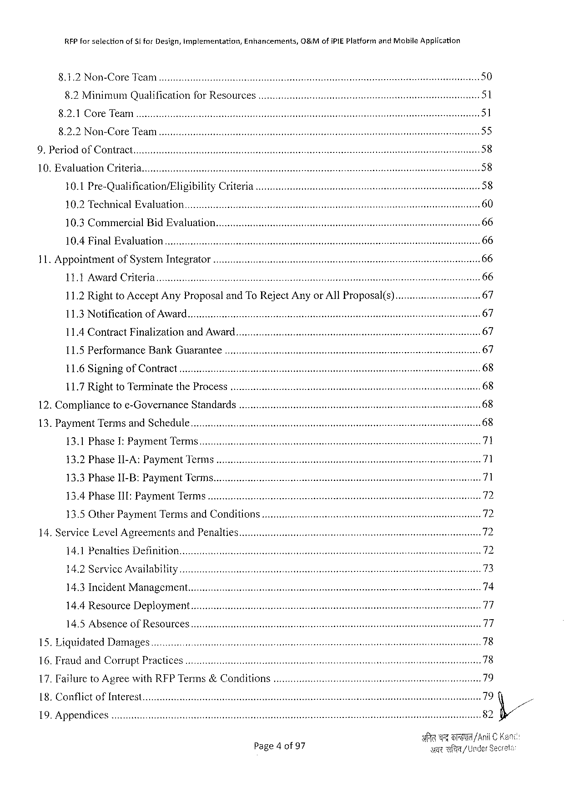

|  |  |  |  |  |  |  |  |  |  |  |  |  |  |  |  |  |  |  |  |  |
| --- | --- | --- | --- | --- | --- | --- | --- | --- | --- | --- | --- | --- | --- | --- | --- | --- | --- | --- | --- | --- |
| x R | RFP forselection | | | | of Si for Design, implementation, | | | | Enhancements, | 0&Mof IPIEP latformand Mobile Application | | | | | | | | | | 50 |
| SR | N o | | o Tee AN | | | | s | e | e | e | | | T | | | TR | TS | |
| s | | | | | | | | | | 51 |
| 8.2 Minimum Qualificationfor RESOUICES.. ot | | | | | | | | |
| 8921©OTEM eai | | | | | e | | | e | T | S | | T R | | STS | | ST | | | 51 |
| 89250\Oy | | C T e | | | TA | o | | TT | se | s | TR | s AT | | | os W TSRSTS | | | AT | 55 |
| TR | | | | | | | T | | | 58 |
| OAI 0 ECOTT At s | | | | | | | | |

10. Evaluation Criteria.

|  |  |  |  |  |
| --- | --- | --- | --- | --- |
| 10.1 Pre-Qualification/Eligibility | Cr Iteria | . .... cccrverirerierimmeissiesiiissss | s | 58 |

10.2 Technical Evaluation   
10.3 Commercial Bid Evaluation.

10.4 Final Evaluation   
11. Appointmentof System Integrator

|  |  |  |  |  |
| --- | --- | --- | --- | --- |
| LI k AW a Td, Chile Ti T | e | e | e | 66 |

11.2 Rightto Accept Any Proposaland To Reject Anyor All Proposal(s)......... c. cocovriercmucns 67

|  |  |  |  |  |  |  |  |  |  |  |
| --- | --- | --- | --- | --- | --- | --- | --- | --- | --- | --- |
| 1183 Netification | of/AW a AI ls | e | e | | e | Te | S | T | I | 67 |
| s | 67 |
| 11.4 Contract Finalizationand AW ard............ coocooiiiiiiiiiii | | | | |
| 11.5 Performance Bank GUAKANTEE ... | | | | | T | e(e | st | 67 |
| LI 6+Sizn INEI o TCON t Tat | | s | T | T | s ST ST |

11.7 Rightto Terminatethe Process   
12. Compliancetoe-Governance Standards   
13. Payment Termsand Schedule   
 13.1 Phase I: Payment Tern

|  |  |  |  |  |  |  |  |  |  |
| --- | --- | --- | --- | --- | --- | --- | --- | --- | --- |
| 132}Phasell LA | SR Ey ME n CICT St | | e | T | | | S | ST | S 71 |
| R | TR | 71 |
| 13:3 Phasejl EB: | Paymentilicin | e | | e | | R |
| s | | 72 |
| 13.4 Phase III: Payment TIMIS.. ottt | | | | | | |
| 13.5 Other Payment Termsand Conditions..... c.. vocioiniiies | | | | | | | 72 |
| 14. Service Level Agreementsand Penalties....... oieircimriiconiicsisscninnsnses | | | | | | | 72 |
| sb st | | 72 |
| 14.1 Penalties Def IMHON.«..... oiiiriiiiiier | | | | s | | |
| 14.2 Service AVAHIADIHLY.. ot | | | | | | | 73 |
| 14.3 Incident Management........ co. oooivieiiiineiiiniciie | | | | s | sssas st | s | 74 |

14.4 Resource Deployment   
14.5 Absenceof Resources   
15. Liquidated Damages.

16. Fraud and Corrupt Practices

|  |  |  |  |  |  |  |  |  |
| --- | --- | --- | --- | --- | --- | --- | --- | --- |
| 17. FF ailure to Agreewith RFPT erms&Conditions.. o | | | east | 7 | B | 79 | | . |
| 79 | |
| 18, CONTIICE | OFINEETES... ittt | ettt |
| 82 fi// | |
| 1 O, APPENAICES.. ottt | | |
| /Ani | C |
| Page 4 of 97 | | | ageil | | / Under Sec | |

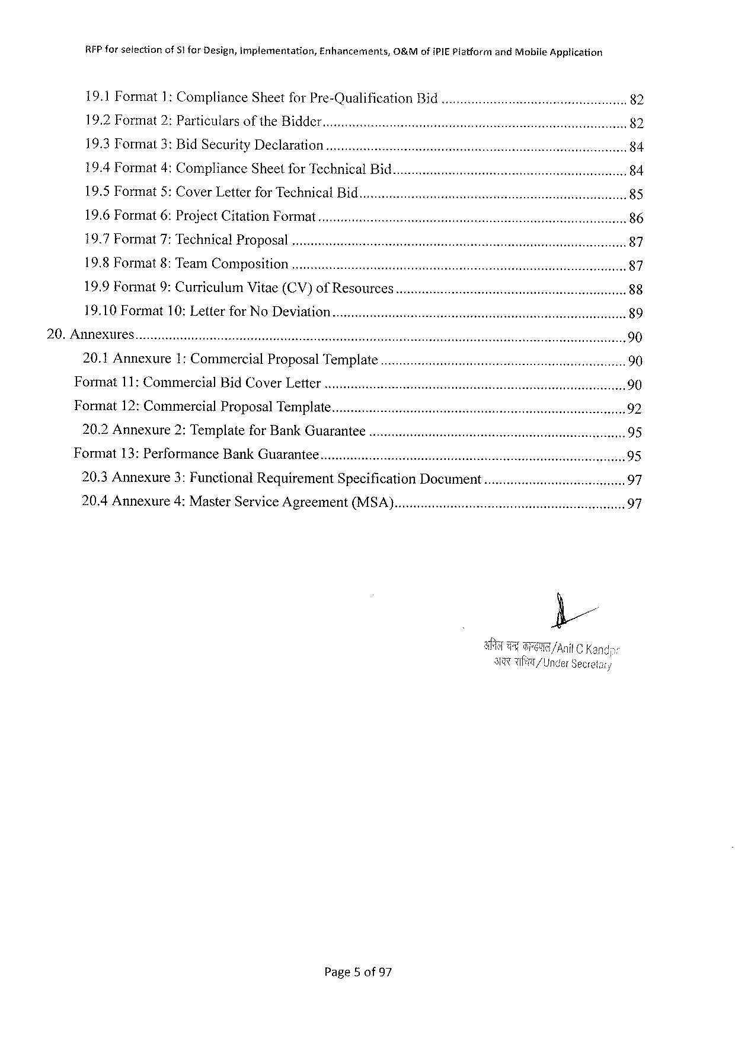

|  |  |  |  |  |  |  |  |  |  |
| --- | --- | --- | --- | --- | --- | --- | --- | --- | --- |
| RFP forsetection | of 51 for Design, implementation, | | Enhancements, | O&Mofi PIEP latformand Mobile Application | | | | s | 82 |
| 19.1 Format 1: Compliance Sheetfor Pre-Qualification | | | | | Bid«... o... coooovvvoo | | |
| 19.2 Format 2: Particulars | | of the BIA der....... oic. orreiiriiiiriiiiosseesoesees | | | | e | | 82 |
| 19.3 Tormat 3: Bid Security Declaration | | | .......... ccoouewieeevvrmeriroonsisssensoooeeeeeeeeeeeecesssiesssees | | | | |
| 84 |
| 19.4 Format 4: Compliance Sheetfor Technical Bid....... cco. ccovveriionvoiieeeeeeseeeeces | | | | | | | e, | 84 |
| 19.5 Format 5: Cover Letterfor Technical Bid... c. ooociovvionronniniensonioeceeresvoneessi | | | | | | | | 85 |

19.6 Format 6: Project Citation Format   
19.7 Format 7: Technical Proposal   
19.8 Format 8: Team Composition   
19.9 Format 9: Curriculum Vitae(CV)of Resources.

19.10 Format 10: Letterfor No Deviation   
20. Annexures   
 20.1 Annexure 1: Commercial Proposal Template.......... coooovrmrmrinrrimsinreosresssieonn 90 Format 11: Commercial Bid COVE r LE ter ........ o.. coimumrrivmrivnniriisssieisnessoesesresssssons sossseeens 90 Format 12: Commercial Proposal Tem MPIAL e............. cc. wwerrueriemmecrieniasinnsisninnssssssssiossissensonnses 92 20.2 Annexure 2: Templatefor Bank GUATANTEE........... evrvveernieiosiesiensreisiesiessssessiessessaones 95 Format 13: Performance Bank GUATANTEE ........... overeriisrmniiaisisesinessessecesrssssssesessosssseseeeeesns 95 20.3 Annexure 3: Functional Requirement Specification DOCUMEN t............. crvorerversrerernnes 97 20.4 Annexure 4: Master Service Agreement (MSA)....... ovvriuiirenieosesrrssosssseeessconsenene 97

Page 5 of 97

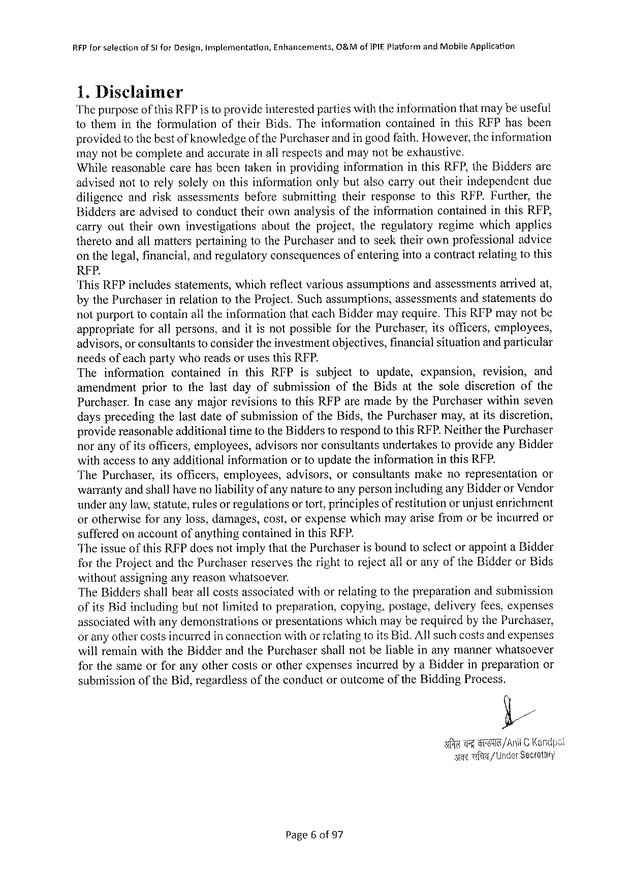

RFP forselection of Si for Design, Implementation, Enhancerents, O&Mofi PIE Platformand Mabile Application

1. Disclaimer   
Thepurposeofthis RFP is toprovideinterestedpartieswiththeinformationthatmaybeuseful tothemintheformulation oftheir Bids. Theinformation contained inthis RFP hasbeen providedtothebestof knowledgeof the Purchaserandin goodfaith. However, theinformation maynotbecompleteandaccurateinall respectsandmaynotbeexhaustive.

Whilereasonablecarehas beentakeninprovidinginformation inthis RFP, the Biddersare advisednottorelysolelyonthisinformationonlybutalsocarryouttheirindependent due

diligence andriskassessments beforesubmitting theirresponsetothis RFP. Further, the

Biddersareadvisedtoconducttheirownanalysisoftheinformation containedinthis RFP,

carryouttheirowninvestigations abouttheproject, theregulatory regimewhichapplies theretoandallmatterspertainingtothe Purchaserandtoseektheirownprofessionaladvice onthelegal, financial, andregulatoryconsequencesofenteringintoa contractrelatingtothis

RFP.

"This RFP includes statements, which reflect various assumptions andassessments arrived at,

bythe Purchaserinrelationtothe Project. Suchassumptions, assessmentsandstatementsdo notpurporttocontainalltheinformationthateach Biddermayrequire. This RFP maynotbe appropriate forallpersons, anditisnotpossibleforthe Purchaser, itsofficers, employees, advisors, or consultantstoconsidertheinvestmentobjectives, financialsituationand particular needsofeachpartywhoreadsorusesthis RFP.

The information contained inthis RFP issubject toupdate, expansion, revision, and

amendment priortothelastdayofsubmission of the Bidsatthesolediscretion of the

Purchaser. Incaseanymajorrevisionstothis RFP aremadebythe Purchaserwithinseven daysprecedingthelastdateofsubmissionofthe Bids, the Purchasermay, atitsdiscretion, providereasonableadditionaltimetothe Bidderstorespondtothis RFP. Neitherthe Purchaser noranyofitsofficers, employees, advisorsnorconsultantsundertakestoprovideany Bidder withaccesstoanyadditionalinformationortoupdatetheinformationinthis RFP.

The Purchaser, itsofficers, employees, advisors, orconsultants makenorepresentation or warrantyand shallhaveno liabilityof anynaturetoanypersonincludingany Bidderor Vendor underanylaw, statute, rulesor regulationsortort, principlesof restitutionor unjustenrichment orotherwiseforanyloss, damages, cost, orexpensewhichmayarisefromorbeincurredor sufferedonaccountofanythingcontainedinthis RFP.

Theissueofthis RFP doesnotimplythatthe Purchaseris boundtoselectorappointa Bidder for the Projectandthe Purchaserreservestherighttorejectalloranyofthe Bidderor Bids

withoutassigninganyreasonwhatsoever.

The Biddersshallbearallcostsassociatedwithorrelatingtothepreparationandsubmission ofits Bidincludingbutnotlimitedtopreparation, copying, postage, deliveryfees. expenses associatedwithanydemonstrations orpresentationswhichmayberequiredbythe Purchaser, or anyothercostsincurredinconnectionwithor refatingtoits Bid. Allsuchcostsandexpenses willremainwiththe Bidderandthe Purchasershallnotbeliableinanymannerwhatsoever forthesameorforanyothercostsorotherexpensesincurredbya Bidderinpreparation or

submissionofthe Bid, regardlessoftheconductoroutcome of the Bidding Process.

E/,

|  |  |  |  |  |
| --- | --- | --- | --- | --- |
| e | e | i | S | /Ani C Kandpal / Under Seceetary |

Page 6 of 97

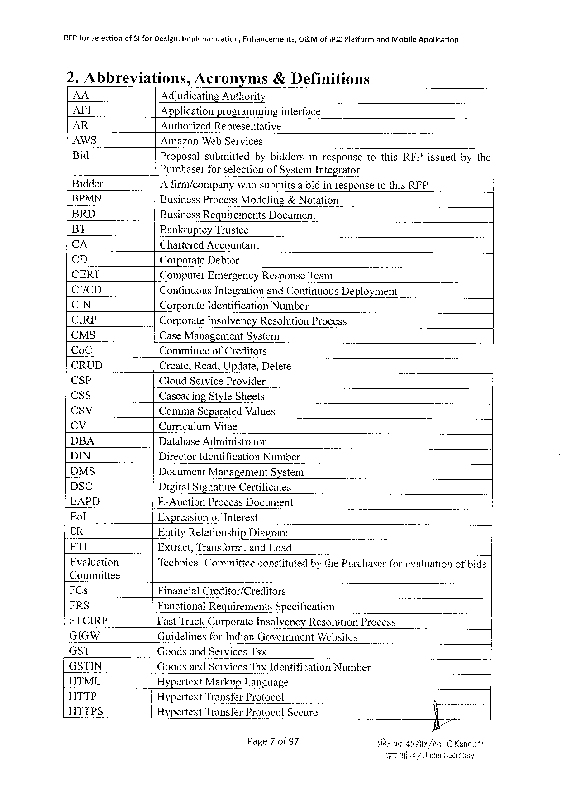

|  |  |  |  |
| --- | --- | --- | --- |
| RFP forselection | of§1 for Design, tmplementation, | Enhancements, | O&Mofi PIEP latformand Mobile Application |

2. Abbreviations, Acronyms& Definitions

|  |  |  |  |  |  |  |  |  |  |  |  |
| --- | --- | --- | --- | --- | --- | --- | --- | --- | --- | --- | --- |
| AA | - | Adjudicating Authority | | | | | | | | | |
| API |
| Applicationprogramming | | | | interface | | | | | |
| AR |
| Authorized Representative | | | | | | | | | |
| AWS |
| Amazon Web Services | | | | | | | | | |
| Bid |
| Proposal | submitted | bybiddersinresponsetothis RFP issuedbythe | | | | | | | |
| Bidder | Purchaserforselectionof System Integrator | | | | | | | | | |
| A firm/companywhosubmitsabidinresponsetothis RFP | | | | | | | | | |
| BPMN |
| Business Process Modeling&Notation | | | | | | | | | |
| BRD |
| Business Requirements Document | | | | | | | | | |
| BT | Bankruptcy Trustee | | | | | | | | | |
| CA | Chartered Accountant | | | | | | | | | |
| CD |
| Corporate Debtor | | | | | | | | | |
| CERT | Computer Emergency Response Team | | | | | | | | | |
| CI/CD |
| Continuous Integrationand Continuous Deployment | | | | | | | | | |
| CIN |
| Corporate Identification Number | | | | | | | | | |
| CIRP | Corporate Insolvency Resolution Process | | | | | | | | | |
| CMS |
| Case Management System | | | | | | | | | |
| Co C |
| Committeeof Creditors | | | | | | | | | |
| CRUD |
| Create, Read, Update, Delete | | | | | | | | | |
| CSP |
| Cloud Service Provider | | | | | | | | | |
| CS s |
| Cascading Style Sheets | | | | | | | | | |
| Ccsv |
| Comma Separated Values | | | | | | | | | |
| (&% | Curriculum Vitae | | | | | | | | | |
| DBA |
| Database Administrator | | | | | | | | | |
| DIN |
| Director Identification Number | | | | | | | | | |
| DMS |
| Document Management | | | System | | | | | | |
| DSC |
| Digital Signature Certificates | | | | | | | | | |
| EAPD | E-Auction Process Document | | | | | | | | | |
| Eol |
| Expressionof Interest | | | | | | | | | |
| ER |
| Entity Relationship | | Diagram | | | | | | | |
| ETL |
| Extract, Transform, and Load | | | | | | | | | |
| Fvaluation |
| Technical Commitieeconstitutedbythe Purchaserforevaluationofbids | | | | | | | | | |
| Committee | Financial Creditor/Creditors | | | | | | | | | |
| FC s |
| FRS |
| Functional Requirements Specification | | | | | | | | | |
| FICIRP | Fast Track Corporate Insolvency Resolution Process | | | | | | | | | |
| GIGW |
| Guidelinesfor Indian Government Websites | | | | | | | | | |
| GST |
| Goodsand Services Tax | | | | | i | | | | | |
| GSTIN | Goodsand Services Tax Identification Number | | | | | | | | | |
| HTML |
| Hypertext Markup Language | | | | | | | | | |
| HTTP |
| Hypertext Transfer Protocol | | | | | o | | B | | |
| HTTPS |
| Hypertext Transfer Protocol Secure | | | | | . | . | “ | | ) |
| |28 | |
| Page 7 of 97 | | | | | A | | TB | /A | |
| s | | | | | | | wfa/U | | |

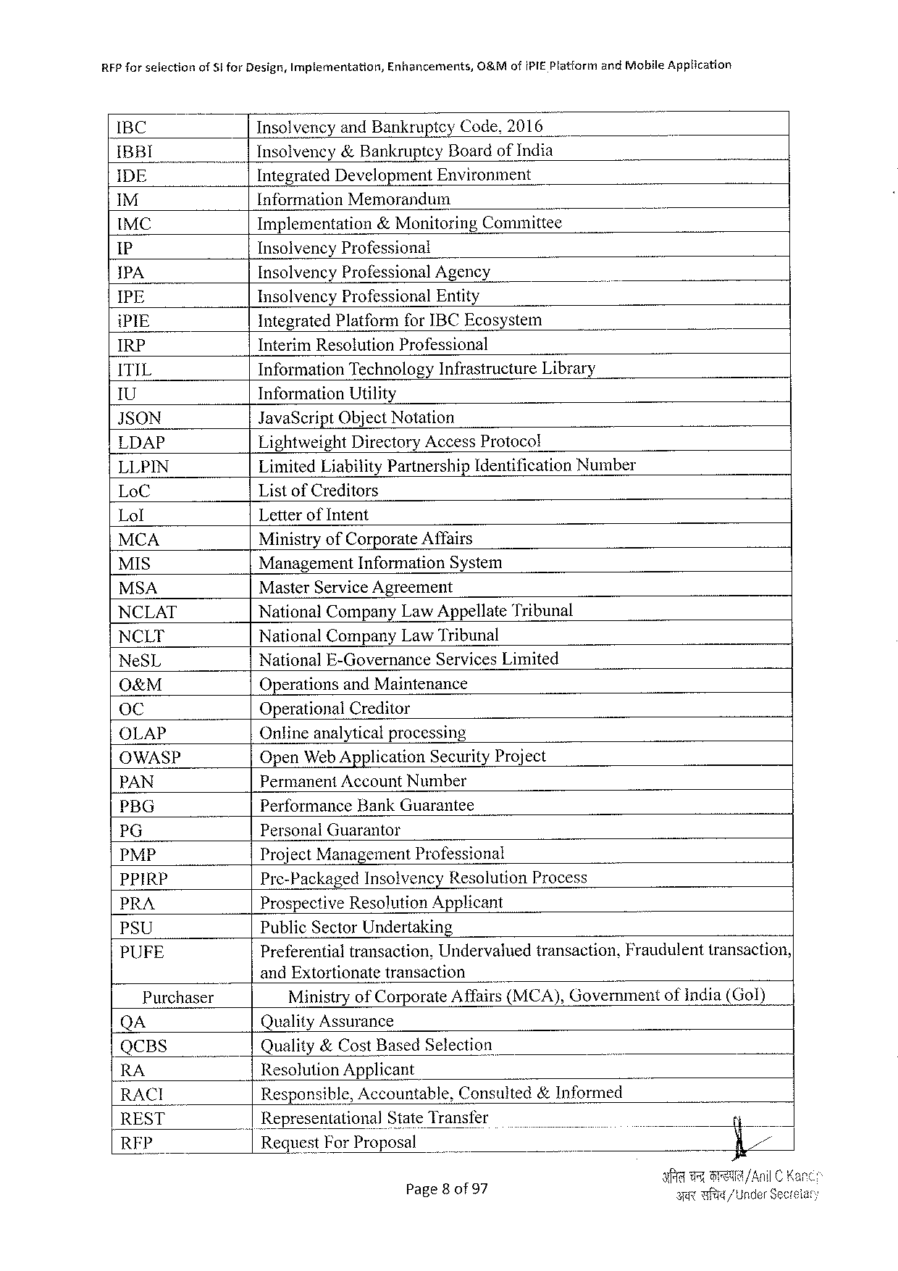

RFP forselection of Sfor Design, Implementation, Enhancements, O&Mof IPIEP latfarm and Mobile Application

IBC Insolvencyand Bankruptey Code,2016

IBBI Insolvency&Bankruptey Boardof India

IDE Integrated Development Environment

M [nformation Memorandum

IMC Implementation &Monitoring Committee

1 P Insolvency Professional

IPA Insolvency Professional Agency

IPE Insolvency Professional Entity

i PIE Integrated Platformfor IBCE cosystem

IRP Interim Resolution Professional

ITIL Information Technology Infrastructure Library

U Information Utility

JSON Java Script Object Notation

LDAP Lightweight Directory Access Protocol

LLPIN Limited Liability Partnership Identification Number

Lo C Listof Creditors

Lol Letterof Intent

MCA Ministryof Corporate Affairs

MIS Management Information System

MSA Master Service Agreement

NCLAT National Company Law Appellate Tribunal

NCLT National Company Law Tribunal

Ne SL National E-Governance Services Limited

O&M Operationsand Maintenance

o C Operational Creditor

OLAP Onlineanalyticalprocessing

OWASP Open Web Application Security Project

PAN Permanent Account Number

PBG Performance Bank Guarantee

PG Personal Guarantor

PMP Project Management Professional

PPIRP Pre-Packaged Insolvency Resolution Process

PRA Prospective Resolution Applicant

PSU Public Sector Undertaking

PUFE Preferentialtransaction, Undervaluedtransaction, Fraudulenttransaction,

___|and Extortionatetransaction

Purchaser Ministryof Corporate Affairs(MCA), Governmentofindia(Gol)

QA Quality Assurance

QCBS Quality&Cost Based Selection

RA Resolution Applicant

RACI Responsible, Accountable, Consuited&Informed

REST _|Representational State Transfer

RFP Request For Proposal

Page 8 of 97 Y TR/ Under Sec

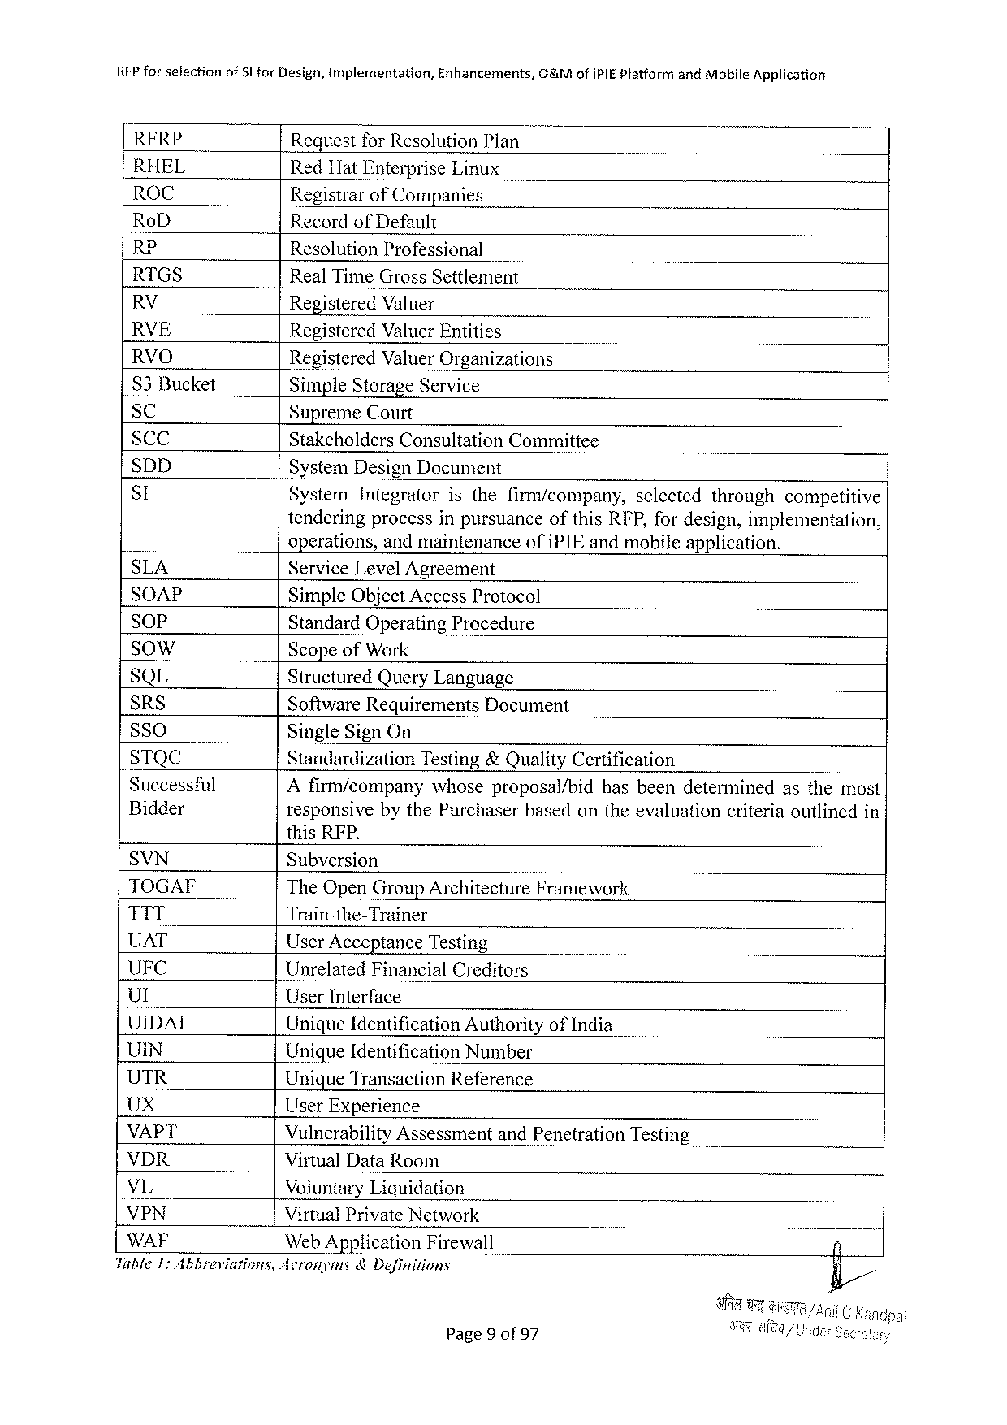

RFP for selectionof$1 for Design, implementation, Enhancements,&Mofi PIEP latform and Mobile Application

|  |  |  |  |  |  |
| --- | --- | --- | --- | --- | --- |
| RERP | Requestfor Resolution Plan | | | selected | throughcompetitive |
| RHEL | Red Hat Enterprise Linux | | |
| ROC |
| Registrarof Companies | | |
| Ro D |
| Recordof Default | | |
| RP |
| Resolution Professional | | |
| RTGS |
| Real Time Gross Settlement | | |
| RV |
| Registered Valuer | | |
| RVE |
| Registered Valuer Entities | | |
| RVO |
| Registered Valuer Organizations | | |
| S 3 Bucket | Simple Storage Service | | |
| SC |
| Supreme Court | | |
| SCC | Stakeholders Consultation | | Committee |
| SDD |
| System Design Document | | |
| St | System Integrator | isthefirm/company, | |

tenderingprocessinpursuanceofthis RFP, fordesign, implementation,

operations, andmaintenanceofi PIE andmobileapplication.

|  |  |  |  |
| --- | --- | --- | --- |
| SLA  SOAP  SO o P  SO w W  SQL  SRS  SSO  STQC  Successful Bidder | Service Level Agreement  Simple Object Access Protocol  Standard Operating Procedure  Scopeof Work  Structured Query Language | | |
| Software Requirements | | Document |
| Single Sign On | | |
| Standardization | Testing&Quality Certification | |
| A firm/companywhoseproposal/bidhasbeendeterminedasthemost responsivebythe Purchaserbasedontheevaluationcriteriaoutlinedin | | |

this RFP.

SVN Subversion

TOGAF The Open Group Architecture Framework

TTT Train-the-Trainer

UAT User Acceptance Testing

UFC Unrelated Financial Creditors

Ul User Interface

UIDAI Unique Identification Authorityof India

UIN Unique Identification Number

UTR Unique Transaction Reference

Ux User Experience

VAPT Vulnerability Assessment and Penetration Testing

VDR Virtual Data Room

VL Voluntary Liquidation

VPN Virtual Private Network B

WAF Web Application Firewall

Tuble 1: Abbreviations, Acronyms&Definitions

Page 9 of 97

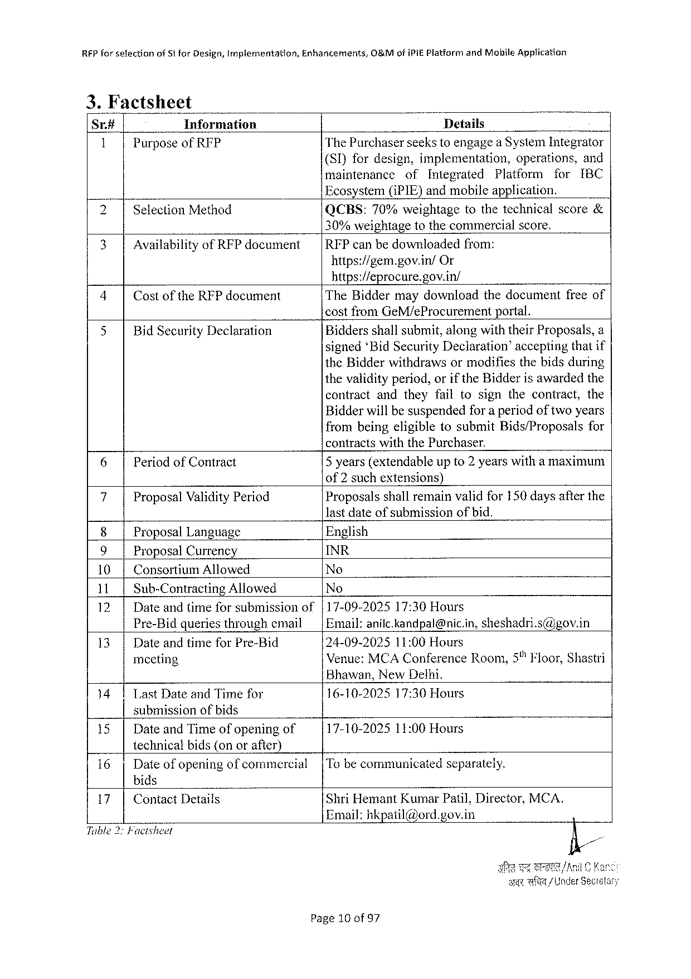

RFP for setectionof Stfor Design, Implementation, Enhancements, O&Mofi PIEP latform and Mobile Application

|  |  |  |  |  |  |  |  |  |  |  |
| --- | --- | --- | --- | --- | --- | --- | --- | --- | --- | --- |
| Sr.# | Information | Details | | | | | | | | |
| 1 | Purposeof RIP | The Purchaserseekstoengagea System Integrator | | | | | | | | |
| (SI)fordesign, implementation, | | | | | | operations, | | and |
| maintenance | | of | Integrated | | Platform | | for | IBC |
| 2 | Selection Method |
| Ecosystem(i PIE)andmobileapplication. | | | | | | | | |
| QCBS: | 70%weightage | | | tothetechnicalscore& | | | | |

30%weightagetothecommercialscore.

|  |  |  |  |
| --- | --- | --- | --- |
| 3 | Availabilityof RFP document | |RFP canbedownloadedfrom: | |
| https://gem. gov. in/ | Or |

https://eprocure. gov. in/

|  |  |  |  |
| --- | --- | --- | --- |
| 4 | Costofthe RFP document | The Biddermaydownloadthedocumentfreeof | |
| 5 | Bid Security Declaration | costfrom Ge M/e Procurement | portal. |
| Biddersshallsubmit, alongwiththeir Proposals, a | |
| signed‘Bid Security Declaration”acceptingthatif | |

the Bidderwithdrawsormodifiesthebidsduring thevalidityperiod, orif the Bidderisawardedthe

contractandtheyfailtosignthecontract, the

Bidderwillbesuspendedfor a periodoftwoyears frombeingeligibletosubmit Bids/Proposals for

contractswiththe Purchaser.

|  |  |  |
| --- | --- | --- |
| 6 | Periodof Contract | 5 years(extendableupto 2 yearswitha maximum |

of 2 suchextensions)

|  |  |  |
| --- | --- | --- |
| 7 | Proposal Validity Period | Proposalsshallremainvalidfor 150 daysafterthe |

lastdateofsubmissionofbid.

|  |  |  |
| --- | --- | --- |
| 8 | Proposal Language | English |
| 9 | Proposal Currency | INR |
| No |
| 10| | Consortium Allowed |
| No |
| 1 il, | Sub-Contracting Allowed |
| 12| | Dateandtimeforsubmissionof | |17-09-202517:30 Hours |
| 13| | Pre-Bidqueriesthroughemail | |Email: anilc. kandpal@nic. in, sheshadri. s@gov. in |
| Dateandtimefor Pre-Bid | 24-09-202511:00 Hours |
| Venue: MCAC onference Room,5% Floor, Shastri |
| meeting |

Bhawan, New Delhi.

141 Last Dateand Timefor submissionofbids

16-10-202517:30 Hours

|  |  |  |
| --- | --- | --- |
| 15| | Dateand Timeofopeningof | 17-10-202511:00 Hours |

technicalbids(onorafter)

|  |  |  |  |
| --- | --- | --- | --- |
| 16| | Dateofopeningofcommercial | |Tobecommunicated | separately. |

bids

|  |  |  |  |
| --- | --- | --- | --- |
| 17| | Contact Details | Shri Hemant Kumar Patil, Director, MCA. | N |
| Email: hkpatil@ord. gov. in |

Tible 2: Facisheet

e Wl/Under Sec

Page 10 of 97

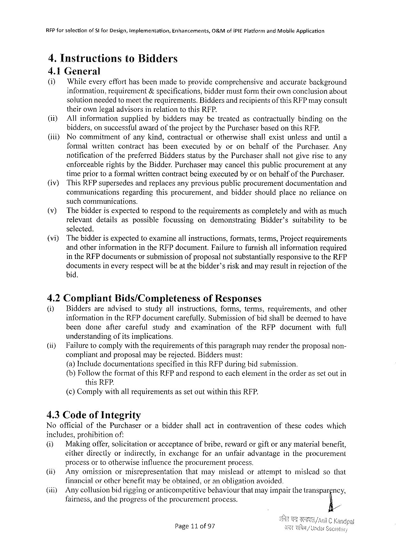

|  |  |  |  |
| --- | --- | --- | --- |
| RFP forselection | of SI for Design, implementation, | Enhancements, | O&Mofi PIE Platformand Mobile Application |

4. Instructionsto Bidders

4.1 General

|  |  |  |
| --- | --- | --- |
| (i) | Whileeveryefforthasbeenmadetoprovidecomprehensive | andaccuratebackground |

information, requirement&specifications, biddermustformtheirownconclusionabout

solutionneededtomeettherequirements. Biddersandrecipientsofthis RFP mayconsult

theirownlegaladvisorsinrelationtothis RFP.

|  |  |  |  |  |  |  |  |  |
| --- | --- | --- | --- | --- | --- | --- | --- | --- |
| (it)  (iii) | Allinformation | | suppliedbybiddersmaybetreatedascontractually | | | | bindingonthe | |
| bidders, on successful awardofthe projectbythe Purchaser basedonthis RFP. | | | | | | | |
| Nocommitment | | ofanykind, contractual | | orotherwise | shallexistunlessanduntila | | |
| formalwritten | | contract | hasbeenexecuied | byoronbehalfofthe Purchaser. | | | Any |
| notification | ofthepreferred Biddersstatusbythe Purchasershallnotgiverisetoany | | | | | | |

enforceablerightsbythe Bidder. Purchasermaycancelthispublicprocurementatany

|  |  |  |  |  |  |
| --- | --- | --- | --- | --- | --- |
| (iv) | timepriortoaformalwrittencontractbeingexecutedbyoronbehalfofthe Purchaser. | | | | |
| This RFP supersedesandreplacesanypreviouspublicprocurementdocumentation | | | | and |
| communications | regarding | thisprocurement, | andbiddershouldplacenorelianceon | |

suchcommunications.

(v) Thebidderisexpectedtorespondtotherequirementsascompletelyandwithasmuch

relevant details aspossible focussing ondemonstrating Bidder’s suitability tobe

selected.

(vi) Thebidderisexpectedtoexamineallinstructions, formats, terms, Projectrequirements

andotherinformationinthe RFP document. Failuretofurnishallinformationrequired

in the RFP documentsorsubmissionof proposalnotsubstantiallyresponsivetothe RFP

documentsineveryrespectwillbeat thebidder’sriskandmayresultinrejectionof the

bid.

4.2 Compliant Bids/Completeness of Responses

(i) Biddersareadvisedtostudyallinstructions, forms, terms, requirements, andother

informationinthe RFP documentcarefully. Submissionofbidshallbedeemedtohave

beendoneaflercarefulstudyandexaminationofthe RFP documentwithfull

understandingofitsimplications.

(ii) Failuretocomplywiththerequirementsofthisparagraphmayrendertheproposalnon-

compliantandproposalmayberejected. Biddersmust:

(a)Includedocumentations specifiedinthis RFP duringbidsubmission.

{b) Followtheformatofthis RFP andrespondtoeachelementintheorderassetoutin

this RFP.

(c)Complywithallrequirementsassetoutwithinthis RFP.

4.3 Codeof Integrity

|  |  |  |
| --- | --- | --- |
| Noofficialofthe Purchaser | orabiddershallactincontravention | ofthesecodeswhich |

includes, prohibitionof:

|  |  |  |  |  |  |
| --- | --- | --- | --- | --- | --- |
| (i) | Makingoffer, solicitation | oracceptance | ofbribe, reward | orgiftoranymaterial | benefit, |

eitherdirectlyorindirectly, inexchangeforanunfairadvantageintheprocurement

processorto otherwise influencethe procurementprocess.

|  |  |  |  |  |  |
| --- | --- | --- | --- | --- | --- |
| (i) | Anyomission | ormisrepresentation | thatmaymislead | orattempt | tomisleadsothat |

financialor otherbenefitmaybeobtained, oranobligationavoided.

(i) Anycollusionbidriggingor anticompetitivebehaviourthatmayimpairthetranspargncy,

fairness, andtheprogressoftheprocurementprocess. E/

Page 11 0 f 97

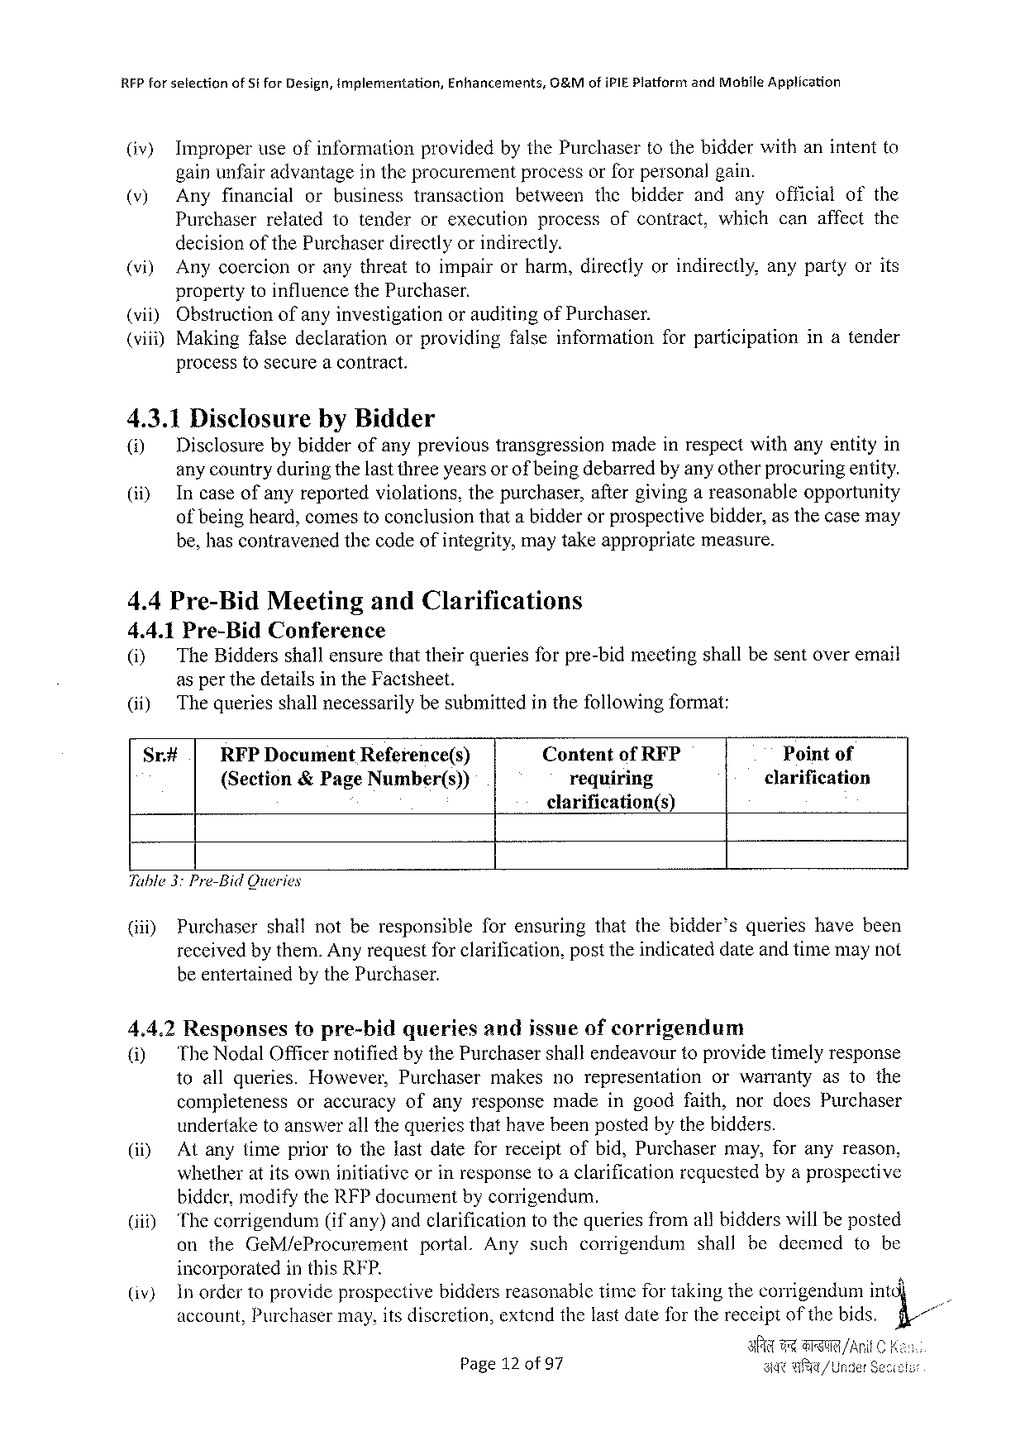

RFP forselection of Stfor Design, implementation, Enhancements, 0&Mofi PIEP latformand Mohile Application

(iv) Improperuseofinformation providedbythe Purchasertothebidderwithanintentto

gainunfair advantagein the procurement process orforpersonal gain.

(v) Anyfinancial orbusiness transaction between thebidder andanyofficial of the

Purchaserrelatedtotenderorexecutionprocessofcontract, whichcanaffectthe

decisionofthe Purchaserdirectlyor indirectly.

(vi) Anycoercionoranythreattoimpairorharm, directlyorindirectly, anypartyorits

propertytoinfluencethe Purchaser.

|  |  |  |  |  |  |  |
| --- | --- | --- | --- | --- | --- | --- |
| (vii) | Obstructionofanyinvestigation | | orauditingof Purchaser. | | forparticipation | inatender |
| (viii)Makingfalsedeclaration | | orproviding | | falseinformation |

processtosecurea contract.

4.3.1 Disclosureby Bidder

|  |  |  |
| --- | --- | --- |
| () | Disclosurebybidderofanyprevioustransgression | madeinrespectwithanyentityin |

any countryduringthelastthreeyearsorofbeingdebarredby anyotherprocuringentity.

(i) Incaseofanyreportedviolations, thepurchaser, aftergivingareasonableopportunity

of being heard, comestoconclusionthata bidderorprospectivebidder, asthecasemay

be, hascontravenedthecodeofintegrity, maytakeappropriate measure.

4.4 Pre-Bid Meeting and Clarifications

4.4.1 Pre-Bid Conference

(i) The Biddersshallensurethattheirqueriesforpre-bidmectingshallbesentoveremail

asper thedetailsinthe Facisheet.

|  |  |  |  |
| --- | --- | --- | --- |
| (ii) | The queriesshallnecessarilybesubmittedinthefollowingformat: | | Pointof |
| Sr# | RFPD ocument Reference(s) | Contentof RFP |
| {Section&Page Number(s)) | requiring | clarification |

clarification(s)

Tuble 3: Pre-Bid Queries

|  |  |  |  |  |
| --- | --- | --- | --- | --- |
| (i) | Purchaser | shallnotberesponsible | forensuring | thatthebidder’squerieshavebeen |

receivedbythem. Anyrequestfor clarification, posttheindicateddateandtimemaynot

beentertainedbythe Purchaser.

4.4.2 Responsestopre-bidqueriesandjssneofcorrigendum

|  |  |  |  |  |
| --- | --- | --- | --- | --- |
| @) | The Nodal Officernotifiedbythe Purchasershallendeavourtoprovidetimelyresponse toallqueries. However, Purchasermakesnorepresentationorwarrantyastothe | | | |
| completeness | oraccuracy | ofanyresponse | madeingoodfaith, nordoes Purchaser |

undertaketoanswerall thequeriesthathavebeenpostedbythebidders.

(i) Atanytimepriortothelastdateforreceiptofbid, Purchasermay, foranyreason,

whetheratitsowninitiativeorinresponsetoaclarificationrequestedbyaprospective

bidder, modifythe RFP documentbycorrigendum.

|  |  |  |  |  |  |  |  |
| --- | --- | --- | --- | --- | --- | --- | --- |
| (i) | Thecorrigendum | (if any) | andclarificationtothequeriesfromallbidderswillbeposted | | | | |
| on the Ge M/e Procurement | | | portal. Anysuch | corrigendum | shallbedecmed | tobe |

incorporatedinthis RFP.

|  |  |  |
| --- | --- | --- |
| (iv) | Inordertoprovideprospectivebiddersreasonabletimefortakingthecorrigendumint | (1// |
| account, Purchasermay, itsdiscretion, extendthelastdateforthereceiptofthebids. |

Page 12 of 97

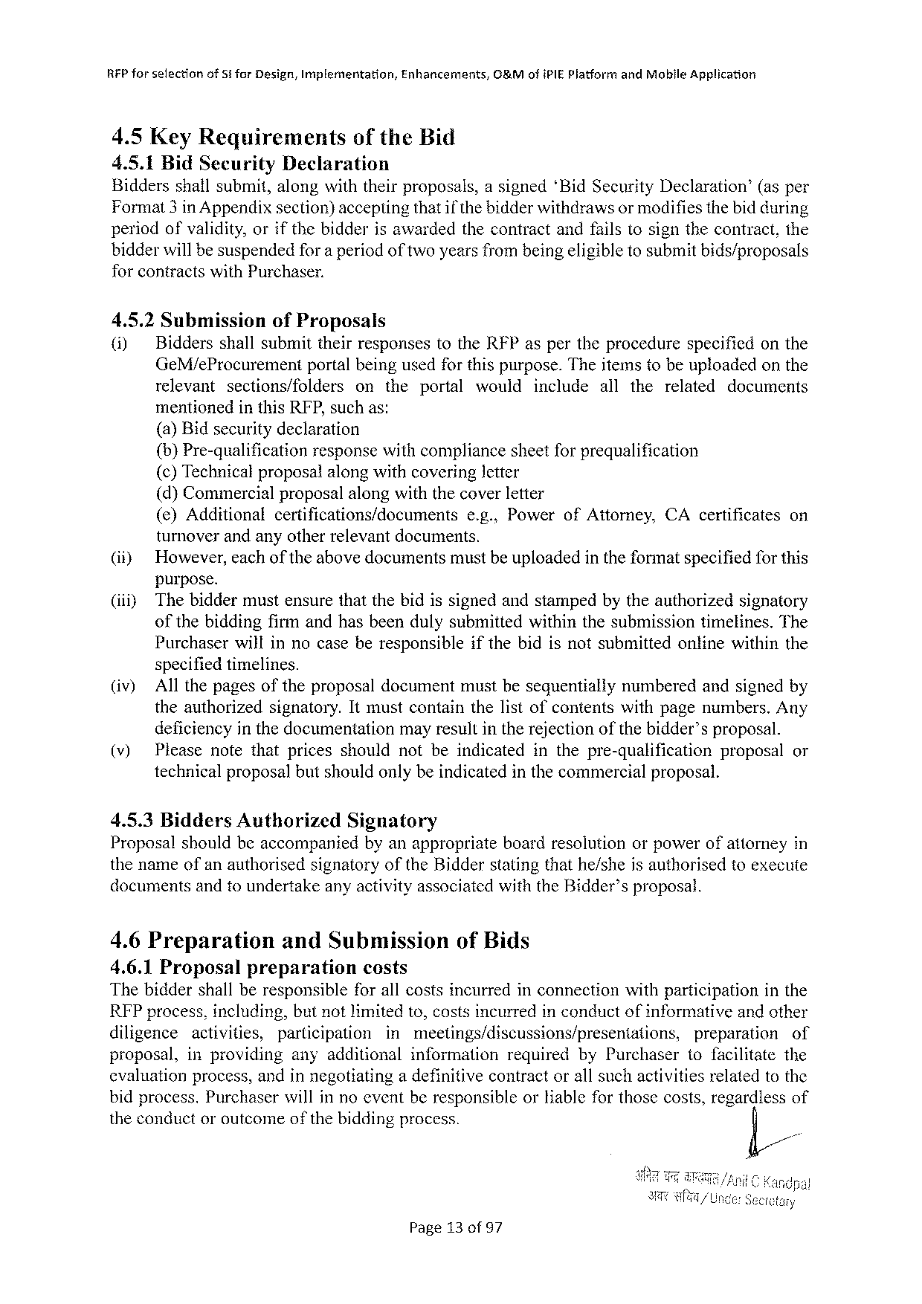

RFP forselection of St for Design, Implementation, Enhancernants, G&Mofi PIE Platformand Mobile Application

4.5 Key Requirements of the Bid

4.5.1 Bid Security Declaration

Biddersshallsubmit, alongwiththeirproposals, asigned‘Bid Security Declaration’ (asper

Format 3 in Appendixsection)acceptingthatif thebidderwithdrawsormodifiesthebidduring

periodofvalidity, orifthebidderisawardedthecontractandfailstosignthecontract, the

bidderwillbesuspendedfora periodoftwoyearsfrombeingeligibletosubmitbids/proposals

forcontractswith Purchaser.

4.5.2 Submission of Proposals

(i) Biddersshallsubmittheirresponsestothe RFP aspertheprocedure specifiedonthe

Ge M/e Procurement portalbeingusedforthispurpose. Theitemstobeuploadedonthe

relevant sections/folders ontheportal would include allthe related documents

mentionedinthis RFP, suchas:

(a)Bidsecuritydeclaration

{b)Pre-qualification responsewithcompliancesheetforprequalification

{c)Technicalproposalalongwithcoveringletter

(d)Commercialproposalalongwiththecoverletter

|  |  |  |  |  |
| --- | --- | --- | --- | --- |
| (e)Additional | certifications/documents | e. g., Powerof Attorney, | CA certificates | on |

turnoverandanyotherrelevantdocuments.

|  |  |
| --- | --- |
| (i)  (iiiy | However, eachoftheabovedocumentsmustbeuploadedintheformatspecifiedforthis purpose.  Thebiddermustensurethatthebidissignedandstampedbytheauthorizedsignatory |

ofthebiddingfirmandhasbeendulysubmittedwithinthesubmissiontimelines. The

Purchaserwillinnocaseberesponsible specifiedtimelines.

ifthebidisnotsubmittedonlinewithinthe

|  |  |  |
| --- | --- | --- |
| (iv) | Allthepagesoftheproposaldocumentmustbesequentially | numberedandsignedby |

theauthorizedsignatory. Itmustcontainthelistofcontentswithpagenumbers. Any

|  |  |  |  |  |  |
| --- | --- | --- | --- | --- | --- |
| (v) | deficiencyin thedocumentation | mayresultintherejectionofthebidder’sproposal. | | | or |
| Pleasenotethatpricesshouldnotbeindicated | | inthepre-qualification | proposal |

technicalproposalbutshouldonlybeindicatedinthecommercialproposal.

|  |  |  |  |
| --- | --- | --- | --- |
| 4.5.3 Bidders Authorized | Signatory | boardresolution | orpowerofattorneyin |
| Proposalshouldbeaccompanied | byanappropriate |

thenameofanauthorisedsignatoryofthe Bidderstatingthathe/sheisauthorisedtoexecute documents andto undertakeanyactivityassociated with the Bidder’sproposal.

4.6 Preparation and Submission of Bids   
4.6.1 Proposal preparation costs   
Thebiddershallberesponsible forallcostsincurredinconnectionwithparticipation in the REP process, including, butnotlimitedto, costsincurredinconductofinformativeandother

|  |  |  |  |  |  |  |  |
| --- | --- | --- | --- | --- | --- | --- | --- |
| diligence | activities, | participation | inmeetings/discussions/presentations, | | | preparation | of |
| proposal, | inproviding | anyadditional | | information | requiredby Purchaser | tofacilitatethe | |

cvaluationprocess, andinnegotiatinga definitivecontractorallsuchactivitiesrelatedtothe bidprocess. Purchaserwillinnoeventberesponsibleor Kableforthosecosts, regardlessof

|  |  |  |
| --- | --- | --- |
| theconductoroutcome | of the | biddingprocess. |

Page 13 of 97

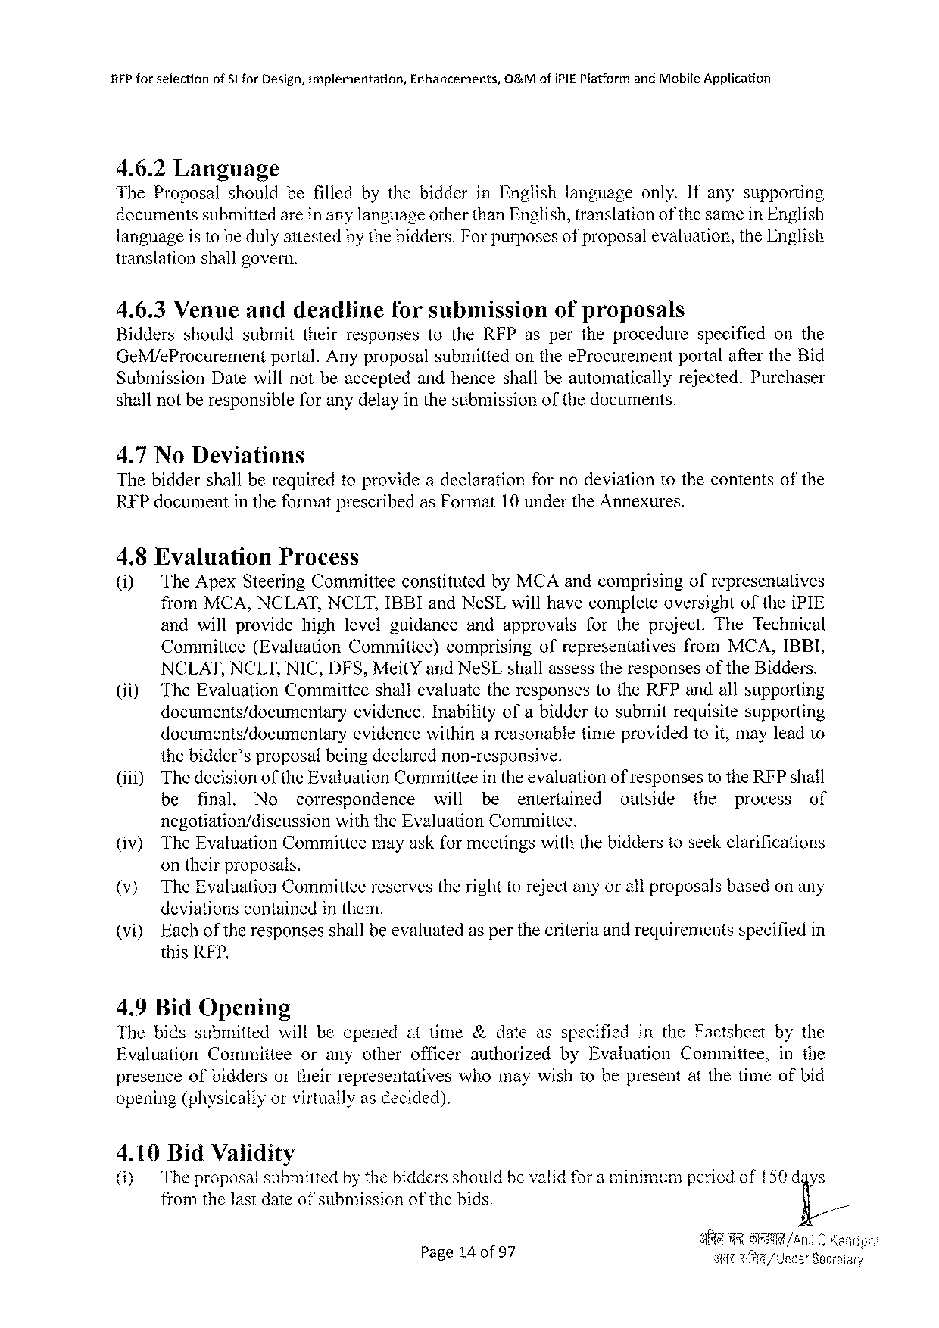

|  |  |  |  |
| --- | --- | --- | --- |
| RFP forselection | of S! for Design, implementation, | Enhancements, | 08&Mofi PIEP latformand Mobife Application |

4.6.2 Language

The Proposalshouldbefilledbythebidderin Englishlanguageonly. Ifanysupporting

documentssubmittedareinanylanguageotherthan English, translationof thesamein English

languageisto bedulyattestedbythebidders. Forpurposesof proposalevaluation, the English

translationshallgovern.

4.6.3 Venueanddeadlineforsubmission ofproposals

Bidders shouldsubmittheirresponsestothe RFP aspertheprocedure specified on the

Ge M/e Procurement portal. Anyproposalsubmittedonthee Procurement portalafterthe Bid

Submission Datewillnotbeacceptedandhenceshallbeautomatically rejected. Purchaser

shallnotberesponsibleforanydelayinthesubmission of the documents.

4.7 No Deviations

Thebiddershallberequiredtoprovideadeclaration fornodeviationtothecontentsofthe

RFP documentin theformatprescribedas Format 10 underthe Annexures.

4.8 Evaluation Process

(i) The Apex Steering Committeeconstitutedby MCA andcomprisingofrepresentatives

from MCA, NCLAT, NCLT, IBBI and Ne SL willhavecompleteoversightofthei PIE

andwillprovide highlevelguidance andapprovals fortheproject. The Technical

Cominittee (Evaluation Committee) comprising ofrepresentatives from MCA, IBBI,

NCLAT, NCLT, NIC, DFS, Meit Yand Ne SL shallassesstheresponsesofthe Bidders.

(ii) The Evaluation Committeeshallevaluatetheresponsestothe RFP andallsupporting

documents/documentaryevidence. Inabilityofabiddertosubmitrequisitesupporting

documents/documentary evidencewithinareasonabletimeprovidedtoit, mayleadto

thebidder’sproposalbeingdeclarednon-responsive.

|  |  |  |  |  |  |  |  |  |  |  |  |
| --- | --- | --- | --- | --- | --- | --- | --- | --- | --- | --- | --- |
| (iii) | Thedecisionofthe Evaluation Committeein theevaluationof responsesto the RFP shall | | | | | | | | | | |
| be | final. | No | correspondence | will | be | entertained | outside | the | process | of |

negotiation/discussionwiththe Evaluation Committee.

(iv) The Evaluation Committeemayaskformeetingswiththebidderstoseekclarifications

ontheirproposals.

(v) The Evaluation Committcereservestherighttorejectanyorallproposalsbasedon any

deviationscontainedinthem.

|  |  |  |  |
| --- | --- | --- | --- |
| (vi) | Each | of the | responsesshallbeevaluatedasperthecriteriaandrequirementsspecifiedin |

this RFP.

4.9 Bid Opening

Thebidssubmitted willbeopenedattime&dateasspecified in the Factsheet bythe

Evaluation Committee oranyotherofficerauthorized by Evaluation Committee, in the

presenceofbiddersortheirrepresentativeswhomaywishtobepresentatthetimeofbid

opening(physicallyorvirtuallyasdecided).

4.10 Bid Validity

(i) The proposalsubmittedby thebiddersshouldbevalidfora minimumperiedof 150 dgys

from the Jastdateof submissionofthebids.

|  |  |  |
| --- | --- | --- |
| Page 14 of 97 | 3 | 9@R/Ani LC K Av/ Under Secre |

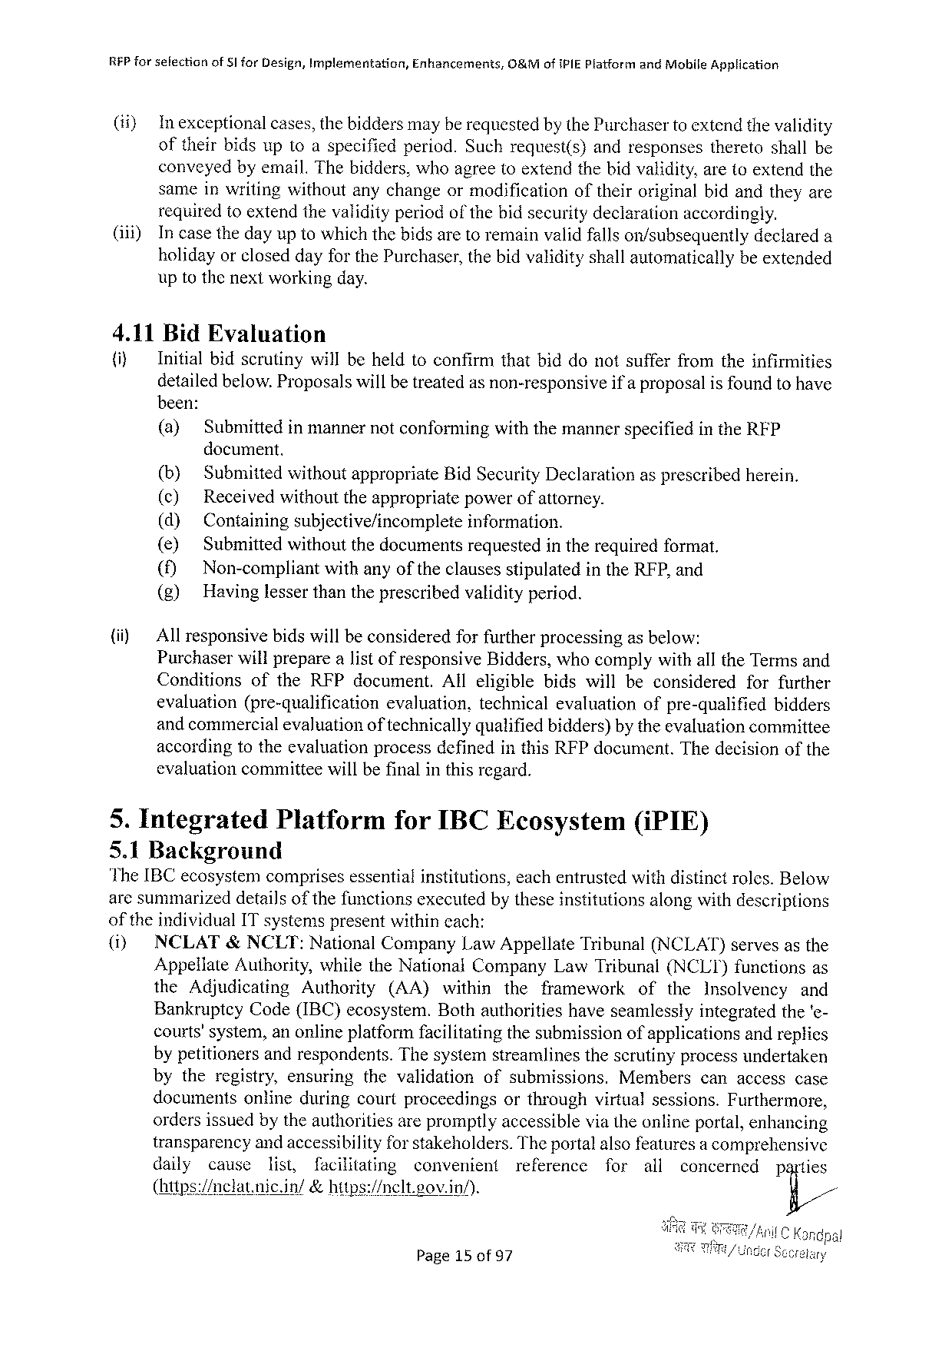

RFP forselfectionof§1 for Design, Implementation, Enhancements, O&Mof IPIEP latformand Mobile Application

(i) Inexceptional cases, thebiddersmayberequestedby the Purchasertoextendthevalidity

oftheirbidsuptoaspecifiedperiod. Suchrequest(s) andresponses theretoshallbe

conveyedbyemail. Thebidders, whoagreetoextendthebidvalidity, aretoextendthe

sameinwritingwithoutanychangeormodification oftheiroriginalbidandtheyare

requiredtoextendthevalidityperiod of thebidsecuritydeclarationaccordingly.

(i) Incasethedayuptowhichthebidsaretoremainvalidfallson/subsequently declareda

holidayorcloseddayforthe Purchaser, thebidvalidityshallautomatically beextended

uptothenextworkingday.

4.11 Bid Evaluation

|  |  |  |  |
| --- | --- | --- | --- |
| {i) | Initialbidscrutinywillbeheldtoconfirmthatbiddonotsufferfromtheinfirmities | | |
| detailedbelow. Proposalswillbetreatedas non-responsive | | ifa proposalis foundtohave |
| been: | | |
| (a) | Submittedinmannernotconformingwiththemannerspecifiedinthe RFP | |

document.

|  |  |  |  |  |  |  |  |  |  |  |  |
| --- | --- | --- | --- | --- | --- | --- | --- | --- | --- | --- | --- |
| (i) | (b) | Submittedwithoutappropriate Bid Security Declarationasprescribedherein. | | | | | | | | | |
| (c) | Receivedwithouttheappropriatepowerofattorney. | | | | | | | | | |
| (d) | Containingsubjective/incomplete | | | | | information. | | | | |
| (e) | Submittedwithoutthedocumentsrequestedintherequiredformat. | | | | | | | | | |
| () | Non-compliant | | withanyoftheclausesstipulatedinthe RFP, and | | | | | | | |
| (g) | Havinglesserthantheprescribedvalidityperiod. | | | | | | | | | |
| Allresponsivebidswillbeconsideredforfurtherprocessingasbelow:  Purchaserwillpreparealistof responsive Bidders, whocomplywithallthe Termsand | | | | | | | | | | |
| Conditions | | of the RFP document. | | | Alleligible | | bidswillbeconsidered | | forfurther | |
| evaluation | | (pre-qualification | | evaluation, | | technicalevaluation | | ofpre-qualified | | bidders |
| andcommercialevaluationof technicallyqualifiedbidders)by theevaluationcommittee accordingtotheevaluationprocessdefinedinthis RFP document. Thedecisionofthe evaluationcommitteewillbefinalinthisregard. | | | | | | | | | | |

5. Integrated Platformfor IBCE cosystem(i PIE)

5.1 Background

The[BC ecosystemcomprises essentialinstitutions, eachentrusted withdistinct roles. Below

aresummarizeddetailsofthefunctionsexecutedbytheseinstitutionsalongwithdescriptions

of the individual IT systems presentwithincach:

(i) NCLAT&NCLT: National Company Law Appellate Tribunal(NCLAT)servesasthe

Appellate Authority, whilethe National Company Law Tribunal(NCLT)functionsas

the Adjudicating Authority (AA) within the framework of the Insolvency and

Bankruptey Code(IBC)ecosystem. Bothauthoritieshaveseamlesslyintegratedthe‘e-

courts’system, anonlineplatformfacilitatingthesubmissionofapplicationsandreplies

bypetitionersandrespondents. Thesystemstreamlinesthescrutinyprocessundertaken

bytheregistry, ensuring thevalidation ofsubmissions. Members canaccesscase

documents onlineduringcourtproceedings orthroughvirtualsessions. Furthermore,

ordersissuedbytheauthoritiesarepromptlyaccessibleviatheonlineportal, enhancing

transparencyandaccessibilityfor stakeholders. Theportalalsofeaturesa comprehensive

daily cause list, facilitating convenient reference for all concerned parties

(https://clatnic. in/ &hitps:/nelt. eov. in/). y//

Page 15 of 97

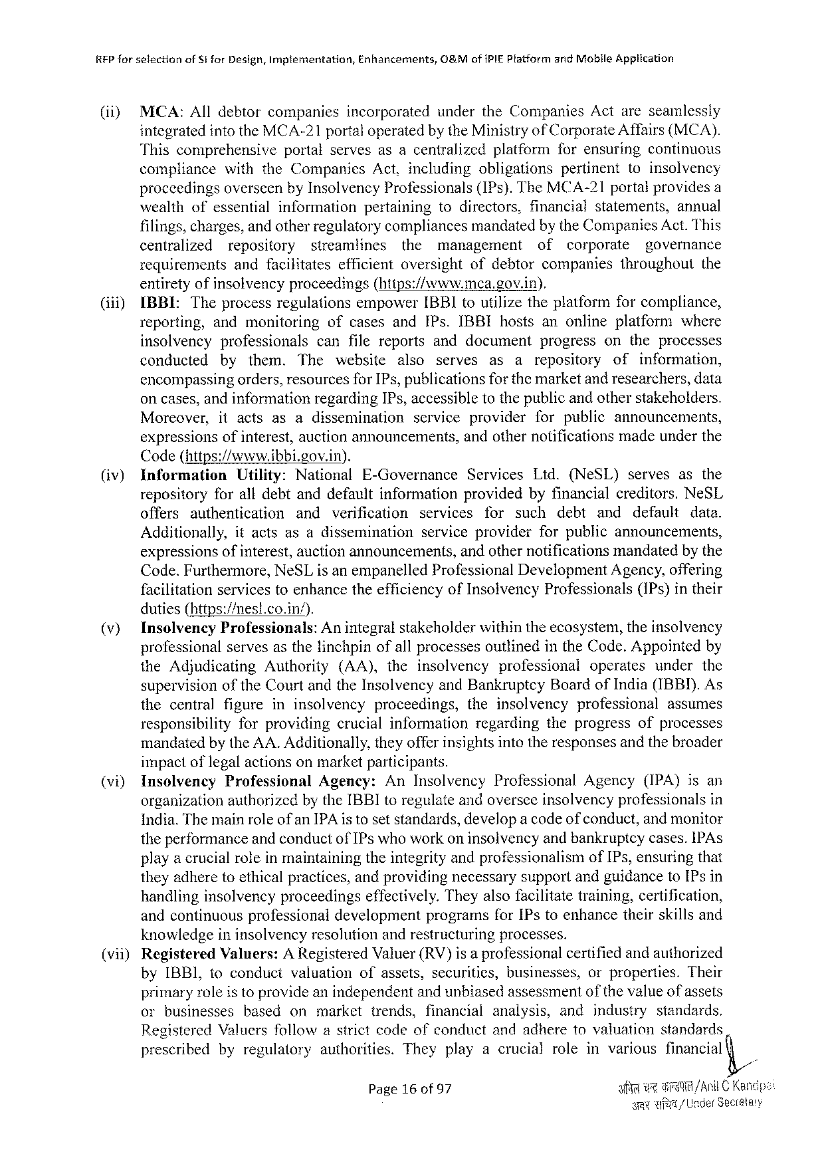

RFP for selectionof Si for Design, Implementation, Enhancements, O&Mof PIEP latform and Moblle Application

|  |  |  |  |
| --- | --- | --- | --- |
| (ii) | MCA: Alldebtorcompanies | incorporated | underthe Companies Actareseamlessly |

integratedintothe MCA-21 portaloperatedby the Ministryof Corporate Affairs(MCA).

Thiscomprehensive portalservesasacentralized platformforensuring continuous

compliance with the Companies Act, including obligations pertinent toinsolvency

proceedingsoverseenby Insolvency Professionals(IP s). The MCA-21 portalprovidesa

|  |  |  |  |  |  |
| --- | --- | --- | --- | --- | --- |
| wealthofessential | information | pertaining | todirectors, | financialstatements, | annual |

filings, charges, and otherregulatorycompliancesmandatedby the Companies Act. This

centralized repository streamlines the management of corporate governance

requirements andfacilitates efficientoversight ofdebtorcompanies throughout the

entiretyofinsolvencyproceedings(https://www. mea. gov. in).

(iii) IBBIL: Theprocessregulations empower IBBI toutilizetheplatformforcompliance,

reporting, andmonitoring ofcasesand IP s. IBBI hostsanonlineplatform where

insolvency professionals canfilereportsanddocument progress ontheprocesses

conducted by them. The website also serves as arepository of information,

encompassingorders, resourcesfor IP s, publicationsforthemarketand researchers, data

oncases, andinformationregarding IP s, accessibletothepublicandotherstakeholders.

|  |  |  |  |  |  |
| --- | --- | --- | --- | --- | --- |
| Moreover, | itacts | asadissemination | service | provider | forpublicannouncements, |

expressionsofinterest, auctionannouncements, Code(https://www. ibbi. gov. in).

andothernotificationsmadeunderthe

|  |  |  |  |  |  |  |  |  |  |  |  |  |  |  |  |  |
| --- | --- | --- | --- | --- | --- | --- | --- | --- | --- | --- | --- | --- | --- | --- | --- | --- |
| (iv) | Information | | Utility: | National | | E-Governance | | | Services | | | Ltd.(Ne SL) | | | serves | asthe |
| repositoryforalldebtanddefaultinformation providedbyfinancialcreditors. Ne SL | | | | | | | | | | | | | | | |
| offers | authentication | | and | verification | | services | | | for | such | | debt | and | default | data. |
| Additionally, | | itactsasadissemination | | | | serviceprovider | | | | | forpublicannouncements, | | | | |
| expressionsofinterest, auctionannouncements, | | | | | | | andothernotificationsmandatedby the | | | | | | | | |

Code. Furthermore, Ne SL isanempanelled Professional Development Agency, offering facilitationservicesfoenhancetheefficiencyof Insolvency Professionals(IP s)intheir duties(https:/mest. co. in/).

|  |  |  |  |
| --- | --- | --- | --- |
| (v) | Inselvency | Professionals: | Anintegralstakeholderwithintheecosystem, theinsolvency |

professionalservesasthelinchpinofallprocessesoutlinedinthe Code. Appointedby

|  |  |  |  |  |  |  |  |
| --- | --- | --- | --- | --- | --- | --- | --- |
| the Adjudicating | Authority | (AA), | theinsolvency | professional | operates | under | the |

supervisionofthe Courtandthe Insolvencyand Bankruptcy Boardof India(IBBI). As

|  |  |  |  |  |  |  |  |
| --- | --- | --- | --- | --- | --- | --- | --- |
| thecentral | figureininsolvency | | proceedings, | theinsolvency | | professional | assumes |
| responsibility | forproviding | crucialinformatjon | | regarding | theprogressofprocesses | | |

mandatedbythe AA. Additionally, theyofferinsightsintotheresponsesandthebroader impactoflegalactionsonmarketparticipants.

(vi) Insolvency Professional Agency: An Insolvency Professional Agency (IPA)isan

organizationauthorizedby the IBBI toregulateandoverseeinsolvencyprofessionals in

India. Themainroleof an IPA istosetstandards, developa codeof conduct, andmonitor theperformanceandconductof IP s whoworkon insolvencyand bankruptcycases. IPA s playa crucialroleinmaintainingtheintegrityandprofessionalism of IP s, ensuringthat

theyadheretoethicalpractices, andprovidingnecessarysupportandguidanceto IP sin

handlinginsolvencyproceedings

effectively. Theyalsofacilitatetraining, certification,

andcontinuousprofessionaldevelopment programsfor IP stoenhancetheirskillsand

knowledgeininsolvencyresolutionandrestructuringprocesses.

(vii) Registered Valuers: AR egistered Valuer(RV)isa professionalcertifiedandauthorized

by IBBI, toconductvaluation ofassets, securities, businesses, orproperties. Their

primaryroleistoprovideanindependentandunbiasedassessmentofthevalueofassets

orbusinesses based onmarkettrends, financial analysis, andindustry standards.

Registered Valuersfollowastrictcodeofconductandadheretovaluation standards

prescribed byregulatory authorities. Theyplayacrucial roleinvarious financial

Page 16 of 97 i w 7 G /ACK a

sy Wi/Under Secestay

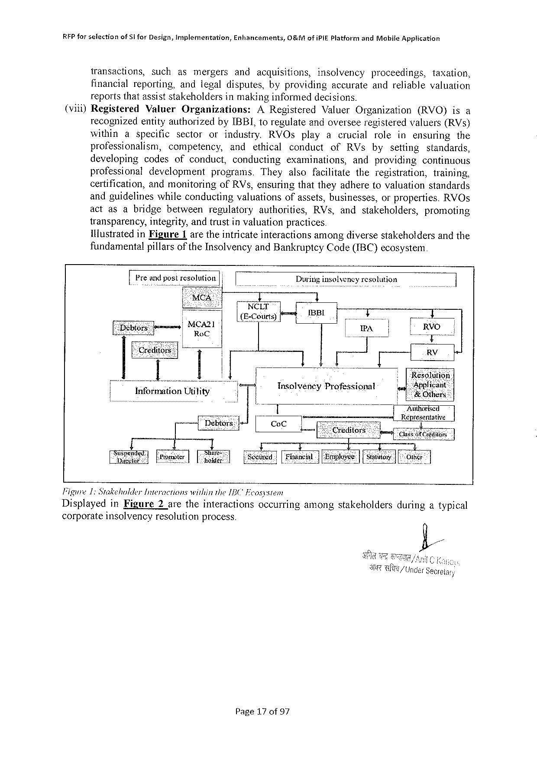

REP forsefection of Sl for Design, inyplementation, Enhancements, O&Mofi PIE Platformand Mabile Apglication

transactions, such asmergers andacquisitions, insolvency proceedings, taxation,

financialreporting, andlegaldisputes, byproviding accurateandreliable valuation

reportsthatassiststakeholdersinmakinginformeddecisions.

(viil)Registered Valuer Organizations: AR egistered Valuer Organization (RVO)isa

recognizedentityauthorizedby IBBL, toregulateandoverseeregisteredvaluers(RV s)

within aspecific sector orindustry, RVO s playacrucial role inensuring the

professionalism, competency, and ethical conduct of RV sby setting standards,

developing codes ofconduct, conducting examinations, andproviding continuous

professional development programs. They alsofacilitate theregistration, training,

certification, andmonitoring of RV s, ensuringthattheyadheretovaluationstandards

andguidelines whileconducting valuationsofassets, businesses, orproperties. RVO s

actasabridge between regulatory authorities, RV s, andstakeholders, promoting

transparency, integrity, andtrustinvaluationpractices

Ilustrated in Figure 1 aretheintricateinteractionsamongdiversestakehotdersandthe

fundamentalpillarsof the Insolvency and Bankruptcy Code(IBC) ecosystem

IP rc’a solution|| | Duringinsolvency resolution

NCLT

|  |  |  |  |  |  |
| --- | --- | --- | --- | --- | --- |
| MCA 2] | (E-Coiirts) | [ | T | ! | Atihorised |

Representative

|  |  |  |  |  |  |  |  |  |  |  |  |
| --- | --- | --- | --- | --- | --- | --- | --- | --- | --- | --- | --- |
| [s_; u; nznafit Frter ! 1 | | | | ||80 | I | i T  [Siduned |[nanel | | T  | [Bolosce| [y | T | [0 | 1  | |
| Figwre 1: Stakeholder | | Interactions | | withinthe 15 C" Fcosysiem | | | | | | duringatypical | |
| Displayed | in Figure | | 2 aretheinteractions | | | | occurringamongstakeholders | | |
| corporateinsolvency resolution process. | | | | | | | | | |

Page 17 of 97

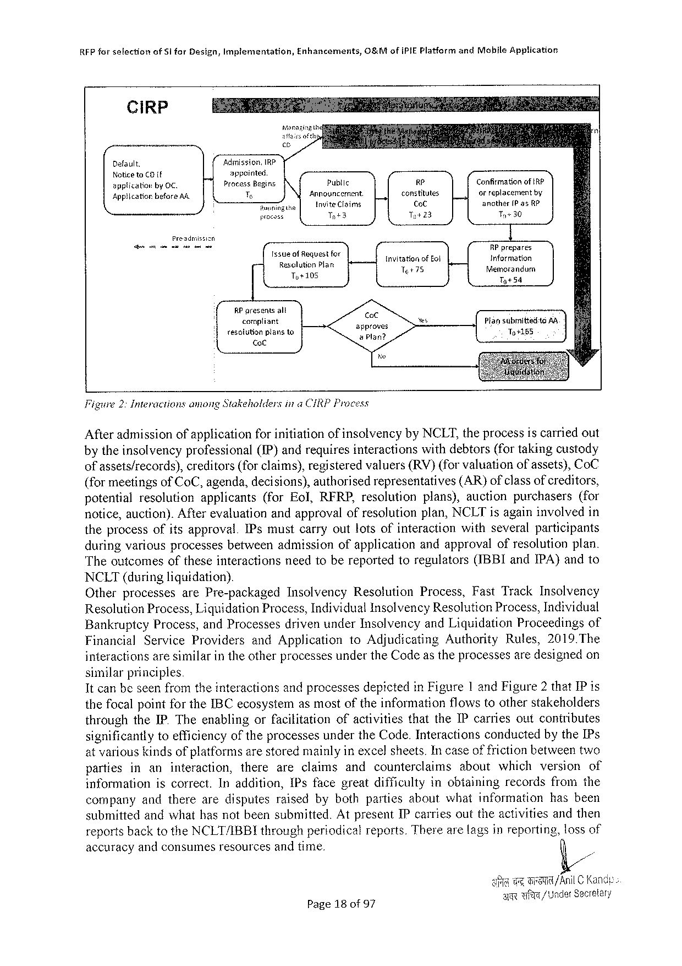

RFP for sslectionof S 1 for Design, Implementation, Enhancements, O&Mof IPIEP latformand Mobile Application

|  |  |  |  |  |
| --- | --- | --- | --- | --- |
| Ci RP | m | | | Confirmationof IRP  ofreplacementby  anather 1 Pas k P  Ty 30  RP prapares  Information  fiemorandurm  Ty S 4  Piansubmittetitg AR To+185 |
| Default. | Adumission, IRP appointed  Process Begins T  Raninge  procass | Public | 4 |
| Noticeto CO {f  spplicationby OC.  Appiicatiorbefore AA. |
| Announcement. Invite Claims | constitutes,   Co C |
| Tot 3 | To+23 |
| Preadmissizn | | | |
| ssucotfeqvestioy   Re; s? in]agng fan  o | | | tnvitationof Eol Tt 75 |
| RP presents alt   corpliant  resolitionpiansto   ot | | approves  & Plan? | |

Figure 2: Interactionsamong Stakeholdersina CIRPP rocess

Afteradmissionofapplicationforinitiationof insolvencyby NCLT, theprocessiscarriedout

by the insolvencyprofessional(IP)andrequires interactions withdebtors(for takingcustody

ofassets/records), creditors(forclaims), registeredvaluers(RV)(forvaluationofassets), Co C

(formeetingsof Co C, agenda, decisions), authorisedrepresentatives (AR)ofclassofcreditors,

potential resolution applicants (for Eol, RFRP, resolution plans), auctionpurchasers (for

notice, auction). After evaluationandapproval of resolutionplan, NCLT isagaininvolved in

theprocessofitsapproval. IP smustcarryoutlotsofinteraction withseveralparticipants

duringvariousprocessesbetweenadmissionofapplicationandapprovalofresolutionplan.

Theoutcomesoftheseinteractionsneedtobereportedtoregulators(IBBI and IPA)andto

NCLT(during liquidation).

Otherprocesses are Pre-packaged Insolvency Resolution Process, Fast Track Insolvency

Resolution Process, Liquidation Process, Individual Insolvency Resolution Process, Individual

Bankruptcy Process, and Processesdrivenunder Insolvencyand Liquidation Proceedings of

Financial Service Providers and Application to Adjudicating Authority Rules,2019. The

interactionsaresimilarintheotherprocessesunderthe Codeastheprocessesaredesignedon

similar principles

It canbeseenfromtheinteractionsandprocessesdepictedin Figure 1 and Figure 2 that IP is

the focal point for the IBC ecosystemasmostof theinformation flows toother stakeholders

throughthe IP. Theenablingorfacilitationofactivitiesthatthe IP carriesoutconiributes

significantlytoefficiencyoftheprocessesunderthe Code. Interactionsconductedbythe IP s

at variouskindsof platformsarestoredmainlyin excel sheets. Incaseof frictionbetweentwo

partiesinaninteraction, thereareclaimsandcounterclaimsaboutwhichversionof

information iscorrect. Inaddition, IP sfacegreatdifficultyinobtainingrecordsfromthe

companyandtherearedisputesraisedbybothpartiesaboutwhatinformation hasbeen

submittedandwhathas notbeen submitted. Atpresent IP carriesoutthe activitiesandthen

reportsbacktothe NCLT/IBBI throughperiodicalreports. Therearelagsinreporting, lossof

accuracyandconsumesresourcesandtime.

|  |  |  |  |
| --- | --- | --- | --- |
| Page 18 of 97 | Bt | Fet | JA nil C Kandy- |
| AR wi E /Under Secrelary | | |

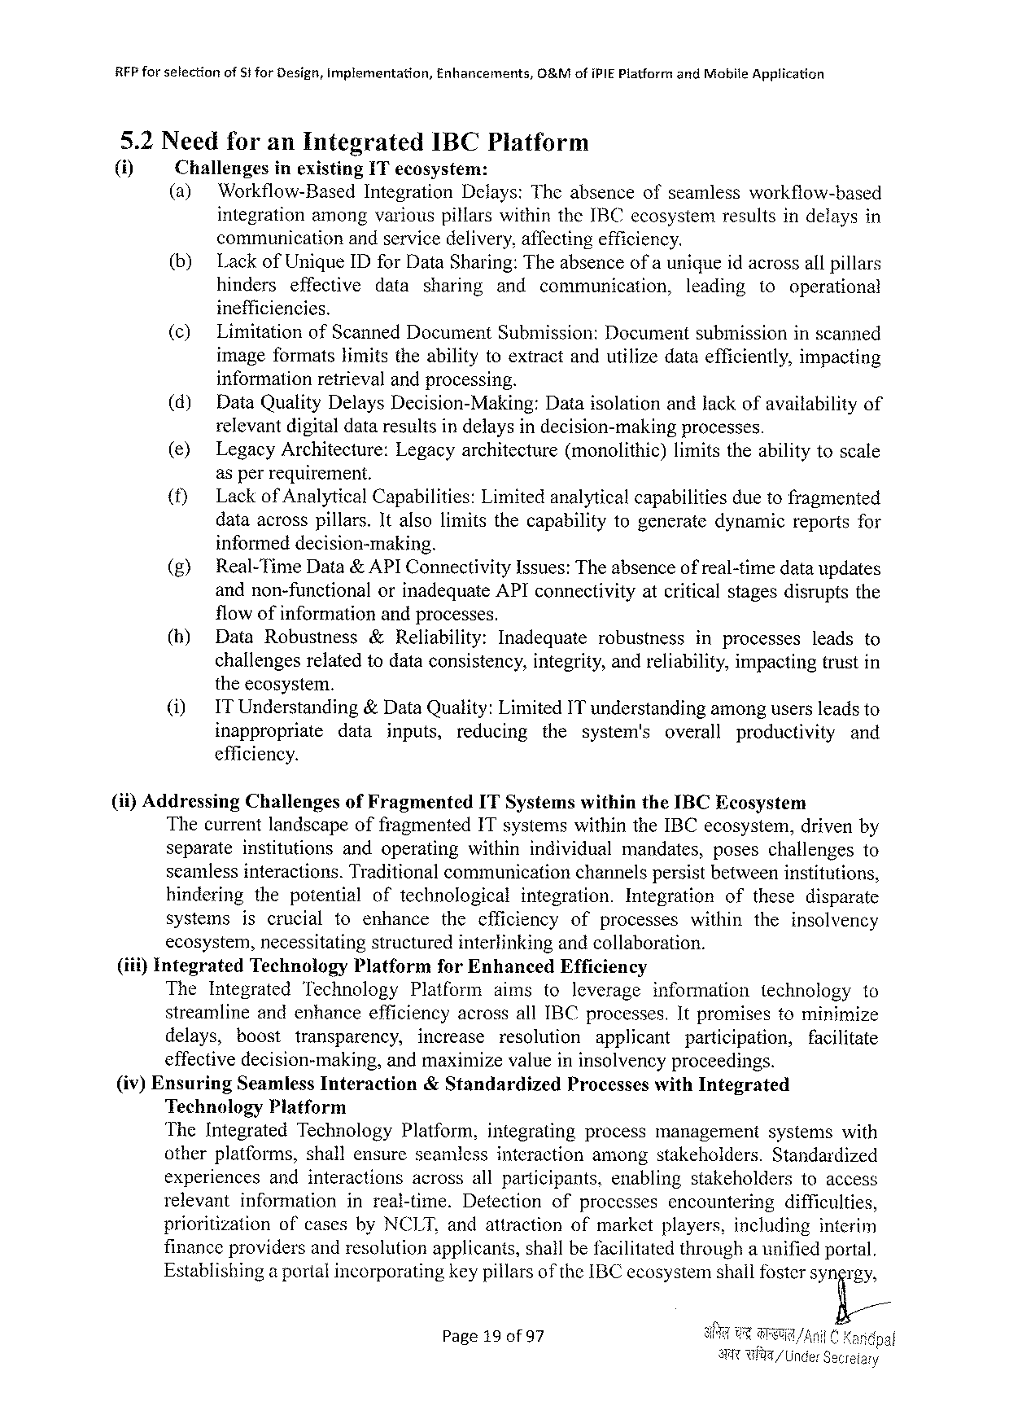

RFF forselection of St for Design, Implementation, Enhancements, O&Mofi PIEP latformand Mabile Application

5.2 Needforan Integrated IBCP latform

(i) Challenges inexisting IT ecosystem:

(a) Workflow-Based Integration Delays: Theabsenceofseamlessworkflow-based

integrationamongvariouspillarswithinthe IBC ecosystemresultsindelaysin

communication andservicedelivery, affectingefficiency.

(b) Lackof Unique ID for Data Sharing: Theabsenceofa unigueidacrossallpillars

hinders effective data sharing and communication, leading to operational

inefficiencies.

(¢) Limitation of Scanned Document Submission: Document submission inscanned

imageformatslimitstheabilitytoextractandutilizedataefficiently, impacting

informationretrievalandprocessing.

(d) Data Quality Delays Decision-Making: Dataisolationandlackofavailabilityof

relevantdigitaldataresultsindelaysindecision-making processes.

(e) Legacy Architecture: Legacyarchitecture (monolithic) limitstheabilitytoscale

asperrequirement.

(f) Lackof Analytical Capabilities: Limitedaralyticalcapabilities duetofragmented

dataacrosspillars. Italsolimitsthecapabilitytogeneratedynamicreportsfor

informeddecision-making.

|  |  |  |  |  |  |  |
| --- | --- | --- | --- | --- | --- | --- |
| (g)  (h) | Real-Time Data& APIC onnectivity Issues: Theabsenceof real-timedataupdates | | | | | |
| andnon-functional | orinadequate API connectivityatcriticalstagesdisruptsthe | | | | |
| flowofinformationandprocesses. | | | | | |
| Data Robustness | &Reliability: | Inadequate | robustness | inprocesses | leadsto |
| challengesrelatedtodataconsistency, integrity, andreliability, impactingtrustin | | | | | |

theecosystem.

|  |  |  |  |  |  |  |  |  |  |  |
| --- | --- | --- | --- | --- | --- | --- | --- | --- | --- | --- |
| (1) | ITU nderstanding | | &Data Quality: Limited IT understandingamongusersleadsto | | | | | | | |
| inappropriate | data | | inputs, | reducing | the | system's | overall | productivity | and |

efficiency.

|  |  |  |  |
| --- | --- | --- | --- |
| (ii)Addressing | Challenges | of Fragmented | ITS ystemswithinthe IBCE cosystem |

Thecurrentlandscapeoffragmented 1 Tsystemswithinthe IBC ecosystem, drivenby

separate institutions andoperating withinindividual mandates, poseschallengesto

seamlessinteractions. Traditionalcommunication channelspersistbetweeninstitutions,

hindering thepotential oftechnological integration. Integration ofthesedisparate

systems iscrucial toenhance thecfficiency ofprocesses within theinsolvency

ecosystem, necessitatingstructuredinterlinkingandcollaboration.

(iii)Integrated Technology Platform for Enhanced Efficiency

The Integrated Technology Platform aimstoleverage information technology to

streamlineandenhanceefficiencyacrossall IBC processes. Itpromisestominimize

delays, boost transparency, increase resolution applicant participation, facilitate

effectivedecision-making, andmaximizevalueininsolvencyproceedings.

(iv)Ensuring Seamless Interaction &Standardized Processeswith Integrated

Technology Platform

The Integrated Technology Platform, integrating process management systemswith

otherplatforms, shallensureseamlessinteractionamongstakeholders. Standardized

experiences andinteractions acrossallparticipants, enabling stakeholders toaccess

relevant information inreal-time. Detection ofprocesses encountering difficulties,

prioritization ofcasesby NCLT, andattractionofmarketplayers, inciuding interim

financeprovidersandresolutionapplicants, shailbefacilitatedthrougha unifiedportal.

Establishinga portalincorporatingkeypillarsof the IBC ecosystemshallfostersyngrg;

Page 19 of 97

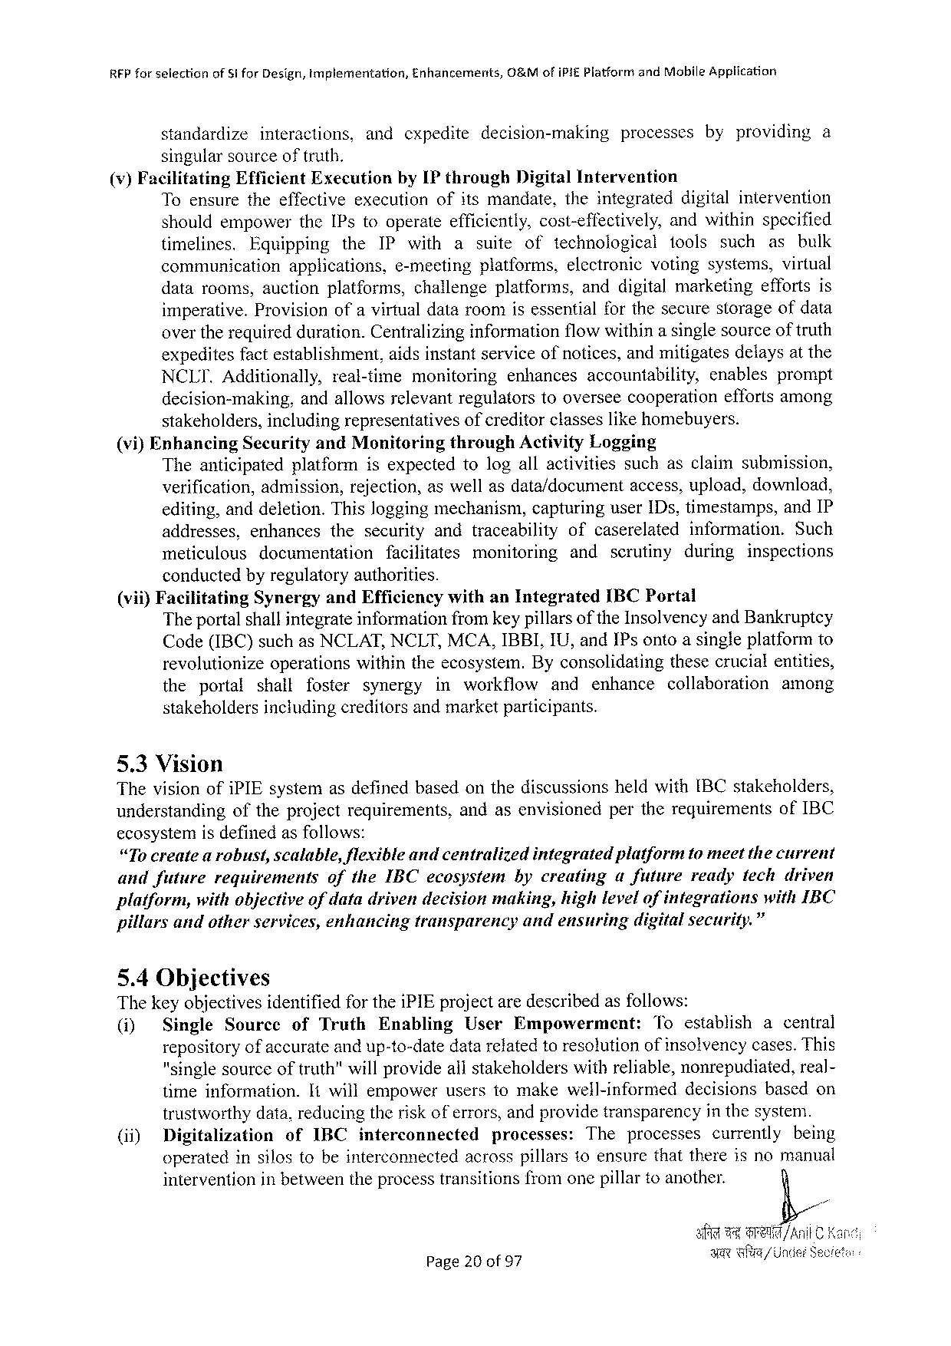

RFP forselection of Si for Design, tmplementation, Enhancements, O&Mofi PIEP latformand Mobile Appiication

standardize interactions, andcxpedite decision-making processes byproviding a

singularsource of truth.

(v)Facilitating Efficient Execution by IP through Digital Intervention

Toensuretheeffectiveexecution ofitsmandate, theintegrated digitalintervention

shouldempower the IP stooperateefficiently, cost-effectively, andwithinspecified

timelines. Equipping the IP with a suite of technological tools such as bulk

communication applications, e-meeting platforms, electronic votingsystems, virtual

datarooms, auctionplatforms, challengeplatforms, anddigitalmarketing effortsis

imperative. Provision ofa virtualdataroomisessentialforthesecurestorageofdata

overtherequiredduration. Centralizinginformationflowwithinasinglesourceof truth

expeditesfactestablishment, aidsinstantserviceofnotices, andmitigatesdelaysatthe

NCLI. Additionally, real-time monitoring enhances accountability, enables prompt

decision-making, andallowsrelevantregulatorstooverseecooperation effortsamong

stakeholders, includingrepresentatives ofcreditorclasseslikehomebuyers.

(vi)Enhancing Security and Monitoring through Activity Logging

Theanticipated platform isexpectedtologallactivities suchasclaimsubmission,

verification, admission, rejection, aswellasdata/document access, upload, download,

editing, anddeletion. Thisloggingmechanism, capturinguser 1 Ds, timestamps, and IP

addresses, enhances thesecurity andtraceability ofcaserelated information. Such

meticulous documentation facilitates monitoring and scrutiny during inspections

conductedbyregulatoryauthorities.

(vii)Facilitating Synergyand Efficiencywithan Integrated IBCP ortal

Theportal shallintegrateinformationfromkey pillarsof the Insolvencyand Bankruptcy

Code(IBC)suchas NCLAT, NCLT, MCA, IBBI, IU, and IP sontoasingleplatformto

revolutionize operationswithintheecosystem. Byconsolidating thesecrucialentities,

the portal shall foster synergy inworkflow and enhance collaboration among

stakeholdersincludingcreditors andmarket participants.

5.3 Vision

Thevisionofi PIE systemasdefinedbasedonthediscussions heldwith[BC stakeholders,

understanding oftheprojectrequirements, andasenvisioned pertherequirements of IBC

ecosystemisdefinedasfollows:

“Tocreatea robust, scalable, flexibleandcentralized integratedplatformtomeetthecurrent

andfuture requirements of the IBC ecosystem bycreating afuture readyfechdriven

platform, withobjectiveofdatadrivendecisionmaking, highlevelofintegrations with IBC

pillarsandotherservices, enhancing transparency andensuring digitalsecurity.”

5.4 Objectives

Thekeyobjectivesidentifiedforthei PIE projectaredescribedasfollows:

(i) Single Sourccof Truth Enabling User Empowerment: Toestablishacentral

repositoryofaccurateandup-to-datedatarefatedtoresolutionofinsolvencycases. This

"singlesourceoftruth"willprovideallstakeholderswithreliable, nonrepudiated, real-

timeinformation. Itwillempoweruserstomakewell-informed decisions basedon

trustworthydata, reducingtheriskoferrors, andprovidetransparency in thesysten.

(ii) Digitalization of IBC interconnected processes: The processes currently being

operatedinsilostobeinterconnected acrosspillarstoensurethatthereisnomanual

intervention inbetweentheprocesstransitionsfromonepillartoanother.

Page 20 of 97

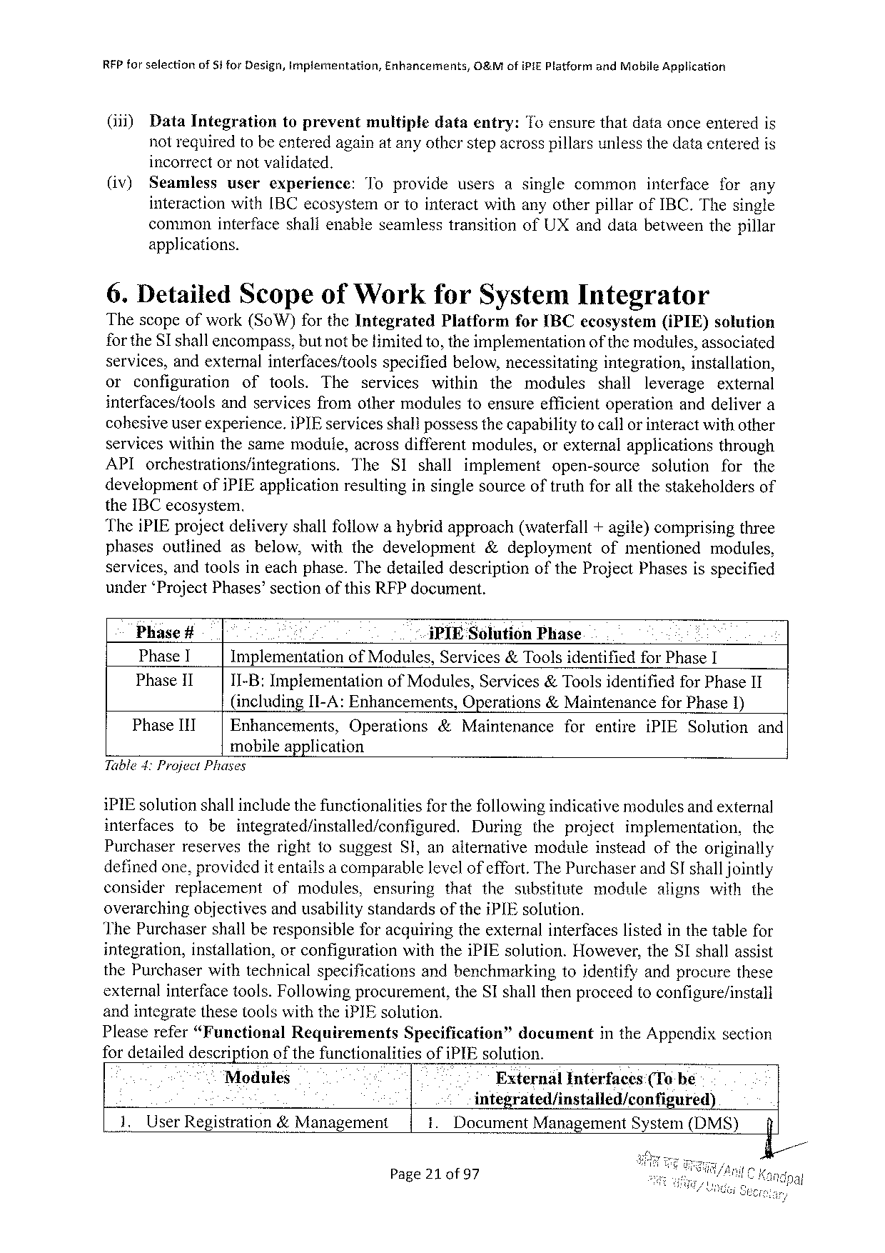

REP for selectionof 81 for Design, Implermentation, Enhancements, O&Mofi PIEP latform and Mobile Application

(iii) Data Integration toprevent multiple dataentry: To ensurethatdataonceenteredis

notrequiredtobeenteredagainat anyotherstepacrosspillarsunlessthedataenteredis

incorrectornotvalidated.

(iv) Seamlessuserexperience: Toprovideusersasinglecommoninterfaceforany

interactionwith[BC ecosystem ortointeractwithanyotherpillarof IBC, Thesingle

commoninterfaceshallenableseamlesstransitionof UX anddatabetweenthepillar

applications.

6. Detailed Scopeof Workfor System Integrator

Thescopeofwork(So W)for the Integrated Platform for IBC ecosystem(i PIE) solution

for the SI shallencompass, butnotbetimitedto, theimplementation of the modules, associated

services, andexternalinterfaces/tools specifiedbelow, necessitating integration, installation,

or configuration of tools. The services within the modules shall leverage external

interfaces/tools andservicesfromothermodulestoensureefficientoperationanddelivera

cohesiveuserexperience. i PIE servicesshall possessthecapabilityto callorinteractwithother

serviceswithinthesamemodule, acrossdifferentmodules, orexternalapplications through

API orchestrations/integrations. The SI shall implement open-source solution for the

development ofi PIE applicationresultinginsinglesourceoftruthforallthestakeholdersof

the IBC ecosystem.

Thei PIE projectdeliveryshallfollowahybridapproach(waterfall+agile)comprisingthree

phasesoutlined asbelow, withthedevelopment &deployment ofmentioned modules,

services, andtoolsineachphase. Thedetaileddescription of the Project Phasesisspecified

under ‘Project Phases’sectionofthis RFP document.

Phase # * i PIE Solution Phase

Phase 1 Implementation of Modules, Services&Toolsidentifiedfor Phase I

Phase 11 11-B: Implementation of Modules, Services &Toolsidentified for Phase II

(including[I-A: Enhancements, Operations&Maintenancefor Phase 1)

Phase IIT Enhancements, Operations &Maintenance forentire i PIES olution and

mobileapplication

Table 4: Project Phases

i PIE solutionshallincludethefunctionalitiesfor thefollowingindicativemodulesand external

interfaces tobeintegrated/installed/configured. During theproject implementation, the

Purchaserreservestherightfosuggest SI, analternative moduleinsteadoftheoriginally

definedone, providedit entailsa comparablelevelofeffort. The Purchaserand SI shalljointly

consider replacement ofmodules, ensuring thatthesubstitute module alignswiththe

overarchingobjectivesandusabilitystandards of the i PIE solution.

The Purchasershall beresponsible foracquiringthe external interfaceslisted in the tablefor

integration, installation, orconfigurationwiththei PIE solution. However, the SI shallassist

the Purchaserwithtechnicalspecifications andbenchmarking toidentifyandprocurethese

externalinterfacetools. Followingprocurement, the SI shallthenproceedtoconfigure/install

and integrate these toolswiththei PIE solution.

Pleaserefer“Funetional Requirements Specification” document in the Appendixsection

fordetaileddescriptionofthefunctionalities ofi PIE solution.

Modules External Interfaces (Tobe

e integrated/installed/configured)

1. User Registration&Management . Document Management System(DMS) f

Page 21 of 97

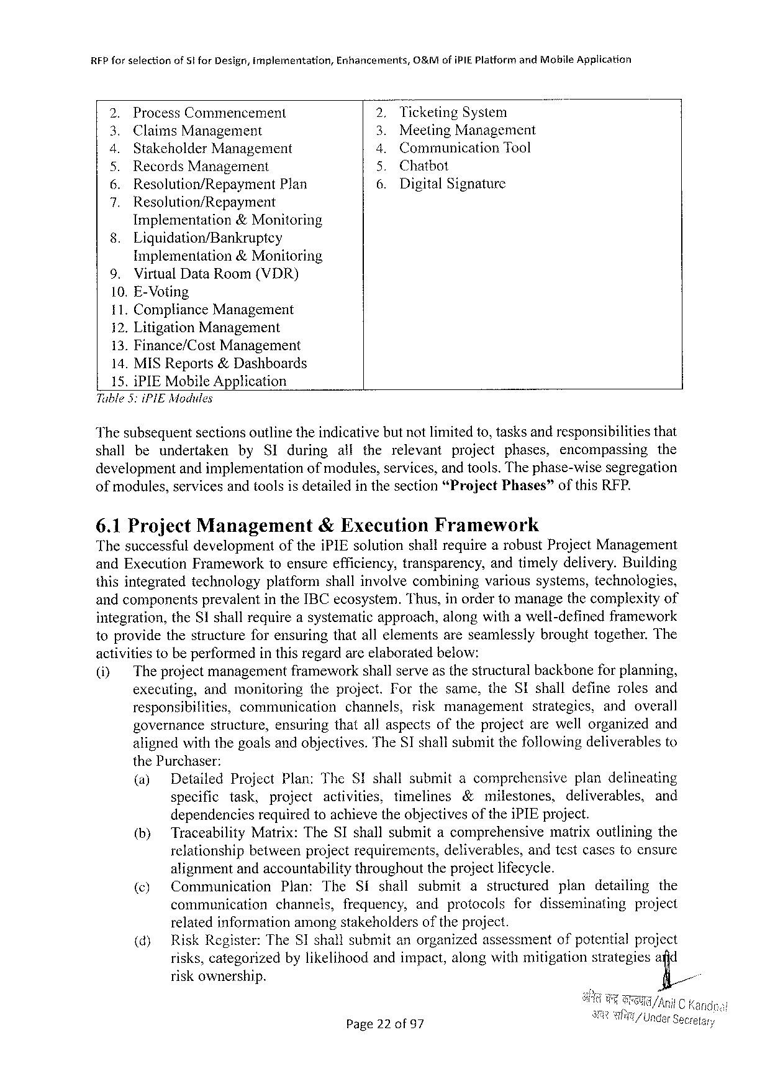

RFP for selectionof Stfor Design, Implementation, Enhancements, O&Mofi PIEP latform and Mobile Application

|  |  |  |  |  |  |
| --- | --- | --- | --- | --- | --- |
| LR | Process Commencement | | S | Ticketing System | |
| Meeting Management | |
| Claims Management | |
| Stakeholder Management | | Communication | Tool |
| Records Management | | Chatbot | |
| Resolution/Repayment | Plan | 6. | Digital Signature | |
| N | Resolution/Repayment | |
| 8. | Implementation &Monitoring | |
| Liquidation/Bankruptey | |

Implementation&Monitoring

9. Virtual Data Room(VDR)

10. E-Voting

11. Compliance Management

12. Litigation Management

13. Finance/Cost Management

14. MISR eports&Dashboards

15. i PIEM obile Application

Tuble 3: i PIEM odules

Thesubsequentsectionsoutlinetheindicativebutnotlimitedto, tasksandresponsibilitiesthat

shall beundertaken by SI during alltherelevant project phases, encompassing the

developmentandimplementation ofmodules, services, and tools. Thephase-wisesegregation

ofmodules, services andtoolsisdetailed inthesection “Project Phases” ofthis REP.

6.1 Project Management &Execution Framework

Thesuccessfuldevelopment ofthei PIE solutionshallrequirearobust Project Management

and Execution Frameworktoensureefficiency, transparency, andtimelydelivery. Building

thisintegratedtechnology platformshallinvolvecombining varioussystems, technologies,

andcomponentsprevalentinthe IBC ecosystem. Thus, inordertomanagethecomplexityof

integration, the S 1 shallrequireasystematicapproach, alongwithawell-definedframework

toprovidethestructureforensuringthatallelementsareseamlesslybroughttogether. The

activitiestobeperformedinthisregardarcelaboratedbelow:

|  |  |  |  |  |  |  |  |  |  |
| --- | --- | --- | --- | --- | --- | --- | --- | --- | --- |
| (i) | The projectmanagementframeworkshallserveasthestructuralbackboneforplanning, | | | | | | | | |
| executing, | andmonitoring | | | theproject. Forthesame, the SI shalldefinerolesand | | | | |
| responsibilities, | | communication | | | channels, | riskmanagement | strategies, | andoverall |
| governance | structure, | | ensuringthatallaspectsoftheprojectarewellorganizedand | | | | | |

alignedwiththegoalsandobjectives. The SI shallsubmitthefollowingdeliverablesto

the Purchaser:

|  |  |  |  |  |  |  |  |  |  |  |  |  |  |  |  |  |  |  |  |  |  |
| --- | --- | --- | --- | --- | --- | --- | --- | --- | --- | --- | --- | --- | --- | --- | --- | --- | --- | --- | --- | --- | --- |
| (a)  (h)  (¢)  (d) | Detailed | Project Plan: The S! shallsubmitacomprehensive | | | | | | | | | | | | | | | | plandelineating | | | |
| specific | task, | | project | activities, | | | | timelines | | | &milestones, | | | | | deliverables, | | | | and |
| dependencies | | | requiredtoachievetheobjectivesofthei PIE project. | | | | | | | | | | | | | | | | | |
| Traceability Matrix: The SI shallsubmitacomprehensive | | | | | | | | | | | | | | | | matrixoutliningthe | | | | |
| relationship | | betweenprojectrequirements, | | | | | | | | deliverables, | | | | | andtestcasestoensure | | | | | |
| alignmentandaccountabilitythroughouttheprojectlifecycle. | | | | | | | | | | | | | | | | | | | | |
| Communication | | | Plan: | The | | Si | shall | | submit | | | a | structured | | | plan | | detailing | | the |
| communication | | | channels, | | frequency, | | | | andprotocols | | | | | fordisseminating | | | | | project | |
| relatedinformationamongstakeholders of the project. | | | | | | | | | | | | | | | | | | | | |
| Risk Register: The SI shallsubmitanorganizedassessment | | | | | | | | | | | | | | | | ofpotentialproject | | | | |
| risks, categorizedbylikelihoodandimpact, alongwithmitigationstrategiesafid | | | | | | | | | | | | | | | | | | | | |
| riskownership. | | | | | | | | | | | | | | | | fi/ | | | | |

Page 22 of 97

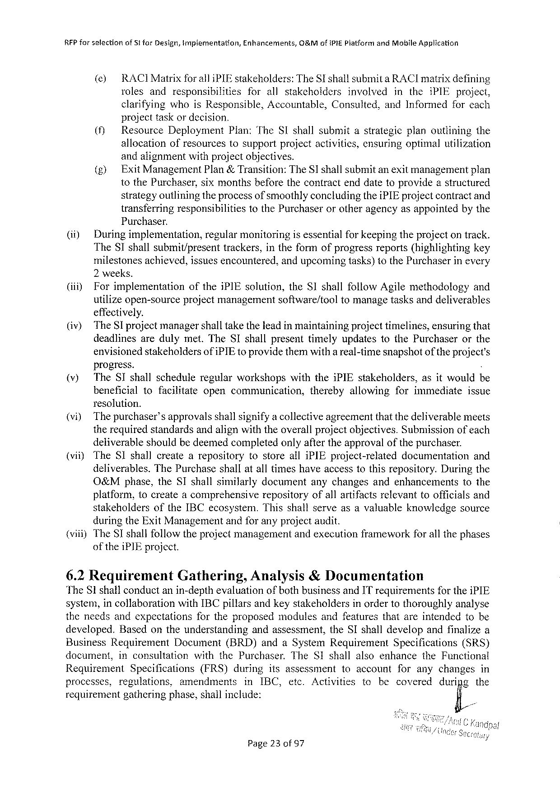

RFP forsefectionof St for Design, implementation, Enhancements, O&Mof IPIEP latform and Mobile Application

() RACIM atrix for all i PIE stakeholders: The SI shallsubmita RACI matrixdefining

rolesand responsibilities forallstakeholders involved inthei PIE project,

clarifying whois Responsible, Accountable, Consulted, and Informedforcach

projecttaskordecision.

|  |  |  |  |
| --- | --- | --- | --- |
| (i | Resource | Deployment | Plan: The SI shallsubmitastrategicplanoutliningthe |
| allocationofresourcestosupportprojectactivities, ensuringoptimalutilization | | |

andalignmentwithprojectobjectives.

|  |  |  |
| --- | --- | --- |
| (&) | Exit Management | Plan&Transition: The SI shallsubmitanexitmanagementplan |

to the Purchaser, sixmonthsbeforethecontractenddatetoprovideastructured

strategyoutliningtheprocessofsmoothlyconcludingthei PIE projectcontractand

transferringresponsibilities Purchaser.

to the Purchaserorotheragencyasappointedbythe

(i) Duringimplementation, regularmonitoringisessentialforkeepingtheprojectontrack.

The SI shallsubmit/present trackers, intheformofprogressreports(highlighting key

milestonesachieved, issuesencountered, andupcomingtasks)to the Purchaserinevery

2 weeks.

|  |  |  |  |
| --- | --- | --- | --- |
| (i) | Forimplementation | ofthei PIE solution, the SI shallfollow Agilemethodology | and |

utilizeopen-sourceprojectmanagement effectively.

software/tooltomanagetasksanddeliverables

|  |  |  |  |  |  |  |  |  |  |
| --- | --- | --- | --- | --- | --- | --- | --- | --- | --- |
| (iv)  (v) | The SI projectmanagershalltaketheleadin maintainingprojecttimelines, ensuringthat | | | | | | | | |
| deadlinesaredulymet. The SI shallpresenttimelyupdatestothe Purchaser | | | | | | | | orthe |
| envisionedstakeholdersofi PIE toprovidethemwitha real-timesnapshotof theproject's | | | | | | | | |
| progress. | | | | | | | | ) |
| The SI shallscheduleregularworkshops | | | withthei PIE stakeholders, | | | | asitwouldb | |
| beneficial | tofacilitate | opencommunication, | | thereby | allowing | forimmediate | | issue |

resolution.

(vi) Thepurchaser’sapprovalsshallsignifya collectiveagreementthatthedeliverablemeets

therequiredstandardsandalignwiththeoverallprojectobjectives. Submissionofeach

deliverableshouldbedeemedcompletedonlyaftertheapprovalofthepurchaser.

(viiy The SI shallcreatearepository tostorealli PIE project-related documentation and

deliverables. The Purchaseshallatalltimeshaveaccesstothisrepository. Duringthe

O&Mphase, the SI shallsimilarlydocument anychangesandenhancements to the

platform, tocreate acomprehensive repositoryofallartifactsrelevant toofficialsand

stakeholders of the IBC ecosystem. Thisshallserveasavaluableknowledgesource

duringthe Exit Managementandforanyprojectaudit.

(viii)The SI shallfollowtheprojectmanagementandexecutionframeworkforall thephases

ofthei PIE project.

|  |  |  |
| --- | --- | --- |
| 6.2 Requirement | Gathering, | Analysis&Documentation |

The Slshallconductanin-depthevaluationofbothbusinessand IT requirementsforthei PIE

system, incollaboration with IBC pillarsandkeystakeholdersinordertothoroughlyanalyse

theneedsandexpectations fortheproposedmodulesandfeaturesthatareintendedtobe

developed. Basedontheunderstanding andassessment, the SI shalldevelopandfinalizea

Business Requirement Document (BRD)anda System Requirement Specifications (SRS)

document, inconsultation with the Purchaser. The SI shallalsoenhance the Functional

Requirement Specifications (FRS) during itsassessment toaccount foranychanges in

processes, regulations, amendments in IBC, etc. Activities to becovered duripg the

requirement gatheringphase, shallinclude: fi/

Page 23 of 97

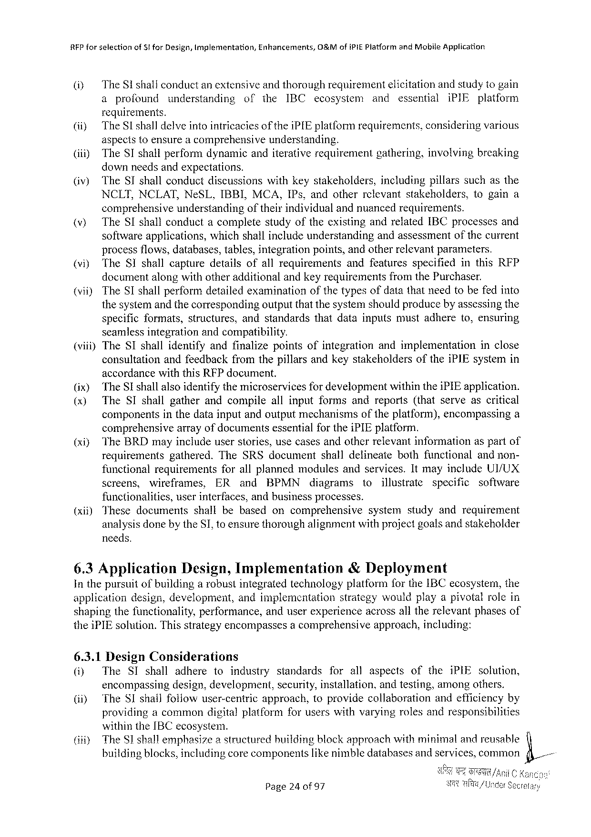

RFP forselection of Stfor Design, Implementation, Enhancements, O&Mofi PIEP latformand Mobile Application

i The Sishallconductanextensiveandthoroughrequirementelicitationandstudytogain

a profound understanding of the IBC ecosysiem and essential i PIE platform

requirements.

|  |  |  |  |
| --- | --- | --- | --- |
| (ii}  (ii) | The Slshalldelveintointricaciesof thei PIE platformrequirements, consideringvarious | | |
| aspectstoensurea comprehensive | understanding. | |
| The SI shallperformdynamicanditerativerequirement | | gathering, involvingbreaking |

downneedsandexpectations.

|  |  |  |  |  |
| --- | --- | --- | --- | --- |
| @) | The SI shallconductdiscussions | withkeystakeholders, | includingpillarssuchasthe | |
| NCLT, NCLAT, Ne SL, IBBI, MCA, IP s, andotherrclevantstakeholders, | | | togaina |

comprehensiveunderstandingoftheirindividualandnuancedrequirements.

|  |  |  |  |
| --- | --- | --- | --- |
| )  S  (vii) | The SI shallconductacompletestudyoftheexistingandrelated IBC processesand | | |
| softwareapplications, | whichshallincludeunderstandingandassessmentofthecurrent | |
| processflows, databases, tables, integrationpoints, andotherrelevantparameters. The SI shallcapturedetailsofallrequirementsandfeaturesspecifiedinthis RFP documentalongwithotheradditionalandkeyrequirementsfromthe Purchaser. The SI shallperformdetailed examinationof the typesofdata thatneed tobefedinto | | |
| thesystemandthecorrespondingoutputthatthesyster | | shouldproducebyassessingthe |

specificformats, structures, andstandardsthatdatainputsmustadhereto, ensuring

seamlessintegrationandcompatibility.

(viii) The SI shallidentifyandfinalizepointsofintegration andimplementation inclose

consultation andfeedbackfromthepillarsandkeystakeholders ofthei PIE systemin

accordancewiththis RFP document.

|  |  |  |  |  |  |  |  |  |  |  |  |  |  |
| --- | --- | --- | --- | --- | --- | --- | --- | --- | --- | --- | --- | --- | --- |
| (x) (x)  (xi)  (xii) | The SI shallalsoidentifythemicroservices | | | | | | | | for developmentwithinthei PIE application. | | | | |
| The SI shallgatherandcompile | | | | | | | allinputformsandreports(thatserveascritical | | | | | |
| components | | inthedatainputandoutputmechanismsoftheplatform), encompassinga | | | | | | | | | | |
| comprehensive | | | arrayofdocumentsessentialforthei PIE platform. | | | | | | | | | |
| The BRD mayincludeuserstories, usecasesandotherrelevantinformationaspartof requirementsgathered. The SRS documentshalldelineatebothfunctionalandnon- | | | | | | | | | | | | |
| functionalrequirements | | | | | forallplannedmodulesandservices. Itmayinclude UI/UX | | | | | | | |
| screens, | wireframes, | | | | ER | and | BPMN | diagrams | to | illustrate | specific | software |
| functionalities, | | | userinterfaces, andbusinessprocesses. | | | | | | | | | |
| Thesedocuments | | | | shallbebased | | | oncomprehensive | | systemstudyandrequirement | | | |

analysisdonebythe SI, toensurethoroughalignmentwithprojectgoalsandstakeholder

needs.

|  |  |  |
| --- | --- | --- |
| 6.3 Application | Design, Implementation | &Deployment |

Inthepursuitofbuildingarobustintegratedtechnologyplatformforthe IBC ecosystem, the

|  |  |  |  |
| --- | --- | --- | --- |
| application | design, development, | andimplementation | strategywouldplayapivotalrolein |

shapingthefunctionality, performance, anduserexperienceacrossalltherelevantphasesof

thei PIE solution. Thisstrategyencompassesacomprehensive 6.3.1 Design Considerations

approach, including:

|  |  |  |  |  |  |  |  |  |  |  |  |
| --- | --- | --- | --- | --- | --- | --- | --- | --- | --- | --- | --- |
| ) | The | SI shall | adhere | toindustry | | standards | forall | aspects | of | thei PIE solution, | L |
| encompassingdesign, development, | | | | | security, installation. andtesting, amongothers. | | | | |
| (i) |
| The SI shallfollowuser-centric | | | | approach, toprovidecollaboration | | | | | andefficiencyby |
| providingacommondigitalplatformforuserswithvaryingrolesandresponsibilities | | | | | | | | | |
| (iti} | withinthe IBC ecosystem. | | | | | | | | | |
| The S 1 shallemphasizeastructuredbuildingblockapproachwithminimalandreusable | | | | | | | | | |
| buiidingblocks, includingcorecomponentslikenimbledatabasesand services, common | | | | | | | | | |
| Page 24 0 f 97 | | | | | | | | | |

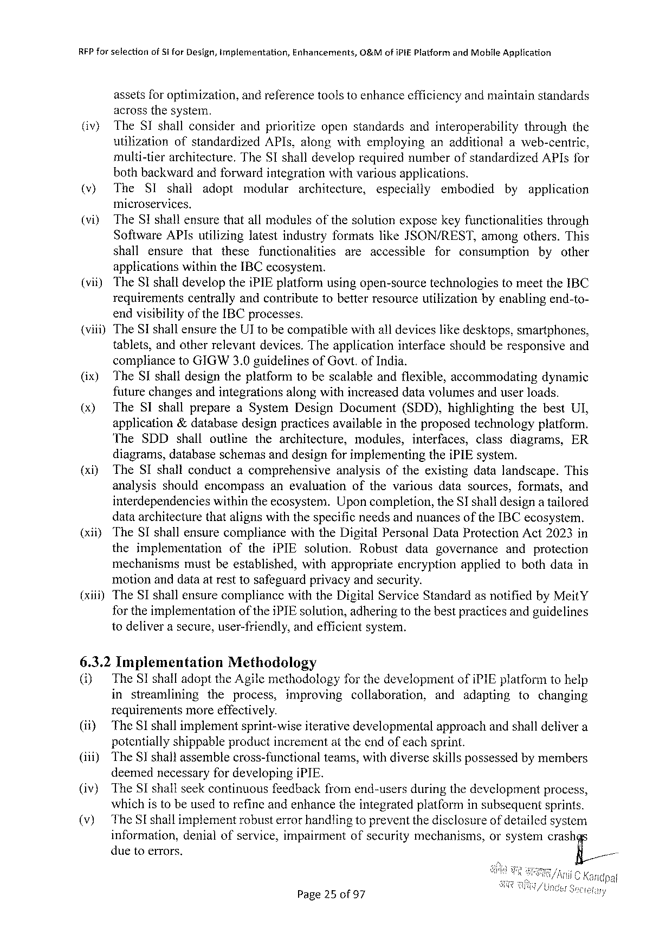

RFP farselectionof Si for Design, tmplementation, Enhancements, O&Mofi PIE Platform and Mobile Application

assetsfor optimization, andreferencetoolstoenhanceefficiencyandmaintainstandards

acrossthesystem.

|  |  |  |
| --- | --- | --- |
| (iv) | The SI shallconsiderandprioritizeopenstandardsandinteroperability | throughthe |
| utilizationofstandardized API s, alongwithemployinganadditionalaweb-centric, | |

multi-tierarchitecture. The ST shalldeveloprequirednumberofstandardized API sfor

bothbackwardandforwardintegrationwithvariousapplications.

|  |  |  |  |  |  |  |  |  |  |
| --- | --- | --- | --- | --- | --- | --- | --- | --- | --- |
| (v) | The SI | shall | adopt | modular | architecture, | especially | embodied | by | application |

microservices.

(vi) The SI shallensurethatallmodulesofthesolutionexposekeyfunctionalities through

Software API sutilizinglatestindustryformatslike JSON/REST, amongothers. This

shall ensure that these functionalities areaccessible for consumption by other

applicationswithinthe IBC ecosystem.

(vit) The SI shalldevelopthei PIE platformusingopen-sourcetechnologiestomeetthe IBC

requirements centrallyandcontributetobetterresourceutilizationbyenablingend-to-

endvisibilityof the IBC processes.

(viii)The SI shallensurethe UT tobecompatiblewithall deviceslikedesktops, smartphones,

|  |  |  |
| --- | --- | --- |
| tablets, andotherrelevantdevices. Theapplication | interfaceshouldberesponsive | and |

complianceto GIGW 3.0 guidelinesof Govt. of India.

|  |  |  |
| --- | --- | --- |
| (ix) | The SI shalldesigntheplatformtobescalableandflexible, accommodating | dynamic |

futurechangesandintegrationsalongwithincreaseddatavolumesanduserloads.

|  |  |  |  |  |
| --- | --- | --- | --- | --- |
| (x) | The SI shallprepare | a System Design Document | (SDD), highlighting | thebest UI, |

application&databasedesignpracticesavailableintheproposedtechnologyplatform.

|  |  |  |  |  |  |  |  |
| --- | --- | --- | --- | --- | --- | --- | --- |
| The | SDD shall | outline | thearchitecture, | modules, | interfaces, | classdiagrams, | ER |

diagrams, databaseschemasanddesignforimplementingthei PIE system.

{xiy The SI shallconductacomprehensive analysisoftheexistingdatalandscape. This

analysisshouldencompass anevaluation ofthevariousdatasources, formats, and

interdependencies withintheecosystem. Uponcompletion, the SI shalldesigna tailored

dataarchitecturethatalignswiththespecificneedsandnuancesofthe IBC ecosystem.

(xiiy The SI shallensurecompliance with the Digital Personal Data Protection Act 2023 in

theimplementation ofthei PIE solution. Robust datagovernance and protection

mechanisms mustbeestablished, withappropriate encryption appliedtobothdatain

motionanddataatresttosafeguardprivacyandsecurity.

(xiii)The SI shallensurecompliancewiththe Digital Service Standardasnotifiedby Meit Y

for theimplementation of thei PIE solution, adheringtothebestpracticesandguidelines

todeliverasecure, user-friendly, andefficientsystem.

6.3.2 Implementation Methodology

(i) The SI shalladoptthe Agilemethodology forthedevelopment ofi PIE platformtohelp

in streamlining theprocess, improving collaboration, and adapting tochanging

requirements more effectively.

(if) The SI shallimplementsprint-wiseiterativedevelopmental approachandshalldelivera

potentiallyshippableproductincrementat theendofeachsprint.

|  |  |  |
| --- | --- | --- |
| (iii) | The SI shallassemblecross-functional | teams, withdiverseskillspossessedbymembers |

deemednecessaryfordevelopingi PIE.

|  |  |  |  |  |
| --- | --- | --- | --- | --- |
| (iv) (v) | The SI shallseekcontinuousfeedbackfromend-usersduringthedevelopmentprocess, whichistobeusedtorefineandenhancetheintegratedplatforminsubsequentsprints. | | | |
| The SE shallimplementrobusterrorhandlingtopreventthedisclosure | | of detailed | system |
| information, | denialofservice, impairmentofsecuritymechanisms, | orsystemcrash | |
| duetoerrors. | | F;,/ | |

Page 25 of 97

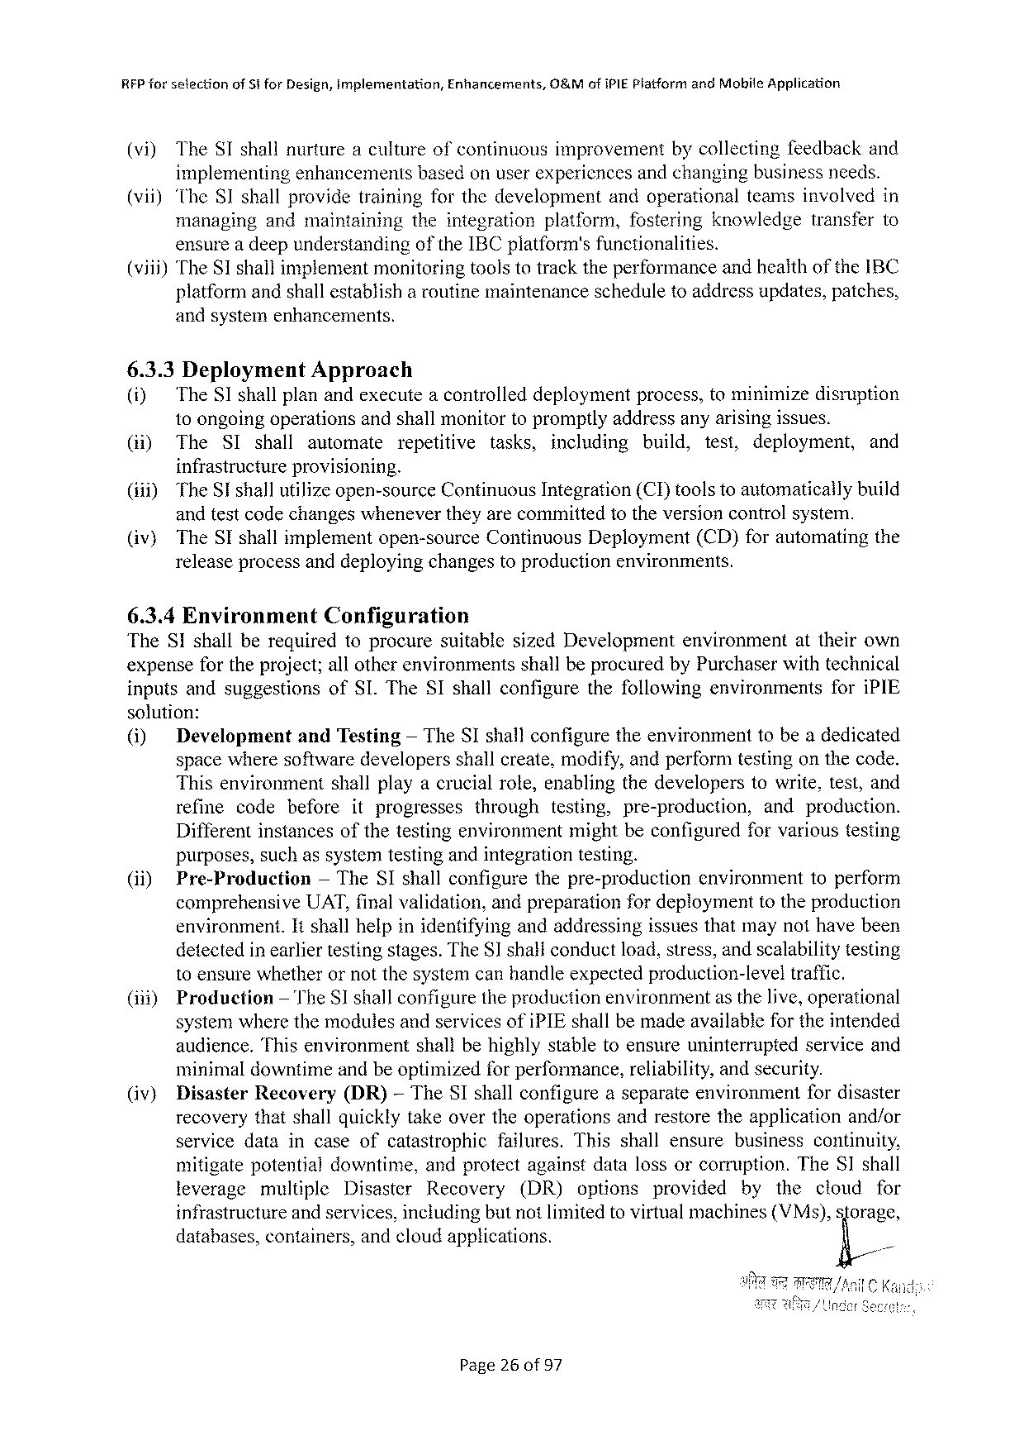

RFP forselection of$ifor Design, Implerentation, Enhancements, O&Mofi PIE Platformand Mobile Application

(vi) The SI shallnurtureacultureofcontinuousimprovement bycollectingfeedbackand

implementingenhancementsbasedonuserexperiencesandchangingbusinessneeds.

(vii) The SI shallprovidetrainingforthedevelopment andoperationalteamsinvolvedin

managing andmaintaining theintegration platform, fostering knowledge transferto

ensurea deepunderstandingofthe IBC platform'sfunctionalities.

(viii)The S 1 shallimplementmonitoringtoolstotracktheperformanceandheaithofthe IBC

platformandshallestablish a routinemaintenancescheduletoaddressupdates, patches,

andsystemenhancements,

6.3.3 Deployment Approach

(i) The SI shallplanandexecutea controlleddeploymentprocess, tominimizedisruption

toongoingoperationsandshallmonitortopromptlyaddressanyarisingissues.

|  |  |  |  |  |  |  |  |  |  |  |
| --- | --- | --- | --- | --- | --- | --- | --- | --- | --- | --- |
| (i) | The | SI shall | automate | repetitive | tasks, | including | build, | test, | deployment, | and |

infrastructureprovisioning.

|  |  |  |
| --- | --- | --- |
| (ii)) (iv) | The SI shallutilizeopen-source Continuous Integration(CI)toolstoautomaticallybuild andtestcodechangeswhenevertheyarecommittedtotheversioncontrolsystem. | |
| The SI shallimplementopen-source | Continuous Deployment(CD)forautomatingthe |

releaseprocessanddeployingchangestoproductionenvironments.

6.3.4 Environment Configuration

The SI shallberequiredtoprocuresuitable sized Development environment attheirown

expensefortheproject; allotherenvironments shallbeprocuredby Purchaserwithtechnical

inputsandsuggestions of SI. The SI shallconfigure thefollowing environments fori PIE

solution:

|  |  |  |  |  |
| --- | --- | --- | --- | --- |
| (i) | Development | and Testing | — The SI shallconfiguretheenvironment | tobeadedicated |

spacewheresoftwaredevelopersshallcreate, modify, andperformtestingonthecode.

Thisenvironment shallplayacrucialrole, enablingthedeveloperstowrite, test, and

refine codebefore itprogresses through testing, pre-production, andproduction.

Differentinstancesofthetestingenvironmentmightbeconfiguredforvarioustesting

purposes, suchassystemtestingandintegrationtesting.

|  |  |  |  |
| --- | --- | --- | --- |
| (ii) | Pre-Production | — The SI shallconfigurethepre-production | environmenttoperform |

comprehensive UAT, finalvalidation, andpreparationfordeploymenttotheproduction

environment. Itshallhelpinidentifyingandaddressingissuesthatmaynothavebeen

detectedinearliertestingstages. The Sshalconductload, stress, andscalabilitytesting

toensurewhetherornotthesystemcanhandleexpectedproduction-level traffic.

(i 11)Production — The SI shallconfiguretheproductionenvironmentasthelive, operational

systemwherethemodulesandservicesofi PIE shallbemadeavailabjefortheintended

|  |  |  |
| --- | --- | --- |
| audience. Thisenvironment | shallbehighlystabletoensureuninterrupted | serviceand |

minimaldowntimeandbeoptimizedforperformance, reliability, andsecurity.

|  |  |  |  |  |
| --- | --- | --- | --- | --- |
| (iv) | Disaster | Recovery | (DR) | — The SI shallconfigureaseparateenvironmentfordisaster |

recoverythatshallquicklytakeovertheoperationsandrestoretheapplicationand/or

servicedataincaseofcatastrophic failures. Thisshallensure businesscontinuity,

mitigatepotentialdowntime, andprotectagainstdatalossorcorruption. The SI shall

leverage multiple Disaster Recovery (DR) options provided by the cloud for

infrastructureandservices, includingbutnotlimitedto virtualmachines(VM s), sforage,

databases, containers, andcloudapplications. fi/

Page 26 of 97

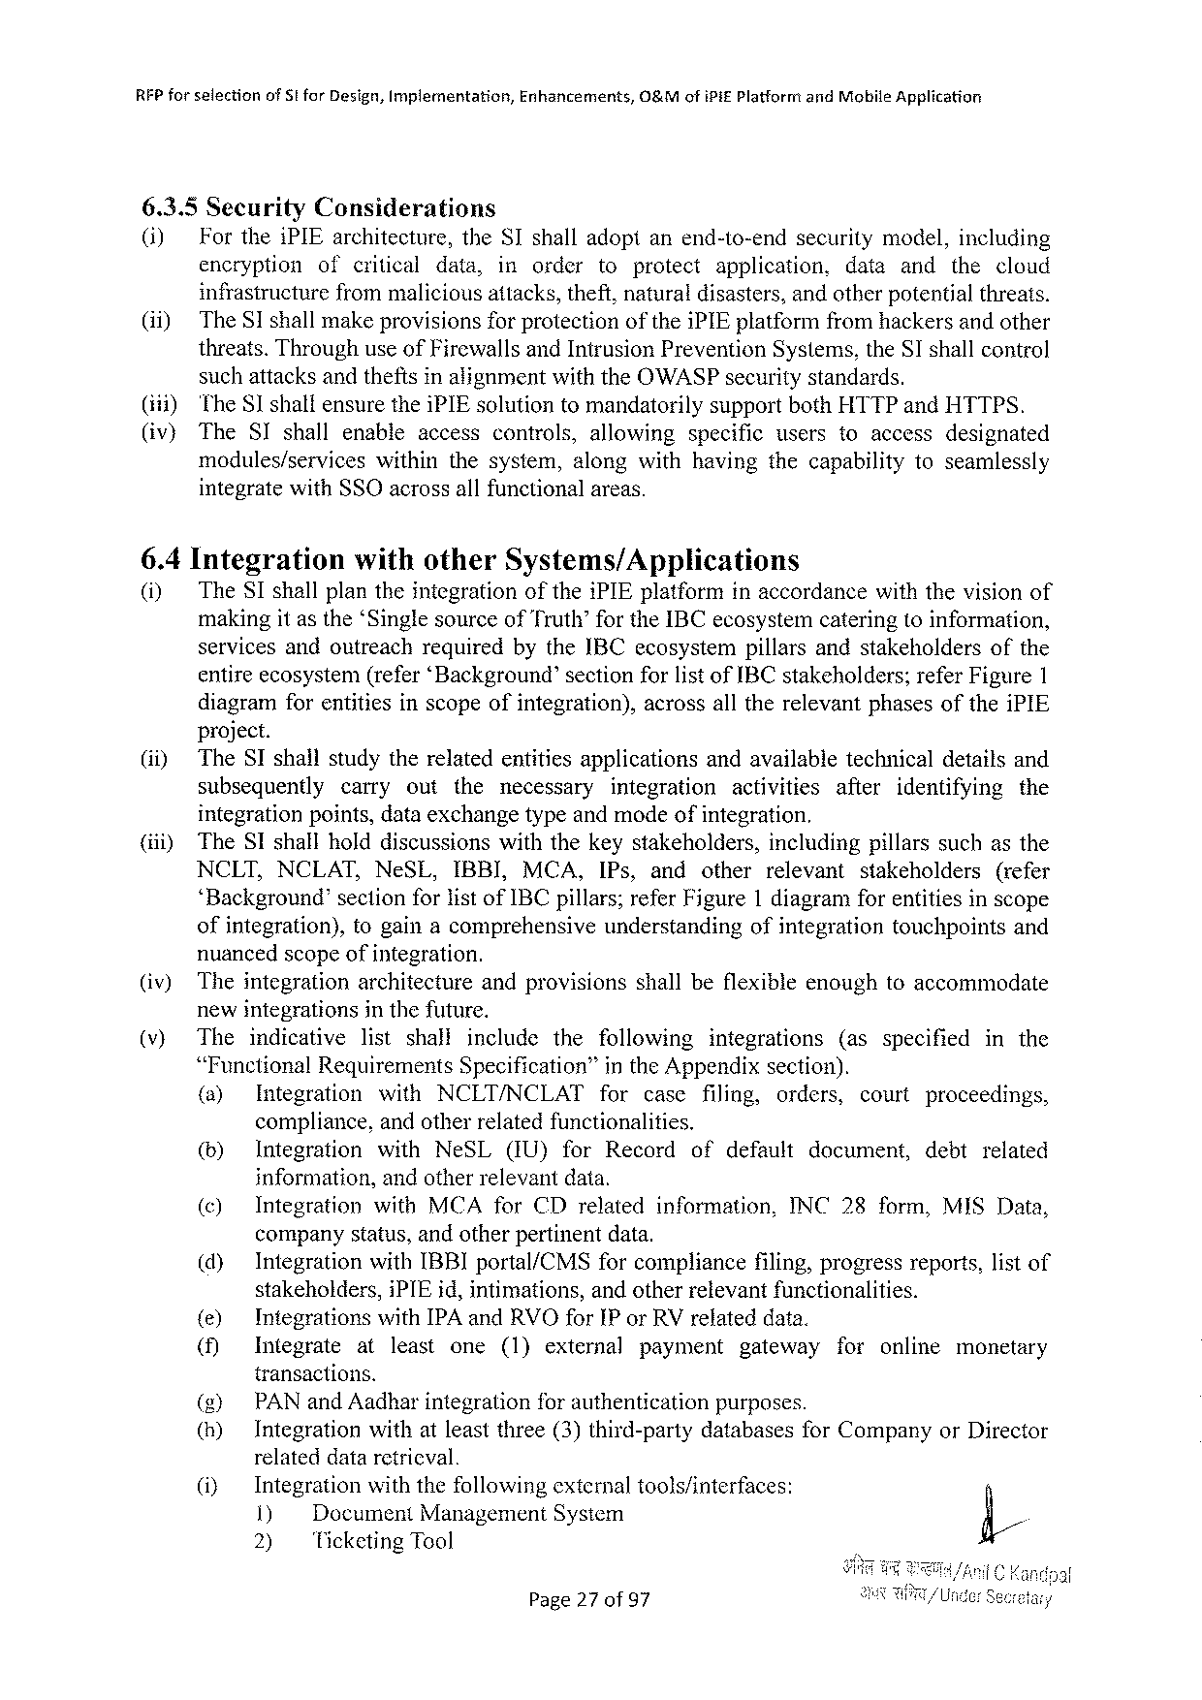

RFP for selectionof 51 for Design, Implementation, Enhancements,&Mofi Pi£Platform and Mobile Application

6.3.5 Security Considerations

(i) Forthei PIE architecture, the SI shall adopt anend-to-end security model, including

encryption ofcritical data, inorder toprotect application, dataand thecloud

infrastructure frommaliciousattacks, theft, naturaldisasters, andotherpotentialthreats.

(ii)~ The SI shallmakeprovisions forprotectionofthei PIE platform fromhackersandother

threats. Throughuseof Firewallsand Intrusion Prevention Systems, the SI shallcontrol

suchattacksand thefts inalignmentwiththe OWASP securitystandards.

(1) The SI shalfensurethei PIE solutiontomandatorily supportboth HTTP and HTTPS.

(iv) The SI shallenableaccess controls, allowing specific userstoaccess designated

modules/services within thesystem, alongwithhavingthecapabilitytoseamlessly

integratewith SSO acrossallfunctionalareas.

6.4 Integration withother Systems/Applications

(i) The SI shallplantheintegrationofthei PIE platforminaccordancewiththevisionof

makingit asthe‘Singlesourceof Truth’for the IBC ecosystemcateringtoinformation,

servicesandoutreachrequiredbythe IBC ecosystempillarsandstakeholdersofthe

entireecosystem(refer‘Background’sectionforlistof IBC stakeholders; refer Figure 1

diagramforentitiesinscopeofintegration), project.

acrossalltherelevantphasesofthei PIE

(i) The SI shallstudytherelatedentitiesapplications andavailabletechnicaldetailsand

subsequently carry out the necessary integration activities after identifying the

integrationpoints, dataexchangetypeandmodeofintegration.

(iii) The SI shallholddiscussionswiththekeystakeholders, includingpillarssuchasthe

NCLT, NCLAT, Ne SL, IBBI, MCA, IP s, and other relevant stakeholders (refer

‘Background’ sectionforlistof IBC pillars; refer Figure 1 diagramforentitiesinscope

ofintegration), togainacomprehensive understanding ofintegrationtouchpointsand

nuancedscopeofintegration.

|  |  |  |  |  |
| --- | --- | --- | --- | --- |
| (iv) | Theintegration | architecture | andprovisions | shallbeflexibleenoughtoaccommodate |

newintegrationsinthefuture.

|  |  |  |  |  |  |  |  |  |  |  |  |  |  |  |  |
| --- | --- | --- | --- | --- | --- | --- | --- | --- | --- | --- | --- | --- | --- | --- | --- |
| (v) | The | indicative | | list | shall | | include | the | following | | integrations | | (asspecified | | in the |
| “Functional | | Requirements | | | | Specification” | | in the Appendixsection). | | | | | | |
| (a) | Integration | | with | | NCLT/NCLAT | | |
| for | case | filing, | orders, | court | proceedings, | |

compliance, andotherrelatedfunctionalities.

|  |  |  |  |  |  |  |  |  |  |  |  |
| --- | --- | --- | --- | --- | --- | --- | --- | --- | --- | --- | --- |
| (&) | Integration | with | Ne SL | (IU) | for | Record | of | default | document, | debt | related |

information, andotherrelevantdata.

|  |  |  |  |
| --- | --- | --- | --- |
| (©) | Integration | with MCA for CD relatedinformation, | INC 28 form, MISD ata, |

companystatus, andotherpertinentdata.

|  |  |  |  |
| --- | --- | --- | --- |
| (d) | Integrationwith IBBI portal/CMS | forcompliance | filing, progressreports, listof |

stakeholders, i PIE id, intimations, andotherretevantfunctionalities.

|  |  |  |  |  |  |  |  |  |  |  |
| --- | --- | --- | --- | --- | --- | --- | --- | --- | --- | --- |
| (&) | Integrations | at | with IPA and RVO for IP or RV related | | | | | data. | foronline | monetary |
| (f) | Integrate | least | one | (1)external | payment | gateway | |

transactions.

() PAN and Aadharintegration forauthenticationpurposes.

() Integrationwithatleastthree(3)third-party databasesfor Companyor Director

relateddataretricval.

|  |  |  |  |  |  |  |  |
| --- | --- | --- | --- | --- | --- | --- | --- |
| (i) | Integration | | | withthefollowing | external | tools/interfaces: | fi/ |
| 1) | | Document Management | | System |
| 2) | Ticketing Tool | | |

Page 27 of 97

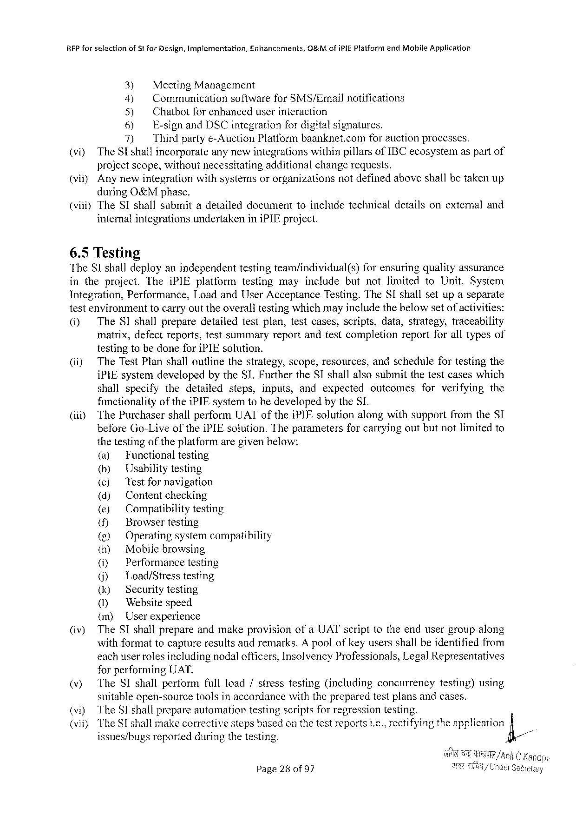

RFP forselection of Stfor Design, Implementation, Enhancements, O&Mofi PIEP latformand Mobile Application

3) Meeting Management

4) Communicationsoftwarefor SMS/Emailnotifications

5) Chatbotfor enhanceduserinteraction

6) E-signand DSC integrationfor digitalsignatures.

7) Thirdpartye-Auction Platformbaanknet. comfor auctionprocesses.

(vi) The Sshallincorporateanynewintegrationswithinpillarsof IBC ecosystemas partof

projectscope, withoutnecessitatingadditionalchangerequests.

(viiy Anynewintegrationwithsystemsororganizationsnotdefinedaboveshallbetakenup

during O&Mphase.

(viii)The SI shallsubmitadetaileddocumenttoincludetechnicaldetailsonexternaland

internalintegrationsundertakenini PIE project.

6.5 Testing

The SI shalldeployanindependenttestingteam/individual(s) forensuringqualityassurance

intheproject. Thei PIE platform testingmayincludebutnotlimited to Unit, System

Integration, Performance, Loadand User Acceptance Testing. The SI shallsetupaseparate

testenvironmenttocarryouttheoveralltestingwhichmayincludethebelowsetofactivities:

(i) The SI shallpreparedetailedtestplan, testcases, scripts, data, strategy, traceability

matrix, defectreports, testsummaryreportandtestcompletionreportforalltypesof

testingtobedonefori PIE solution.

(ii) The Test Planshalloutlinethestrategy, scope, resources, andschedulefortestingthe

i PIE system: developedbythe SI. Furtherthe SI shallalsosubmitthetestcaseswhich

|  |  |  |  |  |  |  |
| --- | --- | --- | --- | --- | --- | --- |
| shallspecify | thedetailed | steps, | inputs, | andexpected | outcomes | forverifyingthe |

functionalityofthei PIE systemtobedevelopedby the SI.

(iiiy The Purchasershallperform UAT ofthei PIE solutionalongwithsupportfromthe SI

before Go-Live of the i PIE solution. Theparameters for carryingoutbutnotlimitedto

thetestingoftheplatformaregivenbelow:

|  |  |  |  |  |
| --- | --- | --- | --- | --- |
| (iv) | (a) | Functionaltesting | | |
| (by | Usabilitytesting | | |
| (c) | 'Testfornavigation | | |
| (d) | Content | checking | |
| () | Compatibilitytesting | | |
| () | Browsertesting | | |
| (g) | Operatingsystemcompatibility | | |
| (h) | Mobilebrowsing | | |
| (i) | Performance | | testing |
| () | Load/Stresstesting | | |
| (k) | Securitytesting | | |
| () | Websitespeed | | |
| (m) | Userexperience | | |
| The SI shallprepareandmakeprovisionofa UAT scripttotheendusergroupalong | | | |

withformattocaptureresultsandremarks. Apoolofkeyusersshallbeidentifiedfrom

eachuserrolesincludingnodalofficers, Insolvency Professionals, Legal Representatives

forperforming UAT.

|  |  |  |  |  |
| --- | --- | --- | --- | --- |
| (v) | The SI shallperformfullload/stresstesting(including | concurrency | testing)using | =~ |
| (vi) | suitableopen-source tools in accordancewith the prepared testplansandcases. | | |
| The SI shallprepareautomationtestingscriptsforregressiontesting. | | |
| (vii) | The SI shallmakecorrectivestepsbasedon thetestreportsi. c., rectifyingtheapplication | | |
| issues/bugsreportedduringthetesting. | | |

Page 28 of 97

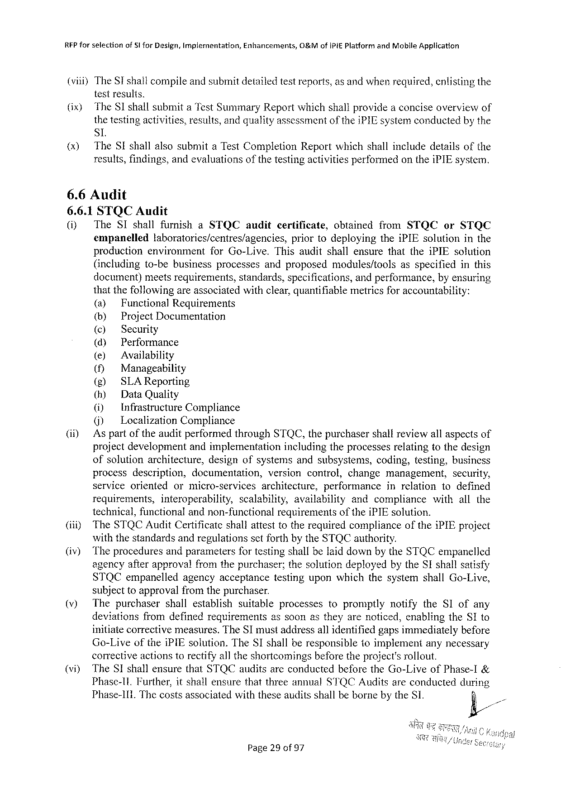

|  |  |  |  |
| --- | --- | --- | --- |
| REP forselection | of SI for Design, Implementation, | Enhancements, | O&Mofi Pi E Platformand Mobile Application |

(viii)The Sishallcompileandsubmitdetailedtestreports, as andwhenrequired, enlistingthe

testresults.

|  |  |  |  |  |  |  |  |  |  |
| --- | --- | --- | --- | --- | --- | --- | --- | --- | --- |
| (ix)  (x) | The SI shallsubmita Test Sunimary Reportwhichshallprovidea conciseoverviewof | | | | | | | | |
| thetestingactivities, results, andqualityassessment | | | | of the | i PIE systemconductedby the | | | |
| SL | | | | | | | | |
| The SI shall | alsosubmit | a Test Completion | Report | which | shall | include | details | of the |

results, findings, andevaluationsofthetestingactivitiesperformedonthei PIE system.

6.6 Audit

6.6.1 STQCA udit

(i) The SI shallfurnish a STQC audit certificate, obtained from STQC or STQC

empanelled laboratories/centres/agencies, priortodeploying thei PIE solutioninthe

production environment for Go-Live. Thisauditshallensurethatthei PIE solution

(including to-bebusinessprocesses andproposed modules/tools asspecifiedinthis

document)meetsrequirements, standards, specifications, andperformance, byensuring

thatthefollowingareassociatedwithclear, quantifiablemetricsforaccountability:

(a) Functional Requirements

(b) Project Documentation

(©) Security

(d) Performance

(e) Availability

() Manageability

(g) SLAR eporting

(h) Data Quality

(i) Infrastructure Compliance

() Localization Compliance

(i) Aspartoftheauditperformedthrough STQC, thepurchasershallreviewallaspectsof

projectdevelopment andimplementation includingtheprocessesrelatingtothedesign

ofsolutionarchitecture, designofsystemsandsubsystens, coding, testing, business

process description, documentation, versioncontrol, changemanagement, security,

serviceorientedormicro-servicesarchitecture, performanceinrelationtodefined

|  |  |  |  |  |  |  |  |  |
| --- | --- | --- | --- | --- | --- | --- | --- | --- |
| (iiiy | requirements, | interoperability, | scalability, | | availability | andcompliance | | withallthe |
| technical, functionalandnon-functional | | | requirementsof thei PIE solution. | | | | i PIE project |
| The STQCA udit Certificateshallattesttotherequiredcompliance | | | | | | of the |

withthestandardsandregulationssetforthbythe STQC authority.

(iv) Theproceduresandparametersfortestingshallbelaiddownbythe STQC empanelled

agencyafterapprovalfromthepurchaser; thesolutiondeployedbythe SI shallsatisfy

|  |  |  |
| --- | --- | --- |
| STQC empanelled | agencyacceptance | testinguponwhichthesystemshall Go-Live, |

subjecttoapprovalfromthepurchaser.

|  |  |  |  |  |  |  |  |
| --- | --- | --- | --- | --- | --- | --- | --- |
| (v) | Thepurchaser | | shallestablish | suitable | processes | topromptly | notifythe SI ofany |
| deviations | fromdefinedrequirements | | | assoonastheyarenoticed, enablingthe SI to | | |

initiatecorrectivemeasures. The ST mustaddressallidentifiedgapsimmediatelybefore

Go-Liveofthei PIE solution. The SI shallberesponsible toimplementanynecessary

correctiveactionstorectifyalltheshortcomingsbeforetheproject'srollout.

(vi) The SI shallensurethat STQC auditsareconductedbeforethe Go-Liveof Phase-I&

Phase-1 t. Further, itshallensurethatthreeannual STQCA uditsareconductedduring

Phase-1 I 1. Thecostsassociatedwiththeseauditsshallbebornebythe SI.

Page 29 of 97

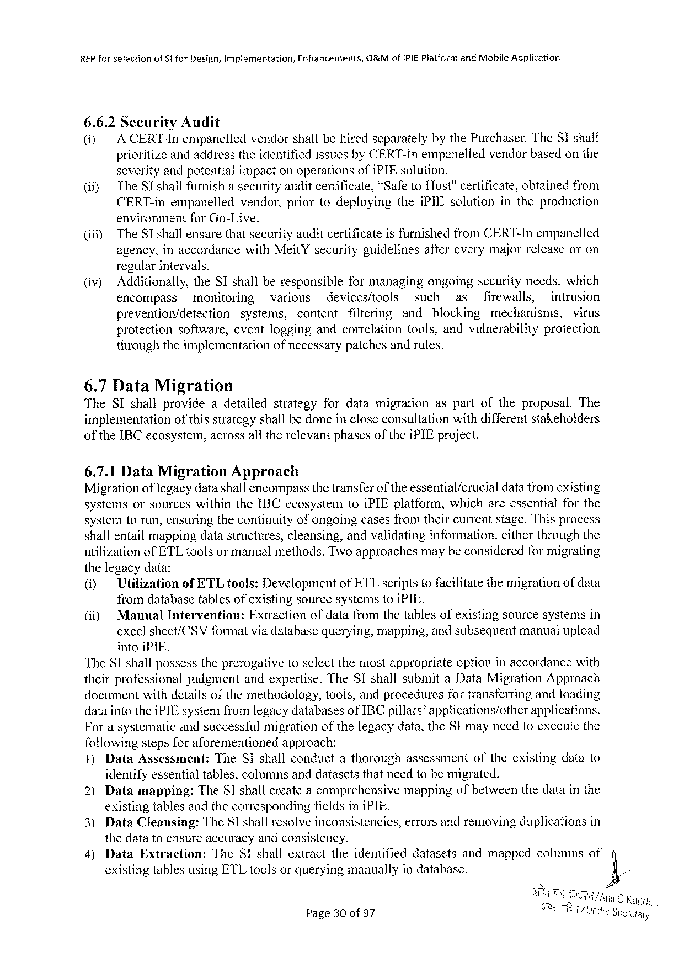

|  |  |  |
| --- | --- | --- |
| REP forsefectionof Stfor Design, Implementation, | Enhancements, | O&Mofi PIEP latformand Mobile Application |

6.6.2 Security Audit

(i) A CERT-Inempanelledvendorshallbehiredseparatelybythe Purchaser. The SI shall

prioritizeandaddresstheidentifiedissuesby CERT-Inempaneliedvendorbasedonthe

severityandpotentialimpactonoperationsofi PIE solution.

@iy The SI shallfurnish asecurity auditcertificate, “Safeto Host"certificate, obtained from

CERT-inempanelled vendor, prior(odeploying thei PIE solutionintheproduction

environmentfor Go-Live.

(iii) The SI shallensurethatsecurityauditcertificateisfurnishedfrom CERT-Inempanelled

agency, inaccordancewith Meit Ysecurityguidelines regularintervals.

aftercverymajorreleaseoron

(iv) Additionally, the SI shallberesponsible formanagingongoingsecurityneeds, which

encompass monitoring various devices/tools such as firewalls, intrusion

prevention/detection systems, content filtering

protection software, cventloggingandcorrelation

and blocking mechanisms, virus

tools, andvulnerability protection

throughtheimplementation of necessary patchesandrules.

6.7 Data Migration

The SI shallprovideadetailed strategyfordatamigration aspartoftheproposal. The

implementation ofthisstrategyshallbedoneincloseconsultationwithdifferentstakeholders

of the IBC ecosystem, acrossalltherelevantphasesofthei PIE project.

6.7.1 Data Migration Approach

Migrationof legacydatashallencompassthetransferof theessential/crucial datafromexisting

systemsorsources withinthe IBC ecosystemtoi PIE platform, whichareessentialforthe

systemtorun, ensuringthecontinuityofongoingcasesfromtheircurrentstage. Thisprocess

shal} entailmappingdatastructures, cleansing, andvalidatinginformation, eitherthroughthe

utilizationof ETL toolsor manualmethods. Twoapproachesmaybeconsideredformigrating

thelegacydata:

(i) Utilizationof ETL tools: Developmentof ETL scriptstofacilitatethemigrationof data

fromdatabasetablesofexistingsourcesystemstoi PIE.

|  |  |  |  |
| --- | --- | --- | --- |
| (i) | Manual | Intervention: | Extractionofdatafromthetablesofexistingsourcesystemsin |

excelsheet/CSV formatviadatabasequerying, mapping, andsubsequentmanualupload

intoi PIE.

The SI shallpossesstheprerogativetosclectthemostappropriateoptioninaccordancewith

theirprofessional judgmentandexpertise. The SI shallsubmita Data Migration Approach

documentwithdetailsofthemethodology, tools, andproceduresfortransferringandloading

dataintothei PIE systemfromlegacydatabasesof IBC pillars®applications/other applications.

Forasystematicandsuccessfulmigrationofthelegacydata, the SI mayneedtoexecutethe

followingstepsforaforementioned approach:

1)Data Assessment: The S shallconductathoroughassessment oftheexistingdatato

identifyessentialtables, columnsanddatasetsthatneedtobemigrated.

|  |  |  |  |  |  |  |  |
| --- | --- | --- | --- | --- | --- | --- | --- |
| 2) | Datamapping: | The SI shallcreateacomprehensive | | | mappingofbetweenthedatainthe | | }, |
| existingtablesandthecorresponding | | | | fieldsini PIE. | | |
| 3) | Data Cleansing: | The SI shallresolveinconsistencies, | | | | errorsandremovingduplicationsin |
| thedatatoensureaccuracyandconsistency. | | | | | | |
| 4)Data Extraction: | | | The SI shallextracttheidentifieddatasetsandmappedcolumnsof | | | |
| existingtablesusing ETL toolsorqueryingmanuallyindatabase. | | | | | | |

Page 30 of 97

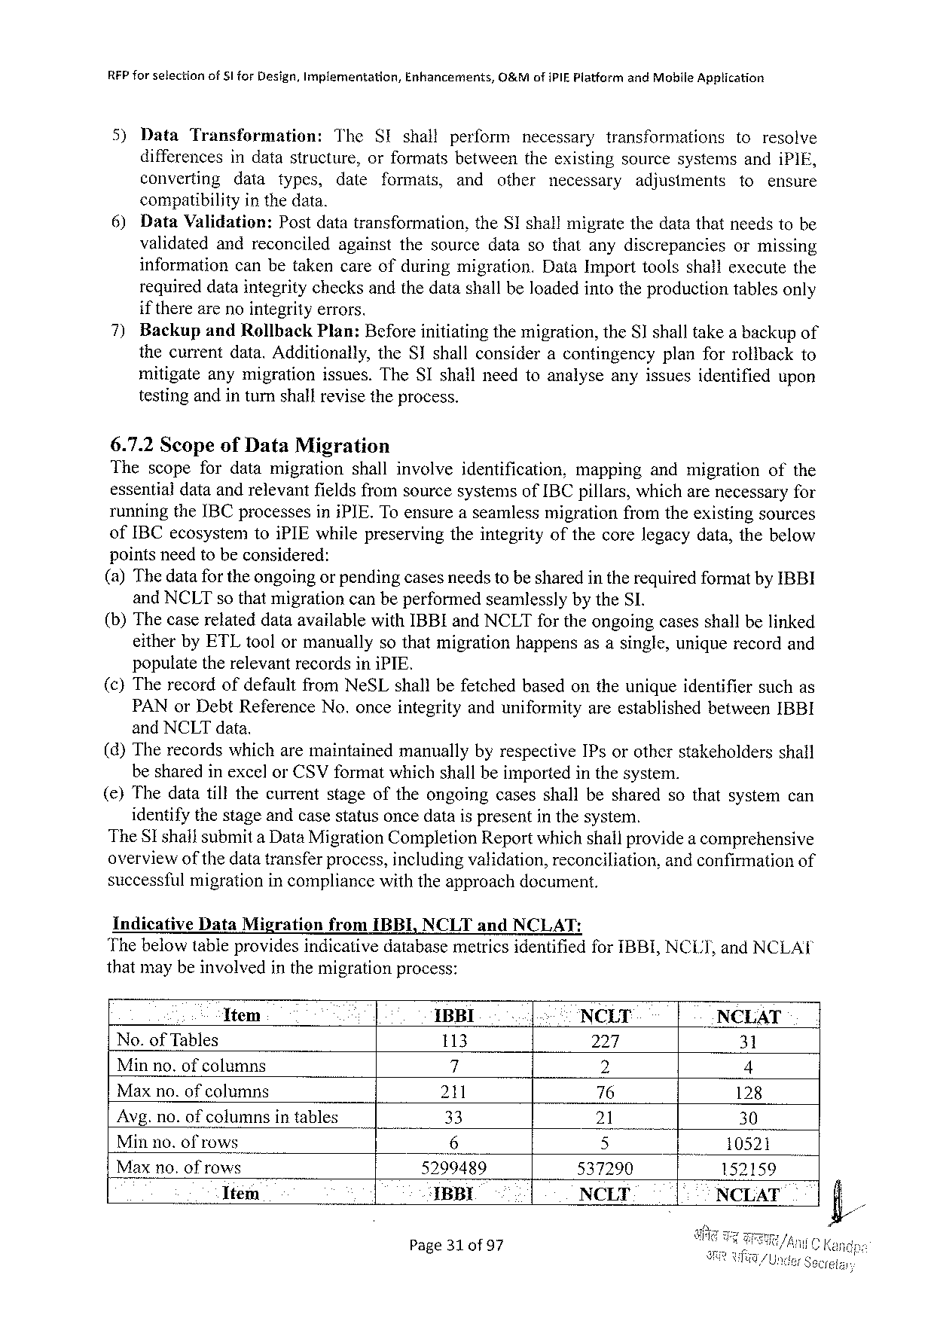

REP forselection of§l for Design, Implementation, Enhancements, O&Mofi PIEP latformand Mohile Application

5) Data Transformation: The SI shall perform necessary transformations toresolve

differencesindatastructure, orformatsbetweentheexistingsourcesystemsandi PIE,

converting data types, date formats, and other necessary adjusiments to ensure

compatibilityinthedata.

6) Data Validation: Postdatatransformation, the SI shallmigratethedatathatneedstobe

validatedandreconciled againstthesourcedatasothatanydiscrepancies ormissing

information canbetakencareofduringmigration. Data Importtoolsshailexccutethe

requireddataintegritychecksandthedatashallbeloadedintotheproductiontablesonly

if therearenointegrityerrors.

7) Backup and Rollback Plan: Beforeinitiatingthemigration, the SI shalltakea backupof

thecurrentdata. Additionally, the SI shallconsideracontingency planforrolibackto

mitigateanymigrationissues. The SI shallneedtoanalyseanyissuesidentified upon

testing andin turnshallrevise the process.

6.7.2 Scopeof Data Migration

Thescopefordatamigration shallinvolve identification, mapping andmigration of the

essentialdataandrelevantfieldsfromsourcesystemsof IBC pillars, whicharenecessaryfor

runningthe IBC processesini PIE. Toensureaseamlessmigrationfromtheexistingsources

of IBC ecosystemtoi PIE whilepreservingtheintegrityofthecorelegacydata, thebelow

pointsneedtobeconsidered:

(a)Thedatafor theongoingor pendingcasesneedstobesharedintherequiredformatby IBBI

and NCLT so thatmigrationcanbeperformedseamlesslybythe SI.

(b)Thecaserelateddataavailablewith IBBI and NCLT fortheongoingcasesshallbelinked

eitherby ETL toolormanuallysothatmigrationhappensasasingle, uniquerecordand

populatetherelevantrecordsini PIE.

(c)Therecordofdefaultfrom Ne SL shallbefetchedbasedontheuniqueidentifiersuchas

PAN or Debt Reference No. onceintegrityanduniformityareestablishedbetween IBBI

and NCLT data.

(d)Therecordswhicharemaintainedmanuallybyrespective IP sorotherstakeholders shall

besharedinexcelor CSV formatwhichshallbeimportedinthesystem.

() Thedatatillthecurrentstageoftheongoingcasesshallbesharedsothatsystemcan

identifythestageandcasestatusoncedatais presentin thesystem.

The SI shallsubmita Data Migration Completion Reportwhichshallprovidea comprehensive

overviewofthedatatransferprocess, includingvalidation, reconciliation, andconfirmationof

successfulmigrationincompliancewiththeapproachdocument.

Indicative Data Migration from IBBI, NCLT and NCLAT:

Thebelowtableprovidesindicativedatabasemetricsidentifiedfor IBBI, NCLT, and NCLAT

thatmaybeinvolvedinthemigrationprocess:

Ttem : IBBI. .| NCLT NCLAT

No. of Tables 113 224, 31

Minno. ofcolumns 7 2 4

Maxno. ofcolumns 211 76 128

Avg. no. ofcolumnsintables 33 21 30

Minno. ofrows 6 5 10521 N

Maxno. of rows 5299489 537290 152159

Item ‘IBBI NCLT - NCLAT

Page 310 f 97

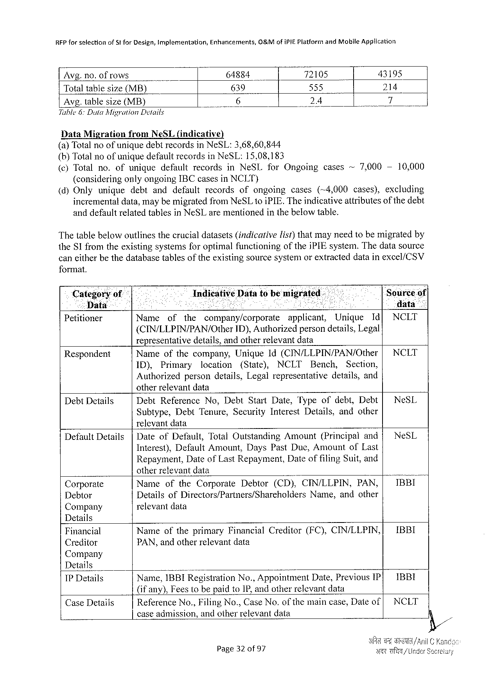

RFP for selectionof Stfor Design, Implementation, Enhaticements,0&M ofi PIEP latform and Mobile Application

|  |  |  |  |  |  |  |
| --- | --- | --- | --- | --- | --- | --- |
| Avg. no. ofrows | - | .6 | 64884 | 72105 | | | 43195 |
| Totaltablesize(MB) | 639 | 535 | 214 |
| 24 | 7 |
| Avg. tablesize(MB) |

Tuble 6: Duta Migration Details

Data Migration from Ne SL(indicative)   
(a)Totalnoofuniquedebtrecordsin Ne SL:3,68,60,844

(b)Totalnoofuniquedefaultrecordsin Ne SL:15,08,183

|  |  |  |  |  |  |
| --- | --- | --- | --- | --- | --- |
| (¢)Totalno. ofunique | defaultrecords | in Ne SL for Ongoing | cases | ~7,000- | 10,0600 |

(consideringonlyongoing IBC casesin NCLT)

|  |  |  |  |  |  |  |  |  |  |
| --- | --- | --- | --- | --- | --- | --- | --- | --- | --- |
| (d)Only | unique | debt | anddefault | records | ofongoing | cases | (~4,000 | cases), | excluding |

incrementaldata, maybemigratedfrom Ne SL 1 o i PIE. Theindicativeattributesofthedebt anddefaultrelatedtablesin Ne SL arementionedinthebelowtable.

Thetablebelowoutlinesthecrucialdatasets(indicartivelist)thatmayneedtobemigratedby the SI fromtheexistingsystemsforoptimalfunctioning of thej PIE system. Thedatasource

caneitherbethedatabasetablesoftheexistingsourcesystemorextracteddatainexcel/CSV

format.

|  |  |  |  |  |  |  |  |  |  |  |
| --- | --- | --- | --- | --- | --- | --- | --- | --- | --- | --- |
| Categoryof | Indicative Data tobe migrated. | | | | | | | | | ‘Sourceof| |
| Data | R | | | | AN | | | | | data” |
| Petitioner | Name | of | the | company/corporate | | | applicant, | Unique | Id[ | NCLT |
| (CIN/LLPIN/PAN/Other | | | | | ID), Authorizedpersondetails, Legal | | | |

representativedetails, andotherrelevantdata

|  |  |  |  |  |  |  |  |  |  |  |  |
| --- | --- | --- | --- | --- | --- | --- | --- | --- | --- | --- | --- |
| Respondent | Nameofthecompany, | | | | Unique 1 d(CIN/LLPIN/PAN/Other | | | | | | | NCLT |
| ID), | Primary | | location | (State), | NCLT | Bench, | | Section, |
| Authorized | | persondetails, Legalrepresentative | | | | | details, and | |

otherrelevantdata

|  |  |  |  |  |  |  |  |
| --- | --- | --- | --- | --- | --- | --- | --- |
| Debt Details | Debt Reference | | No, Debt Start Date, Typeofdebt, Debt[ | | | | Ne SL |
| Subtype, | Debt Tenure, | | Security Interest | Details, | andother |

relevantdata

|  |  |  |  |  |  |  |  |
| --- | --- | --- | --- | --- | --- | --- | --- |
| Default Details | |Dateof Default, Total Outstanding | Amount | | (Principal | | and{ | Ne SL |
| Interest), Default Amount, Days Past Due, Amountof Last | | | | | |
| Repayment, Dateof Last Repayment, Date | | of filing | | Suit, and | |

otherrelevantdata

|  |  |  |  |  |  |  |
| --- | --- | --- | --- | --- | --- | --- |
| Corporate | Nameofthe Corporate | Debtor | (CD), CIN/LLPIN, | | PAN, | IBBI |
| Debtor | Detailsof Directors/Partners/Shareholders | | | Name, andother | |
| Company | relevant data | | | | |

Details

|  |  |  |  |  |
| --- | --- | --- | --- | --- |
| Financial | Nameoftheprimary Financial | Creditor | (FC), CINLLPIN,| | IBBI |
| PAN, andotherrelevantdata |
| Creditor |

Company

|  |  |  |  |  |  |  |
| --- | --- | --- | --- | --- | --- | --- |
| Details | Name, | ; | No., Appointment | Date, Previous | IP| | 1 BBI |
| 1 BBIR egistration |
| 1 PD etails |

(ifany), Fees(o bepaidto IP, andotherrelevantdata

|  |  |  |  |  |  |
| --- | --- | --- | --- | --- | --- |
| Case Details | Reference No., Filing No., Case No. | of the | maincase, Dateof| | NCLT | |
| caseadmission, andotherrelevantdata | | %/, | | |
| ART | | /Under Secreiary |
| Page 320 f 97 | |

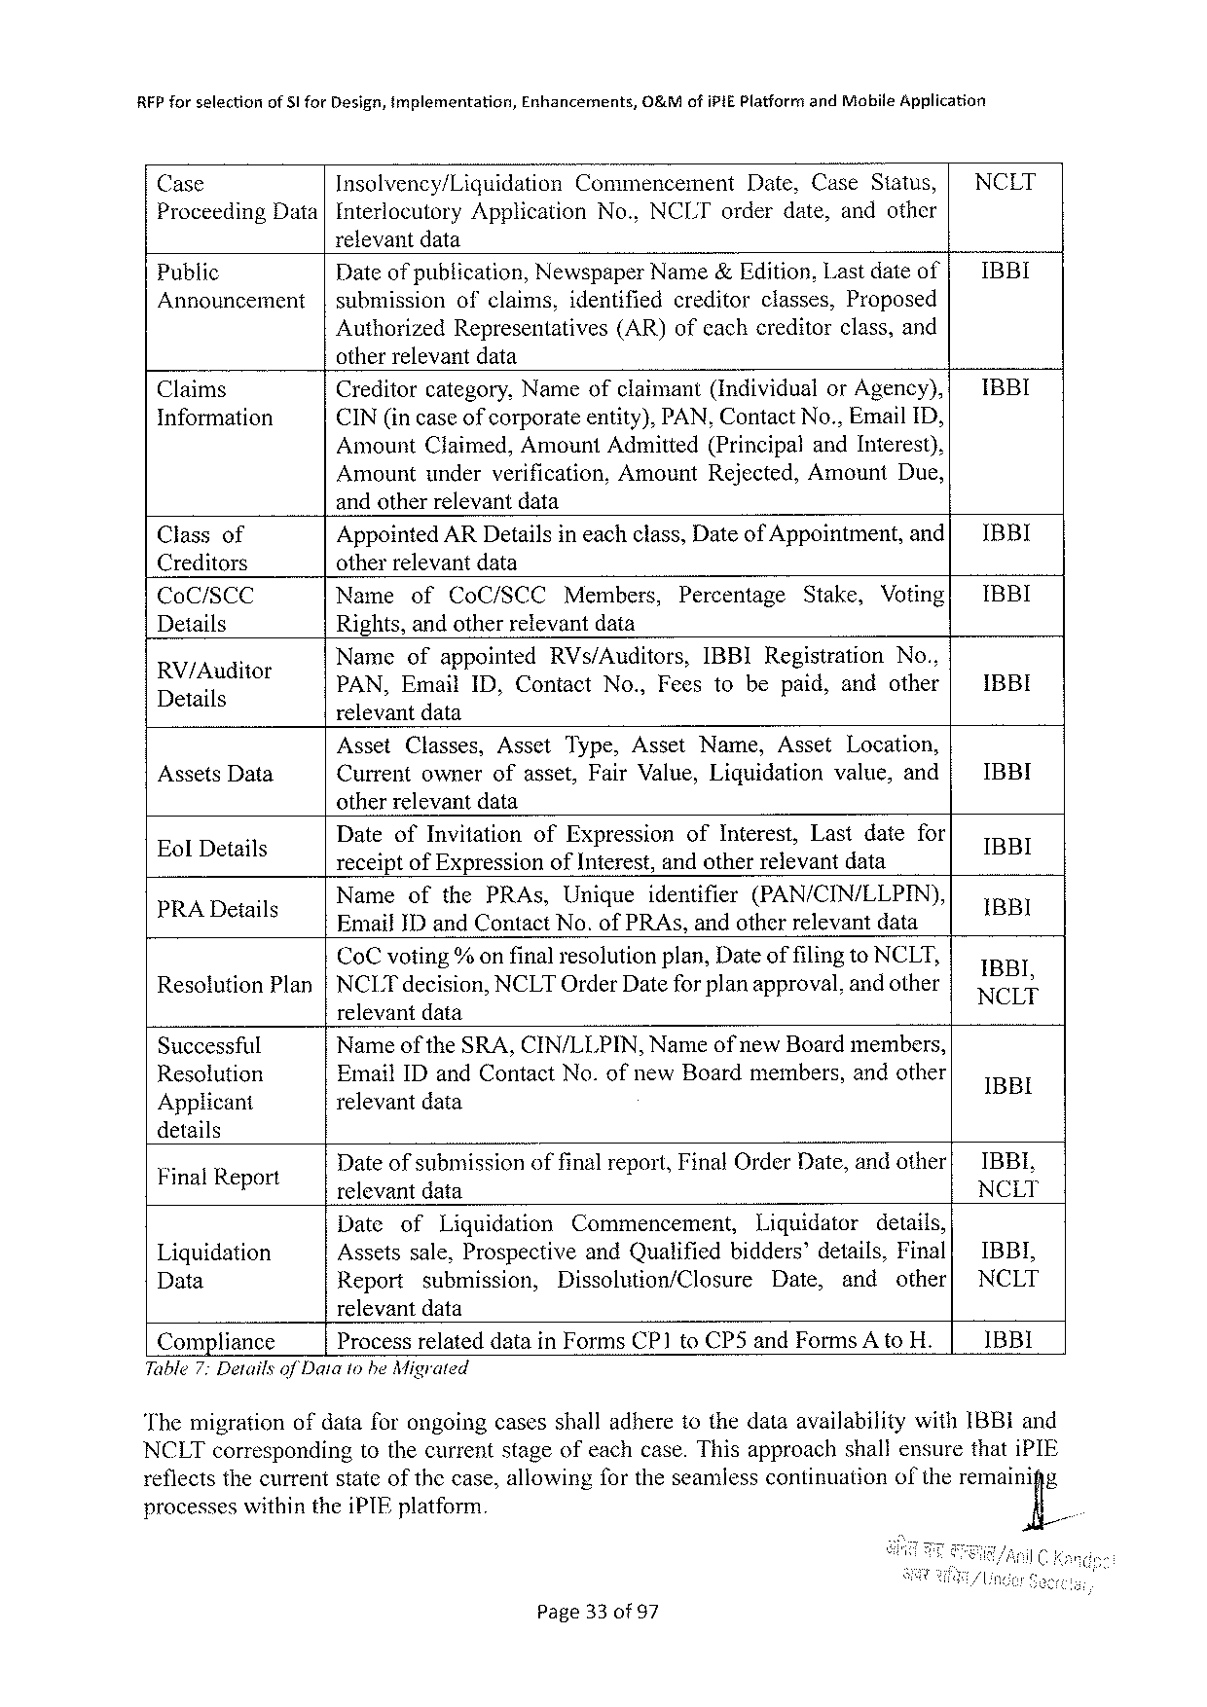

RFP forselection of SI for Design, implementation, Enhancements, O&Mofi PIEP latformand Mobile Application

Case Insolvency/Liquidation Commencement Date, Case Status, | NCLT

Proceeding Data |Interlocutory Application relevantdata

No., NCLT orderdate, andother

|  |  |  |  |  |  |
| --- | --- | --- | --- | --- | --- |
| Public | Dateof publication, Newspaper Name&Edition, Lastdateof| | | | | IBBI |
| Announcement | |submission | ofclaims, identified | creditor | classes, Proposed |

Authorized Representatives otherrelevantdata

(AR)ofeachcreditorclass, and

|  |  |  |  |
| --- | --- | --- | --- |
| Claims | Creditorcategory, Nameofclaimant(Individual | or Agency),{ | IBBI |
| Information | CIN(in caseofcorporateentity), PAN, Contact No., Email ID, | |

Amount Claimed, Amount Admitted(Principaland Interest), Amountunderverification, Amount Rejected, Amount Due, andotherrelevantdata

|  |  |  |  |  |  |  |  |  |  |  |  |  |
| --- | --- | --- | --- | --- | --- | --- | --- | --- | --- | --- | --- | --- |
| Classof | Appointed ARD etailsineachclass, Dateof Appointment, and[ | | | | | | | | | | | IBBI |
| Creditors | otherrelevantdata | | | | | | | | | | | IBBI |
| Co C/SCC | Name | | of | Co C/SCC | | Members, | | Percentage | Stake, | | Voting| |
| Details | Rights, andotherrelevantdata | | | | | | | | | | | IBBI |
| RV/Auditor | Nameofappointed | | | | | RV s/Auditors, | | IBBIR egistration | | | No., |
| .  Details | PAN, Email ID, Contact | | | | | | No., Feestobepaid, andother| | | | | |
| relevantdata | | | | | | | | | | |
| Assets Data | Asset | Classes, | | | Asset | Type, Asset Name, | | | Asset | Location, | | IBBI |
| Currentownerofasset, Fair Value, Liquidation | | | | | | | | | value, and | |

otherrelevantdata

|  |  |  |  |  |  |  |  |  |  |
| --- | --- | --- | --- | --- | --- | --- | --- | --- | --- |
| n | Dateof Invitation | | of Expression | | | of Interest, | | Lastdatefor | IBBI  il  BRI  NCL'l!‘ |
| Eol Details | receiptof Expressionof Inierest, andotherrelevantdata | | | | | | | |
| i | Name | of the PRA s, | | Unigue | identifier | | (PAN/CIN/LLPIN), | |
| PRAD etails | Emaif ID and Contact No. of PRA s, andotherrelevantdata | | | | | | | |
| Co Cvoting%onfinalresolutionplan, Dateoffilingto NCLT, Resolution Plan|NCLT decision, NCLTO rder Datefor planapproval, andother | | | | | | | | |

relevantdata

|  |  |  |  |  |  |  |
| --- | --- | --- | --- | --- | --- | --- |
| Successful | Name | of the | SRA, CIN/LLPIN, | Name | ofnew Boardmembers, | IBBI |
| Resolution | Email ID and Contact No. ofnew Boardmembers, andother | | | | |
| Applicant | relevant data | | | | |

details

|  |  |  |  |  |  |  |  |  |  |
| --- | --- | --- | --- | --- | --- | --- | --- | --- | --- |
| Final Report | Dateofsubmissionoffinalreport, Final Order Date, andother| | | | | | | | | IBBL, |
| relevantdata | | | | | | | | NCLT |
| Liquidation | Date | of | Liquidation | Commencement, | | Liquidator | | details, |
| IBBI, |
| Assetssale, Prospective | | | | and Qualifiedbidders’details, Final| | | | |
| Data | Report | submission, | | Dissolution/Closure | | Date, | and | other| | NCLT |

relevantdata

|  |  |  |
| --- | --- | --- |
| Compliance | Processrelateddatain Forms CP 1 to CP 5 and Forms A to H. | 1 BBI |

Table 7: Detailsof Dataiohe Migrated

Themigrationofdataforongoingcasesshalladheretothedataavailabilitywith IBBI and NCLT corresponding tothecurrentstageofeachcase. Thisapproachshallensurethati PIE reflectsthecurrentstateof thecase, allowingfortheseamlesscontinuation oftheremain‘ig% processeswithinthei PTE platform.

Page 330 f 97

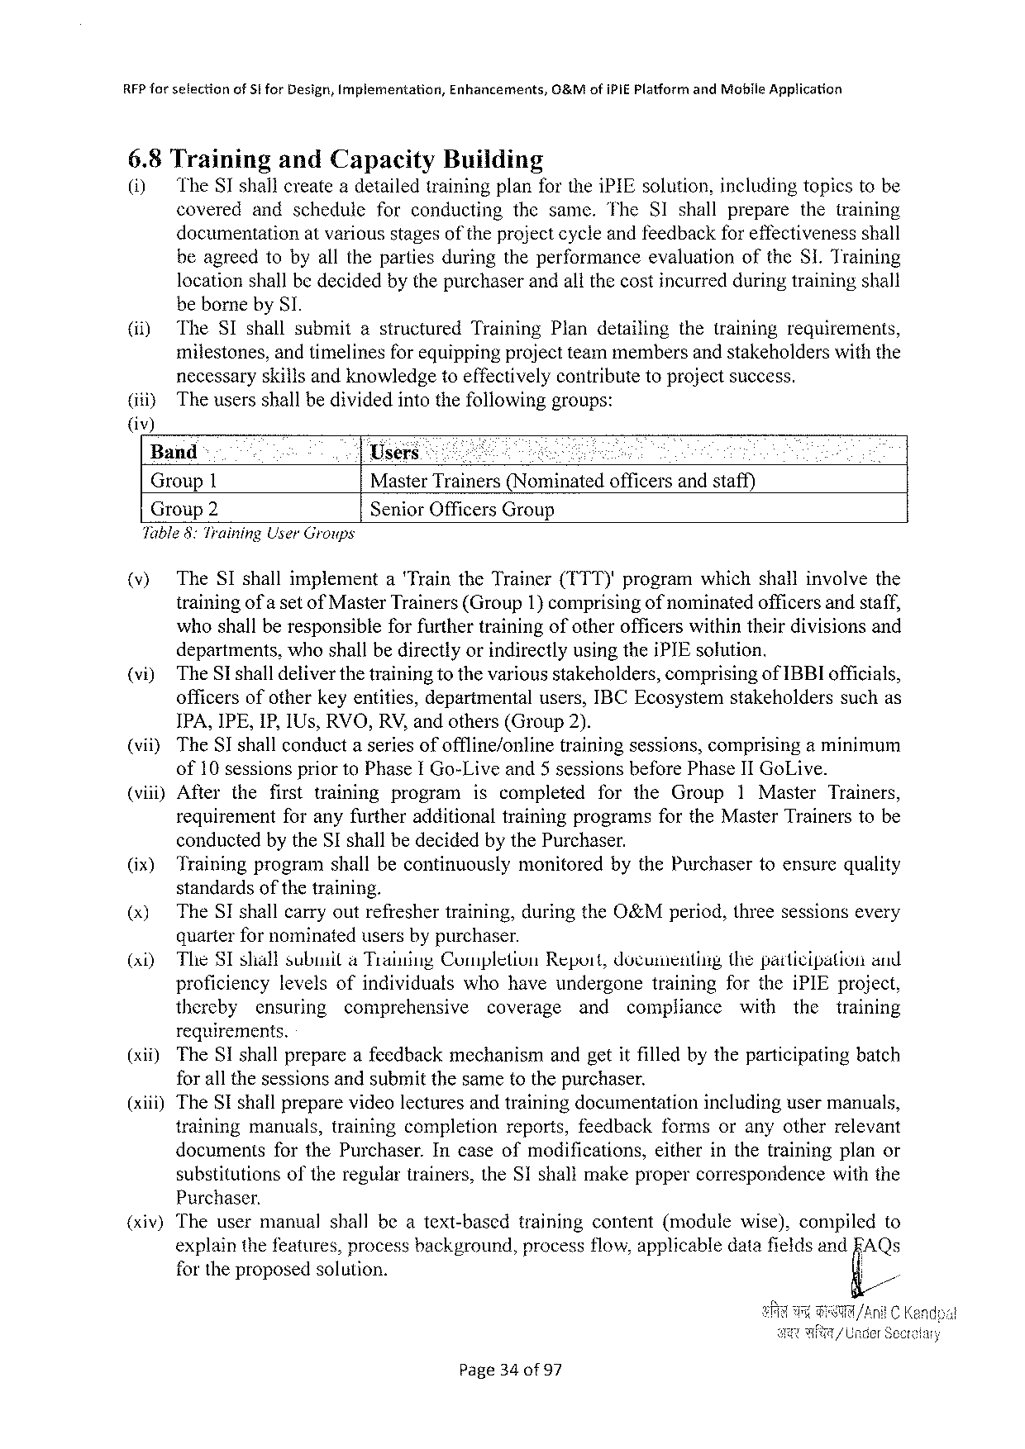

RFP for sefectionof Stfor Design, Implementation, Enhancements, O&Mof IPIEP latform and Moblle Application

6.8 Training and Capacity Building

(1) The ST shallcreateadetailedtrainingplanforthei PIE solution, includingtopicstobe

covered andschedule forconducting thesame. The SI shallprepare thetraining

documentationatvariousstagesof theprojectcycleandfeedbackfor effectivenessshall

beagreedtobyallthepartiesduringtheperformance evaluationofthe SI. Training

locationshallbedecidedbythepurchaserandallthecostincurredduringtrainingshall

beborneby SI.

|  |  |  |  |  |
| --- | --- | --- | --- | --- |
| (i) | The SI shallsubmit | astructured | Training Plandetailing | thetrainingrequirements, |

milestones, andtimelinesfor equippingprojectteammembersand stakeholderswiththe

necessaryskillsandknowledgetoeffectivelycontributetoprojectsuccess.

(itiy The usersshallbedividedintothefollowinggroups:

()

Band Users 1 Mty

Group 1 Master Trainers(Nominatedofficersandstaff)

Group 2 Senior Officers Group

Table 8: Training User Groups

(v) The SI shallimplement a Trainthe Trainer(TTT)'programwhichshallinvolvethe

trainingof a setof Master Trainers(Group 1)comprisingof nominatedofficersandstaff,

whoshallberesponsible for furthertrainingofotherofficerswithintheirdivisionsand

departments, whoshallbedirectlyorindirectlyusingthei PIE solution.

(vi) The SI shalldeliverthetrainingtothevariousstakeholders, comprisingof IBBI officials,

officersofotherkeyentities, departmentalusers, IBCE cosystemstakeholders suchas

IPA, IPE, IP, IU s, RVO, RV, andothers(Group 2).

(vii) The SI shallconduct aseries of offline/online training sessions, comprising aminimum

of 10 sessionsprior to Phase I Go-Live and 5 sessionsbefore Phase II Go Live.

(vii) After thefirsttraining program iscompleted for the Group 1 Master Trainers,

requirement foranyfurtheradditionaltrainingprogramsforthe Master Trainerstobe

conductedbythe SI shallbedecidedbythe Purchaser.

(ix) Trainingprogramshallbecontinuously monitored bythe Purchasertoensurequality

standards of the training.

(x) The SI shallcarryoutrefreshertraining, duringthe O&Mperiod, threesessionsevery

quarterfor nominatedusersbypurchaser.

|  |  |  |  |  |  |  |  |  |  |  |  |  |  |
| --- | --- | --- | --- | --- | --- | --- | --- | --- | --- | --- | --- | --- | --- |
| (xi) | The SI sliallsubusila Traiuing Completion | | | | | Repoit, documentiig | | | | thepatticipation | | | and |
| proficiency | | levelsofindividuals | | whohaveundergone | | | | training | forthei PIE project, | | | |
| thereby | ensuring | | comprehensive | coverage | | and | compliance | | with | the | training | |

requirements.

|  |  |  |
| --- | --- | --- |
| (xii) | The SI shallprepareafeedbackmechanism | andgetitfilledbytheparticipatingbatch |

forall thesessionsandsubmitthesametothepurchaser.

(xiii)The SI shallpreparevideo lectures andtrainingdocumentationincludingusermanuals,

training manuals, trainingcompletion reports, feedback formsoranyotherrelevant

documents for the Purchaser. Incaseofmodifications, eitherinthetrainingplanor

substitutionsoftheregulartrainers, the SI shallmakepropercorrespondence with the

Purchaser.

(xiv) The user manual shall beatext-based training content (module wise), compiled to

explainthefeatures, processbackground, processflow, applicabledatafieldsand FAQ s

fortheproposedsolution. g/

Page 34 of 97

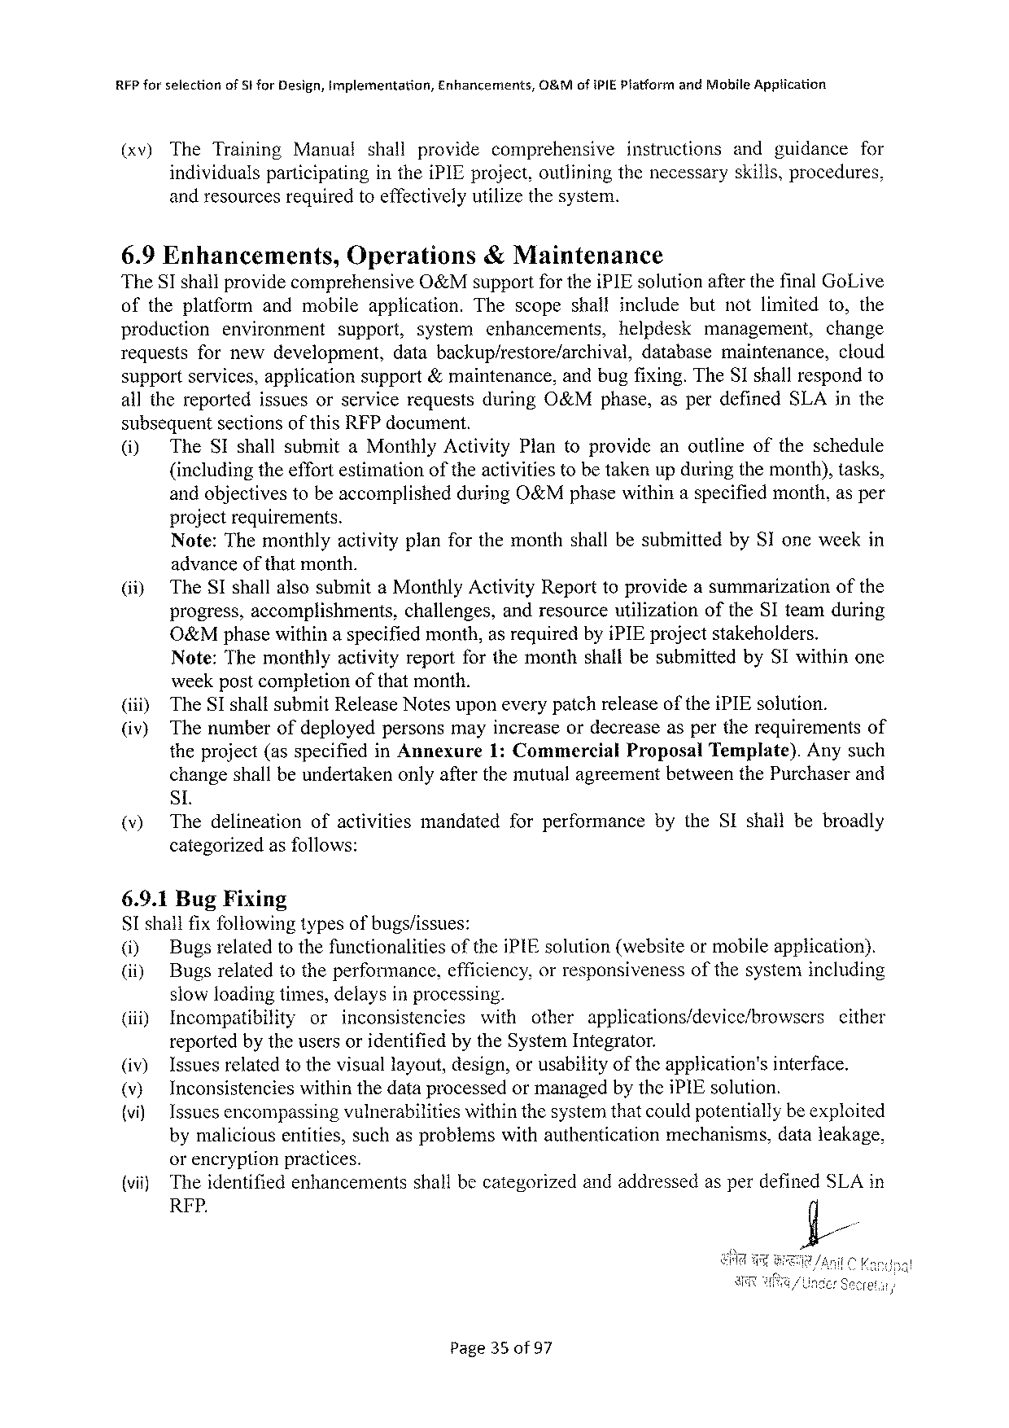

RFP forselection of St for Design, Implementation, Enhancements, O&Mof IPIEP latfarm and Mobile Apptication

(xv) The Training Manual shall provide comprehensive instructions andguidance for

individualsparticipating inthei PIE project, outliningthenecessaryskills, procedures,

andresourcesrequiredtoeffectivelyutilizethesystem.

6.9 Enhancements, Operations &Maintenance

The SI shallprovidecomprehensive O&Msupportforthei PIE solutionafterthefinal Go Live

oftheplatform andmobileapplication. Thescopeshallincludebutnotlimited to, the

production environment support, system enhancements, helpdesk management, change

requests fornewdevelopment, databackup/restore/archival, database maintenance, cloud

supportservices, applicationsupport&maintenance, andbugfixing. The SI shallrespondto

allthereported issuesorservicerequestsduring O&Mphase, asperdefined SLA in the

subsequentsectionsofthis RFP document.

|  |  |  |
| --- | --- | --- |
| (i) | The SI shallsubmita Monthly Activity | Plantoprovideanoutlineoftheschedule |

(includingtheeffortestimationoftheactivitiestobetakenupduringthemonth), tasks,

andobjectivestobeaccomplished projectrequirements.

during O&Mphasewithinaspecifiedmonth, asper

Note: Themonthlyactivityplanforthemonthshallbesubmittedby SI oneweekin

|  |  |  |  |
| --- | --- | --- | --- |
| (i) | advanceof thatmonth.  The SI shallalsosubmita Monthly Activity Reporttoprovideasummarizationofthe | | |
| progress, accomplishments, | challenges, | andresourceutilizationofthe SI teamduring |

O&Mphasewithinaspecifiedmonth, as requiredbyi PIE projectstakeholders.

Note: Themonthlyactivityreportforthemonthshallbesubmittedby SI withinone

weekpost completion of that month.

(i) The SI shallsubmit Release Notesuponeverypatchreleaseofthei PIE solution.

(iv) Thenumberofdeployedpersonsmayincreaseordecreaseaspertherequirements of

theproject(asspecifiedin Annexure 1: Commercial Proposal Template). Anysuch

changeshallbeundertakenonlyafterthemutualagreementbetweenthe Purchaserand

SL

|  |  |  |  |  |  |
| --- | --- | --- | --- | --- | --- |
| (v) | Thedelineation | ofactivities | mandated | forperformance | bythe SI shallbebroadly |

categorizedasfollows:

6.9.1 Bug Fixing

SI shailfixfollowingtypesofbugs/issues:

|  |  |  |  |
| --- | --- | --- | --- |
| (i) | Bugsrelatedtothefunctionalities | ofthei PIE solution(websiteormobileapplication). | |
| (i) | Bugsrelatedtotheperformance, | cfficiency, orresponsiveness | ofthesystemincluding |

slowloadingtimes, delaysinprocessing.

|  |  |  |  |  |  |  |  |
| --- | --- | --- | --- | --- | --- | --- | --- |
| (iiiy | Incompatibility | or | inconsistencies | with | other | applications/device/browsers | cither |

reportedby theusersoridentifiedbythe System Integrator.

|  |  |  |  |  |  |  |
| --- | --- | --- | --- | --- | --- | --- |
| (iv)  (v)  {vi) | Issuesrelatedtothevisuallayout, design, orusabilityoftheapplication's | | | | interface. | |
| Inconsistencies | withinthedataprocessedormanagedbythei PIE solution. | | | | |
| Issuesencompassingvulnerabilities | | withinthe systemthatcouldpotentiallybeexploited | | | |
| bymaliciousentities, suchasproblemswithauthentication | | | mechanisms, | | dataleakage, |

orencryptionpractices.

{vit)Theidentifiedenhancements RFP.

shallbecategorizedandaddressedasperdefined SLA in

Page 35 0 f 97

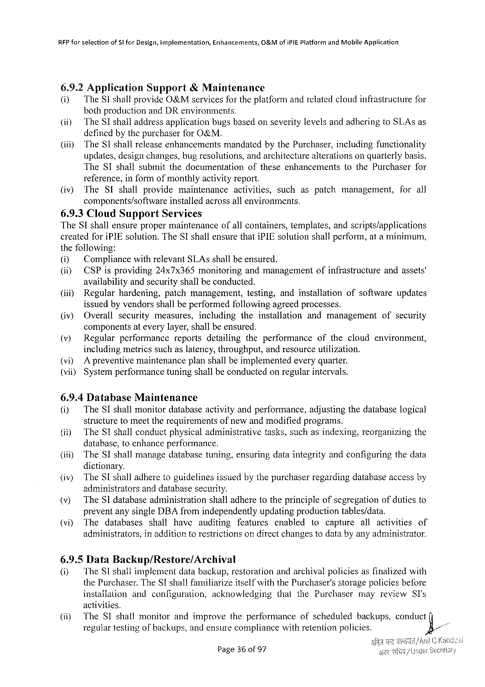

RFP forselectionof 5 tfor Design, implementation, Enhancements, O&Mofi PIEP latform and Mobile Application

6.9.2 Application Support &Maintenance   
(i) The SI shallprovide O&M services fortheplatform andrelatedcloudinfrastructurefor bothproductionand DR environments.

(i) The SI shalladdressapplicationbugsbasedonseveritylevelsandadheringto SLA sas definedbythepurchaserfor O&M.

|  |  |  |
| --- | --- | --- |
| (iiiy | The SI shallreleaseenhancements | mandatedbythe Purchaser, includingfunctionality |

updates, designchanges, bugresolutions, andarchitecturealterationsonquarterlybasis.

|  |  |  |  |
| --- | --- | --- | --- |
| The SI shallsubmitthedocumentation | oftheseenhancements | to the Purchaser | for |

reference, informofmonthlyactivityreport.

(iv) The SI shall provide maintenance activities, such aspatch management, for all components/software installedacrossallenvironments.

6.9.3 Cloud Support Services   
The SI shallensurepropermaintenance ofallcontainers, templates, andscripts/applications createdfori PIE solution. The SI shallensurethati PIE solutionshallperform, ata minimum, thefollowing:

|  |  |  |  |
| --- | --- | --- | --- |
| (i) | Compliancewithrelevant SLA sshallbeensured. | ofinfrastructure | andassets' |
| (i) | CSP isproviding 24 x 7 x 365 monitoringandmanagement |

availabilityandsecurityshallbeconducted.

|  |  |  |  |  |  |
| --- | --- | --- | --- | --- | --- |
| (i) | Regularhardening, | patchmanagement, | testing, | andinstallation | ofsoftwareupdates |

issuedbyvendorsshallbeperformedfollowingagreedprocesses.

|  |  |  |  |  |  |  |  |
| --- | --- | --- | --- | --- | --- | --- | --- |
| (iv) | Overall | security | measures, | including | theinstallation | andmanagement | ofsecurity |

componentsateverylayer, shallbeensured.

|  |  |  |  |  |  |
| --- | --- | --- | --- | --- | --- |
| (v) | Regularperformance | reports | detailing | theperformance | ofthecloudenvironment, |

includingmetricssuchas latency, throughput, andresource utilization. (vi) A preventivemaintenanceplanshallbeimplementedeveryquarter. (vii) Systemperformancetuningshallbeconductedonregularintervals.

6.9.4 Database Maintenance   
(i) The SI shallmonitordatabaseactivityandperformance, adjustingthedatabaselogical structuretomeettherequirementsofnewandmodifiedprograms.

|  |  |  |
| --- | --- | --- |
| (i) | The SI shallconductphysicaladministrative | tasks, suchasindexing, reorganizingthe |

database, toenhanceperformance.

(iti) The SI shallmanagedatabasetuning, ensuringdataintegrityandconfiguringthedata dictionary.

(iv) The SI shalladheretoguidelinesissuedbythepurchaserregardingdatabaseaccessby administrators anddatabasesecurity.

(v) The SI databaseadministration shalladheretotheprincipleofsegregationofdutiesto preventanysingle DBA fromindependentlyupdatingproductiontables/data.

|  |  |  |  |  |  |  |  |  |  |  |  |
| --- | --- | --- | --- | --- | --- | --- | --- | --- | --- | --- | --- |
| (vi) | The | databases | shall | have | auditing | features | enabled | tocapture | all | activities | of |
| administrators, | | inadditiontorestrictionson directchangestodatabyanyadministrator. | | | | | | | | |

6.9.5 Data Backup/Restore/Archival   
(i) The SI shallimplementdatabackup, restorationandarchivalpoliciesasfinalizedwith the Purchaser. The SI shallfamiliarizeitselfwith the Purchaser'sstoragepoliciesbefore

|  |  |  |  |  |  |
| --- | --- | --- | --- | --- | --- |
| installation | andconfiguration, | acknowledging | thatthe Purchaser | mayreview | SI's |

activities.

|  |  |  |  |  |  |  |  |  |  |  |
| --- | --- | --- | --- | --- | --- | --- | --- | --- | --- | --- |
| (iiy | The SI shall | monitor | and | improve | theperformance | ofscheduled | backups, | conduct | (] | - |
| regulartestingofbackups, andensurecompliancewithretentionpolicies. | | | | | | | ’&/ |

Page 36 of 97

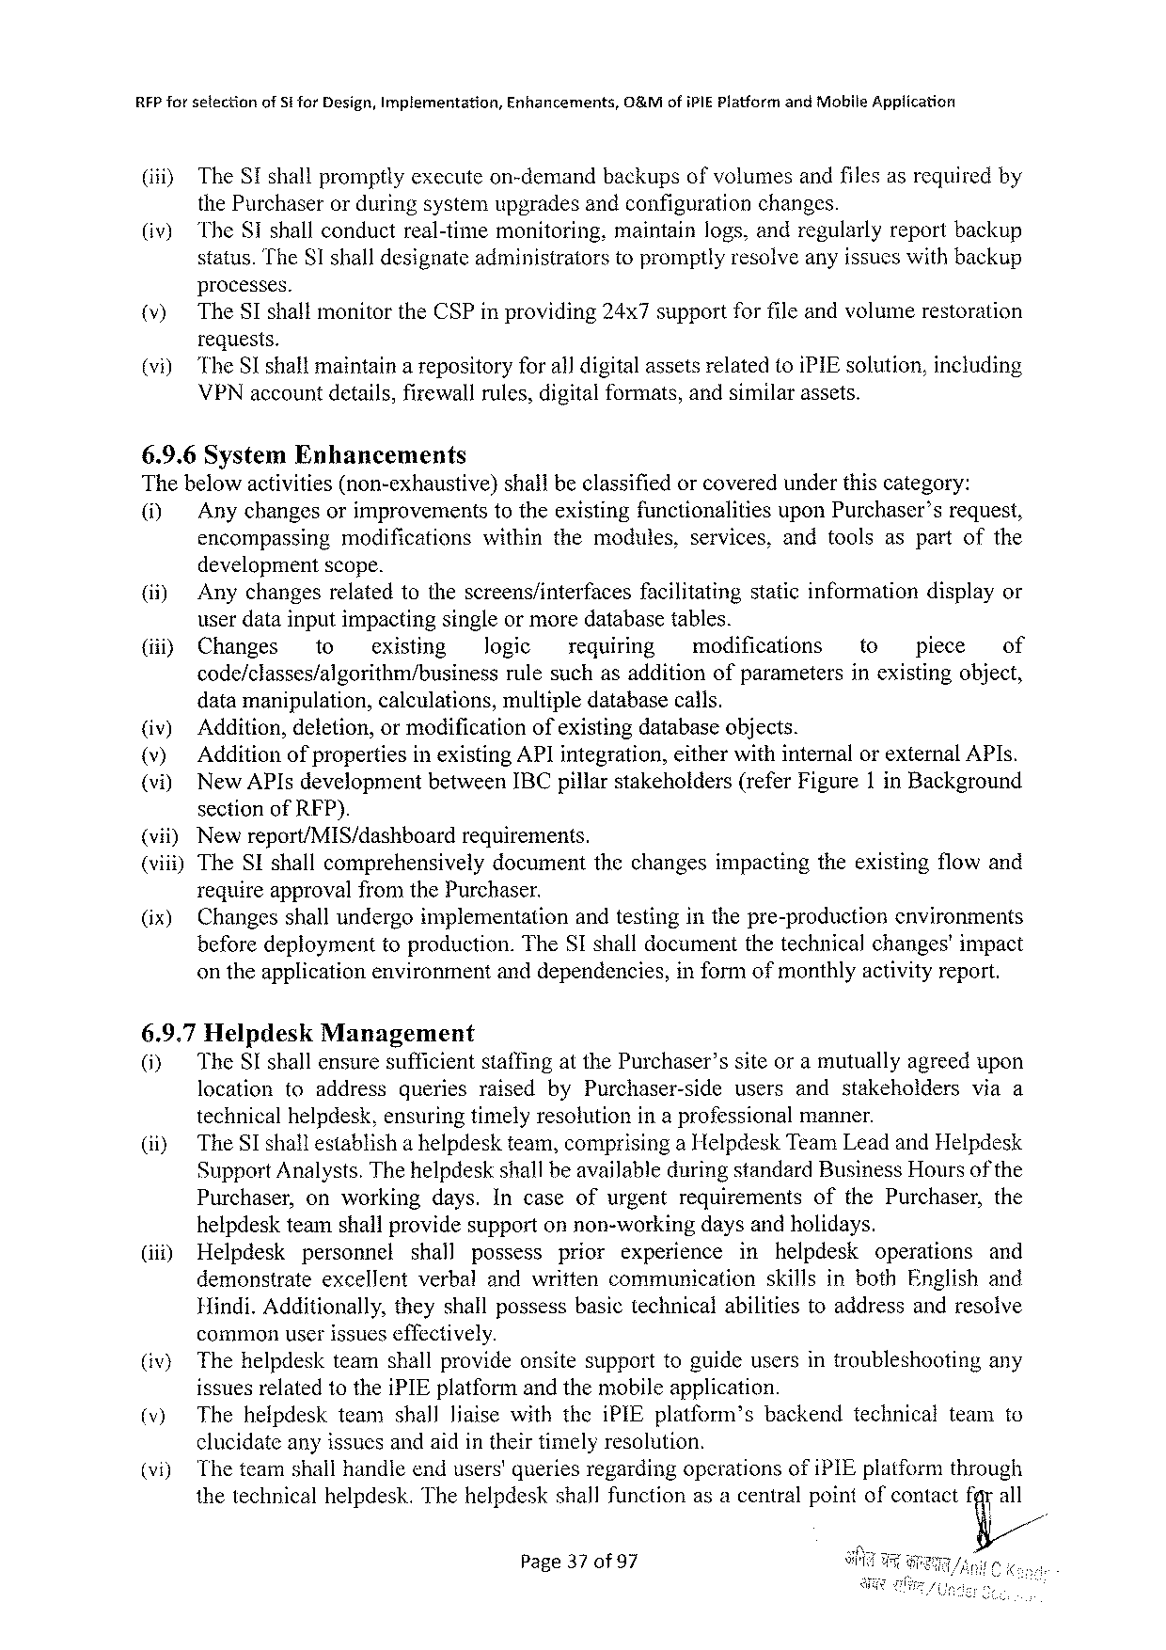

RFP for selectionof S for Design, Implementation, Enhancements, O&Mofi PIEP latform and Mobile Application

(i) The ST shallpromptlyexecuteon-demandbackupsofvolumesandfilesasrequiredby

the Purchaserorduringsystemupgradesandconfigurationchanges.

|  |  |  |
| --- | --- | --- |
| (iv) | The ST shallconductreal-timemonitoring, | maintainlogs, andregularlyreportbackup |
| status. The SI shalldesignateadministratorstopromptlyresolveanyissueswithbackup | |

processes.

|  |  |
| --- | --- |
| )  i) | The ST shallmonitorthe CSP inproviding 24 x 7 supportforfileandvolumerestoration requests.  The Sshallmaintainarepositoryforall digitalassetsrelatedtoi PIE solution, including VPN accountdetails, firewallrules, digitalformats, andsimilarassets. |

6.9.6 System Enhancements   
Thebelowactivities(non-exhaustive) shallbeclassifiedorcoveredunderthiscategory:

ol Anychangesorimprovements totheexistingfunctionalities upon Purchaser’srequest, encompassingmodificationswithinthemodules, services, andtoolsaspartofthe

developmentscope.

|  |  |  |  |  |  |  |  |  |  |  |  |
| --- | --- | --- | --- | --- | --- | --- | --- | --- | --- | --- | --- |
| (ii) (i) | Anychangesrelatedtothescreens/interfaces | | | | | facilitating | | staticinformationdisplayor | | | |
| userdatainputimpactingsingleor moredatabasetables. | | | | | | | | | | |
| Changes | to | existing | Jogic | requiring | | modifications | | to | piece | of |
| code/classes/algorithm/business | | | rulesuchasadditionofparameters | | | | | inexistingobject, | | |

datamanipulation, calculations, multipledatabasecalls.

|  |  |  |  |
| --- | --- | --- | --- |
| (iv) v  vi)  {vii)  (vii) | Addition, deletion, ormodification | | ofexistingdatabaseobjects. |
| Additionof propertiesinexisting API integration, eitherwithinternalorexternal API s. New API sdevelopmentbetween IBC pillarstakeholders(refer Figure 1 in Background sectionof RFP).  Newreport/MIS/dashboard requirements. | | |
| The SI shallcomprehensively | documentthechangesimpactingtheexistingflowand | |

requireapprovalfromthe Purchaser.

|  |  |  |  |
| --- | --- | --- | --- |
| (ix) | Changesshallundergeimplementation | andtestinginthepre-production | environments |
| beforedeploymenttoproduction. The SI shalldocumentthetechnicalchanges'impact | | |

ontheapplicationenvironmentanddependencies,

6.9.7 Helpdesk Management

informofmonthlyactivityreport.

|  |  |  |  |  |  |  |  |
| --- | --- | --- | --- | --- | --- | --- | --- |
| 0}  (ii) | The SI shallensuresufficientstaffingatthe Purchaser’ssiteoramutuallyagreedupon | | | | | | |
| location | toaddress | queries | raisedby Purchaser-side | users | andstakeholders | viaa |
| technicalhelpdesk, ensuringtimelyresolutionina professional | | | | | manner. | |
| The SI shallestablisha helpdeskteam, comprisinga Helpdesk Team Leadand Helpdesk Support Analysts. Thehelpdeskshallbeavailableduringstandard Business Hoursofthe Purchaser, onworkingdays. Incaseofurgentrequirementsofthe Purchaser, the | | | | | | |

helpdeskteamshallprovidesupportonnon-workingdaysandholidays.

(iii) Helpdesk personnel shall possess prior experience in helpdesk operations and

demonstrate excellent verbalandwrittencommunication skillsinboth Englishand

Hindi. Additionally, theyshallpossessbasictechnicalabilitiestoaddressandresolve

commonuserissueseffectively.

|  |  |  |
| --- | --- | --- |
| (iv) v) | Thehelpdeskteamshallprovideonsitesupporttoguideusersintroubleshooting | any |
| issuesrelatedtothei PIE platformandthemobileapplication.  Thehelpdeskteamshallliaisewiththei PIE platform’sbackendtechnicalteamto | |

clucidateanyissucsandaidintheirtimelyresolution.

|  |  |  |
| --- | --- | --- |
| i) | Theteamshallhandleendusers'queriesregardingoperationsofi PIE platformthrough thetechnicalhelpdesk. Thehelpdeskshallfunctionasacentralpointofcontactt%a/ll | |
| Page 37 of 97 | § |

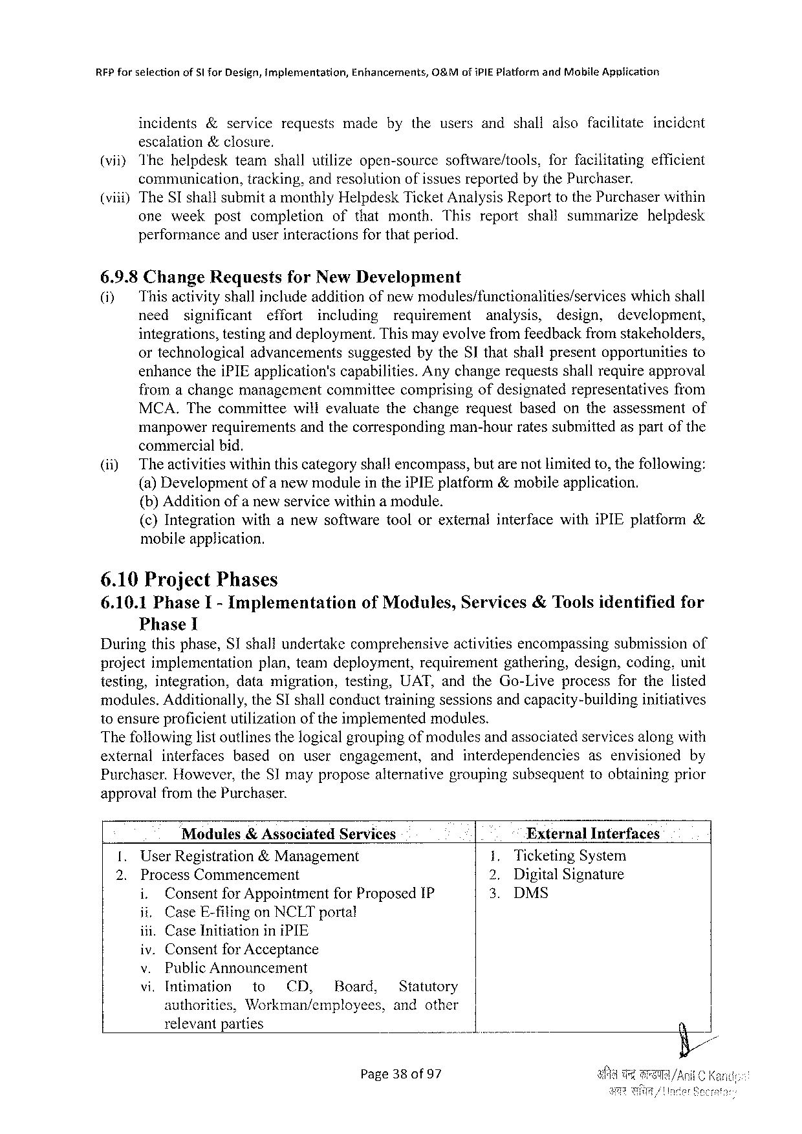

|  |  |  |  |  |  |  |  |  |
| --- | --- | --- | --- | --- | --- | --- | --- | --- |
| RFP forselection | of 5 lfor Design, implementation, | | | Enhancements, | | 0&Mofi PIEP iatfarm | and Mabile Application | incident |
| incidents | | &service | requests | made | bytheusersandshallalsofacilitate | | |

escalation&closure,

|  |  |  |  |  |
| --- | --- | --- | --- | --- |
| (viiy Thehelpdesk | teamshallutilizeopen-source | software/tools, | forfacilitating | efficient |
| communication, | tracking, andresolutionofissuesreportedbythe Purchaser. | | |

(vii))The SI shallsubmita monthly Helpdesk Ticket Analysis Reporttothe Purchaserwithin

|  |  |  |  |  |
| --- | --- | --- | --- | --- |
| oneweek | postcompletion | ofthatmonth. This | reportshallsummarize | helpdesk |

performanceanduserinteractionsforthatperiod.

6.9.8 Change Requests for New Development

(i) Thisactivity shallinclude addition ofnewmodules/functionalities/services whichshall

need significant effort including requirement analysis, design, development,

integrations, testinganddeployment. Thismayevolvefromfeedbackfromstakeholders,

ortechnological advancements suggestedbythe SI thatshallpresentopportunities to

enhancethei PIE application's capabilities. Anychangerequestsshallrequireapproval

fromachangemanagement committeecomprisingofdesignatedrepresentatives from

MCA. Thecommittee willevaluatethechangerequestbasedontheassessment of

manpowerrequirementsandthecorresponding commercialbid.

man-hourratessubmittedaspartofthe

(ii) Theactivitieswithinthiscategoryshallencompass, butarenotlimitedto, thefollowing:

(a)Developmentofa newmoduleinthei PIE platform&mobileapplication.

(b)Additionofa newservicewithina module.

|  |  |  |
| --- | --- | --- |
| (¢)Integration | withanewsoftwaretoolorexternalinterfacewithi PIE platform | & |

mobileapplication.

6.10 Project Phases

6.10.1 Phase I- Implementation Phase 1

of Modules, Services&Toolsidentifiedfor

Duringthisphase, SI shallundertakecomprehensive activitiesencompassingsubmissionof

projectimplementation plan, teamdeployment, requirement gathering, design, coding, unit

testing, integration, datamigration, testing, UAT, and the Go-Liveprocess forthelisted

modules. Additionally, the SI shallconducttrainingsessionsandcapacity-building initiatives

10 ensureproficientutilizationoftheimplementedmodules.

Thefollowinglistoutlinesthelogicalgroupingofmodulesandassociatedservicesalongwith

|  |  |  |  |  |  |  |
| --- | --- | --- | --- | --- | --- | --- |
| external | interfaces | based | onuserengagement, | andinterdependencies | asenvisioned | by |

Purchaser. However, the SI mayproposealternativegroupingsubsequenttoobtainingprior

approvalfromthe Purchaser.

|  |  |  |  |  |  |
| --- | --- | --- | --- | --- | --- |
| [. | Modules& Associated Services | | | External Interfaces | |
| User Registration&Management | | | 1. Ticketing System | |
| 2. | Process Commencement | | | 2. | Digital Signature |
| i. | Consentfor Appointment | for Proposed IP | 3. | DMS |

ii. Case E-filingon NCLT portal

iii. Case Initiationini PIE

iv. Consentfor Acceptance

v. Public Announcement

vi, Intimation to CI, Board, Statutory

authoritics, Workman/employees, andother

relevantparties

Page 380 of 97

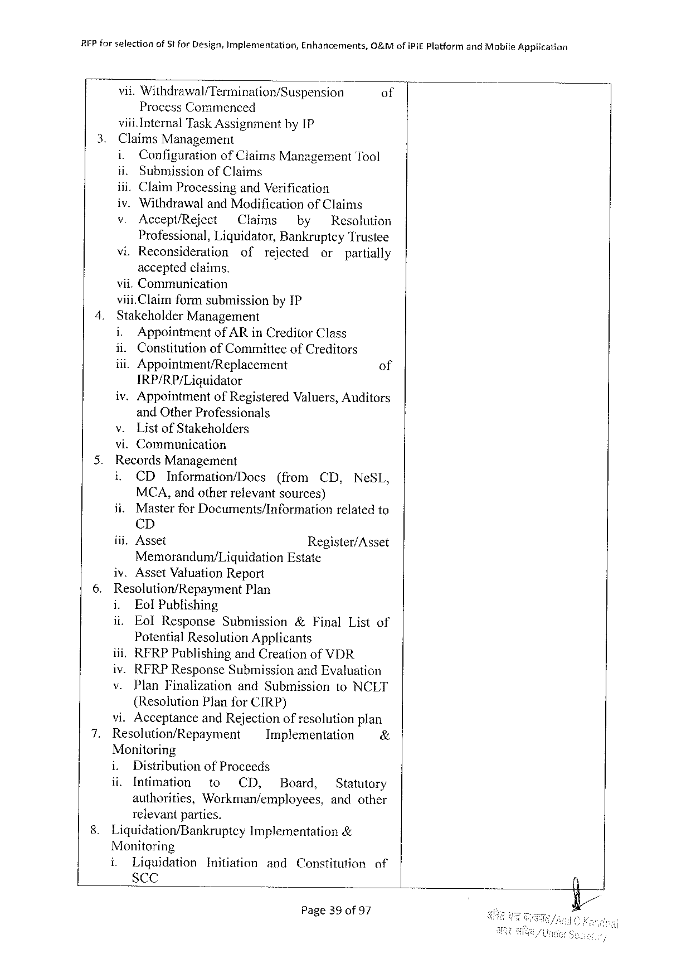

|  |  |  |  |  |
| --- | --- | --- | --- | --- |
| RFP forselection | of Stfor Design, Implementation, | Enhancements, | G&Mofi PIEP latfarm | and Mobife Application |
| vii. Withdrawal/Termination/Suspension | | | of |
| Process Commenced | | |

viii. Internal Task Assignmentby 1 P

|  |  |  |  |  |  |  |  |
| --- | --- | --- | --- | --- | --- | --- | --- |
| 3. | Claims Management | | | | | | |
| i. | Configuration | of Claims Management Tool | | | | |
| ii. | Submissionof Claims | | | | | |
| iii. Claim Processingand Verification  iv. Withdrawaland Modificationof Claims | | | | | | |
| v. | Accept/Reject | Claims | | by | Resolution | |
| Professional, Liquidator, Bankruptcy Trustee | | | | | | |
| vi. Reconsideration | | of | rejected | | or | partially |
| acceptedclaims. | | | | | | |

vii. Communication

|  |  |  |  |  |  |
| --- | --- | --- | --- | --- | --- |
| 4. | viii. Claimformsubmissionby IP  Stakeholder Management | | | | |
| i. | Appointment | | of AR in Creditor Class | |
| ii. | | Constitutionof Committeeof Creditors | | |
| iii. Appointment/Replacement | | | | of |
| IRP/RP/Liguidator | | | | |
| iv. Appointment | | | of Registered Valuers, Auditors | |

and Other Professionals   
v. Listof Stakeholders   
vi. Communication

|  |  |  |  |  |  |  |  |  |  |  |  |
| --- | --- | --- | --- | --- | --- | --- | --- | --- | --- | --- | --- |
| 5.  6. | Records Management | | | | | | | | | | |
| i, | CD | Information/Docs | | | (from | | | CD, | | Ne SL, |
| MCA, andotherrelevantsources) | | | | | | | | | | |
| ii. | Masterfor Documents/Information | | | | | | | relatedto | | |
| CD | | | | | | | | | | |
| iii. Asset | | | | Register/Asset | | | | | | |
| Memoranduny/Liquidation | | | | | | Estate | | | | |
| iv. Asset Valuation Report | | | | | | | | | | |
| Resolution/Repayment | | | | Plan | | | | | | |
| i. | Eol Publishing | | | | | | | | | |
| ii. | Eol Response | | Submission | | | | &Final Listof | | | |
| Potential Resolution Applicants | | | | | | | | | | |
| ili. RFRPP ublishingand Creationof | | | | | | | | VDR | | |
| iv. RFRPR esponse Submission and Evaluation | | | | | | | | | | |
| v. | Plan Finalization | | | and Submission | | | | | to NCLT | |

(Resolution Planfor CIRP)

|  |  |  |  |  |  |  |  |
| --- | --- | --- | --- | --- | --- | --- | --- |
| 7. | vi. Acceptanceand Rejectionofresolutionplan | | | | | | |
| Resolution/Repayment | | | Implementation | | | & |
| Monitoring | | | | | | |
| i. | Distributionof Proceeds | | | | | |
| ii. | Intimation | to | CD, | DB oard, | Statutory | |
| authorities, | | Workman/employees, | | | andother | |

relevantparties.

|  |  |  |  |
| --- | --- | --- | --- |
| 8. | Liquidation/Bankruptcy | Implementation | & |

Monitoring

|  |  |  |  |  |  |
| --- | --- | --- | --- | --- | --- |
| i. | Liquidation | Initiation | and | Censtitution | of |
| Sc C |

Page 39 of 97

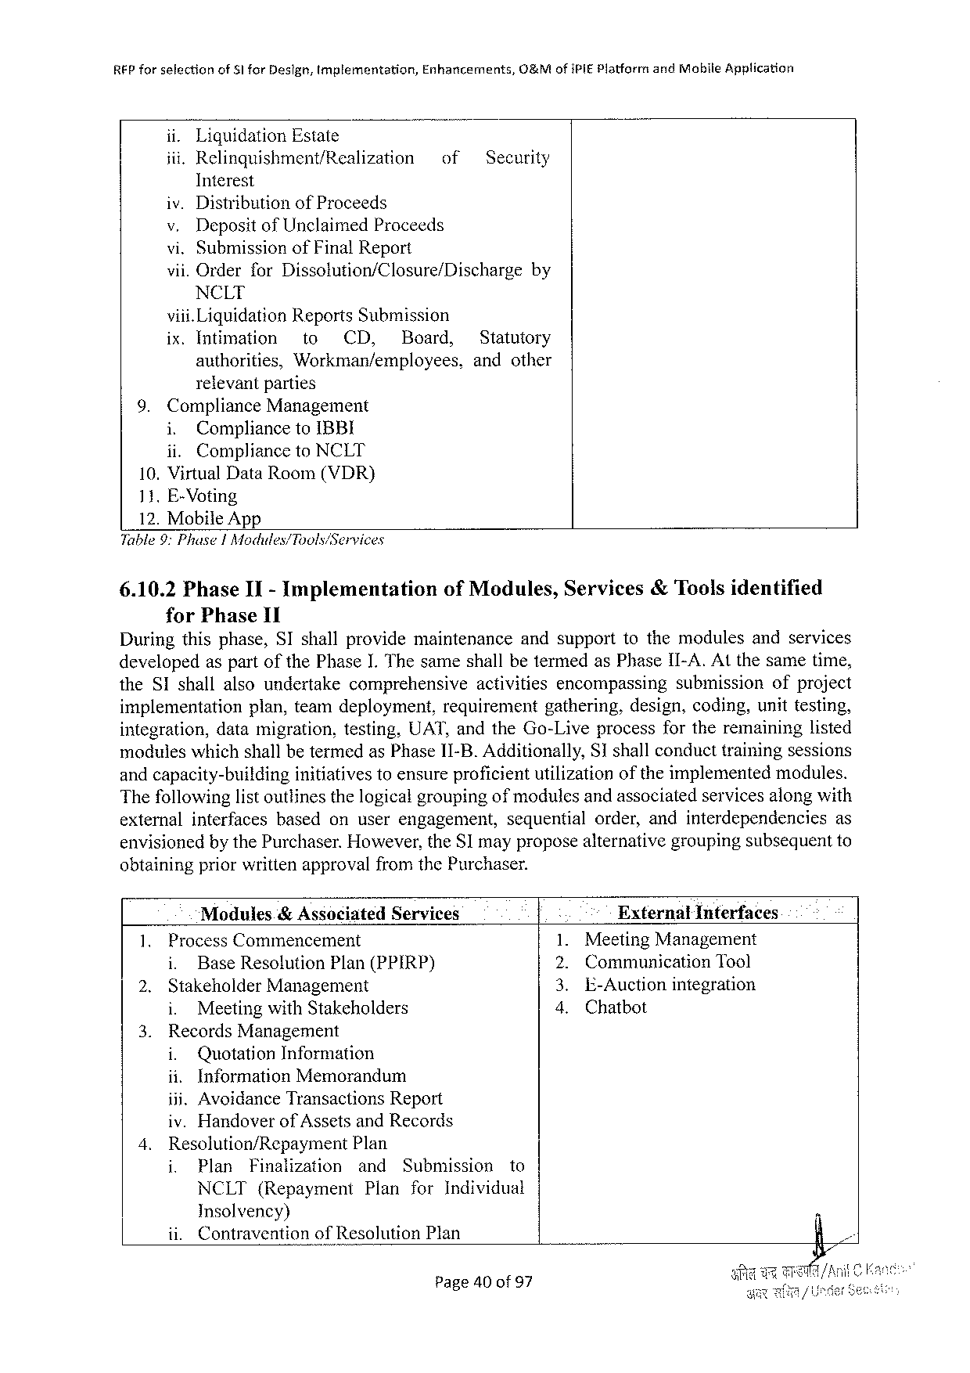

|  |  |  |  |  |
| --- | --- | --- | --- | --- |
| REP forselection | of 51 for Design, Implementation, | Enhancements, | O&Mofi PIEP latforr | and Mobile Application |

ii. Liquidation Estate

|  |  |  |
| --- | --- | --- |
| iii. Relinquishment/Realization | of | Security |

Interest   
iv. Distributionof Proceeds   
v. Depositof Unclaimed Proceeds   
vi. Submissionof Final Report   
vii. Orderfor Dissolution/Closure/Dischargeby NCLT   
viii. Liquidation Reports Submission

|  |  |  |  |  |
| --- | --- | --- | --- | --- |
| ix. Intimation | to | CD, | Board, | Statutory |
| authorities, | Workman/employees, | | | andother |

relevantparties   
 9. Compliance Management   
 i. Complianceto IBBI   
 ii. Complianceto NCLT   
 10. Virtual Data Room(VDR)   
 11. E-Voting   
 12. Mobile App   
Table 9: Phuse|Modules/Tools/Services

6.10.2 Phase II- Implementation for Phase 11

of Modules, Services&Toolsidentified

Duringthisphase, SI shallprovidemaintenance andsupporttothemodulesandservices

developedas part of the Phase I. The sameshall betermedas Phase II-A. Atthe sametime,

the SI shallalsoundertake comprehensive activities encompassing submission ofproject

implementation plan, teamdeployment, requirement gathering, design, coding, unittesting,

integration, datamigration, testing, UAT, and the Go-Liveprocessfortheremaininglisted

moduleswhichshallbetermedas Phase 11-B. Additionally, Sshallconducttrainingsessions

andcapacity-building initiativestoensureproficientutilizationoftheimplementedmodules.

Thefollowinglistoutlinesthelogicalgroupingof modulesandassociatedservicesalongwith

externalinterfaces basedonuserengagement, sequentialorder, andinterdependencies as

envisionedby the Purchaser. However, the SI mayproposealternativegroupingsubsequentto

obtainingpriorwrittenapprovalfromthe Purchaser.

|  |  |  |  |  |
| --- | --- | --- | --- | --- |
| 1. | Modules& Associated Services | | . | External Inferfaces |
| Process Commencement | | Meeting Management |
| i. | Base Resolution Plan(PPIRP) | 129 | Communication Tool |
| 2. |
| Stakeholder Management | | E-Auctionintegration |
| e | Chatbot |
| i. | Meetingwith Stakeholders |
| 3. |
| Records Management | |
| i. | Quotation Information |

ii. Information Memorandum

iii. Avoidance Transactions Report

iv. Handoverof Assetsand Records

|  |  |  |  |  |  |  |
| --- | --- | --- | --- | --- | --- | --- |
| 4. | Resolution/Repayment Plan | | | | Submission | to |
| i. | Plan | Finalization | and |
| NCLT(Repayment | | | Plan | for Individual | |

Insolvency)

ii. Contraventionof Resolution Plan

Page 40 of 97

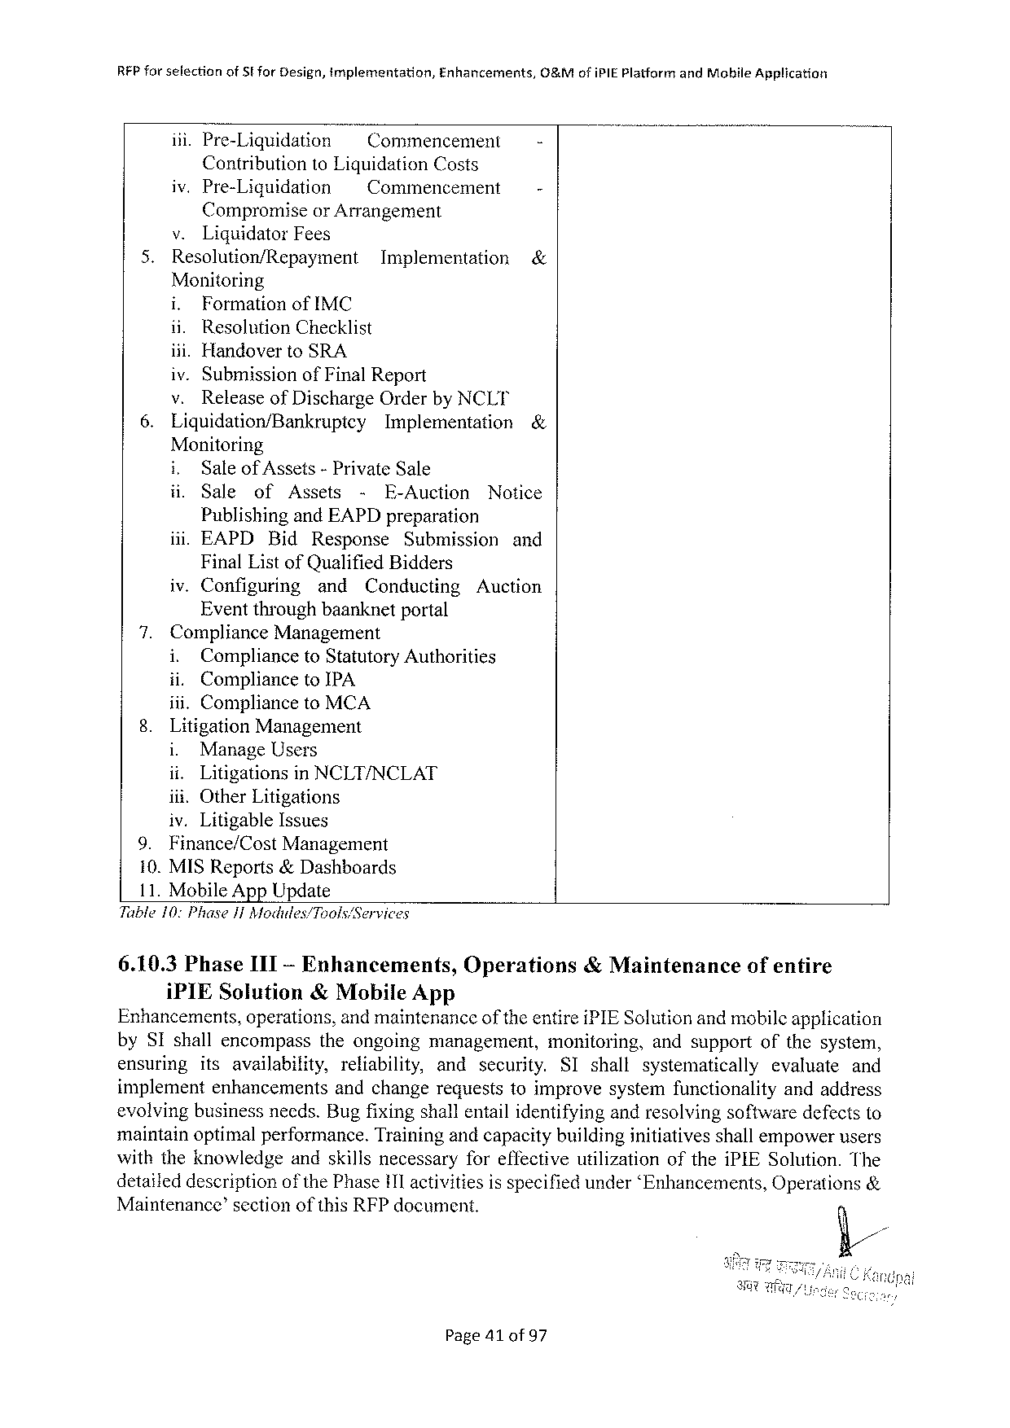

|  |  |  |  |  |
| --- | --- | --- | --- | --- |
| RFP forselection | of Sfor Design, tmplementation, | | Enhancements, | G&Mofi PIEP latformand Mobile Application  -  - |
| iii. Pre-Liquidation | | ~Commencement | |
| Contributionto Liquidation Costs | | | |
| iv. Pre-Liquidation | | =~ Commencement | |

Compromiseor Arrangement

v. Liquidator Fees

|  |  |  |  |
| --- | --- | --- | --- |
| 5. | Resolution/Repayment | Implementation | & |

Monitoring

i. Formationof IMC

ii. Resolution Checklist

iii. Handoverto SRA

iv. Submissionof Final Report

|  |  |  |  |  |
| --- | --- | --- | --- | --- |
| 6. | v. | Releaseof Discharge Orderby NCLT | | & |
| Liquidation/Bankrupicy | | Implementation |

Monitoring

|  |  |  |  |  |  |  |
| --- | --- | --- | --- | --- | --- | --- |
| i, | Saleof Assets-Private Sale | | | | | Notice |
| il. | Sale | of | Assets | - | E-Auction |

Publishingand EAPD preparation

|  |  |  |  |  |
| --- | --- | --- | --- | --- |
| iii. EAPD | Bid | Response | Submission | and |

Final Listof Qualified Bidders

iv. Configuring and Conducting Auction

Eventthroughbaanknetportal

7. Compliance Management

i. Complianceto Statutory Authorities

ii. Complianceto IPA

iii. Complianceto MCA

8. Litigation Management

i. Manage Users

ii. Litigationsin NCLT/NCLAT

iit. Other Litigations

iv. Litigable Issues

|  |  |  |
| --- | --- | --- |
| 9. | Finance/Cost | Management |

10. MISR eports&Dashboards

11. Mobile App Update

Table 10: Phase J 1 Modudes/Tools/Services

|  |  |  |  |
| --- | --- | --- | --- |
| 6.10.3 Phase IIT-Enhancements, | Operations | &Maintenance | ofentire |
| i PIES olution& Mobile App |

Enhancements, operations, andmaintenanceoftheentirei PIES olutionandmobileapplication

by SI shallencompass theongoing management, monitoring, andsupportofthesystem,

ensuring itsavailability, reliability, and security. SI shall systematically evaluate and

implementenhancements andchangerequeststoimprovesystemfunctionality andaddress

evolvingbusinessneeds. Bugfixingshallentailidentifyingandresolvingsoftwaredefectsto

maintainoptimalperformance. Trainingandcapacitybuildinginitiativesshallempowerusers

withtheknowledge andskillsnecessaryforeffectivewtilizationofthei PIES olution. The

detaileddescriptionof the Phasei 1 l activitiesis specifiedunder‘Enhancements, Operations&

Maintenance’sectionofthis RFP document.

Page 41 of 97

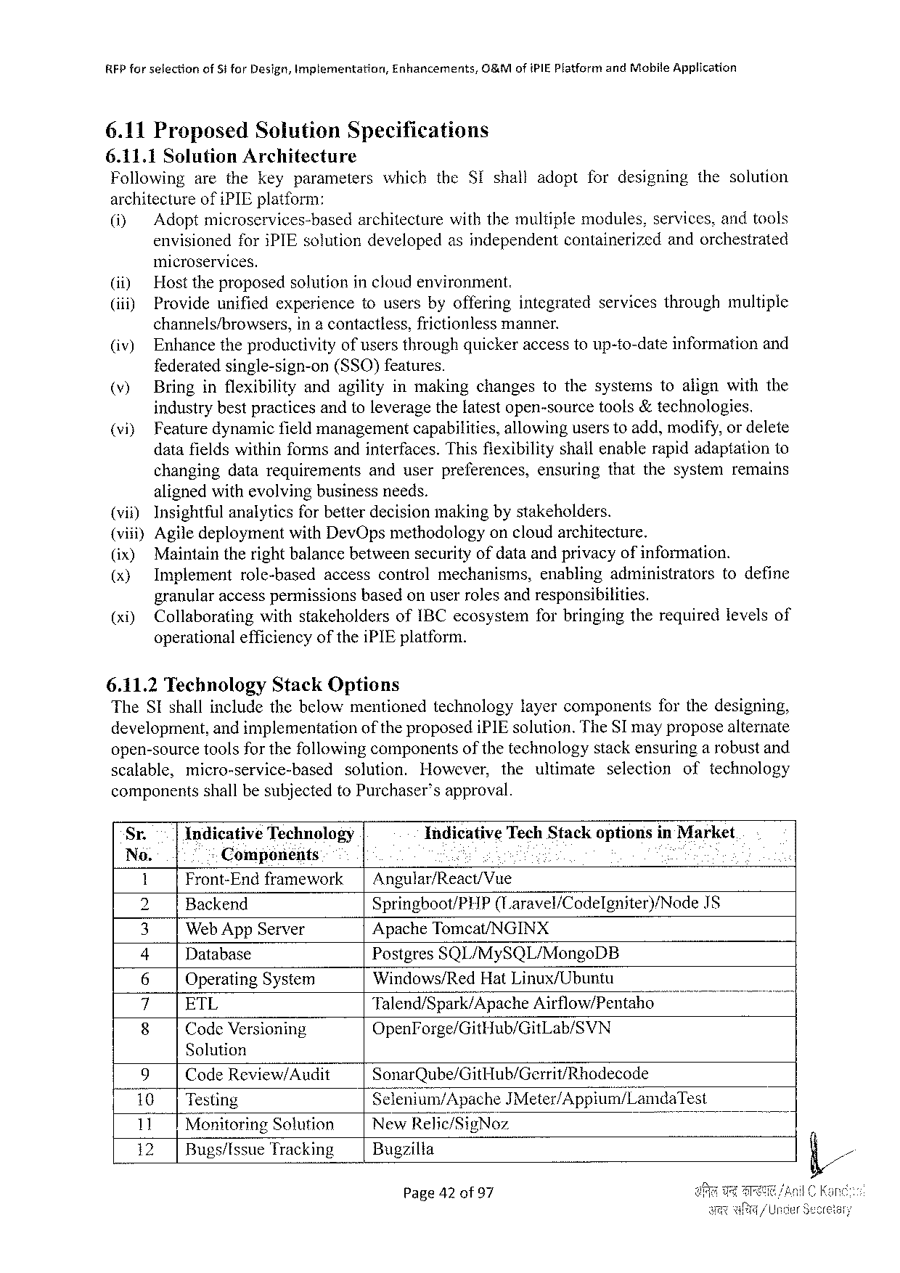

REP forselection of 5 tfor Design, Implementation, Enhancements, G&Mofi PIE Platformand Mobile Application

6.11 Proposed Solution Specifications

6.11.1 Solution Architecture

Following arethekeyparameters which the SI shalladoptfordesigning thesolution

architectureofi PIE platform:

(i) Adopt microservices-basedarchitecturewith themultiplemodules, services, andtools

envisionedfori PIE solution developedasindependent containerizedandorchestrated

microservices.

(i) Hosttheproposedsolutionincloudenvironment.

(iii) Provideunifiedexperience tousersbyofferingintegrated servicesthroughmultiple

channels/browsers, ina contactless, frictionlessmanner.

(iv) Enhancetheproductivityofusersthroughquickeraccesstoup-to-dateinformationand

federatedsingle-sign-on (SSO)features.

(v) Bringinflexibility andagilityinmakingchangestothesystemstoalignwiththe

industrybestpracticesandtoleveragethelatestopen-sourcetools&technologies.

|  |  |  |  |  |  |  |
| --- | --- | --- | --- | --- | --- | --- |
| (vi} | Feature | dynamic | fieldmanagement | capabilitics, | allowing | userstoadd, modify, ordelete |

datafieldswithinformsandinterfaces. Thisfiexibilityshallenablerapidadaptationto

|  |  |  |
| --- | --- | --- |
| changingdatarequirements | anduserpreferences, | ensuringthatthesystemremains |

alignedwithevolvingbusinessneeds.

(vii) Insightfulanalyticsforbetterdecisionmakingbystakeholders.

(viii)Agiledeploymentwith Dev Opsmethodologyoncloudarchitecture.

|  |  |  |  |  |  |  |  |  |
| --- | --- | --- | --- | --- | --- | --- | --- | --- |
| (ix) (x)  (xi) | Maintaintherightbalancebetweensecurityofdataandprivacyofinformation. | | | | | | | |
| Implement | role-based | | accesscontrolmechanisms, | | | enablingadministrators | todefine |
| granularaccesspermissionsbasedonuserrolesandresponsibilities. | | | | | | | |
| Collaborating | | withstakeholders | | of IBC ecosystem | forbringingtherequiredievelsof | | |

operationalefficiencyofthei PIE platform.

6.11.2 Technology Stack Options

The SI shallincludethebelowmentionedtechnology layercomponents forthedesigning,

development, andimplementation oftheproposedi PIE solution. The SI mayproposealternate

open-sourcetoolsforthefollowingcomponentsofthetechnologystackensuringa robustand

scalable, micro-service-based solution. However, theultimate selection oftechnology

componentsshall be subjectedto Purchaser’s approval.

Sr. Indicative Technology Indicative Tech Stackoptionsin Market

No. Components S - o

1 Front-Endframework| Angular/React/Vue

2 Backend Springboot/PHP (Laravel/Codelgniter)/Node IS

3 Web App Server Apache Tomcat/NGINX

4 Database Postgres SQL/My SQL/Mongo DB

6 Operating System Windows/Red Hat Linux/Ubuntu

i ETL Talend/Spark/Apache Airflow/Pentaho o 7

8 Code Versioning Open Forge/Git Hub/Git Lab/SVN

Solution

|  |  |  |  |  |  |
| --- | --- | --- | --- | --- | --- |
| 9 | Code Review/Audit | | Sonar Qube/Git Hub/Gerrit/Rhodecode | B | &// |
| 10|Testing | | | Sclenium/Apache JM eter/Appium/Lamda Test |
| 11 | Monitoring Solution | | New]{e]ic/§ig Noz |
| 12 | | | Bugs/Issue Tracking | Bugzilla |

Page 42 of 97

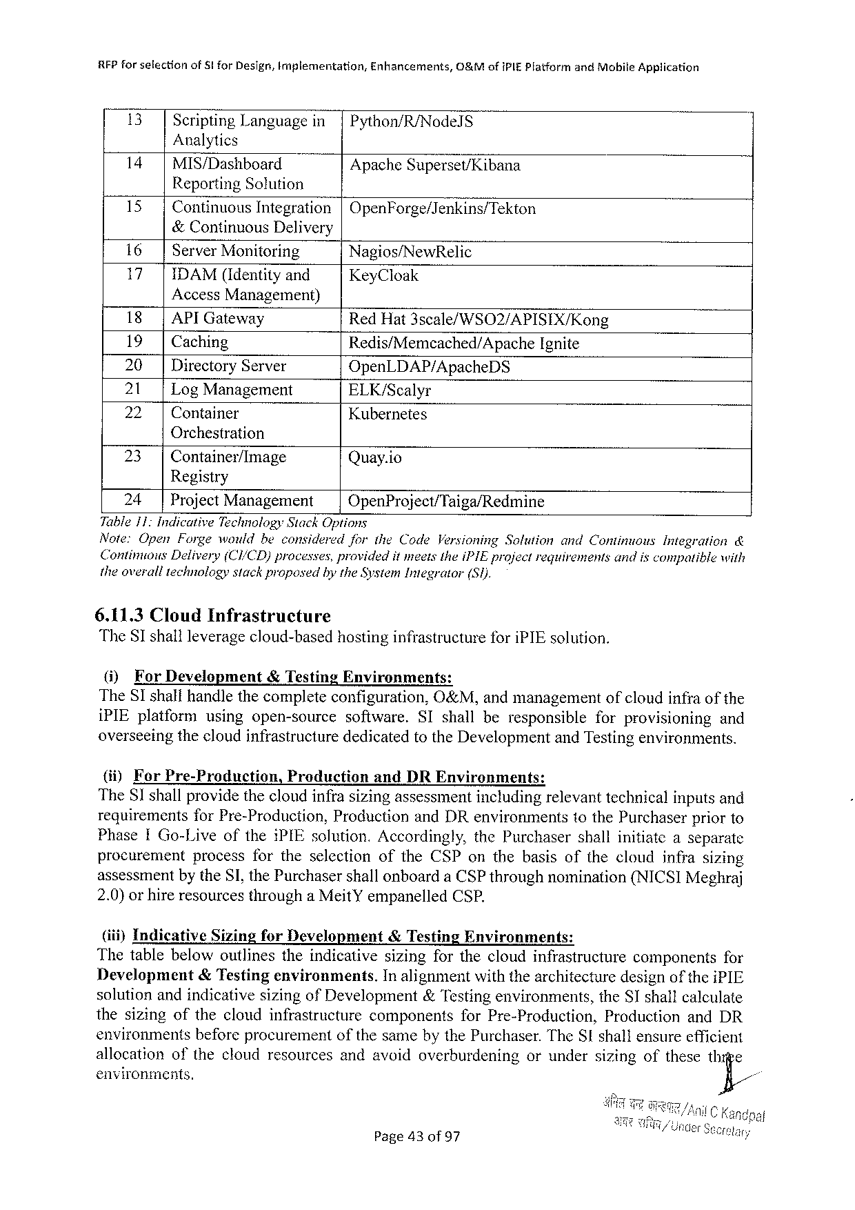

RFP forselection of 8! for Design, Implementation, Enhancements, 0&Mofi PIEP latformand Mobile Application

13 Scripting Languagein|Python/R/Nodel S

Analytics

14|MIS/Dashboard Apache Superset/Kibana

Reporting Solution

15| Continuous Integration|Open Forge/Jenkins/Tekton

&Continuous Delivery

|  |  |  |  |
| --- | --- | --- | --- |
| 16 | | | Server Monitoring | Nagios/New Relic |
| 17 | |IDAM(Identityand | |
| Key Cloak |

Access Management)

18|API Gateway Red Hat 3 scale/WSO 2/APISIX/Kong

19| Caching Redis/Memcached/Apache Ignite

20 | Directory Server Open LDAP/Apache DS

21 | Log Management ELK/Scalyr

22 | Container Kubernetes

Orchestration

|  |  |  |  |
| --- | --- | --- | --- |
| 23 | | | Container/Image | Quay. io |

Registry

24 | Project Management Open Project/Taiga/Redmine

Table 11: Indicative Technology Stack Options

Note: Open Forgewouldbeconsidered for the Code Versioning Sotutionand Continuous Integration&

Continous Delivery(CI/CD)processes, providedit meetsthei PIE projectrequivementsandiscompatible with

theoveralltechnologystackproposed bythe System Integrator (S 1).

6.11.3 Cloud Infrastructure

The ST shall leverage cloud-basedhostinginfrastructure for i PIE solution.

(i) For Development &Testing Environments:

The SI shallhandlethecompleteconfiguration, O&M, andmanagement ofcloudinfraofthe

i PIE platform usingopen-source software. SI shallberesponsible forprovisioning and

overseeingthecloudinfrastructurededicatedtothe Developmentand Testingenvironments.

(ii) For Pre-Production, Praduction and DRE nvironments:

The 81 shallprovidethecloudinfrasizingassessmentincludingrelevanttechnicalinputsand

requirementsfor Pre-Production, Productionand DR environments to the Purchaserpriorto

Phase IG o-Liveofthei PIE solution. Accordingly, the Purchaser shallinitiateaseparatc

procurement process fortheselection of the CSP onthebasisofthecloudinfrasizing

assessmentby the SI, the Purchasershallonboarda CSP throughnomination(NICSIM eghraj

2.0)orhireresourcesthrougha Meit Yempanelled CSP.

(iii)Indicative Sizingfor Development &Testing Environments:

Thetablebelowoutlinestheindicativesizingforthecloudinfrastructure components for

Development &Testingenvironments. In alignmentwiththearchitecturedesignof thei PIE

solutionandindicativesizingof Development&Testingenvironments, the SI shallcalculate

thesizingofthecloudinfrastructure components for Pre-Production, Production and DR

environments beforeprocurement ofthesamebythe Purchaser. The SI shallensureefficient

allocation ofthecloudresourcesandavoidoverburdening orundersizingofthesethige

environments. fi/

Page 43 of 97

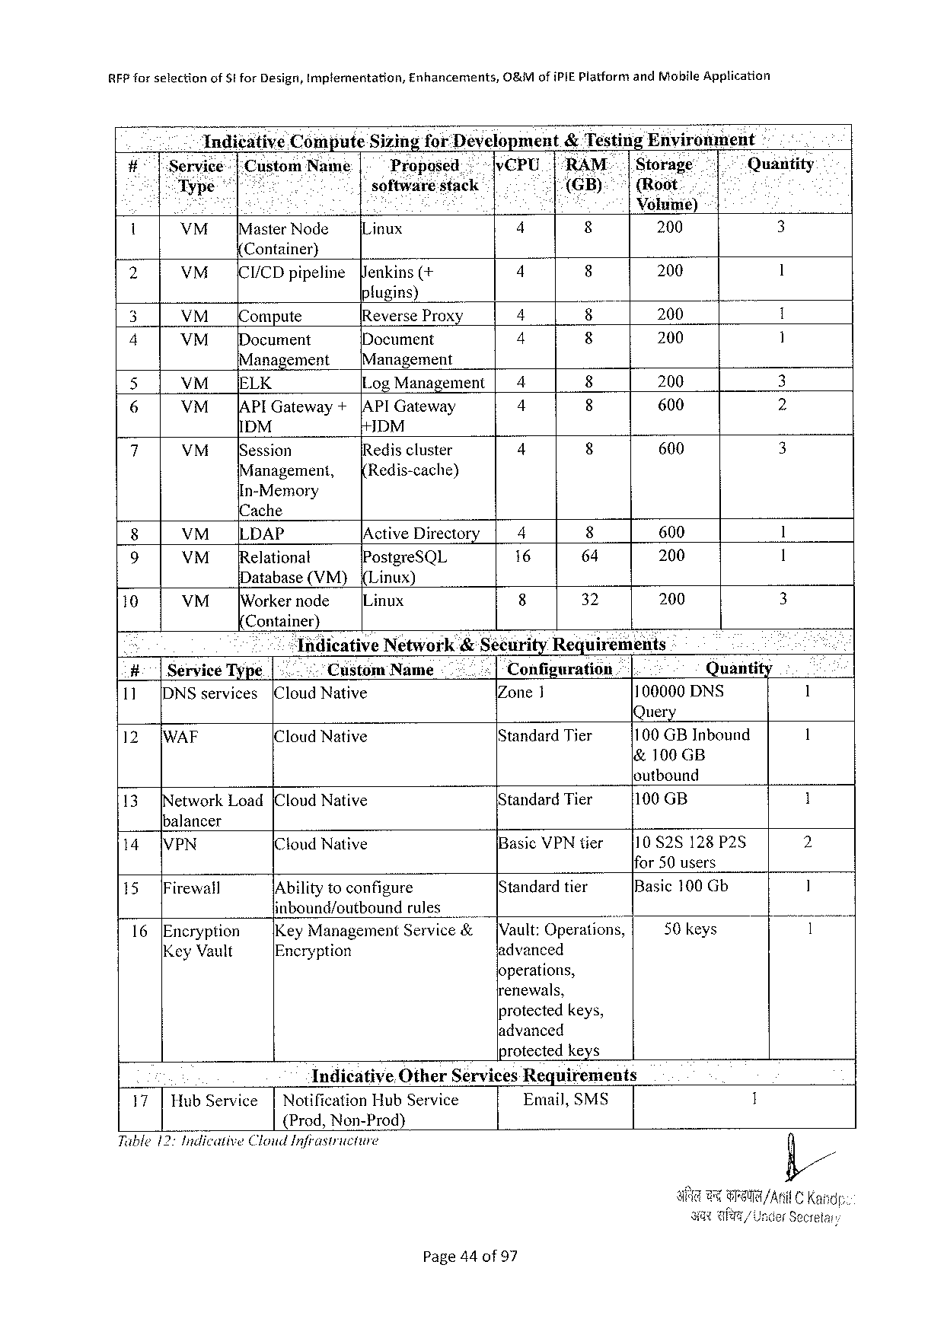

RFP forselection of St for Design, Implementation, Enhancements, O&Mofi PIEP latformand Mohile Application

Indicative Compute Sizingfor Development&Testing Envirenment -

#7158 ice : |: Custom Name Proposed v CPU 1“"RAM.|Storage Quantity

< Typ software: stack J(GB): |(Root.

Eos : . . Voluii¢)

. VM [Master Node Linux 4 8 200 3

Container)

|  |  |  |  |  |  |  |  |
| --- | --- | --- | --- | --- | --- | --- | --- |
| 2 | VM | [CI/CD pipeline | enkins(+ | 4 | 8 | 200 | 1 |

fugins)

|  |  |  |  |  |  |  |  |
| --- | --- | --- | --- | --- | --- | --- | --- |
| 3 | VM | ompute | Reverse Prox | 4 | 8 | 200 | 1 |
| Document | 4 | 8 | 200 | 1 |
| 4 | VM | Document |
| Management | | [Management | 4 | 8 | 200 | 3 |
| S |
| VM__[ELK | | Log Management| |
| 6 | VM | |APIG ateway + | |API Gateway | 4 | 600 | 2 |
| IDM | | DM |
| 7 | 4 | 600 | 3 |
| VM | [Session | Rediscluster |
| Management, | | Redis-cache) |

In-Memory

{Cache

|  |  |  |  |  |  |  |  |
| --- | --- | --- | --- | --- | --- | --- | --- |
| 8 | VM | LLDAP | /Active Directory | 4 | 8 | 600 | 1 |
| [Relationat | Postgre SQL | 16 | 64 | 200 | 1 |
| 9 | VM |
| Database(VM) | {Linux) | 8 | 32 | 200 | 3 |
| 10 | VM |
| [Workernode | IL inux |

Container)

|  |  |  |  |  |  |  |  |
| --- | --- | --- | --- | --- | --- | --- | --- |
| = | | Tndicative Network&Sécurity Requirements | | | | | 1 |
| #:|Service Type| | | .. | Custom | Name | Configuration | Quantity |
| (Cloud Native | | Zone 1 | | 100000 DNS |
| 11 | [DNS services |
| 12 | [WAF | Query | | | | | 1 |
| IC loud Native | | Standard Tier | | 100 GBI nbound |
| &100 GB | | | | |

loutbound

|  |  |  |  |  |
| --- | --- | --- | --- | --- |
| 13 | etwork Load[Cloud Native | Standard Tier | 100 GB | 1 |

balancer

|  |  |  |  |  |  |  |
| --- | --- | --- | --- | --- | --- | --- |
| 14 | VPN | (Cloud Native | | Basic VPN tier | {10 828128 P 25 | 2 |
| [Standard tier | ifor 50 users | 1 |
| 15 | [Firewall | IA bilityto configure | |
| Basic 100 Gb |
| inbound/cutbound | rules | [Vault: Operations, | 50 keys | 1 |
| 16 | [Encryption |
| Key Management | Service& |
| Key Vault | Encryption | | advanced |

operations,

renewals,

protectedkeys,

ladvanced

protected keys

Indicative Other Services Requirements

|  |  |  |  |  |
| --- | --- | --- | --- | --- |
| 17| | Hub Service | | | Notification Hub Service | Email, SMS | 1 |

{Prod, Non-Prod)

Tuble 12: Indicative Clonid Infrastricture

Page 44 of 97

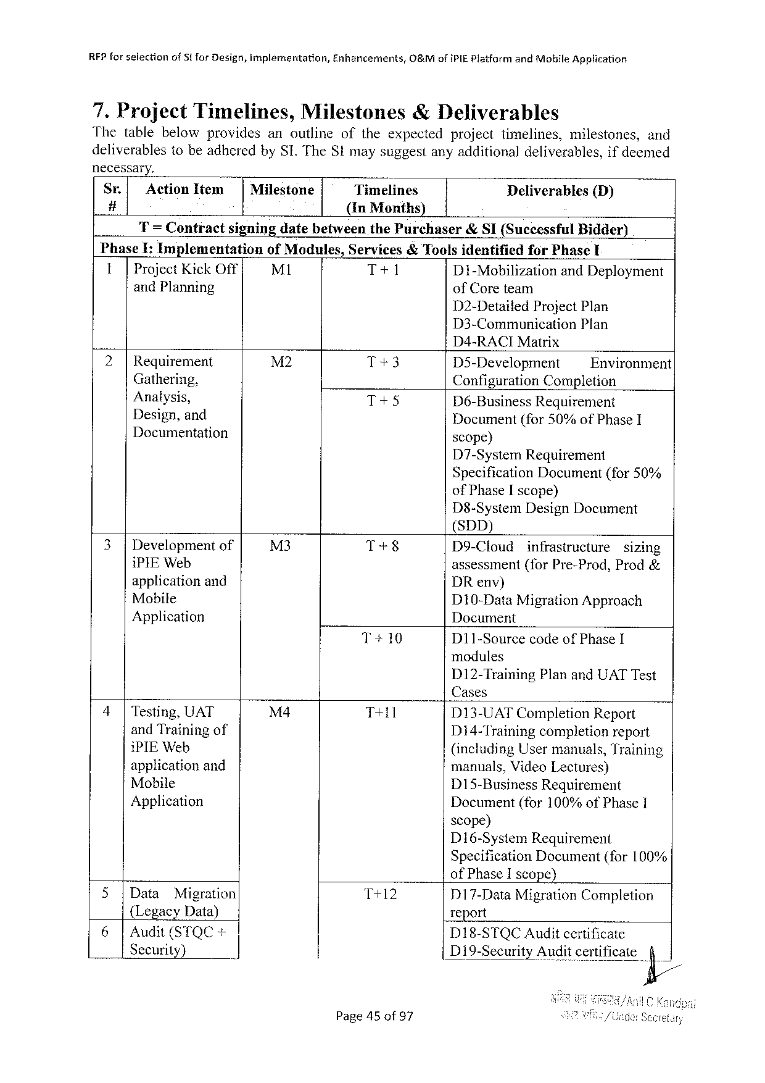

RFP forselection of 51 for Design, Implementation, Enhancements, O&Mofi Pi E Platformand Mobile Application

7. Project Timelines, Milestones& Deliverables

Thetablebelowprovides anoutline oftheexpected projecttimelines, milestones, and

deliverablestobeadheredby SI. The Stmaysuggestanyadditionaldeliverables, ifdeemed

necessary.

Sr.| Action Item | Milestone Timelines Deliverables (D)

# (In Months)

T= Contractsigningdatebetweenthe Purchaser&SI(Successful Bidder)

|  |  |  |  |  |  |
| --- | --- | --- | --- | --- | --- |
| Phase I: Implementation | of Modules, | Services&Toolsidentified | | for Phase¥ | |
| 1|Project Kick Off | M 1 |
| T+1 | D 1-Mobilization | | and Deployment |
| and Planning |
| of Coreteam | | | |

D 2-Detailed Project Plan

D 3-Communication Plan

D 4-RACIM atrix

|  |  |  |  |  |
| --- | --- | --- | --- | --- |
| 2|Requirement | M 2 | T+3 | D 5-Development | Environment |
| Gathering, | T+5 |
| Configuration Completion | |
| Analysis, | D 6-Business Requirement | |

Design, and   
Documentation

Document(for 50%of Phase I scope)

D 7-System Requirement   
Specification Document(for 50% of Phase Iscope)   
D 8-System Design Document   
(SDD)

|  |  |  |  |  |  |
| --- | --- | --- | --- | --- | --- |
| 3|Developmentof | M 3 | T+8 | D 9-Cloud | infrastructure | sizing |

i PIEW eb   
applicationand   
Mobile   
Application

T+10 D 11-Sourcecodeof Phase I

|  |  |  |  |  |
| --- | --- | --- | --- | --- |
| 4|Testing, UAT | M 4 | T+11 | D 13-UATC ompletion Report | |
| and Trainingof | Di 4-Training | completionreport |
| i PIEW eb | (including Usermanuals, Training | |
| applicationand | manuals, Video Lectures) | |
| Mobile | D 15-Business Requirement | |
| Application |
| Document(for 100%of Phase 1 | |

scope)   
D 16-System Requirement   
Specification Document(for 100%   
of Phase Iscope)

|  |  |  |  |  |  |
| --- | --- | --- | --- | --- | --- |
| 5|Data | Migration | T+12 | D 17-Data Migration Completion | | |
| {Legacy Data) | | report | | |
| 6|Audit(STQC+ | |
| DI 18-STQCA uditcertificate | | |
| Security) | | D 19-Security | Audit certificate | fi/ |

Page 45 of 97

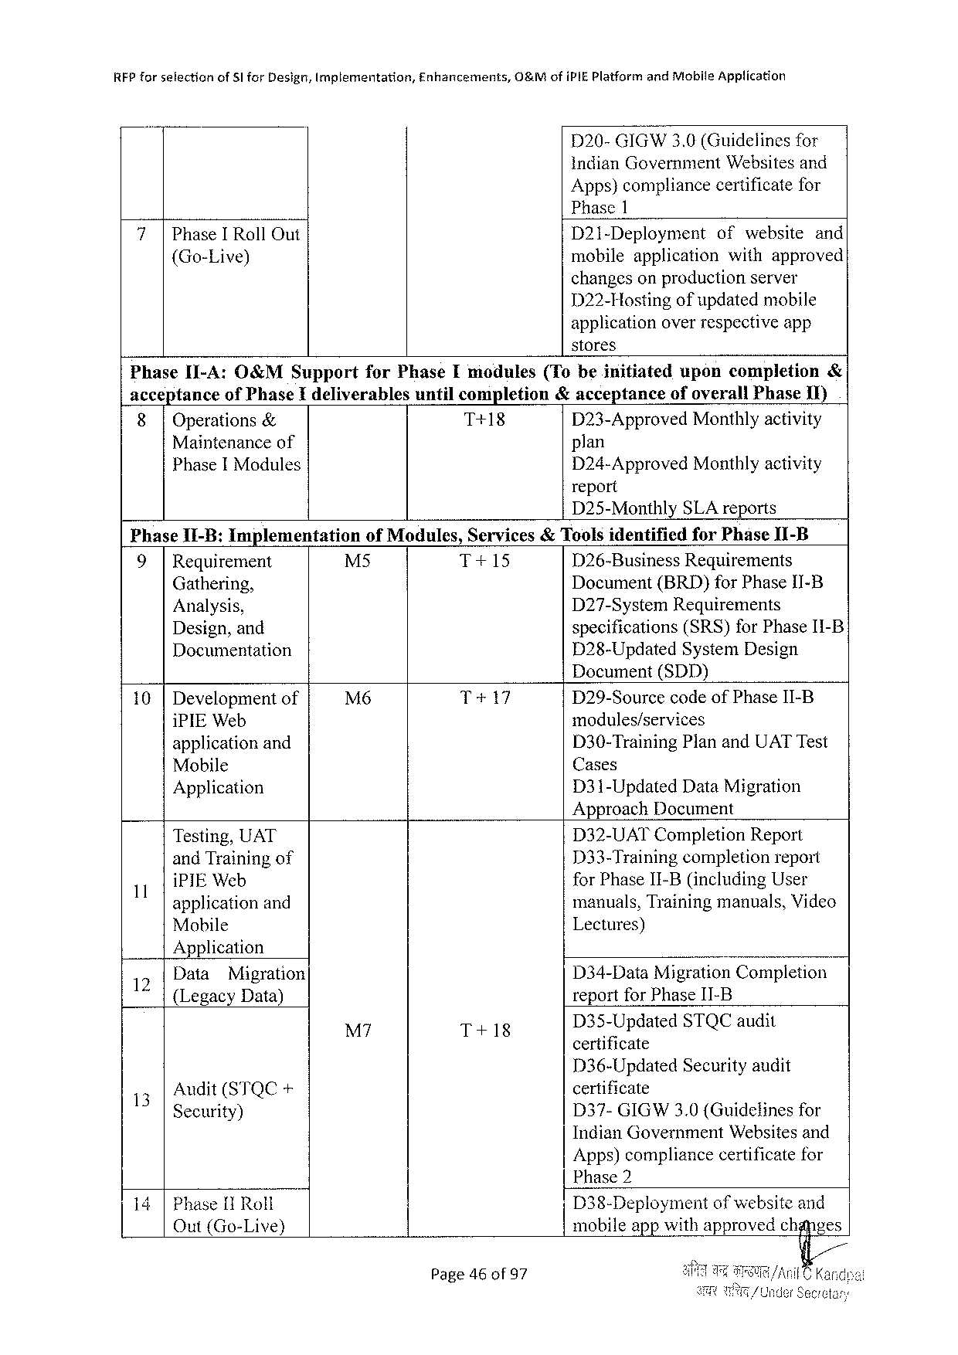

|  |  |  |  |
| --- | --- | --- | --- |
| REP forselection | of 5 lfor Design, Implementation, | Enhancements, | O&Mofi PIEP latformand Mobile Application |

D 20-GIGW 3.0(Guidelinesfor   
indian Government Websitesand   
Apps)compliancecertificatefor   
Phase 1

|  |  |  |  |
| --- | --- | --- | --- |
| 7|Phase IR oll Out {Go-Live) | D 21-Deployment | ofwebsite | and |
| mobileapplication | withapproved | |
| changeson productionserver | | |

D 22-Hostingof updatedmobile   
applicationoverrespectiveapp   
stores

|  |  |  |  |  |  |  |  |  |
| --- | --- | --- | --- | --- | --- | --- | --- | --- |
| Phase I 1-A: O&MS upport | | | for Phase Imodules | | (Tobeinitiated | upon | completion | & |
| accepiance | | of Phase Ideliverables | | untilcompletion | &acceptance | ofoverall Phase 1 I) | |
| 8| | Operations& | | T+18 | | D 23-Approved Monthlyactivity | | |
| Maintenanceof | | | | | plan | | |

Phase IM odules

Phase I 1-B: Implementation

D 24-Approved Monthlyactivity report   
D 25-Monthly SLA reports

of Modules, Services& Toolsidentifiedfor Phase II-B

|  |  |  |  |  |
| --- | --- | --- | --- | --- |
| 9| | Requirement | M 5 | T+15 | D 26-Business Requirements |
| Gathering, | Document(BRD)for Phase I 1 I-B |
| Analysis, | D 27-System Requirements |
| specifications(SRS)for Phase I 1-B |
| Design, and |

Documentation

D 28-Updated System Design Document(SDD)

|  |  |  |  |
| --- | --- | --- | --- |
| 10 |Developmentof | M 6 | T+17 | D 29-Sourcecodeof Phase II-B |
| modules/services |
| i PIEW eb |
| D 30-Training Planand UATT est |
| applicationand |
| Cases |
| Mobile |
| Application | D 31-Updated Data Migration |

Approach Document

|  |  |  |  |
| --- | --- | --- | --- |
| 1 | Testing, UAT | D 32-UATC ompletion Report | |
| and Trainingof | 133-Training | completionreport |
| i PIEW eb | for Phase II-B(including User | |
| applicationand | manuals, Trainingmanuals, Video | |
| Mobile | Lectures) | |

Application

|  |  |  |  |
| --- | --- | --- | --- |
| 12 | Data | Migration | D 34-Data Migration Completion |

{Legacy Data)

|  |  |  |  |
| --- | --- | --- | --- |
| M 7 | T+18 | D 3§-Updated | STQC audit |

|  |  |  |
| --- | --- | --- |
| 13 | Audit(STQC+ | certificate |
| D 37-GIGW 3.0 (Guidelinesfor |
| Security) |

Indian Government Websitesand   
Apps)compliancecertificatefor   
Phase 2

14|Phase[IR oll Out(Go-Live)

Page 46 of 97

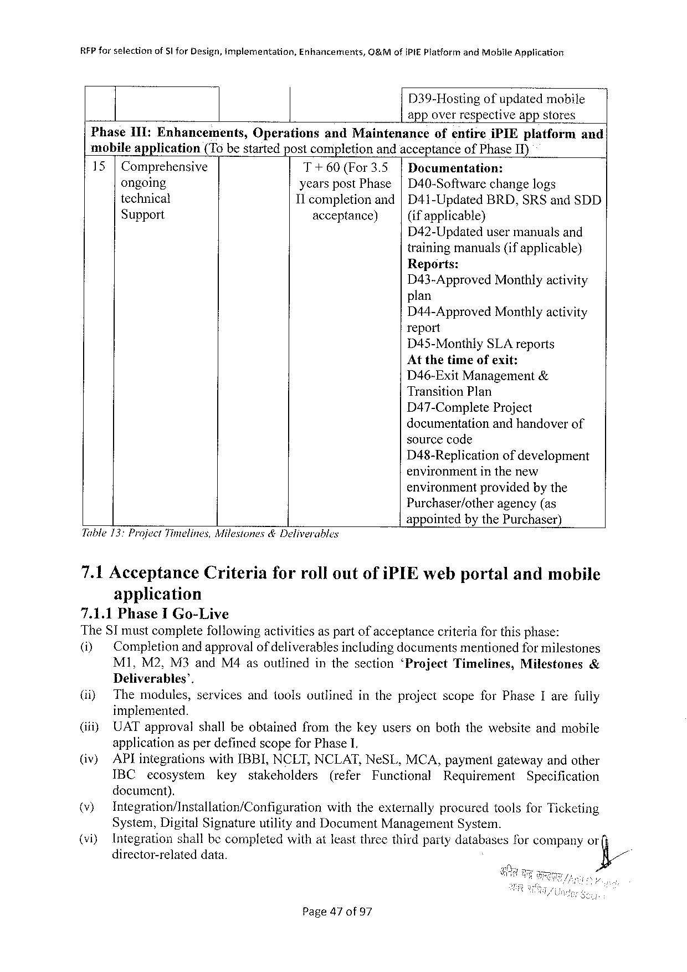

|  |  |  |  |
| --- | --- | --- | --- |
| RFP forselection | of Sl for Design, implementation, | Enhancements, | C&Mofi PIEP latformand Mobile Application |

D 39-Hostingofupdatedmobile

app overrespective appstores

Phase 1 II: Enhancements, Operations and Maintenance ofentire i PIE platform and

mobileapplication (T 6 bestartedpostcompletionandacceptanceof Phase IT)

15|Comprehensive T+60(For 3.5 |Documentation:

ongoing yearspost Phase|D 40-Softwarechangelogs

technical 11 completion and|D 41-Updated BRD, SRS and SDD

Support acceptance) (ifapplicable}

D 42-Updatedusermanualsand

trainingmanuals(ifapplicable)

Reports:

D 43-Approved Monthlyactivity

plan

D 44-Approved Monthlyactivity

report

D 45-Monthly SLA reports

Atthetimeofexit:

D 46-Exit Management&

Transition Plan

D 47-Complete Project

documentationandhandoverof

sourcecode

D 48-Replication ofdevelopment

environmentinthenew

environmentprovidedbythe

Purchaser/other agency(as

Tuble 13: Project Timelines, Milestones&Deliverables

appointedbythe Purchaser)

|  |  |  |  |
| --- | --- | --- | --- |
| 7.1 Acceptance | Criteria | forrolloutofi PIE webportal | andmobile |

application

7.1.1 Phase IG o-Live   
The ST mustcompletefollowingactiviticsaspartof acceptancecriteriaforthisphase:

|  |  |  |  |  |  |  |
| --- | --- | --- | --- | --- | --- | --- |
| (i) | Completionandapprovalof deliverablesincludingdocumentsmentionedfor milestones | | | | | |
| M 1, M 2, M 3 and M 4 asoutlined | inthesection | ‘Project | Timelines, | Milestones | & |

Deliverables’.

|  |  |  |  |  |  |  |  |  |  |
| --- | --- | --- | --- | --- | --- | --- | --- | --- | --- |
| (i)  (iiiy (iv) | Themodules, | | servicesandtoolsoutlined | | | | intheprojectscopefor Phase Iarefully | | |
| implemented.  UAT approvalshallbeobtainedfromthekeyusersonboththewebsiteandmobile applicationasperdefinedscopefor Phase 1.  AP lintegrationswith IBBI, NCLT, NCLAT, Ne SL, MCA, paymentgatewayandother | | | | | | | | |
| IBC | ecosystem | | key | stakeholders | (refer | Functional | Requirement | Specification |

document).

|  |  |  |  |  |
| --- | --- | --- | --- | --- |
| (v}  (viy | Integration/Installation/Configuration | | withtheexternally | procuredtoolsfor Ticketing |
| System, Digital Signatureutilityand Document Management System.  Integrationshallbecompletedwithatleastthreethirdpartydatabasesforcompanyor | | | |
| director-related | data. | &/ | |

Page 47 of 97

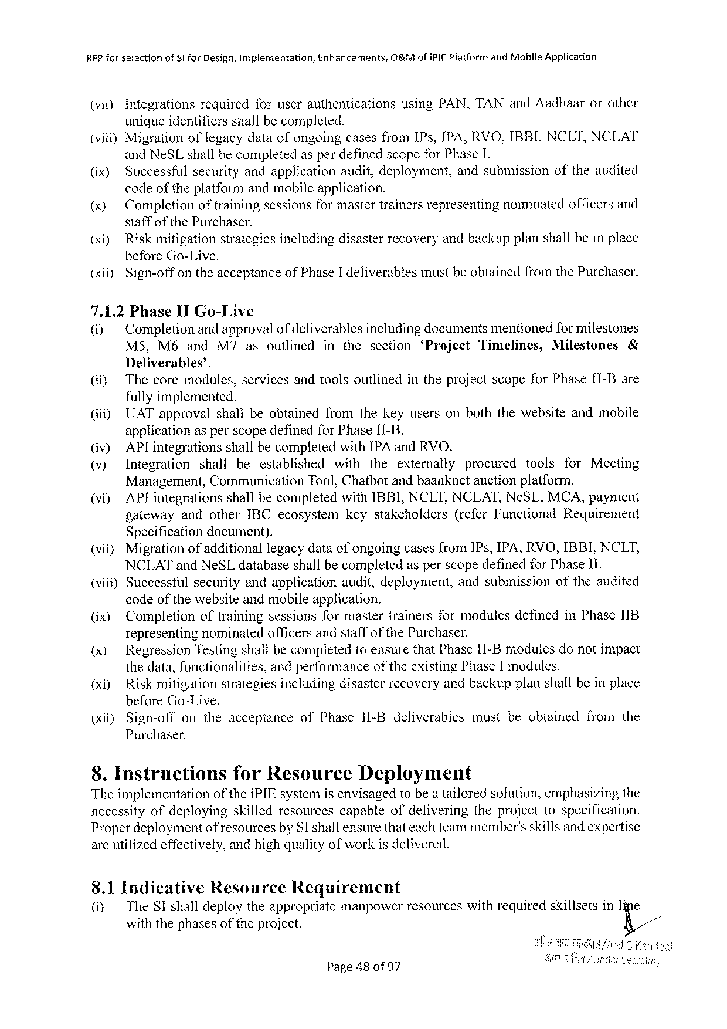

RFP forselection of Slfor Design, Implernentation, Enhancements, O&Mofi PIEP latformand Mobite Application

(vi) Integrationsrequiredforuserauthentications using PAN, TAN and Aadhaarorother

uniqueidentifiersshallbecompleted.

(viii)Migrationoflegacydataofongoingcasesfrom IP s, IPA, RVO, IBBI. NCLT, NCLAT

and Ne SL shallbecompletedasperdefinedscopefor Phase 1.

|  |  |
| --- | --- |
| (ix) (x) | Successfulsecurityandapplicationaudit, deployment, andsubmissionoftheandited codeofthe platformand mobileapplication.  Completionoftrainingsessionsformastertrainersrepresentingnominatedofficersand |

staffofthe Purchaser.

(xi) Riskmitigationstrategiesincludingdisasterrecoveryandbackupplanshallbeinplace

before Go-Live.

(xil) Sign-off ontheacceptance of Phase 1 deliverables mustbeobtained from the Purchaser.

7.1.2 Phase Il Go-Live

(i) Completionandapprovalof deliverablesincludingdocumentsmentionedfor milestones

M 5, M 6 and M 7 asoutlined inthesection ‘Project Timelines, Milestones &

Deliverables’.

(i) Thecoremodules, servicesandtoolsoutlinedintheprojectscopefor Phase[1-Bare

fullyimplemented.

(iii) UAT approvalshallbeobtainedfromthekeyusersonboththewebsiteandmobile

applicationasperscopedefinedfor Phase 1 I-B.

(iv) AP lintegrationsshallbecompletedwith[PA and RVO.

(v) Integration shall beestablished with theexternally procured tools for Meeting

Management, Communication Tool, Chatbotandbaanknetauctionplatform.

(vi) API integrations shallbecompleted with IBBI, NCLT, NCLAT, Ne SL, MCA, payment

gateway andother IBC ecosystem keystakeholders (refer Functional Requirement

Specificationdocument).

|  |  |  |  |
| --- | --- | --- | --- |
| (vii) | Migration | of additional | legacydataof ongoingcasesfrom IP s, IPA, RVO, IBBI, NCLT, |

NCLAT and Ne SL databaseshall becompletedasperscopedefinedfor Phase II.

(vii) Successfulsecurityandapplicationaudit, deployment, andsubmissionoftheaudited

code of the websiteandmobileapplication.

(ix) Completion oftraining sessions formaster trainers formodules defined in Phase 1 IB

representingnominatedofficersandstaffofthe Purchaser.

(x) Regression Testingshallbecompletedtoensurethat Phase II-Bmodulesdonotimpact

thedata, functionalities, andperformanceoftheexisting Phase[modules.

(xi) Riskmitigationstrategiesincludingdisasterrecoveryandbackupplanshallbeinplace

before Go-Live.

|  |  |  |  |  |  |  |  |  |  |  |  |
| --- | --- | --- | --- | --- | --- | --- | --- | --- | --- | --- | --- |
| (xii) | Sign-off | on | the | acceptance | of | Phase | 11-Bdeliverables | must | beobtained | from | the |

Purchaser.

8. Instructionsfor Resource Deployment

Theimplementation ofthei PIE systemisenvisagedtobea tailoredsofution, emphasizingthe

necessityofdeploying skilledresourcescapableofdeliveringtheprojecttospecification.

Properdeploymentof resourcesby SI shallensurethateachteammember’sskillsand expertise

areutilizedeffectively, andhighqualityofworkis delivered.

8.1 Indicative Resource Requirement

(iy The SI shalldeploytheappropriatcmanpowerresourceswithrequiredskillsetsin Iine

withthephases of the project. K/

Page 48 of 97

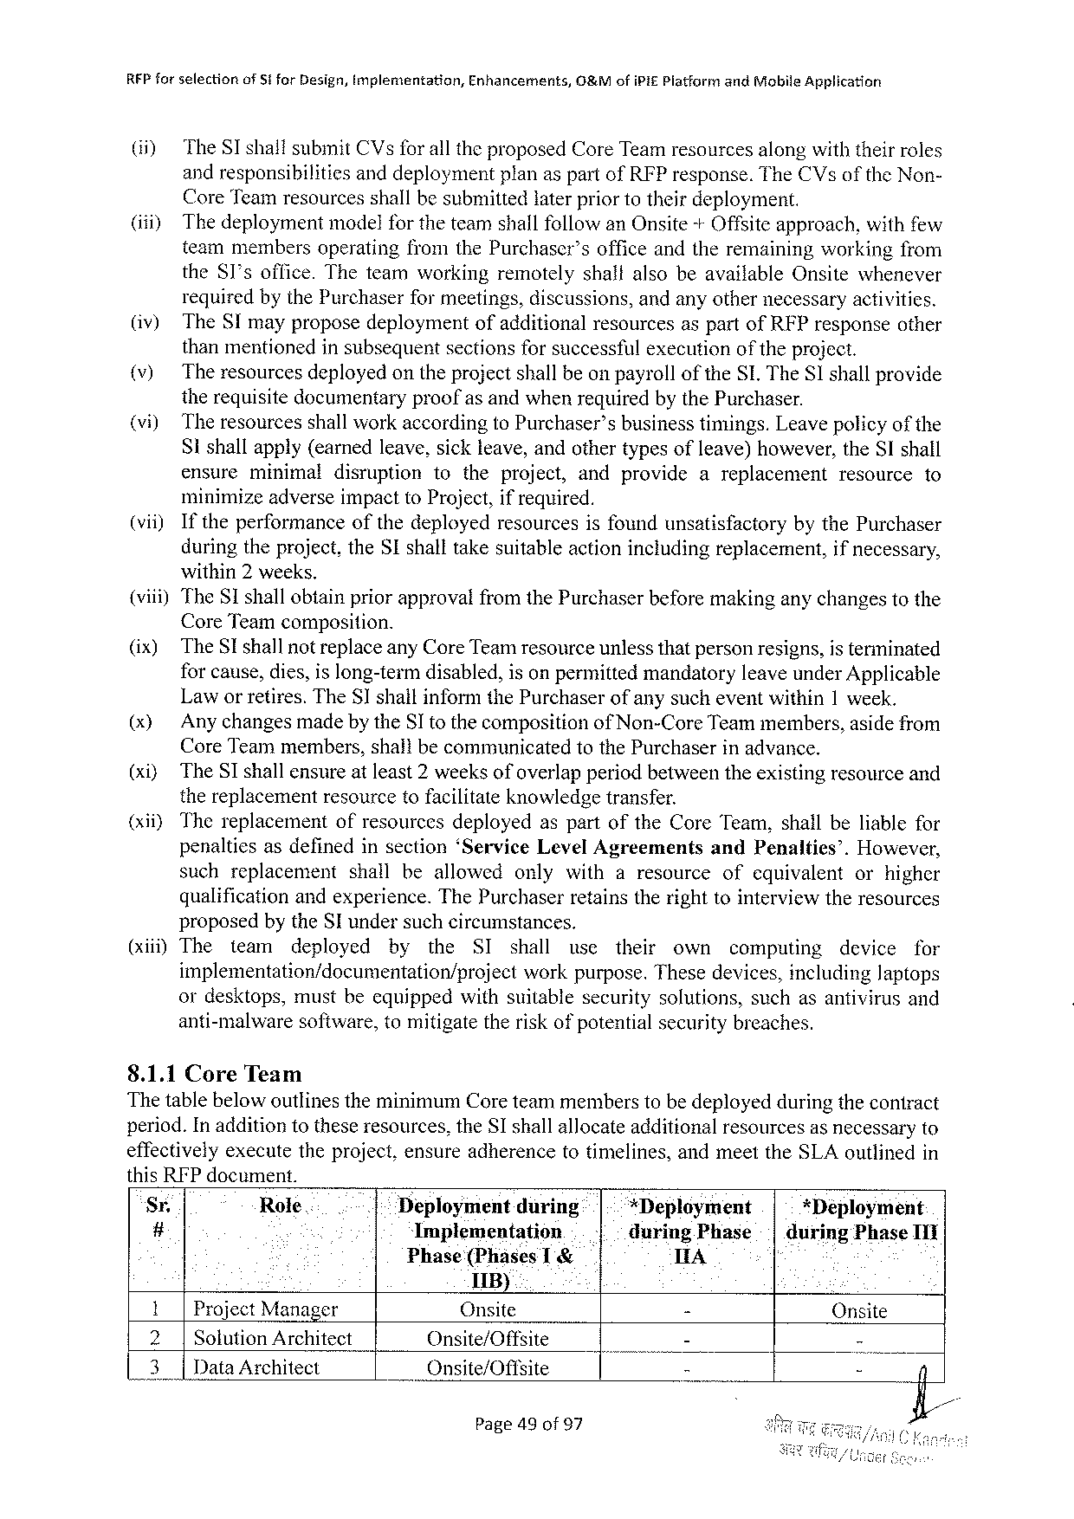

REP forselection of Stfor Design, Implementation, Enhancements, 0&Mofi Pif Platformand Mobile Application

(i) The SI shaitsubmit CV sfor alltheproposed Core Teamresourcesalongwiththeirroles

andresponsibilities anddeploymentplanaspartof RFP response. The CV softhe Non-

Core Teamresourcesshallbesubmittedlaterpriortotheirdeployment.

(i) Thedeploymentmodelfor theteamshallfollowan Onsite+Offsiteapproach, withfew

teammembersoperatingfromthe Purchaser’sofficeandtheremainingworkingfrom

the 8 I’soffice. Theteamworkingremotelyshaltalsobeavailable Onsitewhenever

requiredbythe Purchaserfor meetings, discussions, andanyothernecessaryactivities.

(iv) The SI mayproposedeploymentofadditionalresourcesaspartof RFP responseother

thanmentionedinsubsequentsectionsforsuccessfulexecutionof theproject.

|  |  |  |  |  |  |  |  |  |  |  |
| --- | --- | --- | --- | --- | --- | --- | --- | --- | --- | --- |
| (v)  (vi)  (vii) | The resourcesdeployedontheprojectshallbeonpayrollofthe SL. The SI shallprovide therequisitedocumentaryproofasandwhenrequiredbythe Purchaser. | | | | | | | | | |
| The resourcesshallworkaccordingto Purchaser’sbusinesstimings. Leavepolicy | | | | | | | | of the | |
| Sishallapply(earnedleave, sickleave, andothertypesofleave)however, the SI shall | | | | | | | | | |
| ensure | minimal | disruption | totheproject, | andprovide | areplacement | | resource | | to |
| minimizeadverseimpactto Project, ifrequired. | | | | | | | | | |
| Iftheperformanceofthedeployedresourcesisfoundunsatisfactory | | | | | | bythe Purchaser | | | |

duringtheproject, the SI shalltakesuitableactionincludingreplacement, ifnecessary,

within 2 weeks.

(viii)The SI shallobtainpriorapprovalfromthe Purchaserbeforemakinganychangestothe

Core Teamcomposition.

(ix) The SI shallnotreplaceany Core Teamresourceunlessthatpersonresigns, isterminated

forcause, dies, islong-termdisabled, isonpermittedmandatoryleaveunder Applicable

Laworretires. The SI shallinformthe Purchaserofanysucheventwithin 1 week.

(x) Any changesmadeby the SI tothecomposition of Non-Core Teammembers, asidefrom

Core Teammembers, shallbecommunicated to the Purchaserinadvance.

(xi) The SI shallensureatleast 2 weeksofoverlapperiodbetweentheexistingresourceand

thereplacementresourcetofacilitateknowledgetransfer.

(xii) Thereplacement ofresourcesdeployedaspartofthe Core Team, shallbeliablefor

penaltiesasdefinedinsection‘Service Level Agreements and Penalties’. However,

suchreplacement shallbeallowed onlywitharesource ofequivalent orhigher

qualificationandexperience. The Purchaserretainstherighttointerviewtheresources

proposedbythe SI undersuchcircumstances.

(xiii)The team deployed by the SI shall use their own computing device for

implementation/documentation/project workpurpose. Thesedevices, including Japtops

ordesktops, mustbeequippedwithsuitablesecuritysolutions, suchasantivirusand

anti-malware software, tomitigatetheriskofpotentialsecuritybreaches.

8.1.1 Core Team

Thetablebelowoutlinestheminimum Coreteammemberstobedeployedduringthecontract

period. Inadditiontotheseresources, the Sshallallocateadditionalresourcesasnecessaryto

effectivelyexecutetheproject, ensureadherencetotimelines, andmeetthe SLA outlinedin

this RFP document.

|  |  |  |  |  |  |  |  |  |
| --- | --- | --- | --- | --- | --- | --- | --- | --- |
| Sr. | Role.. | ... | Déployment | during | | | *Deployment | *Deployment |
| # | Implementation | | ..| | | -during Phase| | during Phase III |
| Phase(Phases 11 B) | | T & | | A |
| Project Manager | |
| Onsite |
| - |
| Onsite | | | |
| 3| | Solution Architect | | Onsite/Offsite | | | | | - | - |
| Data Architect | | Onsite/Offsite | | | | - |

Page 49 of 97

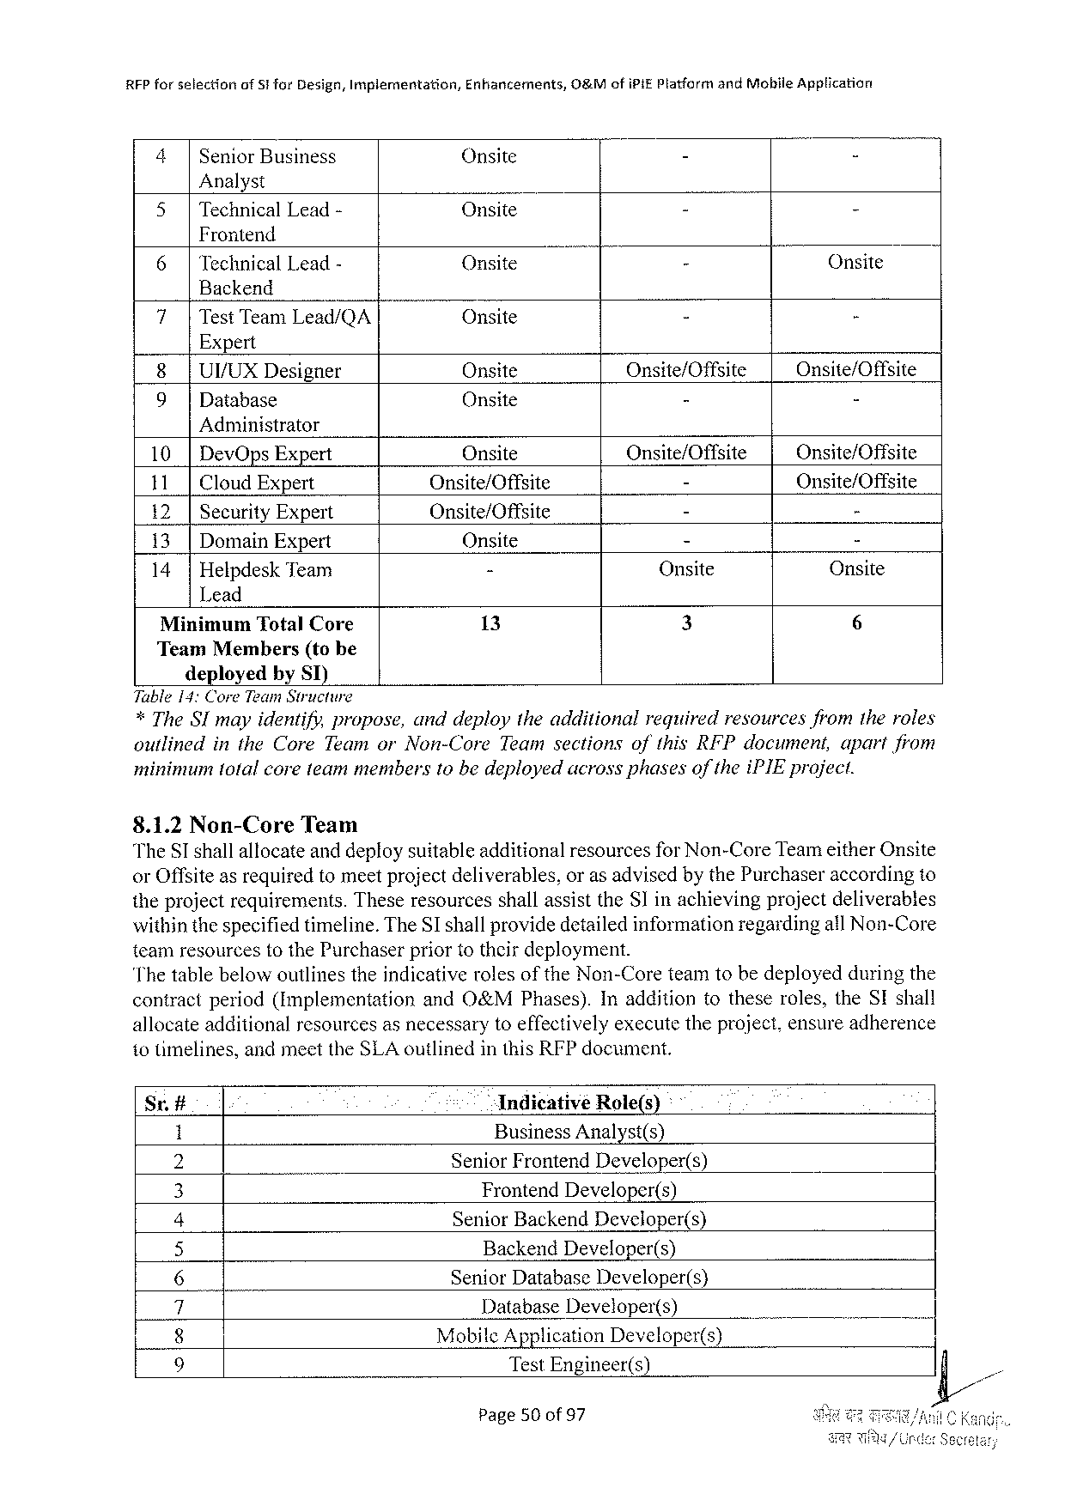

RFP forselectionof 51 for Design, Implementation, Enhancements, O&Mofi PIEP latformand Mobile Application

|  |  |  |  |  |
| --- | --- | --- | --- | --- |
| 4| | Senior Business | Onsite | - | - |

Analyst

|  |  |  |  |
| --- | --- | --- | --- |
| 5|Technical Lead- | Onsite | B | h |

Frontend

|  |  |  |  |
| --- | --- | --- | --- |
| 6|Technical Lead- | Onsite | - | Onsite |

Backend

|  |  |  |  |
| --- | --- | --- | --- |
| 7|Test Team Lead/QA | Onsite | - | - |

Expert

|  |  |  |  |  |
| --- | --- | --- | --- | --- |
| 8|UVUXD esigner | | Onsite | Onsite/Offsite | Onsite/Offsite |
| - |
| 9| | Database | Onsite | - |

Administrator

|  |  |  |  |  |
| --- | --- | --- | --- | --- |
| 10|Dev Ops Expert | | Onsite | Onsite/Offsite | Onsite/Offsite |
| 11| | Cloud Expert | Onsite/Offsite | - | Onsite/Offsite |
| Onsite/Offsite | - | - |
| 12| | Security Expert |
| 13|Domain Expert | | Onsite | - | - |
| 14|Helpdesk Team | | - | Onsite | Onsite |

Lead

|  |  |  |  |  |
| --- | --- | --- | --- | --- |
| Minimum Total Core | | 13 | 3 | 6 |
| Team Members | (tobe |
| deployedby ST) | |

Tuble 14: Core Team Structure   
*The SI mayidentify, propose, anddeploytheadditional requiredresourcesfromtheroles outlined in the Core Teamor Non-Core Teamsectionsofthis RFP document, apartfiom minimumtotalcoreteammembers 10 bedeployedacrossphasesof thei PIE project.

8.1.2 Non-Core Team   
The ST shallaltocateand deploysuitableadditionalresourcesfor Non-Core Teameither Onsite or Offsiteasrequiredtomeetprojectdeliverables, oras advisedbythe Purchaseraccordingto theprojectrequirements. Theseresourcesshallassistthe S]inachievingprojectdeliverables withinthespecifiedtimeline. The SI shallprovidedetailedinformationregardingatl Non-Core teamresourcestothe Purchaserpriortotheirdeployment.

Thetable belowoutlines theindicative roles of the Non-Core teamtobe deployed duringthe contractperiod(fmplementation and O&MP hases). Inadditiontotheseroles, the SI shall allocateadditionalresourcesasnecessarytoeffectivelyexecutetheproject, ensureadherence 1 otimelines, andmeetthe SLA outlinedinthis RFP document.

Sr.# Indicative Role(s)-

P Business Analyst(s)

Senior Frontend Developer(s)

|  |  |  |
| --- | --- | --- |
| VORI | Frontend Developer(s) | j/ |
| S |
| Senior Backend Developer(s) |
| L |
| Backend Developer(s) |
| -\ |
| Senior Database Developer(s) |
| BN | Database Developer(s) |
| U |
| Mobile Application Developer(s) |
| R | Test Engineer(s) |

Page 50 of 97

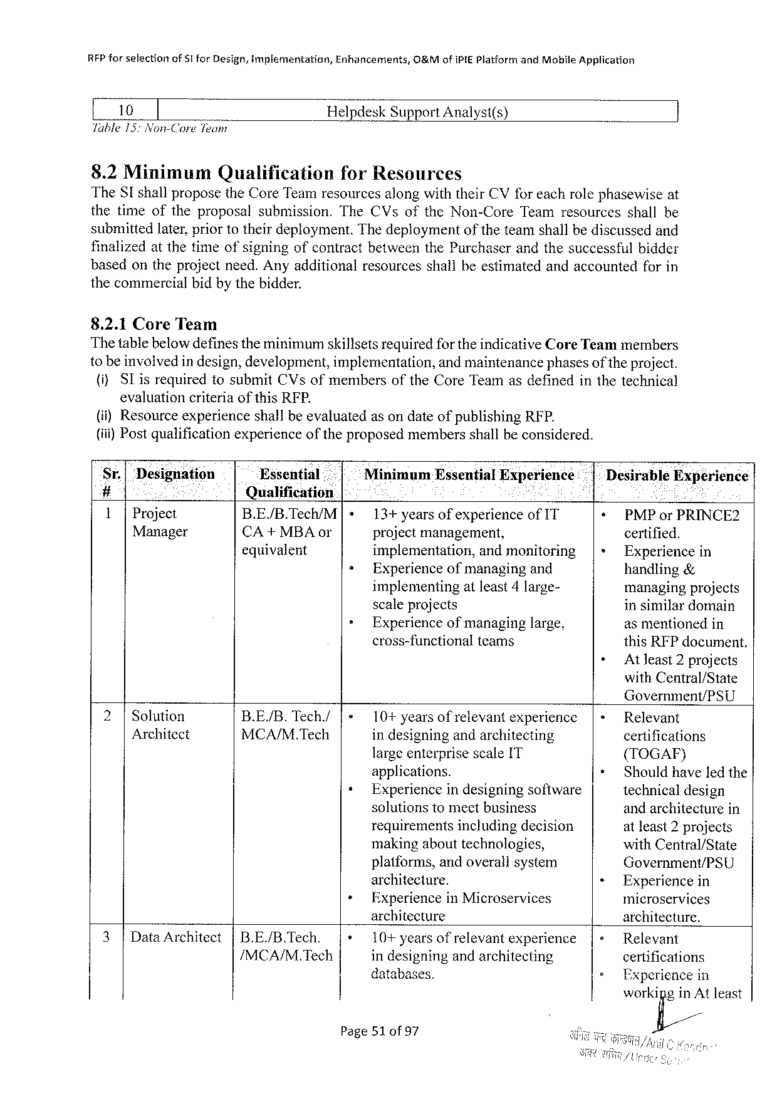

REP forselection of St for Design, implementation, Enhancements, O 8&M of IPIEP latformand Mobile Application

[ 10 ] Helpdesk Support Analyst(s)

Table 15: Non-Core Team

8.2 Minimum Qualification for Resources

The SI shallproposethe Core Teamresourcesalongwiththeir CV for eachrolephasewise at

thetimeoftheproposalsubmission. The CV softhe Non-Core Teamresourcesshallbe

submittedlater, priortotheirdeployment. Thedeploymentoftheteamshallbediscussedand

finalizedat thetimeofsigningofcontract betweenthe Purchaserandthesuccessfulbidder

basedontheprojectneed. Anyadditionalresourcesshallbeestimatedandaccountedforin

thecommercialbidby thebidder.

8.2.1 Core Team

Thetablebelowdefinestheminimumskillsetsrequiredfor theindicative Core Teammembers

to beinvolvedin design, development, implementation, and maintenancephasesof the project.

(i)SI is requiredtosubmit CV sofmembersofthe Core Teamasdefinedinthetechnical

evaluationcriteriaofthis RFP.

(i)Resourceexperienceshallbeevaluatedasondateofpublishing RFP.

(iii) Postqualificationexperienceoftheproposedmembersshallbeconsidered.

|  |  |  |  |  |  |  |  |  |  |  |  |  |  |
| --- | --- | --- | --- | --- | --- | --- | --- | --- | --- | --- | --- | --- | --- |
| Sr.| | Designation | | Essential | | | |+ | Minimum | Essential | | | Experience: | * |-Desirable | | Experience |
| # | ; i | o | Qualification | i | | | | | i | R | |
| 1|Project | | |
| B. E/B. Tec/M | 13+yearsofexperienceof IT | | | | | *+ PMP or PRINCE 2 | | |
| Manager | | | CA+MBA or | « | projectmanagement, | | | | | certified. | | |
| equivalent | implementation, | | | andmonitoring | | |+ | Experiencein | |
| Experienceofmanagingand | | | | | handling& | | |
| » | implementing | | atleast 4 large- | | | managingprojects | | |
| scaleprojects | | | | | in similardomain | | |
| Experienceofmanaginglarge, | | | | | asmentionedin | | |
| cross-functional | | teams | | | this RFP document. | | |
| + | Atleast 2 projects | |

with Central/State

Government/PSU

|  |  |  |  |  |  |  |  |  |
| --- | --- | --- | --- | --- | --- | --- | --- | --- |
| 2|Solution | B. E/B. | Tech./ | |« | 10+ yearsofrelevantexperience | | |« | Relevant | |
| Architect | MCA/M. Tech | | indesigningandarchitecting | | certifications | |
| largeenterprisescale IT | | + | ({TOGAF) | |
| + |
| applications. | | Shouldhaveledthe | |
| Experiencein designing software | | technical design | |
| 3|Data Architect | |B. E/B. Tech. | | + | solutionstomeetbusiness | | « | andarchitecturein | |
| requirementsincludingdecision | | atleast 2 projects | |
| makingabouttechnologies, | | with Central/State | |
| platforms, andoverallsystem | | Government/PSU | |
| architecture. | | Experiencein | |
| Experiencein Microservices | | microservices | |
| architecture | | |+ | architecture. | |
| |+ |
| 10+ yearsof | relevantexperience | Relevant | |
| /MCA/M. Tech | | indesigningandarchitecting | | » |
| certifications | |
| databases. | | Experiencein | |
| workifig/inm | least |

Page 51 of 97

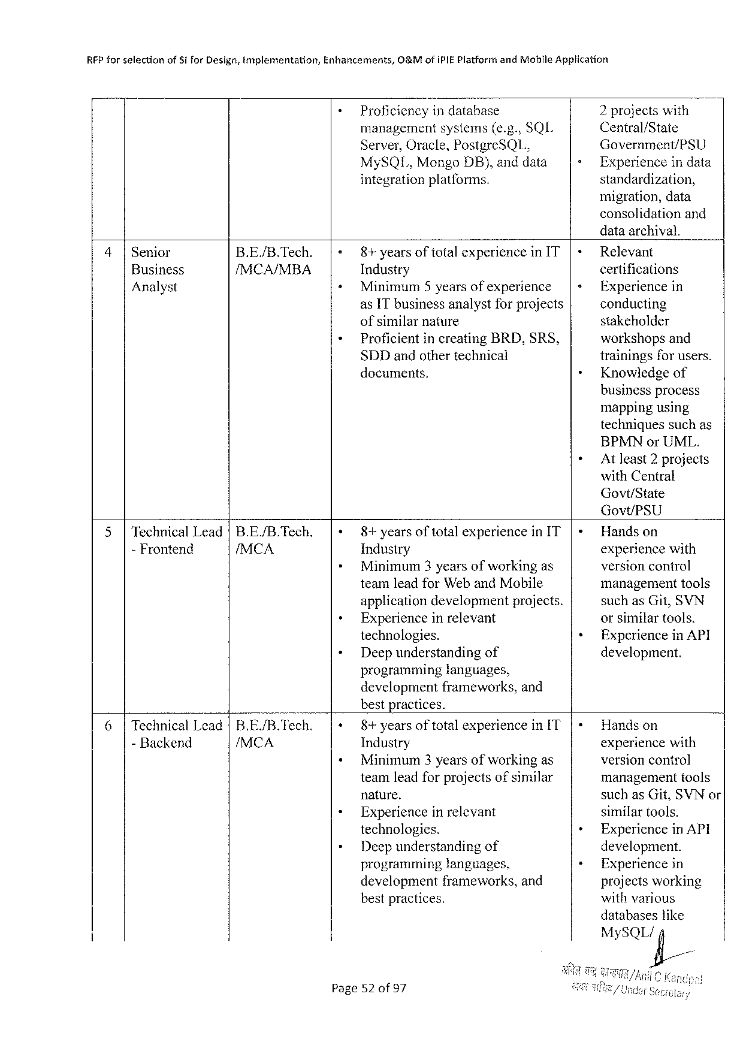

|  |  |  |  |  |
| --- | --- | --- | --- | --- |
| RFP forselection | of Sifor Design, mplementation, | Enhancements, | O&Mofi PIEP latformand Mohile Application | |
| Proficiencyindatabase | | 2 projectswith |
| managementsystems(e. g., SQL | | Central/State |
| Server, Oracle, Postgre SQL, | | Government/PSU |
| My SQI., Mongo DB}, anddata | | Experienceindata |
| integrationplatforms. | | standardization, |

migration, data   
consolidationand   
dataarchival.

|  |  |  |  |  |  |
| --- | --- | --- | --- | --- | --- |
| 4|Senior | B. E./B. Tech. | 8+years | of total | experiencein IT | Relevant |
| certifications |
| Business | /MCA/MBA | Industry | | |
| Analyst | Minimum 5 yearsofexperience | | | Experiencein |
| as IT businessanalystforprojects | | | conducting |
| ofsimilarnature | | | stakeholder |
| Proficientincreating BRD, SRS, | | | workshopsand |
| SDD andothertechnical | | | trainingsfor users. |
| documents. | | | Knowledgeof |

businessprocess   
mappingusing   
techniquessuchas   
BPMN or UML.

At Jeast 2 projects   
with Central   
Govt/State   
Govt/PSU

|  |  |  |  |  |  |  |  |  |
| --- | --- | --- | --- | --- | --- | --- | --- | --- |
| 5|Technical Lead|B. E./B. Tech. | | 8+years | of total | | experiencein IT | | Handson | |
| - Frontend | /MCA | Industry | | | | | experiencewith | |
| o | | Minimum 3 yearsofworkingas | | | | | versionconirol | |
| teamleadfor Web and Mobile | | | | | management | tools |
| applicationdevelopmentprojects. | | | | | suchas Git, SVN | |
| Experienceinrelevant | | | | | orsimilartools. | |
| technologies. | | | | | Experiencein API | |
| Deepunderstanding | | | | of | development. | |
| programminglanguages, | | | | |
| developmentframeworks, and | | | | |
| bestpractices. | | | | |
| 6|Technical Lead|B. E./B. Tech. | | 8+years oftotalexperience in[T | | | | | Handson | |
| - Backend | /MCA | Industry | | | | | experiencewith | |
| Minimum 3 yearsofworkingas | | | | | versioncontrol | |
| teamleadforprojectsofsimilar | | | | | managementtools | |
| nature. | | | | | suchas Git, SVN or | |
| Experienceinrelevant | | | | | similartools. | |
| technologies. | | | | | Experiencein API | |
| Deepunderstanding | | | | of | development. | |
| programming | | languages, | | | Experiencein | |
| development | | frameworks, and | | | projectsworking | |
| bestpractices. | | | | | withvarious | |

databaseslike   
My SQL ig/

Page 52 of 97

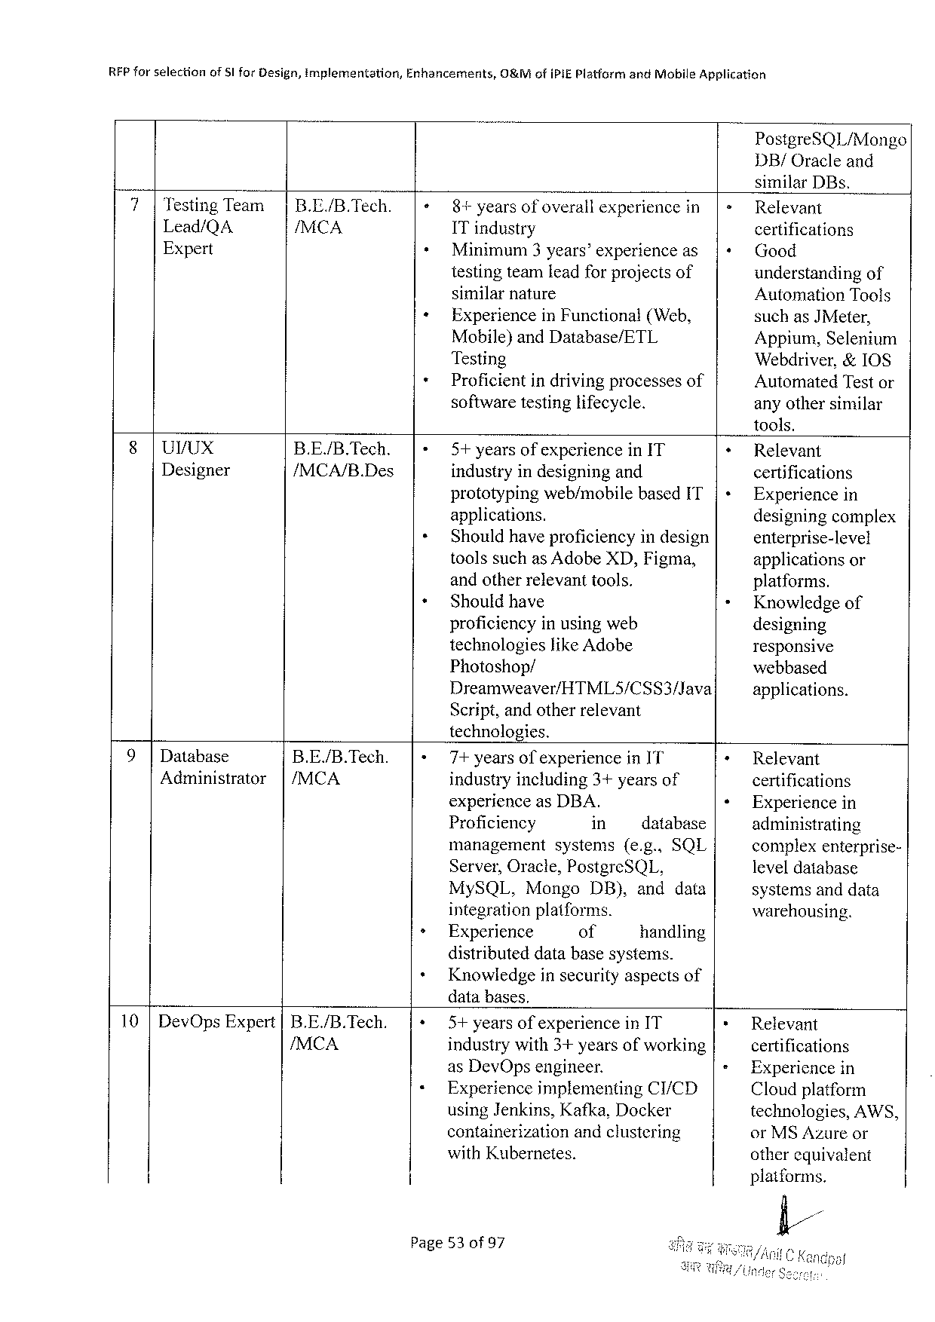

|  |  |  |  |
| --- | --- | --- | --- |
| RFP forselection | of 5 l for Design, implementation, | Enhancements, | O&Mofi PIEP latformand Mobile Application |

Postgre SQL/Mongo   
DB/Oracleand   
similar DB s.

|  |  |  |  |  |  |  |  |  |  |
| --- | --- | --- | --- | --- | --- | --- | --- | --- | --- |
| 7|Testing Team | | | B. E./B. Tech. | 8+years | of overall | experiencein|= | | | Relevant | |
| Lead/QA | /MCA | IT industry | | | certifications | | | |
| Expert | Minimum 3 years’experience as | | | |+ Good | | | |
| testingteamleadfor projectsof | | | understandingof | | | |
| similarnature | | | Automation Tools | | | |
| Experiencein Functional(Web, | | | suchas | | | JM eter, |
| Mobile)and Database/ETL | | | Appium, Selentum | | | |
| Testing | | | Webdriver,&10 S | | | |
| Proficientindrivingprocessesof | | | | Automated Testor | | |
| softwaretestinglifecycle. | | | anyothersimilar | | | |

tools.

|  |  |  |  |  |
| --- | --- | --- | --- | --- |
| §|UVUX | B. E./B. Tech. | 5+yearsofexperiencein IT | + | Relevant |
| Designer | /MCA/B. Des |
| industryindesigningand | certifications |
| |+ |
| prototypingweb/mobilebased IT | Experiencein |
| applications. | » | designingcomplex |
| Shouldhaveproficiencyindesign | enterprise-level |
| toolssuchas Adobe XD, Figma, | applicationsor |
| andotherrelevanttools. | platforms. |
| Shouldhave | Knowledgeof |
| proficiencyinusingweb | designing |
| technologieslike Adobe | responsive |
| Photoshop/ | webbased |
| Dreamweaver/HTML 5/CSS 3/Java |
| applications. |

Script, andotherrelevant   
technologies.

|  |  |  |  |  |  |  |  |  |  |
| --- | --- | --- | --- | --- | --- | --- | --- | --- | --- |
| 9|Database | B. E./B. Tech. | 7+yearsofexperiencein IT | | | | | | + | Relevant |
| Administrator | |/MCA | industryincluding 3+yearsof | | | | | | certifications |
| ¢ |
| experienceas DBA. | | | | | | Experiencein |
| Proficiency | | in | | | database | administrating |
| management | | | systems(e. g.. SQL | | | complexenterprise- |
| Server, Oracle, Postgre SQL, | | | | | |
| leveldatabase |
| My SQL, | Mongo | | | DB), anddata | | systemsanddata |
| integrationplatforms. | | | | | | warehousing. |
| Experience | | of | | | handling |

distributeddatabasesystems.

Knowledgeinsecurityaspectsof   
databases.

|  |  |  |  |  |  |
| --- | --- | --- | --- | --- | --- |
| 10|Dev Ops Expert |B. E./B. Tech. | 5+ yearsofexperience in IT | | | * | Relevant |
| /MCA | industrywith 3+yearsofworking | | | = | certifications |
| as Dev Opsengineer. | | | Experiencein |
| Experienceimplementing | | CI/CD | Cloudplatform |
| using Jenkins, Kafka, Docker | | | technologies, AWS, |
| containerization | andclustering | | or MSA zureor |
| with Kubernetes. | | | other equivalent |

platforms.

fl//

Page 53 of 97

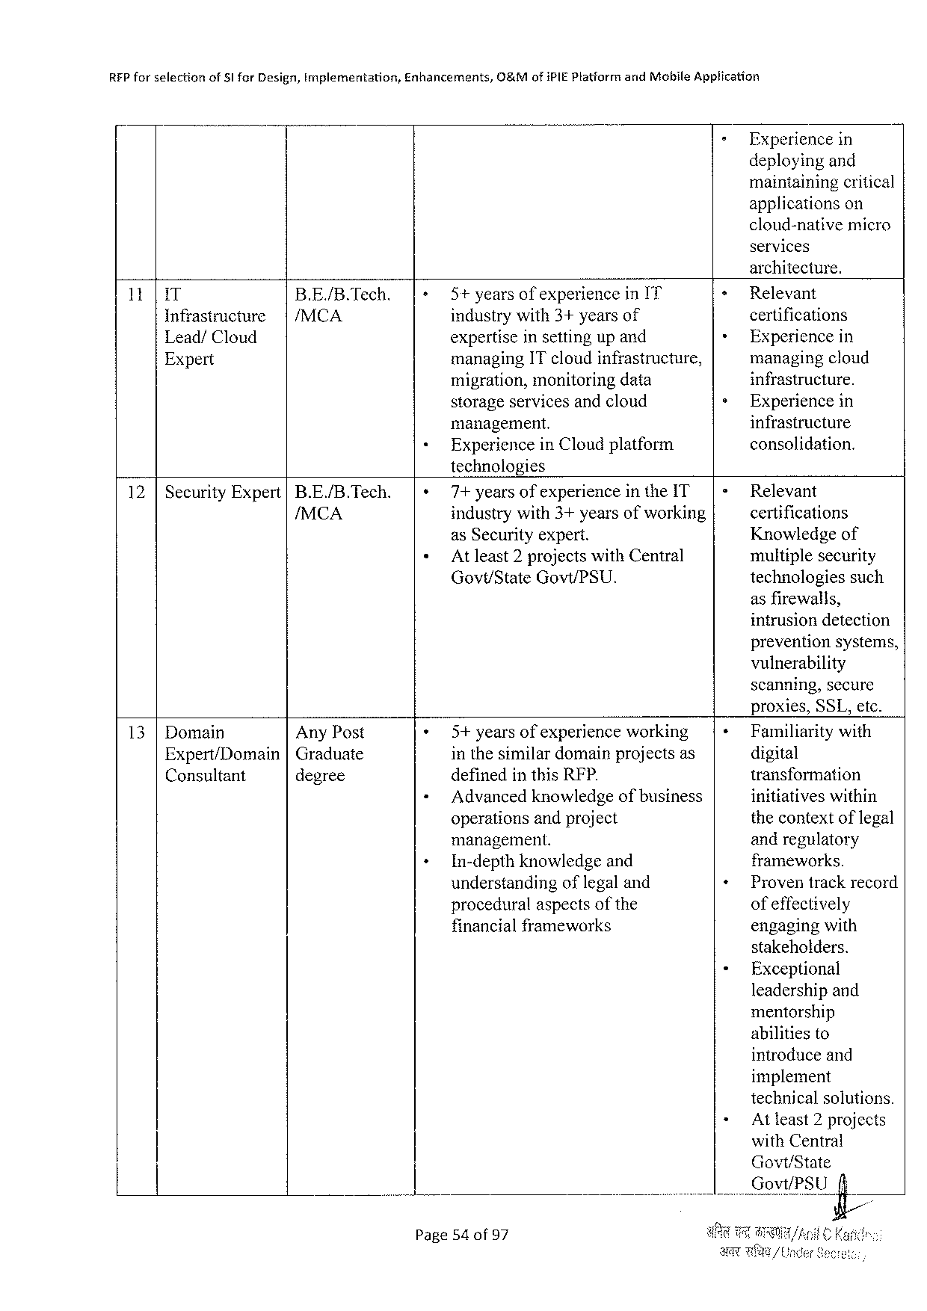

|  |  |  |  |
| --- | --- | --- | --- |
| REP forselection | of§Ifor Design, implementation, | Enhancements, | O&Mofi PIEP latformand Mobile Application |

Experiencein   
deployingand   
maintainingcritical   
applications on   
cloud-native micro   
services   
architecture.

|  |  |  |  |  |  |
| --- | --- | --- | --- | --- | --- |
| 11| | IT | B. E./B. Tech. | 5+yearsofexperiencein I'T | + | Relevant |
| |/MCA | industrywith 3+yearsof | + | certifications |
| Infrastructure |
| Lead/Cloud | expertiseinsettingup and | Experiencein |
| Expert | managing IT cloudinfrastructure, | » | managingcloud |
| migration, monitoringdata | infrastructure. |
| storageservicesandcloud | Experiencein |
| infrastructure |
| management. |
| Experiencein Cloudplatform | consolidation. |

technologies

|  |  |  |
| --- | --- | --- |
| 12 |Security Expert|B. E./B. Tech. | 7+ yearsof experiencein the IT|= | Relevant |
| /MCA | industrywith 3+yearsofworking | certifications |
| as Securityexpert. | Knowledgeof |
| Atleast 2 projectswith Central | multiplesecurity |
| Govt/State Govt/PSU. | technologiessuch |

asfirewalls,   
intrusiondetection   
preventionsystems,   
vulnerability   
scanning, secure   
proxies, SSL, etc.

|  |  |  |  |  |
| --- | --- | --- | --- | --- |
| 13 |Domain | Any Post | 5+yearsofexperienceworking | + | Familiaritywith |
| digital |
| Expert/Domain|Graduate | | inthesimilardomainprojectsas |
| transformation |
| Consultant | degree | definedinthis RFP. |
| Advancedknowledgeofbusiness | initiativeswithin |
| operationsandproject | thecontextoflegal |
| management. | andregulatory |
| In-depthknowledgeand | frameworks. |
| understanding oflegaland | Proventrackrecord |
| proceduralaspectsofthe | ofeffectively |
| financialframeworks | engagingwith |

stakeholders.

Exceptional   
leadershipand   
mentorship   
abilitiesto   
introduceand   
implement   
technicalsolutions.

Atleast 2 projects   
 with Central   
 Govt/State   
i V_QE_VI/J’fit Lfi;

Page 54 of 97

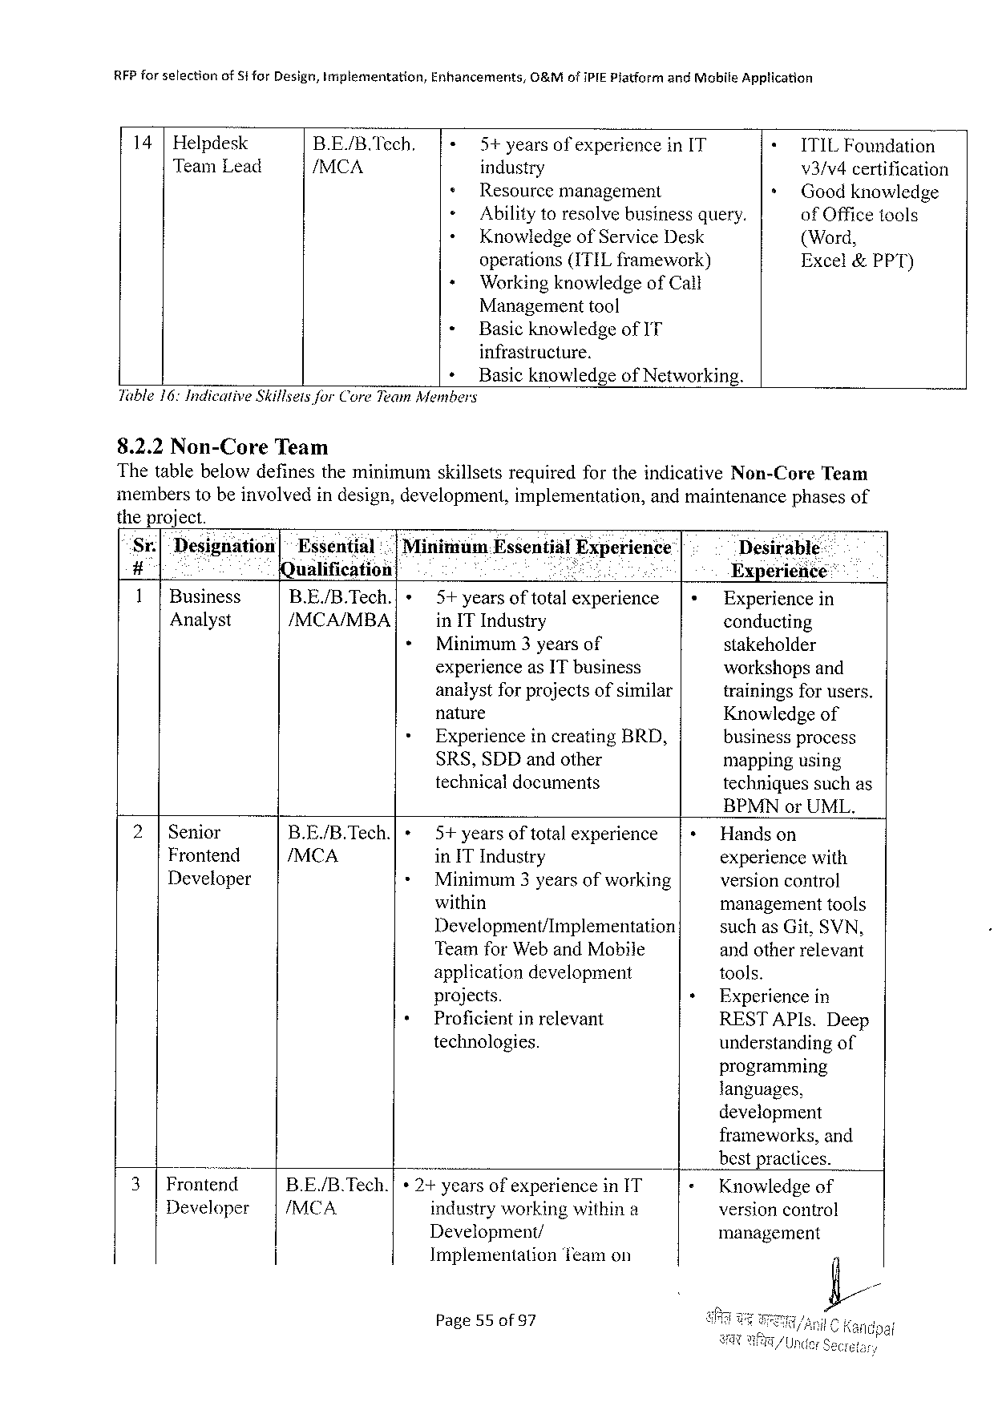

|  |  |  |  |  |  |  |  |
| --- | --- | --- | --- | --- | --- | --- | --- |
| RFP forselection | | of Sfor Design, Implementation, | | Enhancements, | G&Mofi PIEP iatformand Mobile Application | | |
| 14 | Helpdesk | | B. E./B. Tech. | 5+yearsof experience | | in[T | ITILF oundation |
| Team Lead | | | /MCA | industry | | | v 3/v 4 certification |
| Resourcemanagement | | | Goodknowledge |
| Abilitytoresolvebusinessquery. | | | of Officetools |
| Knowledgeof Service Desk | | | (Word, |
| operations(ITIL framework) | | | Excel&PPT) |
| Workingknowledge of Call | | | |

Managementtool

« Basicknowledgeof IT

infrastructure.

+ Basicknowledgeof Networking.

Table 16: Indicative Skillseisfor Core Team Members

8.2.2 Non-Core Team

Thetablebelowdefinesthe minimumskillsets requiredfortheindicative Non-Core Team

memberstobeinvolvedindesign, development, implementation, andmaintenancephasesof

theproject.

Sr.| Designdtion|~Essential .|Minimuam Essential Experience Desirable:

# Qualification Pkl : Experience::

1|Business B. E./B. Tech.| » 5+yearsoftotalexperience Experiencein

Analyst /MCA/MBA in ITI ndustry conducting

+ Minimum 3 yearsof stakeholder

experienceas IT business workshopsand

analystfor projectsofsimilar trainingsfor users.

nature Knowledgeof

+ Experiencein creating BRD, business process

SRS, SDD andother mappingusing

technicaldocuments techniguessuchas

BPMN or UML.

|  |  |  |  |  |  |  |
| --- | --- | --- | --- | --- | --- | --- |
| 2|Senior | B. E/B. Tech.[ | » | 5+years | of total | experience | Handson |
| Frontend | /MCA | * | in ITI ndustry | | | experiencewith |
| Developer | Minimum 3 yearsofworking | | | versioncontrol |
| + | within | | | managementtools |
| Development/Implementation | | | suchas Git, SVN, |
| Teamfor Weband Mobile | | | andotherrelevant |
| applicationdevelopment | | | tools. |
| projects. | | | Experience in |
| Proficientin relevant | | | RESTAPI s. Deep |
| technologies. | | | understandingof |

programming

languages,

development

|  |  |  |  |  |  |
| --- | --- | --- | --- | --- | --- |
| 3| | . | B. E./B. Tech.| | * 2+yearsofexperiencein IT | | frameworks, and |
| bestpractices. |
| Frontend | Knowledgeof |
| Developer | |/MCA | industryworking withina | | version control |
| Development/ | | management |
| Implementation | Teamon |

Page 55 of 97

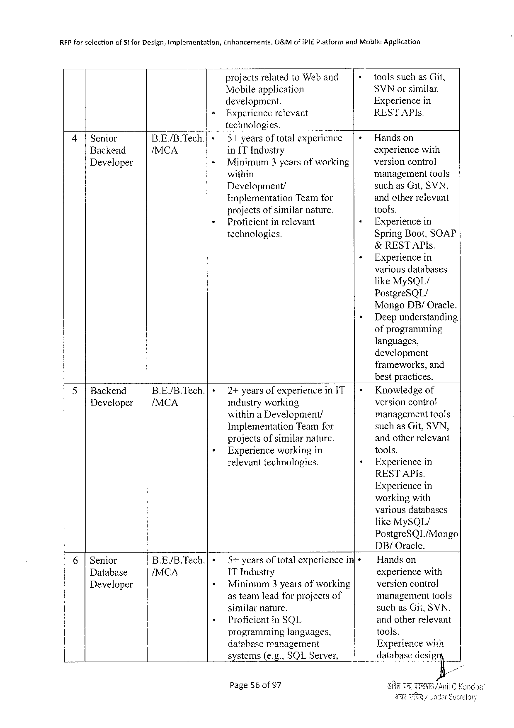

|  |  |  |  |  |  |  |
| --- | --- | --- | --- | --- | --- | --- |
| REP forselection | of 5 t for Design, Implementation, | Enhancements, | O&Mof IPIEP latformand Motile | | | Application |
| + | projects relatedto Weband | | + | toolssuchas Git, | |
| Mobileapplication | | SVN orsimilar. | | |
| development. | | Experiencein | | |
| Experiencerelevant | | RESTAPI s. | | |

technologies.

|  |  |  |  |  |  |
| --- | --- | --- | --- | --- | --- |
| 4|Senior | B. E/B. Tech.|{» | 5+ yearsoftota)experience | |+Handson | | |
| Backend | /MCA | in IT Industry | experiencewith | | |
| Developer | « | Minimum 3 yearsofworking | versioncontrol | | |
| « | within | management | | tools |
| Development/ | suchas Git, SVN, | | |
| Implementation Teamfor | andotherrelevant | | |
| projectsofsimilarnature. | tools, | | |
| Proficient in relevant | « | Experiencein | |
| technologies. | Spring Boot, SOAP | | |

&RESTAPI s.

» Experiencein   
 variousdatabases   
 like My SQL/   
 Postgre SQL/   
 Mongo DB/Oracle.

« Deepunderstanding   
 ofprogramming   
 languages,   
 development   
 frameworks, and   
 bestpractices.

|  |  |  |  |  |  |  |  |
| --- | --- | --- | --- | --- | --- | --- | --- |
| 5|Backend | | | B. E/B. Tech.| | + | 2+yearsofexperiencein IT | | |- | Knowledgeof |
| Developer | /MCA | industryworking | | versioncontro! |
| withina Development/ | | managementtools |
| » | Implementation | Teamfor | suchas Git, SVN, |
| + |
| projects ofsimilarnature. | | andotherrelevant |
| Experienceworkingin | | tools. |
| relevanttechnologies. | | Experiencein |

RESTAPI s.

Experiencein   
workingwith   
variousdatabases   
like My SQL/   
Postgre SQL/Mongo   
DB/Oracle.

|  |  |  |  |  |  |  |  |
| --- | --- | --- | --- | --- | --- | --- | --- |
| 6|Senior | B. E/B. Tech.| | « | 5+years | | of total | experiencein[+ | Handson |
| /MCA | + | 1 T Industry | | | | experiencewith |
| Database |
| Developer | Minimum 3 yearsofworking | | | | versioncontrol |
| + | asteamleadforprojectsof | | | | managementtools |
| similar | nature. | | | suchas Git, SVN, |
| Proficient | | in SQL | | andotherrelevant |
| \_H |
| programminglanguages, | | | | tools. |
| databasemanagement | | | | Experiencewith |
| systems(e. g., SQLS erver, | | | | databasedesigry |

Page 56 of 97

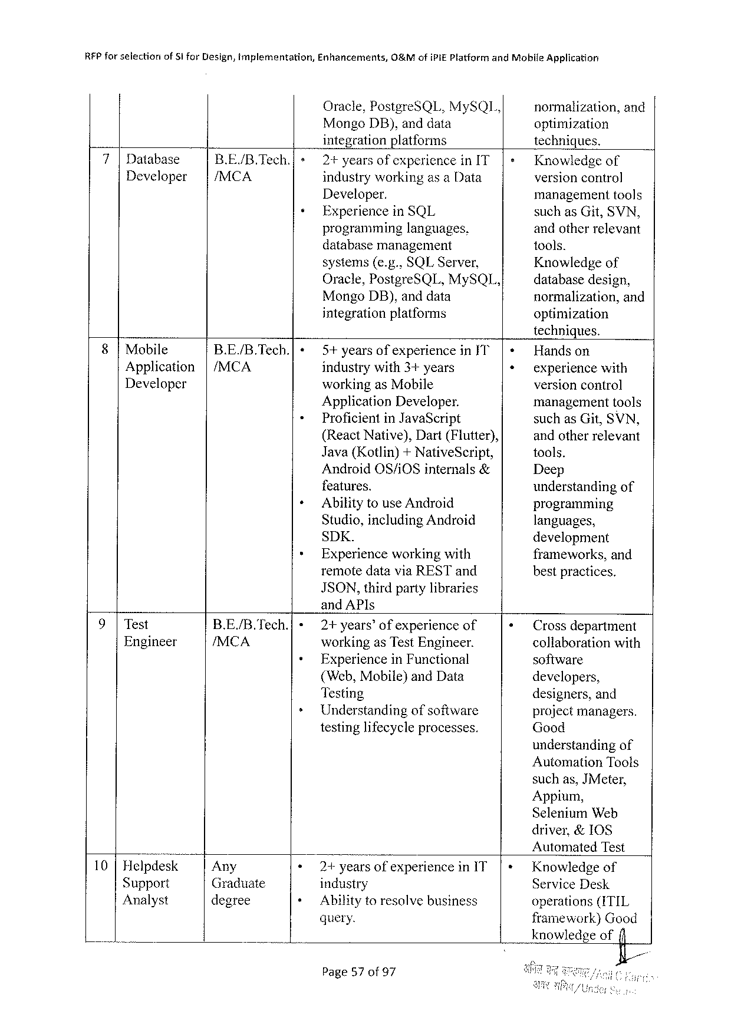

|  |  |  |  |  |  |  |  |  |
| --- | --- | --- | --- | --- | --- | --- | --- | --- |
| RFP forselection | of i | for Design, Implementation, | | Enhancements, | O&Mofi Pi E Platformand Mohile Application | | | |
| 7|Database | | B. E/B. Tech.] | » | Oracle, Postgre SQL, My SQL, | | | normalization, | and |
| Mongo DB), anddata | | | optimization | |
| integrationplatforms | | | techniques. | |
| 2+yearsof experiencein IT | | | Knowledgeof | |
| Developer | | /MCA | | industryworkingas a Data | | | versioncontrol | |
| « | |
| Developer. | | | management | tools |
| Experiencein SQL | | | suchas Git, SVN, | |
| programming | | languages, | andotherrelevant | |
| databasemanagement | | | 100 ls. | |
| systems(e. g., SQLS erver, | | | Knowledgeof | |
| Oracle, Postgre SQL, My SQL, | | | databasedesign, | |
| Mongo DB), anddata | | | normalization, | and |
| integrationplatforms | | | optimization | |

techniques.

|  |  |  |  |  |
| --- | --- | --- | --- | --- |
| 8|Mobile | B. E/B. Tech.| | « | 5+yearsofexperiencein JT' | Handson |
| Application | |/MCA | » | industrywith 3+years | experiencewith |
| Developer | workingas Mobile | versioncontrol |
| Application Developer. | managementtools |
| Proficientin Java Script | suchas Git, SVN, |
| + | (React Native), Dart(Flutter), | andotherrelevant |
| Java(Kotlin)+Native Seript, | tools. |
| Android OS/i OS internals& | Deep |
| features. | understanding of |
| Ability touse Android | programming |
| » | Studio, including Android |
| languages, |
| SDK. | development |
| Experienceworkingwith | frameworks, and |
| remotedatavia REST and | bestpractices. |

JSON, thirdpartylibraries   
and API s

|  |  |  |  |  |
| --- | --- | --- | --- | --- |
| 9|Test | B. E/B. Tech.| | »+2+years’of experienceof | | Crossdepartment |
| Engineer | /MCA | workingas Test Engineer. | | collaborationwith |
| + | Experiencein Functional | software |
| (Web, Mobile)and Data | | developers, |
| Testing | |
| designers, and |
| + | Understandingofsoftware |
| projectmanagers. |
| testinglifecycleprocesses. | | Good |

understandingof   
Automation Tools   
suchas, JM eter,   
Appium,   
Selenium Web

|  |  |  |  |  |
| --- | --- | --- | --- | --- |
| . | Any | « | y | driver,&IOS |
| Automated Test |
| 10 |Helpdesk | 2+yearsofexperiencein IT |
| Knowledgeof |
| Support | Graduate | industry | Service Desk |
| + |
| Analyst | degree | Ability toresolvebusiness | operations(ITIL |
| query. | framework)Good |
| knowledgeofi |

Page 57 of 97

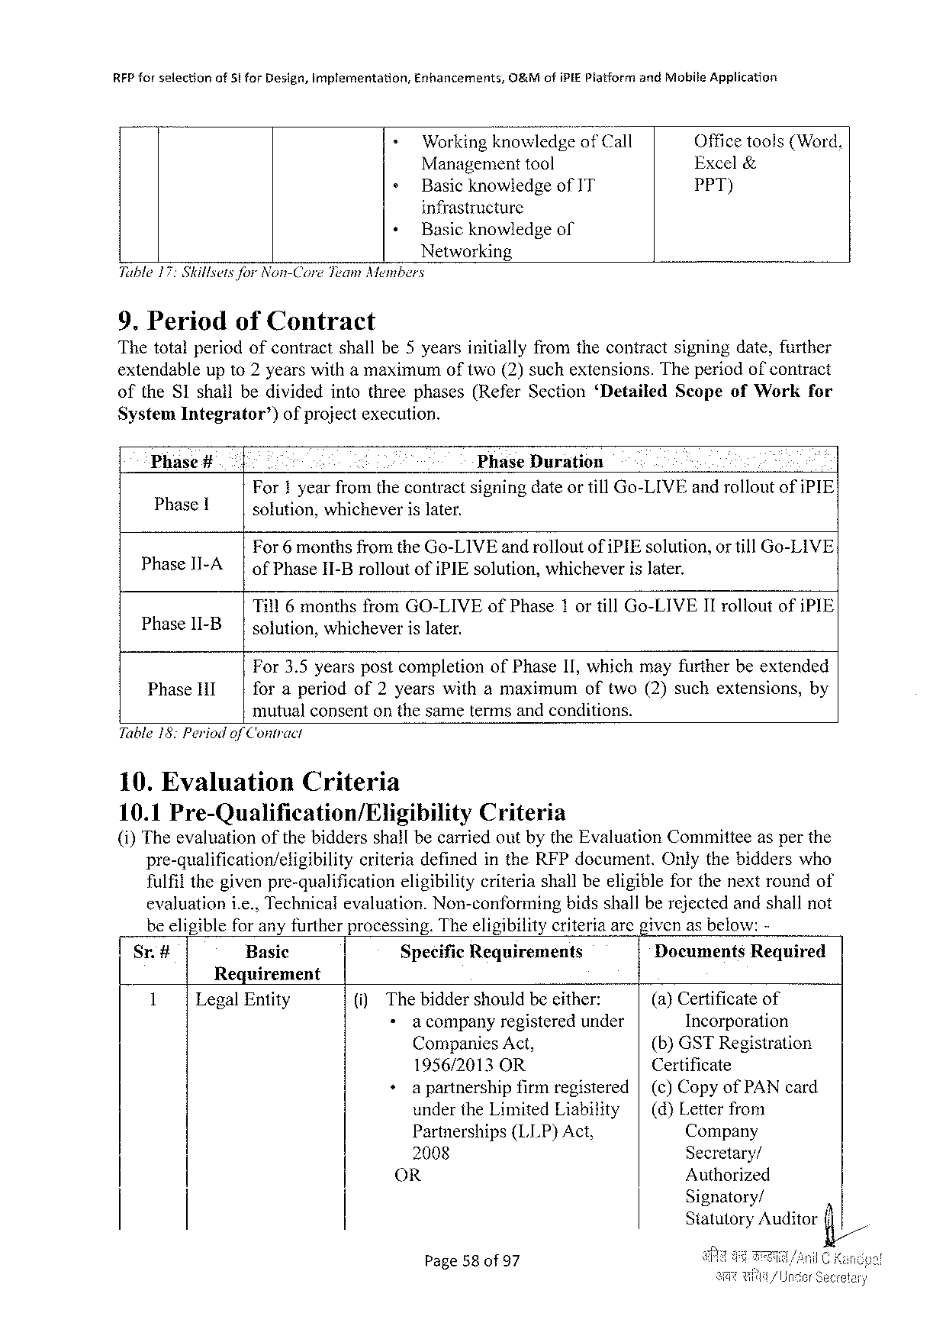

|  |  |  |  |  |
| --- | --- | --- | --- | --- |
| RFP forselection | of 5! for Design, implementation, | Enhancements, | O&Mofi PIEP latformand Mobile Application | |
| - | Workingknowledgeof Call | | Officetools(Word, |
| » | Managementtool | | Excel& |
| Basicknowledgeof IT | | PPT) |

infrastructure  
 « Basicknowledgeof Networking   
Tuble 17: Skilsetsfor Non-Core Team Members

9. Periodof Contract   
Thetotalperiodofcontractshallbe 5 yearsinitiallyfromthecontractsigningdate, further extendableupto 2 yearswithamaximumoftwo(2)suchextensions. Theperiodofcontract

|  |  |  |  |  |
| --- | --- | --- | --- | --- |
| of the SI shallbedividedintothreephases(Refer Section‘Detailed | | | Scopeof Work | for |
| System Integrator’) | ofprojectexecution. | |
| Phase# | : | Phase Duration |

For 1 yearfromthecontractsigningdateortill Go-LIVE androlloutofi PIE Phase[ solution, whicheverislater.

For 6 monthsfromthe Go-LIVE androlloutofi PIE solution, or till Go-LIVE

|  |  |  |  |  |
| --- | --- | --- | --- | --- |
| Phase II-A | | | of Phase II-Brollout | of{PIE solution, | whichever | islater. |

Till 6 monthsfrom GO-LIVE of Phase 1 ortill Go-LIVEII rolloutofi PIE Phase II-B solution, whicheverislater.

For 3.5 yearspostcompletionof Phase II, whichmayfurtherbeextended

|  |  |  |  |
| --- | --- | --- | --- |
| Phase HI | foraperiodof 2 yearswithamaximum | oftwo(2)suchextensions, | by |

mutualconsentonthesametermsandconditions. Table 18: Periodof Contract

10. Evaluation Criteria

10.1 Pre-Qualification/Eligibility Criteria   
(i)Theevaluationofthebiddersshallbecarriedoutbythe Evaluation Committeeasperthe

|  |  |  |
| --- | --- | --- |
| pre-qualification/eligibility | criteriadefinedinthe RFP document. | Onlythebidderswho |

fulfilthegivenpre-qualification

eligibilitycriteriashallbeeligibleforthenextroundof

evaluationi. e., Technicalevaluation. Non-conforming bidsshallberejectedandshallnot beeligibleforanyfurtherprocessing. Theeligibilitycriteriaarcgivenasbelow:-

|  |  |  |  |  |
| --- | --- | --- | --- | --- |
| Sr.# | Basic | Specific Requirements | Documents | Required |

Requirement

|  |  |  |  |  |  |  |  |
| --- | --- | --- | --- | --- | --- | --- | --- |
| 1 | Legal Entity | (i) | Thebiddershouldbeeither: | | | (a)Certificateof | |
| »acompany | registeredunder | | Incorporation | |
| Companies Act, | | | (b)GSTR egistration | |
| 1956/2013 OR | | | Certificate | |
| +apartnership | | firmregistered|(c)Copyof PAN card | | |
| underthe Limited Liability | | | | | (d)Letterfrom |
| Partnerships(LLP)Act, | | | Company | |
| 2008 | | | Secretary/ | |
| OR | | | Authorized | |

Signatory/   
Statutory Auditorfi/

Page 58 of 97 J

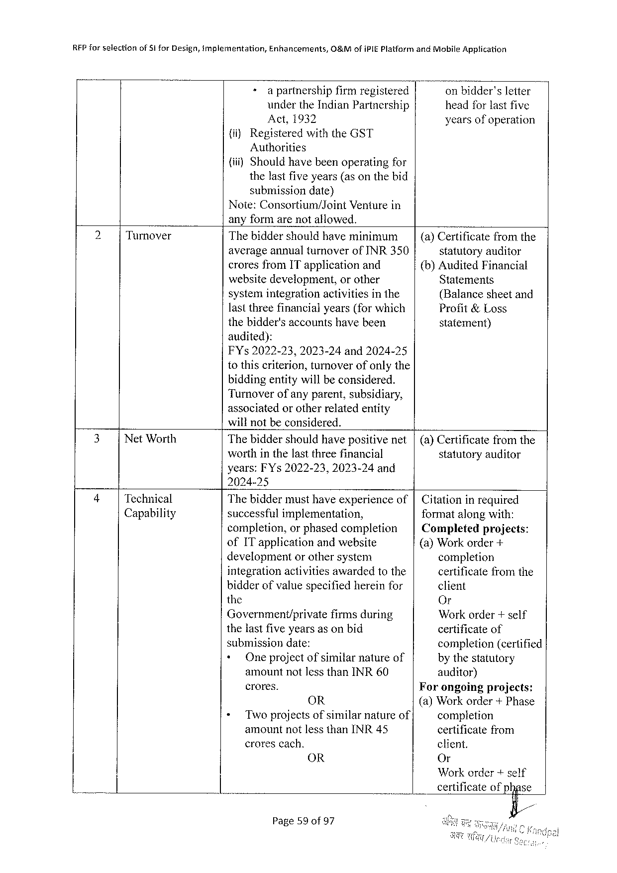

|  |  |  |  |  |  |
| --- | --- | --- | --- | --- | --- |
| REP forselection | of 51 for Design, implementation, | Enhancements, | 0&Mofi PIEP latformand Mobile Apptication | | |
| + | a partnershipfirmregistered | | | onbidder’sletter |
| underthe Indian Partnership | | headforlastfive | |
| Act,1932 | | yearsofoperation | |

{ii)Registeredwiththe GST   
 Authorities   
(i) Shouldhavebeenoperatingfor   
 thelastfiveyears(asonthebid   
 submissiondate)   
Note: Consortium/Joint Venturein   
anyformarenotallowed.

|  |  |  |  |
| --- | --- | --- | --- |
| 2 | Turnover | Thebiddershouldhaveminimum | (a)Certificatefromthe |
| averageannualturnoverof INR 350 | statutoryauditor |
| croresfrom IT applicationand | (b)Audited Financial |
| websitedevelopment, orother | Statements |
| systemintegrationactivitiesinthe | (Balancesheetand |
| lastthreefinancialyears(forwhich | Profit&Loss |
| thebidder'saccountshavebeen | statement) |

audited):   
FY s 2022-23, 2023-24 and 2024-25   
tothiscriterion, turnoverofonlythe   
biddingentitywillbe considered.

Turnoverofanyparent, subsidiary,   
associatedorotherrelatedentity   
willnotbeconsidered.

|  |  |  |  |
| --- | --- | --- | --- |
| 3 | Net Worth | Thebiddershouldhavepositivenet|(a)Certificatefromthe | |
| worthinthelastthreefinancial | statutoryauditor |

years: FY s 2022-23,2023-24 and   
2024-25

|  |  |  |  |  |  |  |
| --- | --- | --- | --- | --- | --- | --- |
| 4 | Technical | Thebiddermusthaveexperienceof|Citationinrequired | | | | |
| Capability | successfulimplementation, | | | | formatalongwith: |
| completion, orphasedcompletion | | | | Completedprojects: |
| of IT applicationandwebsite | | | | (a)Workorder+ |
| development | | | orothersystem | completion |
| integrationactivitiesawardedtothe | | | | certificate from the |
| bidderofvaluespecifiedhereinfor | | | | client |
| the | | | | Or |
| Government/private firmsduring | | | | Workorder+self |
| thelastfiveyearsasonbid | | | | certificateof |
| submissiondate: | | | | completion(certified |
| + | | Oneprojectofsimilarnatureof | | by thestatutory |
| amountnotlessthan INR 60 | | | | auditor) |
| crores. | | | | Forongoingprojects: |
| OR | | | | (a)Workorder+ Phase |
| « | Two projectsofsimilarnatureof | | | completion |
| amountnotlessthan INR 45 | | | | certificatefrom |
| crorescach. | | | | client. |
| OR | | | | Or |

Workorder+self   
certificateofphase   
 fi/

Page 59 of 97

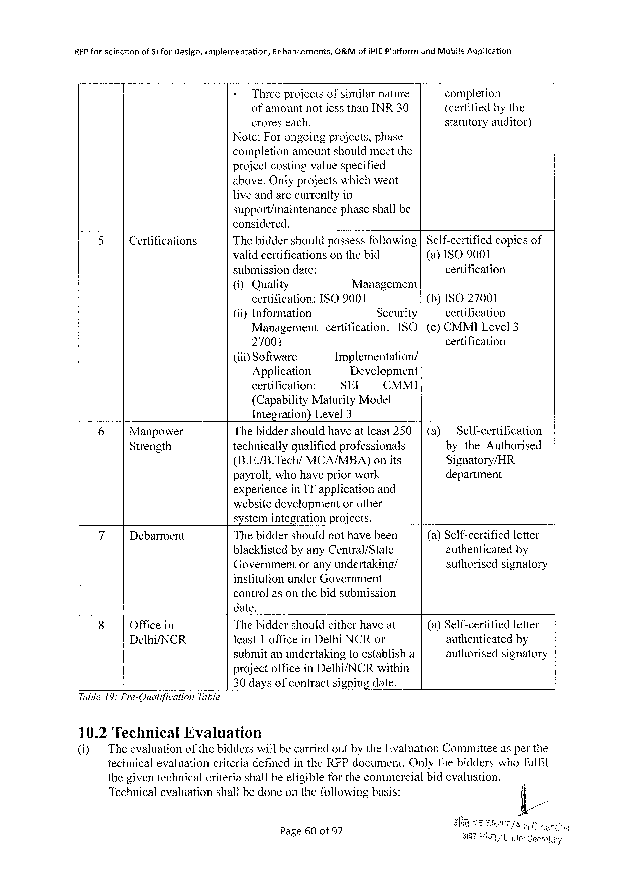

REP forselection of Sfor Design, implementation, Enhancements, O&Mofi PIEP latformand Mobile Application

» Threeprojectsof similarnature completion   
 ofamountnotlessthan INR 30 (certifiedbythe croreseach. statutoryauditor} Note: Forongoingprojects, phase   
completionamountshouldmeetthe   
projectcostingvaluespecified   
above, Onlyprojectswhichwent   
liveandarecurrentlyin

support/maintenance   
considered.

phaseshallbe

|  |  |  |  |  |  |  |  |
| --- | --- | --- | --- | --- | --- | --- | --- |
| 5 | Certifications | Thebiddershouldpossess following | | | | | Self-certifiedcopiesof |
| validcertificationsonthebid | | | | | (a) ISO 9001 |
| submissiondate: | | | | | certification |
| (i)Quality | Management | | | | (b)ISO 27001 |
| certification: | ISO 9001 | | | |
| (iiy Information | Security | | | | certification |
| Management | | certification: | | [SO | (c)CMMIL evel 3 |
| 27001 | | | | | certification |
| (iti) Software | Implementation/ | | | |
| Application | Development | | | |
| certification: | SEI | | CMMI | |

(Capability Maturity Model   
Integration)Level 3

|  |  |  |  |  |  |
| --- | --- | --- | --- | --- | --- |
| 6 | Manpower | Thebiddershouldhaveatleast 250 | | (a) | Self-certification |
| Strength | technicallyqualifiedprofessionals | | bythe Authorised |
| (B. E./B. Tech/MCA/MBA) | onits | Signatory/HR |
| payroll, whohavepriorwork | | department |

experiencein IT applicationand   
websitedevelopmentorother   
systemintegrationprojects.

|  |  |  |  |
| --- | --- | --- | --- |
| 7 | Debarment | Thebiddershouldnothavebeen | (a)Self-certifiedletier |
| authenticatedby |
| blacklistedbyany Central/State |
| Governmentoranyundertaking/ | authorisedsignatory |

institutionunder Government   
controlasonthebidsubmission   
date,

|  |  |  |  |
| --- | --- | --- | --- |
| 8 | Officein | Thebiddershouldeitherhaveat | (a)Self-certifiedletter |
| Delhi/NCR | Jeast 1 officein Delhi NCR or | authenticated by |
| submitanundertakingtoestablisha | authorisedsignatory |

projectoffice in Delhi/NCR within 30 daysofcontractsigningdate. Table 19: Pro-Oualification Table

10.2 Technical Evaluation

(i) Theevaluation of thebidderswillbecarriedoutby the Evaluation Committeeasper the technicalevaluationcriteriadefinedinthe RFP document. Onlythebidderswhofuifil thegiventechnicalcriteriashallbeeligibleforthecommereialbidevaluation.

‘Technical evaluationshallbedoneonthefollowingbasis:

Page 60 of 97

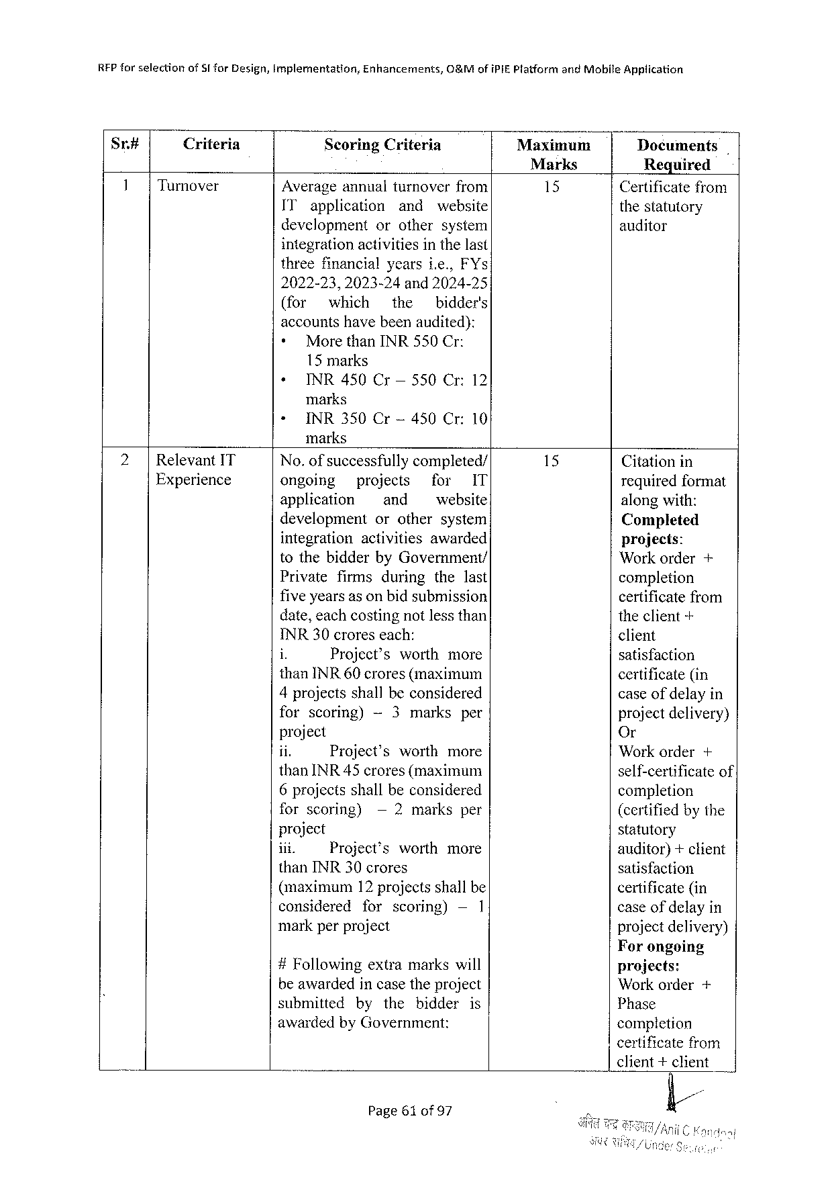

REP farselection of ST for Design, implementation, Enhancements, O&Mofi PIEP latformand Mobile Application

Sr# Criteria Scoring Criteria Maxinmuam Documents

Marks Required

Turnover Averageannualturnoverfrom 15 Certificatefrom

IT application and website thestatutory

development orothersystem auditor

integrationactivitiesin the last

threefinancialyearsie., FY s

2022-23,2023-24 and 2024-25

(for which the bidder's

accountshavebeenaudited):

|  |  |
| --- | --- |
| +  + | Morethan INR 550 Cr:  15 marks  INR 450 Cr— 550 Cr:12 |

marks

« INR 350 Cr-450 Cr:10

marks

|  |  |  |  |  |  |  |  |  |  |  |
| --- | --- | --- | --- | --- | --- | --- | --- | --- | --- | --- |
| Relevant IT | No. of successfully | | | | completed/ | | | | Citationin | |
| Experience | ongoing | projects | | | | for | | IT |
| requiredformat | |
| application | | ~ and | | | website | | | along with: | |
| development | | orothersystem | | | | | | Completed | |
| integration | | activities | | | awarded | | | projects: | |
| tothebidderby Government/ | | | | | | | | Workorder | + |
| Private | firms | | during | | thelast | | |
| completion | |
| fiveyearsas onbidsubmission | | | | | | | | certificatefrom | |
| date, eachcostingnotlessthan | | | | | | | | theclient-+ | |
| INR 30 croreseach: | | | | | | | | client | |
| i | Project’s | | | worth | | more | |
| satisfaction | |
| than INR 60 crores(maximum | | | | | | | |
| certificate(in | |
| 4 projectsshall beconsidered | | | | | | | |
| caseof delayin | |
| forscoring) | | -~3 marks | | | | per | | projectdelivery) | |
| project | | | | | | | | Or | |
| jin | Project’s | | | worth | | more | | Workorder | + |
| than INR 45 crores(maximum | | | | | | | | self-certificateof | |
| 6 projectsshallbeconsidered | | | | | | | |
| completion | |
| forscoring) | | —2 marksper | | | | | |
| (certifiedbythe | |
| project | | | | | | | | statutory | |
| ii. | Project’sworthmore | | | | | | |
| auditor)+client | |
| than INR 30 crores | | | | | | | | satisfaction | |
| (maximum | | 12 projectsshallbe | | | | | | certificate(in | |
| considered | | forscoring) | | | | —1 | | caseofdelayin | |
| markperproject | | | | | | | | projectdelivery) | |

Forongoing

|  |  |  |  |
| --- | --- | --- | --- |
| #Following | extramarkswill | projects: | + |
| beawardedincasetheproject | | Workorder |
| submittedbythebidderis | |
| Phase |
| awardedby Government: | | completion |

certificatefrom

client+client

Page 61 of 97

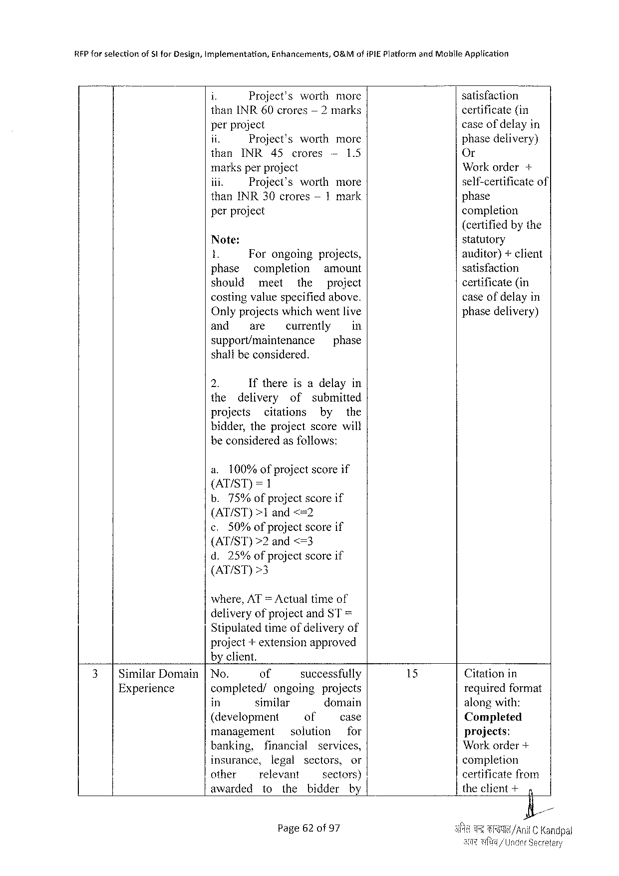

REP forselection of S|for Design, Implementation, Enhancements, O&Mofi PIEP latformand Mobile Application

i Project’s worth more satisfaction

than INR 60 crores — 2 marks certificate(in

perproject caseof delayin

it Project’s worth more phasedelivery)

than INR 45 crores — 1.5 Or

marksperproject Workorder+

iii. Project’s worthmore self-certificateof

than INR 30 crores— 1 mark phase

perproject completion

(certifiedby the

Note: statutory

1. Forongoing projects, auditor)+ client

phase completion amount satisfaction

should meet the project certificate(in

costingvaluespecifiedabove. caseof delayin

Onlyprojectswhichwentlive phasedelivery)

and are currently in

support/maintenance phase

shalibeconsidered.

2. Ifthereisadelayin

the delivery of submitted

projects citations by the

bidder, theprojectscorewill

beconsideredasfoliows:

a. 100%ofprojectscoreif

(AT/ST)=1

b.75%of project scoreif

(AT/ST)>1 and <=2

c. 50%ofprojectscoreif

(AT/ST)>2 and<=3

d.25%ofprojectscoreif

(AT/ST)>3

where, AT =Actualtimeof

deliveryofprojectand ST=

Stipulatedtimeofdeliveryof

project+extensionapproved

byclient.

|  |  |  |  |  |  |  |  |  |  |  |  |  |  |  |
| --- | --- | --- | --- | --- | --- | --- | --- | --- | --- | --- | --- | --- | --- | --- |
| 3| | Similar Domain | No. | of | | | | | successfully | | | | 15 | Citationin | |
| Experience | completed/ | | | ongoing | | | | | projects | | requiredformat | |
| in | similar | | | | | domain | | | | alongwith: | |
| (development | | | | | | of | | | case | Completed | |
| management | | | | | solution | | | | for | projects: | |
| banking, | financial | | | | | | services, | | | Workorder+ | |
| insurance, | | legal | | | | sectors, | | | or | completion | |
| other | relevant | | | | | sectors) | | | | certificatefrom | |
| awarded | to | | | the | | bidder | | | by | theclient+ | 4 |
| Page 62 of 97 | | | | | | | | | | i/Anil C Kandpal | |

Secretary

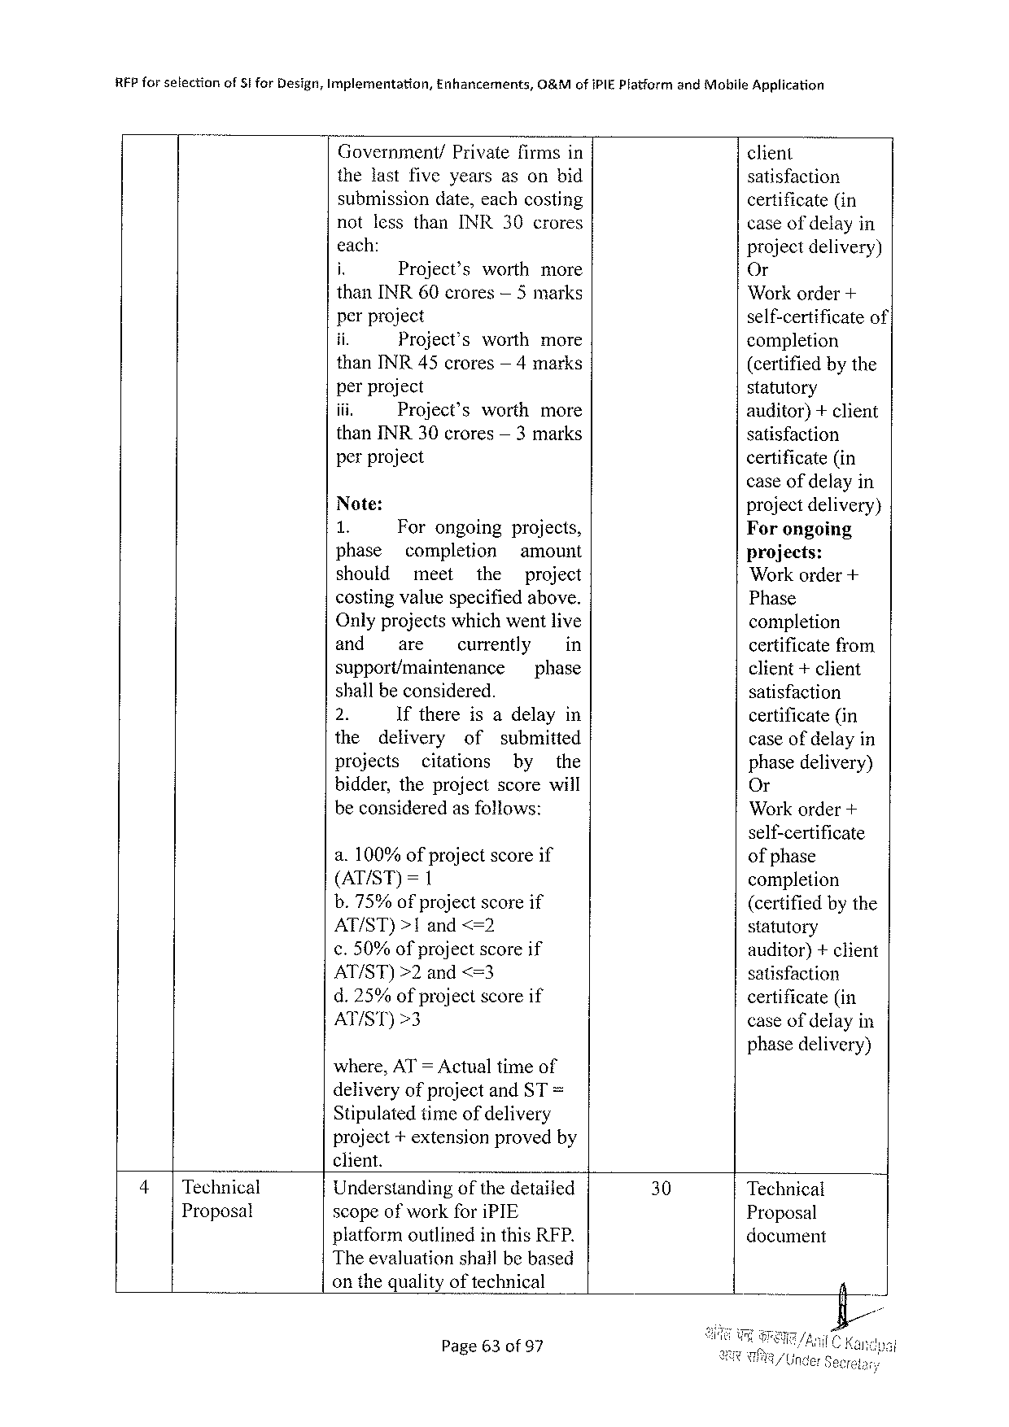

|  |  |  |  |  |  |  |  |  |
| --- | --- | --- | --- | --- | --- | --- | --- | --- |
| RFP forselection | of Sfor Design, Implementation, | | Enhancements, | | | O&Mofi PIEP latform | and Mobile Application | |
| Government/ | | | Privatefirmsin | | | client | |
| thelastfiveyearsasonbid | | | | | | satisfaction | |
| submissiondate, eachcosting | | | | | | certificate(in | |
| notlessthan INR 30 crores | | | | | | caseof delay | in |
| each: | | | | | | projectdelivery) | |
| i. | Project’s | | | worthmore | |
| Or | |
| than INR 60 crores— 5 marks | | | | | | Workorder+ | |
| perproject | | | | | | self-certificate | of’ |
| ii. | Project’s | | | worthmore | |
| completion | |
| than INR 45 crores— 4 marks | | | | | | (certifiedbythe | |
| perproject | | | | | | statutory | |
| iii. | Project’s | | | worth | more | auditor)+client | |
| than INR 30 crores— 3 marks | | | | | | satisfaction | |
| perproject | | | | | | certificate(in | |

caseof delayin

|  |  |  |  |  |  |  |  |  |
| --- | --- | --- | --- | --- | --- | --- | --- | --- |
| Note: | | | | | | | | projectdelivery) Forongoing  projects:  Workorder+  Phase  completion  certificatefrom client+client  satisfaction  certificate(in  caseofdelayin phase delivery) Or  Workorder+ |
| a 8 | | Forongoing | | | projects, | | |
| phase | | completion | | | amount | | |
| should | | meet | | the | | project | |
| costingvaluespecifiedabove. Onlyprojects whichwent live | | | | | | | |
| and | | are | currently | | | | in |
| support/maintenance | | | | | phase | | |
| shallbeconsidered. | | | | | | | |
| 2. | | Ifthereisadelayin | | | | | |
| the | delivery | | of | | submitted | | |
| projects | | citations | | | by | | the |
| bidder, theprojectscorewill beconsideredasfollows: | | | | | | | |

self-certificate

|  |  |  |  |  |  |
| --- | --- | --- | --- | --- | --- |
| a.100% of project  (AT/ST)=1 | | | | scoreif | ofphase  completion  (certifiedbythe statutory  auditor)+client satisfaction  certificate(in  caseofdelayin |
| b.75% | | of project | | scoreif |
| AT/ST)>1 and<=2 | | | | |
| ¢.50%of project | | | | scoreif |
| AT/ST)>2 | | | and<=3 | |
| d.25% | of project | | | scoreif |
| AT/ST)>3 | | | | |

phasedelivery) where, AT= Actualtimeof

deliveryofprojectand ST =

Stipulatedtimeofdelivery   
project+extensionprovedby

|  |  |  |  |  |  |
| --- | --- | --- | --- | --- | --- |
| 4| | Technical | client. | 30 | Technical | R |
| Understandingofthedetailed |
| Proposal | scopeofworkfori PIE | Proposal |
| platformoutlinedin this RFP. | document |

Theevaluationshallbebased

onthequalityoftechnical

Page 63 of 97

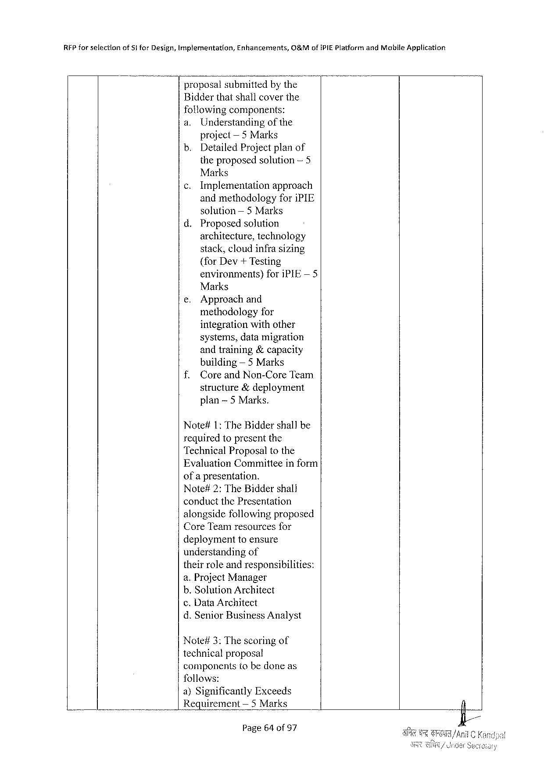

|  |  |  |  |
| --- | --- | --- | --- |
| RFP forselection | of Sifor Design, Implementation, | Enhancements, | O&Mofi PIEP latformand Mobile Application |

proposalsubmittedbythe   
Bidderthatshallcoverthe   
followingcomponents:

|  |  |  |
| --- | --- | --- |
| a. | Understanding | of the |

project— 5 Marks   
b. Detailed Projectplanof   
 theproposedsolution— 5   
 Marks  
¢. Implementation approach   
 andmethodologyfori PIE   
 solution— 5 Marks   
d. Proposedsolution   
 architecture, technology   
 stack, cloudinfrasizing   
 {for Dev+ Testing   
 environments) fori PIE— 5   
 Marks

|  |  |  |
| --- | --- | --- |
| e. | Approachand | for |
| methodology |

integrationwithother   
 systems, datamigration   
 andtraining&capacity   
 building — 5 Marks   
f. Coreand Non-Core Team   
 structure&deployment   
 plan~5 Marks.

Note#1: The Biddershallbe   
requiredtopresentthe   
Technical Proposaltothe   
Evaluation Committeeinform   
ofa presentation.

Note#2: The Biddershall   
conductthe Presentation   
alongsidefollowingproposed   
Core Teamresourcesfor   
deploymenttoensure   
understandingof   
theirroleandresponsibilities:   
a. Project Manager   
b. Solution Architect   
c. Data Architect   
d. Senior Business Analyst

Note#3: Thescoringof   
technicalproposal   
componentstobedoneas   
follows:   
a)Significantly Exceeds   
Requirement — 5 Marks

Page 64 of 97

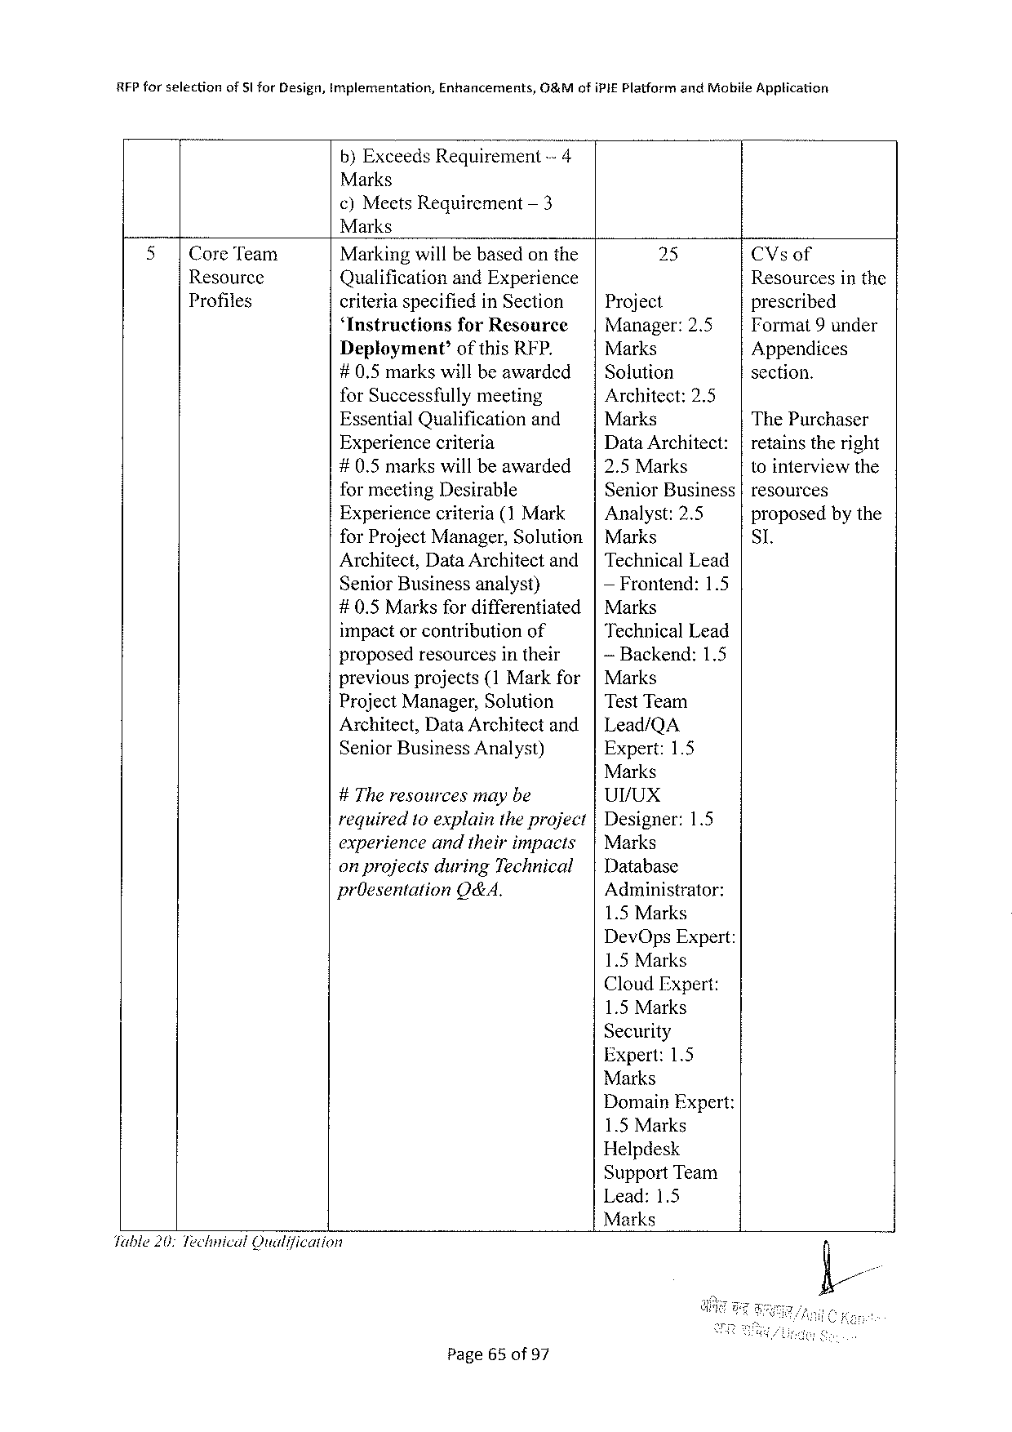

|  |  |  |  |
| --- | --- | --- | --- |
| RFP forselection | of 5 lfor Design, implementation, | Enhancements, | O&Mofi PIEP latformand Mobile Application |

b)Exceeds Requirement-4   
Marks  
¢)Meets Requirement — 3   
Marks

|  |  |  |  |  |  |
| --- | --- | --- | --- | --- | --- |
| 5 | |Core Team | Markingwillbebasedonthe | | 25 | CV sof |
| Resource | Qualificationand Experience | | Project | Resourcesinthe |
| Profiles | criteriaspecifiedin Section | | prescribed |
| ‘Instructionsfor Resource | | Manager:2.5 | TF ormat 9 under |
| Deployment’ofthis RFP. | | Marks | Appendices |
| #0.5 markswillbeawarded | | Solution | section. |
| for Successfullymeeting | | Architect:2.5 | The Purchaser |
| Essential Qualification | and | Marks |
| Experiencecriteria | | Data Architect: | retainstheright |
| #0.5 markswillbeawarded | | 2.5 Marks | tointerviewthe |
| formeeting Desirable | | Senior Business | resources |
| Experiencecriterja (1 Mark | | Analyst:2.5 | proposedbythe |
| for Project Manager, Solution | | Marks | SI. |

Architect, Data Architectand   
Senior Businessanalyst)

Technical Lead  
— Frontend:1.5

#0.5 Marksfor differentiated Marks   
 impactorcontribution of Technical Lead proposedresourcesintheir — Backend:1.5 previousprojects{1 Markfor   
 Marks Project Manager, Solution Test Team Architect, Data Architectand Lead/QA Senior Business Analyst) Expert:1.5 Marks   
 #The resourcesmaybe Ur/ux   
 required 10 explaintheproject Designer:1.5 experienceandtheirimpacts Marks   
 on projectsduring Technical   
 Database pr Oesentation O&A. Administrator: 1.5 Marks Dev Ops Expert: 1.5 Marks Cloud Expert: 1.5 Marks Security   
 Expert:1.5 Marks   
 Domain Expert: 1.5 Marks Helpdesk Support Team Lead:1.5 Marks   
Jable 20: Technical Qualification

Page 65 of 97

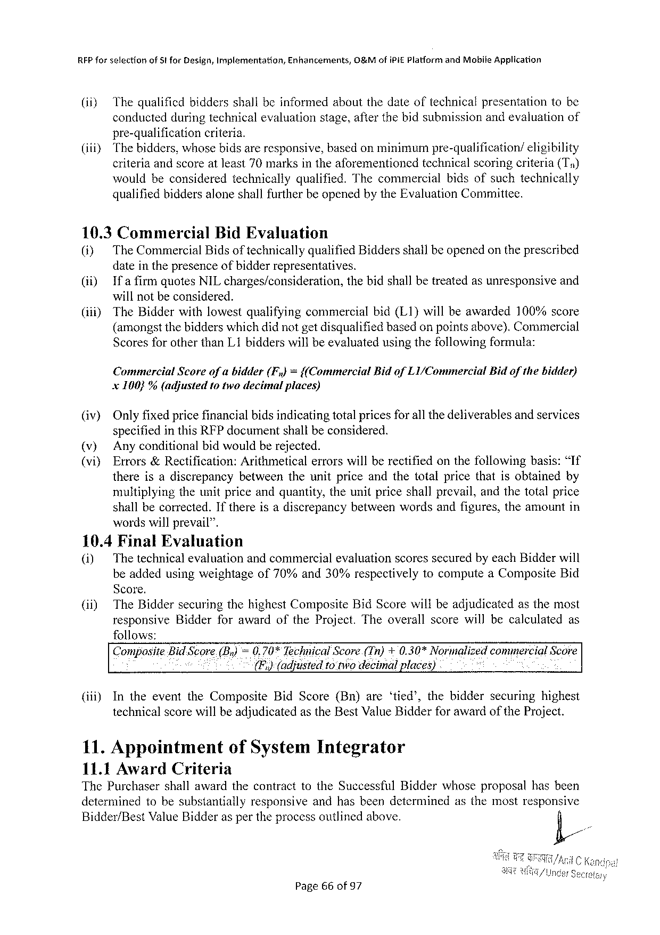

REP forselection of Stfor Design, Implementation, Enhancements, 0%Mofi Pi E Platformand Mobile Application

(ii) Thequalificdbiddersshallbeinformedaboutthedateoftechnicalpresentationtobe

conductedduringtechnicalevaluationstage, afterthebidsubmissionandevaluationof

pre-qualification criteria.

(iiiy Thebidders, whosebidsareresponsive, basedonminimumpre-qualification/ eligibility

criteriaandscoreatleast 70 marksintheaforementioned technicalscoringeriteria(Ty)

wouldbeconsidered technically qualified. Thecommercial bidsofsuchtechnically

qualifiedbiddersaloneshallfurtherbe openedbythe Evaluation Committee.

10.3 Commercial Bid Evaluation

(i) The Commercial Bidsoftechnicallyqualified Biddersshailbeopenedontheprescribed

dateinthepresenceofbidderrepresentatives.

|  |  |  |  |
| --- | --- | --- | --- |
| (i) | Ifafirm | quotes NIL charges/consideration, | thebidshallbetreatedasunresponsiveand |

willnotbeconsidered.

|  |  |  |
| --- | --- | --- |
| (i) | The Bidderwithlowestqualifyingcommercial | bid(L 1}willbeawarded 100%score |

(amongstthebidderswhichdidnotgetdisqualifiedbasedon pointsabove). Commercial

Scoresforotherthan L 1 bidderswillbeevaluatedusingthefollowingformula:

Commercial Scoreofabidder(F,)={(Commercial Bidof L 1/Commercial Bidofthebidder)

x 100}% (adjusted totwodecimalplaces)

(iv) Onlyfixedpricefinancialbidsindicatingtotalpricesfor all thedeliverablesandservices

specifiedinthis RFP documentshallbeconsidered.

(v) Anyconditionalbidwouldberejected.

(vi) Errors&Rectification: Arithmeticalerrorswillberectifiedonthefollowingbasis:“If

thereisadiscrepancy betweentheunitpriceandthetotalpricethatisobtainedby

multiplyingtheunitpriceandquantity, theunitpriceshallprevail, andthetotalprice

shallbecorrected. Ifthereisadiscrepancybetweenwordsandfigures, theamountin

wordswillprevail”.

10.4 Final Evaluation

(i) Thetechnicalevaluationandcommercialevaluationscoressecuredbyeach Bidderwill

beaddedusingweightageof 70%and 30%respectively tocomputea Composite Bid

Score.

(ii) The Biddersecuringthehighest Composite Bid Scorewillbeadjudicatedasthemost

responsive Bidderforawardofthe Project. Theoverallscorewillbecalculated as

follows:

Compmlte Bid Score(By) =0.70%Technical Score(Tn)+0.30*Normalizedcommercial Score

(F,)(adjusted 1 o twodecimalplaces)

|  |  |  |  |
| --- | --- | --- | --- |
| (iii) | Intheeventthe Composite | Bid Score(Bn)are‘tied’, thebidder | securinghighest |

technicalscorewillbeadjudicatedasthe Best Value Bidderfor awardofthe Project.

11. Appointment of System Integrator

11.1 Award Criteria

The Purchasershallawardthecontracttothe Successful Bidderwhoseproposalhasbeen

determinedtobesubstantially responsiveandhasbeendeterminedasthemostresponsive

Bidder/Best Value Bidderaspertheprocessoutlinedabove. /&/

Page 66 of 97

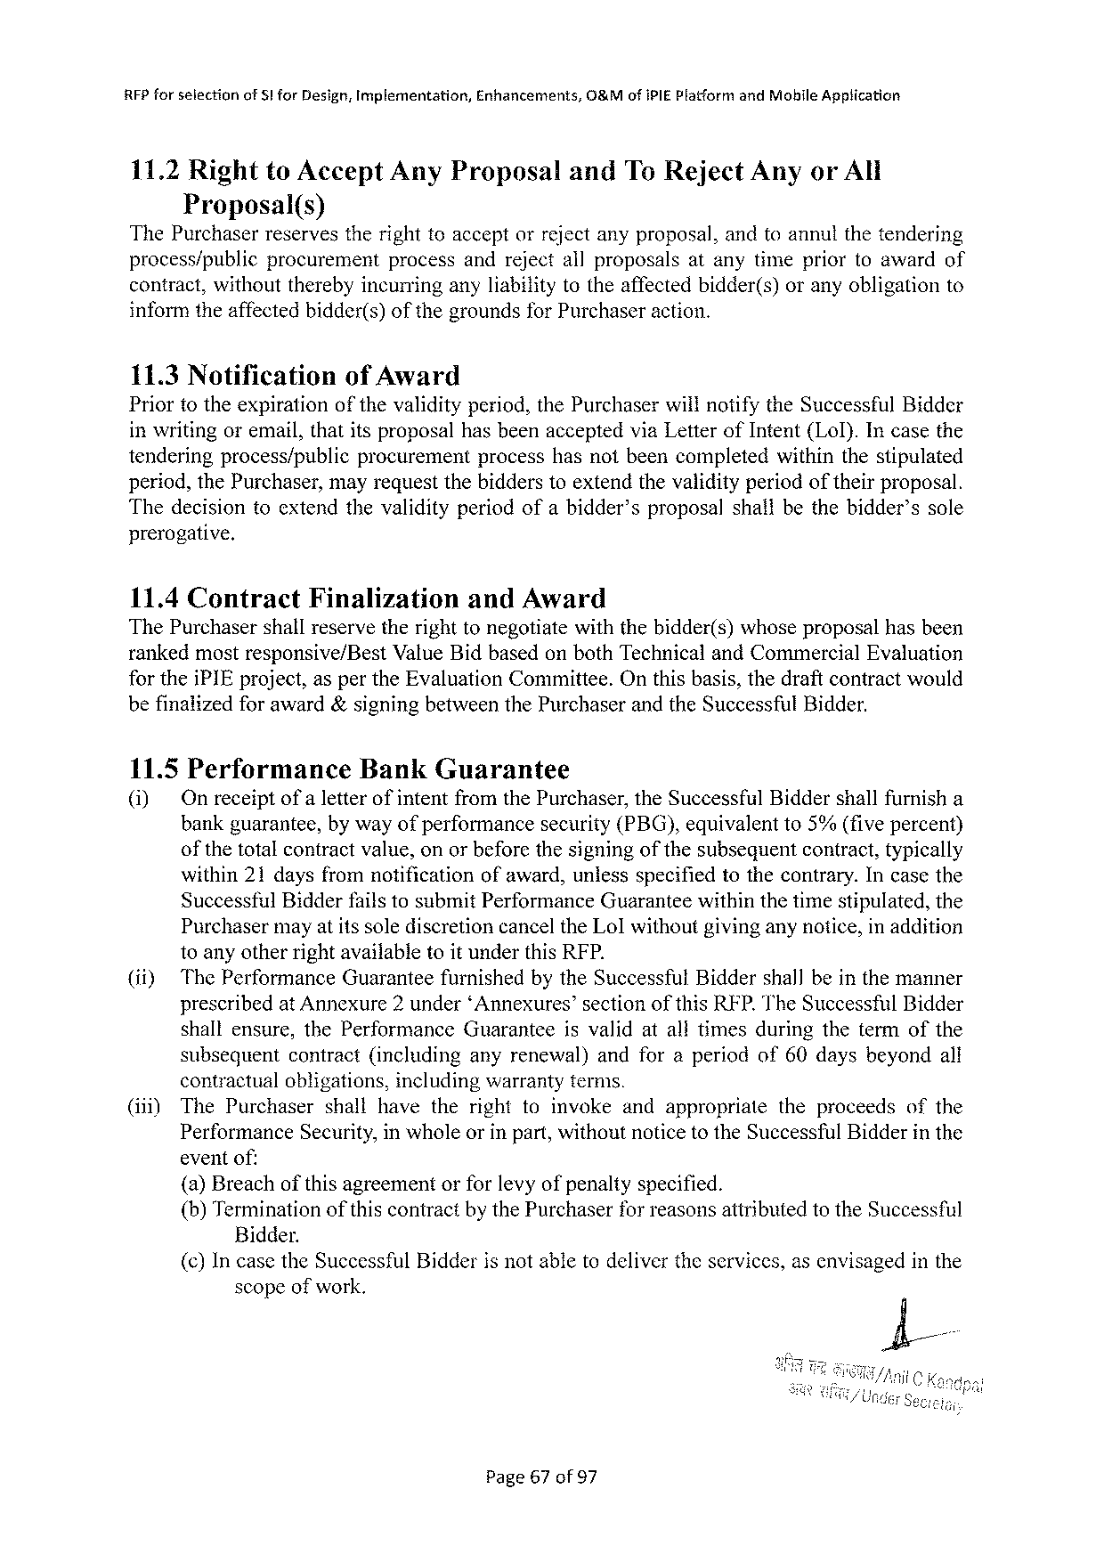

RFP forselection of 8 lfor Design, Implementation, Enhancements, O&Mofi PIE Platformand Mobhile Application

11.2 Rightto Accept Any Proposal and To Reject Anyor All   
 Proposal(s)   
The Purchaser reservesthe righttoaccept orreject anyproposal, andtoannutthe tendering

|  |  |  |  |
| --- | --- | --- | --- |
| process/public | procurement | processandrejectallproposals | atanytimepriortoawardof |

contract, withouttherebyincurringanyliabilitytotheaffectedbidder(s)oranyobligationto informtheaffectedbidder(s)ofthegroundsfor Purchaseraction.

11.3 Notification of Award   
Priortotheexpirationofthevalidityperiod, the Purchaserwillnotifythe Successful Bidder inwritingoremail, thatitsproposalhasbeenacceptedvia Letterof Intent(Lol). Incasethe

|  |  |  |  |
| --- | --- | --- | --- |
| tenderingprocess/public | procurement | processhasnotbeencompleted | withinthestipulated |

period, the Purchaser, mayrequestthebidderstoextendthevalidityperiodoftheirproposal. Thedecisiontoextendthevalidityperiodofabidder’sproposalshallbethebidder’ssole prerogative.

|  |  |  |
| --- | --- | --- |
| 11.4 Contract | Finalization | and Award |

The Purchaser shall reserve the right tonegotiate with the bidder(s) whoseproposalhas been rankedmostresponsive/Best Value Bidbasedonboth Technicaland Commercial Evaluation for thei PIE project, asperthe Evaluation Committee. Onthisbasis, thedraftcontractwould befinalizedforaward&signingbetweenthe Purchaserandthe Successful Bidder.

11.5 Performance Bank Guarantee   
(i) Onreceiptofa letterofintentfromthe Purchaser, the Successful Biddershallfurnisha bankguarantee, bywayofperformancesecurity(PBG), equivalentto 5%(fivepercent) ofthetotalcontractvalue, onorbeforethesigningofthesubsequentcontract, typically within 21 daysfromnotification ofaward, unlessspecifiedtothecontrary. Incasethe Successtul Bidderfailstosubmit Performance Guaranteewithinthetimestipulated, the Purchasermayatitssolediscretioncancelthe Lolwithoutgivinganynotice, in addition toanyotherrightavailabletoitunderthis RFP.

|  |  |  |
| --- | --- | --- |
| (ity | The Performance | Guaranteefurnishedbythe Successful Biddershallbeinthemanner |

prescribedat Annexure 2 under‘Annexures’sectionofthis RFP. The Successful Bidder

|  |  |  |  |  |  |  |  |  |
| --- | --- | --- | --- | --- | --- | --- | --- | --- |
| shall | ensure, | the Performance | Guarantee | isvalid | atalltimes | during | theterm | of the |

subsequentcontract(includinganyrenewal)andforaperiodof 60 daysbeyondall contractualobligations, includingwarrantyterms.

(iil) The Purchasershallhavetherighttoinvokeandappropriatetheproceedsofthe Performance Security, inwholeorinpart, withoutnoticetothe Successful Bidderinthe eventof:   
 (a)Breachofthisagreementorforlevyofpenaltyspecified.

(b)Terminationofthiscontractby the Purchaserfor reasonsattributedtothe Successful Bidder.

{(¢)Incasethe Successful Bidderisnotabletodelivertheservices, asenvisagedinthe scopeofwork.

Page 67 of 97

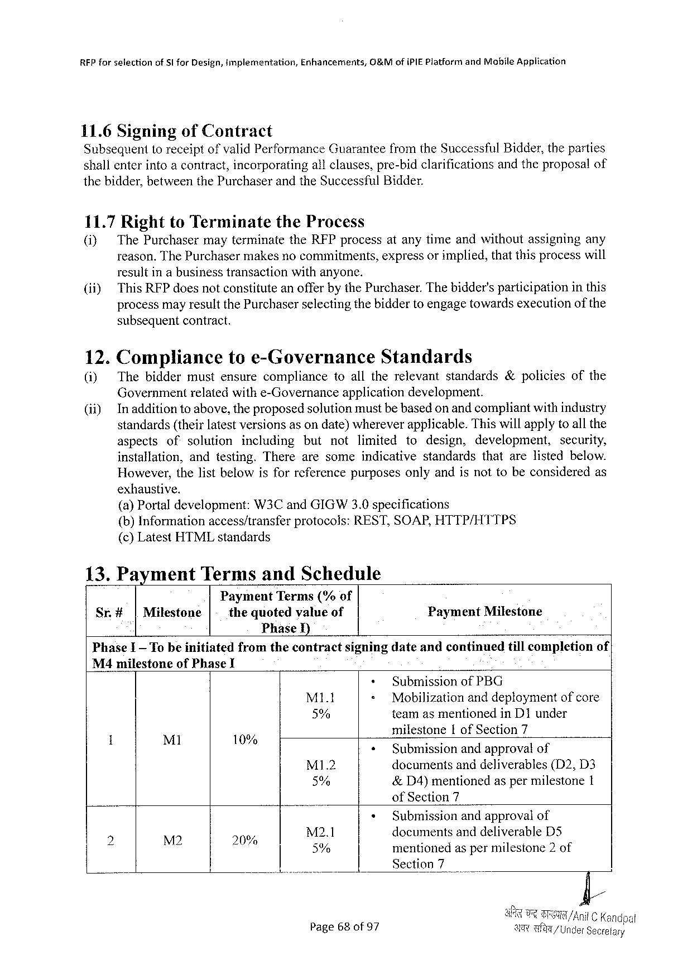

RFP forselection of 5|for Design, implernentation, Enhancemerits, G&Mofi PIEP latformand Mabile Application

11.6 Signing of Contract   
Subsequenttoreceiptofvalid Performance Guaranteefromthe Successful Bidder, theparties shallenterintoacontract, incorporatingallclauses, pre-bidclarifications andtheproposalof thebidder, betweenthe Purchaserandthe Successful Bidder.

11.7 Rightto Terminate the Process

0] The Purchasermayterminatethe RFP processatanytimeandwithoutassigningany reason. The Purchasermakesnocommitments, expressorimplied, thatthisprocesswill resultinabusinesstransactionwithanyone.

|  |  |
| --- | --- |
| (if) | This RFP doesnotconstituteanofferbythe Purchaser. Thebidder'sparticipationinthis processmayresultthe Purchaserselectingthebiddertoengagetowardsexecutionofthe |

subsequentcontract.

|  |  |  |  |  |  |  |  |  |  |  |  |  |  |
| --- | --- | --- | --- | --- | --- | --- | --- | --- | --- | --- | --- | --- | --- |
| 12.  (i) | Complianceto e-Governance Standards | | | | | | | | | | | | |
| Thebiddermustensurecompliance | | | | | toalltherelevant | | | | standards&policies | | | of the |
| Governmentrelatedwithe-Governance | | | | | applicationdevelopment. | | | | | | | |
| Inadditiontoabove, theproposedsolutionmustbebasedonandcompliantwithindustry standards(theirlatestversionsasondate)whereverapplicable. Thiswillapplytoall the | | | | | | | | | | | | |
| aspects | of | solution | including | but | not | limited | to | design, | | development, | security, | |
| installation, | | andtesting. Therearesome | | | | indicativestandards | | | | thatarelistedbelow. | | |
| However, thelistbelowisforreferencepurposesonlyandisnottobeconsideredas | | | | | | | | | | | | |

exhanstive.

(a)Portal development: W 3 Cand GIGW 3.0 specifications   
(b)Informationaccess/transferprotocols: REST, SOAP, HTTP/HTTPS (c)Latest HTML standards

|  |  |  |  |
| --- | --- | --- | --- |
| 13. Payment | | Termsand Schedule | Payment Milestone |
| Sr.# | |Milestone | Payment Terms(%of |
| thequotedvalueof |

Phase I)

|  |  |  |  |  |
| --- | --- | --- | --- | --- |
| Phase I—To beinitiated | fromthecontract | signingdateandcontmued | tillcompletion | of | |

M 4 milestoneof Phase I

|  |  |  |  |  |  |  |  |  |  |
| --- | --- | --- | --- | --- | --- | --- | --- | --- | --- |
| ! | Ml | 3 | - | + | | Submissionof PBG | | | |
| M 1 l | < | Mobilization | | anddeploymentofcore | |
| 5% | | teamasmentionedin D 1 under | | | |
| milestone | Iof Section 7 | | |
| 10% | < | | Submissionandapprovalof | | | |
| . | MI 1.2 | | documents | anddeliverables | | (D 2, D 3 |
| 5% | | &D 4)mentioned aspermilestone I | | | |
| of Section 7 | | | |
| p: | N 2 | « | |
| Submissionandapprovalof | | | |
| M 2.1 | | documentsand deliverable DS | | | |
| 20 | 5% | | mentionedas permilestone 2 of | | | |
| o | | Section 7 | I | | |
| Page 68 of 97 | | T/ | | | Under Seoretary |

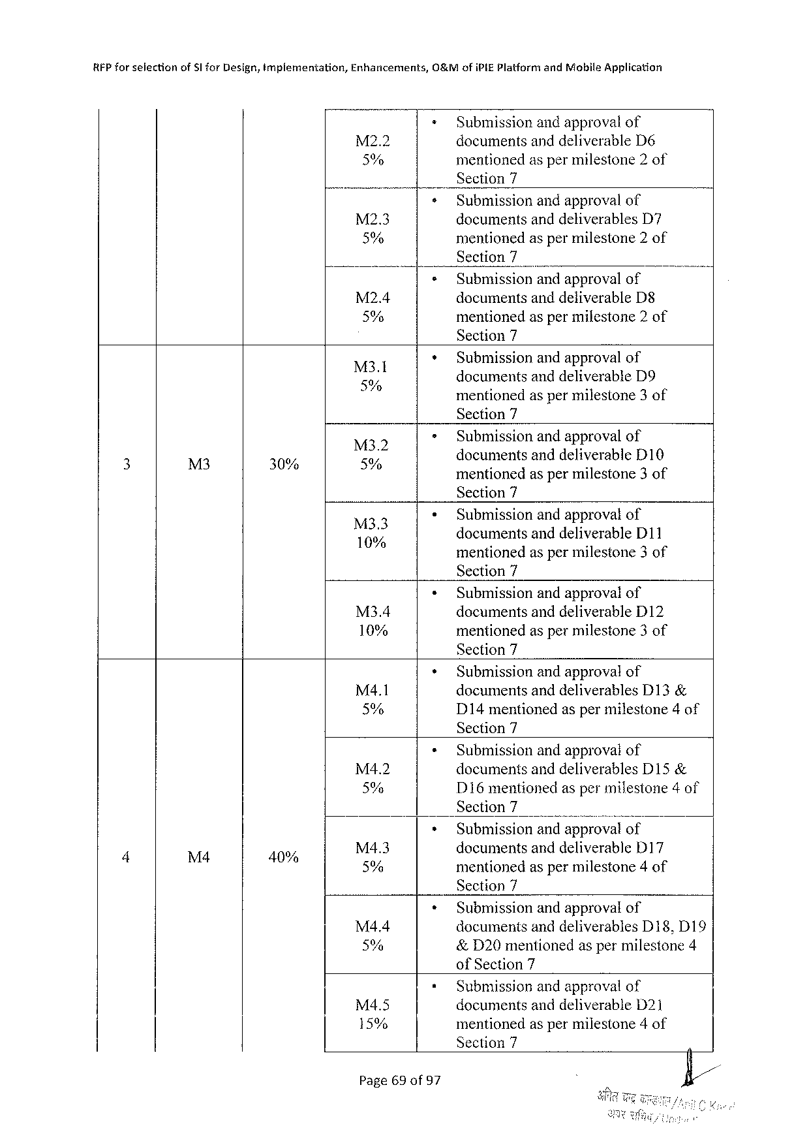

REP for selectionof Sl for Design, implementation, Enhancerments,

0&M ofi PIEP latfornt and Mobile Application

» Submissionandapprovalof

M 2.2 documentsanddeliverable D 6 5% mentionedaspermilestone 2 of Section 7

|  |  |  |  |  |
| --- | --- | --- | --- | --- |
| M 2.3 | + | Submissionandapprovalof | | . |
| documentsanddeliverables | D 7 |
| 5% | ¢ | mentionedaspermilestone 2 of | |
| Section 7 | |
| Submissionandapprovalof | |
| M 2.4 | documentsanddeliverable D 8 | |
| 5% | mentionedaspermilestone 2 of | |

Section 7

|  |  |  |
| --- | --- | --- |
| M 3.1 | » | Submissionandapprovalof |
| ;  5% | documentsanddeliverable D 9 A .  mentionedaspermilestone 3 of |

Section 7

|  |  |  |  |  |  |
| --- | --- | --- | --- | --- | --- |
| 3 | M 3 | 30% | e  5% | > | Submissionandapprovalof |
| documentsanddeliverable D 10 5 3  mentionedaspermilestone 3 of |

Section 7

|  |  |  |
| --- | --- | --- |
| 133 | ¢ | Submissionandapprovalof  d ocumentsand d deliverable D 11 |

mentionedaspermilestone 3 of   
Section 7

|  |  |  |
| --- | --- | --- |
| M 34 | ¢ | Submissionandapprovalof |
| documentsanddeliverable D 12 |
| 10% | mentionedaspermilestone 3 of |

Section 7

|  |  |  |
| --- | --- | --- |
| M 4.1 | * | Submissionandapprovalof |
| documentsanddeliverables D 13& |
| 5% | D 14 mentionedaspermilestone 4 of |

Section 7

|  |  |  |  |  |  |  |
| --- | --- | --- | --- | --- | --- | --- |
| 4 | L& | 5 | M 4.2 | « | Submissionandapprovalof | |
| documentsanddeliverables D 15& | |
| 5% | » | D 16 mentionedaspermilestone 4 of | |
| Section 7 | o |
| Submissionandapprovalof | |
| M 4.3 | documents anddeliverable D 17 | |
| 0% | 5% | mentionedaspermilestone 4 of | |

Section 7

|  |  |  |
| --- | --- | --- |
| M 4.4 | * | Submissionandapproval of |
| documentsanddeliverables D 18, D 19 |
| 5% | &D 20 mentionedaspermilestone 4 |

of Section 7

|  |  |  |
| --- | --- | --- |
| M 4.5 | « | Submissionandapprovalof |
| documentsanddeliverable D 21 |
| 15% | mentionedaspermilestone 4 of |

Section 7

Page 69 of 97

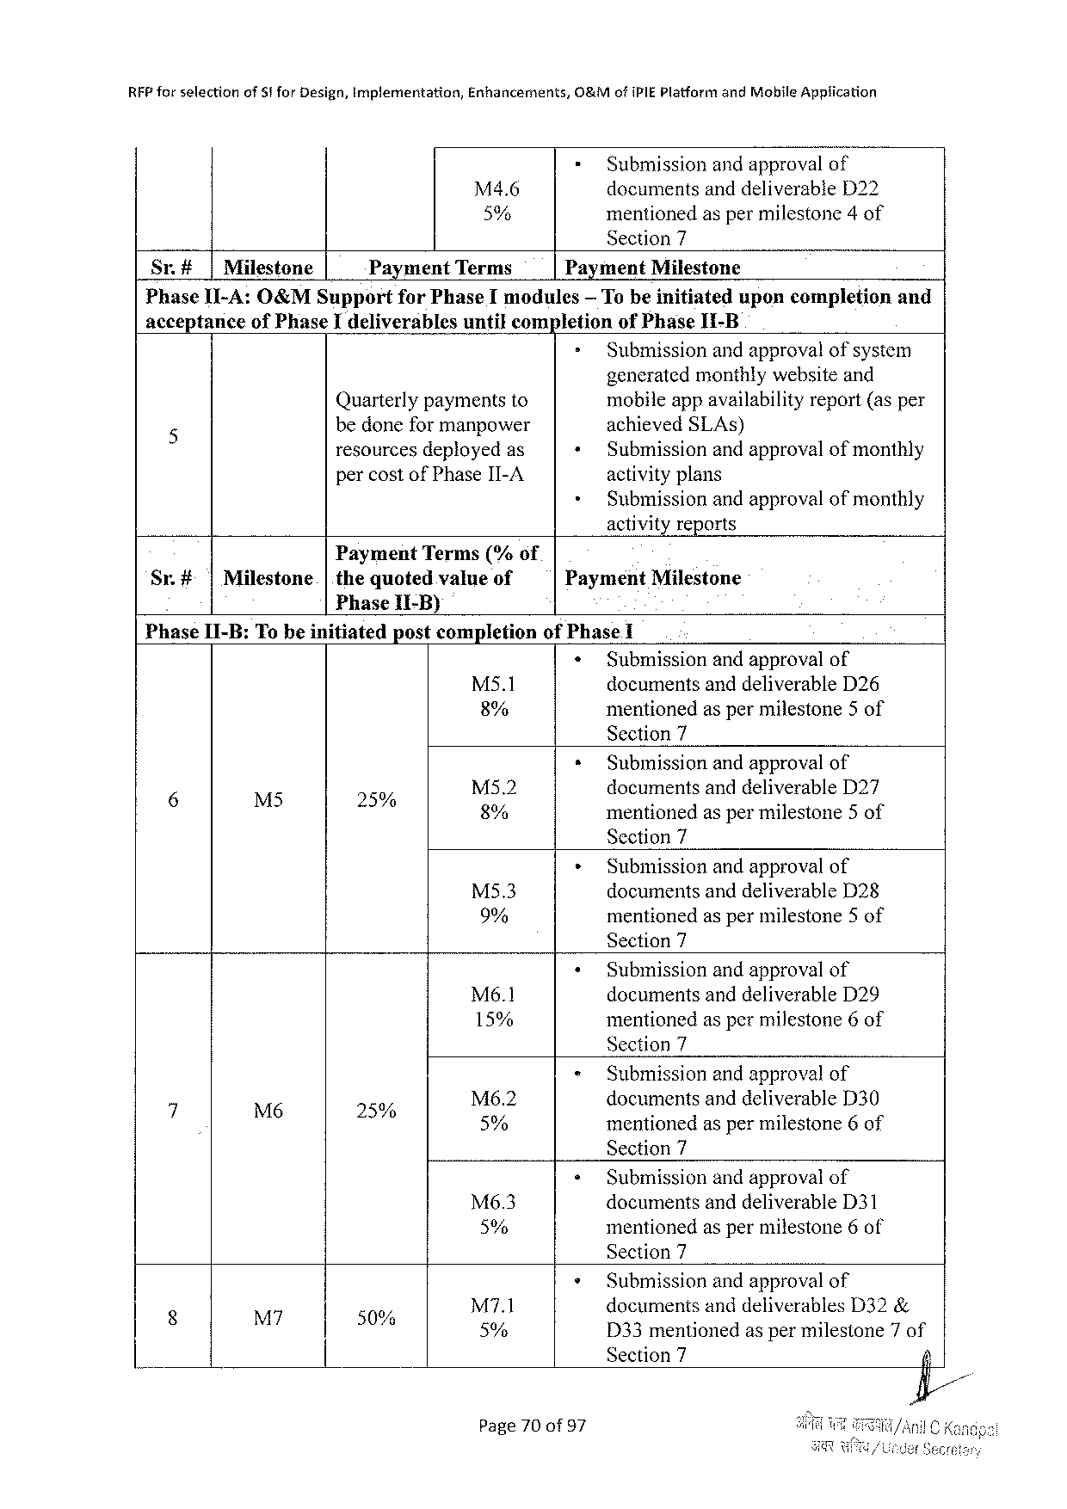

|  |  |  |  |  |
| --- | --- | --- | --- | --- |
| RFP forselection | of Stfor Design, implementation, | Enhancements, | O&Mofi PIEP latformand Mohile Application | |
| M 4.6 | = | Submission andapprovalof |
| documentsanddeliverable D 22 | |
| 5% | mentionedaspermilestone 4 of | |

Section 7

|  |  |  |  |  |  |  |  |
| --- | --- | --- | --- | --- | --- | --- | --- |
| Sr.# | |Milestone | Payment Terms | | Payment Milestone | | uponcompletion | and |
| Phase II-A: O&MS upport | | | for Phase Imodules | | — Tobeinitiated |

acceptanceof Phase Ideliverablesuntilcompletionof Phase II-B

> Submissionandapprovalofsystem   
 generatedmonthlywebsiteand

|  |  |  |  |
| --- | --- | --- | --- |
| 5 | Quarterlypaymentsto | + | mobileappavailabilityreport(asper |
| bedoneformanpower | achieved SLA s) |
| resourcesdeployedas | Submissionandapprovalofmonthly |
| percostof Phase II-A | » | activityplans |
| Submissionandapprovalofmonthly |

activityreports

Payment Terms(%of

|  |  |  |  |  |
| --- | --- | --- | --- | --- |
| Sr.#|Milestone | |thequoted | valueof | Payment | Milestone |

Phase[I-B)

Phase II-B: To beinitiatedpostcompletionof Phase I

|  |  |  |
| --- | --- | --- |
| M 5.1 | « | Submissionandapprovalof |
| documentsanddeliverable D 26 |
| 8% | mentionedas permilestone 5 of |

Section 7

|  |  |  |  |  |  |  |
| --- | --- | --- | --- | --- | --- | --- |
| g | £ | < | o | M 52 | * | Submissionandapprovalof |
| documentsand deliverable D 27 |
| L 0 | 8% | mentionedas permilestone 5 of |

Section 7

|  |  |  |
| --- | --- | --- |
| M 5.3 | » | Submissionandapprovalof |
| documentsanddeliverable D 28 |
| 9% | mentionedas permilestone 5 of |

Section 7

|  |  |  |
| --- | --- | --- |
| Mé6.1 | + | Submissionandapprovalof |
| documentsanddeliverable D 29 |
| 15% | mentionedas permilestone 6 of |

Section 7

|  |  |  |  |  |  |
| --- | --- | --- | --- | --- | --- |
| d | M 6 | o | Ms 6.2 | « | Submissionandapprovalof |
| documentsand deliverable D 30 |
| 2% | 5% | mentionedas permilestone 6 of |

Section 7

|  |  |  |
| --- | --- | --- |
| M 6.3 | + | Submissionandapprovalof |
| documentsanddeliverable D 31 |
| 5% | mentionedas permilestone 6 of |

Section 7

|  |  |  |  |  |  |  |
| --- | --- | --- | --- | --- | --- | --- |
| B | i | . | M 7.1 | * | Submissionandapprovalof | |
| documentsanddeliverables D 32& | |
| 0% | 5% | D 33 mentionedaspermilestone 7 of | |
| Section 7 | Iy |

Page 70 of 97

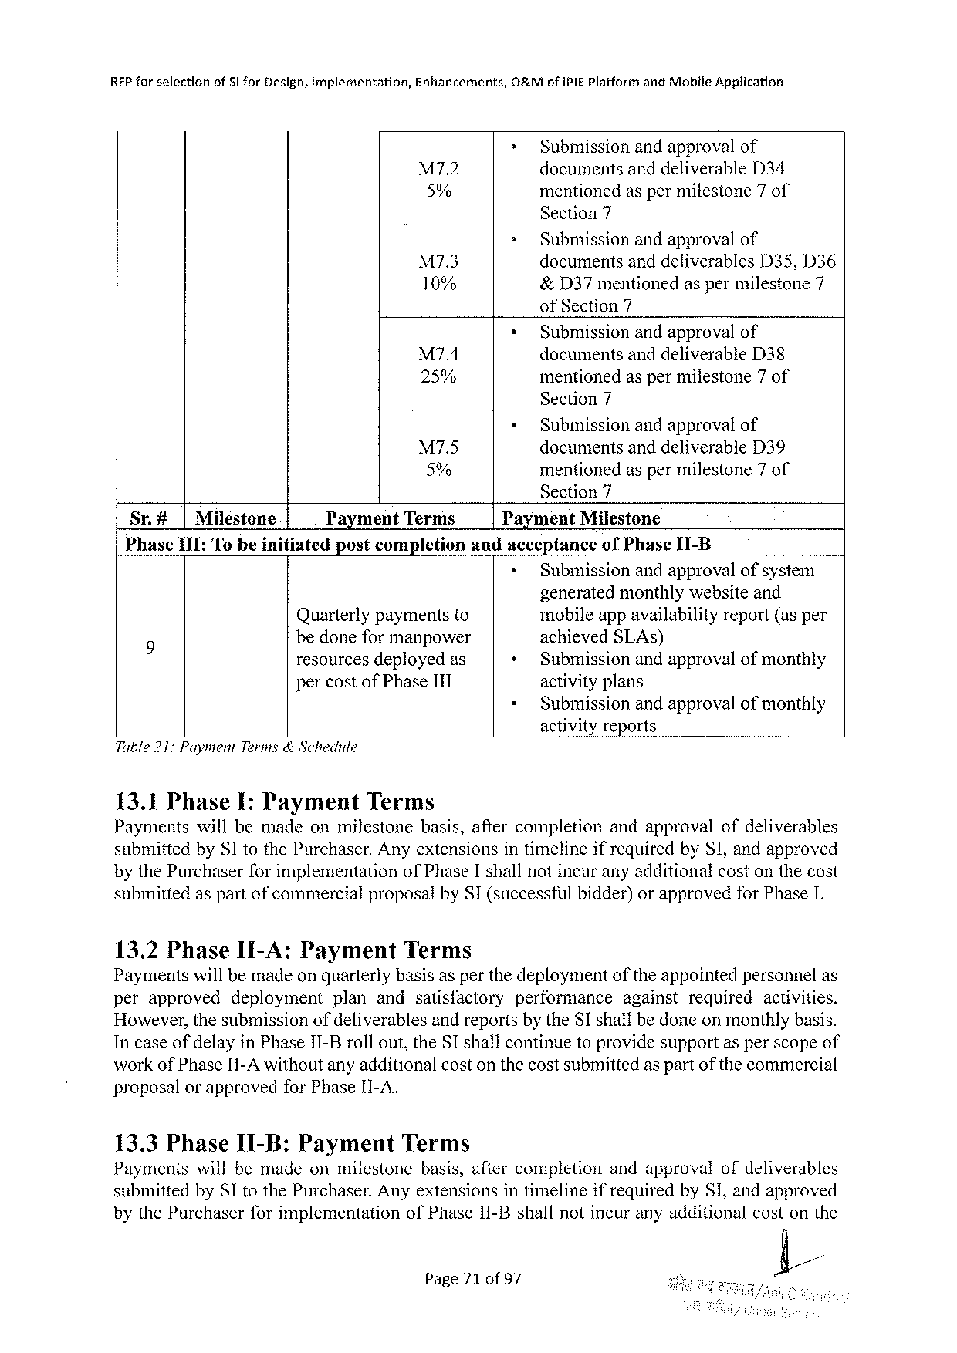

RFP forselectionof 51 for Design, Implementation, Enhancements, O&Mof IPIEP latform and Mobile Apgtication

|  |  |  |
| --- | --- | --- |
| M 7.2 | = | Submissionandapprovalof |
| documentsanddeliverable D 34 |
| 5% | mentionedas permilestone 7 of |

Section 7

|  |  |  |  |
| --- | --- | --- | --- |
| M 7.3 | > | Submissionandapprovalof | |
| documentsanddeliverables | D 33, D 36 |
| 10% | &D 37 mentionedasper milestone 7 | |

of Section 7

|  |  |  |
| --- | --- | --- |
| M 74 | + | Submissionandapprovalof |
| documentsanddeliverable D 38 |
| 25% | mentionedas permilestone 7 of |

Section 7

|  |  |  |  |
| --- | --- | --- | --- |
| M 7.5 | ¢ | Submissionandapprovalof | |
| documentsanddeliverable | D 39 |
| 5% | mentionedaspermilestone 7 of | |

Section 7

|  |  |  |  |  |  |  |
| --- | --- | --- | --- | --- | --- | --- |
| Sr.#|Miléstone | Payment | Terms | Payment | | Milestone | |
| Phase II 1: Tobeinitiated | postcompletion | | andacceptance | | | of Phase I 1-B |
| » | Submissionandapprovalofsystem | | |

generatedmonthlywebsiteand

Quarterlypaymentsto mobileappavailabilityreport(asper

9 bedoneformanpower achieved SLA s)

resourcesdeployedas + Submissionandapprovalofmonthly

percostof Phase ITI activityplans

« Submissionandapprovalofmonthly

activityreports

Table 217 Payment Terms& Schedule

13.1 Phase I: Payment Terms

Paymentswillbemadeonmilestone basis, aftercompletion andapprovalofdeliverables

submittedby SI to the Purchaser. Anyextensionsintimelineifrequiredby SI, andapproved

bythe Purchaserforimplementation of Phase Ishallnotincuranyadditionalcostonthecost

submittedaspartofcommercialproposalby SI(successfulbidder)orapprovedfor Phase I.

13.2 Phase 1 I-A: Payment Terms

Paymentswillbemadeonquarterlybasisasperthedeploymentoftheappointedpersonnelas

|  |  |  |  |  |  |  |  |
| --- | --- | --- | --- | --- | --- | --- | --- |
| perapproved | deployment | plan | andsatisfactory | performance | against | required | activities. |

However, thesubmissionofdeliverablesandreportsbythe SI shallbedoneonmonthlybasis.

Incaseof delayin Phase II-Brollout, the SI shallcontinuetoprovidesupportasperscopeof

workof Phase I 1-A withoutanyadditionalcostonthecostsubmittedas partofthecommercial

proposalorapprovedfor Phase[I-A.

13.3 Phase I 1-B: Payment Terms

Paymentswillbemadeonmilestonebasis, aftercompletionandapprovalofdeliverables

submittedby SI to the Purchaser. Anyextensionsintimelineifrequiredby SI, andapproved

bythe Purchaserforimplementation

of Phase 1 I-B shallnotincuranyadditionalcostonthe

Page 71 of 97 L

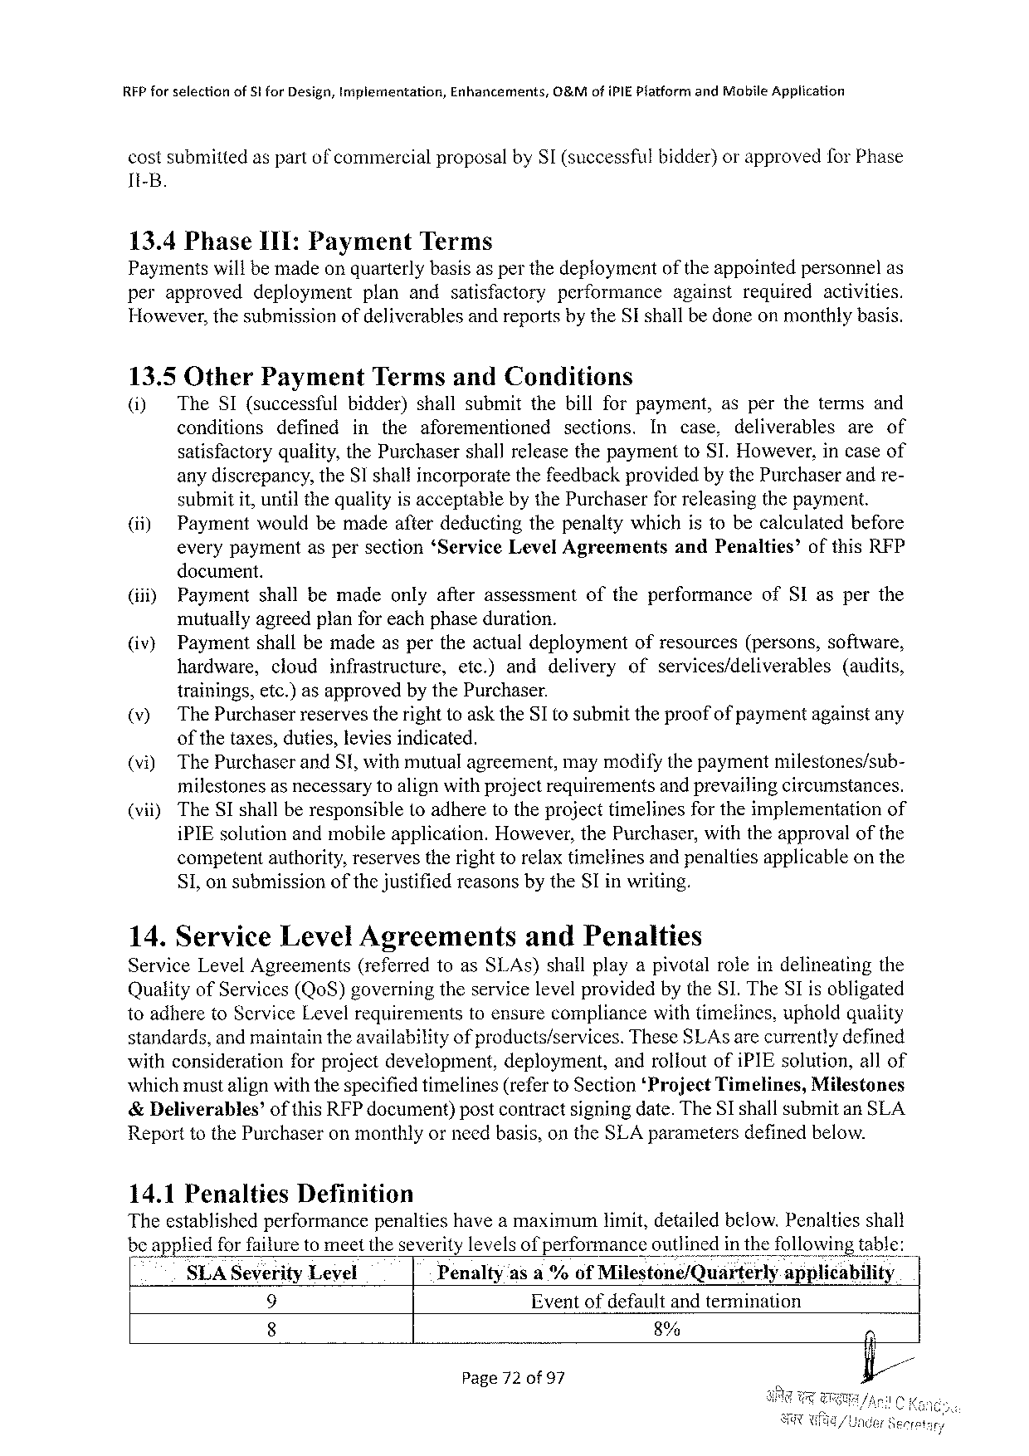

REP for selectionof 5 tfor Design, implementation, Enhancements, O&Mofi PIEP latform and Mobile Application

costsubmittedaspartof commercialproposalby SI (successfulbidder)orapprovedfor Phase

It-B.

13.4 Phase I 1 I: Payment Terms

Paymentswillbemadeonquarterlybasisas perthedeploymentof theappointedpersonnelas

|  |  |  |  |  |  |  |
| --- | --- | --- | --- | --- | --- | --- |
| perapproved | deployment | planandsatisfactory | performance | against | required | activities. |

However, thesubmissionofdeliverablesandreportsbythe SI shallbedoneonmonthlybasis.

13.5 Other Payment Termsand Conditions

(i) The SI(successful bidder)shallsubmitthebillforpayment, asperthetermsand

conditions defined intheaforementioned sections. In case, deliverables areof

satisfactoryquality, the Purchasershallreleasethepaymentto SI. However, incaseof

anydiscrepancy, the SI shallincorporatethefeedbackprovidedbythe Purchaserandre-

submitit, untilthequalityisacceptablebythe Purchaserforreleasingthepayment.

(ii) Paymentwouldbemadeafterdeductingthepenaltywhichistobecalculatedbefore

everypaymentaspersection‘Service Level Agreements and Penalties’ ofthis RFP

document.

|  |  |  |  |
| --- | --- | --- | --- |
| (iii) | Paymentshallbemadeonlyafterassessment | oftheperformance | of SI asperthe |

mutuallyagreedplanforeachphaseduration.

|  |  |  |  |  |  |  |
| --- | --- | --- | --- | --- | --- | --- |
| (iv) | Paymentshallbemadeaspertheactualdeployment | | | | ofresources(persons, software, | |
| hardware, | cloud | infrastructure, | etc.)anddelivery | ofservices/deliverables | (audits, |

trainings, etc.)asapprovedby the Purchaser.

(v) The Purchaserreservestherighttoaskthe SI tosubmittheproofofpaymentagainstany

ofthetaxes, duties, leviesindicated.

(vi) The Purchaserand S!, withmutualagreement, maymodifythepaymentmilestones/sub-

milestonesas necessarytoalignwithprojectrequirementsand prevailingcircumstances.

|  |  |  |
| --- | --- | --- |
| (vii) | The SI shallberesponsible(oadheretotheprojecttimelinesfortheimplementation | of |

i PIE solutionandmobileapplication. However, the Purchaser, withtheapprovalofthe

competentauthority, reservestherighttorelaxtimelinesandpenaltiesapplicableonthe

S 1, on submissionof thejustifiedreasonsbythe SI inwriting.

14. Service Level Agreements and Penalties

Service Level Agreements (referredtoas SI. As)shallplayapivotalroleindelineatingthe

Qualityof Services(Qo S)governingtheservicelevelprovidedby the S 1. The SI isobligated

toadhereto Scrvice Levelrequirements standards, andmaintaintheavailability

toensurecompliancewithtimelines, upholdquality of products/services. These SLA sarecurrentlydefined

|  |  |  |
| --- | --- | --- |
| withconsiderationforprojectdevelopment, | deployment, | androlioutofi PIE solution, allof |

whichmustalignwiththespecifiedtimelines(referto Section‘Project Timelines, Milestones &Deliverables’ ofthis RFP document)postcontractsigningdate. The SI shallsubmitan SLA Reporttothe Purchaseron monthlyorneedbasis, on the SLA parametersdefinedbelow.

|  |  |  |  |
| --- | --- | --- | --- |
| SLAS everity Level | Penalty | asa%of Mllestone/Quarterly | appllcablhty |

9 Eventofdefaultandtermination

8 8%

Page 72 of 97

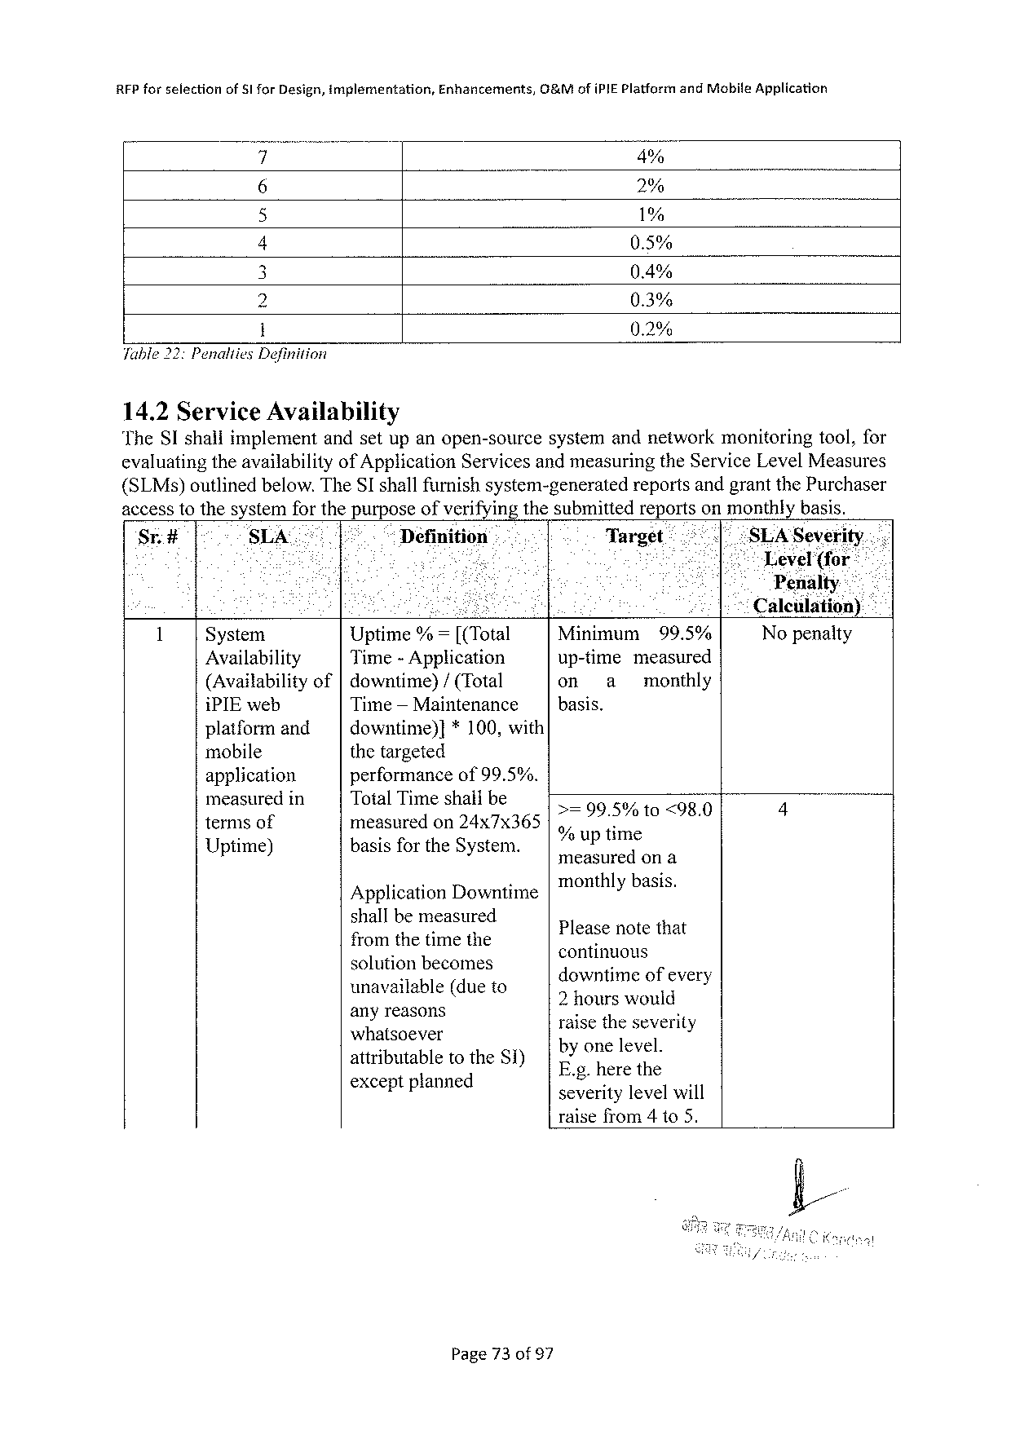

|  |  |  |  |
| --- | --- | --- | --- |
| RFP forselection | of Sl for Design, implementation, | Enhancements, | 0&Mofi PIEP latformand Mobite Application |

4% 2% 1% 0.5% 0.4% 0.3% 0.2% Table 22: Penalties Definition

14.2 Service Availability   
The SI shaliimplementandsetupanopen-source systemandnetworkmonitoringtool, for evaluatingtheavailability of Application Servicesandmeasuringthe Service Level Measures (SLM s)outlinedbelow. The SI shallfurnishsystem-generated reportsandgrantthe Purchaser accesstothesystemforthepurposeofverifyingthesubmittedreportsonmonthlybasis.

|  |  |  |  |  |  |  |  |  |  |  |  |
| --- | --- | --- | --- | --- | --- | --- | --- | --- | --- | --- | --- |
| Sr.# | SLA | Definition | | .. | Target | | | | “SLAS everity.. | | |
| 1 | - | | | | th | | | | Level | | (for |
| Penalty.--2 o 15 Caleulationy | | | | | | |
| e | | i | |
| System | Uptime%=[(Total | | | Minimum | | | 99.5% | | Nopenalty | |
| Availability | Time-Application | | | up-time | | measured | | | | |
| (Availabilityof|downtime)/(Total | | | | on | a | monthly | | | | |
| i PIE web | Time— Maintenance | | | basis. | | | | | | |
| platformand | downtime)]*100, with | | | >=99.5% | | 10 <98.0 | | 2 | | 1 |
| mobile | thetargeted | | |
| application | performanceof 99.5%. | | |
| measuredin | Total Timeshatlbe | | |
| termsof | measuredon 24 x 7 x 365 | | | % uni | | | | | | |
| Uptime) | basisforthe System. | | | ¢ uptime  measuredona | | | | | | |

Application Downtime   
shallbemeasured   
fromthetimethe   
solutionbecomes   
unavailable(dueto   
anyreasons   
whatsoever   
attributable   
 to the Si) exceptptanned

monthlybasis.

Pleasenotethat   
continuous   
downtimeofevery   
2 hourswould   
raisetheseverity   
byonelevel.

E. g. herethe   
severitylevelwill   
raisefrom 4 to 5.

Page 73 of 97

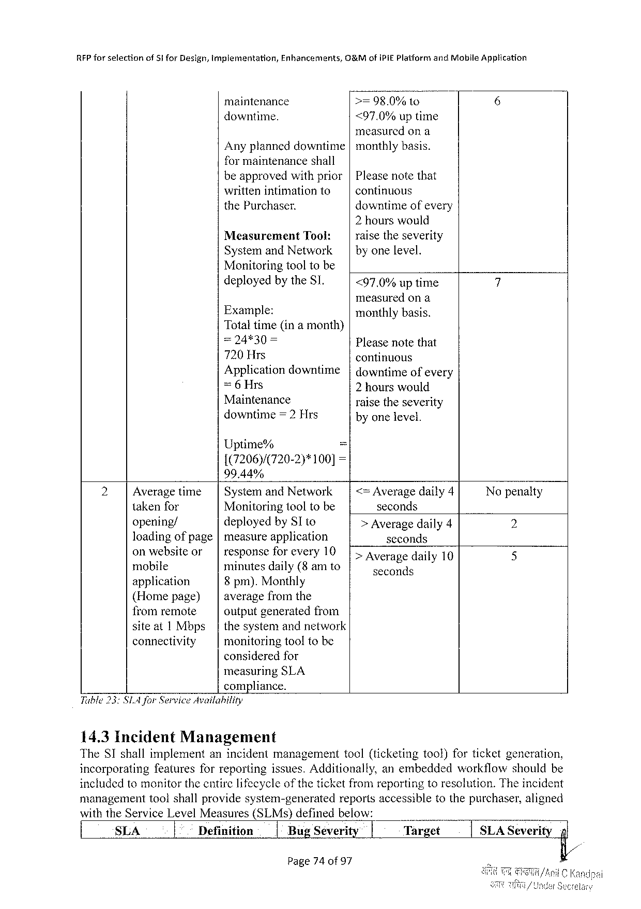

|  |  |  |  |  |  |
| --- | --- | --- | --- | --- | --- |
| RFP forselection | of $ifor Design, tmplementation, | Enhancements, | G&Mofi Pi E Plaiformand Mobile Application | | |
| maintenance | | >=98.0% | to | 6 |
| downtime. | | <97.0%uptime | | |

measuredona   
Anyplanneddowntime|monthlybasis.

formaintenanceshall   
beapprovedwithprior|Pleasenotethat   
writtenintimationto continuous   
the Purchaser. downtimeofevery   
 2 hourswould

|  |  |  |  |
| --- | --- | --- | --- |
| Measurement | Tool: | | | raisetheseverity |
| Systemand Network | | byonelevel. |

Monitoringtooltobe

|  |  |  |
| --- | --- | --- |
| deployedbythe SI. | <97.0%uptime | 7 |

measuredona

|  |  |  |
| --- | --- | --- |
| Example:  Totaltime(ina month) | | monthlybasis. Pleasenotethat |
| =24*30 | = |

720 Hrs   
Applicationdowntime

continuous   
|downtimeofevery

=6 Hrs 2 hourswould

Maintenance   
downtime=2 Hrs

raisetheseverity   
byonelevel.

Uptime% =

1(7206)/(720-2)*100]=

99.44%

|  |  |  |  |  |  |  |  |
| --- | --- | --- | --- | --- | --- | --- | --- |
| 2 | Averagetime | | | | Systemand Network | | | <= Averagedaily 4 | Nopenalty |
| takenfor | Monitoringtooltobe | | | | seconds | 2 |
| opening/ | deployedby SI to | | | | > Averagedaily 4 |
| loadingofpage|measureapplication | | | | | seconds |
| 5 |
| onwcbs: lcor | | | | responsefo_r every 10 | | [Averagedaily 10 |
| mobile | minutesdaily(8 amto | | | | seconds |
| application | 8 pm). Monthly | | | |
| (Homepage) | averagefromthe | | | |
| fromremote | outputgeneratedfrom | | | |
| siteat 1 Mbps | | thesystemandnetwork | | |
| connectivity | monitoringtooltobe | | | |

consideredfor

measuring SLA

compliance.

Table 33 SIA for Service Availability

14.3 Incident Management

The ST shallimplementanincidentmanagement tool(ticketingtool)forticketgeneration,

incorporating featuresforreportingissues. Additionally, anembedded workflowshouldbe

includedtomonitorthecntirelifecycle of the ticketfromreportingtoresolution. Theincident

management toolshallprovidesystem-generated reportsaccessibletothepurchaser, aligned

with the Service Level Measures(SLM s)definedbelow:

|  |  |  |  |  |  |  |
| --- | --- | --- | --- | --- | --- | --- |
| SLA | Definition | 1 Bug Severity | i | Target | SLAS everity | nl |

Page 740 of 97

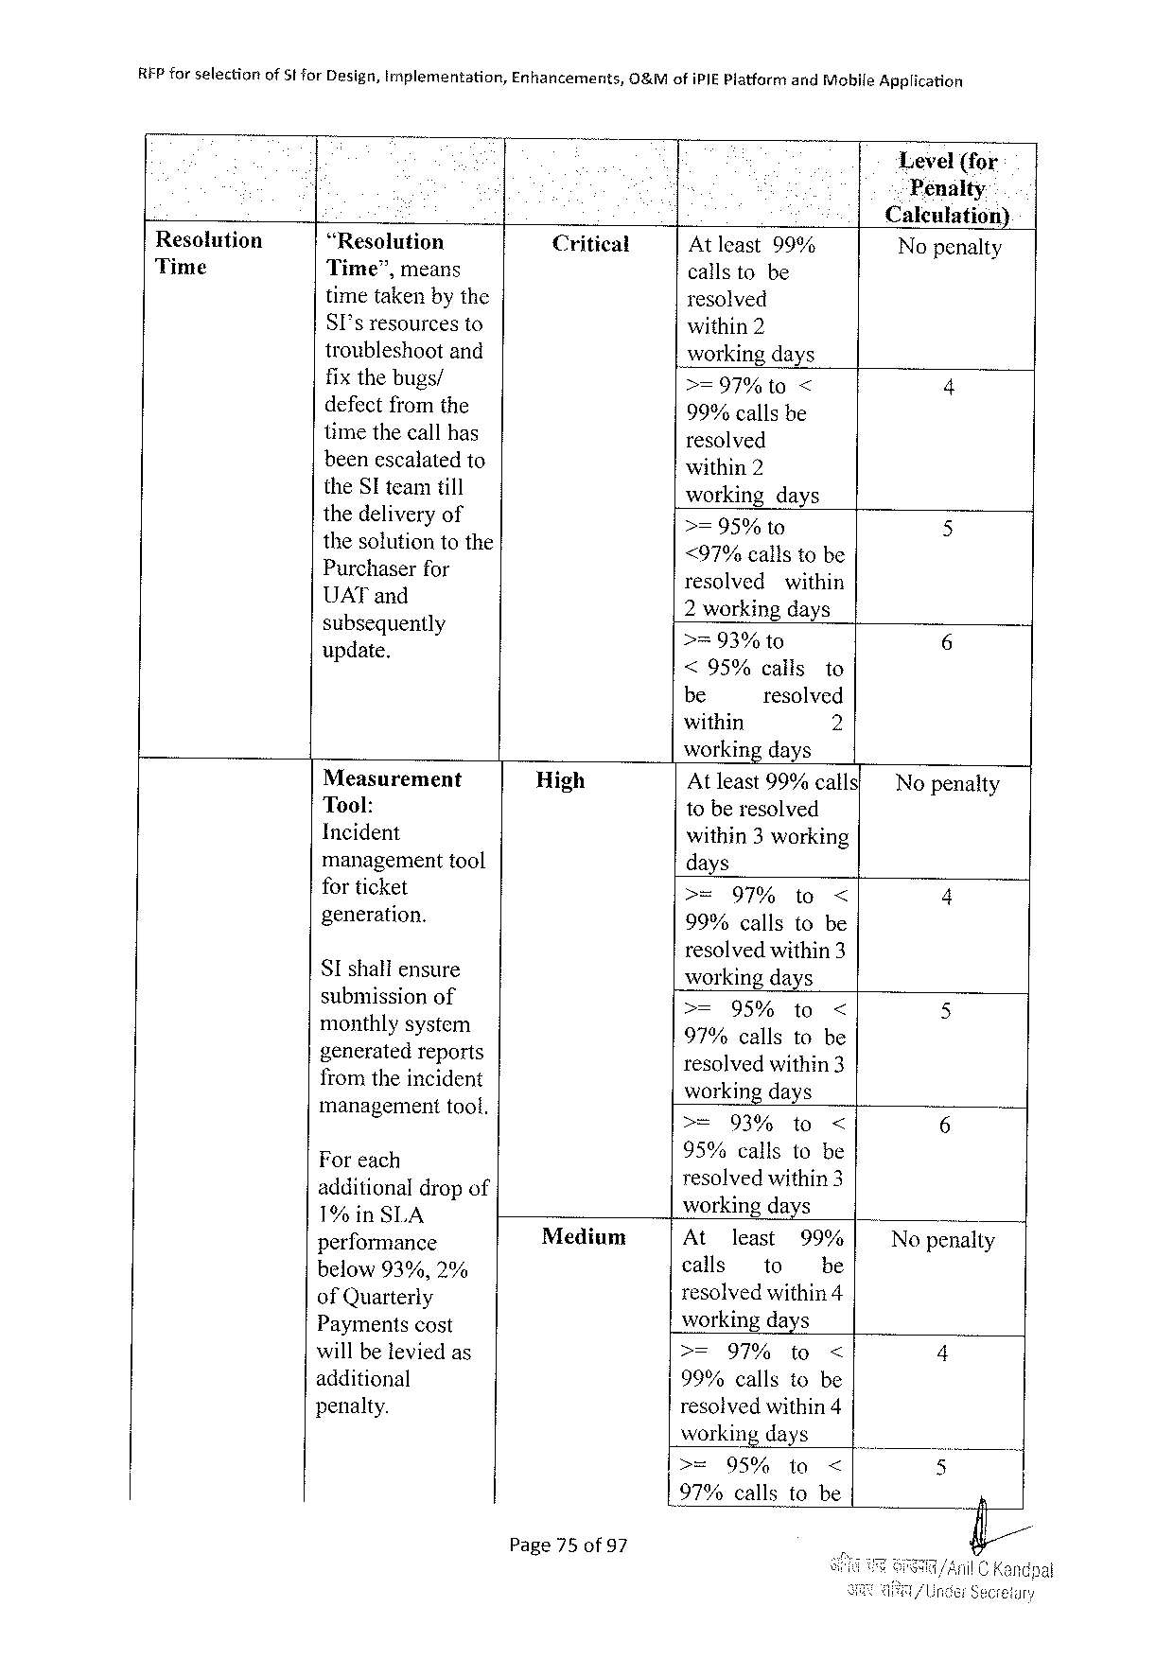

|  |  |  |  |  |
| --- | --- | --- | --- | --- |
| REP forselection | of 5 tfor Design, implementation, | Enhancements, | O&Mofi PIEP latfarm | and Mobile Application |

Level(for   
Penalty

Caleulation)

|  |  |  |  |  |  |  |  |
| --- | --- | --- | --- | --- | --- | --- | --- |
| Resolution | “Resolution | Critical | Atleast 99% | | | | Nopenalty |
| Time | Time”, means |
| callstobe | | | |
| timetakenbythe | resolved | | | | 4 |
| SI'sresourcesto | within 2 | | | |
| troubleshootand | workingdays | | | |
| fix thebugs/ |
| >=97%1 t 0 | | < | |
| defectfromthe | 99%callsbe | | | |
| timethecallhas | resolved | | | | 5 |
| beenescalatedto | within 2 | | | |
| the SI teamtill | working | days | | |
| thedellv. cryof | >=95% | 1 o | | |
| thesolutiontothe | <97%callstobe | | | |
| Pur’c‘haserfor | 6 |
| resolvedwithin | | | |
| UAT and  Ek(; zetguenlly | 2 working days >=93% to | | | |
| : | <95%calls | | | to |
| be | resolved | | |
| within | 2 | | |

workingdays

|  |  |  |  |  |  |  |  |  |
| --- | --- | --- | --- | --- | --- | --- | --- | --- |
| Measurement | | High | Atleast 99%calls' | | | | | No penalty |
| Tool: | | toberesolved | | | | |
| Incident | |
| within 3 working | | | | |
| 4 |
| managementtool | |
| days | | | | |
| for ticket | | >= | 97% | | to | < |
| generation. | |
| 99%callsto be | | | | |
| resolvedwithin 3 | | | | |
| SI shaliensure | |
| workingdays | | | | |
| submission of | | >= | | 95%to | | < | 5 |
| monthlysystem | | 97%callstobe | | | | |
| generatedreports fromtheincident | | 5 |
| resolvedwithin 3 workingdays | | | | |
| management | toof, | = | 039 | | 10< | |

Foreeh   
additional drap of 1%in SLA

95% callsllo‘b::

Iesolvedithins workingdays

|  |  |  |  |  |  |  |  |
| --- | --- | --- | --- | --- | --- | --- | --- |
| performance | | Medium | Atl 1 least | | 99:? | | Nopenalty |
| 0 | 90, | calls | to | e | |
| E? B: Yai}efi;, e | | resol](Yed\évithin 4 | | | | 4 |
| Paymentscost | | w Workingidays | | | |
| will be leviedas additional | | >=97%to< 99%callstobe | | | |
| penalty. | | 5 |
| resolvedwithin 4 | | | |
| working days | | | |
| >= | 95% | to | < |
| L 97%callstobe | | | | n |

Page 75 of 97

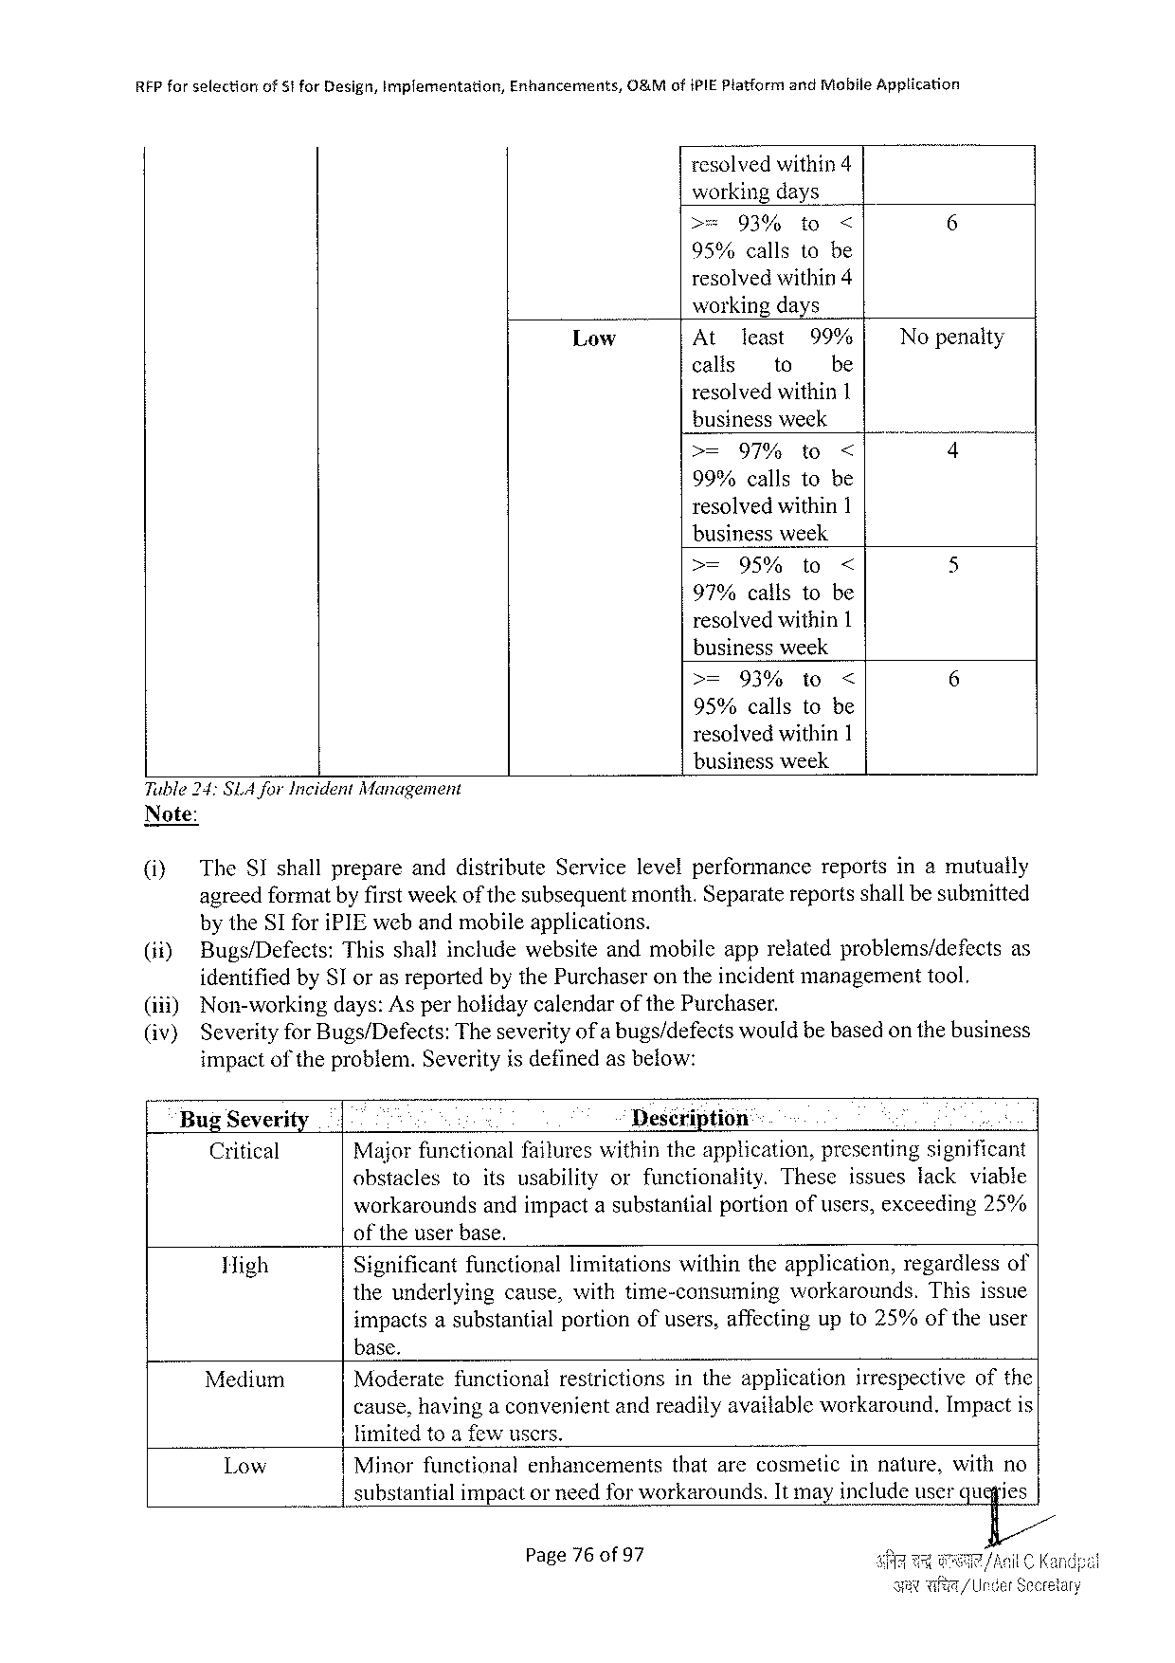

|  |  |  |  |
| --- | --- | --- | --- |
| REP forselection | of 5 tfor Design, implementation, | Enhancements, | O&Mofi PIEP latformand Mobile Application |

resolvedwithin 4   
workingdays

|  |  |  |  |  |
| --- | --- | --- | --- | --- |
| >= | 93% | to | < | 6 |

95%callstobe   
resolvedwithin 4   
workingdays

|  |  |  |  |  |
| --- | --- | --- | --- | --- |
| Low | At | least | 99% | Nopenalty |
| calls | to | be |

resolvedwithin 1   
businessweek

|  |  |  |  |  |
| --- | --- | --- | --- | --- |
| >= | 97% | to | < | 4 |

99%callstobe   
resolvedwithin 1   
businessweek

|  |  |  |  |  |
| --- | --- | --- | --- | --- |
| >= | 95% | to | < | 5 |

97%callstobe   
resolvedwithin 1   
businessweek

|  |  |  |  |  |
| --- | --- | --- | --- | --- |
| >= | 93% | to | < | 6 |

95%callstobe   
resolvedwithin 1   
businessweek

Tuble 24: SLA for Incident Management   
Note:

|  |  |  |  |
| --- | --- | --- | --- |
| @ | The SI shallprepareanddistribute | Servicelevelperformance | reportsinamutually |
| agreedformatbyfirstweekof thesubsequentmonth. Separatereportsshallbesubmitted | | |

by the SI fori PIE webandmobileapplications.

|  |  |  |
| --- | --- | --- |
| (ii) | Bugs/Defects: Thisshallincludewebsiteandmobileapprelatedproblems/defects | as |

identifiedby SI orasreportedbythe Purchaserontheincidentmanagementtool.

|  |  |  |  |  |  |  |
| --- | --- | --- | --- | --- | --- | --- |
| (ii)) (iv) | Non-workingdays: Asperholidaycalendar | | | of the | Purchaser. | |
| Severityfor Bugs/Defects: Theseverityofa bugs/defectswouldbebasedonthebusiness impactofthe problem. Severityis definedasbelow: | | | | | |
| Bug Severity | | | Description | | A |
| Critical | Majorfunctionalfailureswithintheapplication, presentingsignificant | | | | |
| obstacles | | toitsusability | orfunctionality. | | Theseissueslackviable |

workaroundsandimpactasubstantialportionofusers, exceeding 25% of theuserbase.

|  |  |  |  |  |
| --- | --- | --- | --- | --- |
| High | Significantfunctionallimitationswithintheapplication, regardlessof | | | |
| theunderlying | cause, withtime-consuming | workarounds. | Thisissue |

impactsasubstantial   
base.

portionofusers, affectingupto 25%oftheuser

Medium Moderatefunctional restrictions intheapplication irrespectiveofthe

cause, havinga convenijentandreadilyavailableworkaround. Impactis

limitedtoa fowusers.

|  |  |  |
| --- | --- | --- |
| Low | Minorfunctionalenhancements | thatarecosmeticinnature, withno |
| substantialimpactor needforworkarounds. It mayincludeuserqu}ies/ | |

Page 76 of 97

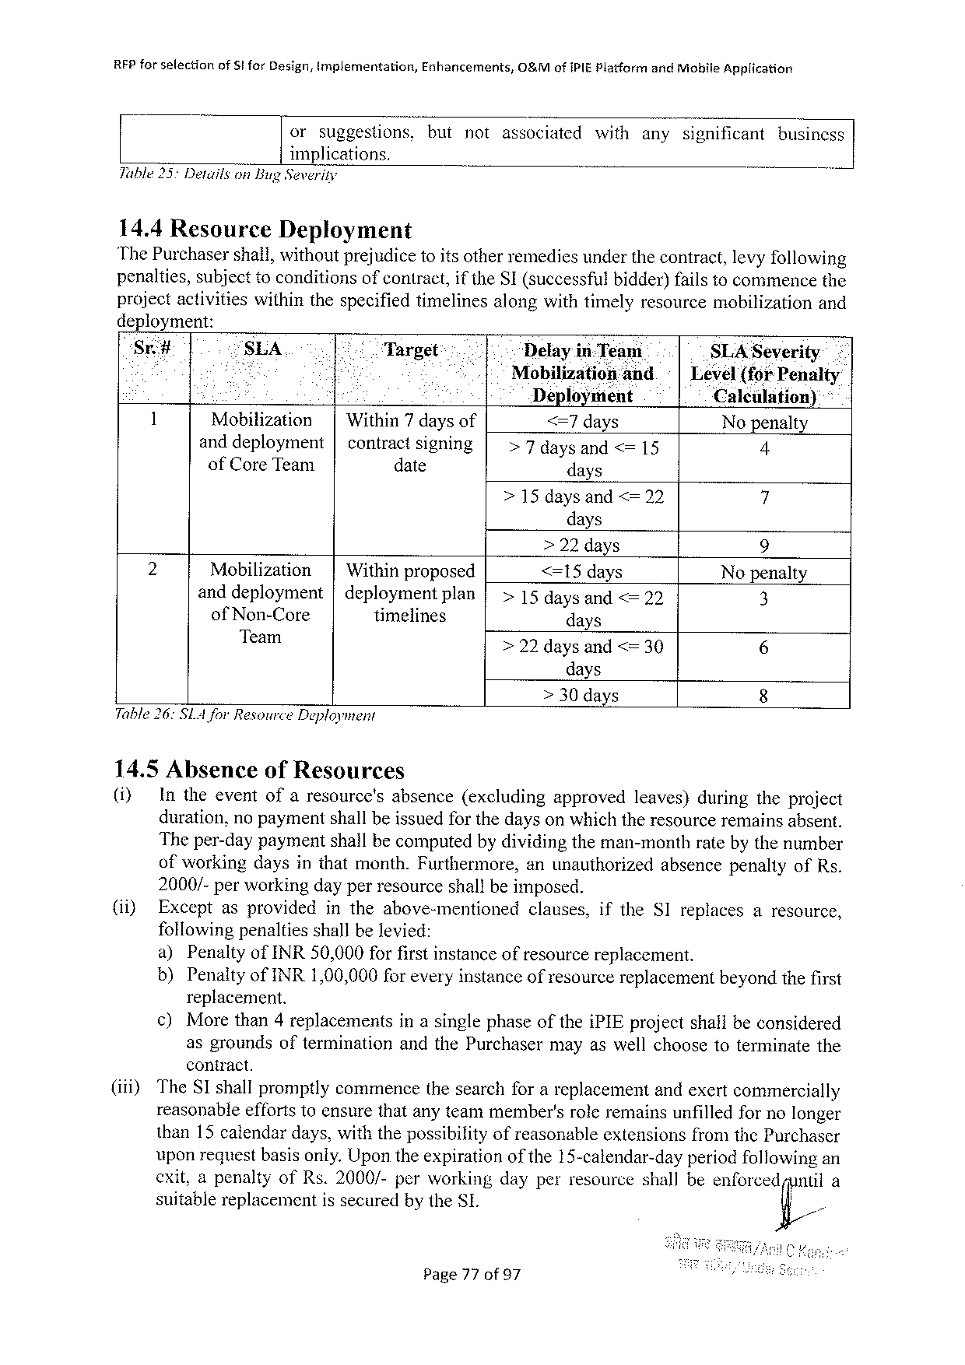

|  |  |  |  |
| --- | --- | --- | --- |
| RFP forselection | of 5 for Design, tmplementation, | Enhancements, | 0&Mofi PIEP latformand Mobile Application |

orsuggestions. butnotassociatedwithanysignificantbusincss

implications.

Table 25 Detailson Bug Severity

14.4 Resource Deployment

The Purchasershall, withoutprejudice 1 o itsotherremediesunderthecontract, levyfollowing

penalties, subjecttoconditionsof contract, if the SI(successfulbidder)failstocommencethe

projectactivitieswithinthespecifiedtimelinesalongwithtimelyresourcemobilization and

deployment:

Sr# “SLA Target Delayin-Team SLA Severity

e Mobilizationand | Level(for Penalty

Deployment Calculation) *

1 Mobilization | Within 7 daysof <=7 days Nopenalty

anddeployment| contractsigning >7 daysand<=15 4

of Core Team date days

>15 daysand<=22 i

days

|  |  |  |  |  |  |  |
| --- | --- | --- | --- | --- | --- | --- |
| 2 | Mobilization | | | Withinproposed | | | >22 days | 9 |
| <=15 days |
| Nopenalty |
| anddeployment | |deploymentplan | |
| >15 daysand<=22 | 8 |
| of Non-Core | timelines | | days |
| 6 |
| Team | >22 daysand <= 30 |

days

> 30 days 8

Table 26: SLA Jor Resource Deployment

14.5 Absenceof Resources

() Intheeventofaresource's absence(excluding approved leaves)duringtheproject

duration, nopaymentshallbeissuedforthedayson whichtheresourceremainsabsent.

Theper-daypaymentshailbecomputedbydividingtheman-monthratebythenumber

ofworkingdaysinthatmonth. Furthermore, anunauthorized absencepenaltyof Rs.

2000/-perworkingdayperresourceshallbeimposed.

(i) Exceptasprovided intheabove-mentioned clauses, ifthe SI replaces aresource,

followingpenaltiesshallbelevied:

a) Penaltyof INR 50,000 forfirstinstanceofresourcereplacement.

b) Penaltyof INR 1,00,000 for everyinstanceofresourcereplacementbeyondthefirst

replacement.

¢) Morethan 4 replacements inasinglephaseofthei PIE projectshalbeconsidered

asgroundsoftermination and the Purchasermayaswellchoosetoterminatethe

contract.

(iii) The SI shallpromptlycommencethesearchforareplacementandexertcommercially

reasonableeffortstoensurethatanyteammember'sroleremainsunfilledfornolonger

than 15 calendardays, withthepossibilityofreasonableextensionsfromthe Purchaser

uponrequestbasisonly. Upontheexpirationofthe 15-calendar-dayperiodfollowingan

cxit, apenaltyof Rs.2000/-perworkingdayperresourceshallbeen(omcdfl;/nul

suitablereplacementissecuredbythe SL

Page 77 of 97

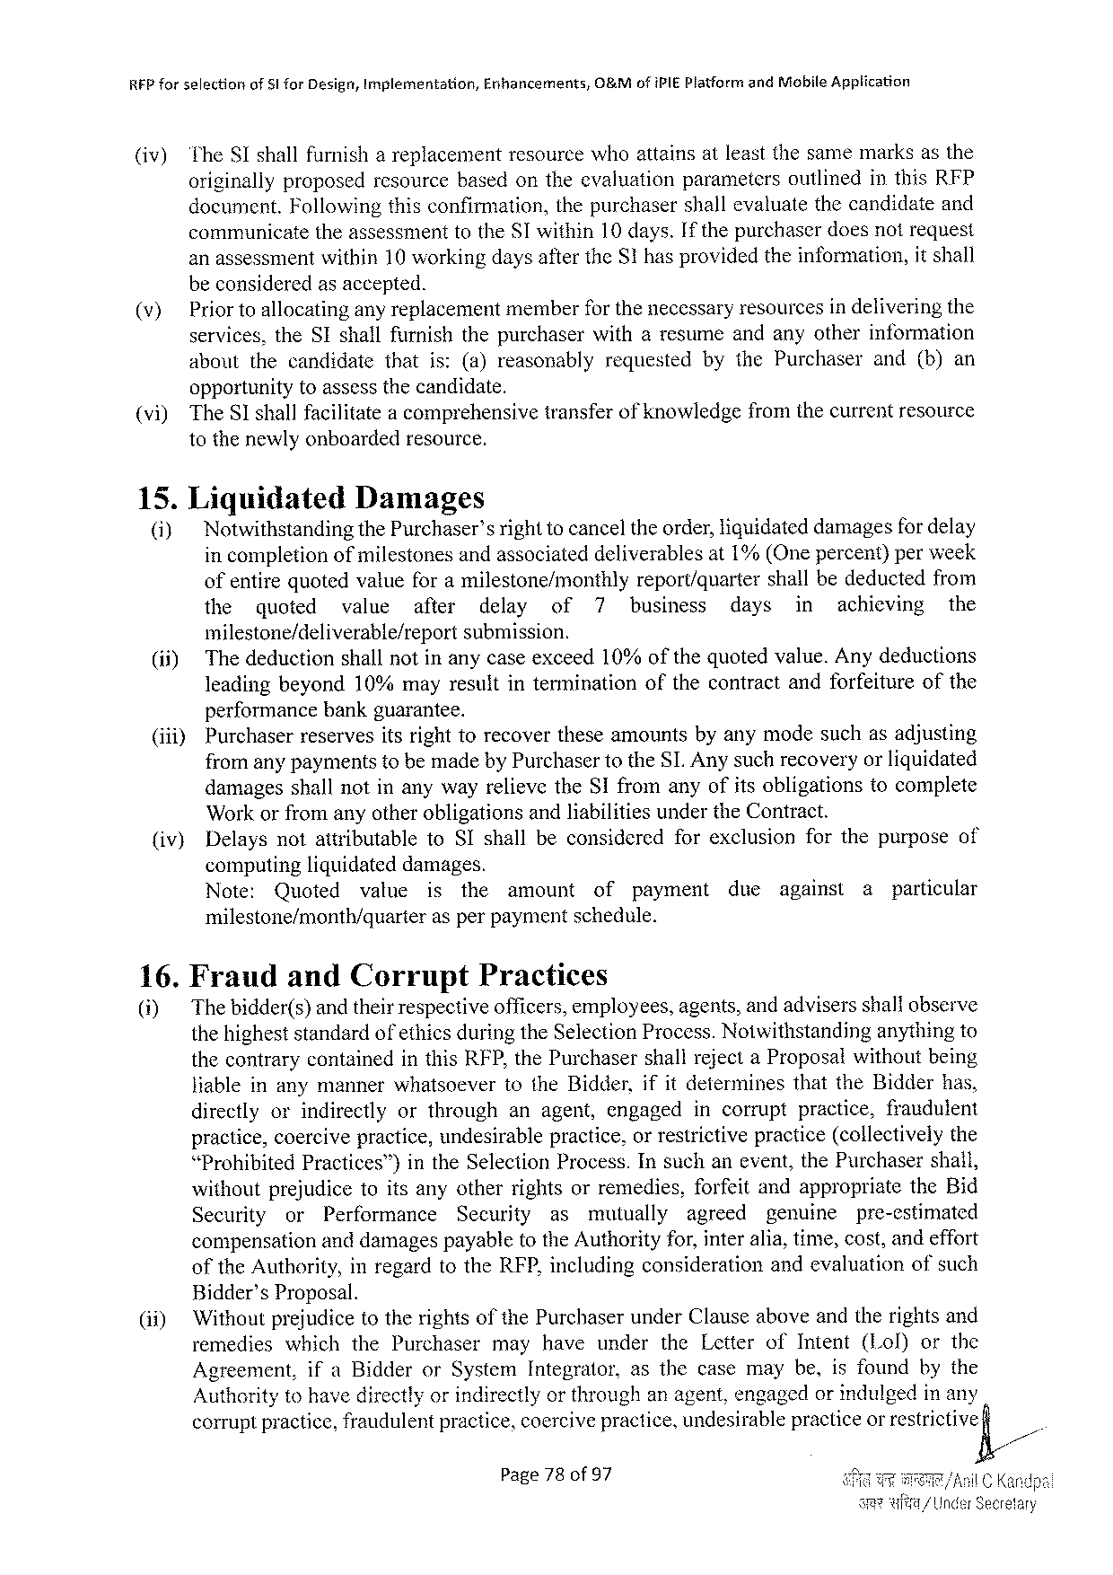

REP forselection of 51 for Desigr, Implementation, Enhancements, O&Mof i PIEP latformand Mobile Appiication

(iv) The SI shallfurnish areplacement resource whoattains atleastthesamemarks asthe

originallyproposedresourcebasedontheevaluationparameters outlinedinthis RFP

document. Followingthisconfirmation, the purchaser shallevaluate the candidateand

communicate theassessmenttothe SI within 10 days. If thepurchaserdoesnotrequest

anassessmentwithin 10 workingdaysafterthe S 1 hasprovidedtheinformation, it shall

beconsideredasaccepted.

(v) Priortoallocatingany replacementmemberfor thenecessaryresourcesindeliveringthe

services, the SI shallfurnishthepurchaserwitharesumeandanyotherinformation

aboutthecandidate that is:(a)reasonably requested bythe Purchaser and(b)an

opportunitytoassessthecandidate.

(vi) The Sshallfacilitatea comprehensivetransferof knowledgefromthecurrentresource

tothenewlyonboardedresource.

15. Liquidated Damages

(i) Notwithstandingthe Purchaser’srighttocanceltheorder, liquidateddamagesfor delay

incompletionofmilestonesandassociateddeliverablesat 1%(Onepercent)perweek

ofentirequotedvatueforamilestone/monthly report/quarter shallbedeductedfrom

the quoted wvalueafter delay of 7 business days in achieving the

milestone/deliverable/report submission.

(ii) Thedeductionshallnotinanycaseexceed 10%ofthequotedvalue. Anydeductions

leadingbeyond 10%mayresultintermination ofthecontractandforfeitureofthe

performancebankguarantee.

(iii) Purchaserreservesitsrighttorecovertheseamountsbyanymodesuchasadjusting

fromanypaymentstobemadeby Purchasertothe SLA nysuchrecoveryorliquidated

|  |  |  |  |  |  |
| --- | --- | --- | --- | --- | --- |
| (iv) | damagesshallnotinanywayrelievethe SI fromanyofitsobligations | | | | tocomplete |
| Workorfromanyotherobligationsandliabilitiesunderthe Contract. | | | | |
| Delaysnotattributable | to SI shallbeconsidered | forexclusion | forthepurposeof | |

computingliguidateddamages.

Note: Quoted vatue is the amount of payment due against a particular

milestone/month/quarter asperpaymentschedule.

16. Fraud and Corrupt Practices

(i) The bidder(s)andtheirrespectiveofficers, employees, agents, andadvisersshallobserve

thehigheststandardofethicsduringthe Selection Process. Notwithstanding anythingto

thecontrarycontainedinthis RFP, the Purchasershallrejecta Proposalwithoutbeing

Jiableinanymanner whatsoever to the Bidder, ifitdetermines that the Bidder has,

directlyorindirectly orthrough anagent, engaged incorrupt practice, fraudulent

practice, coercivepractice, undesirablepractice, orrestrictivepractice(collectivelythe

“Prohibited Practices™)in the Selection Process. Insuchanevent, the Purchaser shall,

withoutprejudicetoitsanyotherrightsorremedies, forfeitandappropriate the Bid

Security or Performance Security as mutually agreed pgenuinepre-estimated

compensationanddamagespayabletothe Authorityfor, interalia, time, cost, andeffort

of the Authority, inregardtothe RFP, includingconsiderationandevaluation ofsuch

Bidder’s Proposal.

(i) Withoutprejudicetotherightsofthe Purchaserunder Clauseaboveandtherightsand

remedies whichthe Purchaser mayhave under the Letterof Intent(Lol) orthe

Agreement, ifa Bidderor System Integrator, asthecasemaybe, isfoundbythe

Authoritytohavedirectlyorindirectlyorthroughanagent, engagedorindulgedinany

corruptpractice, fraudulentpractice, coercivepractice, undesirablepracticeor restrictive

Page 78 of 97

|  |  |  |
| --- | --- | --- |
| e | it | /| |

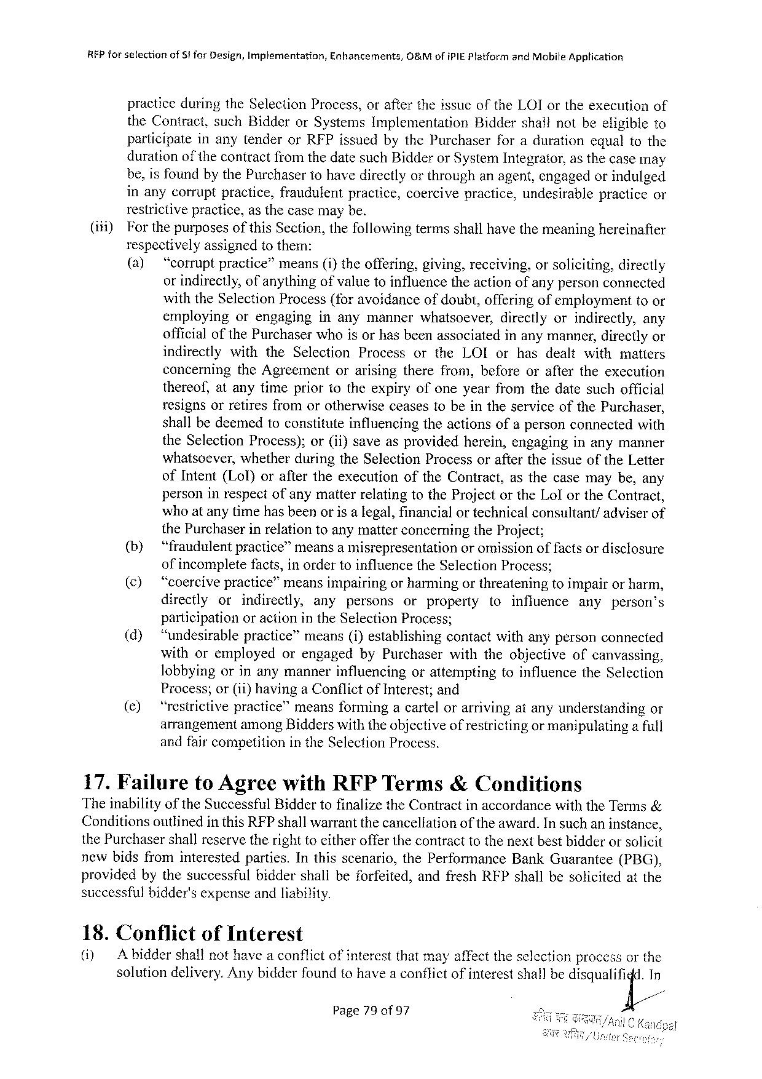

REP forselection of§i for Design, Implementation, Enhancements, O&Mofi PIEP latformand Mobile Application

practiceduringthe Selection Process, oraftertheissueofthe LOI ortheexecutionof the Contract, such Bidderor Systems Implementation Biddershallnotbeeligibleto participate inanytenderor RFP issuedbythe Purchaserforadurationequaltothe duration of the contractfromthedatesuch Bidderor System Integrator, asthecasemay be, isfoundbythe Purchasertohavedirectlyorthroughanagent, engagedorindulged inanycorruptpractice, fraudulentpractice, coercivepractice, undesirablepracticeor restrictivepractice, asthecasemaybe.

(i) Forthepurposes of this Section, thefollowing termsshallhavethemeaning hereinafter respectivelyassignedtothem:   
 (a) “corruptpractice”means(i)theoffering, giving, receiving, orsoliciting, directly orindirectly, ofanythingofvaluetoinfluencetheactionofanypersonconnected with the Selection Process(foravoidanceofdoubt, offeringof emptoyment toor employing orengaging inanymannerwhatsoever, directlyorindirectly, any officialofthe Purchaserwhoisorhasbeenassociatedinanymanner, directlyor indirectly with the Selection Process orthe LOI orhasdealtwithmatters concerning   
 the Agreement orarisingtherefrom, beforeoraftertheexecution thereof, atanytimepriortotheexpiryofoneyearfromthedatesuchofficial resignsorretiresfromorotherwiseceasestobeintheserviceofthe Purchaser, shallbedeemedtoconstituteinfluencingtheactionsofapersonconnectedwith the Selection Process); or(ii)saveasprovidedherein, engaginginanymanner whatsoever, whetherduringthe Selection Processoraftertheissueofthe Letter of Intent(Lol)oraftertheexccutionofthe Contract, asthecasemaybe, any personinrespectofanymatterrelatingtothe Projectorthe Lolorthe Contract, whoatanytimehasbeenorisa legal, financialortechnicalconsultant/adviserof the Purchaserinrelationtoanymatterconcerningthe Project;   
 (b) “fraudulentpractice”meansa misrepresentation or omissionoffactsor disclosure ofincompletefacts, inordertoinfluencethe Selection Process;   
 (¢)  
 “coercivepractice”meansimpairingorharmingorthreateningtoimpairorharm, directly or indirectly, any persons or property toinfluence any person’s participationoractionin the Selection Process;   
 (d) ‘“‘undesirablepractice”means(i)establishingcontactwithanypersonconnected withoremployed orengagedby Purchaserwiththeobjectiveofcanvassing, lobbyingorinanymannerinfluencing orattempting toinfluencethe Selection Process; or(ii)havinga Conflictof Interest; and   
 (e) “restrictivepractice”meansformingacartelorarrivingatanyunderstanding or arrangementamong Bidderswiththeobjectiveof restrictingormanipulatinga full andfaircompetitioninthe Selection Process.

17. Failure to Agreewith RFPT erms&Conditions   
Theinabilityofthe Successful Biddertofinalizethe Contractinaccordancewiththe Terms& Conditionsoutlinedinthis RFP shallwarrantthecanceliationoftheaward. In suchaninstance, the Purchasershallreservetherighttoeitherofferthecontracttothenextbestbidderorsolicit newbidsfrominterestedparties. Inthisscenario, the Performance Bank Guarantee(PBG), providedbythesuccessful   
 biddershallbeforfeited, andfresh RFP shallbesolicitedatthe successful bidder's expense andliability.

18. Conflict of Interest

(i) Abidder shallnothavea conflictofinterestthatmayaffecttheselectionprocessorthe solutiondelivery. Anybidderfoundtohavea conflictofinterestshallbedisqualiijd/n

Page 79 of 97

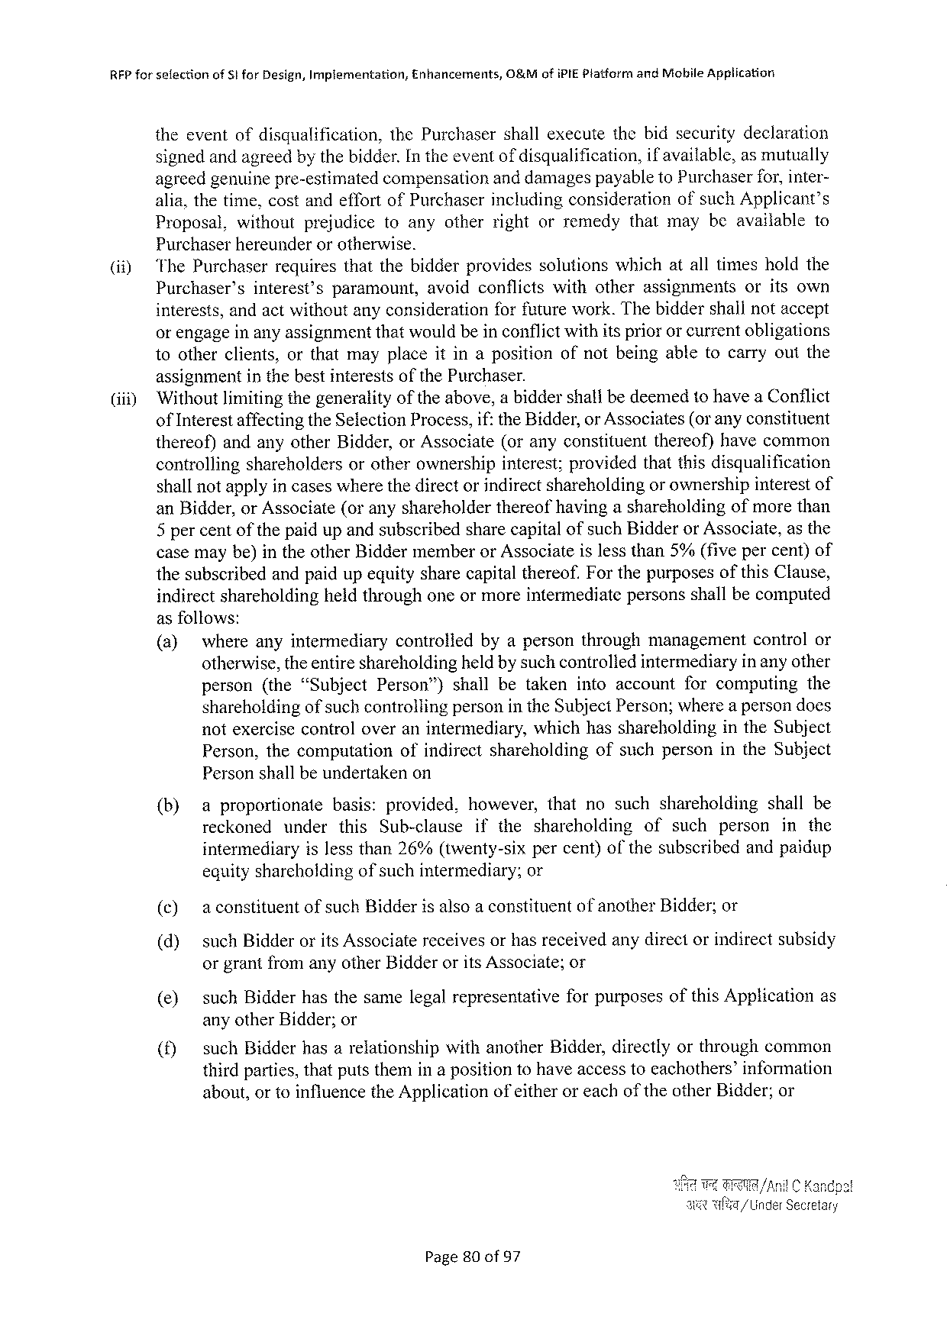

RFP forselection of Sifor Design, Implementation, Enhancements, O&Mofi PIEP latformand Mobile Application

theeventofdisqualification, the Purchasershallexecutethebidsecuritydeclaration signedandagreedbythebidder. In theeventof disqualification, if available, asmutually

agreedgenuinepre-estimatedcompensationanddamagespayableto Purchaserfor, inter-

|  |  |  |  |  |  |  |  |  |  |
| --- | --- | --- | --- | --- | --- | --- | --- | --- | --- |
| (i 1) | alia, thetime, costandeffortof Purchaserincludingconsiderationofsuch Applicant’s | | | | | | | | |
| Proposal, | without | prejudice | toanyotherrightorremedy | | | thatmaybeavailable | | to |
| Purchaserhereunderorotherwise.  ‘The Purchaserrequiresthatthebidderprovidessolutionswhichatalltimesholdthe | | | | | | | | |
| Purchaser’s | interest’sparamount, | | | avoidconflicts | withotherassignments | | oritsown | |

interests, andactwithoutanyconsiderationforfuturework. Thebiddershallnotaccept orengageinanyassignmentthatwouldbeinconflictwithitspriororcurrentobligations tootherclients, orthatmayplaceitinapositionofnotbeingabletocarryoutthe

|  |  |
| --- | --- |
| (iii) | assignmentinthebestinterestsofthe Purchaser.  ‘Withoutlimitingthegeneralityoftheabove, abiddershallbedeemedtohavea Conflict |

of Interestaffectingthe Selection Process, if: the Bidder, or Associates(or anyconstituent thereof)andanyother Bidder, or Associate(oranyconstituentthereof)havecommon controllingshareholdersorotherownershipinterest; providedthatthisdisqualification shallnotapplyin caseswherethedirectorindirectshareholdingor ownershipinterestof an Bidder, or Associate(oranyshareholderthereofhavingashareholdingofmorethan 5 percentofthepaidupandsubscribedsharecapitalofsuch Bidderor Associate, asthe casemaybe)intheother Biddermemberor Associateislessthan 5%(fivepercent)of thesubscribedandpaidupequitysharecapitalthereof. Forthepurposesofthis Clause, indirectshareholdingheidthroughoneormoreintermediatepersonsshallbecomputed asfollows:

|  |  |  |  |  |  |  |  |
| --- | --- | --- | --- | --- | --- | --- | --- |
| (a) | whereanyintermediary | | controliedbyapersonthroughmanagement | | | controlor | |
| otherwise, theentireshareholdingheldby suchcontroliedintermediaryin anyother | | | | | | |
| person(the“Subject | Person”) | | shallbetakenintoaccount | forcomputing | | the |

shareholdingof suchcontrollingpersonin the Subject Person; wherea persondoes

notexercisecontroloveranintermediary, whichhasshareholding in the Subject

Person, thecomputation ofindirectshareholding ofsuchpersoninthe Subject

Personshallbeundertakenon

|  |  |  |  |  |  |  |  |  |  |  |  |  |
| --- | --- | --- | --- | --- | --- | --- | --- | --- | --- | --- | --- | --- |
| (b)  (c)  (d) | aproportionate | | | basis: | provided, | however, thatnosuchshareholding | | | | | | shallbe |
| reckoned | under | | this | Sub-clause | ifthe | shareholding | | of | such | person | in the |
| intermediaryislessthan 26%(twenty-sixpercent)ofthesubscribedandpaidup | | | | | | | | | | | |
| equityshareholdingofsuchintermediary; | | | | | | or | | | | | |
| aconstituent | | of such Bidder 1 salsoa constituent | | | | | of another | | Bidder; or | | |
| such Bidderorits Associatereceivesorhasreceivedanydirectorindirectsubsidy | | | | | | | | | | | |

orgrantfromanyother Bidderorits Associate; or

|  |  |  |  |
| --- | --- | --- | --- |
| (e) | such Bidderhasthesamelegalrepresentative | forpurposesofthis Application | as |

anyother Bidder; or

|  |  |  |  |
| --- | --- | --- | --- |
| (f) | such Bidderhasarelationshipwithanother Bidder, directlyorthroughcommon thirdparties, thatputsthemina positiontohaveaccesstoeachothers’information | | |
| about, ortoinfluencethe Application | of either | oreachoftheother Bidder; or |

/Anil C Kandpa!

/Uinder Secretary

Page 80 of 57

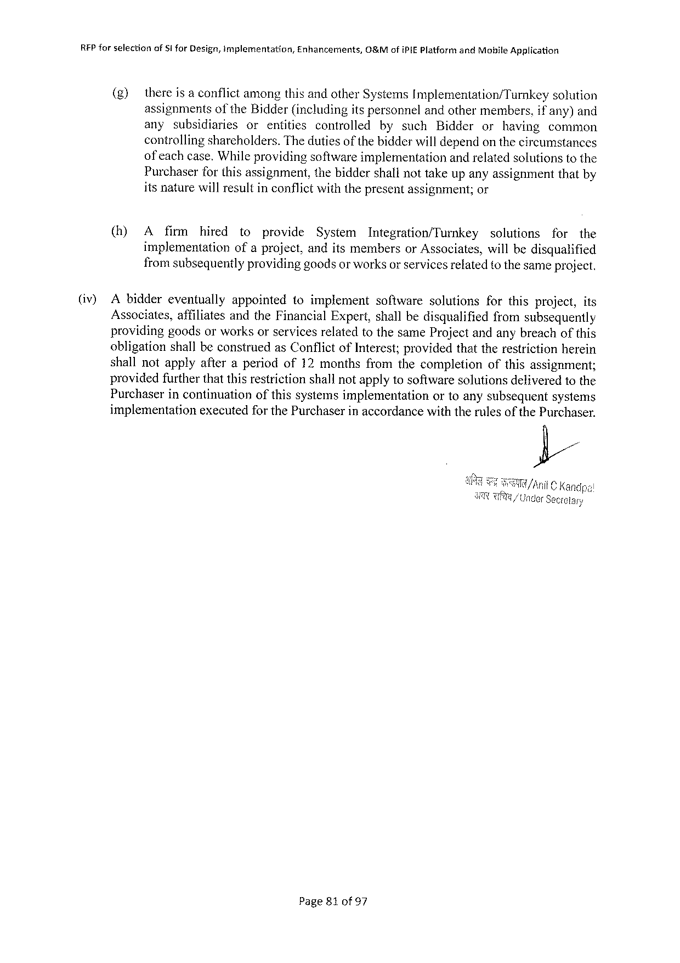

RFP forselection of§1 for Design, implementation, Enhancements, G&Mofi PIEP latformand Mobile Application

(g) there is aconflictamongthisandother Systems Implementation/Turnkey solution

assignments of the Bidder(includingitspersonnelandothermembers, if any)and

any subsidiaries or entities controlled bysuch Bidder or having common

controllingsharcholders. Thedutiesof thebidderwilldependonthecircumstances

of eachcase. Whileprovidingsoftwareimplementation andrelatedsolutionstothe

Purchaserforthisassignment, thebiddershallnottakeupanyassignmentthatby

itsnaturewillresultinconflictwiththepresentassignment; or

(h) A firm hired to provide System Integration/Turnkey solutions for the

implementation ofaproject, anditsmembersor Associates, willbedisqualified

fromsubsequentlyprovidinggoodsor worksorservicesrefatedtothe sameproject.

(iv) Abiddereventually appointed toimplement software solutions forthisproject, its

Associates, affiliatesandthe Financial Expert, shallbedisqualified fromsubsequently

providinggoodsorworksorservicesrelatedtothesame Projectandanybreachofthis

obligationshallbeconstruedas Conflictof Interest; providedthattherestrictionherein

shallnotapplyafteraperiodof 12 monthsfromthecompletion ofthisassignment;

providedfurtherthatthisrestrictionshallnotapplytosoftwaresolutionsdeliveredtothe

Purchaserincontinuation ofthissystemsimplementation ortoanysubsequentsystems

implementation executedfor the Purchaserinaccordancewiththerulesofthe Purchaser.

Page 810 f 97

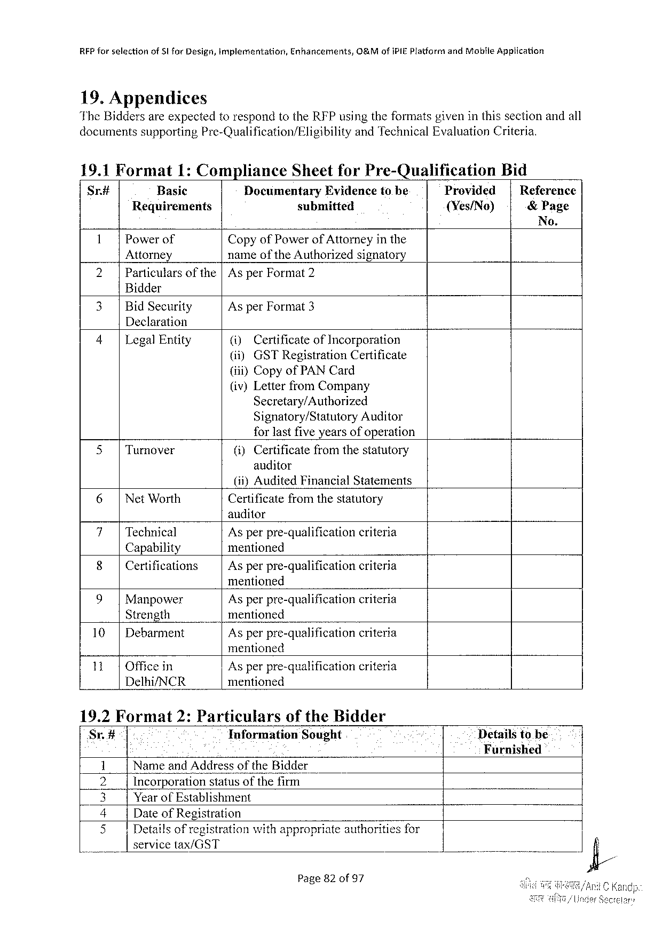

|  |  |  |  |
| --- | --- | --- | --- |
| RFP forselection | of 31 for Design, implementation, | Enhancements, | O&Mofi PIE Platformand Mobile Application |

19. Appendices

The Biddersareexpectedtorespondtothe RFP usingtheformatsgiveninthissectionandall

documentssupporting Pre-Qualification/Eligibility and Technical Evaluation Criteria.

19.1 Format 1: Compliance Sheetfor Pre-Qualification Bid

Sr# Basic Documentary Evidencetobe Provided Reference

Requirements submitted {Yes/No) &Page

No.

1 Powerof Copyof Powerof Attorneyinthe

Attorney nameofthe Authorizedsignatory

2| Particularsofthe|Asper Format 2

Bidder

|  |  |  |
| --- | --- | --- |
| 3| | Bid Security | Asper Format 3 |

Declaration

|  |  |  |  |  |
| --- | --- | --- | --- | --- |
| 4 | | | Legal Entity | (i) | Certificateof Incorporation |
| (i) | GSTR egistration Certificate |

(iii)Copyof PAN Card

(iv)Letterfrom Company

Secretary/Authorized

Signatory/Statutory Auditor

forlastfiveyearsofoperation

|  |  |  |  |
| --- | --- | --- | --- |
| 5 | | | Turnover | (i)Certificatefromthestatutory |

anditor

|  |  |  |  |  |
| --- | --- | --- | --- | --- |
| 6| | Net Worth | (i)} Audited | Financial | Statements |
| Certificatefromthestatutory | | |

auditor

|  |  |  |  |
| --- | --- | --- | --- |
| 7| | Technical | Asperpre-qualification | criteria |
| 8| | Capability | mentioned | criteria |
| Certifications | Asperpre-qualification |

mentioned

|  |  |  |  |
| --- | --- | --- | --- |
| 9| | Manpower | Asperpre-qualification | criteria |
| Strength | mentioned | criteria |
| 10| |
| Debarment | Asperpre-qualification |

mentioned

|  |  |  |  |  |  |  |  |  |
| --- | --- | --- | --- | --- | --- | --- | --- | --- |
| 11| | | Officein | | Asperpre-qualification criteria | | | | Detailstobe Furnished |
| Delhi/NCR | | | | | mentioned | | |
| 19.2 Format | | | 2: Particulars | | | of the Bidder | |
| Sr.# | Information | | | | | | Sought |
| f | Nameand Addressofthe Bidder | | | | | | |
| 1 Y | Incorporation | | | | statusofthefirm | | |
| I | Yearof Establishment | | | | | | |

Dateof Registration

|  |  |  |
| --- | --- | --- |
| [FYES | Detailsof registration | with appropriate authorities for |

servicetax/GST

Page 82 of 97



REP forselection of Sifor Design, implementation, Enhancements, O&Mofi PIEP latformand Mobile Application

6 Name, Address, email. phonenos. andmobilenumber

of contact person

Page 83 of 97

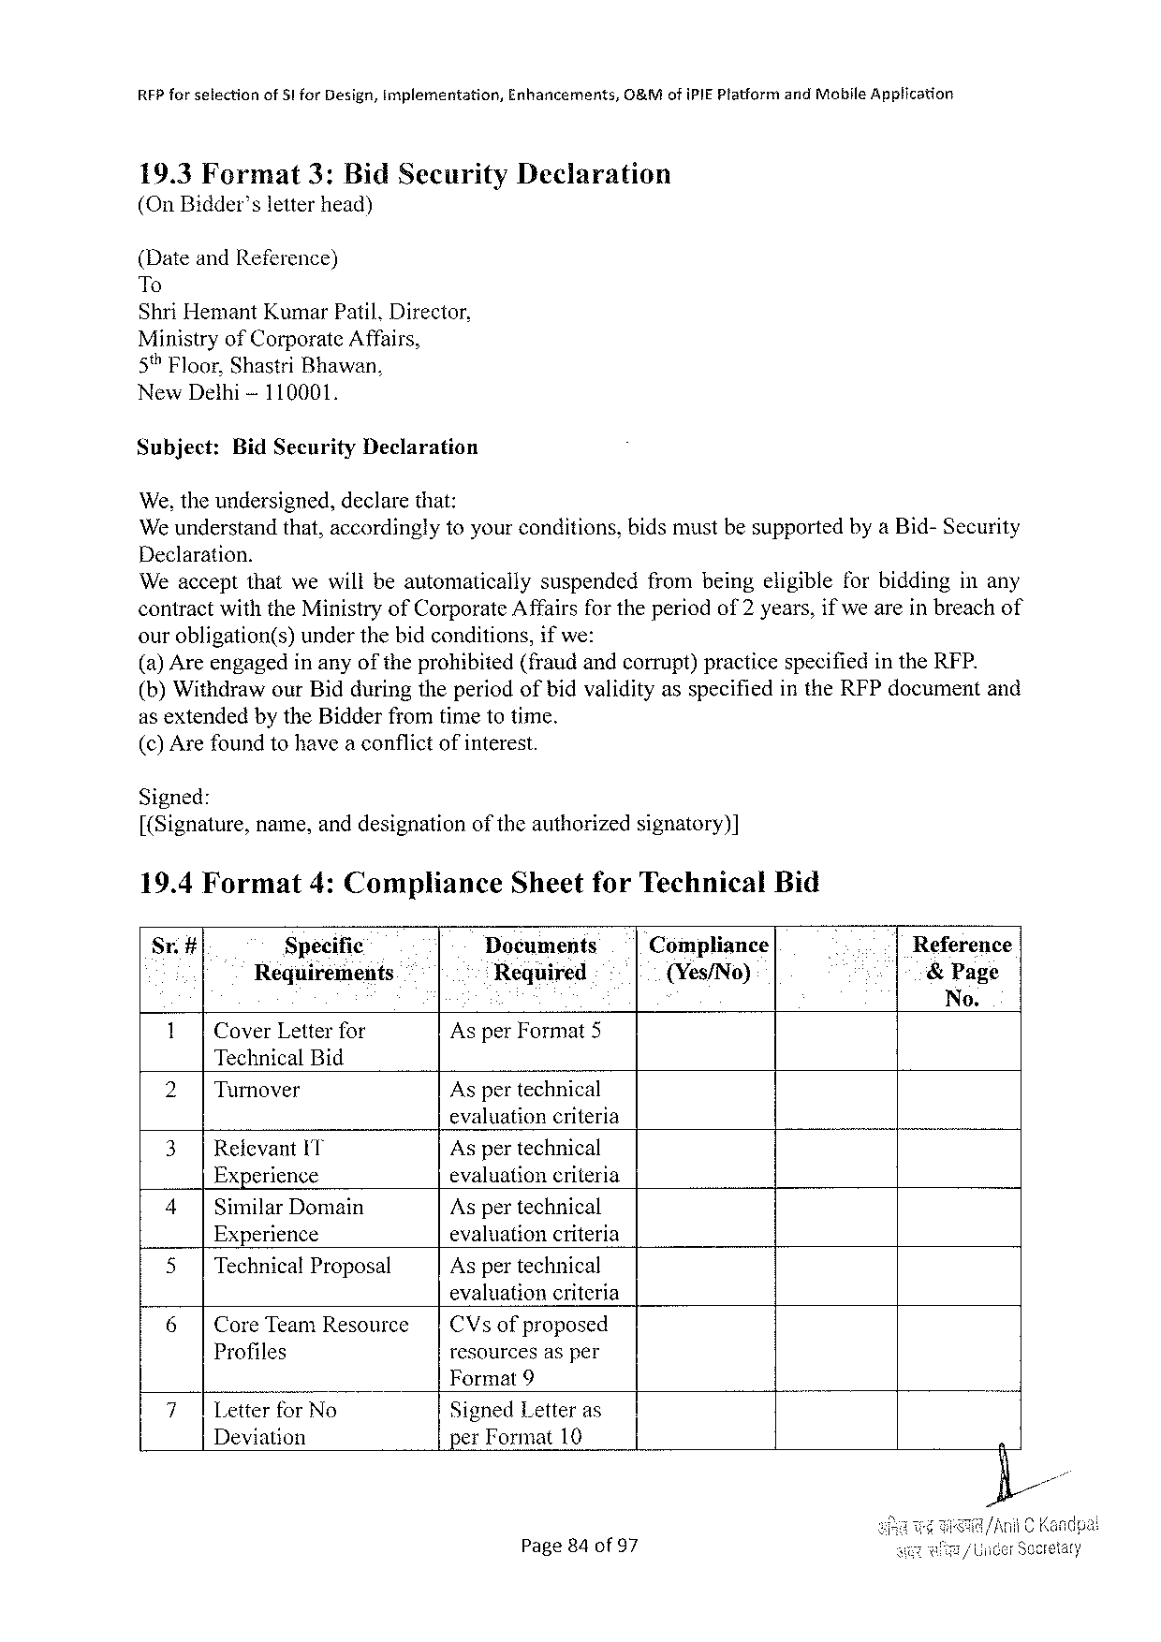

REP forselection of 51 for Design, Implementation, Enhancements, O&Mofi PIEP latformand Mobile Application

19.3 Format 3: Bid Security Declaration (On Bidder’sletterhead)

(Dateand Reference)   
To   
Shri Hemant Kumar Patil, Director,   
Ministryof Corporate Affairs,   
5% Floor, Shastri Bhawan,   
New Dethi-110001,

Subject: Bid Security Declaration

We, theundersigned, declare that:   
We understandthat, accordinglytoyourconditions, bidsmustbesupportedbya Bid-Security

|  |  |  |
| --- | --- | --- |
| Declaration. | suspended | frombeingeligibleforbiddinginany |
| Weacceptthatwewillbeautomatically |

contractwiththe Ministryof Corporate Affairsfor theperiodof 2 years, ifwe areinbreachof ourobligation(s) underthebidconditions, ifwe:   
(a) Areengagedinanyoftheprohibited(fraudandcorrupt)practicespecifiedinthe RFP. (b)Withdrawour Bidduringtheperiodofbidvalidityasspecifiedinthe RFP documentand as extendedby the Bidderfromtimetotime.

(c) Arefoundtohavea conflictofinterest.

Signed:   
[(Signature, name, anddesignationoftheauthorizedsignatory)]

|  |  |  |  |  |  |
| --- | --- | --- | --- | --- | --- |
| 19.4 Format | 4: Compliance | Sheetfor Technical | | Bid | Reference |
| St# | Specific | Documents | Compliance |
| Requirements | | Required | {(Yes/No) | &Page |

No.

|  |  |  |
| --- | --- | --- |
| 1| | Cover Letterfor | Asper Format 5 |

Technical Bid

|  |  |  |
| --- | --- | --- |
| 2| | Turnover | Aspertechnical |

evaluationcriteria

|  |  |  |
| --- | --- | --- |
| 3|Relevant IT Experience | | Aspertechnical  evaluationcriteria  Aspertechnical  evaluationcriteria  Aspertechnical |
| 4| | Similar Domain |
| Experience | |
| 5| | Technical Proposal |

evaluationcriteria

|  |  |  |  |  |
| --- | --- | --- | --- | --- |
| 6| | Core Team Resowrce | | | CV s | of proposed |
| Profiles | resourcesasper | |

Format 9

|  |  |  |
| --- | --- | --- |
| 7| | Letterfor No | Signed Letteras |
| Deviation | per Format 10 |

Page 84 of 97

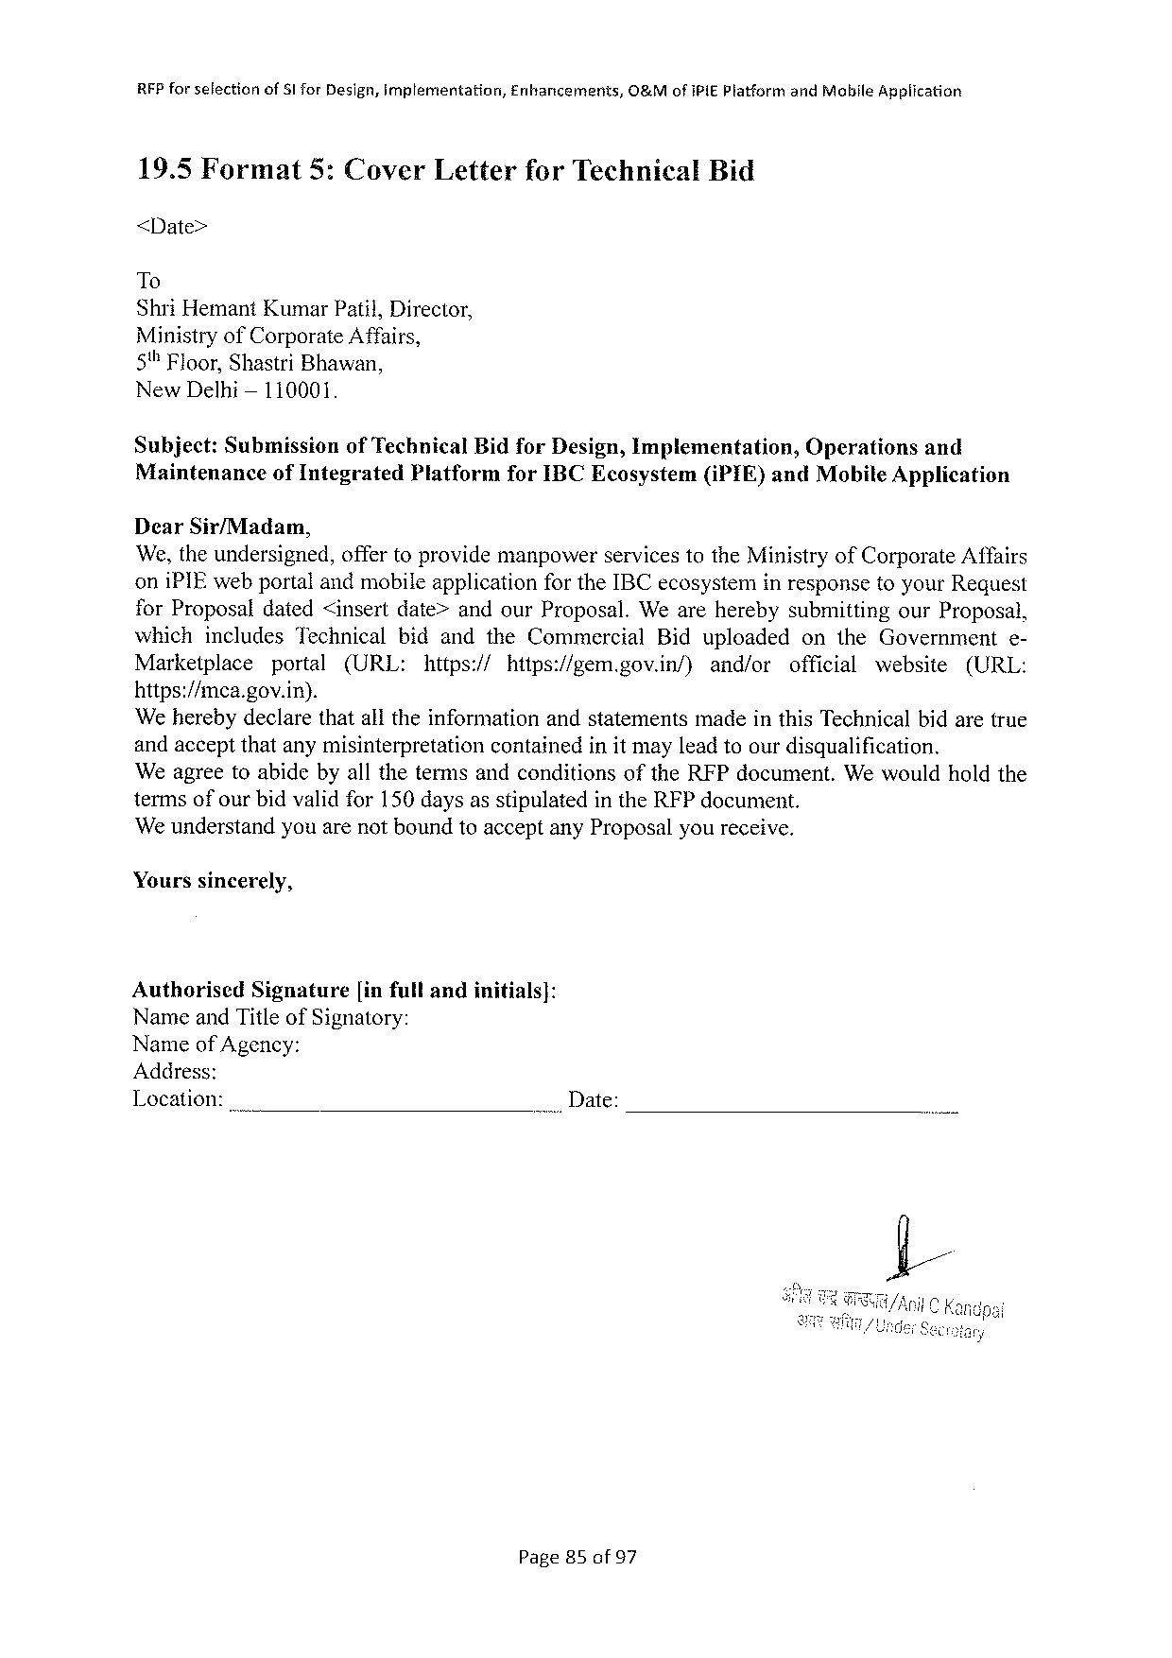

|  |  |  |  |
| --- | --- | --- | --- |
| RFP forselection | of Slfor Design, implementation, | Enhancements, | O&Mof IPIEP latformand Mabile Application |

19.5 Format 5: Cover Letterfor Technical Bid

<Date>

To

Shri Hemant Kumar Patil, Director,

Ministryof Corporate Affairs,

5"Floor, Shastri Bhawan,

New Delhi— 110001.

Subject: Submission of Technical Bidfor Design, Implementation, Operations and

Maintenanceof Integrated Platformfor IBCE cosystem(i PIE)and Mobile Application

Dear Sir/Madam,

We, theundersigned, offertoprovidemanpowerservicestothe Ministryof Corporate Affairs

oni PIE webportalandmobileapplicationfor the IBC ecosysteminresponsetoyour Request

for Proposaldated<insertdate>andour Proposal. Weareherebysubmitting our Proposal,

which includes Technical bidandthe Commercial Biduploaded on the Government e-

Marketplace portal (URL: https:// hitps:/gem. gov. in/) and/or official website (URL:

https://mca. gov. in).

‘Weherebydeclarethatalltheinformationandstatementsmadeinthis Technicalbidaretrue

andacceptthatanymisinterpretation containedinit mayleadtoourdisqualification.

Weagreetoabidebyallthetermsandconditionsofthe RFP document. Wewouldholdthe

termsofourbidvalidfor 150 daysasstipulatedinthe RFP document.

We understandyouarenotboundtoacceptany Proposalyoureceive.

Yourssincerely,

|  |  |  |
| --- | --- | --- |
| Authorised | Signature | [infullandinitials]: |

Nameand Titleof Signatory:

Nameof Agency:

Address:

Location:_ .. Date:

Page 85 of 97

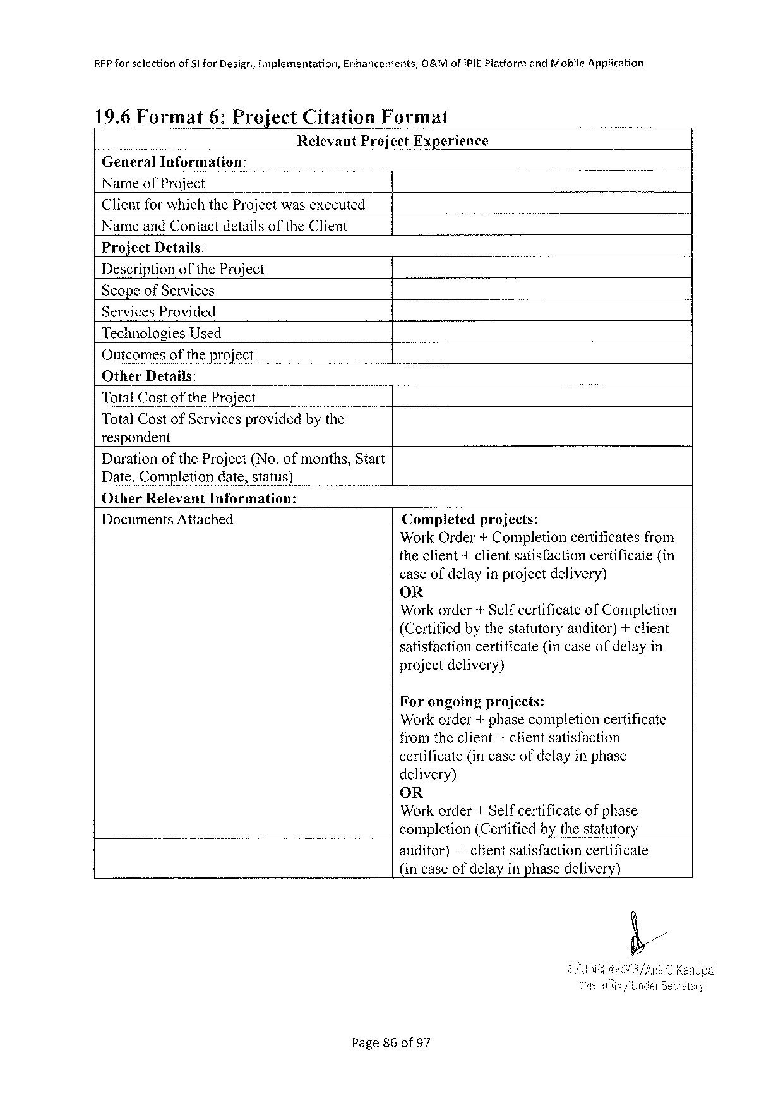

RFP forselectionof SI for Design, implementation, Enhancements, O&Mof IPIEP latform and Mobfle Application

|  |  |  |  |
| --- | --- | --- | --- |
| 19.6 Format | 6: Project | Citation | Format |

Relevant Project Experience General Information:   
Nameof Project   
Clientforwhichthe Projectwasexecuted

Nameand Contactdetailsofthe Client   
Project Details:   
Descriptionofthe Project   
Scopeof Services   
Services Provided   
Technologies Used   
Outcomesofthe project   
Other Details:

|  |  |  |
| --- | --- | --- |
| Total Cost | of the | Project |

Total Costof Servicesprovidedbythe   
respondent   
Durationofthe Project(No. of months, Start   
Date, Completiondate, status)   
Other Relevant Information:

Documents Attached

Completedprojects:   
Work Order + Completioncertificates from theclient+clientsatisfactioncertificate(in caseofdelayinprojectdelivery)   
OR   
Workorder+Selfcertificate of Completion (Certifiedbythestatutoryauditor)+client satisfactioncertificate(incaseofdelayin project delivery)

Forongoingprojects:   
Workorder+phasecompletioncertificate fromtheclient+clientsatisfaction   
certificate(incaseofdelayinphase   
delivery)   
OR   
Workorder+Self certificate ofphase   
completion (Certifiedby the statutory

auditor) +clientsatisfactioncertificate (incaseofdelayinphasedelivery)

Page 86 of 97

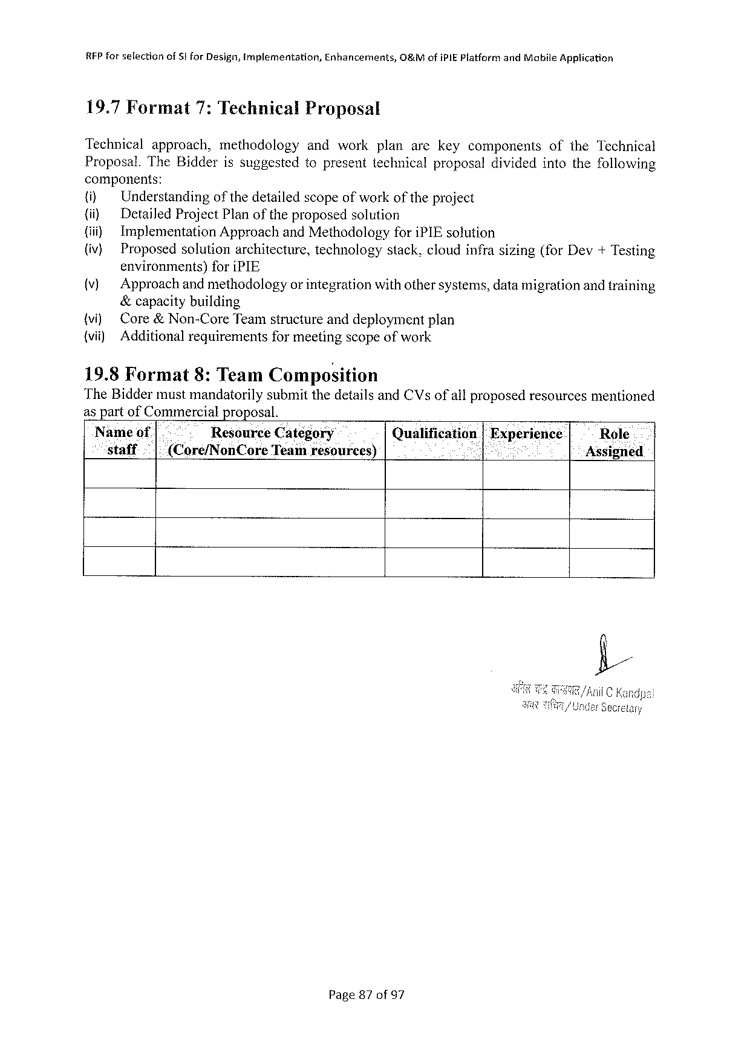

REP for selectionof Stfor Design, implementation, Enhancements, O&Mof IPIEP latform and Mobile Application

19.7 Format 7: Technical Proposal

Technical approach, methodology andwork planarekeycomponents of the Technical

Proposal. The Bidderissuggestedtopresenttechnicalproposaldividedintothefollowing

components:

(i) Understanding of thedetailedscopeofworkof theproject

(i) Detailed Project Planoftheproposedsolution

(ii) Implementation Approachand Methodologyfori PIE solution

(iv) Proposedsolutionarchitecture, technology stack, cloudinfrasizing(for Dev+Testing

environments)fori PIE

(v) Approach andmethodologyor integrationwithothersystems, datamigrationandtraining

&capacitybuilding

{vi) Core& Non-Core Teamstructureanddeploymentplan

(vi) Additionalrequirementsformeetingscopeof work

19.8 Format 8: Team Composition

The Biddermustmandatorilysubmitthedetailsand CV sofail proposedresourcesmentioned

as part of Commercial proposal.

|  |  |  |  |  |  |  |
| --- | --- | --- | --- | --- | --- | --- |
| Nameof[.- | | . | Resource Category | Qualification|Experienice | | Role |
| staff | .|(Core/Non Core Team resources) | | | : | i | Assigned |

Page 87 of 97

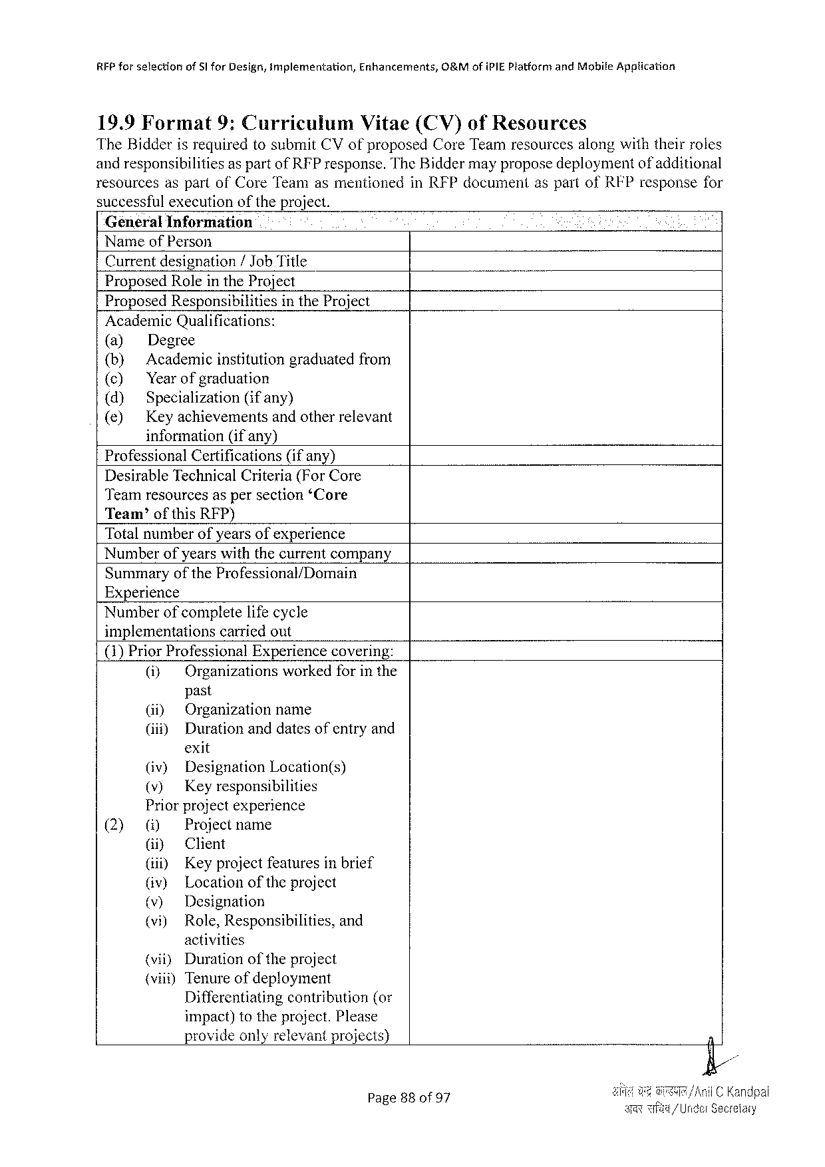

RFP forselection of§I for Design, implementation, Enhancermments, O&Mofi PIE Platformand Mobite Application

19.9 Format 9: Cuarriculum Vitae(CV)of Resources

The Bidderisrequiredtosubmit CV ofproposed Core Teamresourcesalongwiththeirroles

andresponsibilitiesas partof RFP response. The Biddermayproposedeploymentof additional

resourcesaspartof Core Teamasmentioned successfulexecutionoftheproject.

General Information   
Nameof Person   
Currentdesignation/ Job Title   
Proposed Rolein the Project   
Proposed Responsibilities in the Project Academic Qualifications:   
(a)   
 Degree (b) Academicinstitutiongraduatedfrom {¢) Yearofgraduation   
(d) Specialization(ifany)   
(e)   
 Keyachievementsandotherrelevant information(ifany)   
Professional Certifications (ifany)   
Desirable Technical Criteria(For Core   
Teamresourcesaspersection‘Core   
Team’ofthis RFP)   
Totalnumberofyearsofexperience   
Numberofyearswiththecurrentcompany

|  |  |  |
| --- | --- | --- |
| Summary | of the | Professional/Domain |

Experience   
Numberofcompletelifecycle   
implementations carriedout   
(1)Prior Professional Experiencecovering: (i) Organizationsworkedforinthe past   
 (i) Organizationname   
 (iif) Duration anddatesofentryand exit   
 (iv) Designation Location(s)   
 (v) Keyresponsibilities   
 Priorprojectexperience

|  |  |  |  |  |
| --- | --- | --- | --- | --- |
| (2) | () | Projectname | | |
| i) | Client | | |
| (i) | Keyprojectfeaturesinbrief | | |
| (iv) | Location | oftheproject | |
| (v) | Designation | | |
| (vi) | Role, Responsibilities, | | and |

activities   
(vii) Duration of the project   
(viii) Tenureofdeployment   
 Differentiating   
 contribution{(or impact)totheproject. Please provideonlyrelevantprojects)

in RFP documentaspartof RFP responsefor

|  |  |
| --- | --- |
| Page 88 of 97 | {andpai  1 Seceelary |

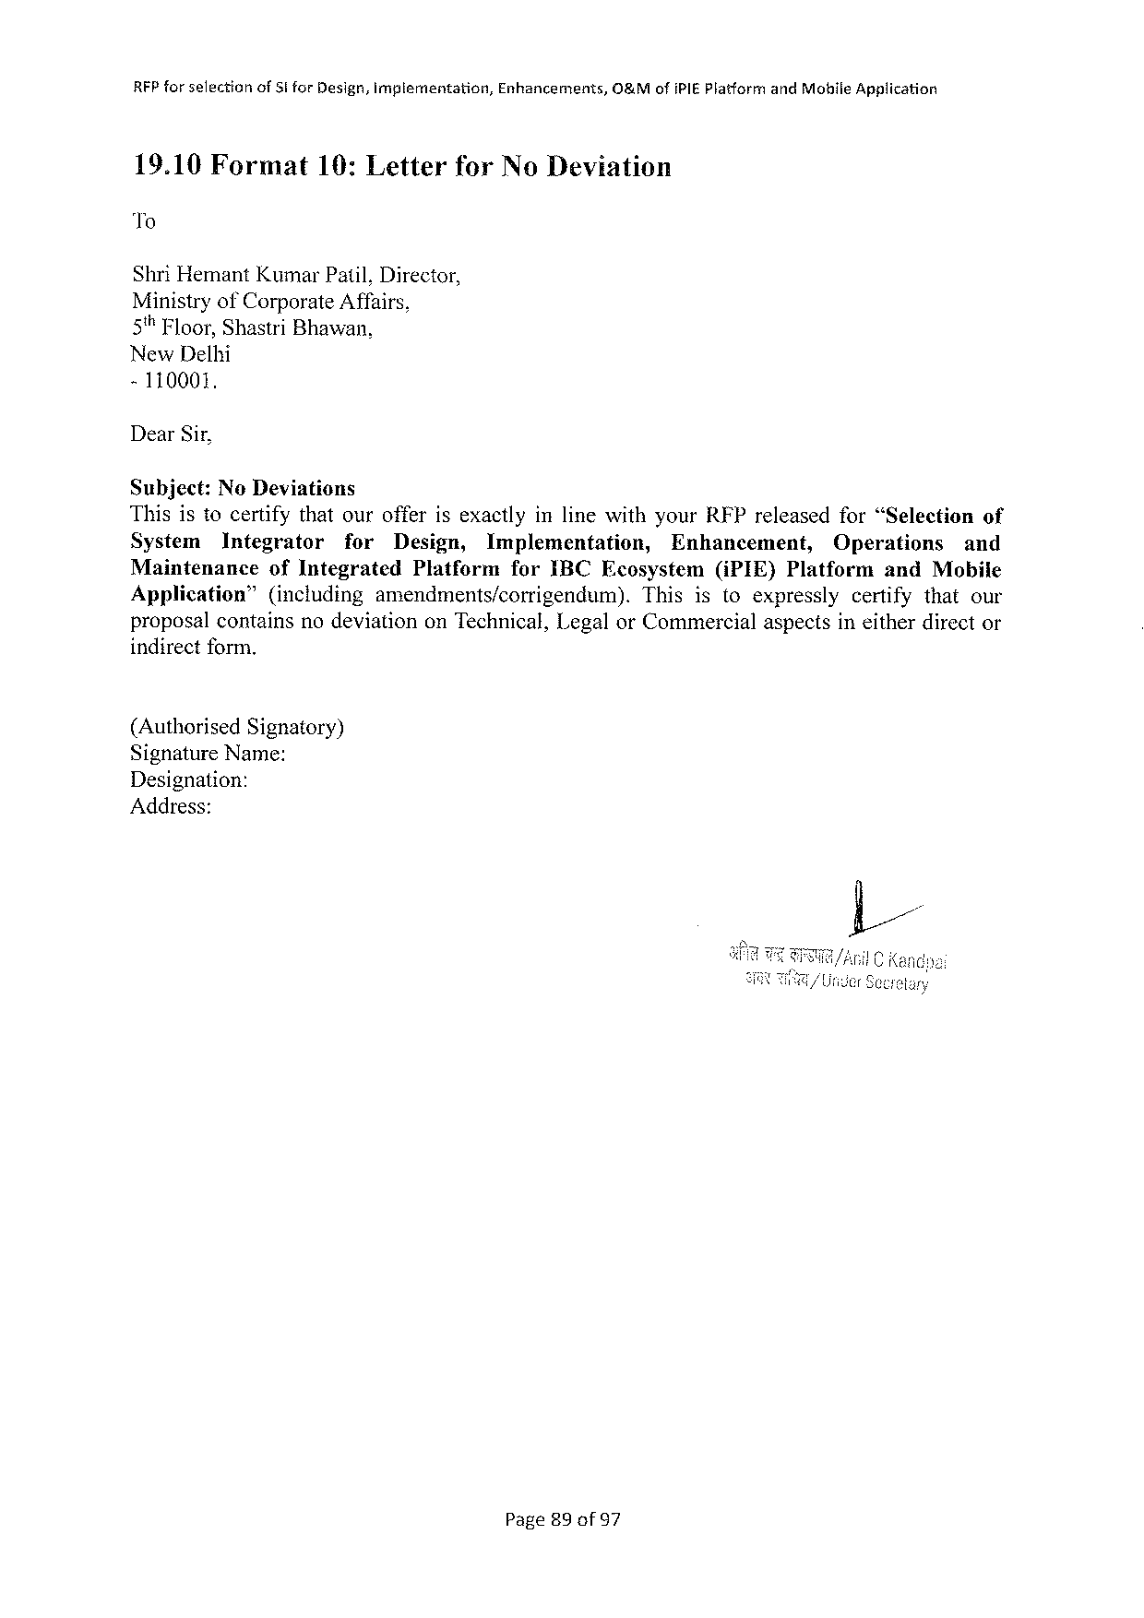

RFP forselection of Si for Design, implementation, Enhancements, O&Mofi PIEP latformand Mobile Application

19.10 Format 19: Letter for No Deviation

To

Shri Hemant Kumar Patil, Director,

Ministryof Corporate Affairs,

5% Floor, Shastri Bhawan,

New Delhi

-110001.

Dear Sir,

Subject: No Deviations

Thisistocertifythatourofferisexactlyinlinewithyour RFP releasedfor“Selection of

System Integrator for Design, Implementation, Enhancement, Operations and

Maintenance of Integrated Platformfor IBCE cosystem(i PIE)Platformand Mobile

Application” (including amendments/corrigendum). Thisistoexpressly certifythatour

proposalcontainsnodeviationon Technical, Legalor Commercialaspectsineitherdirector

indirectform.

(Authorised Signatory)

Signature Name:

Designation:

Address:

Page 89 of 97

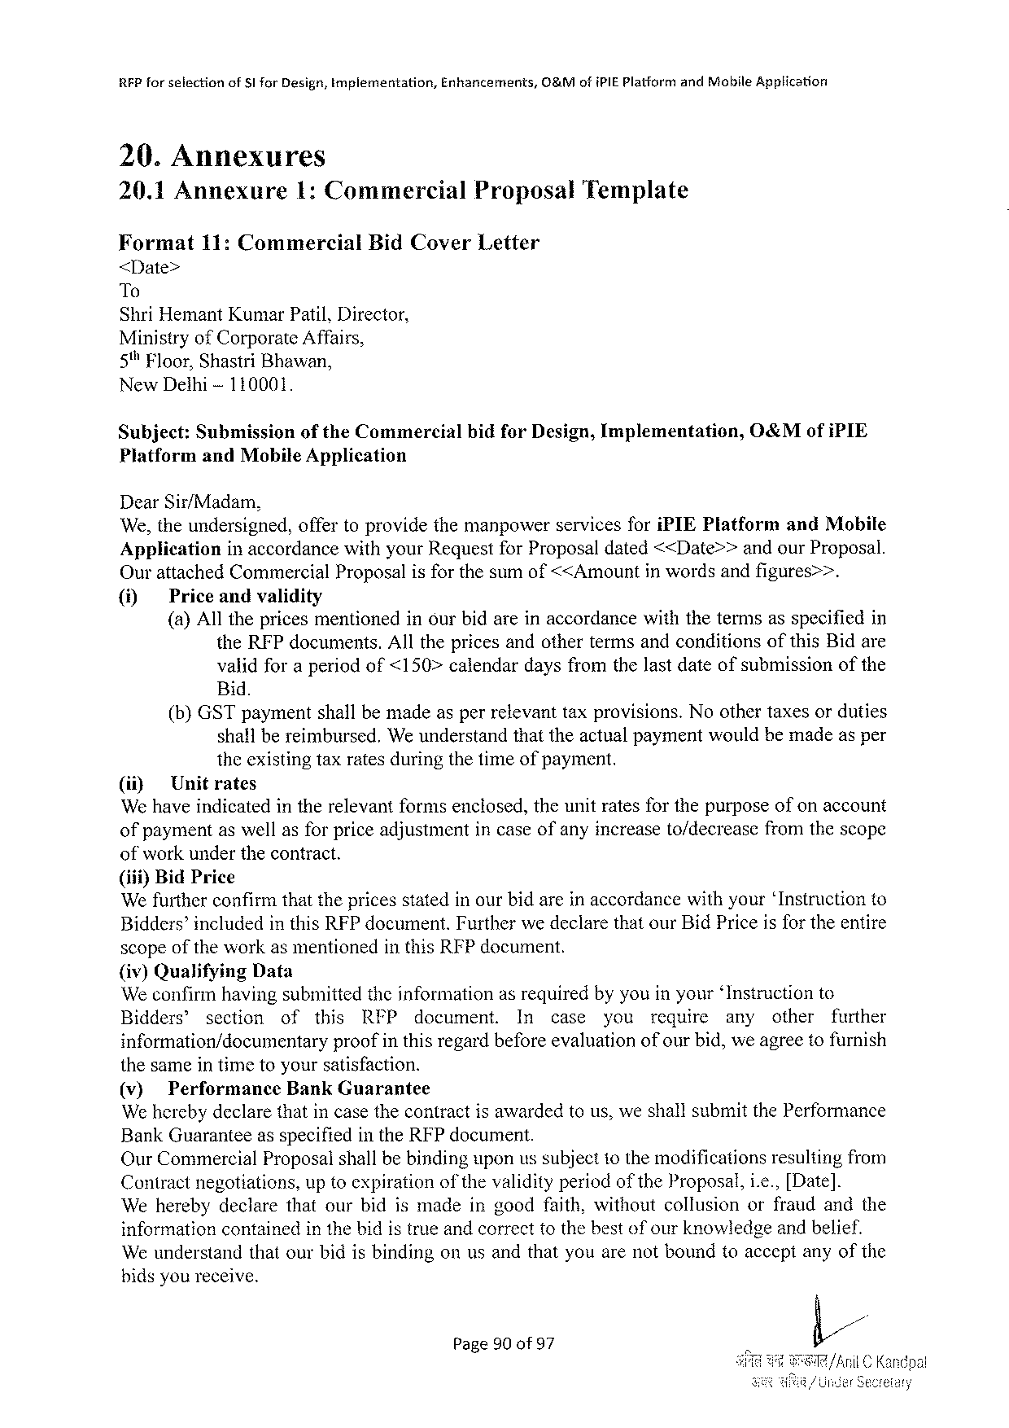

|  |  |  |  |
| --- | --- | --- | --- |
| RFP forselection | of Slfor Design, Implementation, | Enhancements, | O&Mofi PIEP latformand Mobile Application |

20. Annexures

|  |  |  |  |  |  |
| --- | --- | --- | --- | --- | --- |
| 20.1 Annexure | | 1: Commercial | | Proposal | Template |
| Format | 11: Commercial | | Bid Cover | Letter |

<Date>

To   
Shri Hemant Kumar Patil, Director,   
Ministryof Corporate Affairs,   
5% Floor, Shastri Bhawan,   
New Dethi-110001.

|  |  |  |  |  |
| --- | --- | --- | --- | --- |
| Subject: | Submission | of the Commercial | bidfor Design, Implementation, | O 0&Mofi PIE |
| Platformand Mobile Application | | |

Dear Sir/Madam,   
We, theundersigned, offertoprovidethemanpowerservicesfori PIEP latform and Mobile Application inaccordancewithyour Requestfor Proposaldated<<Date>>andour Proposal.

Ourattached Commercial Proposal is for the sum of<<Amount in words andfigures>>.

(1) Priceandvalidity   
 (a)Allthepricesmentionedinourbidareinaccordancewiththetermsasspecifiedin the RFP documents. Allthepricesandothertermsandconditionsofthis Bidare validforaperiodof<150>calendardaysfromthelastdateofsubmissionofthe Bid.

(b)GST paymentshallbemadeasperrelevanttaxprovisions. Noothertaxesorduties shallbereimbursed. Weunderstandthattheactualpaymentwouldbemadeasper theexistingtaxratesduringthetimeofpayment.

(ii) Unitrates   
We haveindicatedintherelevantformsenclosed, theunitratesforthepurposeofonaccount ofpaymentaswellasforpriceadjustmentincaseofanyincreaseto/decreascfromthescope ofworkunderthecontract.

(iif)Bid Price   
We furtherconfirmthat the pricesstated inourbid arein accordance withyour‘Instructionto Bidders’includedinthis RFP document. Furtherwedeclarethatour Bid Priceisfor theentire scopeofthe workasmentionedin this RFP document.

{iv) Qualifying Data   
We confirmhavingsubmittedtheinformationasrequiredbyyouinyour‘Instructionto Bidders®section of this RFP document. In case you require any other further

information/documentary proofinthisregardbeforeevaluationofourbid, we agreetofurnish thesameintimetoyoursatisfaction.

|  |  |  |
| --- | --- | --- |
| (v) | Performance | Bank Guarantee |

We herebydeclarethatincasethecontractisawardedtous, weshallsubmitthe Performance Bank Guaranteeasspecifiedinthe RFP document.

Our Commercial Proposalshallbe bindinguponus subjectto the modificationsresultingfrom Contractnegotiations, uptoexpirationof thevalidityperiodofthe Proposal, i. e.,[Date]. Weherebydeclarethatourbidismadeingoodfaith, withoutcollusionorfraudandthe informationcontainedinthebidistrueandcorrecttothebestofourknowledgeandbelief. Weunderstandthatourbidisbindingonusandthatyouarenotboundtoacceptanyofthe bidsyoureceive.

Page 90 of 97



|  |  |  |  |
| --- | --- | --- | --- |
| RFP forsefection | of 5 t for Design, Implementation, | Enhancements, | O&Mofi PI£Platformand Mobile Application |

Yourssincerely

Authorized Signature:

Nameand Title of Signatory:

Nameof Agency:

|  |  |  |  |  |
| --- | --- | --- | --- | --- |
| Address: | SR | /1) | b | |
| il | C Kandpal |

Page 91 of 97

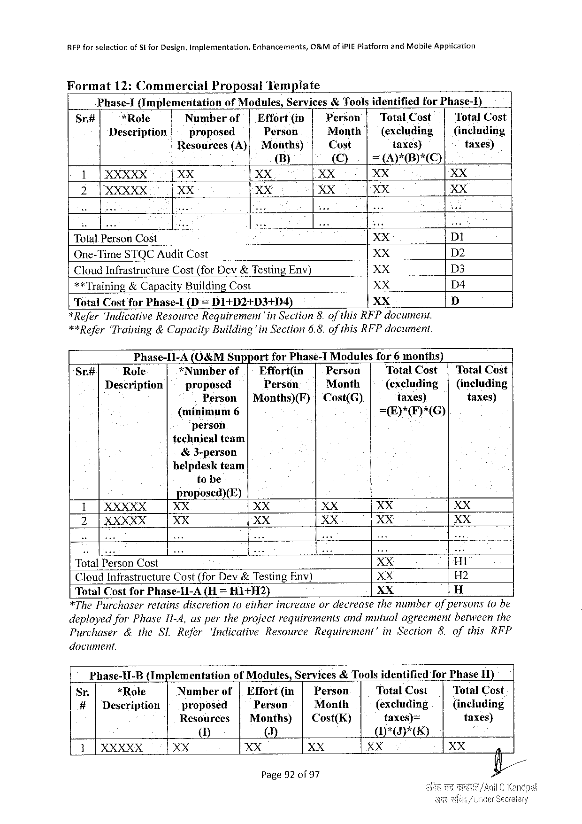

REP forselection of St for Design, Implementation, Enhancements, O&Mofi PIEP latformand Mobile Application

Format 12: Commercial Proposal Template o

Phase-1(Implementation of Modules, Services&Toolsidentified for Phase-)

Sr# *Role Number of| Effort(in Person | Total Cost Total Cost

Description proposed Person Month| (excluding | (inclading

Resources (A)| Months) Cost taxesy taxes)

B) ©). [=APB)*C)

1| XXXXX XX XX XX XX XX

2 P XXXXX XX XX XX XX XX

Total Person Cost XX DI

One-Time STQCA udit Cost XX D 2

Cloud Infrastructure Cost(for Dev&Testing Env) XX D 3

**Training&Capacity Building Cost XX D 4

Total Costfor Phase-I(D = D 1+D 2+D 3+D 4) XX D

*Refer‘Indicative Resource Requirement’in Section 8. ofthis RFP document.

**Refer‘Training&Capacity Building'in Section 6.8. of this RFP document.

Phase-I 1-A(O&MS upport for Phase-1 Modules for 6 months)

Sr.# Role *Number of.| Effort(in Person Total Cost | Total Cost

Description proposed Person Month (excluding| (including

Person |Months)(F)|Cost(G) taxes) taxes)

(minimum 6 =E)*(F)*(G)

person

technicalteam

&3-person

helpdeskteam

tobe

proposed)(E)

1|XXXXX XX XX XX XX XX

2.|XXXXX XX XX XX XX XX

Total Person Cost XX H 1

Cloud Infrastructure Cost(for Dev&Testing Env) XX H 2

Total Cost for Phase-II-A(H = HI+H 2) XX H

*The Purchaser retainsdiscretionfo eitherincreaseordecreasethenumberofpersonstobe

deployedfor Phase 1 I-4, aspertheprojectrequirements andmutualagreement betweenthe

Purchaser &the SLR efer ‘Indicative Resource Requirement’ in Section 8. ofthis RFP

document.

Phase-II-B (Implementation of Modules, Services&Toolsidentified for Phase II)

Sr. *Role Number of| Effort(in| Person Total Cost Total Cost

#|Description proposed Person Meonth (excluding (including

Resources |Months) | Cost(K) taxes)= taxes)

U] ()] MH*D*E)

1|XXXXX XX XX XX XX

Page 92 of 97

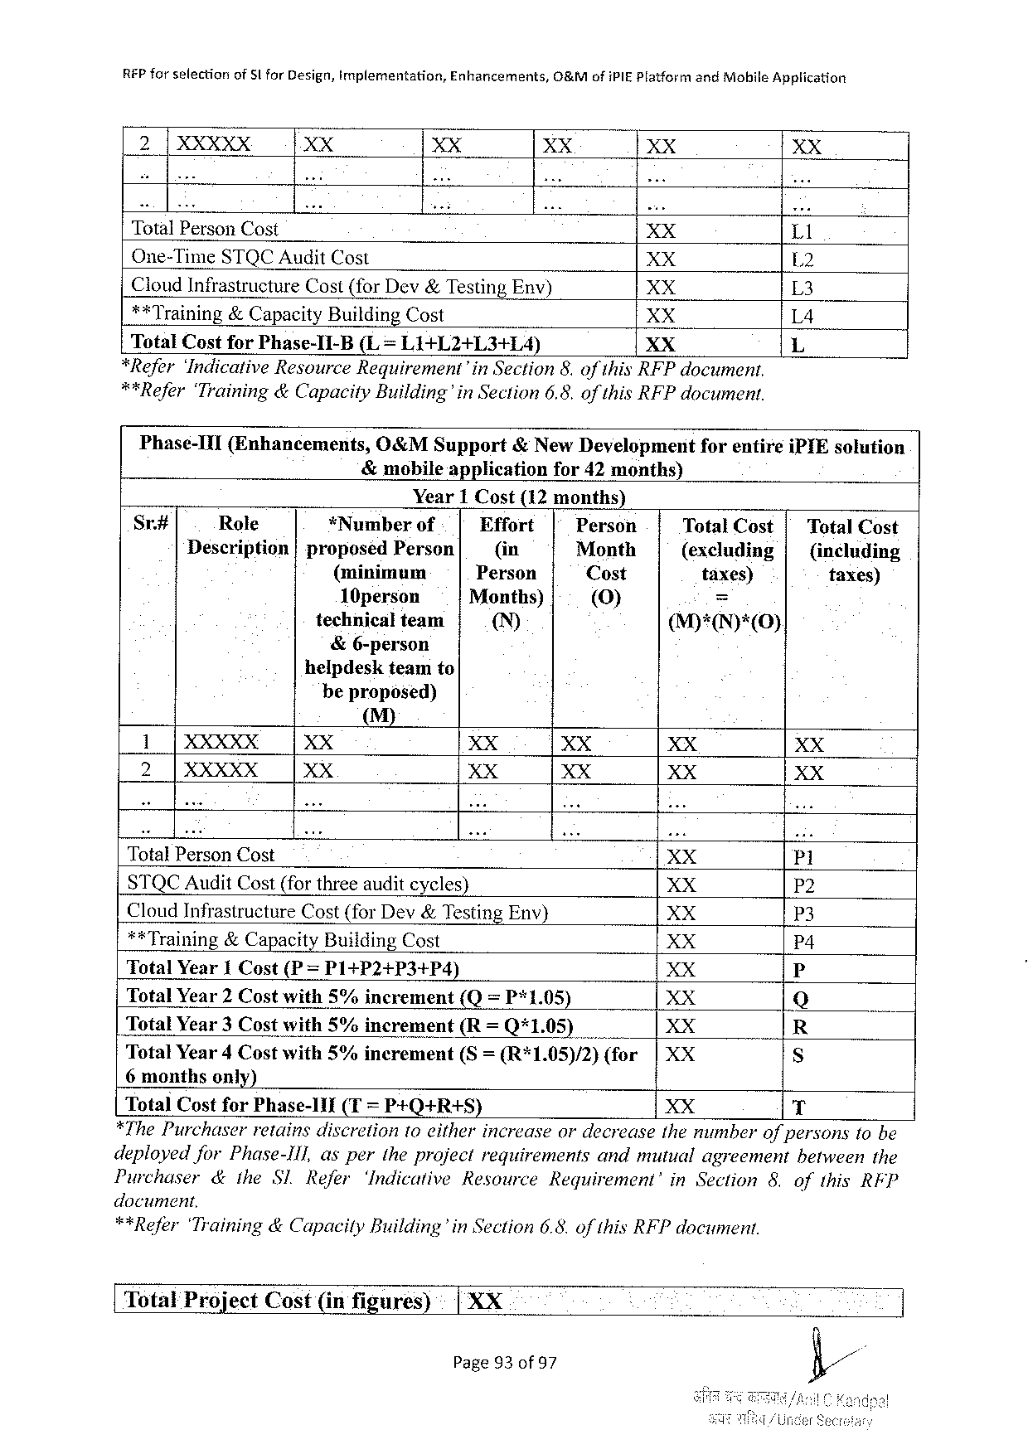

|  |  |  |  |  |  |  |  |  |  |  |
| --- | --- | --- | --- | --- | --- | --- | --- | --- | --- | --- |
| REP forselection | of Slfor Design, implementation, | | | Enhancements, | | O&Mofi PIEP latformandiiobile | | | | Application  XX  Ll  L 2  L 3  L 4  L |
| 2|XXXXX | | XX | XX | | | XX | | | XX |
| Total Person Cost | | | | | | XX | | | |
| One-Time STQCA udit Cost | | | | | | XX | | | |
| Cloud Infrastructure Cost(for Dev&Testing Env) | | | | | | | | XX | |
| **Training&Capacity Building Cost | | | | | | XX | | | |
| Total Costfor Phase-1 I-B(L= L 1+L 2+L 3+1 L 4) | | | | | | | XX | | |
| *Refer‘Indicative Resource Requirement’in Section 8. of this RFP document. | | | | | | | | | |
| **Refer‘Training&Capacity Building’in | | | | | Section 6.8. of this RFP document. | | | | |

Phase-III(Enhancements, O&MS upport&New Developmeritforentirei PIE solution

&mobileapplicationfor 42 months)

Year 1 Cost(12 months)

|  |  |  |  |  |  |  |
| --- | --- | --- | --- | --- | --- | --- |
| Sr# | Role | *Numberof | Effort | Person | Total Cost| | Total Cost |
| Description|proposed Person | | (in | Month | (excluding| | (including |
| (minimum | | Person | Cost | taxes) | taxes) |
| 10 person | | Months) | [(V)] | = |
| technicalteam | | ™ | M)*(IN)*(0). |
| &6-person | |
| helpdeskteamto | |

beproposed)

M)

1 T XXX XX XX XX XX XX

2 |XXXXX XX XX XX XX XX

Total Person Cost XX P 1

STQCA udit Cost(forthreeauditcycles) XX P 2

Cloud Infrastructure Cost(for Dev&Testing Env) XX P 3

**Training&Capacity Building Cost XX P 4

Total Year 1 Cost(P = P 1+P 2+P 3+P 4) XX P

Total Year 2 Costwith 5%increment (Q=P*1.05) XX Q

Total Year 3 Costwith 5%increment(R= Q*1.05) XX R

Total Year 4 Costwith 5%increment(S= (R*1.05)/2)(for|XX S

6 monthsonly)

Total Costfor Phase-11 I (T= P+Q+R+S) XX T

*The Purchaser retainsdiscretiontoeitherincrease ordecrease themumberofpersonstobe

deployedfor Phase-Ill, aspertheprojectrequirements andmutualagreement betweenthe

Purchaser &ithe Sl Refer ‘Indicative Resource Requirement’ in Section 8. ofthis RFP

document,

**Refer‘Training&Capacily Building’in Section 6.8. of this RFP document.

[ Total Project Cost(infigares) | XX

Page 93 of 97

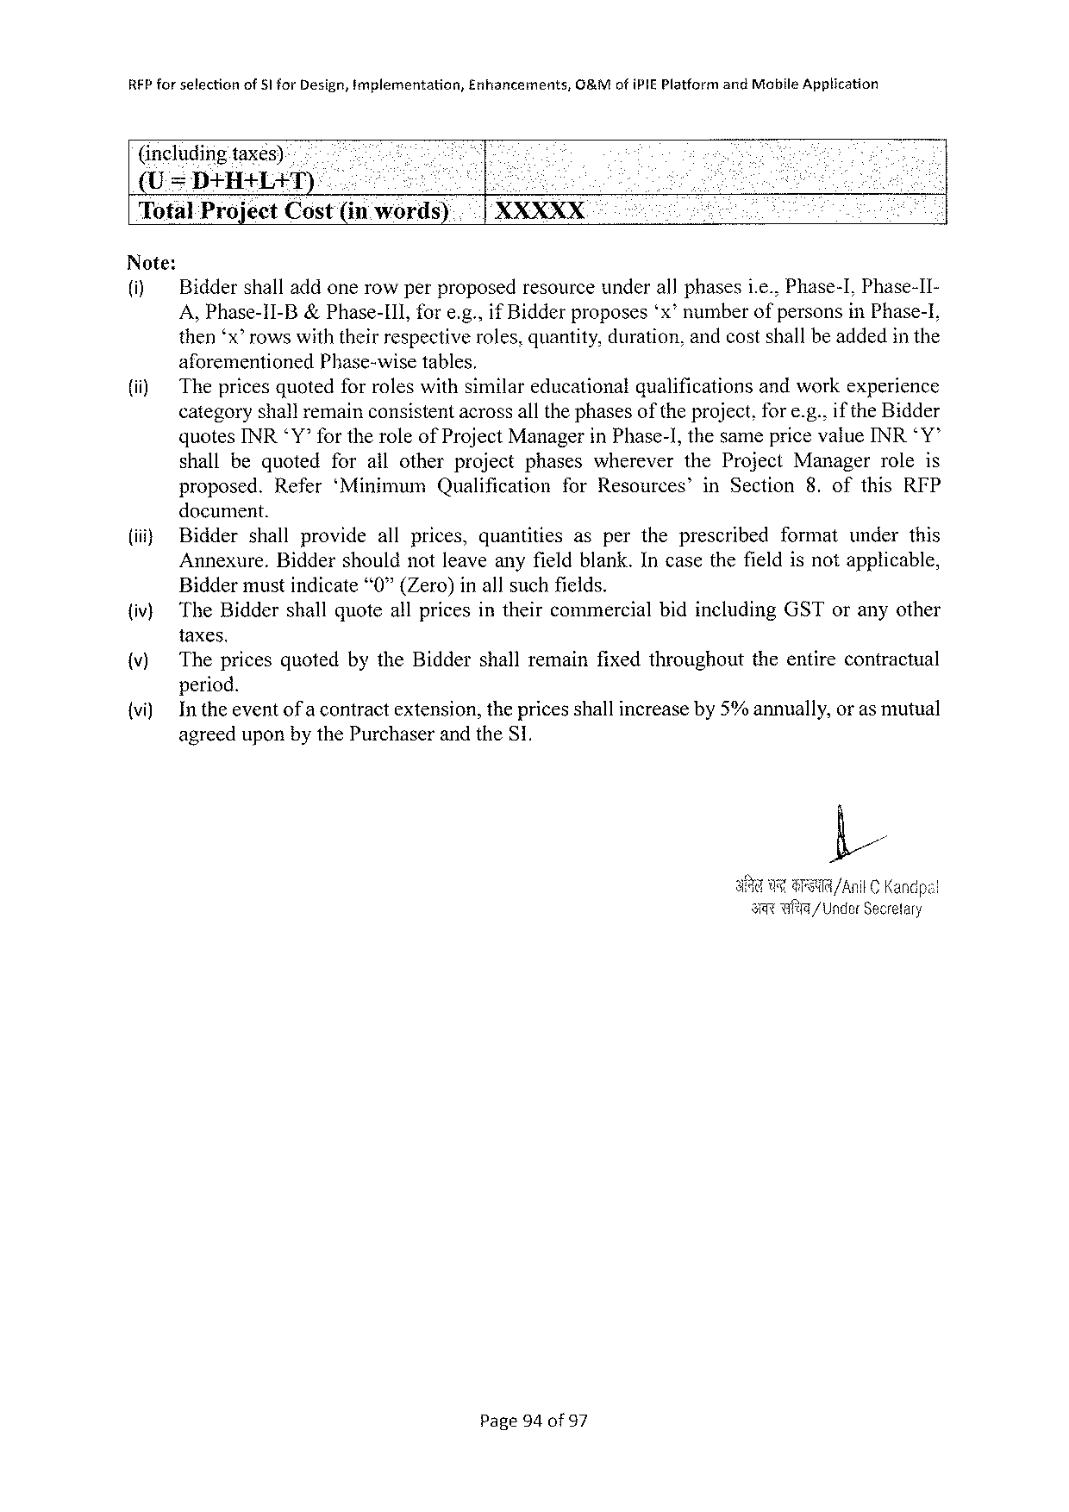

|  |  |  |  |
| --- | --- | --- | --- |
| RFP forselection | of 51 for Design, implementation, | Enhancements, | G 8&M ofi PIEP latformand Mobile Apptication |

(includingtaxes)-

(U=DHHALAT).-

|  |  |  |
| --- | --- | --- |
| Total Project Cost(in | words) | XXXXX |

Note:

(i) Biddershalladdonerowperproposedresourceunderallphasesi. e., Phase-I, Phase-II-

A, Phase-1 I-B&Phase-I 11, fore. g., if Bidderproposes‘x’ numberofpersonsin Phase-I,

then‘x” rowswiththeirrespectiveroles, quantity, duration, andcostshallbeaddedinthe

|  |  |  |  |
| --- | --- | --- | --- |
| (i) | aforementioned | Phase-wisetables, | andworkexperience |
| Thepricesquotedforroleswithsimilareducationalqualifications | |

categoryshallremainconsistentacrossall thephasesoftheproject, fore. g.. if the Bidder

quotes INRY’for theroleof Project Managerin Phase-], thesamepricevalue INR*Y”

shallbequoted forallotherprojectphases wherever the Project Manager roleis

proposed. Refer‘Minimum Qualification for Resources’ in Section 8. ofthis RFP

document.

|  |  |  |  |  |  |  |
| --- | --- | --- | --- | --- | --- | --- |
| (i} | Bidder | shallprovide | allprices, | quantities | aspertheprescribed | formatunderthis |
| Annexure. Biddershouldnotleaveanyfieldblank. Incasethe fieldisnotapplicable, | | | | | |

Biddermustindicate“0”(Zero)inallsuchfields.

{iv) The Biddershallquoteallpricesintheircommercialbidincluding GST oranyother

taxes.

|  |  |  |
| --- | --- | --- |
| (v) | The pricesquotedbythe Biddershallremainfixedthroughout | theentirecontractual |

period.

{vi) Intheeventof a contractextension, thepricesshallincreaseby 5%annually, oras mutual

agreeduponbythe Purchaserandthe S 1.

|  |  |  |
| --- | --- | --- |
| U | G | /Anil C Kandpal |

s wfte/Under Secrefary

Page 94 of 97

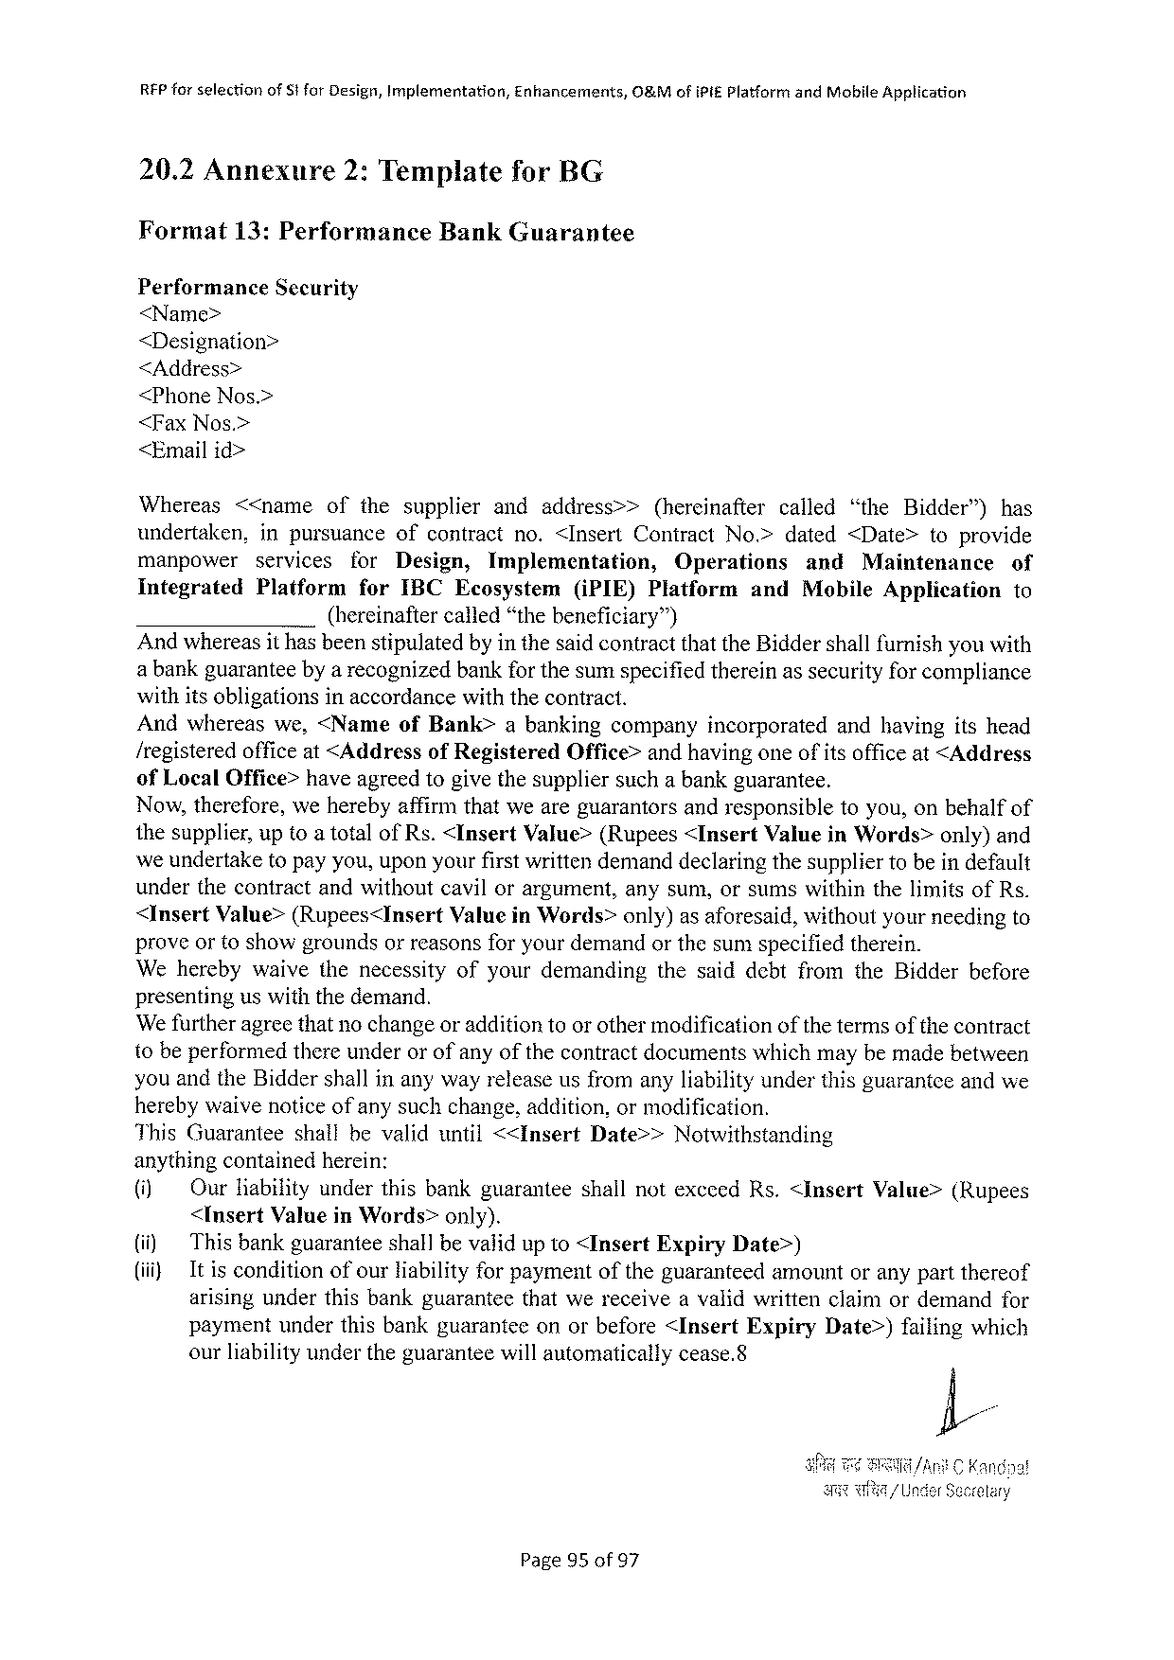

REP forselection of Stfor Design, Implementation, Enhancements, O&Mofi Pi£Platformand Mobile Application

20.2 Annexure 2: Templatefor BG

Format 13: Performance Bank Guarantee

Performance Security

<Name>

<Designation>

<Address>

<Phone Nos.>

<Fax Nos.>

<Emailid>

Whereas <<name ofthesupplier andaddress>> (hereinafter called “the Bidder”) has

undertaken, inpursuance ofcontractno.<Insert Contract No.>dated<Date> toprovide

manpower services for Design, Implementation, Operations and Maintenance of

Integrated Platform for IBCE cosystem(i PIE)Platform and Mobile Applicationto

(hereinaftercalled“thebeneficiary™)

Andwhereasit hasbeenstipulatedbyinthesaidcontractthatthe Biddershallfurnishyouwith

a bankguaranteebya recognizedbankfor thesumspecifiedthereinassecurityforcompliance

withitsobligationsinaccordancewiththecontract.

Andwhereaswe,<Name of Bank> abankingcompanyincorporated andhavingitshead

/registeredofficeat<Addressof Registered Office>andhavingoneofitsofficeat<Address

of Local Office>haveagreedtogivethesuppliersuchabankguarantee.

Now, therefore, weherebyaffirmthatweareguarantorsandresponsibletoyou, onbehalfof

thesupplier, uptoatotalof Rs.<Insert Value>(Rupees<Insert Valuein Words>only)and

weundertaketopayyou, uponyourfirstwrittendemanddeclaringthesuppliertobeindefault

underthecontractandwithoutcavilorargument, anysum, orsumswithinthelimitsof Rs.

<Insert Value>(Rupees<Insert Valuein Words>only)asaforesaid, withoutyourneedingto

proveortoshowgroundsorreasonsforyourdemandorthesumspecifiedtherein.

Weherebywaivethenecessity ofyourdemanding thesaiddebtfromthe Bidderbefore

presenting us with the demand.

We furtheragreethatnochangeoradditionto orothermodificationofthe termsofthe contract

tobeperformedthereunderorofanyofthecontractdocumentswhichmaybemadebetween

youandthe Biddershallinanywayreleaseusfromanyliabilityunderthisguaranteeandwe

herebywaivenoticeof anysuchchange, addition, ormodification.

|  |  |  |  |
| --- | --- | --- | --- |
| This Guarantee | shallbevaliduntil<<Insert | Date>> | Notwithstanding |

anythingcontainedherein:

|  |  |  |  |  |  |
| --- | --- | --- | --- | --- | --- |
| (i) (i) (i) | Our Habilityunderthisbankguaranteeshallnotexcced Rs.<Insert | | | | Value>(Rupees |
| <Insert Valuein Words>only). | | | | |
| Thisbankguaranteeshallbevaiidup 1 o <Insert | Expiry | Date>) | | |
| Itisconditionofourliabilityforpaymentoftheguaranteedamountoranypartthereof arisingunderthisbankguaranteethatwereceiveavalidwrittenclaimordemandfor | | | | |
| paymentunderthisbankguaranteeonorbefore<Insert | | Expiry | Date>)failingwhich | |
| ourliabilityundertheguaranteewillautomaticallycease.8 | | | | |

Page 95 of 97



RFP for selectionof Sifor Design, Implementation, Enhancements, O 8&Mofi PIEP latform and Mobite Application

|  |  |  |  |
| --- | --- | --- | --- |
| 20.3 Annexure 3: Functional | Requirement | Specification | Decument |

ATTACHED

Page 96 of 97



RFP forselection of Sfor Design, Implementation, Enhancements, O&Mof IPIEP latformand Mobile Application

20.4 Annexure 4: Master Service Agreement (MSA)

ATTACHED

Page 97 of 97



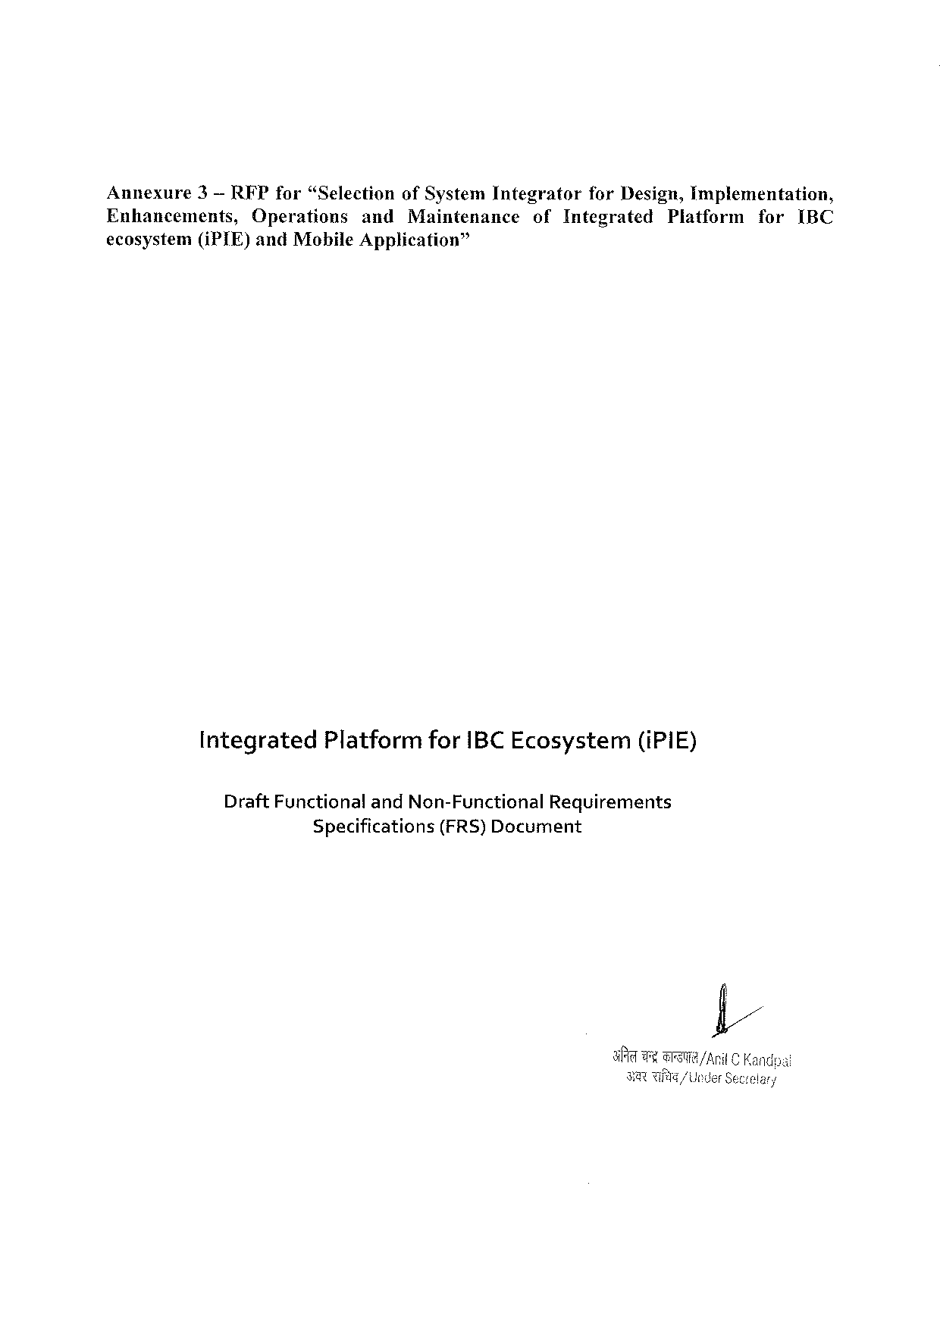

Annexure 3— RFP for“Selection of System Integrator for Design, Implementation,

Enhancements, Operations and Maintenance of Integrated Platform for IBC

ecosystem(i PTE) and Mobile Application”

Integrated Platformfor IBCE cosystem(i PIE)

Draft Functionaland Non-Functional Requirements

Specifications (FRS)Document

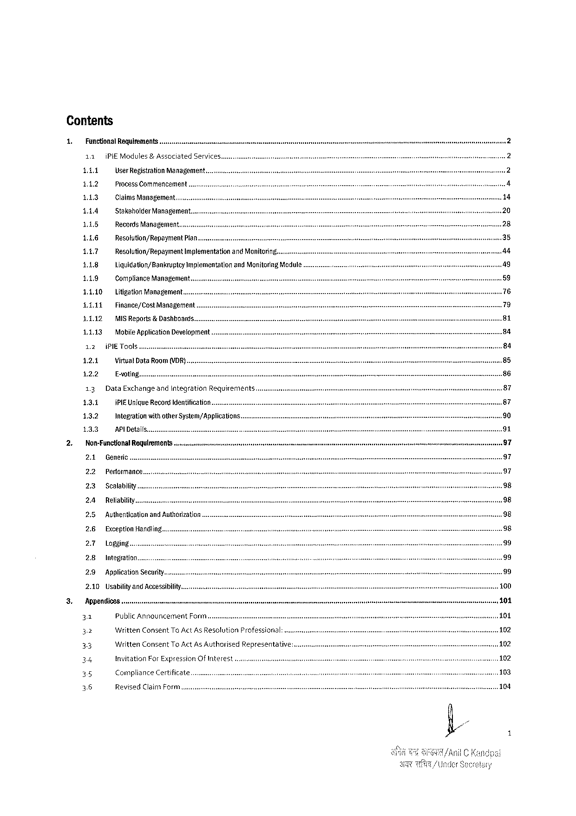

Contents

|  |  |  |  |  |  |  |
| --- | --- | --- | --- | --- | --- | --- |
| 1.  2. | Functional Requirements | | | | | |
| 11 | P | Modules | & Associated | | Services.. |
| 141 | User Registration Management.. | | | | |
| 112 | Process Commencement | | | | |
| 143 | Claims Management... | | | | |
| 114 | Stakeholder Management... | | | | |
| 115 | Records Management. | | | | |
| 116 | Resolution/Repoyment Plan... | | | | |
| 147 | Resolution/Repayment | | | Implementationand Monitoring. | |
| 118 | Liquidation/Banknptcy | | | Implementationand Monitering Module... | |
| 119 | Compliance Management... | | | | |
| 1110 | Litigation Management... | | | | |
| 1111 | Finance/Cost Management | | | | |
| 1112 | MISR eporis& Dashboards. | | | | |
| 1113 | Mobile Application Development | | | | |
| 12 | i PIE Tools | | | | |
| 121 | Virtual Data Room(VDR) . | | | | |
| 122 | E-voting | | | | |
| 13 | Data Exchangeand Integration Requirements. | | | | |
| 131 | i PIE Unigue Record Identification. | | | | |
| 13.2 | Integrationwith other System/Appiication: | | | | |
| 133 | APID etalls | | | | |
| Non-Functiona! Requlrements | | | | ........... | |
| 2.1 | Generic .. | | | | |
| 2.2 | Performance... | | | | |

23 Scalability.

2.4 Reliabi   
25 Authenticationand Authorization   
2.6 Exception Handiin...

2.7 Logging..

28 Integration   
29 Application Security   
2.10 Usabilityand Accessibilty.

|  |  |  |  |  |  |
| --- | --- | --- | --- | --- | --- |
| 3. | Appendices.. | | | s | e |
| 31 | Public Announcement Forrm.. | |
| g | Written Consent To Act As Resolution Professional:. | |
| 33 | Written Consent To Act As Authorised Representative:.... | |
| 34 | Invitation For Expression Of IMEETES t | e |
| 15 | Compliance Certificate...... | |
| 36 | Revised Claim Form | |

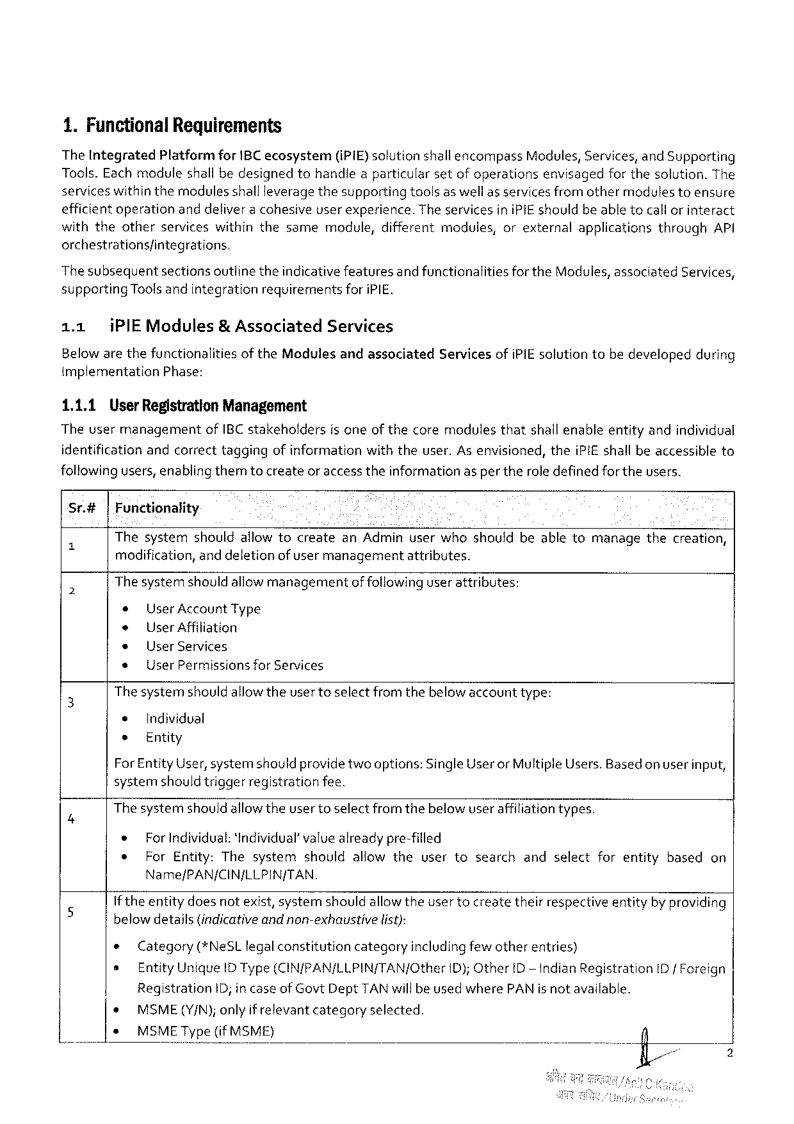

1. Functional Requirements

The Integrated Platformfor IBC ecosystem(i PIE) solutionshallencompass Modules, Services, and Supporting Tools. Each moduleshall bedesignedtohandlea particularsetof operationsenvisagedfor thesolution. The services withinthemodules shallleveragethesupportingtoolsas well as servicesfromothermodules toensure efficientoperationanddeliver a cohesiveuser experience. The servicesini PIE shouldbeable tocallorinteract withtheotherserviceswithinthesamemodule, differentmodules, orexternalapplicationsthrough API orchestrationsfintegrations,

|  |  |  |  |  |  |
| --- | --- | --- | --- | --- | --- |
| The subsequentsectionsoutlinetheindicativefeaturesand functionalitiesforthe Modules, associated Services | | | | | 3 |
| supporting | | Toolsandintegration | requirerents | fori PIE. |
| 1.1 | i PIEM odules& Associated | | | Services |

Belowarethefunctionalitiesof the Modulesandassociated implementation Phase:

1.1.1 User Registration Management

Servicesofi PIE solutiontobedevelopedduring

Theusermanagement of IBC stakeholdersisoneof thecoremodulesthatshall enableentityandindividual

identificationandcorrecttaggingofinformationwiththeuser. Asenvisioned, thei PIE shall beaccessibleto

following users, enabling themtocreateor access theinformationasper theroledefinedfortheusers.

Sr.#|Functionality

" Thesystemshouldallowtocreatean Adminuserwhoshouldbeabletomanagethecreation,

modification, and deletionofusermanagementattributes.

o Thesystemshouldallowmanagementof followinguserattributes:

* User Account Type

* User Affiliation

* User Services

e User Permissionsfor Services

3 The systemshouldallowtheusertoselectfrom thebelow accounttype:

e Individval

e Entity

For Entity User, systemshouldprovidetwooptions: Single Useror Multiple Users. Basedon userinput,

systernshould triggerregistrationfee.

B Thesystemshould allowtheusertoselect fromthebelow user affiliationtypes.

* For Individual: ‘Individual’ value alreadypre-filled

e For Entity: Thesystemshouldallowtheusertosearchandselectforentitybasedon

Name/PAN/CIN/LLPIN/TAN.

If theentitydoesnotexist, systemshouldallowtheusertocreatetheirrespectiveentityby providing

|  |  |  |  |  |  |
| --- | --- | --- | --- | --- | --- |
| 5 | belowdetails{indicativeandnon-exhaustive | | list): | | ID/ Foreign |
| e | Category(*Ne SL legalconstitutioncategoryincludingfewotherentries) | | |
| s | Entity Unique IDT ype(CIN/PAN/LLPIN/TAN/Other | | ID); Other D— indian Registration |

Registration ID; in case of Govt Dept TAN will be usedwhere PAN isnot available.

|  |  |  |  |
| --- | --- | --- | --- |
| * | MSME(Y/N); onlyif relevantcategory | selected. | T |
| s | MSMET ype(if MSME) |

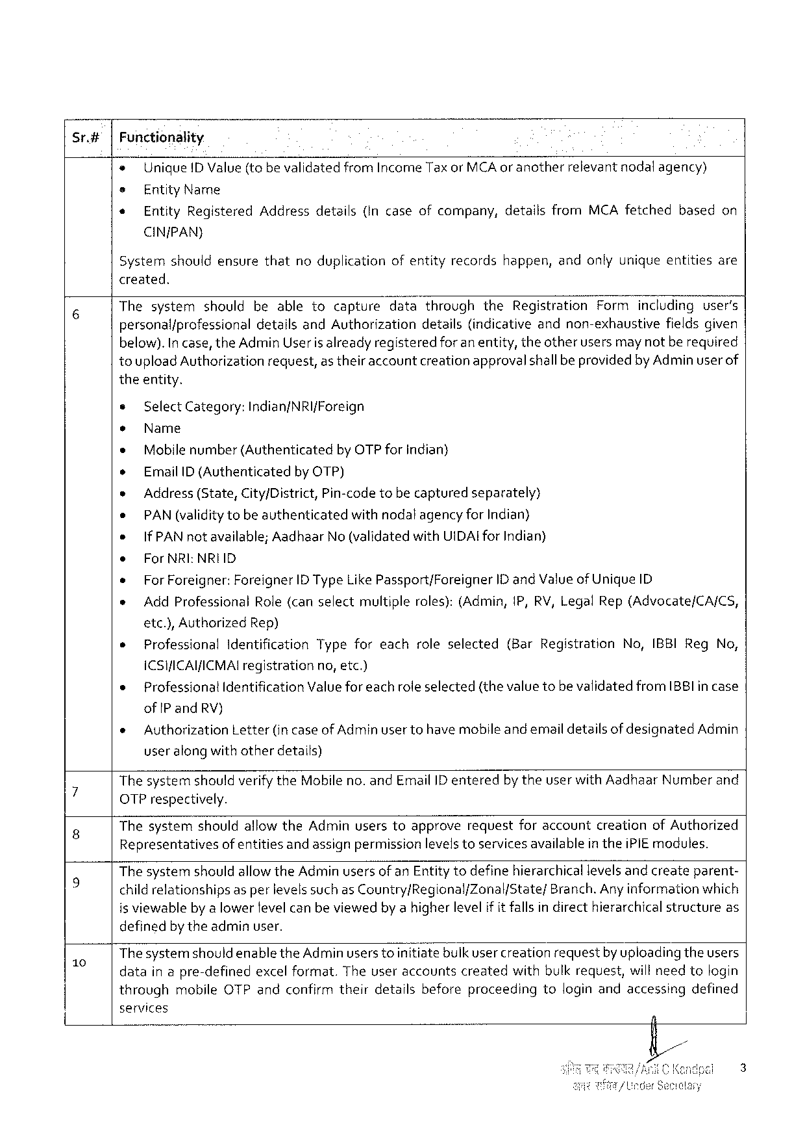

Sr.#|Functionality

e Unique ID Value(tobevalidatedfrom Income Taxor MCA oranother relevantnodalagency)

= Entity Name

« Entity Registered Addressdetails{Incaseofcompany, detailsfrom MCA fetchedbasedon

CIN/PAN)

Systemshouldensurethatnoduplicationofentityrecordshappen, andonlyuniqueentitiesare

created.

|  |  |  |
| --- | --- | --- |
| 6 | Thesystemshouldbeabletocapture | datathroughthe Registration Formincludinguser’s |
| personal/professionaldetailsand Authorizationdetails(indicativeandnon-exhaustivefieldsgiven | |

below). In case, the Admin Useris alreadyregisteredforanentity, theotherusersmaynotbe required

toupload Authorizationrequest, as theiraccountcreationapprovalshallbe providedby Adminuser of

theentity.

» Select Category: Indian/NRI{Foreign

¢ Name

* Mobilenumber(Authenticated by OTP forindian}

o Email ID (Authenticated by OTP)

s Address (State, City/District, Pin-code tobecapturedseparately)

e PAN (validitytobeauthenticatedwithnodalagency for Indian}

e If PAN notavailable; Aadhaar No (validated with UIDAI for Indian)

e For NRI: NRIID

* For Foreigner: Foreigner ID Type Like Passport/Foreigner ID and Valueof Unique ID

» Add Professional Role(canselectmultiple roles):(Admin,1 P, RV, Legal Rep(Advocate/CA/CS,

etc.), Authorized Rep)

e Professional Identification Typeforeachroleselected(Bar Registration No, IBBIR eg No,

ICSHICAI/ICMAI registration no, etc.)

o Professional Identification Valueforeachroleselected(thevaluetobe validatedfrom IB 8 Iincase

of IP and RV)

|  |  |  |  |
| --- | --- | --- | --- |
| e | Authorization | Letter(in caseof Adminusertohavemobileandemaildetailsof designated | Admin |

useralong withotherdetails)

; Thesystemshouldverifythe Mobileno. and Email ID enteredby theuserwith Aadhaar Numberand

OTP respectively.

8 Thesystemshouldallowthe Adminuserstoapproverequestforaccountcreationof Authorized

Representativesof entitiesand assignpermissionlevelstoservicesavailable in thei PIE modules.

The systemshouldallowthe Adminusersof an Entitytodefinehierarchical levelsandcreateparent-

|  |  |
| --- | --- |
| k S | childrelationshipsas perlevelssuch as Country/Regional/Zonal/State/Branch. Any information which is viewableby a lower fevelcan beviewedbya higherlevelif it fallsin directhierarchical structureas |

definedbytheadminuser.

- Thesystemshouldenablethe Adminusers toinitiatebulk usercreationrequestbyuploading theusers

datain apre-definedexcel format. Theuseraccountscreatedwithbulkrequest, willneedtologin

throughmobile OTP andconfirmtheirdetailsbeforeproceedingtologinandaccessingdefined

services

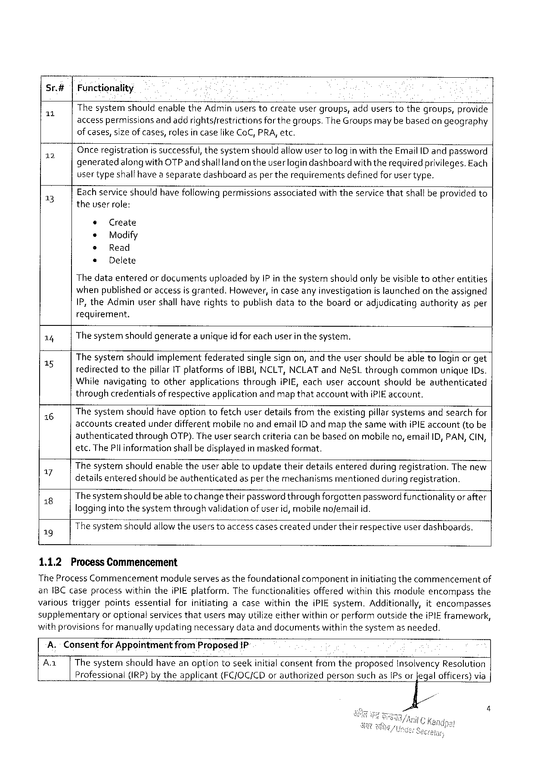

|  |  |  |  |
| --- | --- | --- | --- |
| Sr.#  L | Functionality  Thesystemshouldenablethe Adminuserstocreateusergroups, adduserstothegroups, provide | | |
| accesspermissions | andaddrightsfrestrictions | forthegroups. The Groupsmaybebasedongeography |

ofcases, sizeofcases, rolesincaselike Co C, PRA, etc.

|  |  |  |
| --- | --- | --- |
| 12  3] | Onceregistrationissuccessful, thesystemshould allowuser tologinwiththe Email ID andpassword generatedalong with OTP andshalllandon theuser logindashboardwith therequiredprivileges. Each usertypeshallhave a separatedashboardasper therequirementsdefinedforusertype.  Eachservice shouldhave following permissionsassociatedwiththeservice thatshall beprovidedto theuser role: | |
| ¢ | Create |
| * | Modify |
| ® | Read |
| s | Delete |

Thedataenteredor documentsuploadedby IP in thesystemshouldonlybe visibletootherentities whenpublished oraccessis granted. However, in caseany investigationis launchedon theassigned IP, the Adminusershall haverightstopublishdatatotheboardoradjudicatingauthorityasper requirement.

|  |  |  |  |
| --- | --- | --- | --- |
| 14  15  16  17  18  19  1.1.2 | The systemshould generatea uniqueid for eachuser in thesystem.  Thesystemshouldimplementfederatedsinglesignon, and theusershouldbeabletologinor get redirectedtothepillar 1 T platformsof IBBI, NCLT, NCLAT and Ne SL throughcommonunique[Ds. Whilenavigatingtootherapplicationsthroughi PIE, eachuseraccountshouldbeauthenticated throughcredentialsof respectiveapplication andmap thataccountwithi PIE account.  Thesystemshouldhaveoptiontofetchuserdetailsfromtheexistingpillarsystemsandsearchfor accountscreatedunderdifferentmobileno andemail ID andmapthesamewithi PIE account(tobe | | |
| authenticated | through | OTP). Theusersearchcriteriacanbebasedonmobileno, email ID, PAN, CIN, |
| etc. The Plinformationshallbedisplayedin maskedformat.  Thesystemshouldenabletheuser abletoupdatetheirdetailsenteredduring registration. The new detailsenteredshouldbe authenticatedasperthe mechanismsmentionedduring registration. Thesystemshouldbeable tochangetheirpassword throughforgottenpasswordfunctionalityor after loggingintothesystemthroughvalidationof user id, mobilenofemail id.  Thesystemshouldaliowtheusers toaccesscasescreatedunderthelir respectiveuser dashboards.  Process Commencement | | |

The Process Commencementmodule servesas thefoundationalcomponentin initiatingthecommencementof an IBC caseprocesswithinthei PIE platform. Thefunctionalitiesofferedwithinthismoduleencompassthe varioustriggerpointsessentialforinitiatingacasewithinthei PIE system. Additionally, itencompasses supplementaryoroptionalservices thatusersmayutilizeeitherwithin orperformoutsidethei PIE framework,

|  |  |  |  |
| --- | --- | --- | --- |
| withprovisionsformanuallyupdating | necessary | dataanddocuments | withinthesystemasneeded. |

A.- Consentfor Appointmentfrom Proposed 1 P

Aa Thesystemshouldhaveanoptiontoseekinitialconsentfromtheproposed Insolvency Resolution Professional (IRP) by theapplicant (FC/OC/CD orauthorized personsuchas IP sor Jegalofficers)via

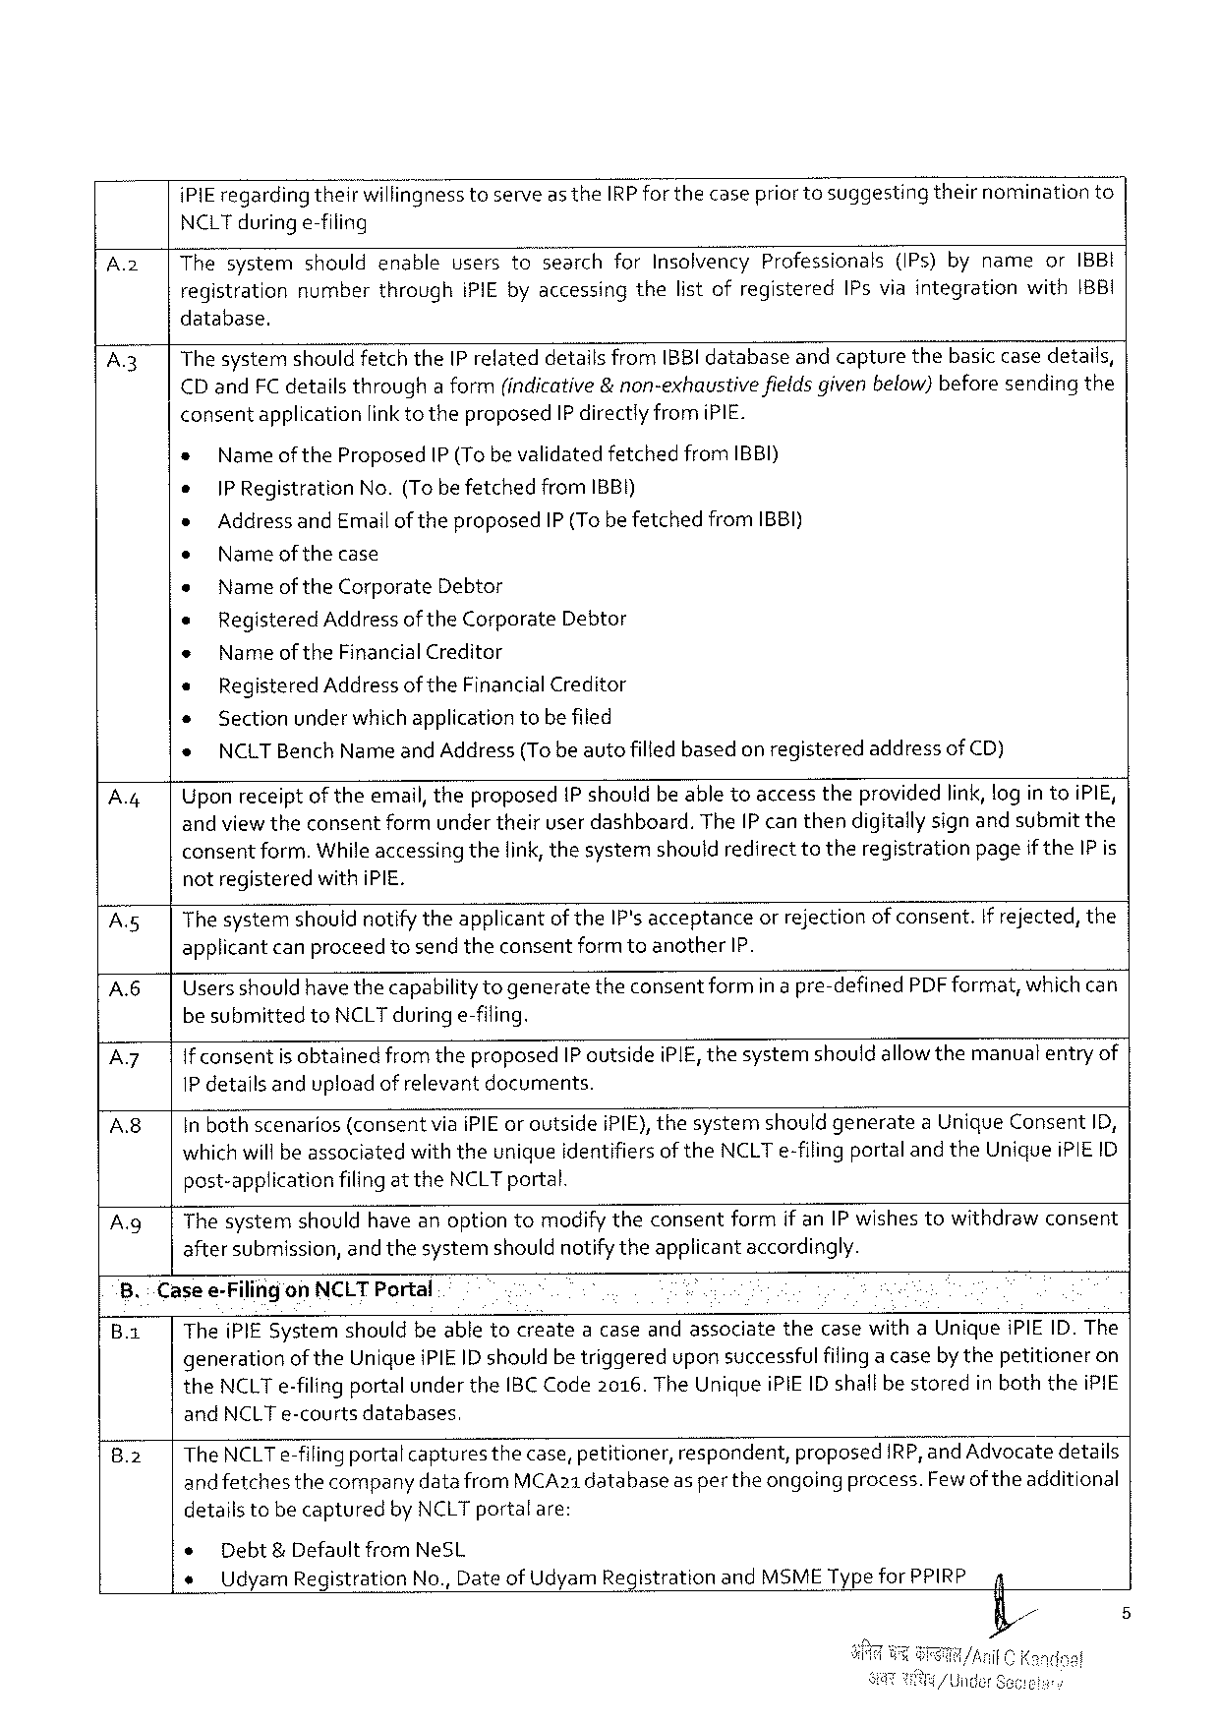

|  |  |  |
| --- | --- | --- |
| i PIE regardingtheir Wi\iinanesstoserveas the IRP forthecasepriorto suggesting | theirnomination | to |

NCLT duringe-filing

|  |  |  |  |  |  |  |  |  |
| --- | --- | --- | --- | --- | --- | --- | --- | --- |
| A 2 | | | Thesystemshouldenableusersto“searchfor Insolvency Professionals(IP s)bynameor IBBI | | | | | | |
| registration | number | through | IPIE byaccessing | thelistofregistered | IP sviaintegration | with 1 BBI |

database.

|  |  |  |  |  |  |  |  |  |
| --- | --- | --- | --- | --- | --- | --- | --- | --- |
| A 3  A.4| | The systemshould fetchthe IP relateddetailsfrom IBBI databaseandcapturethebasic casedetails, | | | | | | | |
| CD and FC detailsthrougha form(indicative&non-exhaustive | | | | | | fieldsgivenbelow)beforesendingthe | |
| consentapplicationlinkto theproposed IP directlyfromi PIE. | | | | | | | |
| » | Nameofthe Proposed | | | IP (Tobevalidatedfetchedfrom IBBI) | | | |
| e | |PR egistration | | No.(Tobe fetched | | from 1 BBI) | | |
| » | | Address and Emailoftheproposed IP (Tobefetchedfrom IBBI) | | | | | |
| o | | Name ofthecase | | | | | |
| e | Nameof the Corporate Debtor | | | | | | |
| « | | Registered Address of the Corporate Debtor | | | | | |
| « | | Name of the Financial Creditor | | | | | |
| * | | Registered Address of the Financial Creditor | | | | | |
| « | | Sectionunder whichapplication tobefiled | | | | | |
| e | NCLTB ench Nameand Address(Tobeautofilledbasedonregistered | | | | | | addressof CD) |
| Uponreceiptoftheemail, theproposed 1 Pshouldbeabletoaccesstheprovidedlink, log in toi PIE, andviewtheconsentformunder theiruserdashboard. The IP canthendigitallysignand submitthe consentform. Whileaccessingthelink, thesystemshouldredirecttotheregistrationpageifthe IP is | | | | | | | |

notregisteredwith i PIE.

|  |  |
| --- | --- |
| Asg  A 6 | The systemshouldnotifytheapplicantof the IP'sacceptanceorrejectionof consent. If rejected, the applicantcanproceedtosendtheconsentformtoanother IP.  Usersshould have thecapabilityto generatetheconsentformin a pre-defined PDF format, whichcan |

be submittedto NCLT during e-filing.

Az If consentis obtainedfromtheproposed IP outsidei PIE, thesystemshouldallowthemanuatentryof

1 P detailsandupload of relevantdocuments.

|  |  |
| --- | --- |
| A 8 | In bothscenarios(consentviai PIE or outsidei PIE), thesystemshouldgeneratea Unique Consent ID, whichwill beassociatedwith theuniqueidentifiersof the NCLT e-filingportaland the Uniquei PIEID |

post-applicationfilingat the NCLT portal.

A. g| The systemshouldhave anoptiontomodify theconsentformif an IP wishestowithdrawconsent

aftersubmission, and thesystemshouldnotifytheapplicantaccordingly.

8.: Casee-Filingon NCLT Portal 5

B.1 Thei PIE Systemshouldbeabletocreatea caseandassociatethecasewitha Uniquei PIEID. The

generationof the Uniquei PIEID shouldbetriggeredupon successfulfilinga caseby thepetitioneron

the NCLT e-filingportalunder the IBC Code 2016. The Unique i PIEID shallbe storedin boththei PIE

and NCLT e-courtsdatabases,

|  |  |  |  |  |  |  |
| --- | --- | --- | --- | --- | --- | --- |
| 8.2 | The NCLT e-filingportalcapturesthecase, petitioner, | | | respondent, | proposed | IRP, and Advocatedetails |
| andfetches | thecompanydatafrom | MCA 21 databaseaspertheongoingprocess. Fewof theadditional | | | |

detailstobecapturedby NCLT portalare:

|  |  |  |
| --- | --- | --- |
| e | Debt&Defaultfrom Ne SL | 4 |
| « | Udyam Registration No., Date of Udyam Registration and MSMET ypefor PPIRP |

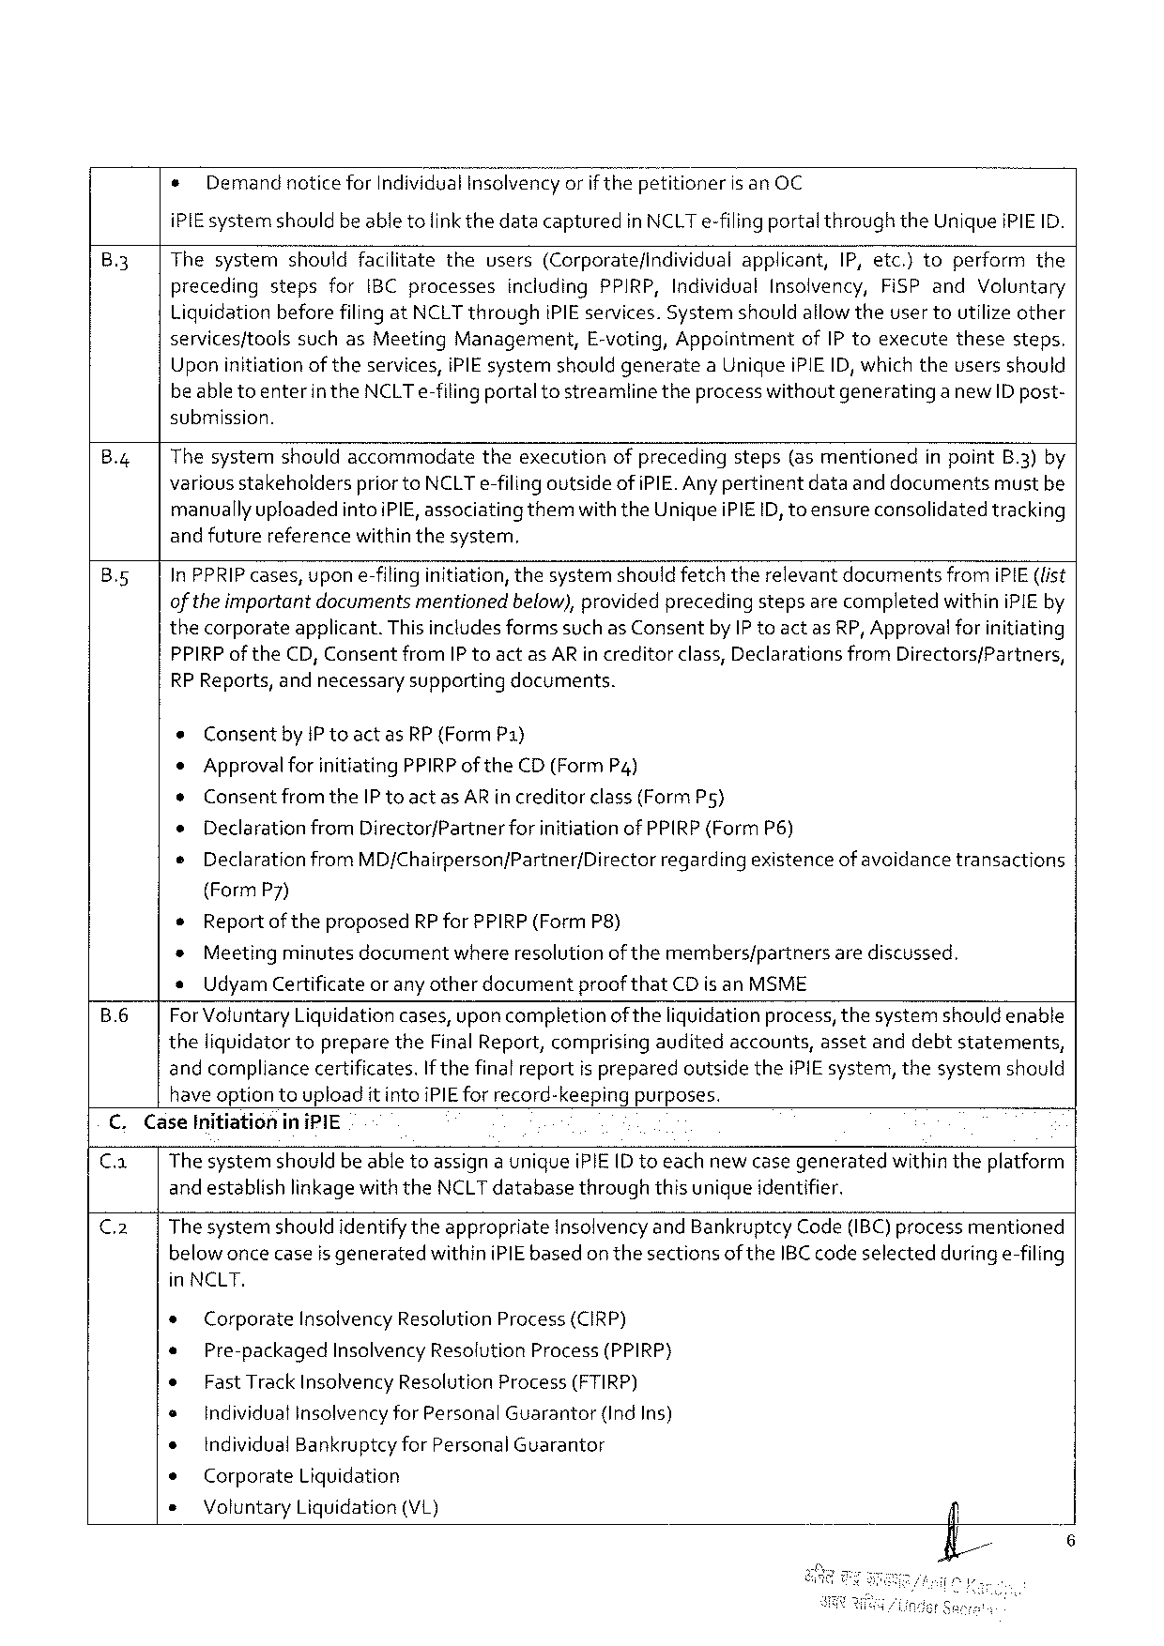

* Demandnotice for Individual Insclvencyorif thepetitioneris an OC

i PIE systemshould beable tolinkthedatacapturedin NCLT e-filingportalthroughthe Uniquei PIEID.

|  |  |  |  |  |  |  |  |  |  |  |  |  |  |  |  |
| --- | --- | --- | --- | --- | --- | --- | --- | --- | --- | --- | --- | --- | --- | --- | --- |
| B 3 | Thesystem | should | | facilitate | the | users | (Corporatefindividual | | applicant, | | IP, etc.)to | | perform | | the |
| preceding | steps | for | IBC processes | | including | | PPIRP, Individual | | Insolvency, | | Fi SP and | | Voluntary | |

Liquidation beforefilingat NCLT throughi PIE services. Systemshouldallowtheuser toutilize other

|  |  |  |  |  |  |  |
| --- | --- | --- | --- | --- | --- | --- |
| servicesftools | suchas Meeting | Management, | E-voting, Appointment | of IP toexecute | these | steps. |

Upon initiationof theservices, i PIE systemshouldgeneratea Uniquei PIEID, which theusersshould

beabletoenterin the NCLT e-filingportaltostreamlinetheprocess withoutgeneratinga new ID post-

submission.

B.4 Thesystemshouldaccommodatetheexecutionofprecedingsteps(as mentionedin point B.3)by

various stakeholderspriorto NCLT e-filingoutside ofi PIE. Anypertinentdataanddocumentsmustbe

manuallyupfoadedintoi PIE, associatingthemwiththe Uniquei PIEID, toensureconsolidated tracking

andfuturereferencewithinthesystem,

|  |  |  |
| --- | --- | --- |
| Bs 5 | In PPRIP cases, upon e-filinginitiation, thesystemshould fetchtherelevantdocumentsfromi PIE(fist of the importantdocumentsmentionedbelow), provided precedingstepsarecompletedwithini PIE by | |
| thecorporate | applicant. Thisincludesformssuchas Consentby IP toactas RP, Approvalforinitiating |

PPIRP of the CD, Consentfrom IP toact as AR in creditorclass, Declarationsfrom Directors/Partners,

RP Reports, andnecessary supporting documents.

e Consent by IP toactas RP (Form P 1)

* Approvalforinitiating PPIRP of the CD(Form P 4)

* Consentfromthe IP toactas AR increditorclass(Form Ps)

o Declarationfrom Director/Partner forinitiationof PPIRP(Form P 6)

e Declaration from MD/Chairperson/Partner/Directorregardingexistenceofavoidancetransactions

(Form P 7)

* Reportof theproposed RP for PPIRP(Form P 8)

* Meetingminutesdocumentwhereresolutionof themembers/partnersarediscussed.

* Udyam Certificateor anyotherdocumentproof that CD is an MSME

B.6 For Voluntary Liquidationcases, uponcompletion of theliquidationprocess, thesystemshouldenable

theliquidator topreparethe Final Report, comprisingauditedaccounts, assetanddebtstatements,

andcompliancecertificates. If thefinal reportis preparedoutsidethei PIE system, thesystermn should

have optiontouploadit intoi PIE for record-keepingpurposes.

C. Case Initiationin i PIE

Ca Thesystemshouldbe abletoassigna uniquei PIE(D toeachnewcasegeneratedwithintheplatform

and establishlinkagewiththe NCLT databasethroughthis uniqueidentifier.

C 2 Thesystemshouldidentifythe appropriate Insolvencyand Bankruptcy Code(IBC) processmentioned

belowoncecaseis generatedwithini PIE basedon thesectionsof the IBC code selectedduringe-filing

in NCLT.

|  |  |  |  |  |  |
| --- | --- | --- | --- | --- | --- |
| * | Corporate | Insolvency Resolution Process(CIRP) | | | /fl/ |
| * | Pre-packaged | | Insolvency Resolution Process(PPIRP) | |
| * | Fast Track Insolvency Resolution Process(FTIRP) | | | |
| s | Individualinsolvencyfor Personal Guarantor | | | (Ind Ins) |
| e | Individual Bankruptcyfor Personal Guarantor | | | |
| e | Corporate | Liquidation | | |
| * | Voluntary Liquidation(VL) | | | |

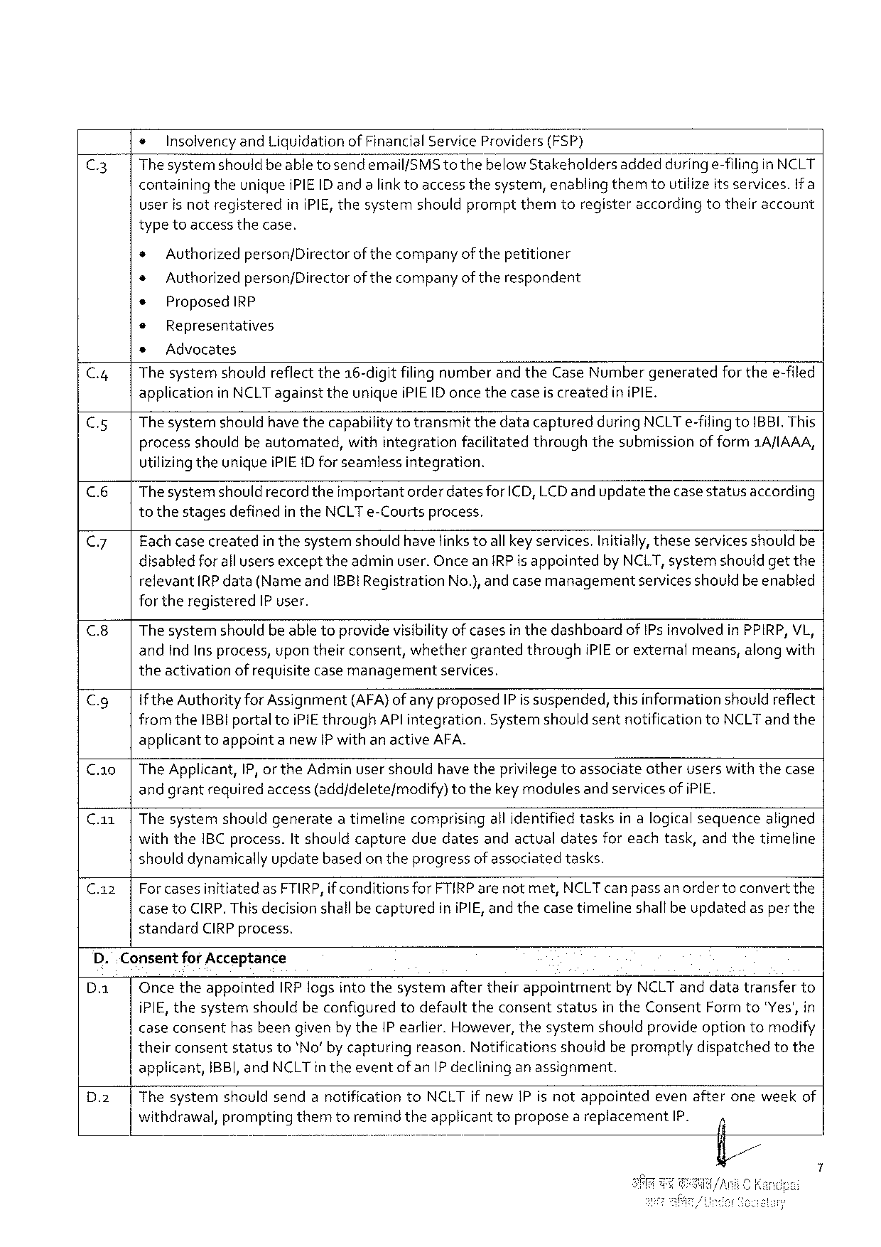

s Insolvencyand Liquidationof Financial Service Providers(FSP)

C 3 Thesystemshould beabletosendemail/SMS tothebelow Stakeholdersaddeddun’r@e-filingin NCLT containing theuniquei PIEID andalinktoaccessthesystem, enablingthemtoutilizeits services. if a

userisnotregistered in IPIE, thesystemshouldpromptthemtoregisteraccording totheiraccount

typetoaccess thecase.

* Authorizedperson/Directorof thecompanyof thepetitioner

* Authorizedperson/Directorof thecompanyoftherespondent

* Proposed IRP

© Representatives

* Advocates

C.4| Thesystemshouldreflectthe 16-digitfilingnumberand the Case Numbergeneratedfor thee-filed applicationin NCLT againsttheuniquei PIEID once thecaseis createdin i PIE.

C 5 Thesystemshould have thecapabilitytotransmitthedatacapturedduring NCLT e-filingto BBI. This processshouldbeautomated, withintegrationfacilitatedthroughthesubmissionof form 1 A/IAAA, utilizingtheuniquei PIEID forseamless integration.

(& Thesystemshould recordtheimportantorder datesfor ICD, LCD and updatethecasestatusaccording tothestagesdefinedinthe NCLT e-Courtsprocess,

C 7 Fachcase createdin thesystemshould havefinks toallkey services. Initially, theseservicesshouldbe disabledforall usersexcepttheadminuser. Oncean IRP is appointedby NCLT, systemshould getthe relevant RP data(Nameand IBBIR egistration No.), andcase managementservicesshouldbeenabled fortheregistered IP user.

C.8| The systemshouldbe abletoprovidevisibilityof casesin thedashboardof IP s involvedin PPIRP, VL, and Ind Ins process, upon theirconsent, whethergrantedthrough IPIE or externalmeans, along with theactivationofrequisitecasemanagement services,

Cg If the Authorityfor Assignment(AFA)ofany proposed IP is suspended, thisinformationshouldreflect from the IBBI portaltoi PIE through AP lintegration. Systemshould sentnotificationto NCLT and the applicanttoappointa new IP withanactive AFA.

C. a 0|The Applicant, IP, orthe Adminusershouldhave theprivilegetoassociateotheruserswiththecase andgrantrequiredaccess(add/deletefmodify)tothekeymodulesand services of i PIE.

Ca 1|Thesystemshouldgenerateatimelinecomprisingall identifiedtasksinalogicalsequencealigned with the IBC process. It shouldcaptureduedatesandactualdatesfor eachtask, andthetimeline shoulddynamically updatebasedon theprogressof associatedtasks.

C. az| Forcasesinitiatedas FTIRP, if conditionsfor FTIRP arenotmet, NCLT can passanordertoconvert the case to CIRP. This decisionshallbe capturedini PIE, and thecase timelineshallbeupdatedas per the standard CIRP process.

D.. Consentfor Acceptance

D. a| Oncetheappointed IRP logsinto thesystemaftertheirappointmentby NCLT anddatatransferto i PIE, thesystemshouldbeconfigured todefaulttheconsent status in the Consent Formto"Yes', in caseconsenthasbeengiven bythe IP earlier. However, thesystemshouldprovideoptiontomodify theirconsentstatusto*No’ bycapturingreason. Notificationsshouldbepromptlydispatchedtothe

|  |  |  |
| --- | --- | --- |
| D.2 | applicant, | IBBI, and NCLT intheeventofan IP declininganassignment. |
| Thesystem withdrawal, | shouldsendanotification to NCLT if new IP isnotappointed evenafteroneweekof  prompting themtoremindtheapplicant remnd! toproposeareplacement IP. i |

S

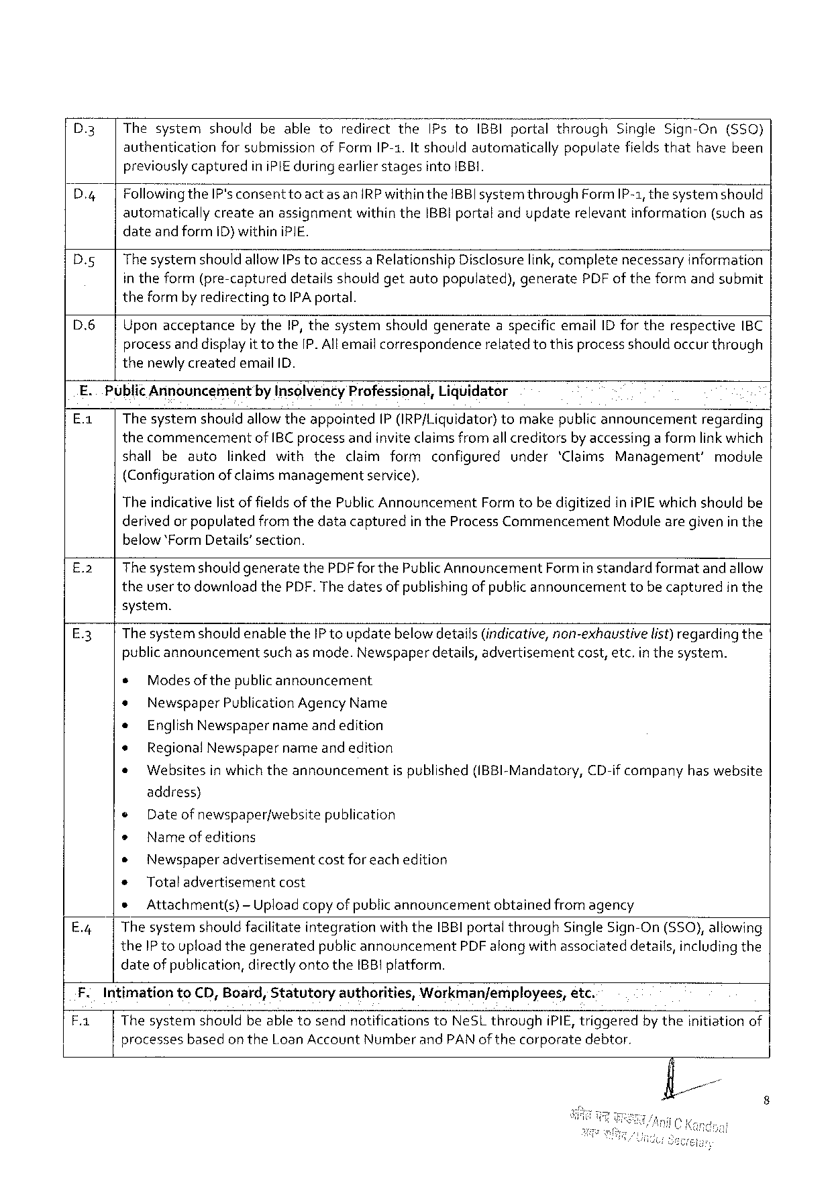

|  |  |  |
| --- | --- | --- |
| D.3 | |Thesystemshouldbeabletoredirectthe IP sto IBBI portalthrough | Single Sign-On(S 50) |

authenticationforsubmissionof Form IP-1. It shouldautomaticallypopulatefieldsthathavebeen previouslycapturedini PIE during earlier stagesinto IBBI.

D. g Followin‘&the IP'sconsenttoact as an IRP withinthe IBBI systemthrough Form IP-1, thesystemshould automaticallycreateanassignmentwithinthe IBB}portalandupdaterelevantinformation(suchas dateandform ID) withini PIE.

|  |  |  |  |  |
| --- | --- | --- | --- | --- |
| D. g | Thesystemshouldallow IP s toaccessa Relationship | Disclosurelink, complete | necessary | information |

in theform(pre-captureddetailsshouldgetautopopulated), generate PDF of theformandsubmit theformby redirectingto IPA portal.

D.6| Uponacceptanceby the IP, thesystemshouldgenerateaspecificemail ID fortherespective IBC

processanddisplayittothe[P. Allemailcorrespondence thenewlycreatedemail ID.

relatedtothisprocessshouldoccurthrough

|  |  |  |  |
| --- | --- | --- | --- |
| E.. | Public Announcement | by Insolventy Professional, Liquidator | regarding |
| E-: | The systemshouldallowtheappointed IP(IRP/Liquidator)tomakepublicannouncement | |

thecommencementof IBC processandinviteclaimsfromall creditorsby accessinga formlink which

|  |  |  |  |  |  |  |
| --- | --- | --- | --- | --- | --- | --- |
| shallbeauto | linkedwiththe | claimformconfigured | | under | ‘Claims Management’ | module |
| (Configuration | of claimsmanagement | | service), |

The indicativelist of fields of the Public Announcement Formtobe digitizedini PIE which shouldbe

derivedor populatedfromthedatacapturedin the Process Commencement Modulearegivenin the

below*Form Details’section.

|  |  |  |
| --- | --- | --- |
| E.2 | | | Thesystemshouldgeneratethe PDF for the Public Announcement Formin standardformatand allow |

theuser todownloadthe PDF. The datesof publishing of publicannouncementtobecapturedin the

system.

E 3 Thesystemshouldenablethe IP toupdatebelow details(indicative, non-exhaustive list)regardingthe

publicannouncementsuch as mode. Newspaperdetails, advertisementcost, etc. inthesystem.

|  |  |  |  |  |  |  |
| --- | --- | --- | --- | --- | --- | --- |
| s | Modesofthepublicannouncement | | is published | (IBBI-Mandatory, | CD-if company | haswebsite |
| * | Newspaper Publication Agency Name | |
| * | English Newspaper | nameandedition |
| * | Regional Newspapername andedition | |
| * | Websitesinwhichtheannouncement | |

address)

© Dateofnewspaperfwebsite publication

* Name ofeditions

o Newspaper advertisement costforeachedition

* Totaladvertisementcost

s Attachment(s)-Uploadcopyof publicannouncementobtainedfrom agency

E.4 Thesystemshouldfacilitateintegrationwiththe IBBI portalthrough Single Sign-On (SSO), allowing

the IP toupload thegeneratedpublicannouncement PDF alongwith associateddetails, includingthe

dateof publication, directlyontothe IBB 1 pfatform.

|  |  |  |  |  |  |  |
| --- | --- | --- | --- | --- | --- | --- |
| F. | Intimationto CD, Board, Statutoryauthorities, | | Workman/employees, | | etc. | bytheinitiationof |
| B |
| Thesystemshouldbeabletosendnotifications | | to Ne SL through | i PIE, triggered | |
| processes | basedon the Loan Account Numberand PAN of thecorporate | | | debtor. |

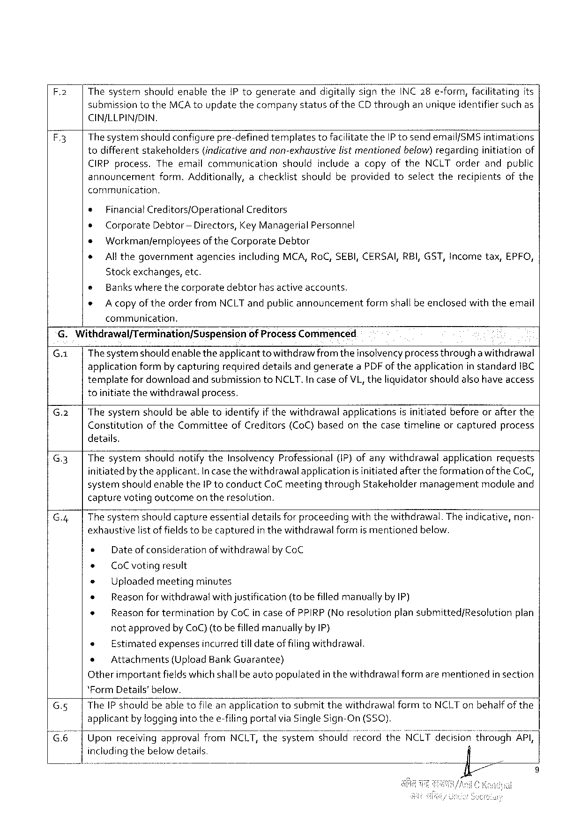

F.2 Thesystemshouldenablethe IP togenerateandd‘\gitaliy‘signthe INC 28 e-form, facilitatingits

submissiontothe MCA toupdatethecompanystatusof the CD throughanunique identifiersuchas

CIN/LLPIN/DIN.

A 3 Thesystemshouldconfigurepre-definedtemplatestofacilitatethe IP tosendemail{SMS intimations

todifferent stakeholders (indicativeandnon-exhaustive listmentionedbelow)regarding initiation of

CIRP process. Theemailcommunicationshouldincludeacopyofthe NCLT orderandpublic

announcement form. Additionally, achecklistshouldbeprovidedtoselecttherecipientsofthe

communication.

* Financial Creditors/Operational Creditors

¢ Corporate Debtor — Directors, Key Managerial Personnel

» Workmanfemnployeesof the Corporate Debtor

* All thegovernment agencies including MCA, Ro C, SEBI, CERSAI, RBI, GST, Incometax, EPFO,

Stockexchanges, etc.

® Bankswhere thecorporatedebtorhasactive accounts.

* A copyof theorderfrom NCLT andpublicannouncementformshallbeenclosedwiththeemail

communication,

G. Withdrawal/Termination/Suspension of Process Commenced

G.1| Thesystemshould enabletheapplicantto withdrawfromtheinsolvencyprocess througha withdrawal

applicationformbycapturingrequireddetailsandgeneratea PDF oftheapplicationin standard 1 BC

templatefordownloadand submissionto NCLT. Incase of VL, theliguidator should alsohave access

toinitiate thewithdrawalprocess.

G.2| Thesystemshouldbeabletoidentifyif thewithdrawalapplicationsisinitiatedbeforeorafterthe

Constitution of the Committee of Creditors (Co C)based onthecasetimeline orcaptured process

details.

G.3| Thesystemshouldnotifythe Insolvency Professional(i P) ofanywithdrawalapplicationrequests

initiatedby theapplicant. Incasethewithdrawalapplicationis initiatedafter theformationof the Co C,

systemshouldenablethe IP toconduct Co Cmeetingthrough Stakeholdermanagementmoduleand

capturevotingoutcome on theresolution.

G.4| The systemshouldcaptureessentialdetailsforproceedingwith thewithdrawal. Theindicative, non-

exhaustivelist of fieldstobecapturedin thewithdrawalformis mentionedbelow.

e Dateof considerationof withdrawalby Co C

+ Co Cvotingresult

* Uploadedmeetingminutes

* Reasonforwithdrawalwithjustification(to befilledmanuallyby IP)

e Reason for terminationby Co Cin caseof PPIRP(No resolutionplan submitted/Resolutionplan

notapprovedby Co C) (to befilledmanuallyby IP)

e Estimatedexpensesincurredtill dateof filingwithdrawal.

e Attachments (Upload Bank Guarantee)

Otherimportantfieldswhichshallbe autopopulatedin thewithdrawal formarementionedin section

*Form Details’below.

G.5| The IP shouldbeabletofileanapplicationtosubmitthewithdrawalformto NCLT onbehalfof the

applicantby loggingintothee-filingportalvia Single Sign-On (S 50).

G 6 Uponreceivingapprovalfrom NCLT, thesystemshouldrecordthe NCLZIZHémslor? throuafii/Klgl, i

includingthebelow details

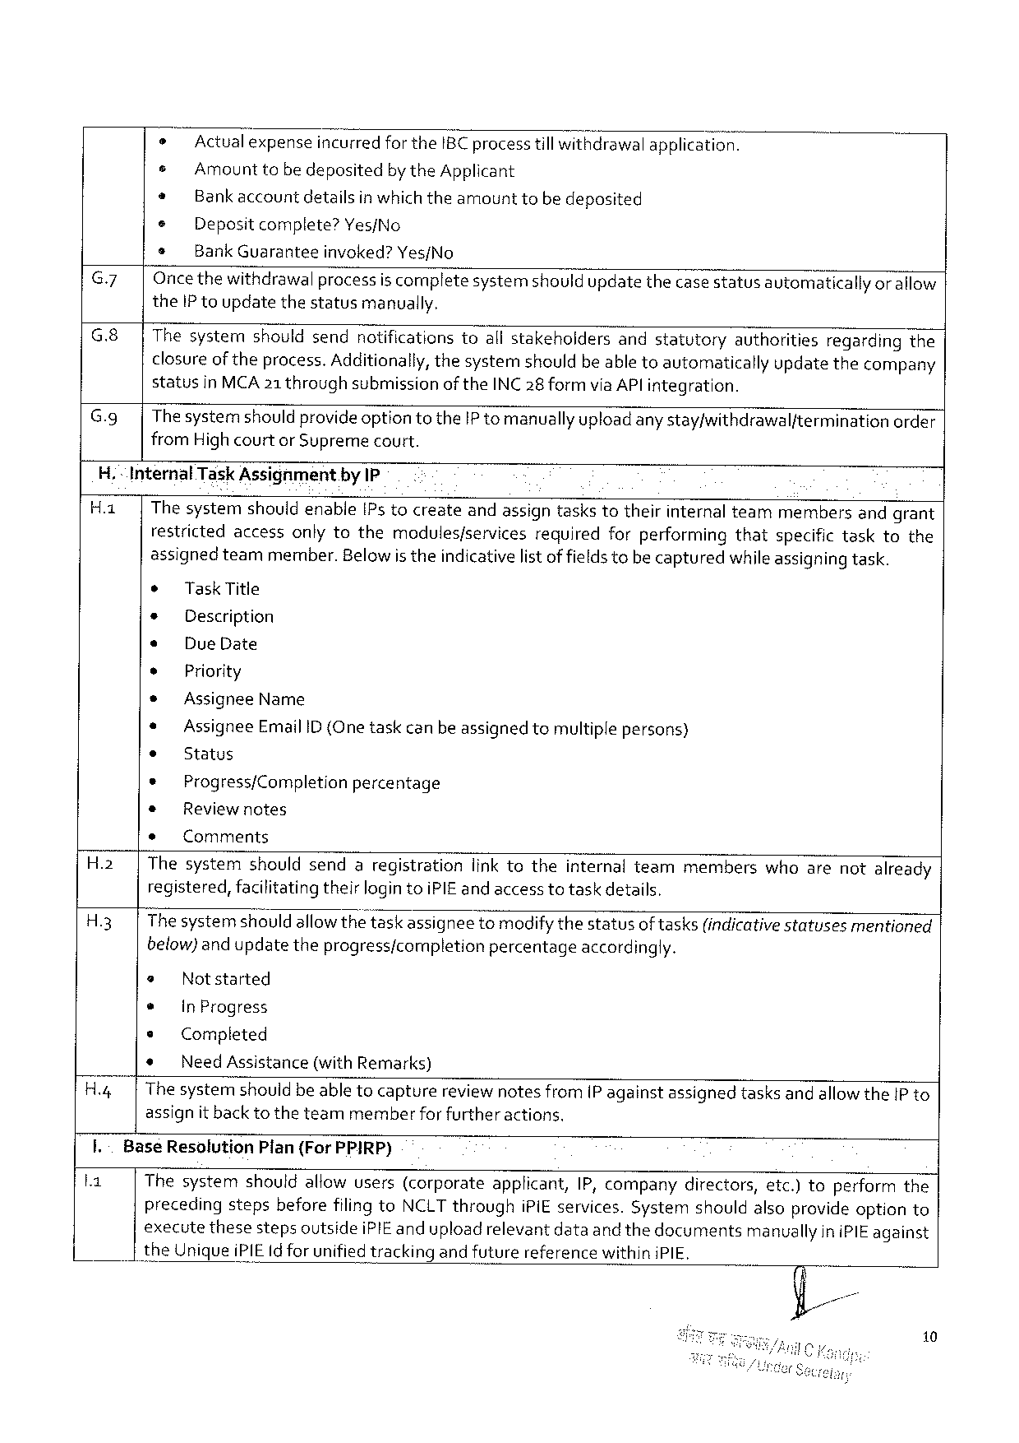

|  |  |  |  |  |  |
| --- | --- | --- | --- | --- | --- |
| G.7  G.8|  G.9| | » | | Actual expenseincurredforthe IBC processtill withdrawalapplication. | | |
| e | Amounttobedepositedbythe Applicant | | | |
| * | Bankaccount | | detailsinwhichtheamount | tobedeposited |
| e | Depositcomplete? Yes/No | | | |
| * | Bank Guarantee | | invoked? Yes/No | |
| Oncethewithdrawalprocessis completesystemshouldupdatethecase statusavtomaticallyor allow the IP toupdatethestatusmanually.  Thesystemshouldsendnotificationstoallstakeholdersandstatutoryauthoritiesregardingthe closureoftheprocess. Additionally, thesystemshouldbeable toautomaticallyupdatethecompany statusin MCA 21 throughsubmissionofthe INC 28 formvia AP! integration.  Thesystemshould provideoptiontothe IP tomanually uploadanystay/withdrawalfterminationorder from High courtor Supremecourt. | | | | |

H.“Internal Task Assighment. by IP

Ha | Thesystemshouidenable[Ps tocreateandassigntaskstotheirinternalteammembersandgrant restrictedaccessonlytothemodules/servicesrequiredforperformingthatspecifictasktothe assignedteammember. Belowis theindicativelistoffieldstobecapturedwhileassigningtask.

* Task Title

* Description

e Due Date

e Priority

* Assignee Name

* Assignee Email ID (One taskcan beassigned tomultiplepersons)

* Status

¢ Progress/Completionpercentage

® Reviewnotes

* Comments

H.2| Thesystemshouldsendaregistrationlink totheinternalteammemberswhoarenotalready registered, facilitatingtheirlogintoi PIE and access totaskdetails.

H 3 Thesystemshould allowthetaskassigneetomodifythestatusoftasks(indicativestatusesmentioned below)and updatetheprogress/completionpercentageaccordingly.

@ Notstarted

* In Progress

s Completed

* Need Assistance (with Remarks)

H.4| Thesystemshouldbeable tocapturereviewnotesfrom[P againstassignedtasksandallowthe IP to assignit back totheteammemberforfurtheractions.

I.-Base Resolution Plan(For PPIRP)

Thesystemshouldallowusers(corporateapplicant, IP, companydirectors, etc.)toperformthe precedingstepsbeforefilingto NCLT throughi Pi Eservices. Systemshouldalsoprovideoptionto executethesestepsoutsidei PIE anduploadrelevantdataand thedocumentsmanuallyini PIE against

the Uniquei PIEI dforunifiedtracking andfuturereferencewithini PIE,

10

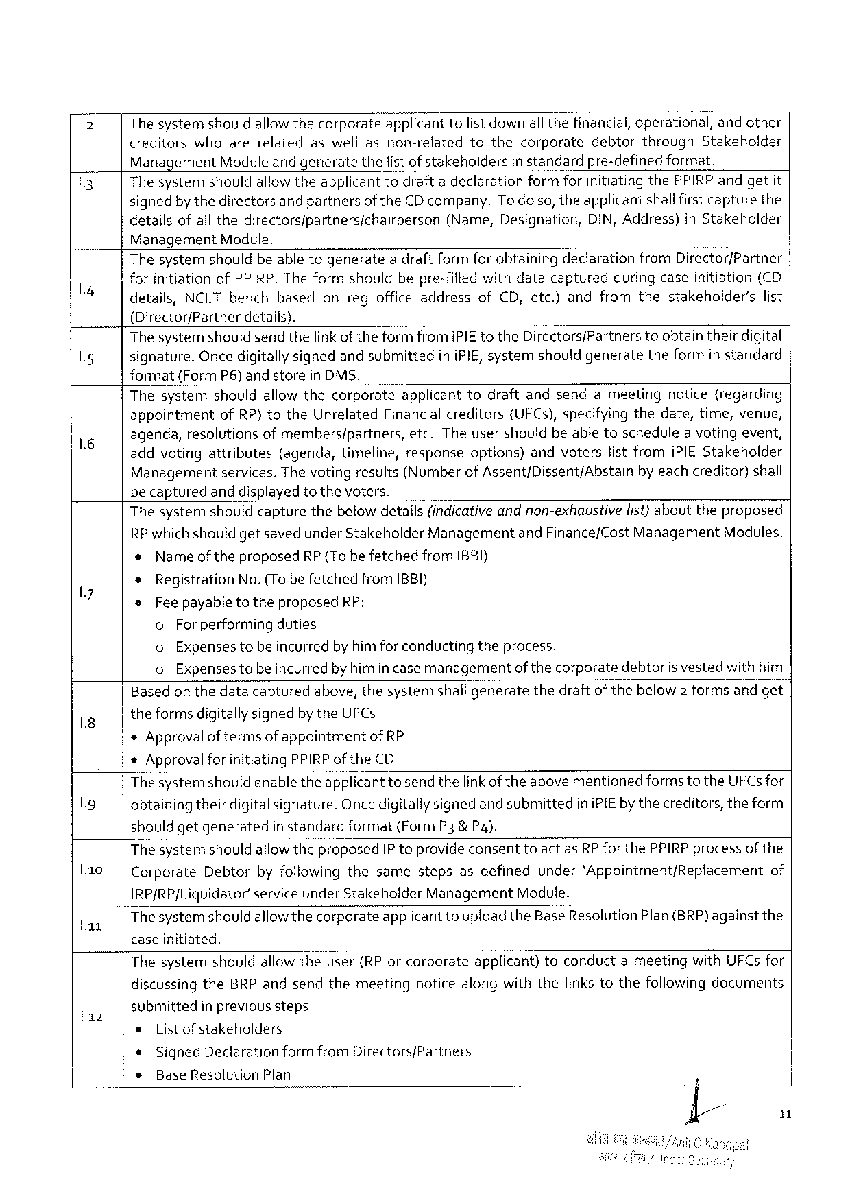

The systemshouldallowthecorporate"a‘ppficant 1 o listdownallthefinancial, operational, andother

creditorswhoarerelatedaswellasnon-relatedtothecorporatedebtorthrough Stakeholder

Management Moduleand generatethelistof stakehoidersin standardpre-definedformat.

Thesystem shouldallowtheapplicant todraftadeclaration formforinitiatingthe PPIRP andgetit

signedbythedirectorsand partnersof the CD company. To do so, theapplicantshallfirstcapturethe

detailsofallthedirectorsfpartnersfchairperson (Name, Designation, DIN, Address)in Stakeholder

Management Module.

Thesystemshouldbeabletogenerateadraft formforobtainingdeclarationfrom Director/Partner

forinitiationof PPIRP. The formshouldbepre-filled withdatacapturedduringcaseinitiation(CD

|  |  |  |  |  |  |  |  |
| --- | --- | --- | --- | --- | --- | --- | --- |
| details, | NCLT bench | | based | onregofficeaddress | of CD, etc.}andfromthe | stakeholder’s | list |
| {Directorf Partner | | details). | |

The systemshouldsend thelinkof theformfromi PIE to the Directors/Partnerstoobtaintheirdigital

signature. Oncedigitallysignedandsubmittedini PIE, systemshouldgeneratetheformin standard

format{Form P 6)andstorein DMS.

Thesystemshouldallowthecorporateapplicanttodraftandsendameetingnotice(regarding

appointment of RP)to the Unrelated Financialcreditors (UFC s), specifyingthedate, time, venue,

agenda, resolutionsofmembers/partners, etc. Theusershouldbeabletoschedulea votingevent,

addvotingattributes (agenda, timeline, responseoptions)andvoterslistfromi PIES takeholder

Managementservices. The votingresulis(Numberof Assent/Dissent/Abstainby eachcreditor)shall

be capturedand displayedto thevoters.

Thesystemshouldcapturethebelow details(indicativeand non-exhaustivelist}abouttheproposed

RP whichshouldgetsavedunder Stakeholder Managementand Finance/Cost Management Modules.

« Nameoftheproposed RP{To befetchedfrom IBBI}

* Registration No.(Tobe fetchedfrom IBBI}

®Fee payableto theproposed RP:

o For performingduties

o Expensestobeincurredby himfor conductingtheprocess.

o Expensestobeincurredby himincase managementof thecorporatedebtoris vestedwithhim

Based on thedatacapturedabove, thesystemshallgeneratethedraftof thebelow 2 formsandget

theformsdigitallysignedbythe UFC s.

*Approvalof termsof appointmentof RP

*Approvalfor initiating PPIRP of the CD

Thesystemshouldenabletheapplicanttosend thelink oftheabovementionedforms to the UFC sfor

obtainingtheirdigitalsignature. Oncedigitallysignedand submittedini PIE by thecreditors, theform

should getgenerated in standardformat(Form P 3& P 4).

The systemshouldallow theproposed IP toprovideconsenttoactas RP for the PPIRP processofthe

|  |  |  |
| --- | --- | --- |
| l.1 o | Corporate Debtorbyfollowingthesamestepsasdefinedunder‘Appointment/Replacement | of |

IRP/RP/Liquidator’service under Stakeholder Management Module.

|  |  |
| --- | --- |
| a 1 | Thesystemshouldallowthecorporateapplicanttouploadthe Base Resolution Plan(BRP)againstthe caseinitiated. |

Thesystemshouldallow theuser(RP orcorporateapplicant)toconductameetingwith UFC sfor

discussingthe BRP andsendthemeetingnoticealongwiththelinkstothefollowingdocuments

|  |  |  |  |  |
| --- | --- | --- | --- | --- |
| la 2 | submitted | | | in previoussteps: |
| s | List ofstakeholders | | |
| « | Signed Declarationformfrom Directors/Partners | | |
| + | | Base Resolution Plan | |

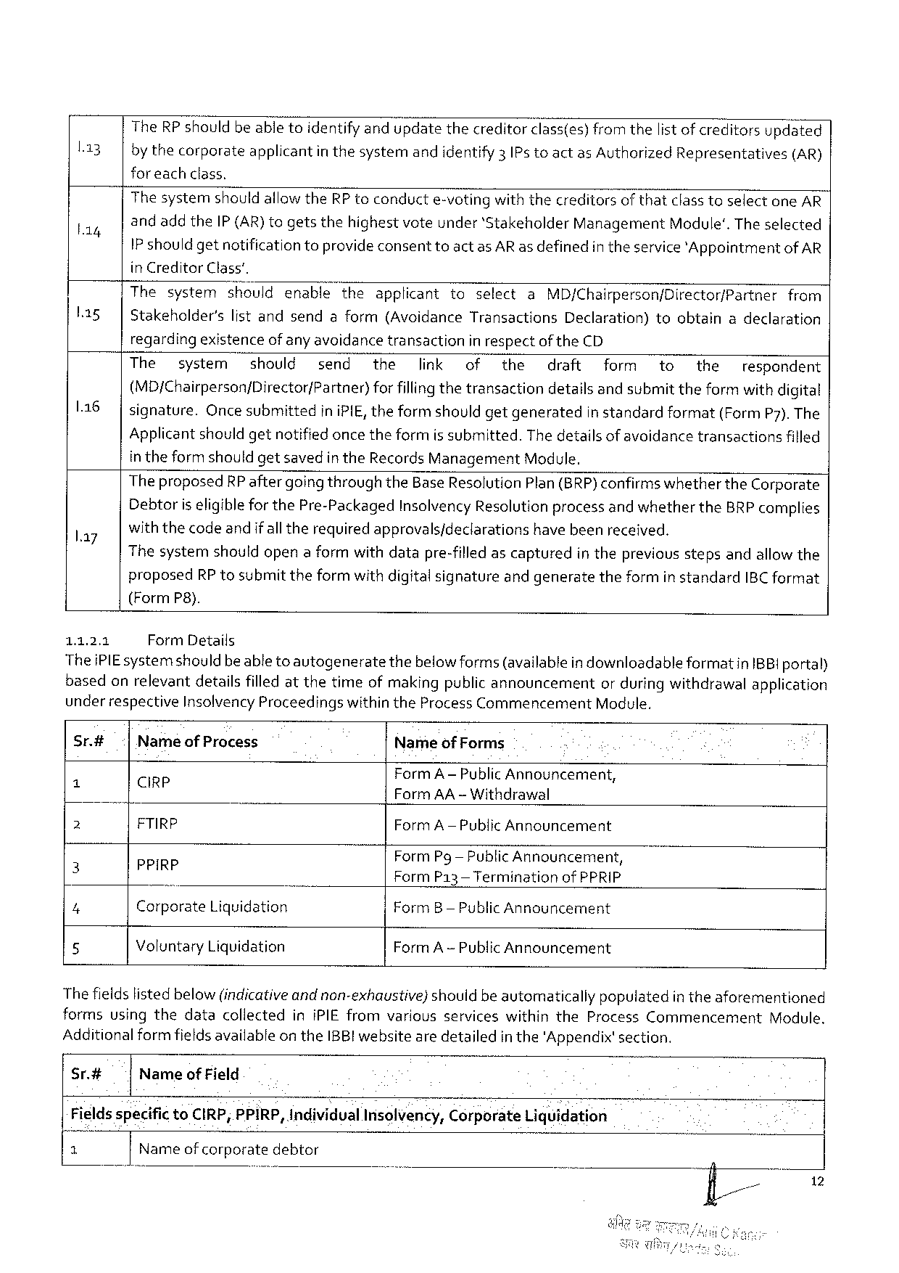

|  |  |
| --- | --- |
| l 13 | The RP shouldbe abletoidentify andupdatethecreditorclass(es) from thelist of creditorsupdated bythecorporateapplicantin thesystemandidentify 3 IP s toactas Authorized Representatives(AR) |

for each class.

|  |  |  |  |  |  |  |  |  |  |  |  |
| --- | --- | --- | --- | --- | --- | --- | --- | --- | --- | --- | --- |
| L 14  L 1 sg | The systemshould allowthe RP toconducte-votingwith thecreditorsof thatclasstoselectone AR andadd the IP(AR)togetsthehighestvoteunder‘Stakeholder Management Module'. The selected IP shouldgetnotificationtoprovideconsenttoactas AR as definedin theservice'Appointmentof AR in Creditor Class’. | | | | | | | | | | |
| Thesystem | | shouldenable | theapplicant | toselect | | a | MD/Chairperson/Director/Partner | | | from |
| Stakeholder's | listandsendaform(Avoidance | | | | Transactions | | Declaration) | toobtain | adeclaration | |

regardingexistenceofany avoidancetransactionin respectof the CD

|  |  |  |  |  |  |  |  |  |  |  |  |  |  |  |
| --- | --- | --- | --- | --- | --- | --- | --- | --- | --- | --- | --- | --- | --- | --- |
| 116 | The | system | should | send | the | link | of | the | draft | | form | to | the | respondent |
| (MD/Chairperson/Director/Partner)forfillingthetransactiondetailsandsubmit theformwith digital | | | | | | | | | | | | | |
| signature. Once submittedini PIE, theformshouldgetgenerated | | | | | | | | | in standardformat(Form P 7). The | | | | |

Applicant shouldgetnotified oncetheformis submitted. The detailsof avoidancetransactionsfilled

in theform shouldgetsavedin the Records Management Module.

Theproposed RP aftergoing throughthe Base Resolution Plan(BRP)confirms whetherthe Corporate

Debtoriseligiblefor the Pre-Packaged Insolvency Resolutionprocessandwhetherthe BRP complies

|  |  |
| --- | --- |
| l. ay | withthecodeandif alltherequiredapprovals/declarationshavebeenreceived.  Thesystemshouldopena formwithdatapre-filled ascapturedin thepreviousstepsandallowthe |

proposed RP tosubmittheformwith digitalsignatureandgeneratetheformin standard IBC format

(Form P 8).

1.1.2.1 Form Details

Thei PIE systemshould beable to autogeneratethebelowforms(availablein downloadableformatin IBBI portal)

basedonrelevantdetailsfilled atthetimeofmakingpublic announcement orduringwithdrawalapplication

under respective Insolvency Proceedingswithinthe Process Commencement Module.

Sr.# Nameof Process Nameof Forms

N Cirp Form A—Pub‘hc Announcement,

) Form AA -Withdrawal

2 FTIRP Form A—Public Announcement

Form Pg— Public Announcement,

5 PP{R? Form P 13 —Terminationof PPRIP

4 Corporate Liquidation Form B— Public Announcement

5 Voluntary Liquidation Form A -Public Announcement

Thefieldslisted below (indicativeandnon-exhaustivej shouidbe automaticallypopulatedin theaforementioned

formsusingthedatacollectedini PIE fromvariousserviceswithinthe Process Commencement Module.

Additionalformfieldsavailable on the IBB! websiteare detailedin the'Appendix'section.

Sr.# Nameof Field

Fieldsspecificto CIRP, PPIRP, Individual Insolvency, Corporate Liquidation

|  |  |  |  |  |
| --- | --- | --- | --- | --- |
| T | Name ofcorporatedebtor o | o | 3 fl// | 12 |

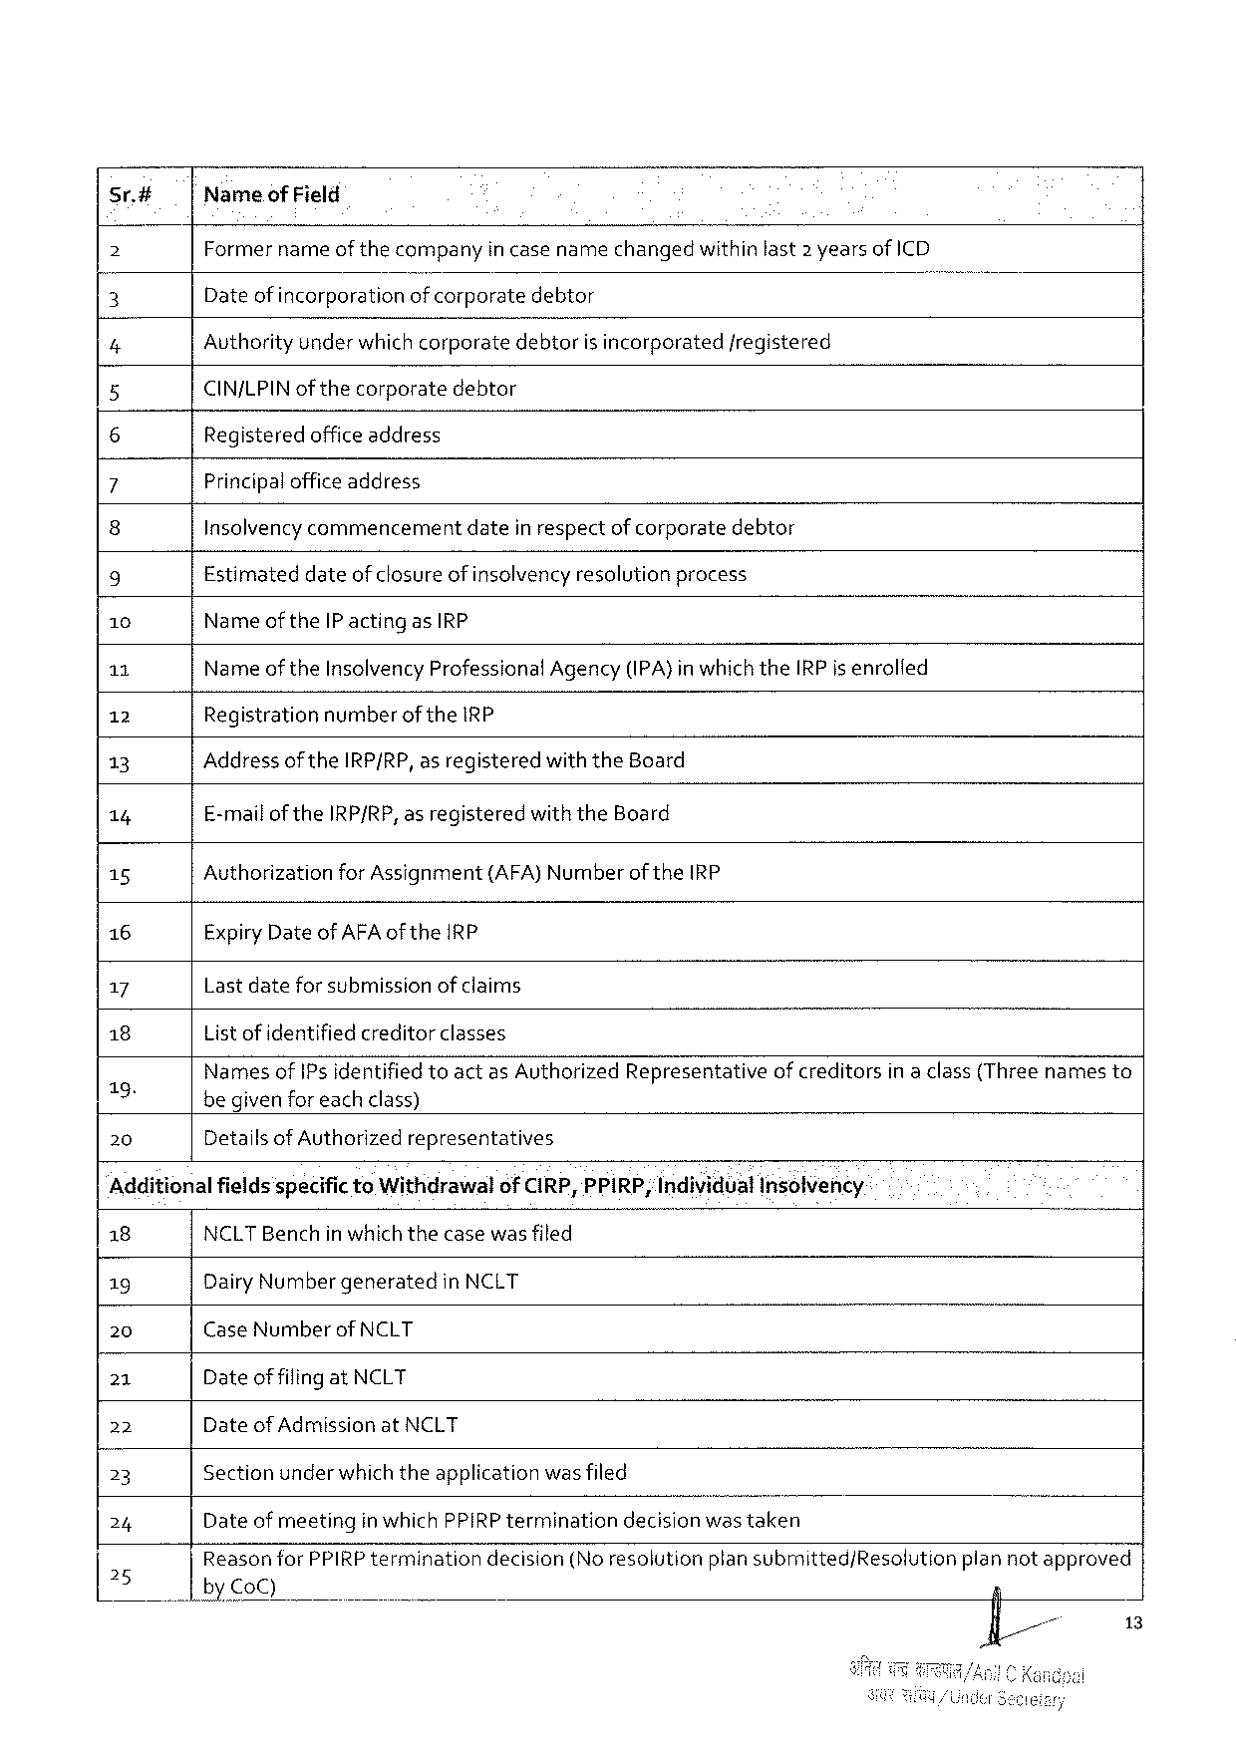

sr.# Nameof Field

2 Former nameof thecompanyin case namechangedwithin last 2 yearsof ICD

3 Dateof incorporationof corporatedebtor )

4 Authority underwhichcorporatedebtoris incorporatedfregistered

5 CIN/LPIN of thecorporatedebtor

6 Registeredofficeaddress

7 Principalofficeaddress

8 Insolvencycommencementdatein respectof corporatedebtor

9 Estimateddateof closure of insolvencyresolutionprocess

10 Nameofthe IP actingas IRP

11 Nameof the Insolvency Professional Agency(IPA)inwhichthe IRP is enrolfed

12 Registration numberof the IRP

13 Addressofthe IRP/RP, asregistered with the Board

14 E-mailof the IRP/RP, asregistered with the Board

15 Authorization for Assignment (AFA)Numberof the IRP

16 Expiry Date of AFA of the IRP

17 Lastdateforsubmissionof claims

18 List ofidentified creditorclasses

7 o) Nanjesof IP s identified toactas Authorized Representativeof creditorsin a class(Threenamesto

begivenforeachclass)

|  |  |  |
| --- | --- | --- |
| 20 | Detailsof Authorized | representatives |

Additionalfields'specificto Withdrawalof CIRP, PPIRP; Individual Insolvency

|  |  |  |  |  |  |
| --- | --- | --- | --- | --- | --- |
| 18 | NCLTB enchinwhichthecasewasfiled | | | | plannotapproved |
| 19 | Dairy Numbergeneratedin NCLT | | | |
| 20 | Case Number | of NCLT | | |
| 21 | Dateof filingat NCLT | | | |
| 22 | Dateof Admissionat NCLT | | | |
| 23 | Sectionunderwhich theapplicationwas filed | | | |
| 24 | Date of meetingin which PPIRP terminationdecisionwastaken | | | |
| 25 | Reasonfor PPIRP termination by Co C) | | decision(Noresolution | plansubmitted/Resolution |

13

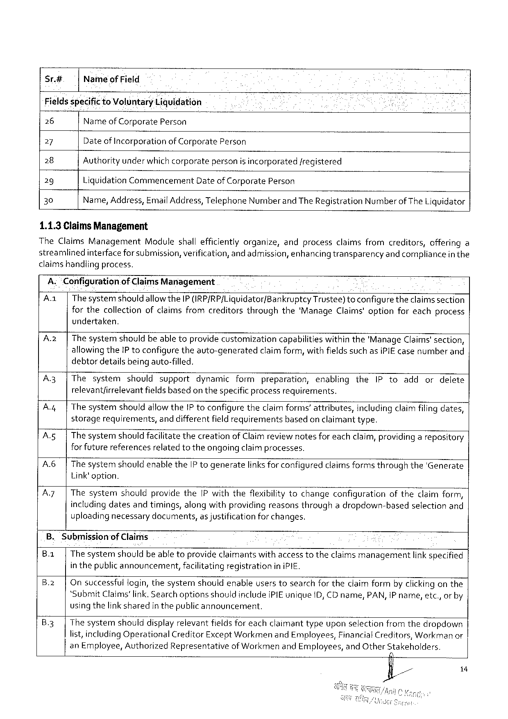

Sr.# Nameof Field

Fields specific to Voluntary Licjuidation

26 Nameof Corporate Person

27 Date of Incorporationof Corporate Person

28 Authorityunder whichcorporatepersonis incorporated/registered

29 Liquidation Commencement Dateof Corporate Person

30 Name, Address, Email Address, Telephone Numberand The Registration Numberof The Liquidator

1.1.3 Claims Management

The Claims Management Moduleshallefficientlyorganize, andprocessclaimsfromcreditors, offeringa

streamlinedinterface forsubmission, verification, and admission, enhancingtransparencyand compliancein the

claims handlingprocess.

A.“Configuration. of Claims Management

Aa| Thesystemshould allowthe IP (IRP/RP/Liguidator/Bankruptcy Trustee)toconfiguretheclaimssection

forthecollectionofclaimsfromcreditorsthroughthe‘Manage Claims'optionforeachprocess

undertaken.

|  |  |  |  |  |  |  |  |  |  |  |  |  |
| --- | --- | --- | --- | --- | --- | --- | --- | --- | --- | --- | --- | --- |
| A.2 z| | | Thesystemshouldbeabletoprovidecustomization | | | | | capabilities | | withinthe'Manage Claims'section, | | | |
| A 3 | | | allowingthe IP toconfiguretheauto-generated | | | | claimform, withfields such asi PIE casenumberand | | | | | | |
| debtordetailsbeingauto-filled, | | | | | | | | | | |
| Thesystem | shouldsupport | dynamic | formpreparation, | | | enabling | | the | IP toadd | ordelete |
| A | | | relevantfirrelevantfieldsbasedon thespecificprocessrequirements. | | | | | | | | | | |
| Thesystem | shouldallowthe IP toconfiguretheclaimforms’attributes, | | | | | | | includingclaimfilingdates, | | |
| A.5| | | storagerequirements, and differentfield requirementsbased on claimanttype.  The systemshouldfacilitatethecreationof Claimreviewnotesfor eachclaim, providing a repository for futurereferencesrelatedtotheongoingclaimprocesses.  The systemshouldenablethe IP togeneratelinks for configuredclaimsformsthroughthe'Generate Link'option.  Thesystemshouldprovidethe IP withtheflexibilitytochangeconfigurationoftheclaimform, includingdatesandtimings, alongwithproviding reasonsthroughadropdown-basedselectionand uploading necessarydocuments, as justificationforchanges. | | | | | | | | | | |
| A 6 | | |
| A 7| | |

B. Submissionof Claims

B.1| The systemshouldbe abletoprovideclaimantswithaccesstotheclaimsmanagementlinkspecified

inthepublicannouncement, facilitatingregistration in i PIE.

B.2| Onsuccessfulfogin, thesystemshouldenableuserstosearchfor theclaim formby clickingonthe

*Submit Claims'link. Searchoptionsshouldinclude i PIE unique ID, CD name, PAN, IP name, etc., or by

usingthelink sharedin thepublicannouncement.

B.3|Thesystemshoulddisplayrelevantfields for eachclaimanttypeuponselectionfromthedropdown

list, including Operational Creditor Except Workmen and Employees, Financial Creditors, Workman or

an Employee, Authorized Representativeof Workmenand Employees, and Other Stakeholders.

o

/& P 1

7

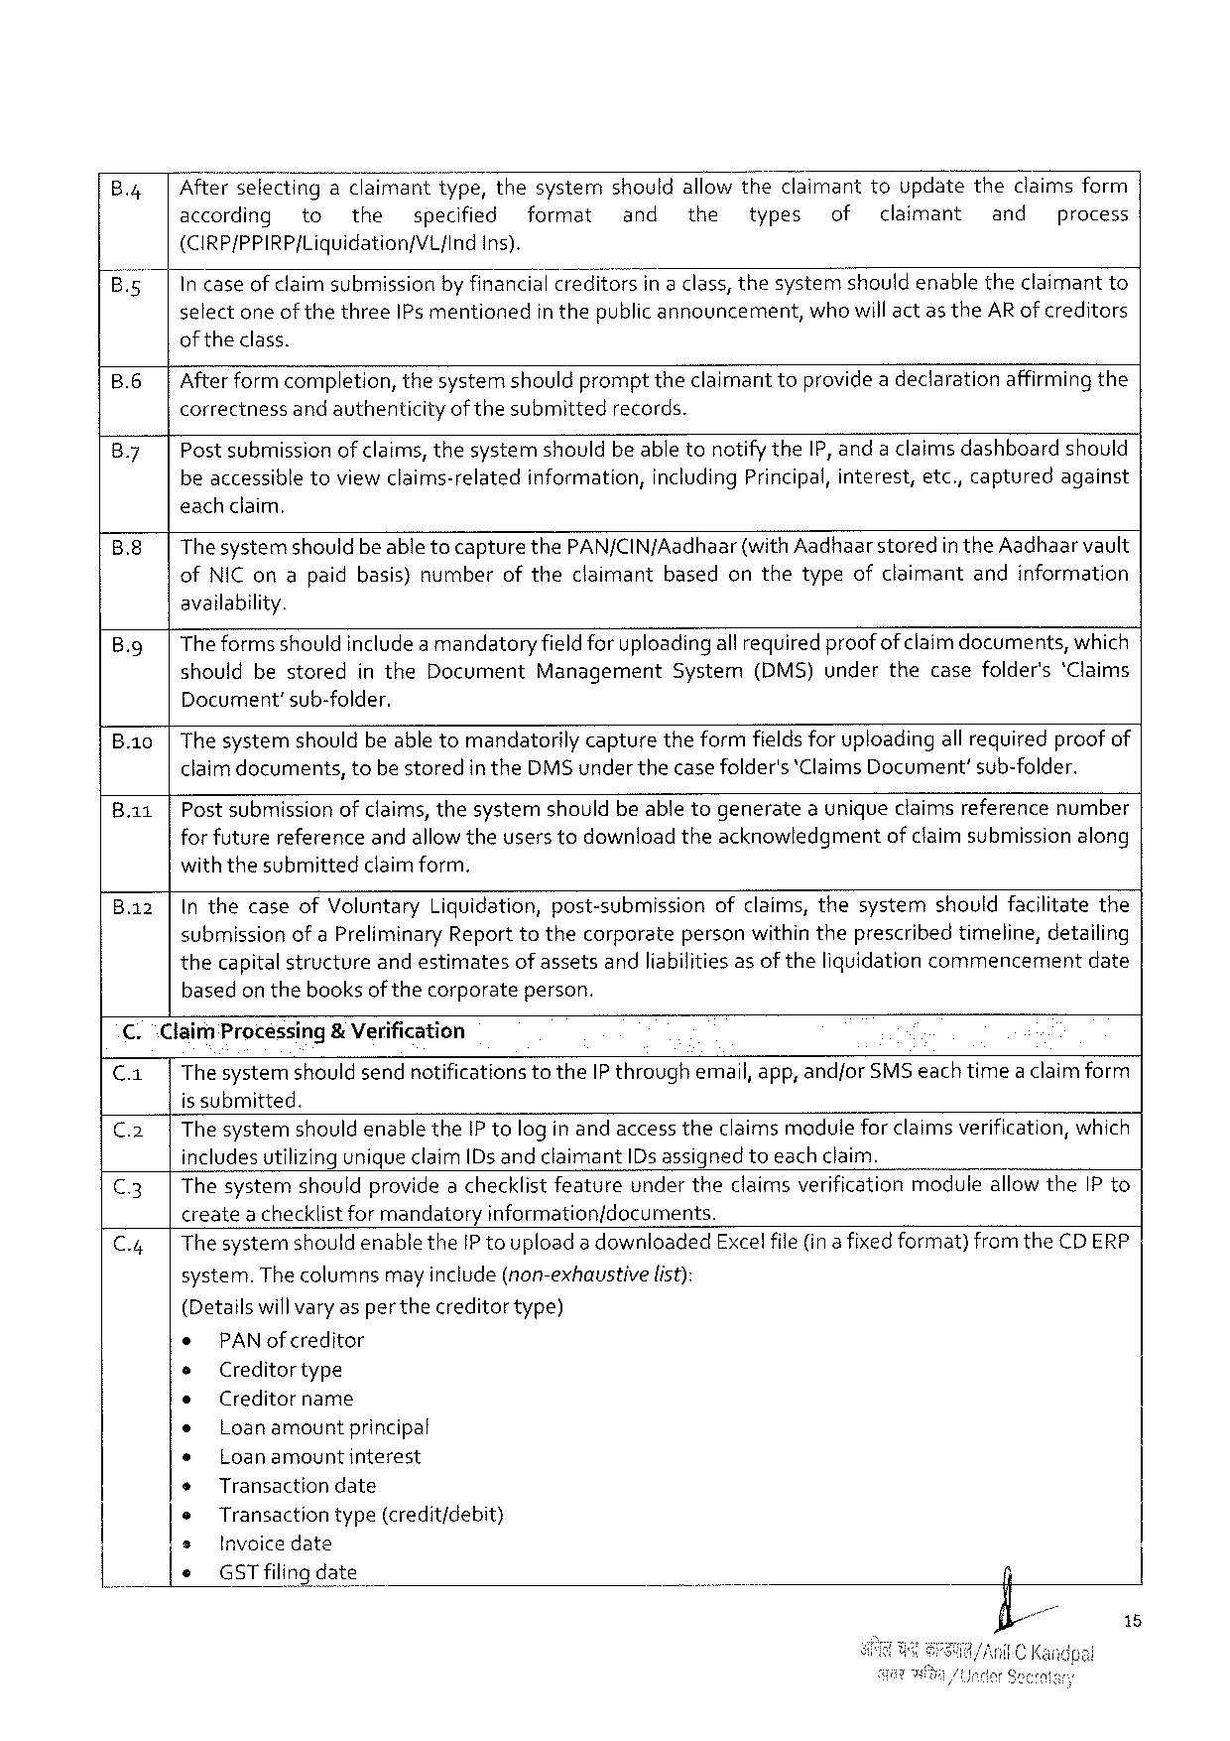

Afterselectingadaima;{twtype, thesystemshouldallowtheclaimanttoupdatetheclaimsform

according to the specified format and the types of claimant and process

(CIRP/PPIRP/Liquidation/VL{Ind ins).

In caseofclaimsubmission byfinancialcreditors ina class, thesystemshouldenabletheclaimant to

selectoneof thethree IP s mentionedin thepublicannouncement, whowill act as the AR of creditors

oftheclass.

B.6 Afterformcompletion, thesystemshouldprompttheclaimant toprovidea declarationaffirmingthe

correctnessand avthenticityof thesubmittedrecords.

|  |  |
| --- | --- |
| By | Post submissionof claims, thesystemshouldbe abletonotifythe IP, anda claimsdashboardshould beaccessibletoviewclaims-relatedinformation, including Principal, interest, etc,, capturedagainst |

eachclaim,

B.8 Thesystemshouldbeabletocapturethe PAN/CIN f Aadhaar(with Aadhaarstored in the Aadhaarvault

of NIC onapaidbasis)number oftheclaimant based onthetypeofclaimant andinformation

availability.

|  |  |  |  |  |  |  |  |  |  |
| --- | --- | --- | --- | --- | --- | --- | --- | --- | --- |
| B. g | Theformsshould includeamandatoryfieldfor uploadingall requiredproofofclaim documents, which | | | | | | | | |
| should | bestored | in the | Document | Management | System | (DMS)under | thecasefolder's | ‘Claims |

Document’sub-folder.

|  |  |  |  |  |  |
| --- | --- | --- | --- | --- | --- |
| B.1 io  Bai | Thesystemshouldbeabletomandatorilycapturetheformfieldsforuploadingall requiredproof of claimdocuments, tobestoredin the DMS underthecasefolder's‘Claims Document’sub-folder. | | | | |
| Postsubmission | ofclaims, thesystem | shouldbeabletogenerate | auniqueclaimsreference | number |

forfuturereferenceandallowtheuserstodownloadtheacknowledgmentof claimsubmissionalong

withthesubmittedclaimform,

Inthecaseof Voluntary Liquidation, post-submissionofclaims, thesystemshouldfacilitatethe

submissionof a Preliminary Reporttothecorporatepersonwithin theprescribedtimeline, detailing

thecapitalstructureandestimatesof assetsandliabilitiesas of theliquidationcommencementdate

basedon thebooksof thecorporateperson.

C. “Claim Processing& Verification

C. a| The systemshould sendnotifications to the IP throughemail, app, andfor SMS each timea claimform

is submitted.

|  |  |
| --- | --- |
| C.2| C.3| | The systemshould enablethe IP tologin andaccess theclaims modulefor claims verification, which includesutilizinguniqueclaim[Ds andclaimant ID sassigned toeach claim.  Thesystemshouldprovidea checklistfeatureundertheclaimsverificationmoduleallowthe IP to |

createachecklistfor mandatoryinformation/documents.

|  |  |  |  |  |
| --- | --- | --- | --- | --- |
| C.4| | Thesystemshouldenablethe IP touploada downloaded | | | Exce! file(ina fixedformat)from the CDERP |
| system. Thecolumns | mayinclude(non-exhaustive | list): |

(Detailswillvaryas per thecreditortype)

|  |  |  |  |  |
| --- | --- | --- | --- | --- |
| * | PAN ofcreditor | | . | n |
| e | Creditortype | |
| e | Creditorname | |
| e |
| Loanamount | principal |
| e | Loanamountinterest | |
| + | Transactiondate | |
| e | Transactiontype(credit/debit) | |
| * |
| Invoicedate | |
| * |
| GST filingdate | |

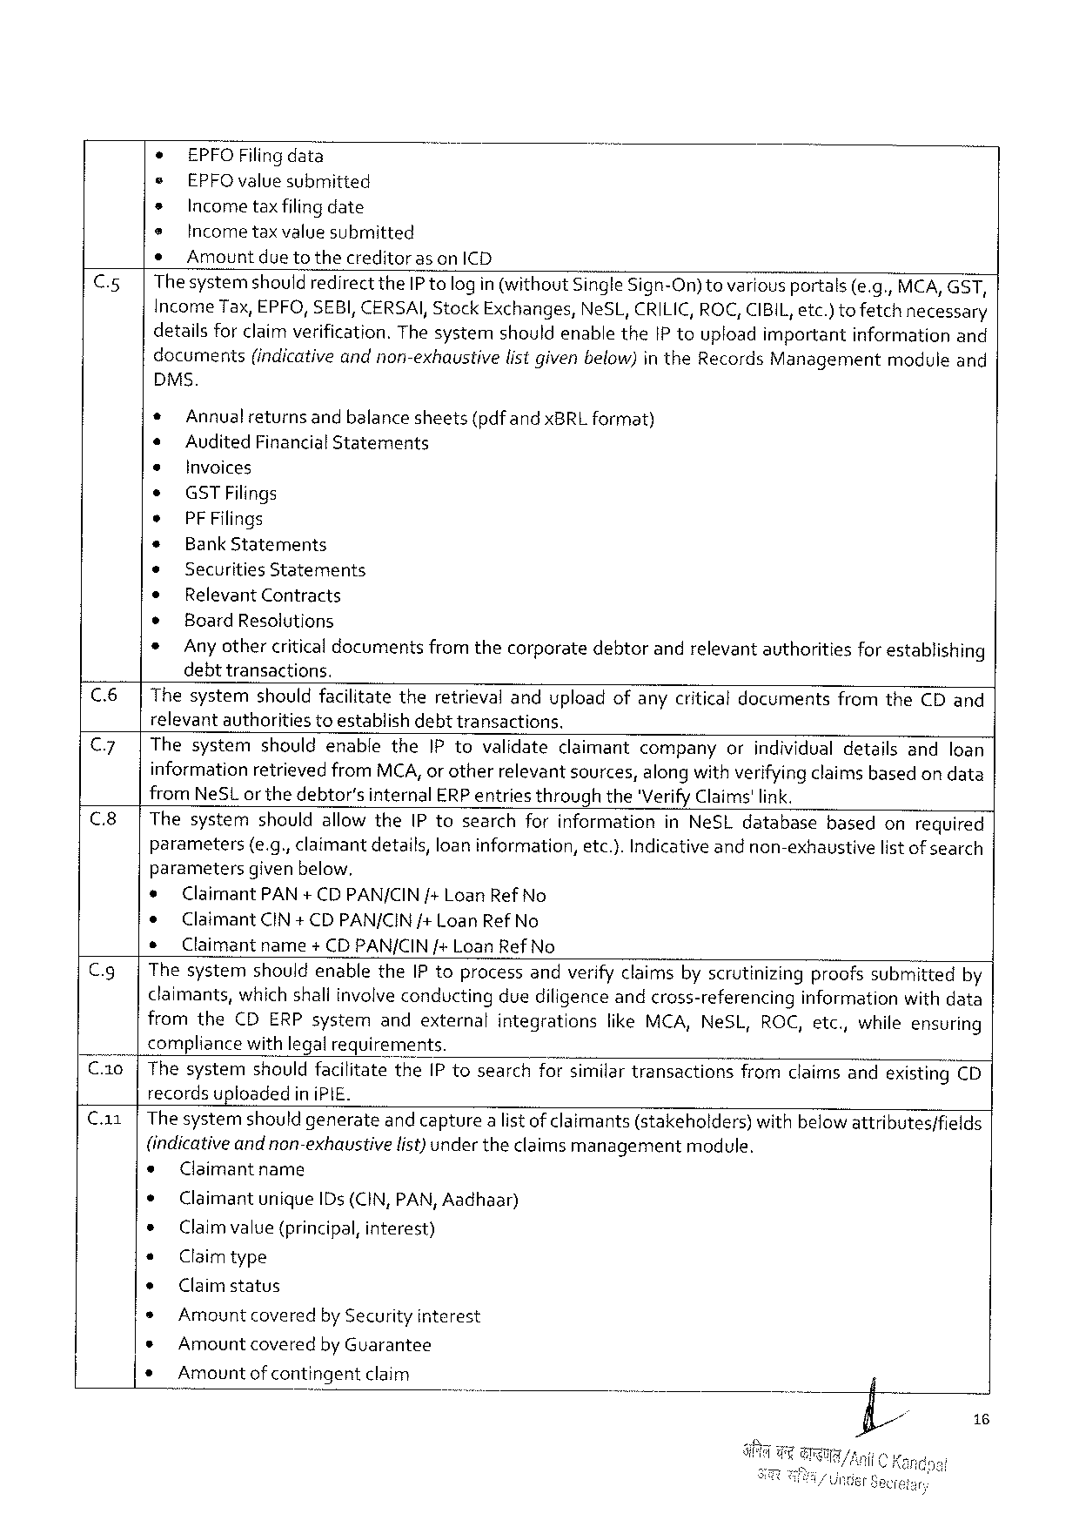

* EPFOF ilingdata

e EPFO value submitted

s Incometaxfilingdate

e Incometaxvalue submitted

* Amountdue tothecreditoras on ICD

C.5|Thesystemshouldredirectthe IP tologin(without Single Sign-On)tovariousportals(e. g., MCA, GST,

Income Tax, EPFO, SEBI, CERSAI, Stock Exchanges, Ne SL, CRILIC, ROC, CIBIL, etc.)tofetchnecessary

detailsfor claimverification. Thesystemshouldenablethe IP touploadimportantinformationand

documents (indicativeandnon-exhaustive listgivenbelow)in the Records Management module and

DMS.

|  |  |  |
| --- | --- | --- |
| *  e  *  *  *  e ® ¢ ¢ * | Annualreturns | andbalancesheets(pdfandx BRL format) |
| Audited Financial Statements  Invoices  GSTF ilings  PFF ilings  Bank Statements  Securities Statements  Relevant Contracts  Board Resolutions  Anyothercriticaldocumentsfromthecorporatedebtorandrelevantauthoritiesfor establishing debttransactions. | |

C.6|Thesystemshouldfacilitatetheretrievalanduploadofanycriticaldocumentsfromthe CD and

relevantauthoritiestoestablishdebttransactions.

|  |  |  |  |  |  |  |  |  |  |  |  |  |  |  |
| --- | --- | --- | --- | --- | --- | --- | --- | --- | --- | --- | --- | --- | --- | --- |
| || | C 7 | | | Thesystemshouldenablethe IP tovalidateclaimantcompanyorindividualdetailsandloan informationretrievedfrom MCA, or otherrelevantsources, alongwithverifyingclaimsbased ondata from Ne SL or thedebtor’sinternal ERP entriesthroughthe'Verify Claims'link. | | | | | | | | | | | |
| C 8 | | | Thesystemshouldallowthe IP tosearchforinformationin Ne SL database | | | | | | | | | | basedonrequired | |
| C. g| | | parameters(e. g., claimantdetails, loan information, etc.). Indicativeandnon-exhaustivelistof search | | | | | | | | | | | |
| parameters | | | givenbelow, | | | | | | | | |
| * | | Claimant PAN+ CDPAN/CIN /+Loan Ref No | | | | | | | | | |
| e | Claimant CIN+ CDPAN/CIN/+ Loan Ref No | | | | | | | | | | |
| s | Claimant | | | name | +CDPAN/CIN/+Loan Ref No | | | | | | |
| Thesystemshouldenablethe IP toprocessandverifyclaimsbyscrutinizingproofssubmittedby | | | | | | | | | | | |
| claimants, which shallinvolveconductingduediligence andcross-referencinginformationwithdata | | | | | | | | | | | |
| from the | | | CDERP system | | | andexternal | integrations | like MCA, Ne SL, | ROC, etc., | | whileensuring |
| compliancewithlegalrequirements. | | | | | | | | | | | |

C.10|Thesystemshouldfacilitatethe IP tosearchforsimilartransactionsfromclaimsandexisting CD

recordsupioadedin i PIE.

Ca 1|The systemshouldgenerateand capturea list ofclaimants(stakeholders)withbelow attributes/fields

(indicativeand non-exhaustivelist)under theclaims managementmodule.

s Claimantname

e Claimantunique ID s(CIN, PAN, Aadhaar)

e Claimvalue (principal, interest)

« Claimtype

¢ Claimstatus

» Amountcoveredby Securityinterest

s Amountcoveredby Guarantee

s Amountofcontingentclaim

16

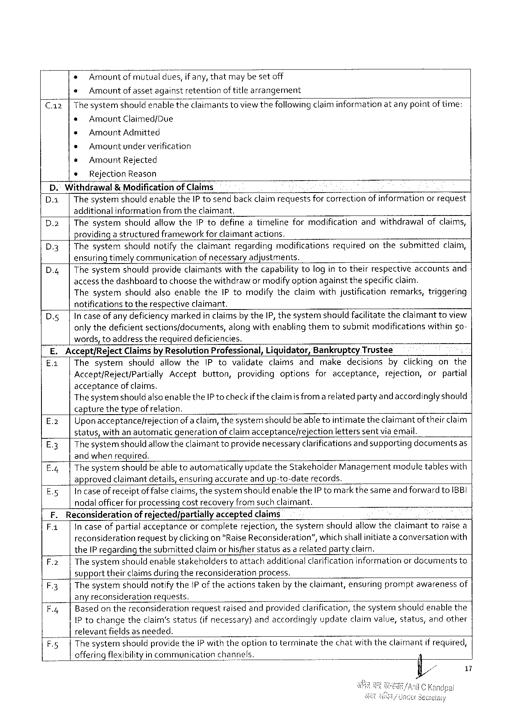

s Amountof mutualdues, if any, thatmaybesetoff

« Amountofassetagainstretention of title arrangement

Thesystemshouldenabletheclaimantstoviewthefollowingclaiminformationatanypointof time:

* Amount Claimed/Due   
* Amount Admitted

» Amountunderverification

e Amount Rejected

e Rejection Reason

D." Withdrawal& Modificationof Claims   
D. a| Thesystemshouldenablethe IP tosendback claim requestsfor correctionof informationorrequest additionalinformationfrom theclaimant.

D.2|Thesystemshouldallowthe IP todefineatimelineformodificationandwithdrawalofclaims, providingastructuredframeworkfor claimant actions.

D.3|Thesystemshouldnotifytheclaimantregardingmodificationsrequiredonthesubmittedclaim, ensuring timely communicationof necessary adjustments.

D.4| Thesystemshouldprovideclaimantswiththecapabilitytologin totheirrespectiveaccountsand access thedashboardtochoosethewithdrawor modifyoption againstthespecificclaim.

Thesystemshouldalsoenablethe IP tomodifytheclaimwithjustificationremarks, triggering notificationstotherespectiveclaimant.

|  |  |  |
| --- | --- | --- |
| D.5| | Incaseof anydeficiency markedin claims by the[P, thesystemshouldfacilitatetheclaimanttoview | |
| onlythedeficientsections/documents, | alongwithenablingthemtosubmitmodificationswithin 5 o~ |

words, toaddresstherequireddeficiencies.

|  |  |  |  |  |  |  |  |  |  |  |  |  |  |  |
| --- | --- | --- | --- | --- | --- | --- | --- | --- | --- | --- | --- | --- | --- | --- |
| | | E. Accept/Reject Claimsby Resolution Professional, Liquidator, Bankruptey Trustee | | | | | | | | | | | | | |
| Ea | | Thesystem | | shouldallowthe | | | IP tovalidateclaimsandmakedecisionsbyclickingonthe | | | | | | |
| Accept/Reject/Partially Accept | | | | | | | button, | | providingoptionsforacceptance, | | | rejection, | orpartial |
| acceptanceof claims.  Thesystemshouldalsoenablethe IP to checkif theclaimis from a relatedpartyand accordinglyshould capturethetypeof refation. | | | | | | | | | | | | | |
| E%3 | | Uponacceptance/rejectionofa claim, thesystemshould beable tointimatetheclaimantoftheirclaim | | | | | | | | | | | |
| status, withanautomatic | | | | | | generation | | of claimacceptance/rejection | | | letterssentvia email. | | |
| E 3 | | Thesystemshould allowtheclaimanttoprovide necessaryclarificationsand supportingdocumentsas | | | | | | | | | | | |
| By | | andwhen required.  Thesystemshould beable toautomaticallyupdatethe Stakeholder Managementmoduletableswith approvedclaimantdetails, ensuringaccurateandup-to-daterecords. | | | | | | | | | | | |
| Es | | In caseofreceiptof falseclaims, thesystemshould enablethe IP tomarkthesameand forward to IBBI | | | | | | | | | | | |
| nodal officerforprocessing costrecovery fromsuch claimant. | | | | | | | | | | | | | |
| F. Reconsiderationof rejected/partially | | | | | | | | acceptedclaims | | | | | |
| F 1 | | | In caseofpartialacceptanceor completerejection, thesystemshouldallowtheclaimanttoraise a | | | | | | | | | | | |
| reconsiderationrequestby clickingon "Raise Reconsideration”, whichshallinitiateaconversationwith the IP regardingthesubmittedclaimor hisfherstatusas a relatedpartyclaim.  F.2|Thesystemshould enablestakeholderstoattachadditionalclarification information or documentsto supporttheirclaimsduringthereconsiderationprocess.  F.3|Thesystemshouldnotifythe IP of theactionstakenby theclaimant, ensuringpromptawarenessof any reconsiderationrequests. | | | | | | | | | | | | | |
| F.4| | | | Basedon thereconsiderationrequestraised andprovided clarification, thesystemshouldenablethe | | | | | | | | | | |
| IP tochangetheclaim’sstatus(ifnecessary)andaccordingly updateclaimvalue, status, andother | | | | | | | | | | | | | |
| [relevantfields | | | | | as needed. | | | | | | | | |
| F.5| | | Thesystem | | shouldprovidethei P withtheoptiontoterminate | | | | | | thechatwiththeclaimantif required, | | | |
| offeringflexibilityincommunication | | | | | | | | channels. | | | | | |

17

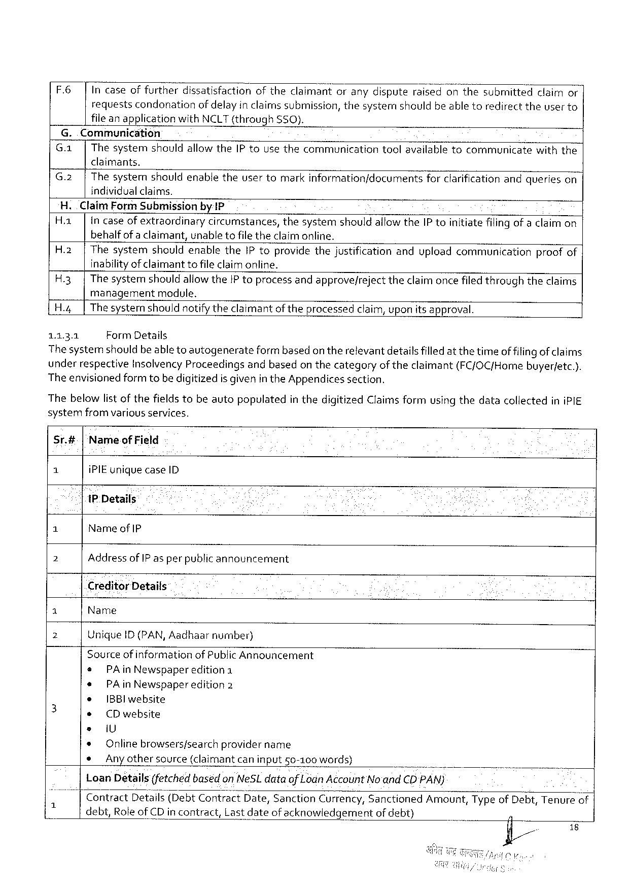

F 6 | Incaseoffurtherdissatisfactionoftheclaimantoranydisputeraisedonthesubmittedclaimor requestscondonationofdelayin claims submission, thesystemshouldbe abletoredirecttheuser to fileanapplicationwith NCLT(through SSO}.

G.. Communication

G. a|Thesystemshouldallow the IP tousethecommunicationtoolavailabletocommunicatewiththe claimants.

|  |  |
| --- | --- |
| G.2| | Thesystemshouldenabletheusertomarkinformation/documentsforclarification andquerieson individualclaims. |

H. Claim Form Submissionby IP

|  |  |  |
| --- | --- | --- |
| H. a| | Incase ofextraordinarycircumstances, thesystemshouldallowthe IP toinitiatefilingofa claim on | |
| behalfofaclaimant, | unabletofile theclaimonline. |

H.2|Thesystemshouldenablethe IP toprovidethejustificationanduploadcommunicationproofof inabilityofclaimantto fileclaimonline.

H.3|Thesystemshouldallowthe IP toprocessandapprove/rejecttheclaimoncefiledthroughtheclaims managementmodule,

H.4| Thesystemshouldnotifytheclaimantof theprocessedclaim, uponitsapproval.

1131 Form Details

Thesystemshould beabletoautogenerateform basedontherelevantdetails filledat thetimeof filingof claims underrespective Insolvency Proceedingsandbasedonthecategoryof theclaimant(FC/OC/Homebuyer/etc.). The envisionedformtobedigitizedis givenin the Appendicessection.

Thebelowlistofthefieldstobeautopopulatedin thedigitized Claimsformusing thedatacollectedini PIE systemfromvariousservices.

Sr.#|‘Nameof Field

1 i PIE uniquecase ID

‘|1 P Details

3 Nameof IP

2 Address of IP asper publicannouncement

Creditor Details

1 Name

2 Unique ID (PAN, Aadhaarnumber)

Sourceof informationof Public Announcement

|  |  |  |  |  |  |
| --- | --- | --- | --- | --- | --- |
| 3 | e | PA in Newspaper | edition 1 | . | - |
| ¢ | PA in Newspaper | edition 2 |
| ¢ |
| IBB lwebsite | |
| * |
| CD website | |
| e | i U | |
| * |
| Onlinebrowsers/searchprovidername | |
| * |
| Any othersource(claimantcaninput 50-100 words) | |

Loan Details(fetched based on Ne SL dataof Lodn Account No'and CD PAN)

|  |  |  |  |  |  |  |  |
| --- | --- | --- | --- | --- | --- | --- | --- |
| i | Contract | Detalls(Debt Contract | | Date, Sanction | Currency, Sanctioned | | Amount, Typeof Debt, Tenureof| |
| debt, Roleof CD incontract, | | Lastdateofacknowledgement | | | ofdebt) |
| | |

18

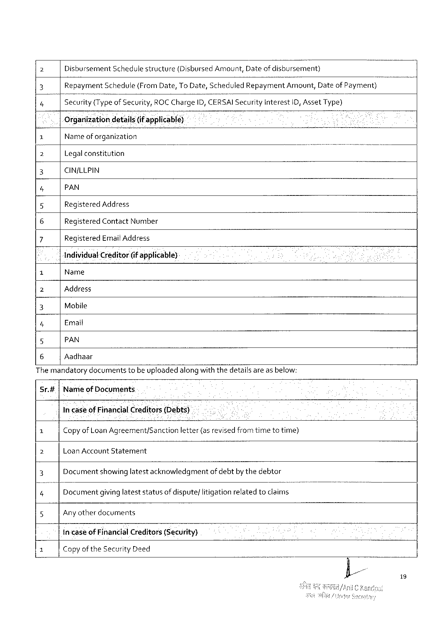

2 Disbursement Schedulestructure (Disbursed Amount, Dateof disbursement)

2 Repayment Schedule(From Date, To Date, Scheduled Repayment; rnount, Dateof Payment)

4 Security(Typeof Security, ROCC harge ID, CEéSAIS ecurity Interest 1 D, Asset Type)

Organizationdetails(if applicable)

|  |  |  |  |
| --- | --- | --- | --- |
| 1 | Nameof organization | N | - |
| 2 | Legalconstitution |
| 3 | CIN/LLPIN |
| 4 | PAN |
| 5 | Registered Address |
| 6 | Registered Contact Number |
| 7 | Registered Emait Address |

Individual Creditor(if applicable)-

o Name

2 Address

3 Mobile

4 Email

5 PAN

6 Aadhaar

The mandatorydocumentstobe uploadedalongwiththedetailsare asbelow:

Sr.# Nameof Documents

In caseof Financial Creditoljs(Debts)

|  |  |  |  |
| --- | --- | --- | --- |
| 1 | Copyof Loan Agreement/Sanction | letter(asrevisedfromtimetotime) | o |
| 2 | Loan Account Statement | |
| 3 | Documentshowinglatestacknowledgmentofdebtbythedebtor | |
| '4"” | Documentgivinglateststatusof dispute/litigationrelatedtoclaims | |
| 5 | Any otherdocuments | |

in-caseof Financial Creditors(Security)

3 Copyof the Security Deed

i 9

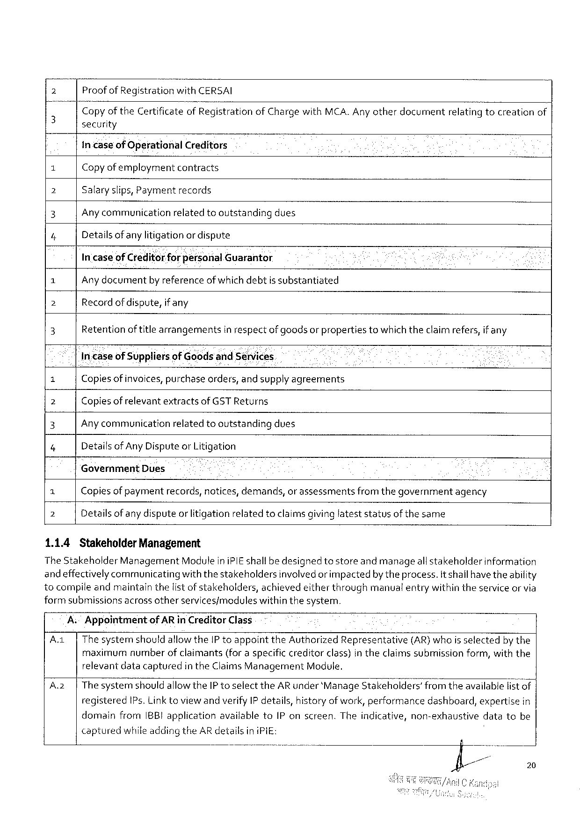

2 Proof of Registration wiht‘I: E: ERSAI

Copyof the Certificateof I‘? egistratlonof Chargewith MCA. Anyotherdocumentrelatingtocreationof

3 security

incaseof Operational Creditors

ol Copyofemployment contracts

2 Salaryslips, Payment records

3 Anycommunicationrelatedtooutstandingdues

4 Detailsofany litigation or dispute

In'caseof Creditorforfiersonal Guarantor

1 Anydocumentby referenceofwhichdebtis substantiated

2 Recordof dispute, if any

3 Retentionof title arrangementsin respectof goodsor propertiestowhichtheclaimrefers, if any

Incaseof Suppliersof Goodsand Sénvices

= Copiesof invoices, purchaseorders, and supplyagreements

] Copiesof relevantextractsof GSTR eturns

3 Any communication relatedtooutstanding dues

7 Detailsof Any Disputeor Litigation

Government Dues i

7 Copiesof paymentrecords, notices, demands, or assessmentsfrom thegovernmentagency

7 Detailsof anydisputeor litigationrelatedtoclaimsgivinglateststatusofthesame

1.1.4 Stakeholder Management

The Stakeholder Management Moduleini PIE shallbe designedtostoreandmanageall stakeholderinformation

andeffectivelycommunicatingwiththestakeholdersinvolvedorimpactedbytheprocess. it shallhavetheability

tocompileandmaintainthelistof stakeholders, achievedeitherthroughmanualentrywithintheserviceor via

formsubmissions acrossotherservices/moduleswithinthesystem.

A: Appointment of AR in Creditor Class

A.1| Thesystemshouldallowthe IP toappointthe Authorized Representative(AR)whois selectedby the

maximum numberofclaimants (foraspecificcreditorclass)intheclaimssubmission form, with the

relevantdatacapturedin the Claims Management Module.

A 2 |The systemshouldallowthe IP toselect the AR under‘Manage Stakeholders’from theavailablefistof|

registered IP s. Link toviewandverify IP details, historyof work, performancedashboard, expertisein

domainfrom IBBI applicationavailableto IP onscreen. Theindicative, non-exhaustivedatatobe

capturedwhileadding the AR detailsin i Pi E:

20

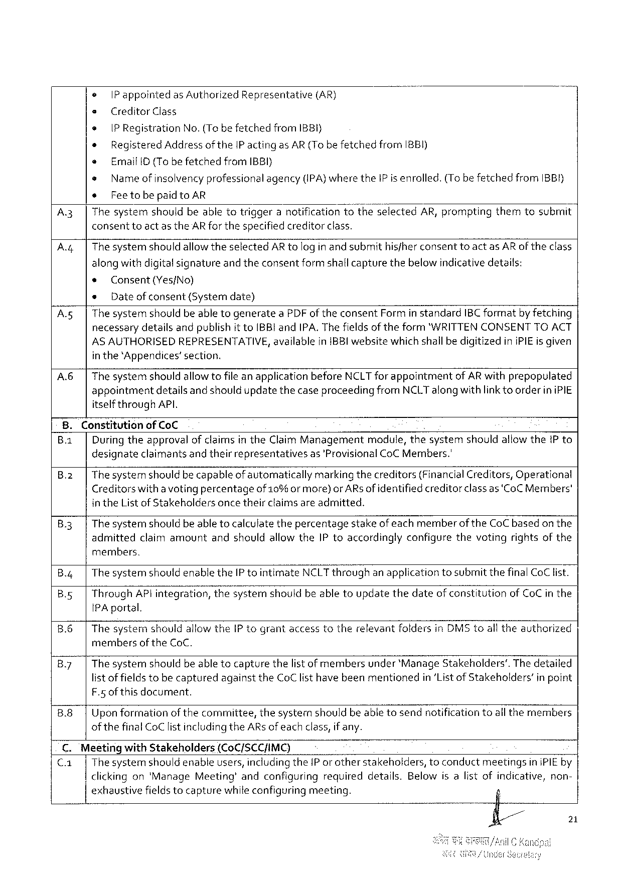

e |Pappointed as Authorized Representative (AR)

e Creditor Class

* IPR egistration No.(Tobefetched from IBBI}

* Registered Addressofthe IP actingas AR(Tobefetchedfrom IBBI)

« Email ID (Tobefetchedfrom IBBI)

e Name of insolvencyprofessional agency(IPA)where the IP is enrolled.(Tobefetchedfrom IBBH)

¢ Feetobepaidto AR

A.3| Thesystemshouldbeabletotriggeranotificationtotheselected AR, promptingthemtosubmit

consenttoact as the AR for thespecifiedcreditorclass.

A.4|Thesystemshouldallowtheselected AR tologin andsubmithisfherconsenttoactas AR of theclass

alongwithdigitalsignatureand theconsentform shallcapturethebelowindicativedetails:

« Consent(Yes/No)

* Dateofconsent(Systemdate)

A. s| The systemshould beable togeneratea PDF of theconsent Formin standard IBC formatbyfetching

necessarydetailsandpublishit to IBBI and IPA. The fieldsof theform*"WRITTENCONSENTTOACT

ASAUTHORISEDREPRESENTATIVE, in the*Appendices’section.

availablein{BBI websitewhichshallbedigitizedini PIE is given

A.6| The systemshould allowtofile anapplicationbefore NCLT forappointmentof AR withprepopulated appointmentdetailsand shouldupdatethecaseproceedingfrom NCLT alongwith linkto orderin i PIE itself through API.

8. Constitutionof Co C i   
B.1| Duringtheapprovalof claimsinthe Claim Managementmodule, thesystemshouldallow the Pto designateclaimantsandtheirrepresentativesas'Provisional Co C Members.'

B.2| Thesystemshould becapableof automaticallymarkingthecreditors(Financial Creditors, Operational Creditorswitha voting percentageof 10% ormore)or AR s ofidentifiedcreditor classas ‘Co CM embers' in the List of Stakeholdersonce theirclaimsareadmitted.

|  |  |
| --- | --- |
| B.3| | The systemshouldbe able tocalculatethepercentagestakeofeachmemberofthe Co C basedon the admittedclaimamountandshouldallowthe IP toaccordinglyconfigurethevotingrightsofthe |

members.

B.4| The systemshouldenablethe IP tointimate NCLT throughanapplicationtosubmitthefinal Co C list.

B.5| Through AP lintegration, thesystemshouldbeabletoupdatethedateof constitutionof Co C in the IPA portal.

B.6|Thesysternshouldallowthe IP tograntaccesstotherelevantfoldersin DMS toall theauthorized

members of the Co C.

B.7| The systemshouldbe able tocapturethelistof membersunder*Manage Stakeholders’. The detailed listof fieldstobe capturedagainstthe Co Clisthave beenmentionedin‘Listof Stakeholders’in point F.5 ofthisdocument.

B.8|Uponformationof thecommittee, thesystemshouldbeable tosendnotificationtoall themembers of the final Co Clist includingthe AR sof eachclass, if any.

C. Mesetingwith Stakeholders (Co C/SCCIMC)

C. a| Thesystemshould enableusers, includingthe IP orotherstakeholders, toconductmeetingsin i PIE by clickingon‘Manage Meeting’andconfiguringrequireddetails. Belowisalistofindicative, non- exhaustivefieldstocapturewhileconfiguringmeeting.

21

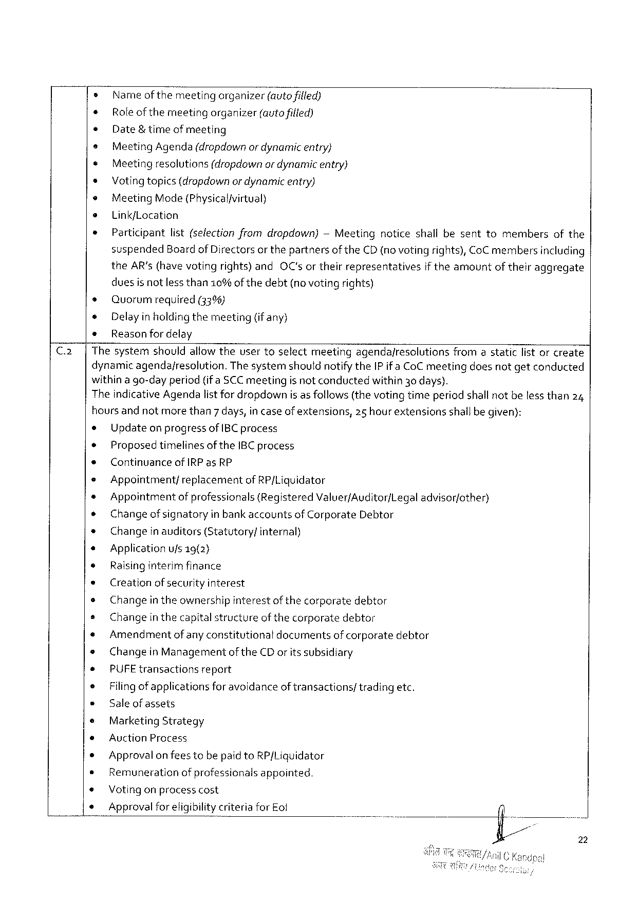

o Name ofthemeetingorganizer(Mautofified)

* Role of themeetingorganizer(autofilled)

¢ Date& timeofmeeting

e Meeting Agenda(dropdownor dynamicentry}

¢ Meetingresolutions(dropdownor dynamicentry)

* Voting topics(dropdownor dynamicentry)

¢ Meeting Mode(Physicalfvirtual}

e Link/Location

* Participantlist(selectionfromdropdown)— Meetingnoticeshallbesenttomembersofthe

suspended Boardof Directors or thepartnersof the CD(novoting rights), Co C membersincluding

|  |  |  |  |
| --- | --- | --- | --- |
| the AR’s (havevotingrights)and | OC'sortheirrepresentatives | iftheamount | oftheiraggregate |

duesisnotlessthan 10%of thedebt(novotingrights)

s Quorum required (33%)

e Delayin holding themeeting(if any)

¢ Reasonfor delay

Thesystemshouldallow theusertoselectmeetingagendafresolutionsfromastaticlistor create

dynamic agendajresolution. The systemshoutdnotifythe IP ifa Co Cmeetingdoesnotgetconducted

withina go-dayperiod(ifa SCC meetingis notconductedwithin 30 days).

Theindicative Agendalist for dropdownis as follows (the votingtimeperiodshallnotbeless than 24

hoursand notmorethan 7 days, in caseofextensions,25 hour extensionsshallbegiven):

|  |  |  |  |  |  |  |  |  |  |  |
| --- | --- | --- | --- | --- | --- | --- | --- | --- | --- | --- |
| ¢ | Updateonprogressof IBC process | | | | | | | | | 0. |
| * |
| Proposedtimelinesofthe IBC process | | | | | | | | |
| ¢ | Continuance | of IRP as RP | | | | | | | |
| * |
| Appointment/ | replacement | | of RP/Liquidator | | | | | |
| * |
| Appointmentof professionals{Registered Valuer/Auditor/Legal | | | | | | | | advisor/other) |
| ® |
| Changeof signatoryin bankaccountsof Corporate Debtor | | | | | | | | |
| + | Changeinauditors(Statutory/ | | | | internal) | | | | |
| « | Applicationufs 19(2} | | | | | | | | |
| © | Raisinginterimfinance | | | | | | | | |
| « | Creationof securityinterest | | | | | | | | |
| e | Changein theownershipinterestofthecorporatedebtor | | | | | | | | |
| e |
| Changein thecapitalstructureofthecorporatedebtor | | | | | | | | |
| « |
| Amendment | of anyconstitutional | | | | documents | ofcorporate | debtor | |
| e |
| Changein Managementofthe CD orits subsidiary | | | | | | | | |
| * | PUFE transactions | | report | | | | | | |
| e |
| Filingof applicationsforavoidanceof transactions/tradingetc. | | | | | | | | |
| e |
| Saleofassets | | | | | | | | |
| e | Marketing Strategy | | | | | | | | |
| e | Auction Process | | | | | | | | |
| * | Approvalon feestobepaidto RP/Liquidator | | | | | | | | |
| * |
| Remunerationof professionalsappointed. | | | | | | | | |
| * |
| Votingonprocesscost | | | | | | | | |
| * |
| Approvalforeligibilitycriteriafor Eof | | | | | | n | | |

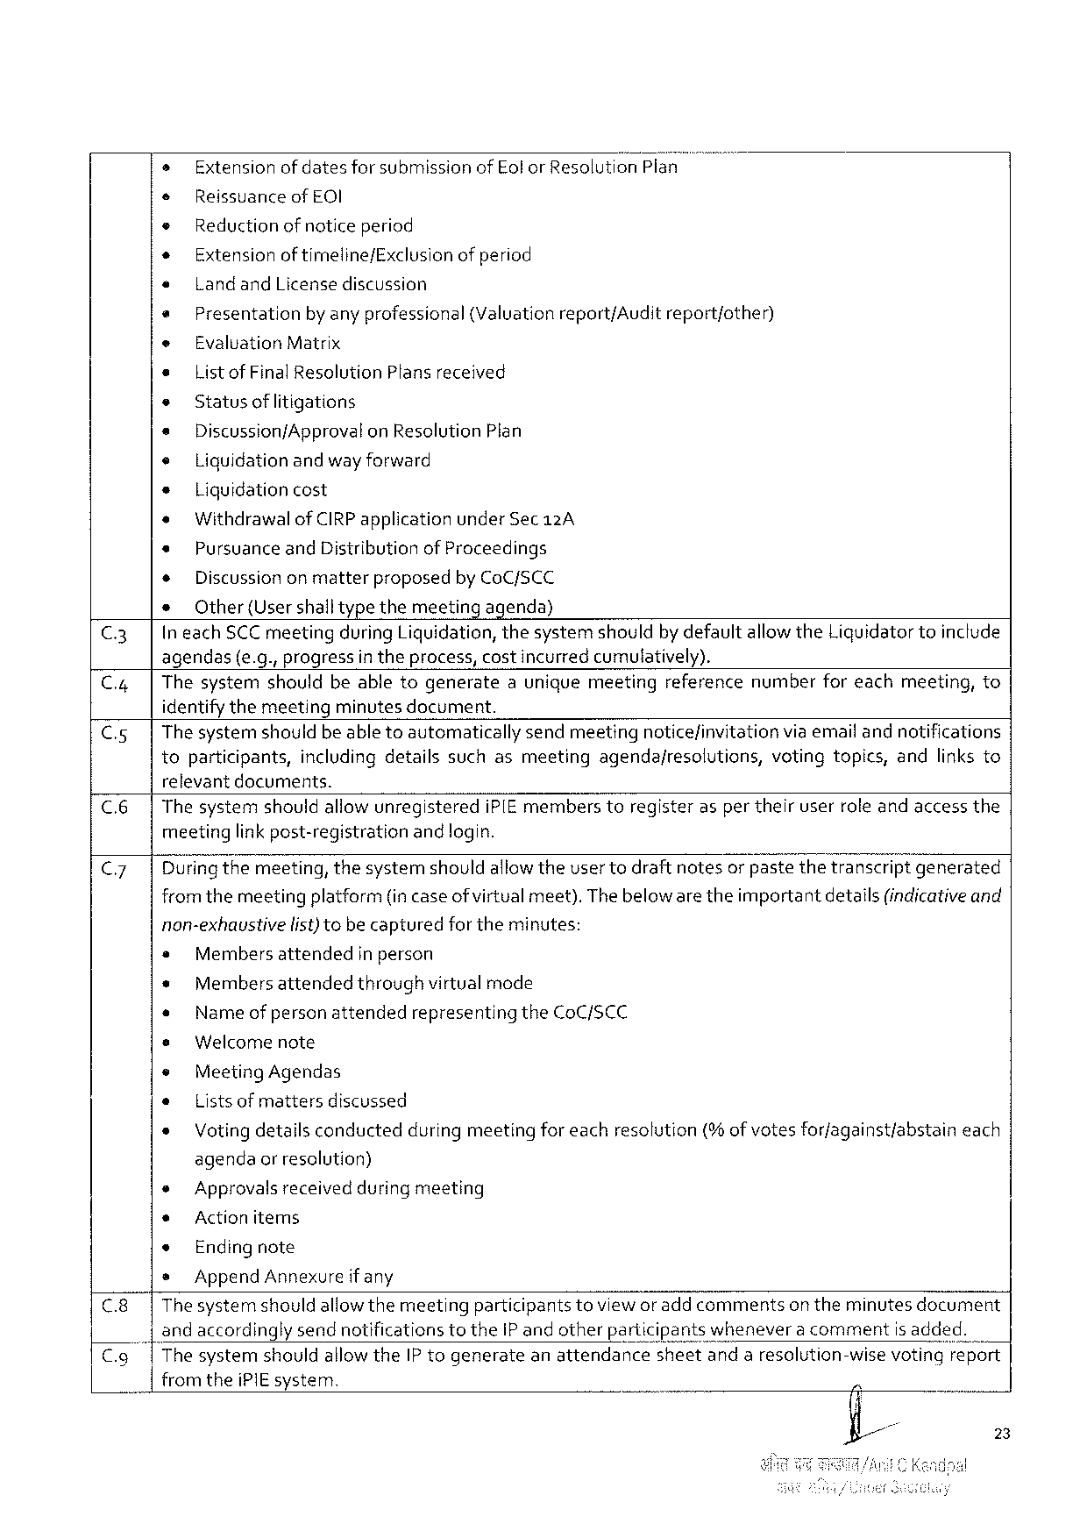

» Extensionofdatesfor submissionof Eolor Resolution Plan

e Reissuanceof EOI

* Reduction of notice period

+ Extensionof timeline/Exclusion of period

e Landand Licensediscussion

* Presentation by anyprofessional (Valuationreport/Audit report/other)

e Evaluation Matrix

* Listof Final Resolution Plans received

s Statusof litigations

* Discussionf Approvalon Resolution Plan

¢ Liquidationandwayforward

+ Liquidationcost

« Withdrawalof CIRP applicationunder Sec 12 A

* Pursuanceand Distribution of Proceedings

+ Discussiononmatter proposed by Co C/SCC

s Other(Usershalltypethemeetingagenda)

C 3| Ineach SCC meetingduring Liquidation, thesystemshouldby defaultallowthe Liguidatortoinclude

agendas(e. g., progressin theprocess, costincurred cumulatively).

C.4| Thesystemshouldbeabletogenerateauniquemeetingreferencenumberforeachmeeting, to

identifythemeetingminutesdocument.

C.5| The systemshouldbe able toautomaticallysendmeetingnoticefinvitationviaemaifandnotifications

toparticipants, includingdetailssuchasmeetingagendajresolutions, votingtopics, andlinksto

relevantdocuments.

C.6| The systemshouldallow unregisteredi PIE memberstoregisterasper theiruserrole andaccessthe

meetinglink post-registrationand login.

C 7 Dufingthemeeting, thesystemshouldallowtheuser todraftnotesor pastethetranscriptgenerated

fromthemeetingplatform(incaseof virtualmeet). Thebeloware theimportantdetails(indicativeand

non-exhaustive fist)tobecaptured fortheminutes:

e Membersattended in person

* Membersattendedthroughvirtualmode

« Name of personattendedrepresentingthe Co C/SCC

* Welcomenote

® Meeting Agendas

e Lists of mattersdiscussed

* Voting detailsconductedduring meetingfor eachresolution(%of votesforjagainst/abstaineach

agendaor resolution)

|  |  |  |  |  |  |  |
| --- | --- | --- | --- | --- | --- | --- |
| C.8| | * | Approvalsreceivedduringmeeting | | | toviewor addcomments | on theminutesdocument |
| s | Actionitems | | |
| * | Endingnote | | |
| » | Append Annexure | if any | |
| Thesystemshouldallowthemeeting | | | participants |

and accordingly sendnotificationstothe IP and otherparticipantswheneveracommentis added.

|  |  |  |  |  |
| --- | --- | --- | --- | --- |
| C.9| | Thesystemshouldallowthe IP togenerate | anattendance | sheetandaresolution-wise | votingreport |

fromthei PIE system.

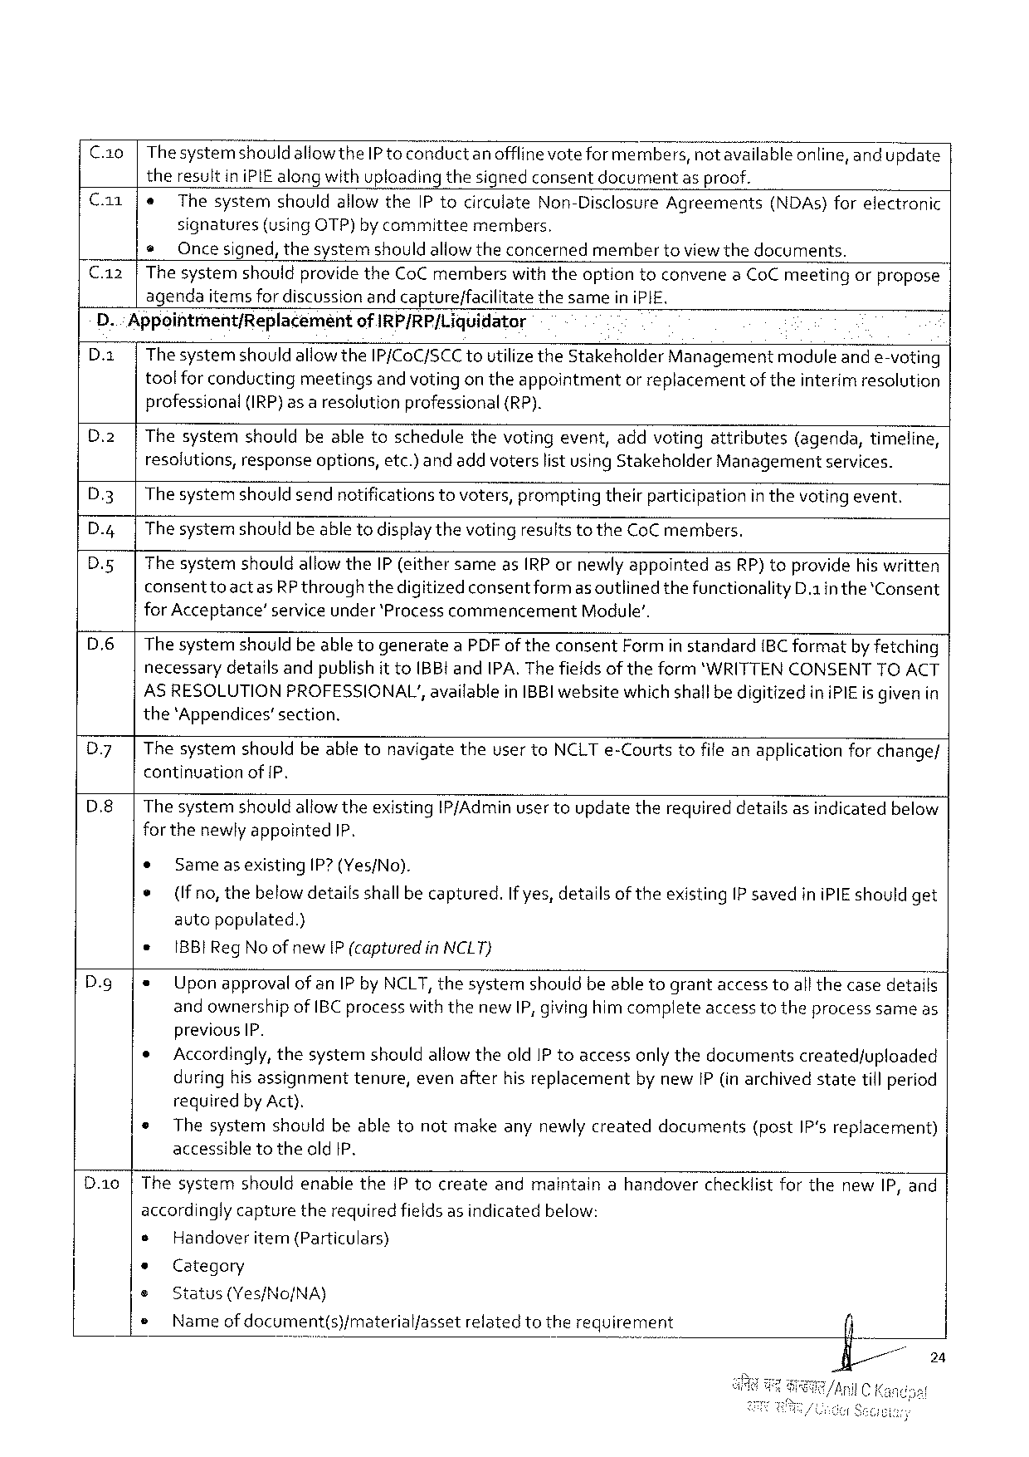

C.1 o | Thesystemshouldallowthe IP to conductanofflinevoteformembers, notavailableonline, and update

theresultin i PIE alongwithuploadingthesignedconsentdocument asproof.

Ca 1 e Thesystem shouldallowthe IP tocirculate Non-Disclosure Agreements (NDA s)forelectronic

signatures (using OTP)by committee members,

@Oncesigned, thesystemshould allowtheconcernedmembertoviewthedocuments.

C.12 |Thesystemshouldprovidethe Co Cmemberswith theoptiontoconvenea Co Cmeetingorpropose

agendaitemsfordiscussionandcapture/facilitate thesameini PIE,

D.: Appointment/Replacemeéntof IRP/RP/Liquidator

D.2| Thesystemshould allowthe IP/Co C/SCC toutilizethe Stakeholder Managementmoduleand e-voting

toolfor conductingmeetingsand votingon theappointmentor replacementof theinterim resolution

professional(IRP)as a resolutionprofessional {(RP).

D.2|Thesystemshouldbeabletoschedulethevotingevent, addvotingattributes(agenda, timeline,

resolutions, responseoptions, etc.) andadd voterslist using Stakeholder Managementservices.

D.3| The systemshould sendnotifications tovoters, promptingtheirparticipationin thevoting event.

D.4|The systemshouldbe able todisplaythevotingresultsto the Co Cmembers.

|  |  |  |
| --- | --- | --- |
| D.5|  D.6|  D 7| | Thesystemshouldallowthe IP (eithersameas IRP ornewly appointedas RP) toprovidehiswritten | |
| consenttoactas | RP throughthedigitizedconsentformas outlinedthefunctionality D.1 in the*Consent |
| for Acceptance’ serviceunder ‘Processcommencement Module’.  The systemshouldbeable togeneratea PDF oftheconsent Form in standard{BC formatby fetching necessarydetafls andpublishit to IBB! and IPA. Thefields of theform‘WRITTENCONSENTTOACT AS RESOLUTIONPROFESSIONAL’, availablein IBBI websitewhichshallbedigitizedini PIE is givenin the‘Appendices’section.  Thesystemshouldbeabletonavigatetheuser to NCLT e-Courtstofile anapplicationfor change/ | |

continuationof P,

D.8|The systemshouldallowtheexisting IP/Adminuser toupdatetherequireddetailsas indicatedbelow

forthenewlyappointed IP.

|  |  |  |  |  |
| --- | --- | --- | --- | --- |
| ® | Same | asexisting | IP?(Yes/No). | If yes, detailsoftheexisting IP savedini PIE shouldget |
| * | (Ifno, thebelow detailsshallbecaptured. | | |

autopopulated.)

|  |  |  |
| --- | --- | --- |
| D. g | * | BB l Reg No ofnew IP (capturedin NCLT} |
| {e Uponapprovalof an IP by NCLT, thesystemshouldbeable tograntaccesstoall thecasedetails and ownershipof IBC processwiththenew IP, givinghimcompleteaccess totheprocesssameas | |

previous IP.

|  |  |
| --- | --- |
| *  ® | Accordingly, thesystemshouldallowtheold IP toaccessonlythedocumentscreatedfuploaded duringhisassignmenttenure, evenafterhis replacementby new[P(in archivedstatetillperiod requiredby Act).  Thesystemshouldbeabletonotmakeanynewly createddocuments(post IP's replacement) accessibletotheold 1 P, |

D.10 |Thesystemshouldenabiethe IP tocreateandmaintainahandoverchecklistforthenew IP, and

accordingly capturetherequiredfields as indicatedbelow:

|  |  |  |
| --- | --- | --- |
| e | Handoveritem(Particulars) | relatedtotherequirement |
| * | Category |
| e | Status(Yes/No/NA) |
| e | Nameof document(s)/materialfasset |

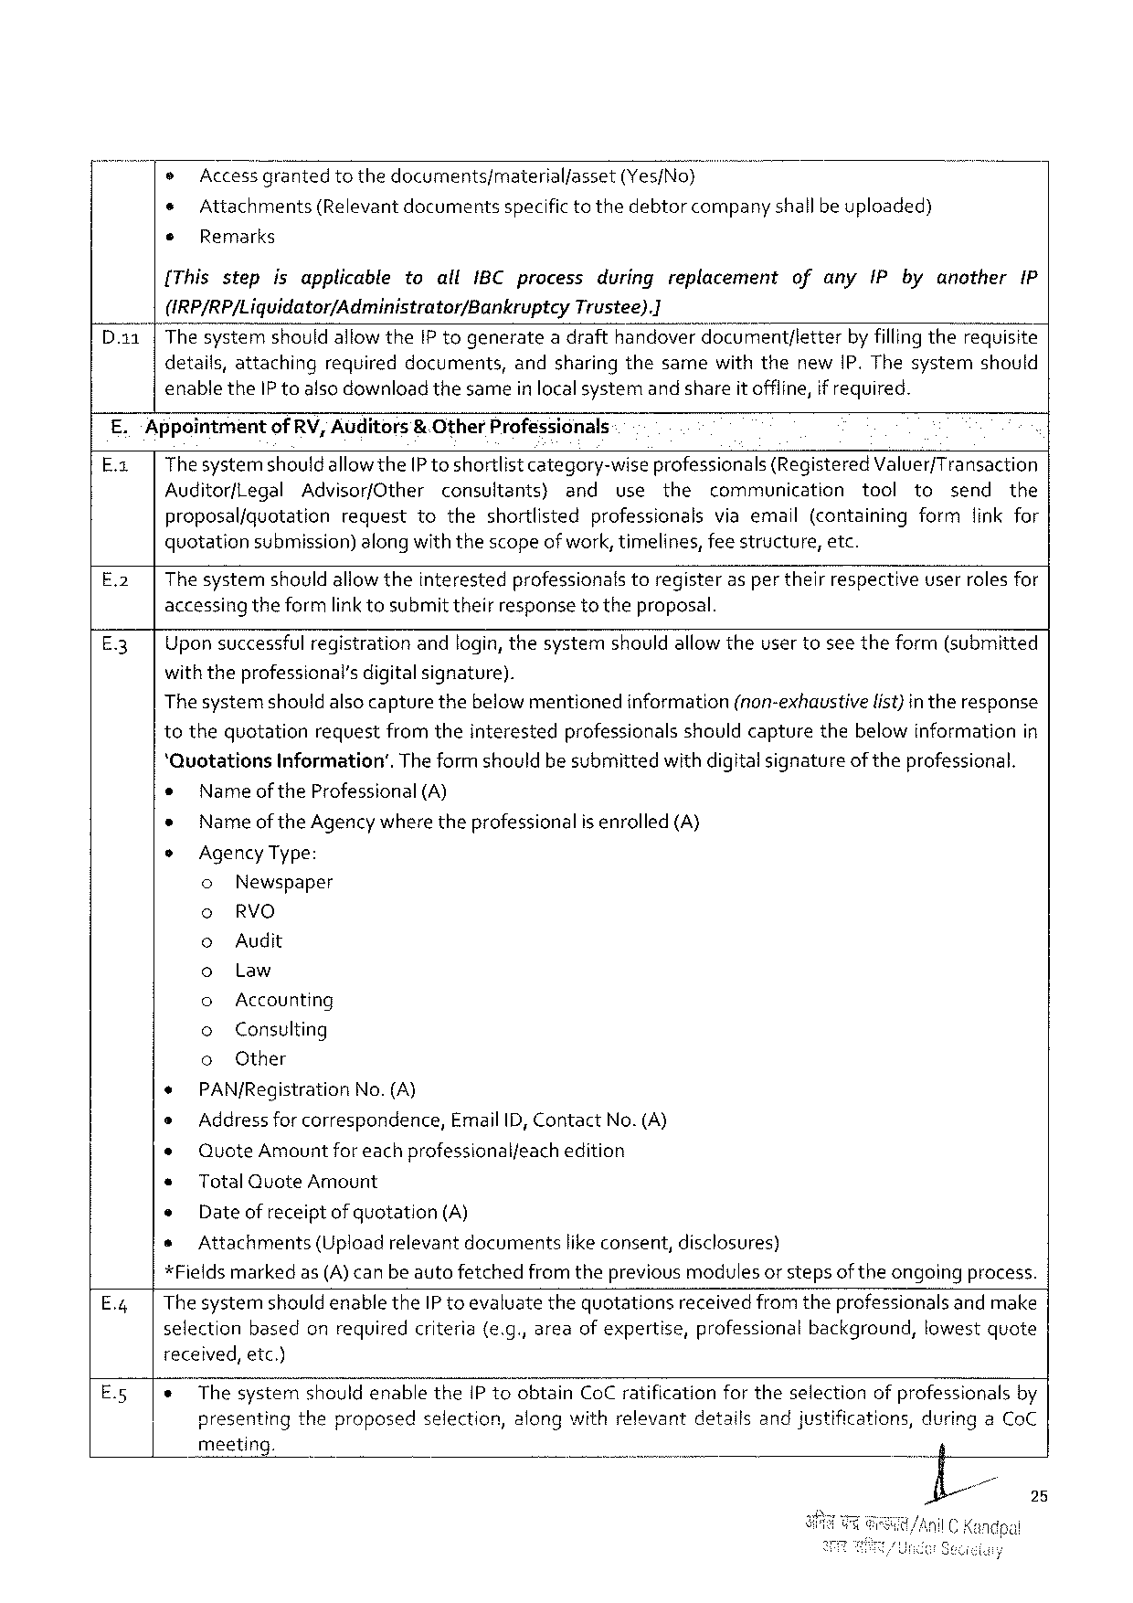

® Access_g“ranted tothedocuments/material/asset (Yes/No)m

¢ Attachments(Relevant documentsspecifictothedebtorcompanyshallbeuploaded)

® Remarks

[Thisstep isapplicable toall IBC process duringreplacement ofany IP byanother IP

(IRP/RP/Liguidator/Administrator/Bankruptcy Trustee).]

Thesystemshouldallowthe IP togenerateadrafthandoverdocument/letter by fillingtherequisite

details, attaching required documents, andsharingthesamewiththenew IP. Thesystem should

enablethe IP toalsodownloadthesameinlocalsystemand shareitoffline, if required.

E.‘Appointmentof RV, Auditors& Other Professionals

E. x| Thesystemshouldallowthe[P toshortlist category-wiseprofessionals (Registered Valuer/Transaction

Auditorf Legal Advisor/Other consultants) and use the communication tool to send the

proposalfquotation requesttotheshortlisted professionalsviaemail(containingformfinkfor

quotationsubmission) along withthescopeofwork, timelines, feestructure, etc.

E.2| The systemshould allowtheinterestedprofessionalstoregisteras per theirrespectiveuserrolesfor

accessing theformlink tosubmittheirresponsetotheproposal.

E.3| Uponsuccessfulregistrationandlogin, thesystemshouldallowtheusertoseetheform(submitted

withtheprofessional’sdigitalsignature).

|  |  |  |  |
| --- | --- | --- | --- |
| Thesystemshouldalsocapturethebelowmentioned | information | (non-exhaustive | list)intheresponse |

tothequotationrequestfromtheinterestedprofessionalsshouldcapturethebelowinformationin

‘Quotations Information’. Theformshouldbesubmittedwithdigitalsignatureof theprofessional.

o Nameof the Professional (A)

* Nameof the Agencywhere theprofessionalis enrolled (A)

o Agency Type:

o Newspaper

o RVO

o Audit

o Law

o Accounting

o Consulting

o Other

+ PAN/Registration No.(A)

e Addressforcorrespondence, Email ID, Contact No.(A)

¢ Quote Amount foreachprofessionalfeachedition

* Total Quote Amount

e Date of receiptof quotation(A)

s Attachments (Uploadrelevantdocuments likeconsent, disclosures)

*Fieldsmarkedas(A)canbeautofetchedfromthepreviousmodulesorstepsoftheongoingprocess.

|  |  |  |
| --- | --- | --- |
| E.;| | Thesystemshould | enablethe IP toevaluatethequotationsreceived fromtheprofessionals andmake |

selectionbasedonrequiredcriteria(e. g., areaof expertise, professionalbackground, lowestquote

received, etc.)

|  |  |  |  |  |  |  |
| --- | --- | --- | --- | --- | --- | --- |
| E.5| | ¢ | Thesystemshouldenablethe IP toobtain Co Cratificationfortheselectionofprofessionalsby | | | | |
| presenting | theproposed | selection, | alongwithrelevant | detailsandju: |

meeting.

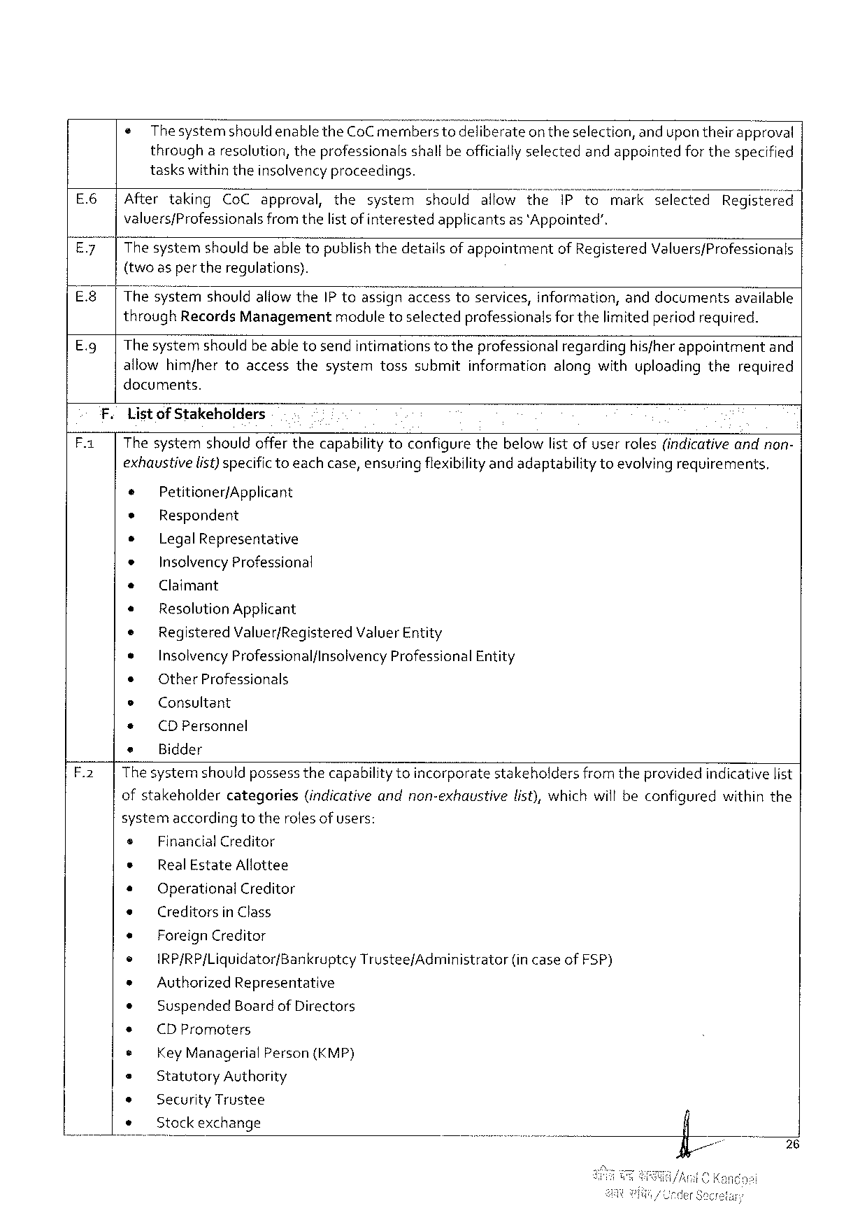

|  |  |  |
| --- | --- | --- |
| e | Thesystemshouldenablethe Co Cmemberstodeliberate | on theselection, andupontheirapproval |
| througharesolution, theprofessionalsshall be officiallyselectedandappointedforthespecified | |

taskswithintheinsolvencyproceedings.

|  |  |  |  |  |  |  |  |
| --- | --- | --- | --- | --- | --- | --- | --- |
| E.6| | Aftertaking | Co Capproval, the | system | shouldallowthe | i Pto | markselected | Registefé(’;! |

valuers/Professionalsfromthelist ofinterestedapplicantsas ‘Appointed’.

E.7| Thesystemshouldbeabletopublishthedetailsof appointmentof Registered Valuers/Professionals

{two asper theregulations).

|  |  |  |  |  |  |  |
| --- | --- | --- | --- | --- | --- | --- |
| E 8 | | | The s’ystemshouldallowthe IP toassignaccesstoservices, information, anddocumentsavailable | | | | |
| E.9 | | | through Records Managementmodule toselectedprofessionals forthelimited periodrequired. | | | | |
| Thesystemshouldbeabletosendintimations | totheprofessional | regarding | hisfherappointment | and |

allowhim/hertoaccessthesystemtosssubmitinformationalongwithuploadingtherequired

documents.

F. Listof Stakeholders

F.1| Thesystemshouldofferthecapabilitytoconfigurethebelowlistofuserroles(indicativeandnon-

exhaustivelist) specifictoeachcase, ensuringflexibilityand adaptabilitytoevolving requirements,

e Petitioner/Applicant

* Respondent

e Legal Representative

* Insolvency Professional

e Claimant

* Resolution Applicant

e Registered Valuer/Registered Valuer Entity

* Insolvency Professional/lnsolvency Professional Entity

¢ Other Professionals

e Consultant

* (DP ersonnel

e Bidder

F.2| Thesystemshouldpossess thecapabilitytoincorporatestakeholdersfromtheprovided indicativelist

ofstakeholder categories (indicative andnon-exhaustive list), whichwillbeconfigured withinthe

systemaccordingtotherolesof users:

|  |  |  |  |  |  |  |
| --- | --- | --- | --- | --- | --- | --- |
| s | Financial Creditor | | | | Trusteef Administrator | (incaseof FSP) |
| * | Real Estate Allottee | | | |
| * | Operational Creditor | | | |
| e | Creditorsin Class | | | |
| e | Foreign Creditor | | | |
| ¢ |
| IRP/RP/Liquidator/Bankruptcy | | | |
| * | Authorized Representative | | | |
| ¢ | Suspended | Boardof Directors | | |
| + | (DP romoters | | | |
| e |
| Key Managerial | | Person | (KMP) |
| e | Statutory Authority | | | |
| * | Security Trustee | | | |
| s | Stock exchange | | | |

26

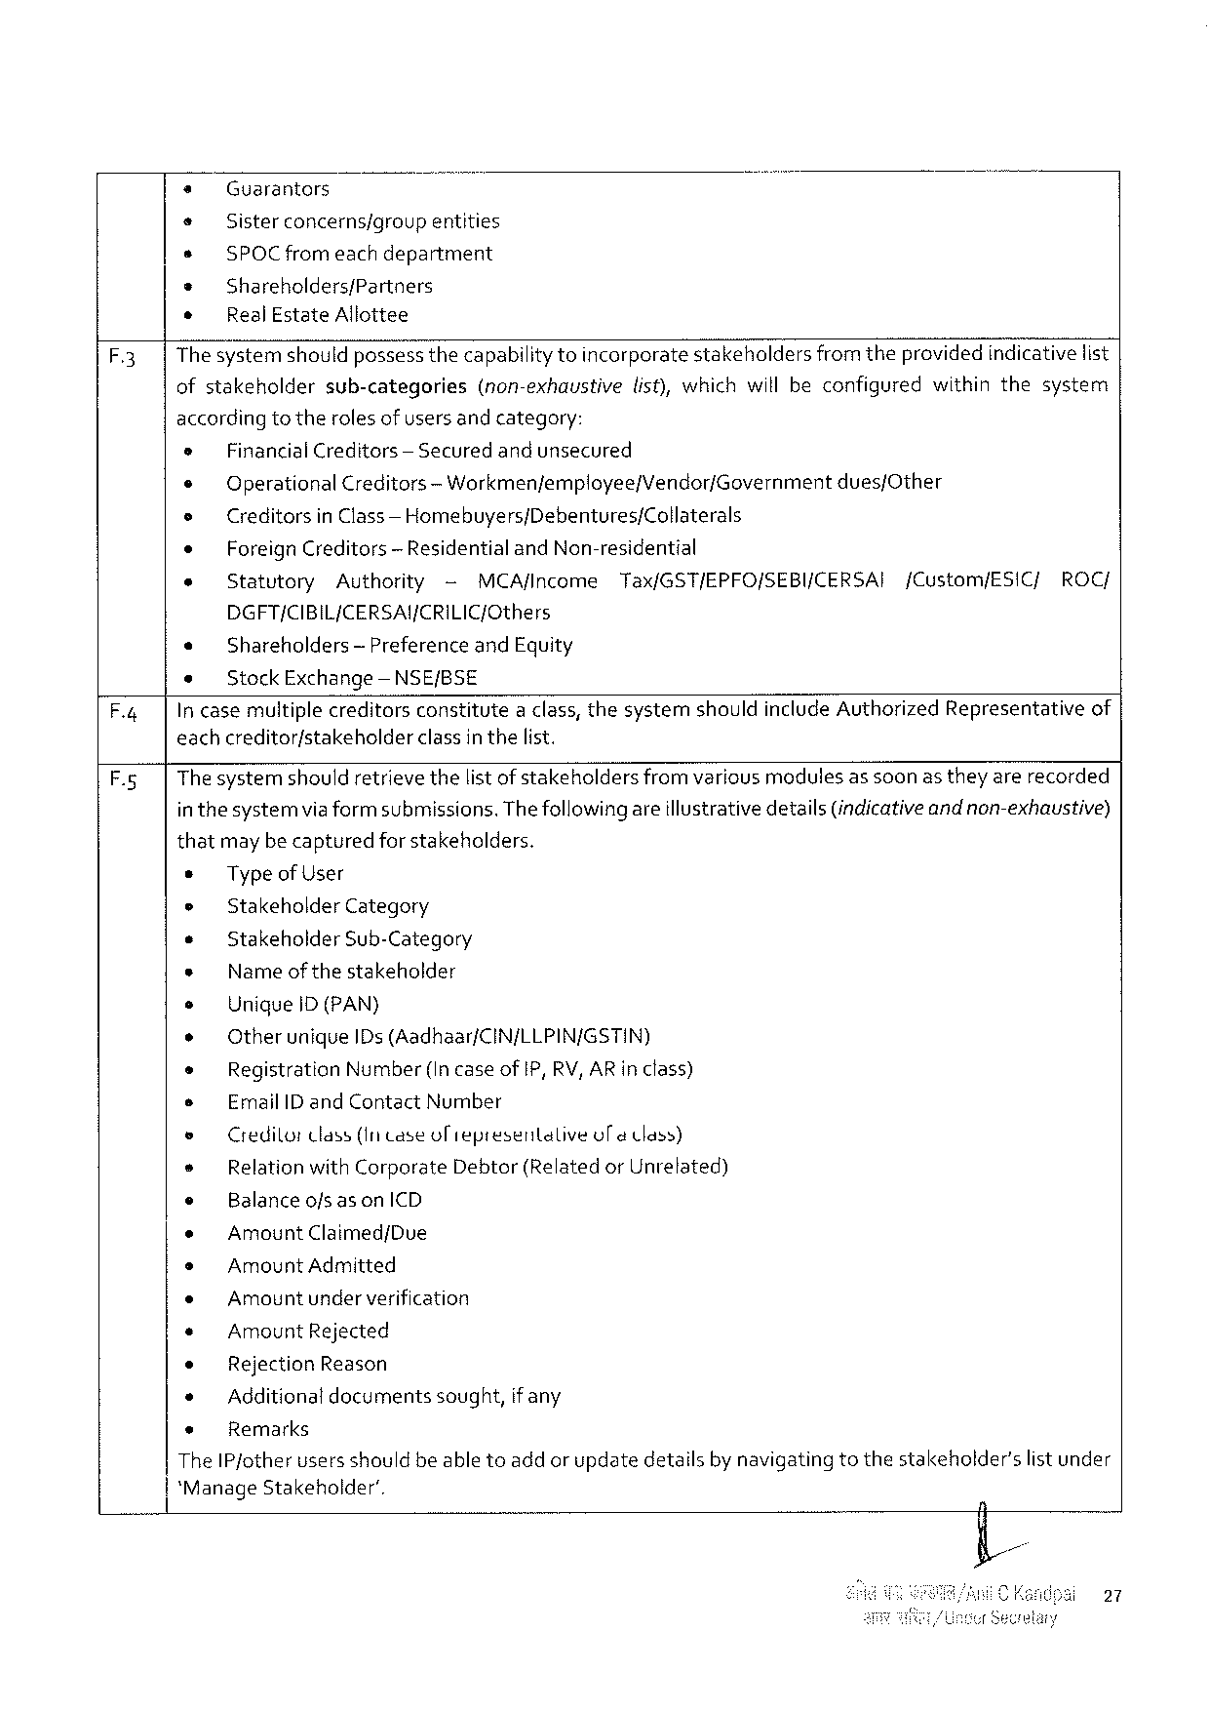

+ Guarantors

+ Sister concerns/group entities

s SPOC fromeachdepartment

s Shareholders/Partners

* Real Estate Allottee

F.3 Thesystemshouldpossessthecapabilitytoincorporate stakeholders fromtheprovidedindicativelist

ofstakeholdersub-categories (non-exhaustivelist), whichwillbeconfiguredwithinthesystem

accordingto therolesof users and category:

|  |  |  |  |  |  |  |  |  |  |
| --- | --- | --- | --- | --- | --- | --- | --- | --- | --- |
| » | Financial Creditors | | | — Securedandunsecured | | | | | ROC/ |
| e |
| Operational Creditors | | | | — Workmenfemployee/Vendor/Governmentdues/Other | | | |
| e | Creditorsin Class— Homebuyers/Debentures/Collaterals | | | | | | | |
| e | Foreign Creditors | | — Residential and Non-residential | | | | | |
| e | Statutory | Authority | | | - | MCA/Income | Tax/GST/EPFO/SEBI/CERSAI | [Custom/ESIC/ |

DGFT/CIBIL/CERSAY/CRILIC/Cthers

e Shareholders— Preferenceand Equity

e Stock Exchange —NSE/BSE

F.4| In casemultiplecreditorsconstitutea class, thesystemshouldinclude Authorized Representativeof

eachcreditor/stakeholderclassin thelist.

F.5| Thesystemshouldretrievethelist ofstakeholdersfrom variousmedulesas soonas they arerecorded

in thesystemvia formsubmissions. Thefollowingareillustrativedetails(indicativeandnon-exhaustive)

thatmaybecapturedforstakeholders.

* Typeof User

e Stakeholder Category

* Stakeholder Sub-Category

e Name ofthestakeholder

s Uniquei D(PAN)

e Otherunique ID s(Aadhaar/CIN/LLPIN/GSTIN)

* Registration Number(Incaseof IP, RV, AR inclass)

s Email ID and Contact Number

o Credilortlass(Intase oliepresentalive ol@ Cass)

e Relationwith Corporate Debtor(Relatedor Unrelated)

e Balanceofsason ICD

o Amount Claimed/Due

s Amount Admitted

e Amountunderverification

« Amount Rejected

* Rejection Reason

* Additionaldocumentssought, if any

+ Remarks

The IP jotherusers shouldbe abletoadd or updatedetailsby navigatingtothestakeholder'slist under

*Manage Stakeholder’.

27

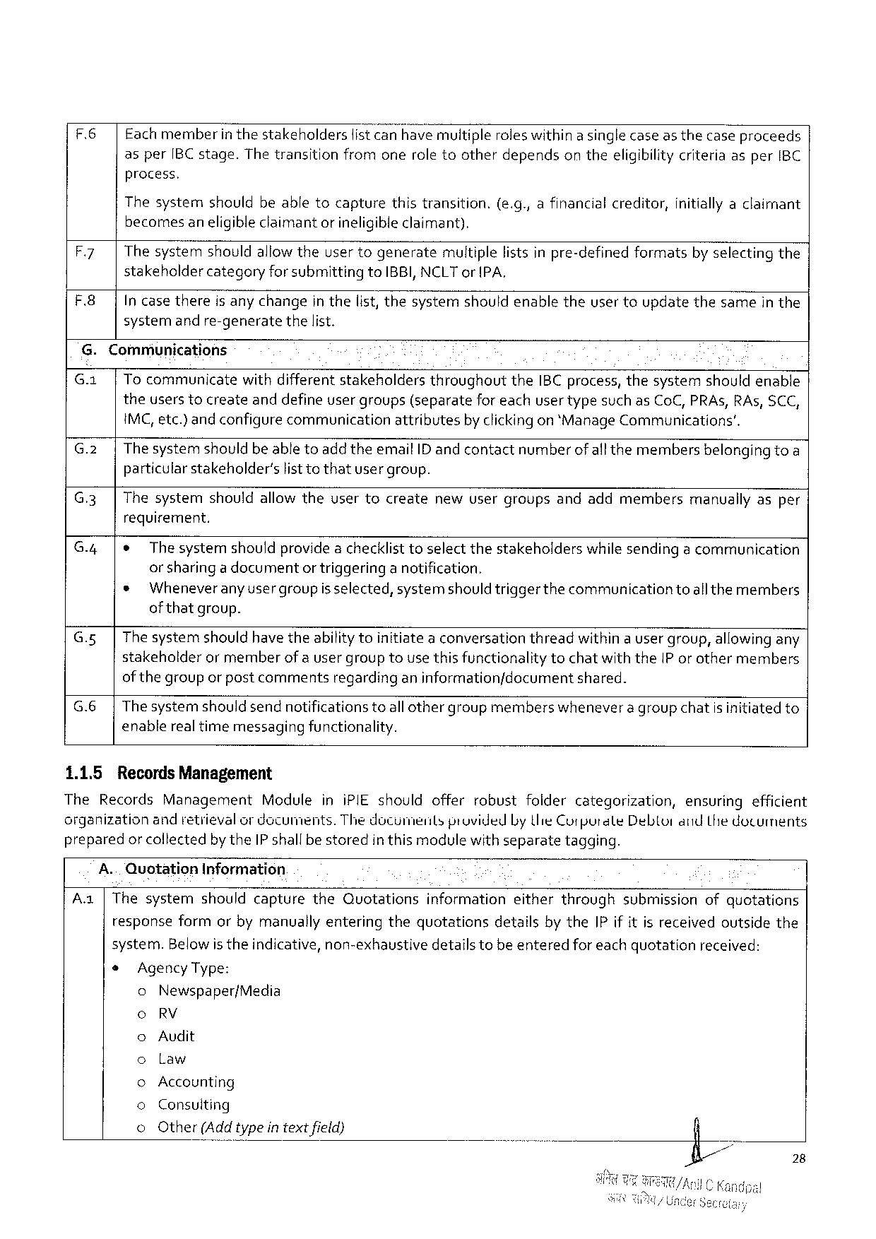

|  |  |
| --- | --- |
| F.6| | Eachmemberin thestakeholderslistcan have multipleroleswithin a singlecaseas thecase proceeds asper[BC stage. Thetransitionfromoneroletootherdependson theeligibilitycriteriaasper IBC process. |

Thesystemshouldbeabletocapturethistransition.(e. g., afinancialcreditor, initiallyaclaimant becomesaneligibleclaimant or ineligibleclaimant).

|  |  |
| --- | --- |
| F.7|  F.8| | Thesystemshouldallowtheusertogeneratemultiplelistsinpre-definedformatsby selectingthe stakeholdercategoryforsubmittingto IBBI, NCLT or IPA,  In casethereis anychangein thelist, thesystemshouldenabletheuser toupdatethesamein the systemand re-generatethelist. |

G. Communications

|  |  |  |  |  |  |  |
| --- | --- | --- | --- | --- | --- | --- |
| G. x|  G.2|  G.3| | Tocommunicatewithdifferentstakeholdersthroughoutthe IBC process, thesystemshouldenable theuserstocreateanddefineuser groups(separatefor eachuser typesuch as Co C, PRA s, RA s, SCC, IMC, etc.) and configurecommunicationattributesby clickingon *Manage Communications’.  The systemshouldbe abletoadd theemail ID andcontactnumberof allthemembersbelonging toa particularstakeholder’slisttothatusergroup. | | | | | |
| Thesystem | shouldallowtheusertocreate | newusergroups | andaddmembers | manuaily | asper |

requirement.

G.4|¢ The systemshouldprovidea checklist toselectthestakeholderswhile sendinga communication or sharinga documentor triggeringa notification.

* Wheneveranyusergroupis selected, systemshouldtriggerthe communicationtoallthemembers of thatgroup.

G.5| The systemshouldhave theabilitytoinitiatea conversationthreadwithin a usergroup, allowingany stakeholderormemberof auser grouptousethis functionalitytochatwiththe IP or othermembers of thegroupor pastcommentsregardinganinformationfdocumentshared.

G.6|The systemshould sendnotificationstoall othergroupmemberswhenevera groupchatis initiatedto enablereal timemessagingfunctionality.

1.1.5 Records Management

The Records Management Moduleini PIE shouldofferrobustfoidercategorization, ensuringefficient organizationandretievalor documents. Thedocumentsprovided Lythie Cutpurate Debtorand Lthe dotuments preparedor collectedby the IP shallbestoredinthis modulewith separatetagging.

A.. Quotation Information

Aa|Thesystemshouldcapturethe Quotationsinformationeitherthroughsubmissionofquotations

responseformorbymanuallyenteringthequotationsdetailsby the IP if it is receivedoutsidethe

system. Belowis theindicative, non-exhaustivedetails tobe enteredfor eachquotationreceived:

* Agency Type:

0 Newspaper/Media

0 RV

Audit

00 Law

Accounting

00 Consuiting

© Other(Add typein textfield}

28

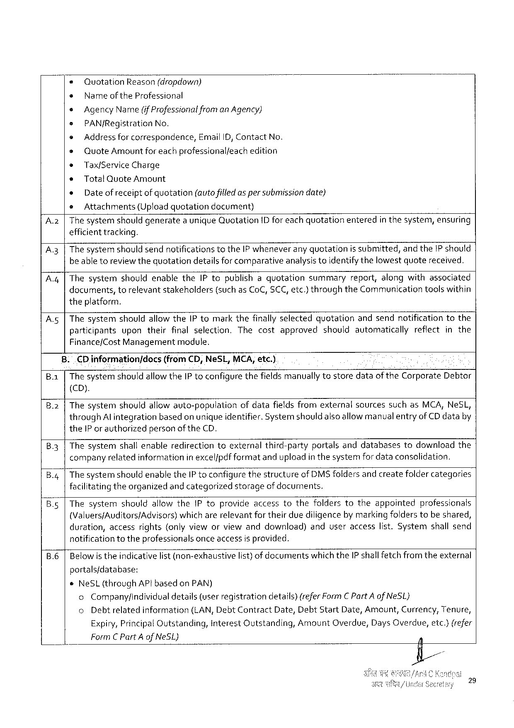

|  |  |  |  |  |  |  |  |  |  |
| --- | --- | --- | --- | --- | --- | --- | --- | --- | --- |
| * | Quotation | | Reason(dropdown) | | | | | entered | inthesystem, ensuring |
| ¢ | | Nameof the Professional | | | | | |
| s | Agency Name(if Professionalfrom an Agency) | | | | | | |
| e | PAN/Registration | | | No. | | | |
| e | Address for correspondence, Email ID, Contact No. | | | | | | |
| e | Quote Amount foreachprofessionalfeachedition | | | | | | |
| e | Tax/Service Charge | | | | | | |
| * | | Total Quote Amount | | | | | |
| « | | Date of receiptof quotation(autofilledas per submissiondate) | | | | | |
| e | Attachments | | (Uploadquotation | | | decument) | |
| A.2|Thesystemshouldgenerate | | | | | aunique Quotation | | ID foreachquotation |

efficient tracking.

A.3 |The systemshould sendnotificationstothe IP wheneverany quotationis submitted, and the 1 P should beabletoreviewthequotationdetailsforcomparativeanalysistoidentifythelowestquotereceived.

A.4 |Thesystemshouldenablethe IP topublishaquotationsummaryreport, alongwithassociated

|  |  |  |  |
| --- | --- | --- | --- |
| documents, | torelevantstakeholders | (suchas Co C, SCC, etc.)throughthe Communication | toolswithin |

theplatform.

A.5|Thesystemshouldallowthe Ptomarkthefinallyselectedquotationandsendnotificationtothe

|  |  |  |  |  |
| --- | --- | --- | --- | --- |
| participants | upontheirfinalselection. | Thecostapproved | shouldautomatically | reflectinthe |

Finance/Cost Managementmodule.

|  |  |  |  |
| --- | --- | --- | --- |
| Ba | . | . CD informationjdocs | (from CD, Ne SL, MCA, etc.) |
| The systemshouldallowthe IP toconfigurethefieldsmanually tostoredataof the Corporate Debtor | |

(CD).

B 2 Thesystemshouldallowauto-populationofdatafieldsfromexternalsourcessuchas MCA, Ne SL, through Al integrationbasedon unique identifier. Systemshould alsoallowmanualentryof CD databy the IP or authorizedpersonof the CD.

|  |  |
| --- | --- |
| B 3 | Thesystemshallenableredirectiontoexternalthird-partyportalsanddatabasestodownloadthe companyrelatedinformationinexcelfpdfformatanduploadin thesystemfordataconsolidation. |

B. g 4 The systemshould enablethe IP toconfigurethestructureof DMS foldersand createfoldercategories facilitatingtheorganizedand categorizedstorageofdocuments.

Thesystemshouldallowthe Ptoprovideaccesstothefolderstotheappointedprofessionals

(Valuers/Auditors/Advisors) whicharerelevantfortheirduediligencebymarkingfolderstobeshared, duration, accessrights{onlyvieworviewanddownload)anduseraccesslist. Systemshallsend notificationtotheprofessionalsonceaccess isprovided.

|  |  |  |  |
| --- | --- | --- | --- |
| B.6 | Belowis theindicativelist(non-exhaustive | list) ofdocuments | whichthe IP shallfetchfromtheexternal |

portals/database:

e Ne SL(through AP tbased on PAN)

o Companyfindividual details(userregistrationdetails) (refer Form CP art Aof Ne SL}

o Debtrelatedinformation (LAN, Debt Contract Date, Debt Start Date, Amount, Currency, Tenure,

Expiry, Principal Outstanding, Interest Qutstanding, Amount Overdue, Days Overdue, etc.)(refer

Form C Part A of Ne SL)

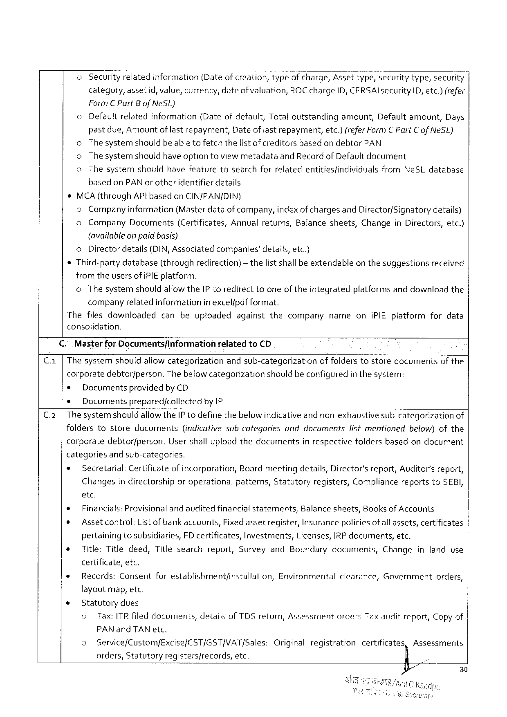

o Securityrelatedinformation (Dateofcreation, typeofcharge, Assettype, wsecuritytype, secur! t);

category, assetid, value, currency, dateofvaluation, ROC charge ID, CERSAI security ID, etc.)(refer

Form C Part Bof Ne SL)

|  |  |  |  |  |  |  |
| --- | --- | --- | --- | --- | --- | --- |
| o | Defaultrelated | information | (Dateofdefault, Totaloutstanding | amount, | Defaultamount, | Days |

pastdue, Amountof last repayment, Dateof lastrepayment, etc.) (refer Form C Part Cof Ne SL)

o Thesystemshouldbeable tofetchthelist ofcreditorsbasedon debtor PAN

o Thesystemshouldhave option toviewmetadataand Recordof Defaultdocument

¢ Thesystem should havefeature tosearchforrelatedentitiesfindividuals from Ne SL database

based on PAN or otheridentifierdetails

MCA(through AP lbasedon CIN/PAN/DIN)

o Companyinformation (Masterdataof company, indexof chargesand Director/Signatorydetails)

|  |  |  |  |  |  |  |  |  |
| --- | --- | --- | --- | --- | --- | --- | --- | --- |
| o | Company | Documents | (Certificates, | Annualreturns, | Balancesheets, | Change | in Directors, | etc.) |

{availableon paidbasis)

o Directordetails(DIN, Associatedcompanies’details, etc.)

Third-partydatabase(throughredirection) fromtheusers ofi PIE platform.

— thelistshallbeextendableon thesuggestionsreceived

o The systemshouldallowthe IP toredirecttooneoftheintegratedplatformsanddownloadthe

companyrelatedinformationin excel/pdf format.

Thefilesdownloaded canbeuploadedagainstthecompanynameoni PIE platformfordata

consolidation.

C.. Masterfor Documentsf Information relatedto CD

C. a |Thesystemshouldallowcategorizationandsub-categorizationof folderstostoredocumentsofthe

corporatedebtor/person. Thebelow categorizationshouldbe configuredin thesystem:

* Documentsprovidedby CD

¢ Documentsprepared/collectedby IP

C.2|The systemshouldaliowthe IP todefinethebelowindicativeand non-exhaustivesub-categorizationof

|  |  |  |  |  |  |  |
| --- | --- | --- | --- | --- | --- | --- |
| folders | tostore | documents | (indicativesub-categories | anddocuments | listmentioned | below)of the |

corporatedebtorfperson. Usershalluploadthedocumentsinrespectivefoldersbasedondocument

categories andsub-categories.

e Secretarial: Certificate ofincorporation, Boardmeetingdetails, Director's report, Auditor’sreport,

Changes indirectorship oroperational patterns, Statutory registers, Compliance reportsto SEBI,

etc.

e Financials: Provisionalandauditedfinancialstatements, Balancesheets, Booksof Accounts

¢ Assetcontrol: List ofbankaccounts, Fixedassetregister, Insurancepoliciesof allassets, certificates

pertainingtosubsidiaries, FD certificates, Investments, Licenses, IRP documents, etc.

|  |  |  |
| --- | --- | --- |
| * | Title: Titledeed, Titlesearchreport, Surveyand Boundarydocuments, | Changeinlanduse |

certificate, etc.

|  |  |  |
| --- | --- | --- |
| * | Records: Consentforestablishmentfinstallation, | Environmentalclearance, Governmentorders, |

layoutmap, etc.

e Statutorydues

o Tax: ITR filed documents, detailsof TDS return, Assessmentorders Taxauditreport, Copyof

PAN and TAN etc.

|  |  |  |  |  |  |  |
| --- | --- | --- | --- | --- | --- | --- |
| o | Service/Custom/Excise/CST/GST/VAT/Sales: | Original | registration | certificatesn | Assessments | 30 |
| orders, Statutoryregistersfrecords, etc. | § . | ; |

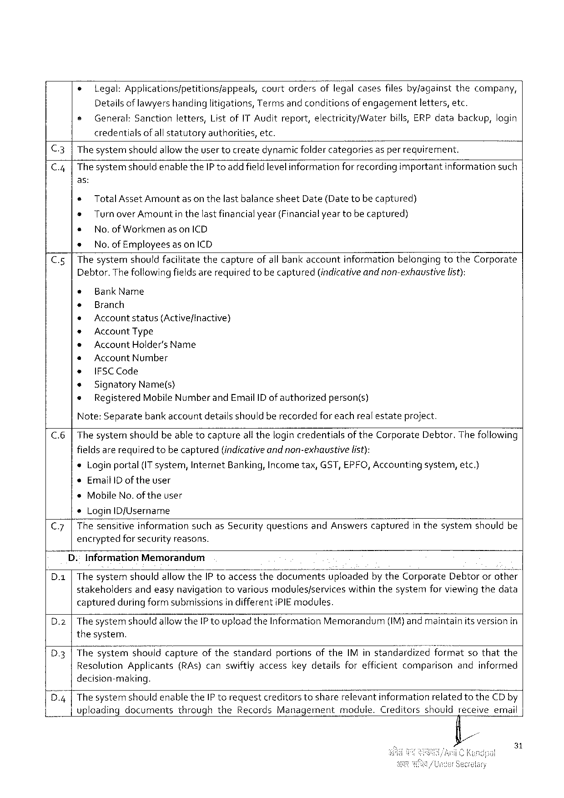

|  |  |  |
| --- | --- | --- |
| e | legal: Applications/petitions/appeals, | courtordersoflegalcasesfilesby/againstthecompany, |

Detailsof lawyers handinglitigations, Terms and conditionsof engagementletters, etc.

|  |  |  |  |  |  |  |  |  |
| --- | --- | --- | --- | --- | --- | --- | --- | --- |
| e | General: | Sanction | letters, | Listof IT Auditreport, electricity/Water | | bills, ERP data | backup, | login |
| credentials | ofallstatutory | | authorities, | etc. |

C.3|Thesystemnshouldallowtheuser tocreatedynamicfoldercategoriesas per requirement.

|  |  |  |  |  |
| --- | --- | --- | --- | --- |
| C.4| | Thesystemshouldenablethe IP toaddfieldlevelinformation | forrecordingimportant | information | such |

as:

« Total Asset Amountasonthelastbalancesheet Date(Datetobecaptured)

® Turnover Amount inthelastfinancialyear(Financialyeartobecaptured)

* No. of Workmen as on ICD

* No. of Employees as on ICD

C.5|Thesystemshouldfacilitatethecaptureof all bankaccountinformationbelongingtothe Corporate Debtor. Thefollowingfieldsarerequiredtobecaptured(indicativeand non-exhaustive list):

|  |  |  |  |
| --- | --- | --- | --- |
| * | Bank Name | | person(s) |
| + | Branch | |
| + |
| Accountstatus(Active/inactive) | |
| * |
| Account Type | |
| * | Account Holder's Name | |
| s | Account Number | |
| e | IFSCC ode | |
| * |
| Signatory | Name(s) |
| ® | Registered | Mobile Numberand Email ID ofauthorized |

Note: Separatebank accountdetailsshould berecordedfor eachrealestateproject.

C.6|The systemshouldbeable tocaptureall thelogincredentialsofthe Corporate Debtor. Thefollowing

|  |  |  |
| --- | --- | --- |
| fieldsarerequiredtobecaptured | (indicativeandnon-exhaustive | list): |

*Loginportal(IT system, Internet Banking, Incometax, GST, EPFO, Accountingsystem, etc.)

¢Email ID of theuser

*Mobile No. of theuser

®Login ID/Username

|  |  |  |  |  |  |  |  |
| --- | --- | --- | --- | --- | --- | --- | --- |
| C.7| | Thesensitive | information | suchas Securityquestions | and Answers | captured | inthesystem | shouldbe |

encryptedfor securityreasons.

D.: Information Memorandum

D. a|Thesystemshouldallowthe IP toaccessthedocumentsuploadedbythe Corporate Debtororothei stakeholdersandeasynavigationtovariousmodules/serviceswithinthesystemforviewingthedata capturedduring form submissionsin differenti PIE modules.

D.2 |The systemshould allowthe IP toupload the Information Memorandum(IM)and maintainitsversion in thesystem.

D 3|Thesyst Ve»n:-swhouid captureofthestandardportionsofthe IM instandardizedformatsothatthe Resolution Applicants(RA s)canswiftlyaccesskeydetailsforefficientcomparisonandinformed decision-making.

D 4 |The systemshouldenablethe IP torequestcreditorstosharerelevantinformationrelated to the CD by vploadingdocumentsthroughthe Records Managementmodule. Creditorsshouidreceiveemnail

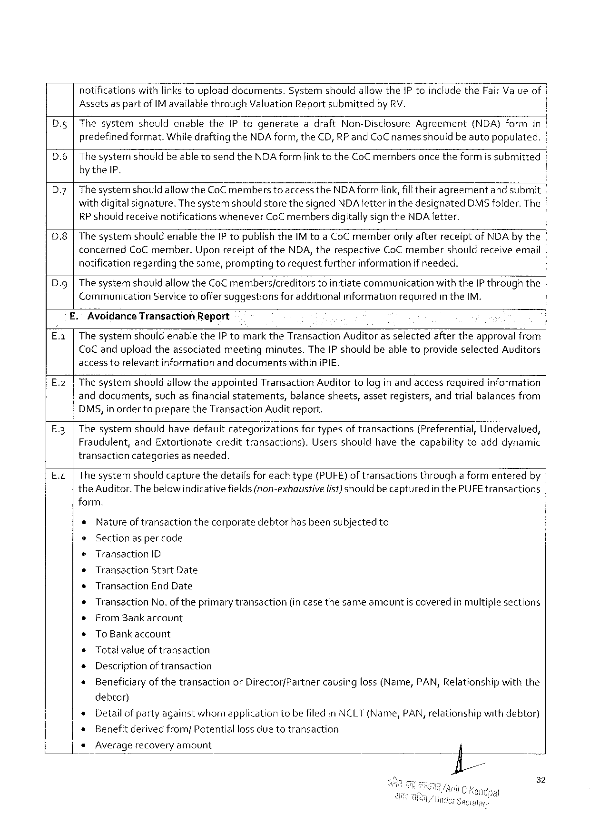

notificationswithlinkstouploaddocuments. Systemshouldallowthe 1 Ptoincludethe Fair Valueof

Assetsas partof IM availablethrough Valuation Report submittedby RV.

|  |  |  |
| --- | --- | --- |
| D. g | Thesystemshouldenablethe IP togenerateadraft Non-Disclosure Agreement | (NDA)formin |

predefinedformat. Whiledrafting the NDA form, the CD, RP and Co Cnamesshouldbeautopopulated.

|  |  |  |
| --- | --- | --- |
| D.6 | Thesystemshouldbeabletosendthe NDA formlinktothe Co Cmembers | oncetheformissubmitted |

by the IP.

|  |  |
| --- | --- |
| D 7 | The systemshouldallow the Co Cmemberstoaccess the NDA form link, fill theiragreementandsubmit with digitalsignature. Thesystemshould storethesigned NDA letterin thedesignated DMS folder. The |

RP shouldreceive notifications whenever Co C membersdigitallysignthe NDA letter.

D 8 The systemshouldenablethe IP topublish the IM toa Co Cmemberonlyafterreceiptof NDA by the

concerned Co Cmember. Uponreceiptofthe NDA, therespective Co Cmembershouldreceiveemail

notificationregardingthesame, promptingtorequestfurtherinformationif needed.

Dy The systemshouldallowthe Co C members/creditorstoinitiatecommunicationwiththe IP throughthe

Communication Servicetooffersuggestionsforadditionalinformationrequiredin the IM.

Avoidance Transaction Report

The systemshouldenablethe IP tomarkthe Transaction Auditoras selectedaftertheapprovalfrom

Co Canduploadtheassociatedmeetingminutes. The IP shouldbeabletoprovideselected Auditors

accesstorelevantinformation anddocuments withini PIE.

E.2 The systemshouldallowtheappointed Transaction Auditor tolog in andaccessrequiredinformation

anddocuments, suchasfinancialstatements, balancesheets, assetregisters, andtrialbalancesfrom

DMS, inordertopreparethe Transaction Audit report.

|  |  |  |  |  |  |
| --- | --- | --- | --- | --- | --- |
| E 3 | Thesystemshouldhavedefault | categorizations | fortypesoftransactions | (Preferential, | Undervalued, |

Fraudulent, and Extortionatecredittransactions). Usersshouldhavethecapabilitytoadddynamic

transactioncategoriesas needed.

E. q Thesystemshouldcapturethedetailsforeachtype(PUFE)of transactionsthrougha formenteredby

the Auditor. Thebelowindicativefields(non-exhaustive list)shouldbecaptured in the PUFE transactions

form.

*Natureof transactionthecorporatedebtorhasbeensubjectedto

®Sectionas per code

|  |  |  |  |  |
| --- | --- | --- | --- | --- |
| e | Transaction | D | (in casethesameamount | iscoveredinmultiplesections |
| s | Transaction | Start Date |
| « | Transaction | End Date |
| ¢ | Transaction | No. oftheprimarytransaction |
| e | From Bankaccount | |

s To Bankaccount

¢Totalvalueof transaction

* Descriptionoftransaction

* Beneficiaryof thetransactionor Director/Partnercausingloss (Name, PAN, Relationshipwiththe

debtor)

* Detailofpartyagainstwhomapplicationtobefiled in NCLT(Name, PAN, relationshipwithdebtor)

» Benefitderivedfrom/Potential lossduetotransaction

e Averagerecoveryamount

32

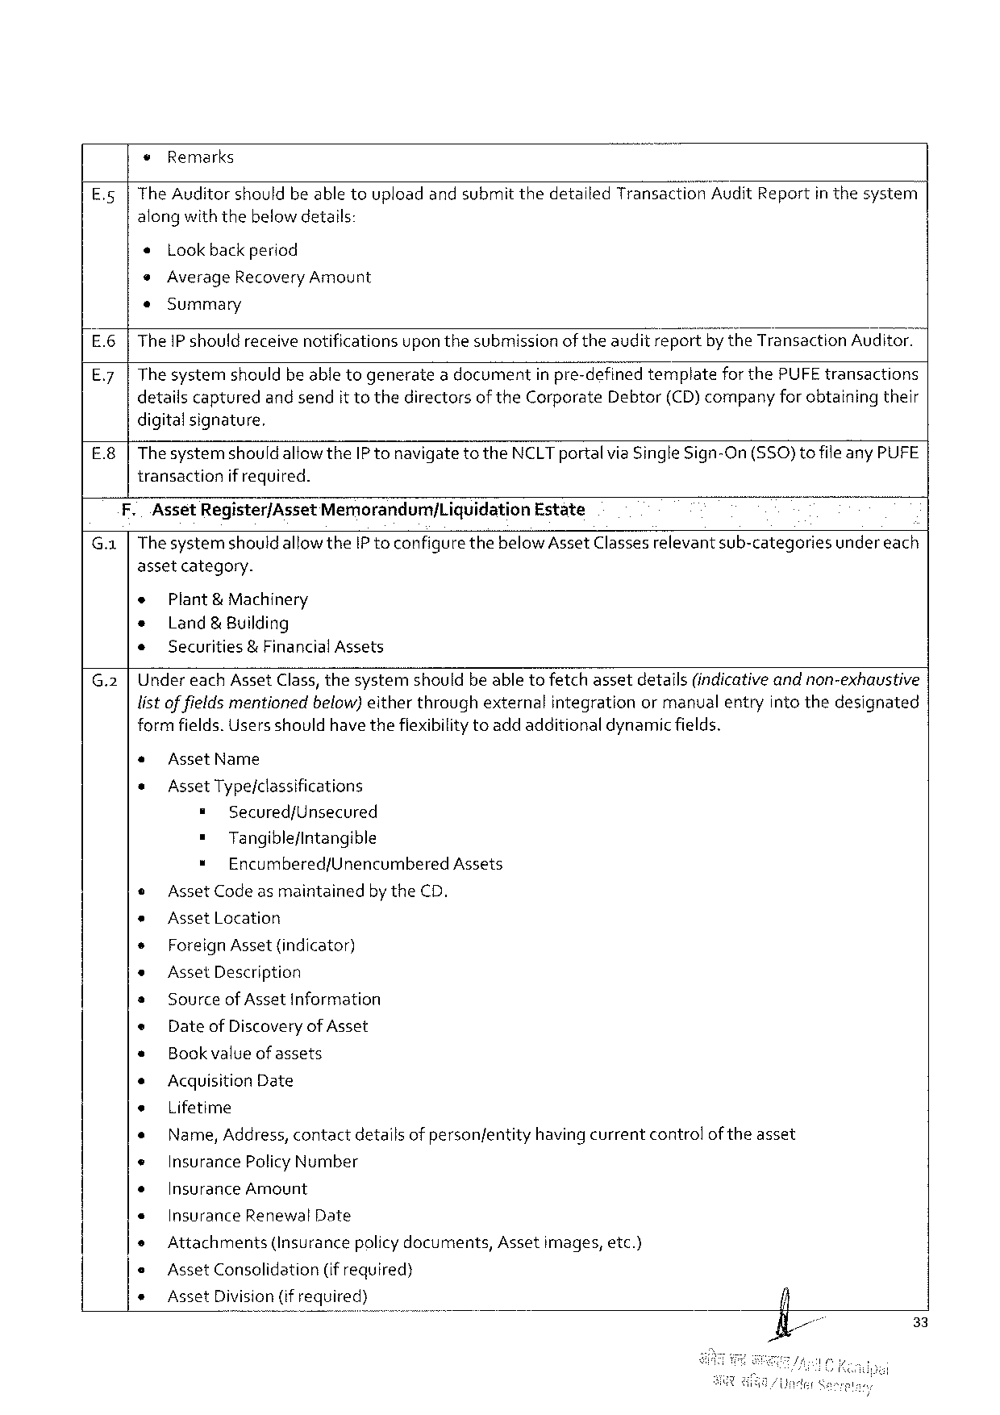

¢ Remarks

E.5 |The Auditorshouldbeabletouploadandsubmit thedetailed Transaction Audit Reportin thesystem

alongwiththebelowdetails:

« Lookbackperiod

*Average Recovery Amount

e«Summary

E.6 |The IP shouldreceive notificationsuponthesubmissionoftheauditreportby the Transaction Auditor.

E.7 |The systemshouldbe abletogeneratea documentin pre-definedtemplateforthe PUFE transactions

detailscapturedandsendit tothedirectorsof the Corporate Debtor(CD)companyfor obtainingtheir

digitalsignature.

E.8|Thesystemshouldallowthe IP tonavigatetothe NCLT portalvia Single Sign-On(SSO)tofile any PUFE

transactionif required.

|  |  |  |
| --- | --- | --- |
| F. | Asset Register/Asset Memorandumj Liquidation | Estate |

G.1 |Thesystemshould allowthe IP toconfigurethebelow Asset Classesrelevantsub-categoriesundereach

assetcategory.

e Plant& Machinery

* Land& Building

* Securities&Financial Assets

G.2 |Under each Asset Class, thesystemshouldbe abletofetchassetdetails(indicativeandnon-exhaustive

listoffieldsmentionedbelow)eitherthroughexternalintegrationormanualentryinto thedesignated

formfields. Usersshouldhave thefiexibilitytoadd additionaldynamicfields.

« Asset Name

* Asset Type/classifications

= Secured/Unsecured

= Tangible/intangible

* Encumbered/Unencumbered Assets

© Asset Codeas maintainedbythe CD.

* Asset Location

* Foreign Asset {indicator)

e Asset Description

s Sourceof Asset Information

e Dateof Discoveryof Asset

« Bookvalueof assets

* Acquisition Date

e Lifetime

* Name, Address, contactdetailsof personfentityhavingcurrentcontrolof theasset

« Insurance Policy Number

* Insurance Amount

« Insurance Renewal Date

* Attachments (Insurancepolicydocuments, Assetimages, etc.)

e Asset Consolidation (if required)

* Asset Division(ifrequired)

33

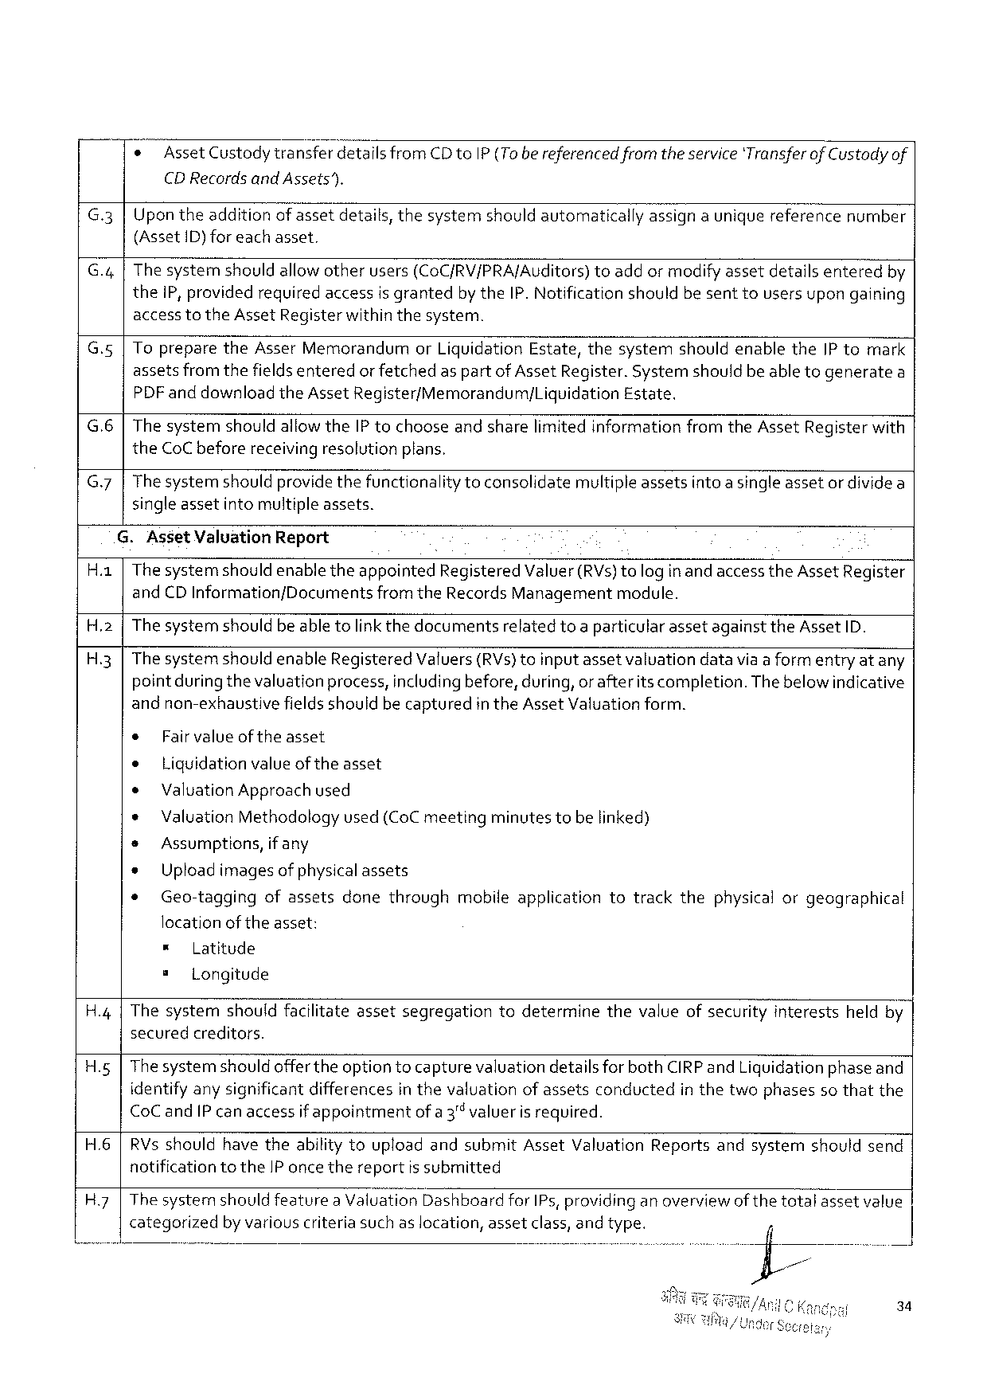

* Asset Custodytransferdetails from CD to IP(Tobe referencedfromthe service‘Transferof Custodyof

CDR ecordsand Assets”).

G.3 Upontheadditionofassetdetails, thesystemshould automaticallyassigna uniquereferencenumber

(Asset{D) foreachasset.

G.4 The systemshouldallowotherusers(Co C/RV/PRA/Auditors)toaddor modify assetdetailsenteredby

the 1 P, providedrequiredaccessisgranted by the IP. Notificationshouldbesenttousersupongaining

accesstothe Asset Registerwithinthesystem.

|  |  |  |  |  |  |  |  |  |
| --- | --- | --- | --- | --- | --- | --- | --- | --- |
| Gs  G.6 | Toprepare | the Asser Memorandum | | | or Liquidation | Estate, | thesystem | shouldenablethe IP tomark |
| assetsfromthefieldsenteredor fetchedas partof Asset Register. Systemshouldbe able togeneratea | | | | | | | |
| PDF anddownload | | the Asset | Register/Memorandum/Liguidation | | | Estate. | |
| Thesystemshouldallowthe IP tochooseand sharelimited informationfromthe Asset Registerwith | | | | | | | |

the Co C beforereceivingresolutionplans.

G.7 Thesystemshouldprovidethefunctionality toconsolidatemultipleassetsintoasingleassetor dividea

singleassetintomultipleassets.

G. Asset Valuation Report

|  |  |  |
| --- | --- | --- |
| Ha | Thesystemshouldenabletheappointed | Registered Valuer(RV s)tologin andaccessthe Asset Register |

and CDI nformation/Documentsfromthe Records Managementmodule.

|  |  |  |  |  |  |
| --- | --- | --- | --- | --- | --- |
| H.2  H 3 | The systemshouldbe able tolink thedocumentsrelatedtoa particularassetagainstthe Asset ID. The systemshouldenable Registered Valuers(RV s)toinputassetvaluationdatavia aform entryatany pointduringthevaluation process, includingbefore, during, orafterits completion. Thebelow indicative andnon-exhaustivefieldsshouldbecapturedin the Asset Valuationform. | | | | |
| ¢ | Fairvalue | | oftheasset. | |
| e | Liquidationvalue of the asset | | | |
| ¢ | | Valuation Approachused | | |
| * | | Valuation Methodologyused (Co Cmeetingminutes tobe linked) | | |
| s | Assumptions, | | | if any |
| » | Uploadimagesof physicalassets | | | |
| * | Geo-taggingofassetsdonethroughmobileapplicationtotrackthephysicalorgeographical | | | |

locationoftheasset:

|  |  |  |  |  |  |  |  |  |  |
| --- | --- | --- | --- | --- | --- | --- | --- | --- | --- |
| H.4 | = | | Latitude | | assetsegregation | todetermine | thevalueofsecurity | interests | heldby |
| s | Longitude | | |
| Thesystem | | | shouldfacilitate |

securedcreditors.

H. g Thesystemshouldofferthe optiontocapturevaluationdetailsfor both CIRP and Liguidationphaseand

identifyany significantdifferencesin thevaluationofassetsconductedin thetwophasesso thatthe

|  |  |  |
| --- | --- | --- |
| Co C and IP canaccess | ifappointment | ofa 3"valuerisrequired. |

H.6|RV s shouldhavetheabilitytouploadandsubmit Asset Valuation Reportsandsystemshouldsend

notificationtothe IP once thereportis submitted

|  |  |  |  |  |
| --- | --- | --- | --- | --- |
| H.7|Thesystemshouldfeaturea Val Uation Dashboard | | for IP s, providinganoverview | of the | totalassetvalue |
| categorized | by variouscriteriasuchaslocation, assetclass, andtype. | |

34

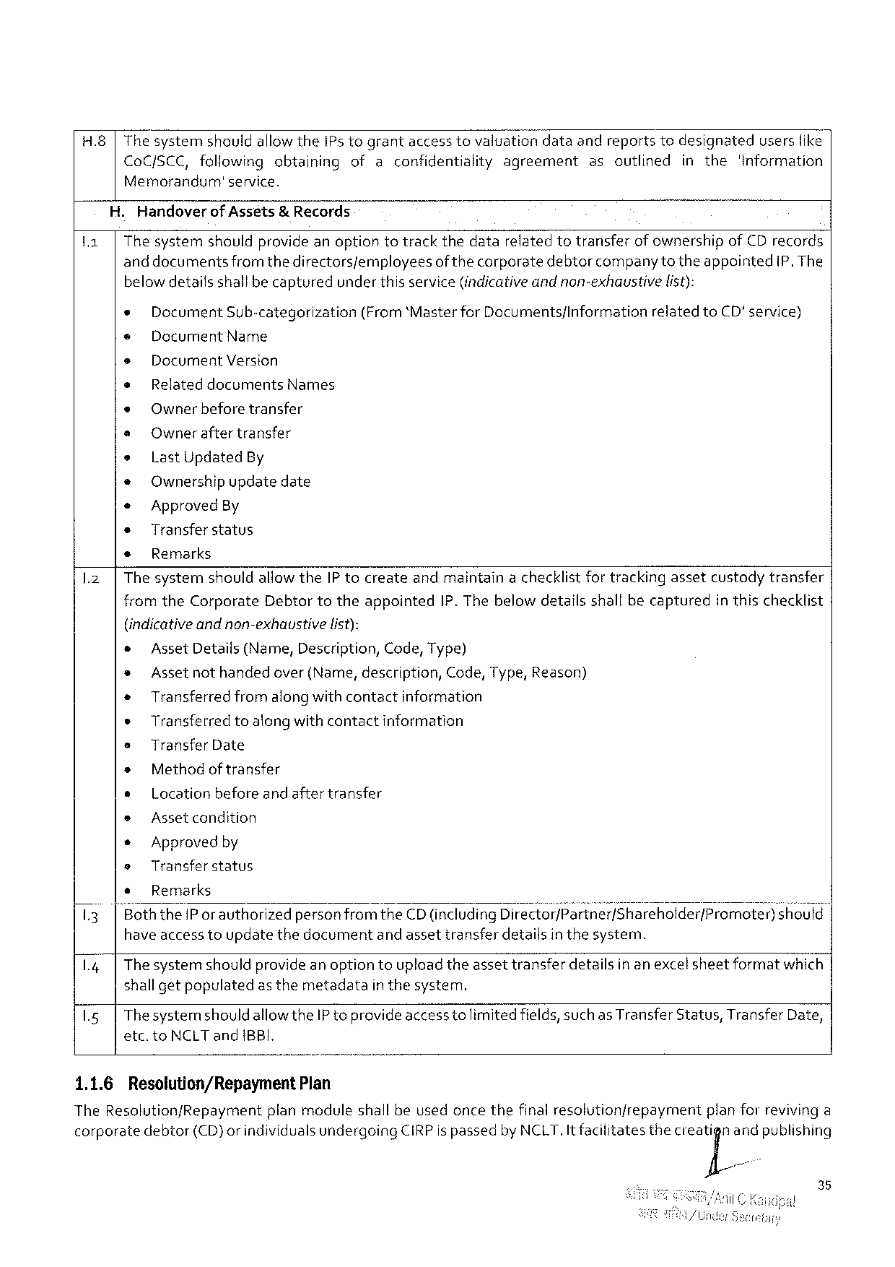

H.8|The systemshouldallowthe IP s tograntaccess tovaluationdataandreportstodesignateduserslike

|  |  |  |  |  |  |
| --- | --- | --- | --- | --- | --- |
| Co Cf SCC, followingobtaining | | ofaconfidentialityagreement | asoutlined | in the | 'Information |
| Memorandum' | service. |

. Handoverof Asséts& Records

11| The systemshouldprovideanoptiontotrackthedatarelatedtotransferof ownershipof CD records

anddocuments fromthedirectorsfemployees of thecorporate debtor companytotheappointed IP. The

belowdetailsshallbecaptured underthisservice(indicativeandnon-exhaustive list):

e Document Sub-categorization (From‘Master for Documents/Information related to CD'service)

¢ Document Name

e Document Version

e Relateddocuments Names

e Owner beforetransfer

e Owner after transfer

e Last Updated By

* Ownershipupdatedate

« Approved By

* Transferstatus

s Remarks

1.2| The systemshouldallowthe IP tocreateandmaintaina checklistfor trackingassetcustodytransfer

from the Corporate Debtortotheappointed IP. Thebelowdetailsshallbecapturedin thischecklist

|  |  |  |  |  |  |  |  |  |
| --- | --- | --- | --- | --- | --- | --- | --- | --- |
| 13 | (indicativeandnon-exhaustive | | | | list): | | | should |
| * | | Asset Details(Name, Description, Code, Type) | | | | |
| * | Assetnothandedover(Name, description, | | | | | Code, Type, Reason) |
| « | | Transferredfromalongwith contactinformation | | | | |
| e | Transferredtoalongwithcontactinformation | | | | | |
| s | Transfer Date | | | | | |
| * | | Methodof transfer | | | | |
| ¢ | | Locationbefore and aftertransfer | | | | |
| e | Asset condition | | | | | |
| * | | Approved by | | | | |
| e | Transfer status | | | | | |
| * | | Remarks | | | | |
| |"Boththe IP or authorized | | | personfrom | | the CD(including Dlrsctor/}séf{né;/shareho! der/Promoter) | |

have access toupdatethedocumentand assettransferdetailsin thesystem.

1.4| Thesystemshouldprovideanoptiontoupload theassettransferdetailsin an excelsheetformatwhich |

shallgetpopulated as themetadata inthesystem.

1.5| Thesystemshouldallow the IP toprovideaccesstolimitedfields, such as Transfer Status, Transfer Date,

etc. to NCLT and IBBI.

|  |  |  |
| --- | --- | --- |
| 1.1.6 | Resolution/Repayment | Plan |

The Resolution/Repaymentplanmoduleshall beusedoncethefinalresolutionfrepaymentplanforrevivinga

|  |  |  |  |  |  |
| --- | --- | --- | --- | --- | --- |
| corporate | debtor | (CD)orindividualsundergoing | CIRP ispassedby NCLT, Itfaciiitates | thecleaj[iand | publishing |

35

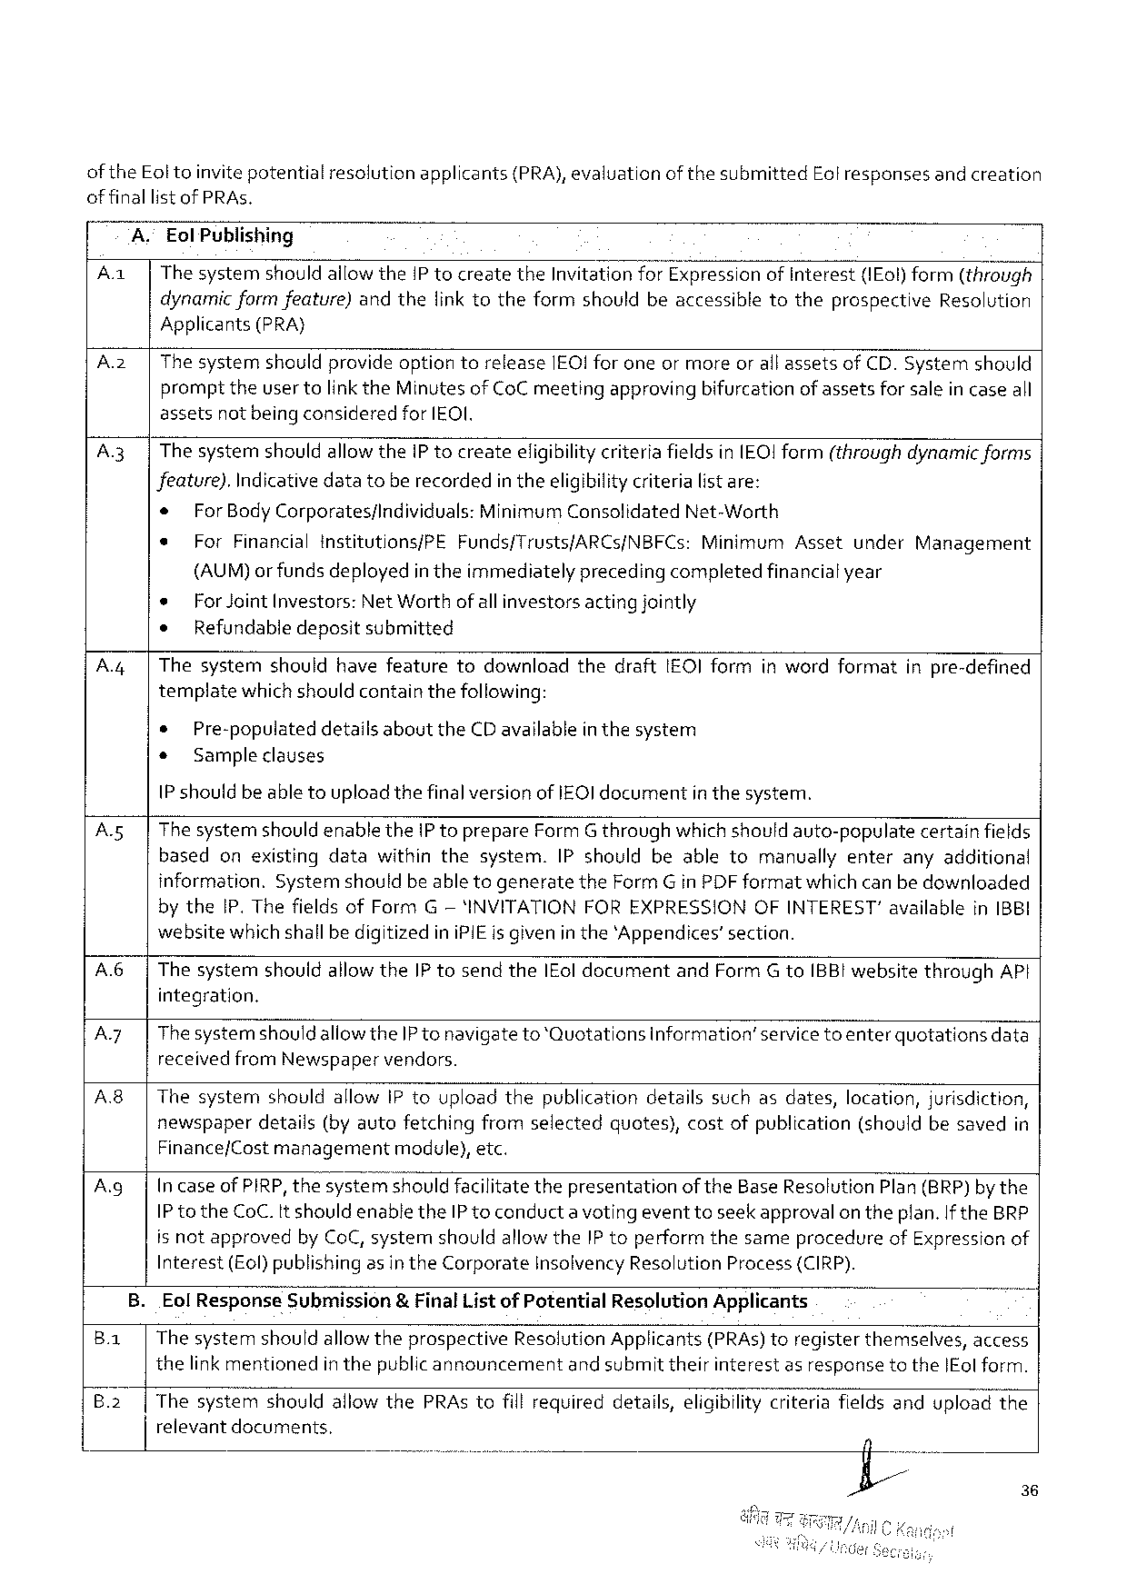

of the Eoltoinvitepotentialresolutionapplicants(PRA), evaluationof thesubmitted Eolresponsesand creation

offinallistof PRA s.

A." Eol Publishing

|  |  |
| --- | --- |
| A | |The systemshould allowthe IP tocreatethe Invitationfor Expressionof Interest(IE ol) form(through dynamicformfeature)andthefinktotheformshouldbeaccessibletotheprospective Resolution |

Applicants(PRA}

|  |  |  |
| --- | --- | --- |
| A 2 | | | The systemshouldprovideoptiontorelease IEO! foroneor moreorall assetsof CD. Systemshould |
| prompttheuser tolinkthe Minutes of Co C meetingapprovingbifurcationof assetsfor salein caseall |

assetsnot being consideredfor [EOI.

A.3| Thesystemshouldallowthei P tocreateeligibilitycriteria fieldsin IEO! Iform(throughdynamic forms

Jeature). Indicativedatatoberecordedin theeligibilitycriteria listare:

|  |  |  |  |  |  |  |
| --- | --- | --- | --- | --- | --- | --- |
| * | For Body Corporates/individuals: Minimum Consolidated Net-Worth | | | Asset | under | Management |
| e |
| For Financialinstitutions/PE | Funds/Trusts/ARCS/NBFC s: | Minimum |

(AUM)or fundsdeployedin theimmediatelyprecedingcompletedfinancialyear

|  |  |  |  |  |  |  |  |  |  |  |
| --- | --- | --- | --- | --- | --- | --- | --- | --- | --- | --- |
| A.4| | * | For Joint Investors: | | | Net Worthofallinvestorsactingjointly | | | | inwordformat | inpre-defined |
| ¢ | Refundabledepositsubmitted | | | | | | |
| Thesystem | | should | havefeature | | todownload | thedraft | 1 EOI form |
| templatewhichshouldcontainthefollowing: | | | | | | | |
| * | Pre-populateddetailsaboutthe CD availablein thesystem | | | | | | |
| o | Sample clauses | | | | | | |

1 P shouldbeable toupload thefinalversionof IEQ] documentin thesystem.

|  |  |  |
| --- | --- | --- |
| A 5 | | | The systemshould enablethe IP toprepare Form G throughwhichshouldauto-populatecertainfields |

basedonexistingdatawithinthesystem. IP shouldbeabletomanuallyenteranyadditional

information. Systemshouldbe able togeneratethe Form Gin PDF formatwhich can bedownloaded

by the IP. Thefieldsof Form G— 'INVITATIONFOREXPRESSIONOFINTEREST"availablein 1 BBI

websitewhichshallbedigitizedini PIE is givenin the‘Appendices’section.

|  |  |  |  |  |  |  |
| --- | --- | --- | --- | --- | --- | --- |
| A.6| | | Thesystemshouldallowthe IP tosendthe IE oldocumentand Form G to IBBI websitethrough AP t integration. | | | | |
| A 7 | | | Thesystemshould | aliowthe IP tonavigateto‘Quotations | | information’servicetoenterquotations | data |
| A 8| | | receivedfrom Newspaper | | vendors. | | |
| Thesystemshouldallow IP touploadthepublicationdetailssuchasdates, location, jurisdiction, newspaperdetails(byautofetchingfromselectedquotes), costofpublication(shouldbesavedin | | | | |

Finance/Cost managementmodule), etc.

|  |  |
| --- | --- |
| A. g| | Incaseof PIRP, thesystemshouldfacilitatethepresentationof the Base Resolution Plan(BRP)by the IP to the Co C. It shouldenablethe IP toconducta voting eventtoseekapprovalon theplan. If the BRP |

is notapprovedby Co C, systemshouldallowthe IP toperformthesameprocedureof Expressionof

Interest(Eol) publishingasin the Corporate Insolvency Resolution Process {CIRP).

B. Eol Response Submission& Final Listof Potential Resolution Applicants q

Ba | The systemshouldallowtheprospective Resolution Applicants(PRA s) toregisterthemselves, access

thelinkmentionedin thepublic announcement and submit theirinterestas responsetothe IE ol form.

B.2| Thesystemshouldallowthe PRA stofillrequireddetails, eligibility criteriafieldsanduploadthe

relevantdocuments,

36

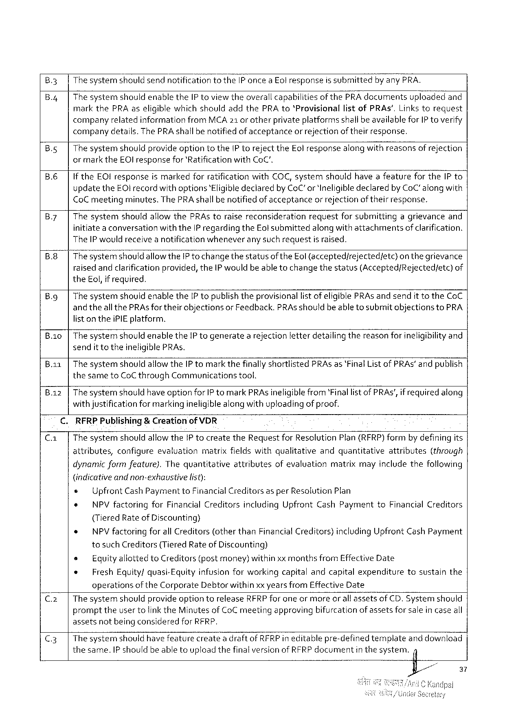

B 3 Thesystemshouldsendnotificationtothe IP oncea Eol response is submitted by any PRA.

B.4 Thesystemshouldenablethe IP toviewtheoverallcapabilities of the PRA documentsuploadedand markthe PRA aseligible whichshouldaddthe PRA to‘Provisionallistof PRA s’, Links torequest companyrelatedinformation from MCA 21 or otherprivateplatformsshallbeavailablefor IP toverify

|  |  |  |  |
| --- | --- | --- | --- |
| B. s  B.6 | company | details. The PRA shallbenotifiedof acceptance | orrejectionof theirresponse. |
| Thesystemshouldprovideoptiontothe 1 P torejectthe Eol responsealongwithreasonsof rejection or markthe EOI responsefor'Ratification with Co C".  If the EOI responseis markedforratificationwith COC, systemshouldhave afeatureforthe IP to | | |

updatethe EOI record withoptions‘Eligible declaredby Co C’or 'Ineligibledeclaredby Co C” alongwith Co Cmeetingminutes. The PRA shallbe notifiedof acceptanceor rejection of theirresponse.

|  |  |  |  |  |  |  |
| --- | --- | --- | --- | --- | --- | --- |
| B.7 | Thesystem | shouldallowthe PRA storaisereconsideration | request | forsubmitting | agrievance | and |

initiate a conversationwiththe IP regardingthe Eolsubmittedalong withattachmentsofclarification. The IP wouldreceive a notificationwheneverany such requestis raised.

B.8 Thesystemshouldallowthe IP tochangethestatusof the Eol(accepted/rejectedfetc)on thegrievance raised andclarificationprovided, the IP would beable tochangethestatus(Accepted/Rejected/etc)of the Eol, if required.

|  |  |
| --- | --- |
| B. g | Thesystemshouldenablethe IP topublishtheprovisionallist of eligible PRA s andsendittothe Co C and theall the PRA sfortheirobjectionsor Feedback. PRA sshouldbeabletosubmit objectionsto PRA |

list onthei PIE platform.

B. io Thesystemshouldenablethe IP togeneratea rejectionletterdetailing thereasonforineligibilityand sendit totheineligible PRA s.

|  |  |
| --- | --- |
| B. aa  B. az | Thesystemshouldallowthe IP tomark thefinallyshortlisted PRA s as‘Final Listof PRA s” andpublish thesameto Co Cthrough Communicationstool.  Thesystemshouldhave optionfor IP tomark PRA sineligiblefrom‘Finallist of PRA s’, ifrequired along |

withjustificationfor markingineligiblealong with uploadingof proof.

RFRPP ubtishing& Creationof VDR

Thesystemshouldallowthe[P tocreatethe Requestfor Resolution Plan(RFRP)formby definingits

|  |  |  |  |  |  |  |
| --- | --- | --- | --- | --- | --- | --- |
| attributes, | configure | evaluation | matrixfieldswithqualitative | andquantitative | attributes | (through |

dynamicformfeature). Thequantitativeattributesofevaluationmatrixmayincludethefollowing

(indicativeandnon-exhaustive list):

e Upfront Cash Payment to Financial Creditorsasper Resolution Plan

e NPV factoringfor Financial Creditorsincluding Upfront Cash Paymentto Financial Creditors

(Tiered Rateof Discounting)

* NPV factoringforall Creditors(otherthan Financial Creditors}including Upfront Cash Payment

tosuch Creditors(Tiered Rateof Discounting)

|  |  |  |  |  |  |
| --- | --- | --- | --- | --- | --- |
| s | Equityallottedto Creditors (postmoney)withinxxmonthsfrom Effective Date | | | tosustain | the |
| * | Fresh Equity/quasi-Equity | | infusionforworkingcapitalandcapitalexpenditure |
| operations | of the Corporate | Debtorwithinxx yearsfrom Effective Date |

The systemshouldprovide optionterelease RFRP for eneormoreor all assetsof CD. Systemshould prompttheuser tolink the Minutesof Co C meetingapprovingbifurcation of assetsfor salein case all assetsnotbeing consideredfor RFRP,

|  |  |  |  |  |
| --- | --- | --- | --- | --- |
| C 3 | Thesystemshouldhavefeaturecreatea draftof RFRP ineditablepre-defined | | template | anddownload |
| thesame. IP shouldbeabletouploadthefinalversionof RFRP document | inthesystem. | | fl |

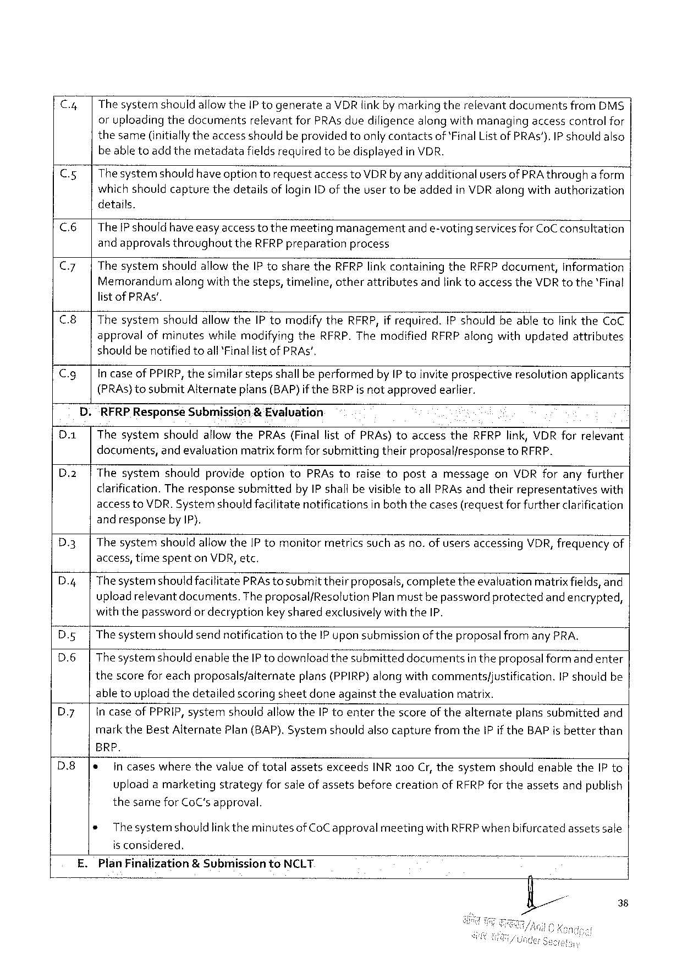

|  |  |  |  |  |  |
| --- | --- | --- | --- | --- | --- |
| Cy  Cxs | Thesystemshouldallowthe IP togenerate | | a VDR linkby markingtherelevantdocuments | | from DMS$ |
| oruploadingthedocuments | relevantfor PRA s duediligencealongwithmanaging | | accesscontrolfor | |
| thesame(initiallytheaccess shouldbeprovided toonly contactsof‘Final List of PRA s'). IP shouldalso beabletoadd themetadatafieldsrequiredtobedisplayedin VDR.  Thesystemshould have optiontorequestaccessto VDR by anyadditionalusersof PRA througha form which shouldcapturethedetailsoflogin ID of theusertobeaddedin VDR alongwithauthorization | | | | |

details.

|  |  |
| --- | --- |
| c 6  Cy  c 8 | The IP should haveeasyaccessto themeetingmanagementand e-votingservicesfor Co Cconsultation and approvals throughoutthe RFRP preparationprocess  Thesystemshouldallowthe IP tosharethe RFRP linkcontainingthe RFRP document, Information Memorandumalongwiththesteps, timeline, otherattributesandlinktoaccessthe VDR to the'Final listof PRAS’.  Thesystemshouldallow the IP tomodify the RFRP, if required. IP shouldbeabletolinkthe Co C |

approvalofminuteswhilemodifyingthe RFRP. Themodified RFRP alongwithupdatedattributes shouldbenotified toall*Finallistof PRAS’,

|  |  |  |
| --- | --- | --- |
| Cg | . | in caseof PPIRP, thesimilarstepsshallbe performedby IP toinvite prospectiveresolutionapplicants |
| (PRA s)tosubmit Alternateplans(BAP)if the BRP is not approvedearlier. |
| “RFRP Response Submission& Evaluation |

Thesystemshouldaflow the PRA s(Finallistof PRA s)toaccessthe RFRP link, VDR forrelevant documents, and evaluationmatrixform forsubmittingtheirproposaliresponseto RFRP.

Thesystemshouldprovideoptionto PRA storaisetopostamessageon VDR foranyfurther clarification. Theresponsesubmittedby IP shall bevisibletoall PRA sandtheirrepresentativeswith access to VDR. Systemshould facilitatenotificationsin boththecases(requestfor furtherclarification and responseby IP),

|  |  |  |  |  |  |
| --- | --- | --- | --- | --- | --- |
| D 3 | Thesystem | shouldallowthe IP tomonitor | metricssuchasno. ofusersaccessing | VDR, frequency | of |

access, timespenton VDR, etc.

|  |  |
| --- | --- |
| D.4 | Thesystemshouldfacilitate PRA stosubmittheirproposals, compietetheevaluationmatrixfields, and uploadrelevantdocuments. Theproposalf Resolution Planmustbe passwordprotectedand encrypted, |

withthepasswordor decryptionkeysharedexclusivelywith the IP.

D. g Thesystemshould sendnotificationtothe IP uponsubmissionofthe proposalfrom any PRA.

D.6 Thesystemshould enablethe IP to downloadthesubmitteddocumentsin theproposal form and enter

thescorefor eachproposalsfalternateplans (PPIRP)alongwithcommentsfjustification. IP shouldbe

abletouploadthedetailedscoringsheetdoneagainsttheevaluation matrix.

D. y Incase of PPRIP, systemshouldallowthe IP toenterthescoreof thealternateplanssubmittedand

mark the Best Alternate Plan (BAP). Systemshouldalsocapturefromthe IP ifthe BAP isbetterthan

BRP.

|  |  |  |
| --- | --- | --- |
| D.8 | * | in caseswherethevalue oftotalassetsexceeds INR 100 Cr, thesystemshouldenablethe IP to |

uploadamarketingstrategyforsale ofassetsbeforecreationof RFRP for theassetsandpublish

thesamefor Co C'sapproval.

® The systemshould linkthe minutesof Co C approvalmeetingwith RFRP whenbifurcatedassetssale

is considered.

£. Plan Finalization& Submissionto NCLT

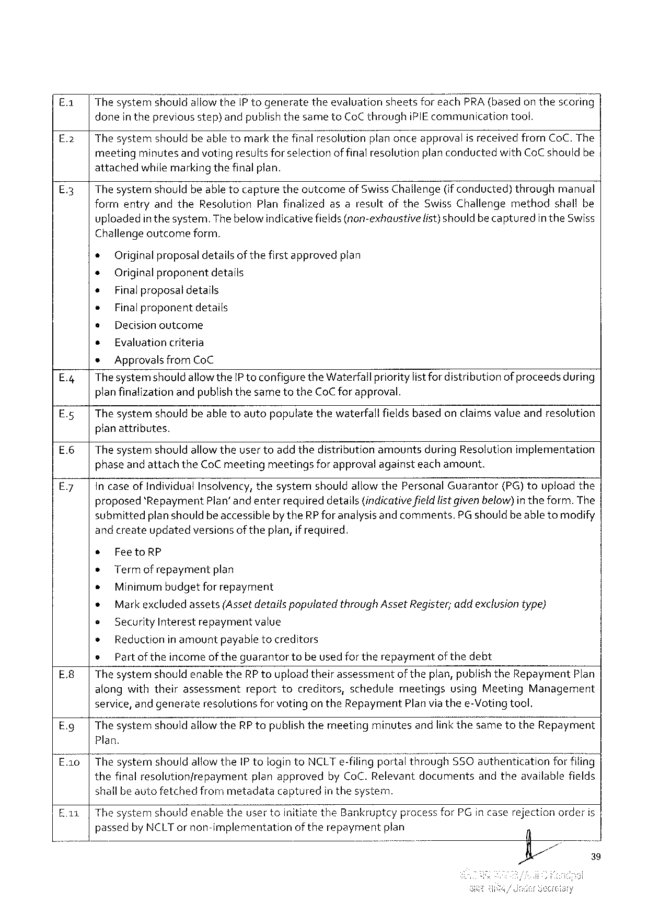

|  |  |  |  |  |  |  |
| --- | --- | --- | --- | --- | --- | --- |
| £.1 | Thesystemshouldallowthe IP togenerate | theevaluation | sheetsforeach PRA(basedonthescoring | | | |
| E.2 | doneinthepreviousstep)andpublishthesameto Co Cthrough | | | i PIE communication | | tool. |
| Thesystemshouldbeabletomarkthefinalresolutio—r\"E! anonceapproval | | | | is receivedfrom Co C. The | |

meetingminutesand voting resultsforselectionof finalresolutionplanconductedwith Co C shouldbe attachedwhilemarkingthefinalplan.

E.3| Thesystemshouldbeable tocapturetheocutcomeof Swiss Challenge(ifconducted)throughmanual formentryandthe Resolution Planfinalizedasaresultofthe Swiss Challengemethodshallbe

uploadedin the system. Thebelowindicativefields(non-exhaustive

Challengeoutcome form.

* Originalproposaldetailsof thefirst approvedplan

+ Original proponentdetails

+ Final proposal details

e Finalproponent details

s Decisionoutcome

s Evaluationcriteria

* Approvalsfrom Co C

list) should becapturedin the Swiss

|  |  |  |
| --- | --- | --- |
| E.4| | Thesystemshould | allowthe IP toconfigurethe Waterfallprioritylistfordistributionof proceedsduring |

planfinalization andpublishthesametothe Co Cfor approval.

E.5|Thesystemshouldbeabletoautopopulatethewaterfall fieldsbasedon claimsvalue andresolution

planattributes.

E.6|Thesystemshouldallowtheusertoadd thedistributionamountsduring Resolutionimplementation

phaseand attachthe Co C meetingmeetingsforapprovalagainsteachamount.

E.7| In caseof Individual Insolvency, thesystemshouldallow the Personal Guarantor(PG)touploadthe

proposed‘Repayment Plan’ andenter requireddetails(indicativefieldlistgiven below)intheform. The

submittedplanshouldbeaccessibleby the RP foranalysisand comments. PG shouldbe abletomodify

and createupdatedversions of theplan, if required.

s Feeto RP

» Term of repaymentplan

e Minimumbudgetfor repayment

* Markexcluded assets(Assetdetails populatedthrough Asset Register; addexclusiontype)

e Security Interest repayment value

* Reductionin amountpayabletocreditors

o Partoftheincomeof theguarantortobeused fortherepaymentofthedebt

E.8| Thesystemshouldenablethe RP toupload theirassessmentoftheplan, publishthe Repayment Plan

alongwiththeirassessment reporttocreditors, schedulemeetingsusing Meeting Management

service, andgenerateresolutionsforvotingon the Repayment Planvia thee-Votingtool.

E. g| Thesystemshouldallowthe RP topublishthemeetingminutesandlinkthesametothe Repayrment

Plan.

E. a 0|Thesystemshouldallowthe IP tologinto NCLT e-filingporté’\ through SSO authenticationfor fi! ing’

|  |  |  |  |
| --- | --- | --- | --- |
| thefinalresolutionfrepayment | planapproved | by Co C. Relevantdocuments | andtheavailablefields |

shallbeautofetchedfrommetadatacapturedin thesystem.

E.1 |Thesystemshouldenabletheusertoinitiatethe Bankruptcy processfor PG incaserejectionorderis

passedby NCLT ornon-implementation oftherepayment plan

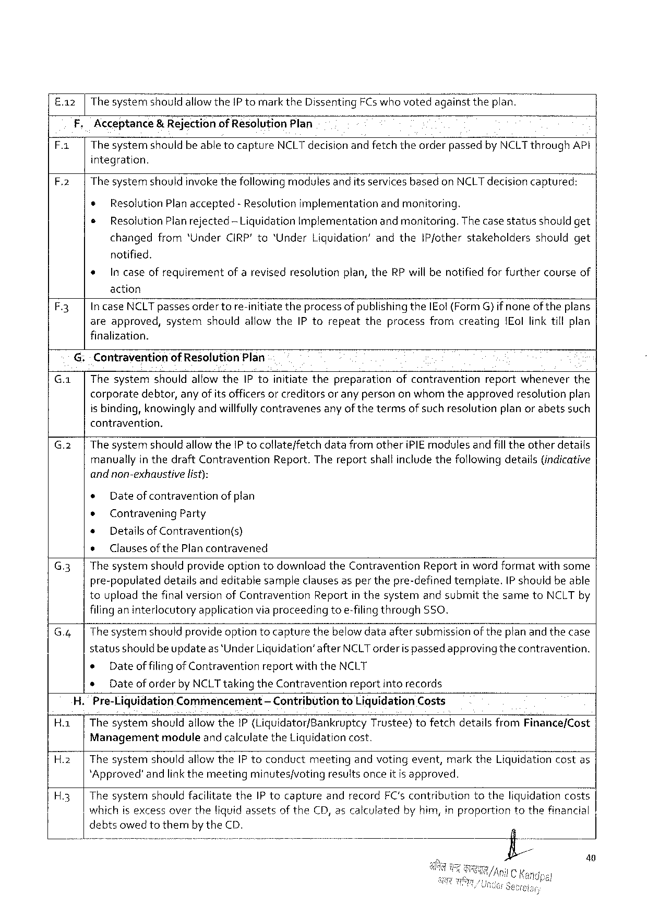

E. a 2 |The systemshould allowthe IP tomarkthe Dissenting FC s whovotedagainsttheplan.

F, Acceptance& Rejectionof Resolution Plan

|  |  |  |
| --- | --- | --- |
| F.1 | Thesystemshouldbeabletocapture | NCLT decisionandfetchtheorderpassedby NCLT through API |

integration.

F.2| The systemshouldinvokethefollowingmodulesanditsservices basedon NCLT decisioncaptured:

¢ Resolution Planaccepted- Resolutionimplementationandmonitoring.

¢ Resolution Planrejected-Liquidation Implementation andmonitoring. Thecasestatusshouldget

changedfrom‘Under CIRP'to“Under Liquidation’ and the IP/otherstakeholdersshouldget

notified.

* Incaseofrequirementof arevisedresolutionplan, the RP willbenotifiedforfurthercourseof

action

F 3 Incase NCLT passesordertore-initiate theprocessofpublishingthe IE ol(Form G} ifnoneof theplans

areapproved, system should allowthe IP torepeat theprocess fromcreating IE ollinktillplan

finalization.

G:- Contraventionof Resolution Plan

G. a| Thesystemshouldallowthe IP toinitiatethepreparationofcontraventionreportwheneverthe

corporate debtor, anyofitsofficersorcreditors oranypersononwhomtheapproved resolution plan

is binding, knowinglyandwillfullycontravenesany ofthetermsof suchresolutionplan or abetssuch

contravention.

|  |  |  |  |
| --- | --- | --- | --- |
| G.2 | | | Thesystem | shouldallowthe IP tocollate/fetch | datafromotheri PIE modulesandfill theotherdetails |

manuallyin thedraft Contravention Report. Thereportshall includethefollowing details(indicative

andnon-exhaustive list):

« Dateof contraventionof plan

¢ Contravening Party

e Detailsof Contravention(s)

e Clausesof the Plancontravened

G.3| Thesystemshouldprovideoptiontodownloadthe Contravention Reportin wordformatwithsome

pre-populateddetailsandeditablesampleclauses asper thepre-definedtemplate. IP shouldbeable

touploadthefinalversionof Contravention Reportin thesystemand submitthesameto NCLT by

filinganinterlocutory application viaproceeding toe-filingthrough SSO.

G.4| Thesystemshouldprovide optiontocapturethebelowdataaftersubmissionof theplan and thecase

statusshould beupdateas*Under Liquidation’after NCLT orderispassedapprovingthecontravention.

e Dateof filingof Contraventionreportwiththe NCLT

* Dateof orderby NCLT takingthe Contraventionreportinto records

H. Pre-Liquidation Commencement — Contributionto Liquidation Costs

Ha | Thesystemshouldallowthei P (Liquidator/Bankruptcy Trustee)tofetchdetailsfrom Finance/Cost

Management module andcalculatethe Liquidationcost.

H.2| Thesystem shouldallowthe IP toconduct meeting andvotingevent, markthe Liquidationcostas

*Approved’andlinkthemeetingminutes/voting resultsonceitis approved.

H.3| Thesystemshouldfacilitatethe IP tocaptureandrecord FC'scontributiontotheliquidationcosts

whichisexcessovertheliquidassetsof the CD, ascalculatedby him, in proportiontothefinancial

debtsowedtothembythe CD.

40

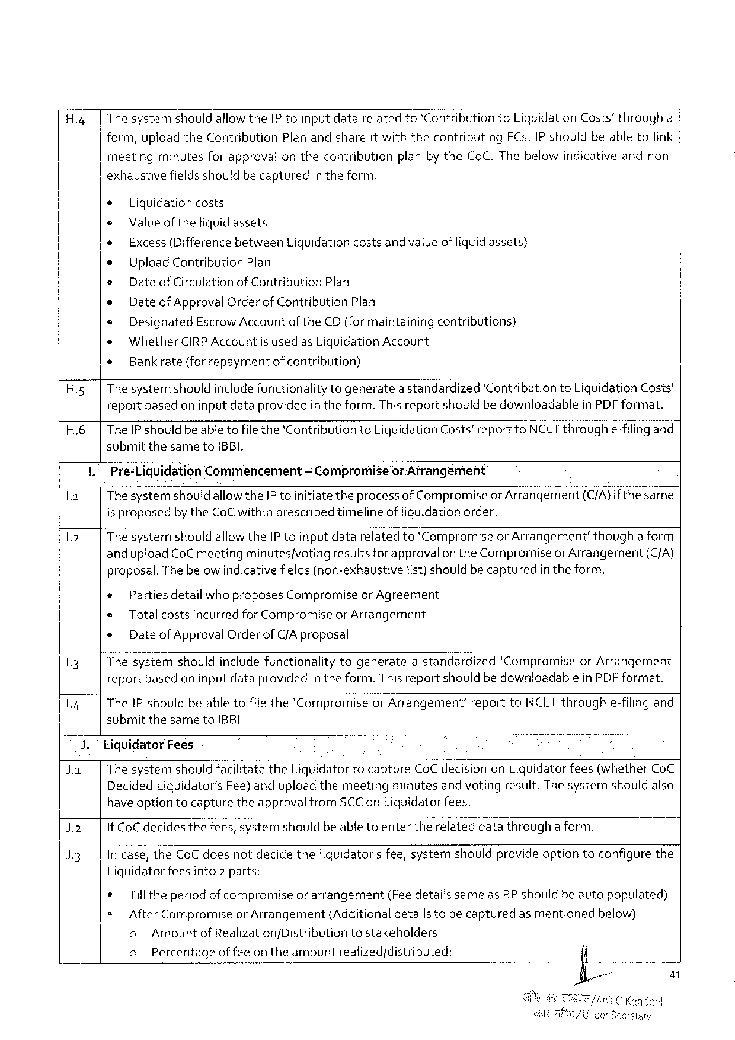

H.4| The systemshouldallowthe IP toinputdatarelatedto‘Contribution to Liquidation Costs’througha

form, uploadthe Contribution Planandshareit withthecontributing FC s. IP shouldbeabletolink

meeting minutesforapproval onthecontribution planbythe Co C. Thebelowindicativeandnon-

exhaustive fieldsshouldbecaptured intheform.

e Liquidationcosts

e Valueof theliquidassets

* Excess(Differencebetween Liquidationcostsandvalueof liquidassets)

s Upload Contribution Plan

» Date of Circulationof Contribution Plan

e Dateof Approval Orderof Contribution Plan

e Designated Escrow Accountof the CD(formaintaining contributions)

o Whether CIRPA ccountis usedas Liquidation Account

« Bankrate(for repaymentofcontribution)

H.5| Thesystemshouldincludefunctionality togeneratea standardized'Contribution to Liquidation Costs'

reportbasedon inputdataprovidedin theform. This reportshouldbe downloadablein PDF format.

H.6|The Pshouldbeable to filethe‘Contributionto Liquidation Costs’reportto NCLT throughe-filingand

submit thesameto IBBI.

I.-Pre-Liquidation Commencement — Compromiseor Arrangement

la Thesystemshould allowthe IP toinitiatetheprocessof Compromiseor Arrangement(C/A}if thesame

is proposedby the Co Cwithinprescribed timelineof liquidationorder.

1.2 Thesystemshouldallowthe IP toinputdatarelatedto*Compromiseor Arrangement’thougha form

andupload Co Cmeetingminutes/votingresultsforapprovalon the Compromiseor Arrangement(C/A)

proposal. The below indicativefields(non-exhaustivetist)should becapturedin theform.

|  |  |  |  |
| --- | --- | --- | --- |
| 13  L 4 | * | | Parties detailwho proposes Compromiseor Agreement |
| e | Total costsincurredfor Compromiseor Arrangement | |
| e | Dateof Approval Orderof C/Aproposal | |
| Thesystemshouldinclude functionalitytogenerateastandardized'Compromiseor Arrangement' reportbasedon inputdataprovidedin the form. Thisreportshouldbedownloadablein PDF format.  The IP shouldbeabletofilethe*Compromiseor Arrangement’reportto NCLT throughe-filingand | | |

submitthesameto IBBI.

|  |  |  |  |  |
| --- | --- | --- | --- | --- |
| Ja | 3. | Liquidator Fees | | |
| The systemshould facilitatethe Liquidatortocapture Co Cdecisionon Liquidatorfees(whether Co C | | |
| Decided Liguidator’s Fee)anduploadthemeeting | minutes | andvotingresult. Thesystemshouldalso |

have optiontocapturetheapprovalfrom SCC on Liguidatorfees.

)2 If Co Cdecidesthefees, systemshouldbeable toentertherelateddatathroughaform.

13 In case, the Co Cdoesnotdecidetheliquidator'sfee, systemshouldprovideoptiontoconfigurethe

Liguidatorfeesinto 2 parts:

* Tilltheperiod of compromiseor arrangement(Feedetailssameas RP shouldbeautopopulated)

= After Compromiseor Arrangement(Additionaldetailstobecapturedas mentionedbelow)

o Amountof Realization/Distribution tostakeholders

o Percentageoffee ontheamountrealized/distributed:

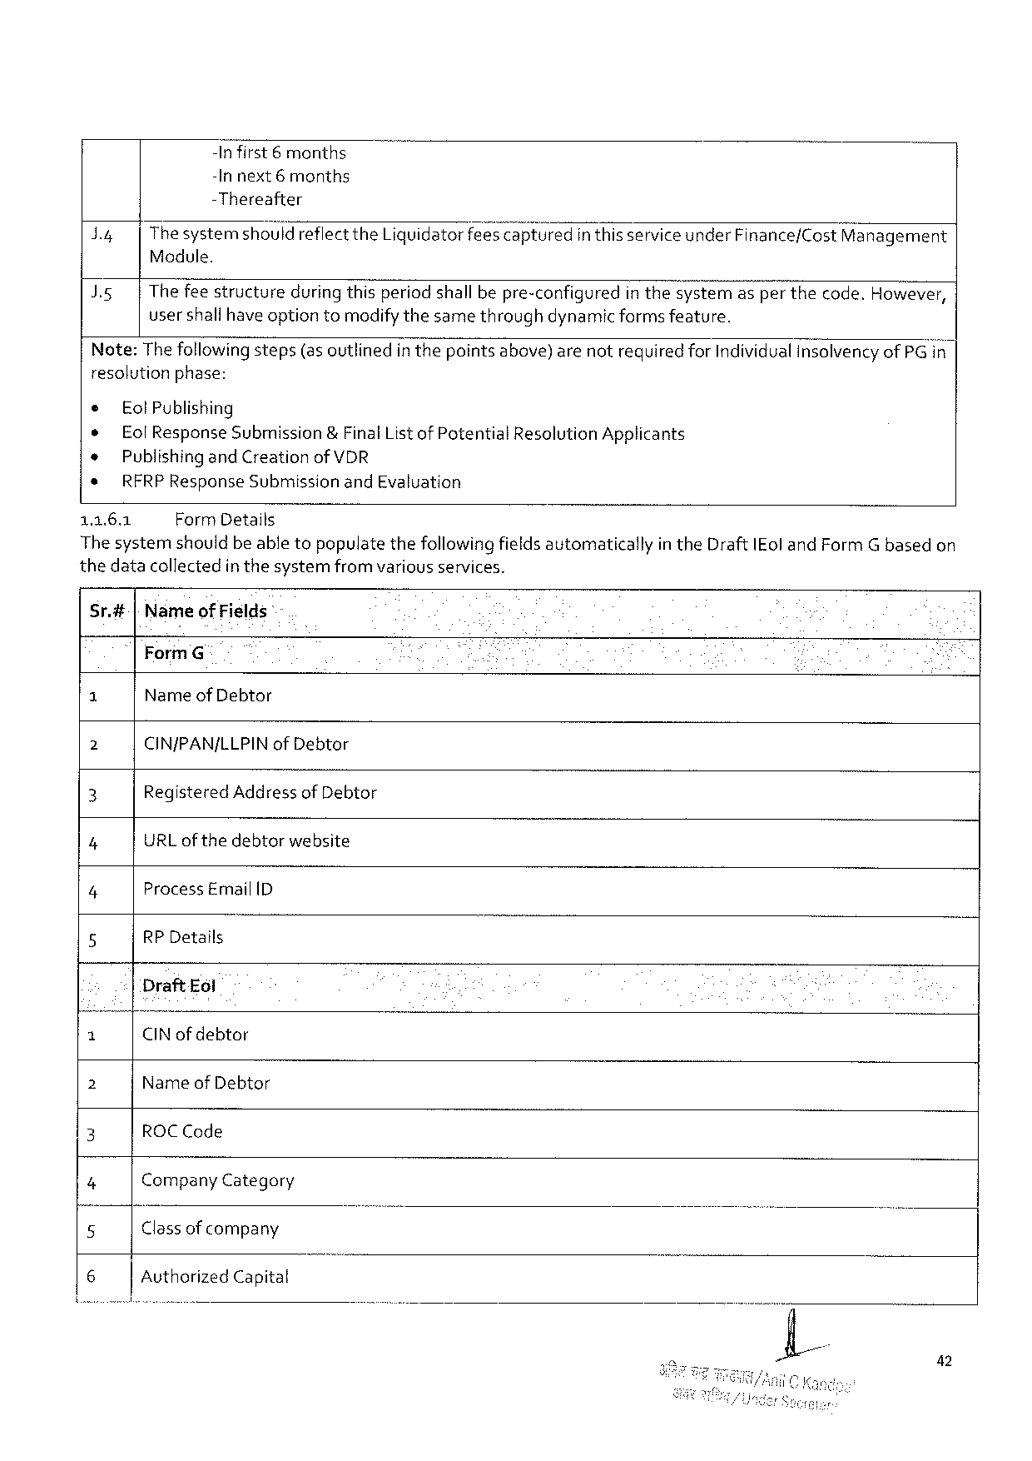

-Infirst 6 months

-In next 6 months

-Thereafter

|  |  |  |
| --- | --- | --- |
| d 4  IR | Thesystemshouldreflectthe Liquidatorfeesca;; tured | in thisserviceunder Finance/Cost Management |
| Module.  Thefeestructureduring thisperiodshall bepre-configuredin thes? stemasper thecode. However, usershallhave optiontomodifythesamethroughdynamic formsfeature. | |

resolutionphase:

|  |  |
| --- | --- |
| e ® *  *  1162 | Eol Publishing  Eol Response Submission&Final List of Potential Resolution Applicants Publishingand Creation of VDR  RFRP Response Submissionand Evaluation  Form Details |

The systemshouldbe abletopopulatethefollowingfieldsautomaticallyin the Draft IE oland Form Gbasedon

thedatacollectedin thesystemfrom variousservices.

Sr.#[Nameof Fields -

Form G

G Name of Debtor

2 CIN/PAN/LLPIN of Debtor

3 Registered Addressof Debtor

7 URL of thedebtorwebsite

4 Process Email ID

5 RP Details

Draft Eol

|  |  |  |  |
| --- | --- | --- | --- |
| 3 | CIN of debtor | - | ) |
| 2 | Name of Debtor |
| 3 |
| ROCC ode |
| 4 |
| Company Category |
| 5 | Classof company |
| 6 |
| Authorized Capital |

42

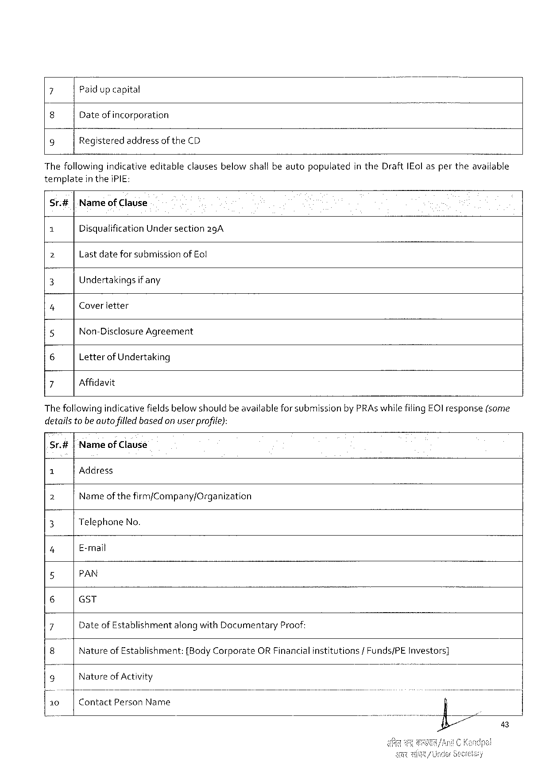

7 Paidup capital

8 Dateof incorporation

9 Registeredaddressof the CD

Thefollowing indicativeeditableclausesbelowshallbeavtopopulatedin the Draft IE ol asper theavailable

templatein thei PIE:

Sr.#|Nameof Clause

1 Disqualification Undersection 2 g A

b Lastdatefor submissionof Eol

3 Undertakings ifany

4 Coverletter

5 Non-Disclosure Agreement

6 Letterof Undertaking

7 Affidavit

Thefollowingindicativefieldsbelow shouldbe availableforsubmissionby PRA swhilefiling EC) response(some

detailsto beauto filled based on userprofite):

Sr.#|Nameof Clause

|  |  |  |  |  |  |  |  |  |  |
| --- | --- | --- | --- | --- | --- | --- | --- | --- | --- |
| 1 | Address | | | | | | institutions | /Funds/PE | Investors] |
| Name | of the | firm/Company/Organization | | | |
| 2 |
| 3 | Telephone No. | | | | | |
| 4 | E-mail | | | | | |
| 5 | PAN | | | | | |
| 6 | GST | | | | | |
| 7 | Dateof Establishment | | | alongwith Documentary | | Proof: |
| 8 | Nature | of Establishment: | | {Body Corporate | ORF inancial | |
| 9 | Natureof Activity | | | | | |
| 10 | Contact Person Name | | | | | |

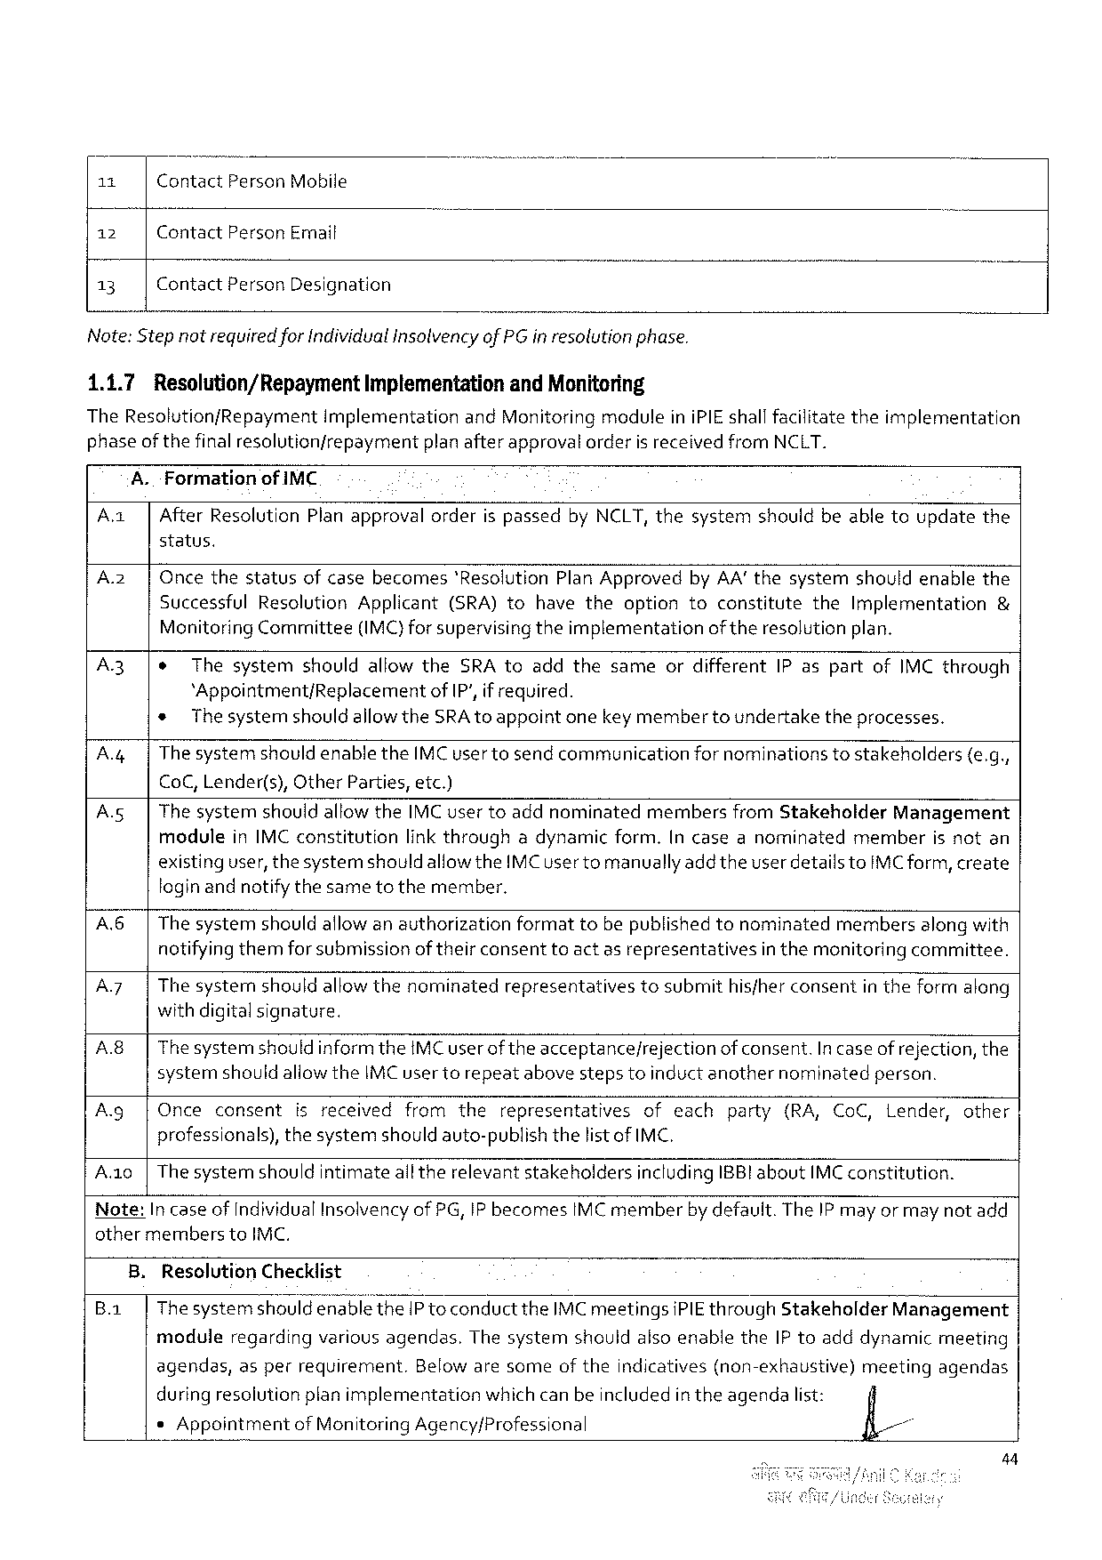

|  |  |  |
| --- | --- | --- |
| 11 | Contact Person Mobile | o |
| 12 | Contact Person Email |
| 13 | Contact Person Designation |

Note: Step notrequiredfor Individualinsolvencyof PG inresolutionphase.

1.1.7 Resolution/Repayment Implementationand Monitoring

The Resolution/Repaymentimplementationand Monitoring moduleini PIE shallfacilitatetheimplementation

|  |  |  |  |
| --- | --- | --- | --- |
| phase | of the | finalresolutionfrepayment | planafterapprovatorderisreceivedfrom NCLT. |

A. Formationof IMC

Az After Resolution Planapprovalorderis passedby NCLT, thesystemshouldbeabletoupdatethe

status.

Az Oncethestatusofcasebecomes'Resolution Plan Approvedby AA’thesystemshouldenablethe Successful Resolution Applicant(SRA)tohavetheoptiontoconstitutethe Implementation & Menitoring Committee(IMC)forsupervisingtheimplementationofthe resolutionplan.

|  |  |  |  |  |  |
| --- | --- | --- | --- | --- | --- |
| A 3  A | e | Thesystemshouldallowthe SRA toaddthesameordifferent IP aspartof IMC through | | | |
| *Appointment/Replacementof IP', if required. | | | | |
| * | The systemshouldallowthe SRA toappointonekeymembertoundertaketheprocesses. | | | |
| Thesystemshouldenablethe IMC usertosendcommunication | | fornominations | tostakeholders | {e. g., |

Co C, Lender(s), Other Parties, etc.)

|  |  |  |  |
| --- | --- | --- | --- |
| As | Thesystemshouldallowthe IMC usertoaddnominatedmembersfrom Stakeholder | | Management |
| modulein IMC constitution | linkthroughadynamicform.[n caseanominatedmemberis notan | |

existinguser, thesystemshould allowthe IMC user tomanuallyaddtheuser detailsto IMC form, create foginandnotifythesametothemember.

Ab Thesystemshould allowanauthorizationformattobepublishedtonominatedmembersalongwith notifying themforsubmissionof theirconsenttoact asrepresentativesin themonitoringcommittee.

A 7 Thesysternshouldallowthenominatedrepresentativestosubmithisfherconsentin theformalong withdigitalsignature.

|  |  |  |  |  |  |  |
| --- | --- | --- | --- | --- | --- | --- |
| A 8  Ag  Ao | Thesystemshould informthe IMC userofthe acceptance/rejectionofconsent. In caseofrejection, the systemshouldallowthe IMC usertorepeatabovestepstoinductanothernominatedperson. | | | | | |
| Once | consent | isreceivedfromthe | representatives | ofeach | party(RA, Co C, Lender, other |
| professionals), thesystemshouldauto-publishthelistof IMC,  The systemshouldintimateall therelevantstakeholdersincluding IBB! about IMC constitution. | | | | | |

Note: In caseof Individual Insolvencyof PG, IP becomes IMC memberby default. The IP may or may notadd other membersto IMC.

B. Resolution Checklist

B. a Thesystemshould enablethe IP to conductthe IMC meetingsi PIE through Stakeholder Management

moduleregardingvariousagendas. Thesystemshouldalsoenablethe IP toadddynamicmeeting

|  |  |  |  |  |  |
| --- | --- | --- | --- | --- | --- |
| agendas, | asperrequirement. | Belowaresomeoftheindicatives | (non-exhaustive) | meeting | agendas |

during resolutionplan implementationwhichcanbeincluded in theagendalist:

s Appointmentof Monitoring Agency/Professional fl//

44

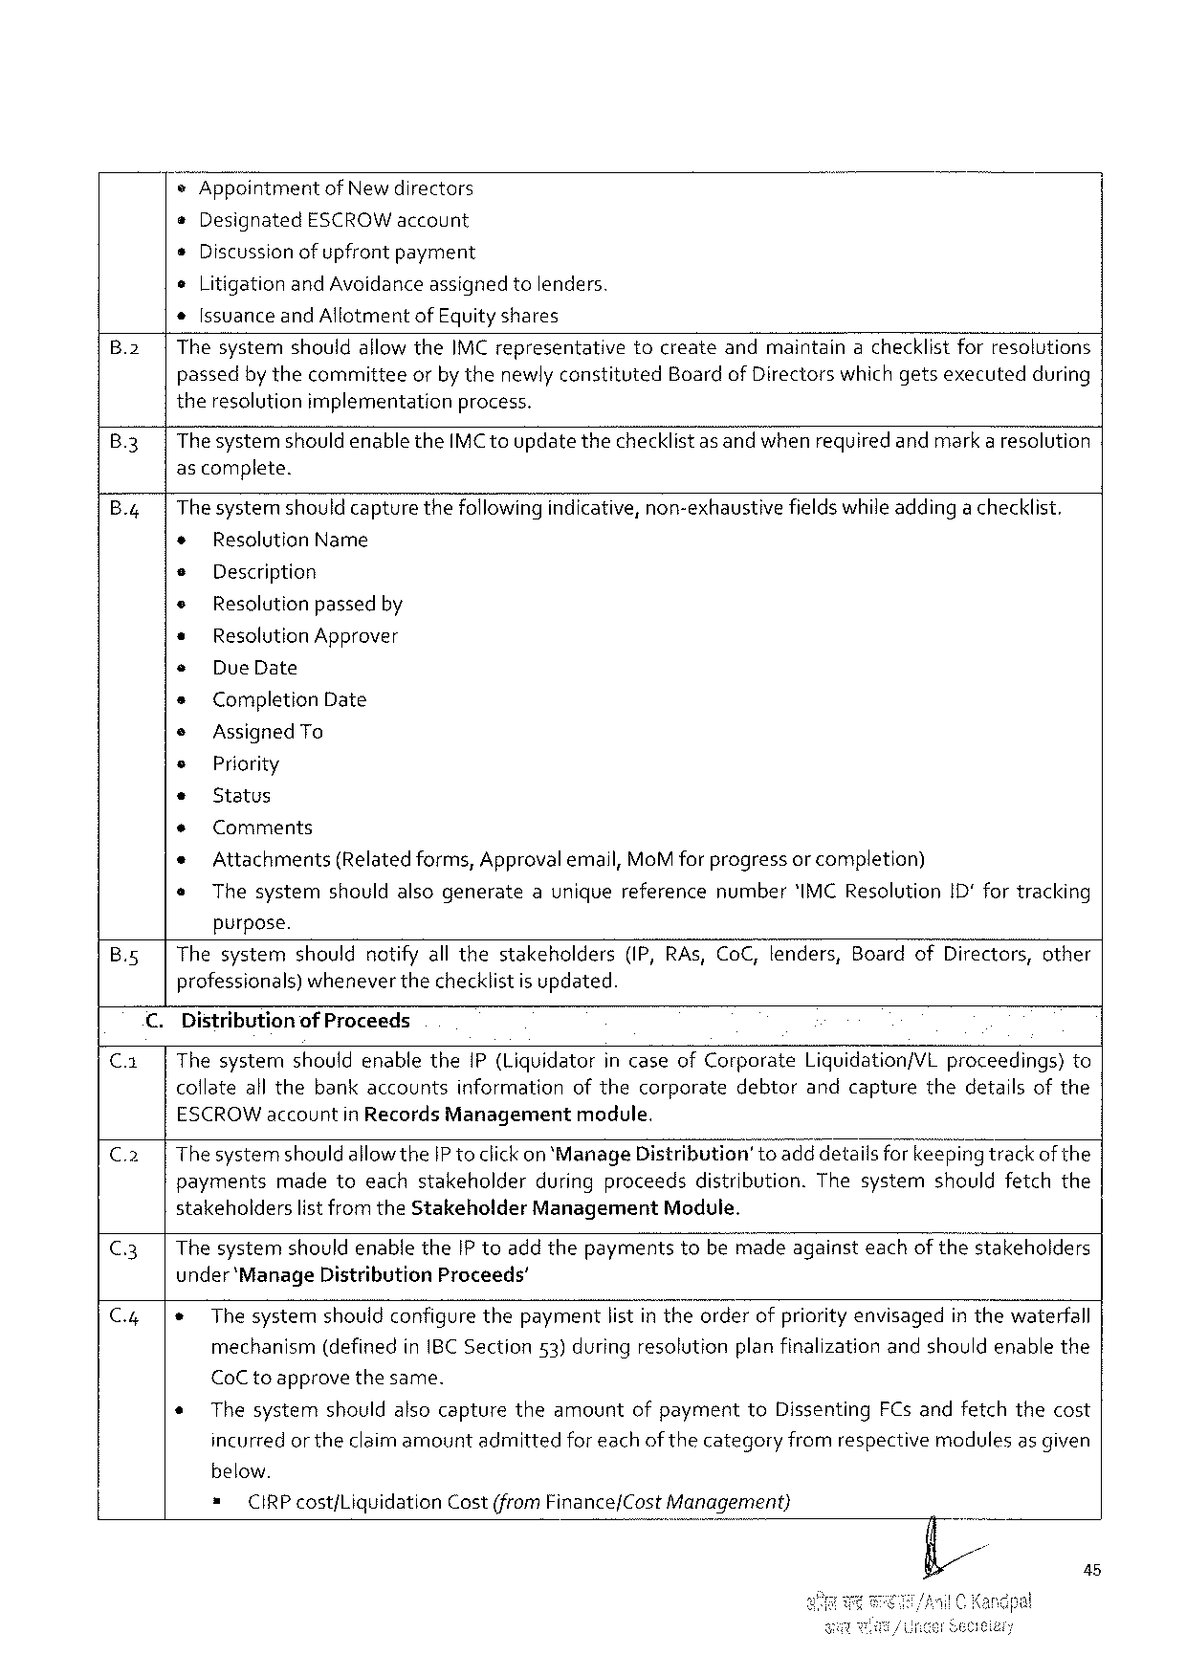

*Appointment of Newdirectors

e Designated ESCROW account

s Discussionofupfrontpayment

o Litigationand Avoidanceassignedtolenders.

*[ssuanceand Allotmentof Equityshares

B.2| Thesystemshouldallowthe IMC representativetocreateandmaintainachecklistforresolutions

passedbythecommitteeorby thenewlyconstituted Board of Directors which getsexecutedduring

theresolutionimplementationprocess.

|  |  |  |  |
| --- | --- | --- | --- |
| B.3| | Thesystem | shouldenablethe | IMC toupdatethechecklistasandwhenrequiredandmarkaresolution |

ascomplete.

B.4|Thesystemshould capturethefollowingindicative, non-exhaustivefieldswhileaddingachecklist.

* Resolution Name

e Description

e Resolution passedby

* Resolution Approver

« Due Date

s Completion Date

e Assigned To

¢ Priority

* Status

+ Comments

* Attachments(Relatedforms, Approvalemail, Mo M for progressor completion)

s Thesystemshouldalsogenerateauniquereferencenumber'IMCR esolution 1 D fortracking

purpose.

B.5| Thesystemshouldnotifyall thestakeholders(IP, RA s, Co C, tenders, Boardof Directors, other

professionals)whenever thechecklistis updated.

C. Distributionof Proceeds

C.1| Thesystermshouldenablethe 1 P(Liquidatorincaseof Corporate Liquidation/VL proceedings)to

collateall thebankaccountsinformationofthecorporatedebtorandcapturethedetailsofthe

ESCROW accountin Records Managementmodule.

C.2| The systemshould allowthe IP toclick on‘Manage Distribution’toadd detailsforkeepingtrackof the

paymentsmadetoeachstakeholderduringproceedsdistribution. Thesystemshouldfetchthe

stakeholderslist from the Stakeholder Management Module.

C.3| Thesystemshouldenablethe[P toaddthepaymentstobemadeagainsteachof thestakeholders

under‘Manage Distribution Proceeds’

|  |  |  |  |  |  |
| --- | --- | --- | --- | --- | --- |
| C.4 | |+ | Thesystemshouldconfigurethepaymentlist in theorderofpriority envisagedin thewaterfall | | | |
| mechanism | (definedin IBCS ection | 53)duringresolution | planfinalizationandshouldenablethe |

Co C toapprovethesame.

* Thesystemshouldalsocapturetheamountofpaymentto Dissenting FC sandfetchthecost

incurredor the claimamountadmittedforeachof thecategoryfromrespectivemodulesas given

below.

|  |  |  |  |
| --- | --- | --- | --- |
| = | CIRP costf Liquidation | Cost(from Finance/Cost | Management) |

45

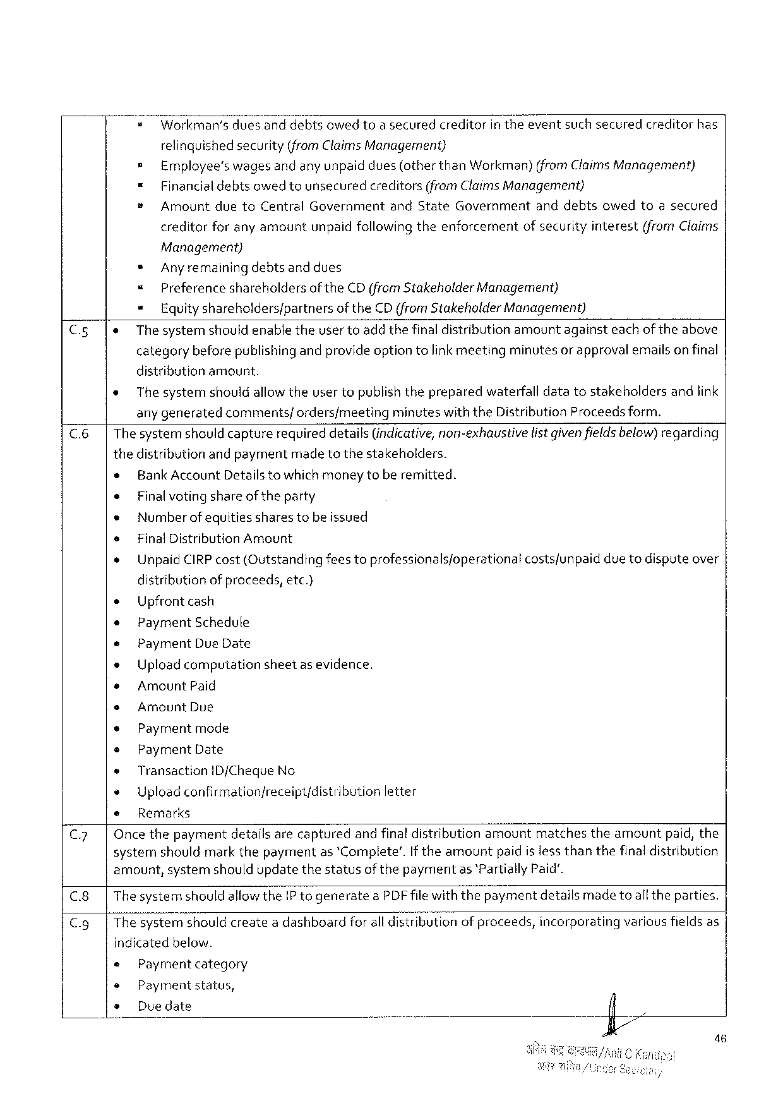

|  |  |  |  |
| --- | --- | --- | --- |
| = | Workman's | duesanddebtsowedtoasecuredcreditorintheeventsuchsecured | creditorhas |

relinquished security(from Claims Management)

= Employee’swagesandanyunpaiddues(otherthan Workman)(from Claims Management)

= Financialdebtsowed tounsecuredcreditors(from Claims Management)

s Amountdueto Central Governmentand State Governmentanddebtsowedtoasecured

creditorforanyamountunpaidfollowing theenforcementof securityinterest(from Claims

Management)

* Anyremainingdebtsanddues

= Preferenceshareholdersof the CD(from Stakeholder Management)

= Equityshareholders/partners of the CD (from Stakeholder Management)

C.5|e The systemshouldenabletheuser toadd thefinaldistributionamountagainsteachoftheabove

categorybeforepublishingandprovideoption tolink meetingminutesor approvalemailson final

distributionamount.

e The systemshouldallowtheusertopublishthepreparedwaterfalldatatostakeholdersandlink

any generatedcomments/ordersfmeetingminuteswiththe Distribution Proceedsform.

C.6|Thesystemshould capturerequireddetails(indicative, non-exhaustive listgivenfieldsbelow)regarding

thedistributionandpaymentmade tothestakeholders.

* Bank Account Detailstowhichmoneytoberemitted.

e Finalvoting shareoftheparty

* Numberofequitiessharestobeissued

s Final Distribution Amount

e Unpaid CIRP cost(Qutstandingfeestoprofessionalsjoperationalcostsfunpaiddue todisputeover

distribution ofproceeds, etc.}

e Upfront cash

e Payment Schedule

e Payment Due Date

e Uploadcomputationsheetasevidence.

* Amount Paid

s Amount Due

* Paymentmode

e Payment Date

® Transaction ID/Cheque No

+ Upload confirmationjreceipt/distribution letter

e Remarks

C.7| Oncethepaymentdetailsarecapturedandfinal distributionamountmatchestheamountpaid, the

systemshouldmarkthepaymentas ‘Complete’. If theamountpaidislessthanthefinaldistribution

amount, systemshouldupdatethestatusof thepaymentas *Partially Paid’.

C.8|Thesystemshouldallowthe IP togeneratea PDF filewiththepaymentdetailsmade toall theparties.

C. g|Thesystemshouldcreatea dashboardforall distributionof proceeds, incorporatingvariousfieldsas

indicatedbelow.

Paymentcategory

Paymentstatus,

Duedate

46

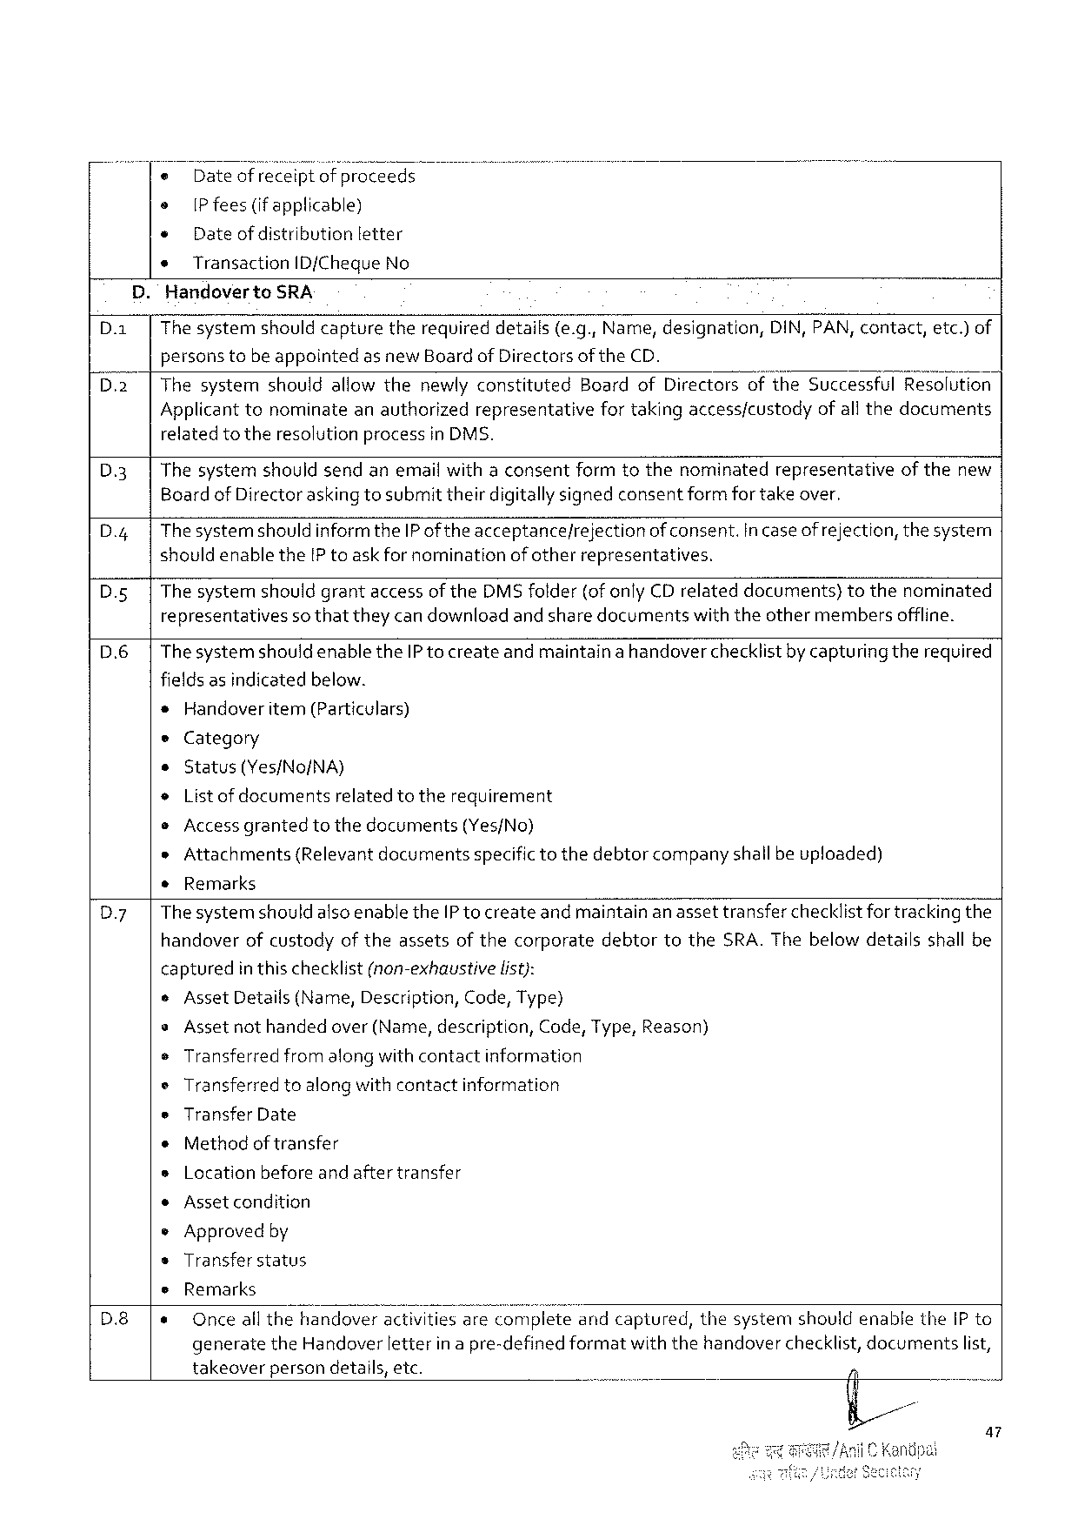

o Dateof receiptofproceeds

o [P fees(ifapplicable)

¢ Dateof distribution letter

* Transaction ID/Cheque No

. Handoverto SRA

|  |  |  |  |  |
| --- | --- | --- | --- | --- |
| D. a | Thesystemshouldcapture | therequireddetails(e. g., Name, designation, | DIN, PAN, contact, | etc.)of |

personstobeappointedas new Boardof Directorsof the CD.

Thesystemshouldallowthenewlyconstituted Boardof Directorsofthe Successful Resolution

Applicant tonominateanauthorizedrepresentativefortakingaccessfcustodyofall thedocuments

relatedtotheresolutionprocessin DMS.

|  |  |  |  |
| --- | --- | --- | --- |
| D 3  D.4  D. s | Thesystemshouldsendanemailwithaconsentformtothenominatedrepresentativeof thenew Boardof Directoraskingtosubmittheirdigitallysignedconsentformfor takeover. | | |
| Thesystemshould informthe IP of theacceptance/rejection | | of consent. incaseof rejection, thesystem |
| shouldenablethe[P toaskfornomination | ofotherrepresentatives. | |
| The systemshouldgrantaccessofthe DMS folder(ofonly CD relateddocuments)tothenominated | | |

representativesso thattheycan downloadand sharedocumentswiththeothermembersoffline.

D.6 Thesystemshould enablethe IP to createandmaintainahandoverchecklistby capturingtherequired

fieldsas indicatedbelow.

=Handoveritem(Particulars)

e Category

o Status(Yes/No/NA)

o List ofdocuments relatedtotherequirement

e Accessgranted tothedocuments (Yes/No)

»Attachments(Relevant documentsspecifictothedebtorcompanyshallbe uploaded)

*Remarks

Dy Thesystemshouldalsoenablethe IP tocreateand maintainan assettransferchecklistfortracking the

handoverofcustodyof theassetsof thecorporatedebtortothe SRA. Thebelowdetailsshall be

|  |  |  |
| --- | --- | --- |
| captured | inthischecklist(non-exhaustive | list): |

¢Asset Details(Name, Description, Code, Type)

s Assetnothandedover(Name, description, Code, Type, Reason)

e Transferred fromalongwithcontact information

o Transferredtoalongwith contactinformation

e Transfer Date

¢Methodof transfer

s Location beforeand aftertransfer

¢Assetcondition

e Approvedby

s Transfer status

|  |  |  |  |  |  |
| --- | --- | --- | --- | --- | --- |
| D.8 | e | Remarks | | | |
| Onceall thehandoveractivitiesare Lo; vplwetueandcaptured, thesystemshouldenablethe IP to | | | |
| generate | the Handoverletterinapre-definedformat | withthehandoverchecklist, documents | list, |

takeoverpersondetails, etc.

a 7

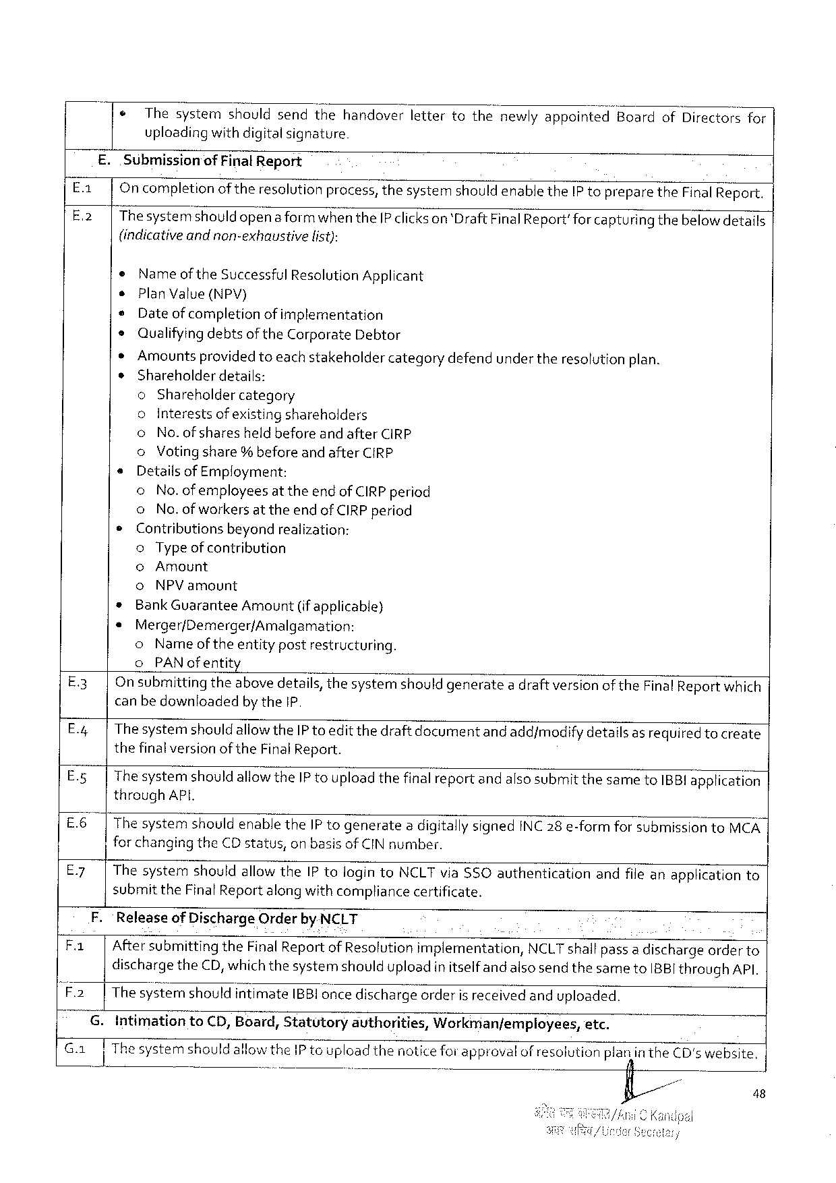

|  |  |  |
| --- | --- | --- |
| ¢ | Thesystemshouldsendthehandoverlettertothenewlyappointed“Board | of Directorsfor |
| uploadingwithdigitalsignature |

E. Submissionof Final Report

|  |  |  |  |  |
| --- | --- | --- | --- | --- |
| Ex  E-2 | Oncompletionof theresolutionpracess, thesystemshould enablethe IP topreparethe Final Report. Thesystemshouldopenaformwhen the IP clickson ‘Draft Final Report'forcapturingthebelowdetails | | | |
| (indicative | | andnon-exhaustive | list): |
| e | Nameof the Successful Resolution Applicant | | |
| s | Plan Value(NPV) | | |
| * | Dateof completionof implementation | | |
| ¢ | Qualifyingdebtsof the Carporate Debtor | | |

*Amountsprovidedtoeach stakeholdercategorydefendundertheresolutionplan.

¢Shareholderdetails:

o Shareholdercategory

|  |  |  |  |
| --- | --- | --- | --- |
| s  ¢ | o Interestsofexisting shareholders | | |
| o | No. of sharesheldbeforeand after CIRP | |
| o | Votingshare% beforeand after CIRP | |
| Detailsof Employment: | | |
| o | No. ofemployeesat theend of CIRP period | |
| o | No. ofworkers attheend of CIRP period | |
| Contributions | | beyondrealization: |
| o Type ofcontribution | | |

©Amount

o NPV amount

* Bank Guarantee Amount(if applicable)

* Merger/Demerger/Amalgamation:

o Nameoftheentitypostrestructuring.

o PAN ofentit

E 3 On submittingtheabovedetails, thesystemshould generatea draft version of the Final Reportwhich canbe downloadedby the 1 P

E.4 Thesystemshould allowthe IP toeditthedraftdocumentand add/modifydetailsas requiredtocreate thefinalversion of the Final Report.

E.5 Thesystemshouldallowthe IP touploadthefinalreportandalsosubmit thesameto IBBI application through API.

E 6 The systemshouldenablethe IP togenerate 2 digitallysigned INC 28 e-formforsubmission to MCA | for changingthe CD status, on basisof CIN number.

E 7 Thesystemshouldallowthe IP tologinto NCLT via$SO authenticationandfileanapplicationto

submitthe Final Report along withcompliancecertificate.

F. ‘Releaseof Discharge Orderby NCLT

Fa | Aftersubmittingthe Final Report of Resolutionimplementation, NCLT shallpass a dischargeorderto dischargethe CD, whichthesystemshoulduploadin itselfand alsosendthesameto IBBI through API.

F 2 |The systernshouldintimate IBBI once dischargeorderisreceived anduploaded.

G. Intimation to CD, Board, Statutory authorities, Workman/employees, etc.

Ga gl T Thesystemshouldallow the 1 P toupload thenotice forapprovalofresolutionpiax}linthe CD's website, o

fi/ - 48

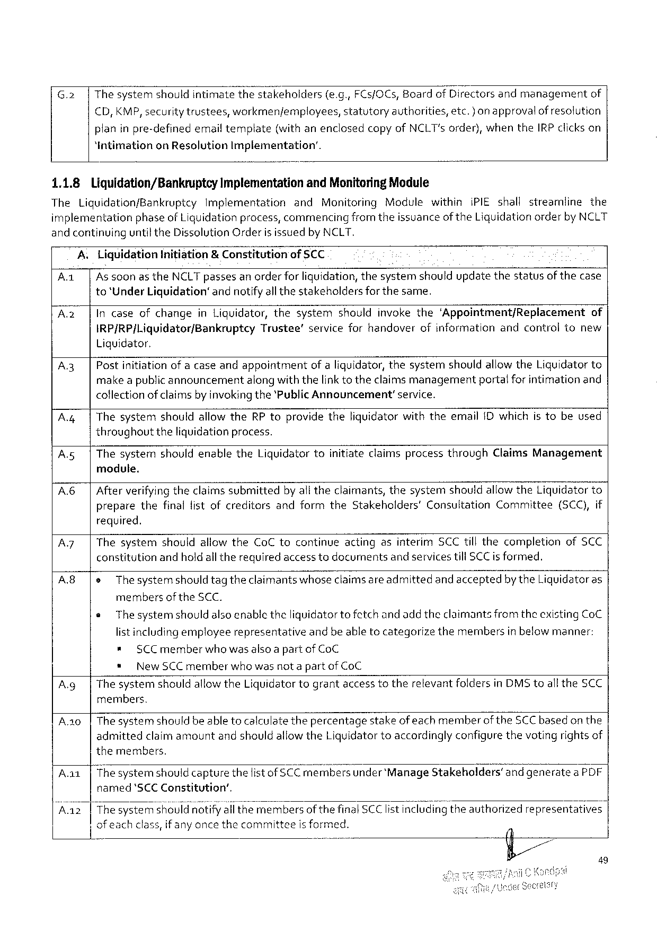

|  |  |  |  |  |  |  |  |  |
| --- | --- | --- | --- | --- | --- | --- | --- | --- |
| G.2 | Thesystemshouldintimate | thestakeholders | | (e. g., FC s/OC s, Boardof Directorsandmanagement | | | | of |
| €D, KMP, securitytrustees, | workmenjemployees, | | | statutory | authorities, | etc.) on approvalof resolution | |
| planinpre-definedemail template | | (withanenclosedcopyof NCLT's order), whenthe IRP clickson | | | | | |

“Intimationon Resolution Implementation’.

1.1.8 Liquidation/Bankruptcy Implementationand Monitoring Module

The Liquidation/Bankruptcy Implementation and Monitoring Modulewithini PIE shallstreamline the

implementationphaseof Liquidationprocess, commencingfromtheissuanceof the Liguidationorderby NCLT

and continuinguntilthe Dissolution Orderis issuedby NCLT.

|  |  |  |  |  |  |  |
| --- | --- | --- | --- | --- | --- | --- |
| A 1 | A | Llquldatlan | Initiation | | &Constitution | of SCC |
| | | Assoonasthe | | NCLT passesanorderfor liquidation, thesystemshouldupdatethestatusof thecase | | |

to‘Under Liquidation®andnotifyall thestakeholdersfor the same.

|  |  |  |  |
| --- | --- | --- | --- |
| A 2 | | | Incaseofchangein Liquidator, thesystemshouldinvokethe‘Appointment/Replacement | of |

IRP/RP|Liquidator/Bankruptcy Liquidator.

Trustee’serviceforhandoverofinformationandcontroltonew

A.3| Postinitiationofa caseandappointmentofa liquidator, thesystemshouldallowthe Liquidatorto make apublicannouncementalongwiththelink totheclaimsmanagementportalforintimationand collectionof claimsby invokingthe‘Public Announcement’service.

|  |  |  |
| --- | --- | --- |
| A 4 | | | Thesystemshouldallowthe RP toprovidetheliquidatorwiththeemail ID which is tobeused |

throughouttheliquidationprocess.

A.5| Thesystemshouldenablethe Liquidatortoinitiateclaimsprocessthrough Claims Management

module.

|  |  |
| --- | --- |
| A 6| | Afterverifyingtheclaimssubmittedby alltheclaimants, thesystemshouldallow the Liquidator to preparethefinallistofcreditorsandformthe Stakeholders’Consultation Committee(SCC), if |

required.

|  |  |  |  |
| --- | --- | --- | --- |
| A 7  A 8 | | | Thesystemshouldallowthe Co C tocontinueactingasinterim SCC tillthecompletionof SCC | |
| constitutionandholdall therequiredaccesstodocumentsandservicestill SCC isformed. | | |
| |e | | Thesystemshouldtagtheclaimants whoseclaimsare admittedand acceptedbythe Liquidatoras |

membersof the SCC.

e Thesystemshouldalsoenabletheliquidator to fetchand addtheclaimantsfrom theexisting Co C

list includingemployeerepresentativeandbe abletocategorizethemembersin below manner:

* SCC memberwhowas alsoa partof Co C

* New SCC memberwhowasnot a partof Co C

A. g|Thesystemshould allowthe Liquidatortograntaccesstotherelevantfoldersin DMS toallthe SCC members.

A.20|Thesystemshouldbe able tocalculatethepercentagestakeofeachmemberofthe SCC based on the admittedclaimamountandshouldallowthe Liquidatortoaccordingly configure thevotingrightsof themembers.

Aa 1|Thesystemshould capturethefist of SCC membersunder ‘Manage Stakeholders’and generatea PDF named‘SCCC onstitution’,

.......... a

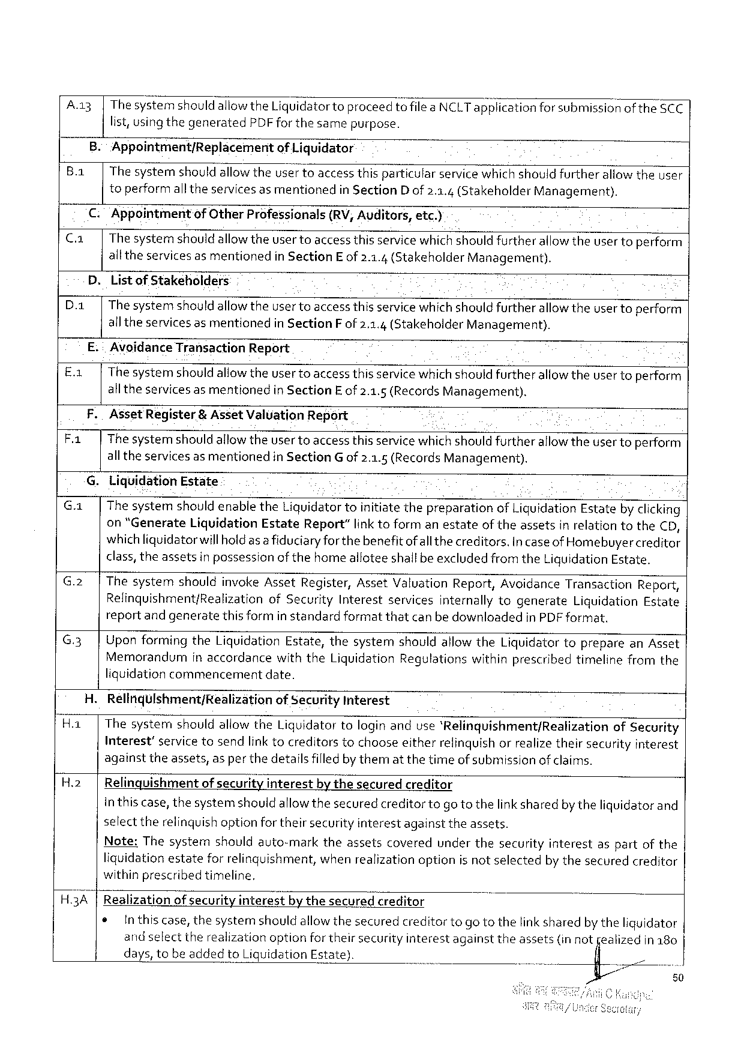

A. a 3|Thesystemshould aliow the Liquidatortoproceedtofilea NCLT ap‘EI icationforsubmissionof the 5 CC

list, usingthegenerated PDF forthesamepurpose.

B.: Appointment/Replacement of Liquidator

B. a| The systemshould allowtheuser toaccessthisparticularservicewhich shouldfurtherallowtheuser

toperformalltheservicesasmentionedin Section D of 2.3.4(Stakeholder Management).

€. Appointment of Other Professionals (RV, Auditors, etc.)

C. a| Thesystemshouldallowtheusertoaccess thisservicewhichshould furtherallowtheuser toperform

alltheservices as mentionedin Section E of 2.1.4(Stakeholder Management).

D. Listof Stakeholders

|  |  |
| --- | --- |
| D. a| | Thesystemshould allowtheusertoaccess thisservicewhichshould furtherallow theuser toperform  alltheservicesasmentioned in Section F of 2.1.4(Stakeholder Management). |

E.: Avoidance Transaction Report

E.1| Thesystemshould allowtheuser toaccess thisservicewhichshouldfurtherallowtheuser toperform

all theservices asmentionedin Section Eof 2.1.5 (Records Management).

F. Asset Register & Asset Valuation Report .

Fa The systemshould allowtheusertoaccess thisservicewhich shouldfurtherallowtheusertoperform

alltheservicesasmentioned in Section G of 2.1.5(Records Management).

G. Liquidation Estate

|  |  |  |  |  |  |  |  |  |  |  |  |  |
| --- | --- | --- | --- | --- | --- | --- | --- | --- | --- | --- | --- | --- |
| G.1| | | Thesystemshouldenablethe Liquidator toinitiatethepreparationof Liquidation Estateby clicking on "Generate Liquidation Estate Report”link toformanestateof theassetsin relationtothe€D, whichliquidatorwillholdasa fiduciaryforthebenefitofall thecreditors. Incaseof Homebuyercreditor  class, theassetsin possessionofthehomealloteeshallbe excludedfromthe Liquidation Estate. | | | | | | | | | | |
| G.2 | | | Thesystem | shouldinvoke Asset Register, | | | Asset Valuation | | | Report, Avoidance | | Transaction | Report, |
| Relinquishment/Realization | | of Security | Interest | | services | internally | | togenerate | Liquidation | Estate |
| reportand generatethis formin standardformatthatcanbe downloadedin PDF format. | | | | | | | | | | |

G.3]Uponformingthe Liquidation Estate, thesystemshouldallowthe Liquidatortopreparean Asset

Memorandumin accordancewiththe Liquidation Regulationswithinprescribedtimelinefromthe

liquidationcommencementdate.

H. Relinqulshment/Realization of Security Interest

H.1| Thesystemshouldallowthe Liquidatortologinanduse‘Relinquishment/Realization of Security

Interest’ servicetosendlinktocreditors tochooseeitherrelinquish orrealizetheirsecurity interest

againsttheassets, asper thedetailsfilledby thematthetimeof submissionof claims.

H.2| Relinquishmentof securityinterestbythesecuredcreditor

inthiscase, thesystemshouldallowthesecuredcreditortogotothelinksharedby theliquidator and

select therelinquishoptionfortheirsecurityinterestagainsttheassets.

|  |  |  |  |  |  |  |
| --- | --- | --- | --- | --- | --- | --- |
| Note: Thesystem | shouldauto-mark | theassets | covered | underthesecurity | interest | aspartofthe |
| liquidationestate | forrelinguishment, | whenrealizationoptionisnotselected | | | by thesecuredcreditor | |
| withinprescribed | timeline, |

H.3 A |Realizationof securityinterestbythesecuredcreditor

|  |  |  |
| --- | --- | --- |
| ¢ | Inthiscase, thesystemshouldallowthesecuredcreditortogo tothelink sharedby theliquidator | |
| andselecttherealizationoptionfortheirsecurityinterestagainsttheassets(in not | jealizedin 180 |
| days, tobeaddedto Liquidation Estate). | fi |

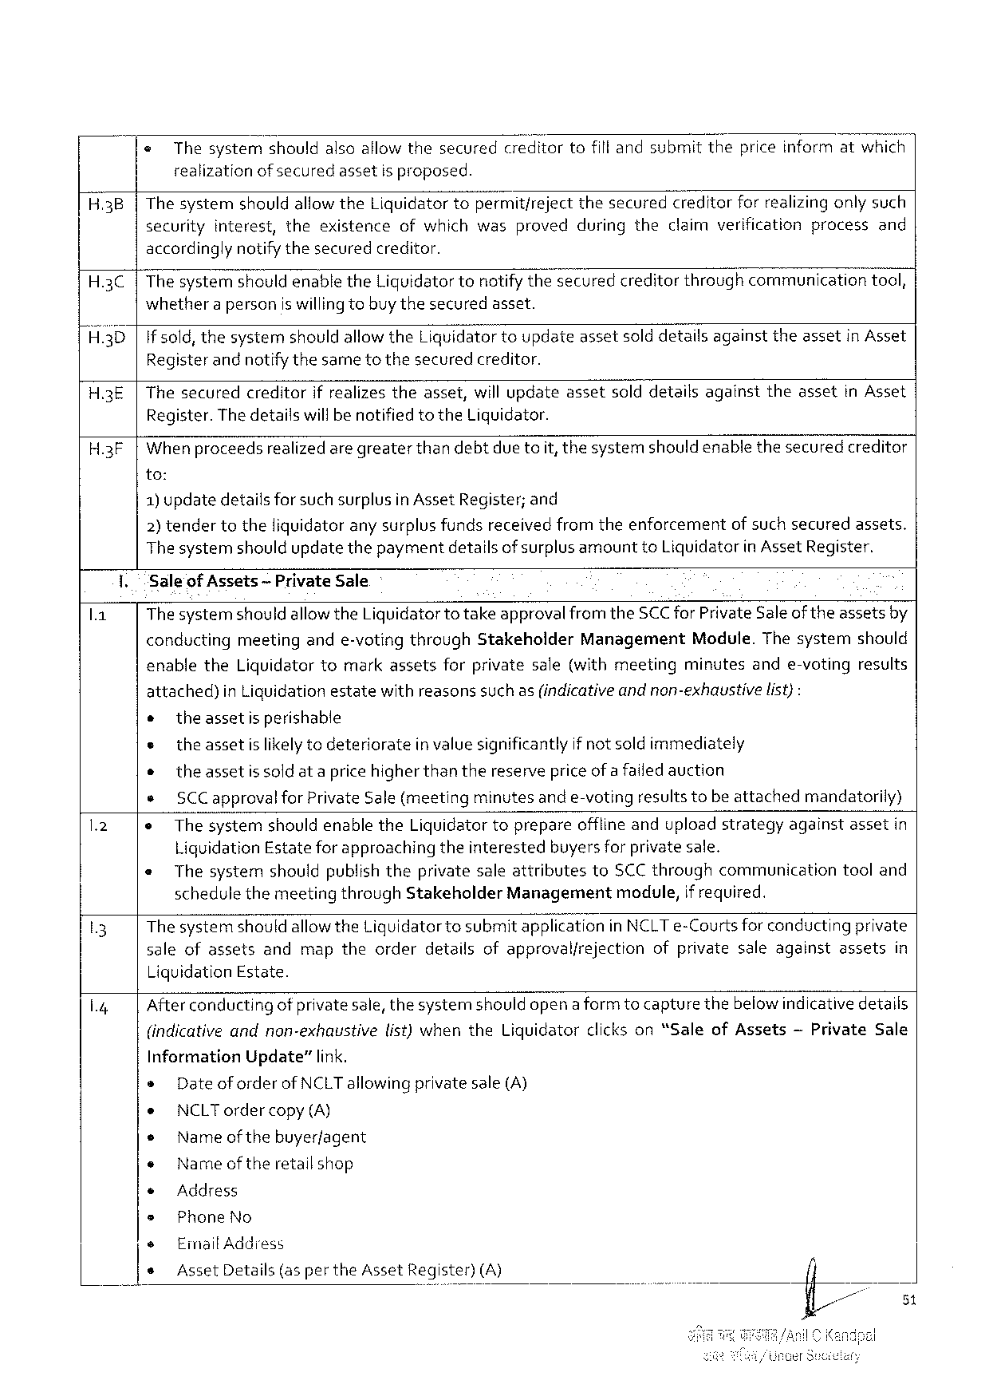

« Thesystemshouldalsoallowthesecuredcreditortofillandsubmitthepriceinformatwhich realizationofsecuredassetisproposed.

|  |  |  |  |
| --- | --- | --- | --- |
| H.3 B | Thesystem | shouldallowthe Liquidatortopermitfreject | thesecuredcreditorforrealizingonlysuch |
| securityinterest, theexistenceofwhichwasprovedduringtheclaimverificationprocessand | | |

accordinglynotifythesecuredcreditor.

H.3 C The systemshould enablethe Liguidatortonotifythesecuredcreditorthroughcommunicationtool, whethera personiswilling tobuy thesecuredasset.

H.3 D if sold, thesystemshould allowthe Liquidatortoupdateassetsolddetailsagainsttheassetin Asset Registerandnotifythesametothesecuredcreditor.

H.3 E Thesecuredcreditorif realizestheasset, willupdateassetsolddetailsagainsttheassetin Asset Register. Thedetailswill benotified to the Liquidator.

H.3 F Whenproceedsrealizedaregreaterthan debtdue toit, thesystemshould enablethesecuredcreditor

to:

1)updatedetailsfor suchsurplusin Asset Register; and

2) tendertotheliquidatorany surplus fundsreceivedfromtheenforcementof suchsecuredassets. Thesystemshouldupdatethepaymentdetailsofsurplus amountto Liquidatorin Asset Register.

Sale of Assets— Private Sale

Thesystemshould allowthe Liquidatortotakeapprovalfrom the SCC for Private Saleof theassetsby

|  |  |  |
| --- | --- | --- |
| conductingmeetingande-votingthrough Stakeholder | Management | Module. Thesystemshould |

enablethe Liquidatortomarkassetsforprivatesale(withmeetingminutesande-votingresults

attached) in Liquidationestatewithreasonssuchas(indicativeandnon-exhaustivelist):

o theassetisperishable

e theassetis likely todeterioratein valuesignificantlyif notsold immediately

o theassetis sold at apricehigher thanthereservepriceofafailedauction

e SCC approval for Private Sale(meetingminutesand e-votingresults tobe attachedmandatorily)

o Thesystem shouldenablethe Liquidatortoprepare offlineanduploadstrategy against assetin

Liquidation Estate for approachingtheinterestedbuyers for private sale.

|  |  |  |
| --- | --- | --- |
| e | Thesystemshouldpublish theprivatesaleattributesto SCC throughcommunicationtooland | |
| schedulethemeetingthrough Stakeholder Management | module, if required. |

The systemshouldallowthe Liguidatortosubmitapplicationin NCLT e-Courts for conductingprivate saleofassetsandmaptheorderdetailsofapprovalfrejectionofprivatesaleagainstassetsin Liquidation Estate.

Afterconductingof privatesale, thesystemshould opena formto capturethebelowindicativedetails

|  |  |  |  |  |  |
| --- | --- | --- | --- | --- | --- |
| (indicativeandnon-exhaustive | list)whenthe Liquidator | clickson“Sale | of Assets | ~Private | Sale |

Information Update”link.

s Dateoforderof NCLT allowingprivatesale(A)

e NCLT order copy(A)

e Nameof thebuyerfagent

e Nameof theretailshop

© Address

» Phone No

e Email Address

e Asset Details (asperthe Asset Register) (A)

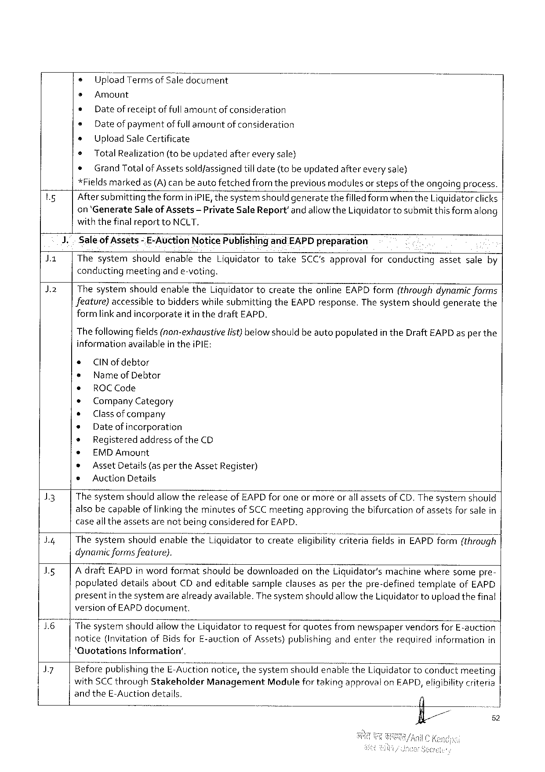

o Upload Termsof Saledocument

s Amount

* Date of receiptoffull amountof consideration

= Date of paymentof fullamountof consideration

s Upload Sale Certificate

® Total Realization(tobe updatedafterevery sale)

e Grand Totalof Assetssold/assignedtill date(tobeupdatedaftereverysale)

*Fieldsmarked as(A)canbeautefetchedfrom theprevious modules or stepsof theongoingprocess.

|  |  |  |  |  |
| --- | --- | --- | --- | --- |
| Ly | 1. | Aftersubmitting theformini PIE, thesystemshould generatethefilled form when the Liquidatorclicks | | |
| Ja | on‘Generate Saleof Assets-Private Sale Report’andallowthe Liquidatortosubmitthis formalong | | |
| withthefinalreportto NCLT. | | |
| Saleof Assets | - E-Auction Notice Publishirgand EAPD preparation | |
| Thesystemshouldenablethe Liquidatortotake SCC'sapprovalforconductingassetsaleby | | |
| J 2 | conducting | meetingande-voting. | |
| Thesystemshouldenablethe Liquidatortocreatetheonline EAPD form(throughdynamic forms | | |
| Jeature)accessibletobidderswhilesubmittingthe EAPD response. The systemshouldgeneratethe | | |
| formlink andincorporate | | itinthedraft EAPD. |

Thefollowingfields(non-exhaustive

informationavailable in thei PIE:

* CIN ofdebtor

s Name of Debtor

¢ ROCC ode

¢ Company Category

s Classof company

e Dateofincorporation

® Registeredaddressofthe CD

e EMDA mount

list) below shouldbeautopopulatedin the Draft EAPD as per the

|  |  |  |  |  |  |  |  |  |  |  |  |  |
| --- | --- | --- | --- | --- | --- | --- | --- | --- | --- | --- | --- | --- |
| 13  by  Is  76|  J 7 | * | | Asset Details(as per the Asset Register) | | | | | | | | | |
| e | Auction Details | | | | | | | | | | |
| Thesystemshouldallowthereleaseof EAPD forone ormoreor all assetsof CD. The systemshould alsobecapableoflinkingtheminutesof SCC meetingapprovingthebifurcationof assetsforsalein caseall theassetsarenotbeing consideredfor EAPD. | | | | | | | | | | | |
| Thesystemshouldenablethe Liguidatortocreateeligibiiit;}‘iriteria | | | | | | | fieldsin EAPD form(through | | | | |
| dynamicformsfeature).  Adraft EAPD in wordformatshouldbedownloadedonthe Liquidator'smachinewheresomepre-populateddetailsabout CD andeditablesampleclausesasperthepre-definedtemplateof EAPD presentin thesystemarealready available. Thesystemshouldallowthe Liquidatortouploadthefinal versionof EAPD document. | | | | | | | | | | | |
| Thesystemshouldallowthe Liquidatortorequestforquotesfromnewspaper | | | | | | | | vendorsfor E-auction | | | |
| notice(Invitationof Bidsfor E-auction | | | | of Assets)publishing | | andenter | therequired | | information | | in |
| ‘Quotations Information’, | | | | | | | | | | | |
| Beforepublishingthe E-Auctionnotice, thesystemshouldenablethe Liquidatortoconduct | | | | | | | | | | meeting | |
| with SCC through Stakeholder | | | Management | | Modulefortakingapprovalon EAPD, eligibilitycriteria | | | | | | |
| and the E-Auctiondetails. | | | | | | | 4 | | | | |
| fl/// | | | | | | | | | 52 | | |
| i | | | | | | | | | 3 | | |

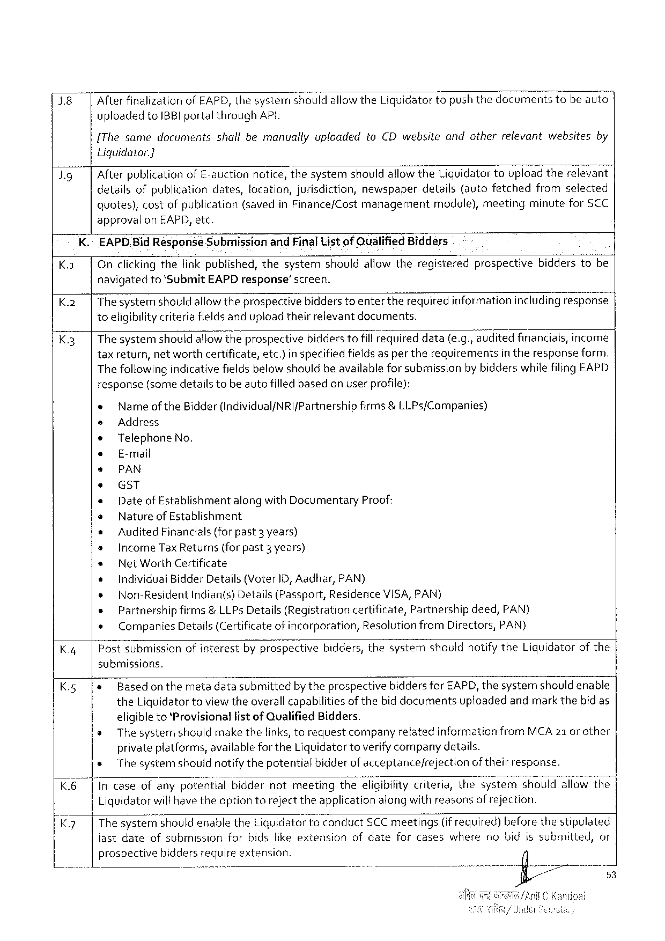

1.8 After finalizationof EAPD, thesysternshould allowthe Ligquidatortopushthedocomentstobe auto|

uploadedto IBBI portalthrough API.

{The samedocumentsshallbemanuallyuploadedto CD websiteandotherrelevantwebsitesby

Liquidator.]

|  |  |  |  |  |  |  |  |
| --- | --- | --- | --- | --- | --- | --- | --- |
| Jg | Afterpublicationof E-auctionnotice, thesystemshouldallowthe Liquidatortoupload therelevant detailsofpublicationdates, location, jurisdiction, newspaperdetails(autofetchedfromselected | | | | | | |
| quotes), | costofpublication | (savedin Finance/Cost | management | module), | meeting | minutefor SCC |

approvalon EAPD, etc.

K.~ EAPD. Bid Response Submissionand Final List of Qualified Bidders

|  |  |  |  |  |
| --- | --- | --- | --- | --- |
| K. | | | Onclicking thefink published, thesystemshouldallowtheregisteredprospectivebidderstobe navigatedto‘Submit EAPD response’screen.  Thesystemshould allowtheprospectivebidderstoenter therequiredinformationincludingresponse toeligibilitycriteriafieldsandupload theirrelevantdocuments.  Thesystemshould allowtheprospectivebidders tofill Fequned data(e. g., auditedfinancials, income | | |
| K.2|  K 3| | |
| taxreturn, networthcertificate, | etc.)inspecifiedfieldsaspertherequirements | intheresponseform. |
| Thefollowing indicativefieldsbelow shouldbeavailablefor submissionby bidderswhilefiling EAPD | | |

response(some detailstobe autofilledbasedonuser profile):

e Nameof the Bidder(Individual/NRI f Partnership firms&LLP s{Companies)

e Address

e Telephone No.

e E-mail

e PAN

e GST

s Date of Establishmentalongwith Documentary Proof:

e Nature of Establishment

* Audited Financials(forpast 3 years)

Income Tax Returns(forpast 3 years)

Net Worth Certificate

|  |  |  |  |  |  |
| --- | --- | --- | --- | --- | --- |
| K.4| | o | Individual Bidder Details(Voter ID, Aadhar, PAN) | | | |
| « | Non-Resident | | indian(s)Details(Passport, | Residerice VISA, PAN) |
| s | Partnershipfirms&LLP s Details(Registrationcertificate, Partnershipdeed, PAN) | | | |
| ¢ | | Companies Details(Certificateof incorporation, Resolutionfrom Directors, PAN) | | |
| Postsubmissionofinterestbyprospectivebidders, thesystemshouldnotify the Liquidatorof the | | | | |

submissions.

|  |  |  |  |
| --- | --- | --- | --- |
| K.5 | |e | Basedonthe | metadatasubmittedby theprospectivebiddersfor EAPD, thesystemshould enable |
| the Liquidatortoviewtheoverallcapabilitiesofthebid documentsuploadedandmarkthebidas | |

eligibleto‘Provisionallistof Qualified Bidders.

s The systemshouldmake thelinks, torequestcompanyrelatedinformationfrom MCA 21 orother

privateplatforms, availablefor the Liquidatortoverifycompanydetails.

s The systemshould notifythepotentialbidderof acceptancefrejection oftheirresponse.

K.6| Incaseofanypote‘fi’tlalbiddernotmeetingthe; Iigib«lltycriteria, thesystemshouldallowthe

Liquidatorwillhave theoption torejecttheapplicationalongwithreasonsof rejection.

K 7 |The syste‘rfi; houldenablethe Liquidatortoconduct SCC meetings(if required)beforethestipulated

fastdate ofsubmission forbidsiikeextension ofdate forcases where nobidissubmitted, or

prospective biddersrequireextension.

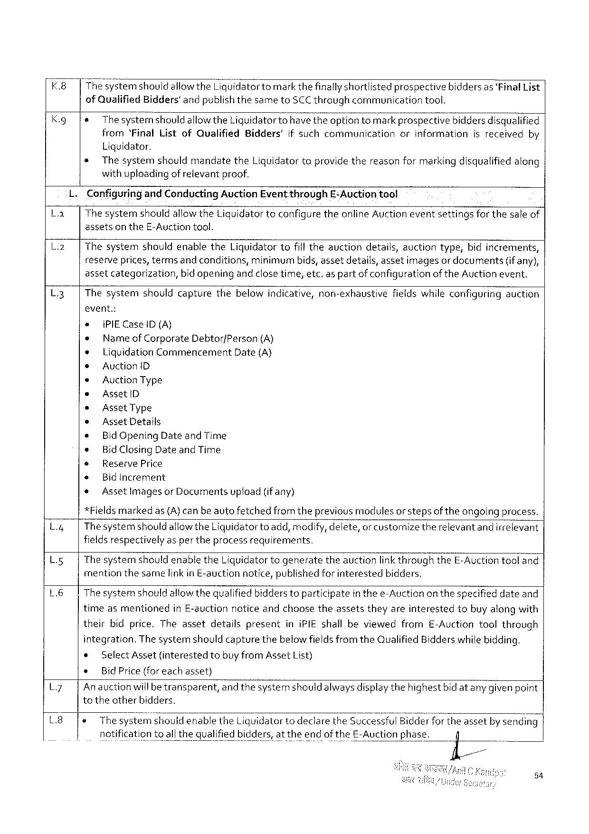

|  |  |  |  |
| --- | --- | --- | --- |
| K.8  K. g | The"; ystem should allowthe Liquidatortomarkthefinallyshortlistedprospectivebidders as ‘Final List of Quaiified Bidders'andpublishthesameto SCC throughcommunicationtool. | | |
| e | Thesystemshould | allowthe Liquidatortt)have theoption tomarkprospectivebiddersdisqualified |

from‘Final Listof Qualified Bidders'if suchcommunicationorinformationisreceivedby

Liquidator.

s Thesystemshouldmandatethe Liquidator toprovidethereasonfor markingdisqualified along

withuploading of relevantproof.

Configuringand Conducting Auction Event through E-Auction tool

|  |  |  |
| --- | --- | --- |
| La | | | Thesystemshouldallowthe Liquidatortoconfigure theonline Auctioneventsettingsfor thesale of |

assetsonthe E-Auctiontool.

L.2| Thesystemshouldenablethe Liquidatortofilltheauctiondetails, auctiontype, bidincrements,

reserveprices, termsandconditions, minimum bids, assetdetails, assetimagesordocuments (if any),

assetcategorization, bidopeningandclosetime, etc. aspart ofconfigurationof the Auction event,

L 3 Thesystemshouldcapturethebelowindicative, non-exhaustivefieldswhileconfiguringauction

event.:

e {PIEC ase ID(A)

* Nameof Corporate Debtorf Person (A)

* Liquidation Commencement Date(A)

s Auctioni D

« Auction Type

* Assetl D

* Asset Type

® Asset Details

* Bid Opening Date and Time

* Bid Closing Date and Time

s Reserve Price

* Bid Increment

* Assetlmagesor Documentsupload(if any)

*Fieldsmarkedas(A)canbe autofetchedfromtheprevious modulesor stepsof theongoing process.

L.4| Thesystemshould allowthe Liquidatorto add, modify, delete, orcustornize therelevantandirrelevant

fieldsrespectively aspertheprocessrequirements.

L. g The systemshouldenablethe Liquidatortogeneratetheauctionlink throughthe E-Auctiontooland

mention thesamelinkin E-auctionnotice, publishedforinterested bidders.

L 6 Thesystemshould allowthequalified bidderstoparticipatein thee-Auctionon thespecifieddateand

timeasmentionedin E-auction noticeandchoosetheassetstheyareinterestedtobuyalongwith

theirbidprice. Theassetdetailspresentini PIE shallbeviewedfrom E-Auctiontoolthrough

integration. The systemshouldcapturethebelowfieldsfromthe Qualified Bidderswhilebidding.

|  |  |  |  |  |  |  |  |
| --- | --- | --- | --- | --- | --- | --- | --- |
| L 7  L 8 | * | Select Asset | (interested | tobuyfrom Asset | | List) | |
| s | Bid Price(foreachasset) | | | | | |
| An auctionwill betransparent, and thesystemshouldalwaysdisplaythehighestbid atanygivenpoint totheotherbidders.  1 e Thesystemshouldenablethe Liquidatortodeclarethe Successful Bidderfortheassetby sending | | | | | | |
| notification | | toallthequalified | | bidders, attheendofthe E-Auctionphase. | | il |

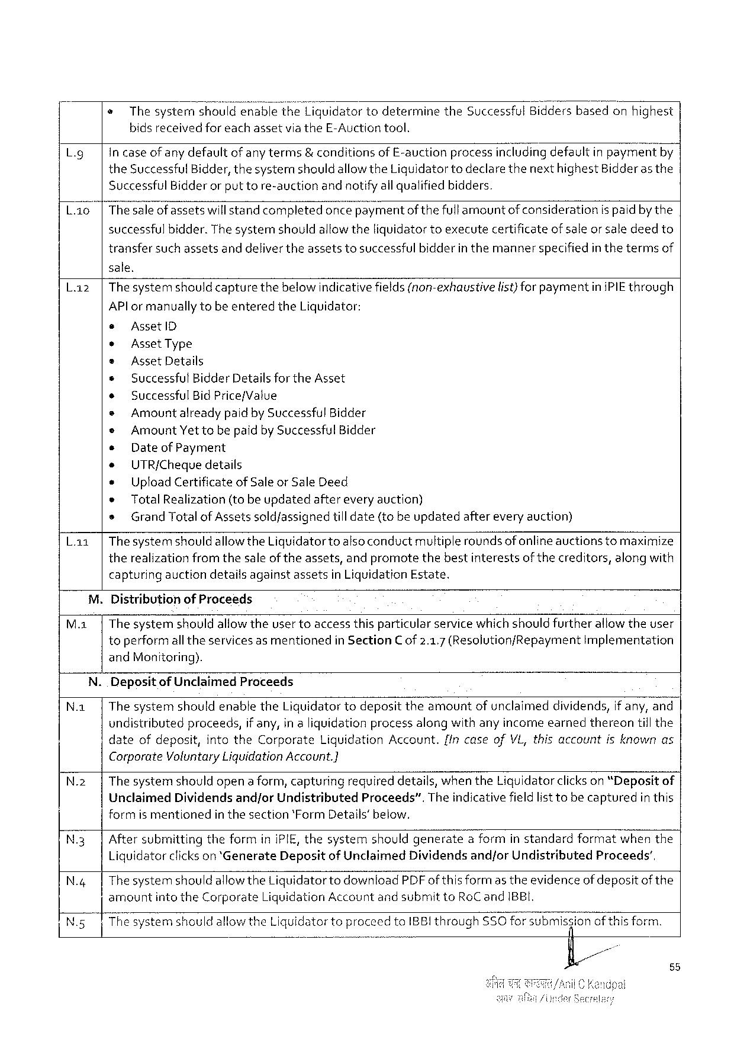

@Thesystemshouldenablethe Liquidator todeterminethe Successful Biddersbasedonhighest

bidsreceivedforeachassetvia the E-Auctiontool.

Lg in case of any defaultof anyterms& conditionsof E-auctionprocessincludingdefaultinpaymefitby

the Successful Bidder, thesystemshould allowthe Liquidatortodeclare thenext highest Bidderas the

Successful Bidderor puttore-auctionandnotifyallqualified bidders.

L. ao|Thesaleof assetswillstandcompletedonce pa\; mentof thefullamountof considerationispaidbythe

successfulbidder. Thesystemshouldallowtheliquidator toexecutecertificateofsaleor saledeedto

transfersuchassetsanddelivertheassetstosuccessful bidderin themannerspecifiedin thetermsof

sale.

|  |  |  |
| --- | --- | --- |
| L. z | |Thesystemshould capturethebelowindicativefields(non-exhaustive | list)for paymentini PIE through |

AP lor manually tobe enteredthe Liquidator:

e Assetl D

e Asset Type

e Asset Details

* Successful Bidder Details for the Asset

e Successful Bid Price/Value

e Amountalreadypaidby Successful Bidder

e Amount Yettobe paidby Successful Bidder

e Date of Payment

* UTR/Chequedetails

e Upload Certificateof Saleor Sale Deed

* Total Realization(tobeupdated aftereveryauction)

s Grand Totalof Assetssoldfassignedtill date(tobe updatedaftereveryauction)

L. az|Thesystemshouldallowthe Liquidatortoalsoconductmultiplerounds of onlineauctionstomaximize

therealization fromthesale of theassets, andpromotethebestinterestsof thecreditors, alongwith

capturingauctiondetailsagainstassetsin Liquidation Estate.

M. Distributionof Proceeds

M.1|The systemshouldallowtheuser toaccessthisparticular service whichshould furtherallowtheuser

toperformall theservicesas mentionedin Section C of 2.1.7 (Resolutionf Repayment Implementation

and Monitoring).

N. Depositof Unclaimed Proceeds

N. a| Thesystemshouldenablethe Liquidator todeposittheamountof unclaimeddividends, if any, and

undistributedproceeds, if any, in aliquidationprocessalongwithanyincomeearnedthereontill the

|  |  |  |  |  |  |
| --- | --- | --- | --- | --- | --- |
| date | ofdepesit, | intothe Corporate | Liquidation | Account. | {In caseof VL, thisaccountisknownas |

Corporate Yoluntary Liquidation Account.]

N.2 | Thesystemshouldopena form, capturing requireddetails, whenthe Liquidatorclickson“Deposit of

Unclaimed Dividends and/or Undistributed Proceeds”. Theindicativefieldlist tobecaptured inthis

formismentioned inthesection‘Form Details’below.

N.3| Aftersubmittingtheformini PIE, thesystemshouldgeneratea formin standardformatwhenthe

Liquidatorclickson *‘Generate Depositof Unclaimed Dividendsandfor Undistributed Proceeds’,

|  |  |
| --- | --- |
| N.4| | Thesystemshould allowthe Liquidatorto download PDF of this formas theevidence of depositof the amountintothe Corporate Liquidation Accountand submitto Ro Cand IBBI.  |Thesystemshouldallowthe Liquidatortoproceedto IBBI through ,,,,, A SSO forsubmisfiianof thisform. e |

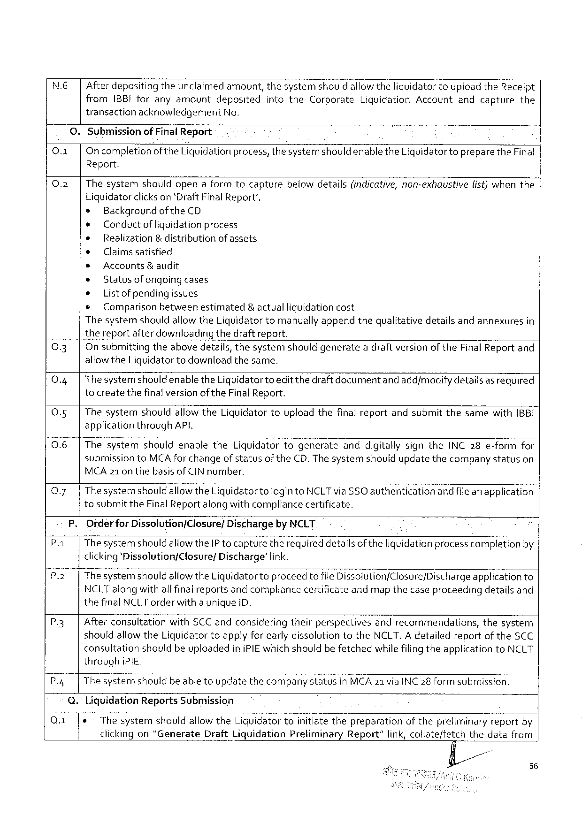

N.6| Afterdeposit\r\gtheunclaimedamount, thesystemshouidallowtheliquidator touploadthe Receipt

from IBBI foranyamount deposited intothe Corporate Liquidation Account and capture the

transactionacknowledgement No.

0. Submissionof Final Report

O |Oncompletion of the Liquidationprocess, thesystemshouldenablethe Liquidatortopreparethe Final

Report.

|  |  |  |
| --- | --- | --- |
| 0.2 | | | Thesystemshouldopenaformtocapturebelowdetails(indicative, non-exhaustivelist)whenthe |

Liquidatorclickson 'Draft Final Report'.

s Background of the CD

e Conductof liquidationprocess

¢ Realization & distributionof assets

o Claimssatisfied

* Accounts& audit

e Statusof ongoingcases

» Listof pending issues

e Comparison betweenestimated &actualliguidationcost

Thesystemshouldallowthe Liquidatortomanually appendthequalitativedetailsandannexuresin

thereportafterdownloadingthedraftreport.

|  |  |  |
| --- | --- | --- |
| 0.3 | | | On submittingtheabovedetails, thesystemshouldgeneratea draftversionof the Final Reportand |
| 0.4 | | | allowthe Liquidatortodownloadthesame. |
| Thesystemshouldenable the Liquidatortoeditthe draft documentand add/modifydetailsas required |
| 0.5 | | | tocreatethefinalversionof the Final Report. |
| Thesystemshouldallow the Liquidatortouploadthefinalreportandsubmitthesamewith(BB{ |

applicationthrough AP,

0.6 |Thesystemshouldenablethe Liquidatortogenerateanddigitallysignthe INC 28 e-formfor

submissionto MCA for changeof statusofthe CD. The systemshouldupdatethecompanystatuson

MCA 21 on thebasisof CIN number.

|  |  |  |
| --- | --- | --- |
| Q.7| | Thesystemshould | allowthe Liquidatortologinto NCLT via SSO authenticationandfile anapplication |

tosubmit the Final Report along withcompliancecertificate.

P.-Orderfor Dissolution/Closure/Dischargeby NCLT

P.1| Thesystemshould allowthe IP tocapturetherequireddetailsof theliquidationprocess completionby

clicking‘Pissolution/Closure/ Discharge’ link.

P 2 |Thesystemshould allowthe Liquidatortoproceedto file Di 5;31 ution/CI osure/Discharge app! fcationto

NCLT alongwithall final reportsand compliancecertificateandmap thecaseproceedingdetailsand

thefinal NCLT orderwitha unique ID.

|  |  |
| --- | --- |
| P.3| | Afterconsultationwith SCC andconsideringtheirperspectivesandrecommendations, thesystem shouldallowthe Liquidatortoapplyforearlydissolutiontothe NCLT. A detailedreportof the SCC |

consultationshouldbeuploadedini PIE which shouldbefetchedwhilefilingtheapplicationto NCLT

through i PIE.

P.4| The systemshouldbe able toupdatethecompanystatusin MCA 21 via INC 28 form submission.

Q. Liquidation Reports Submission

|  |  |  |  |  |  |
| --- | --- | --- | --- | --- | --- |
| Q.1 | e | Thesystem | shouldallowthe Liquidatortoinitiatethepreparation | ofthepreliminary | reportby |

56

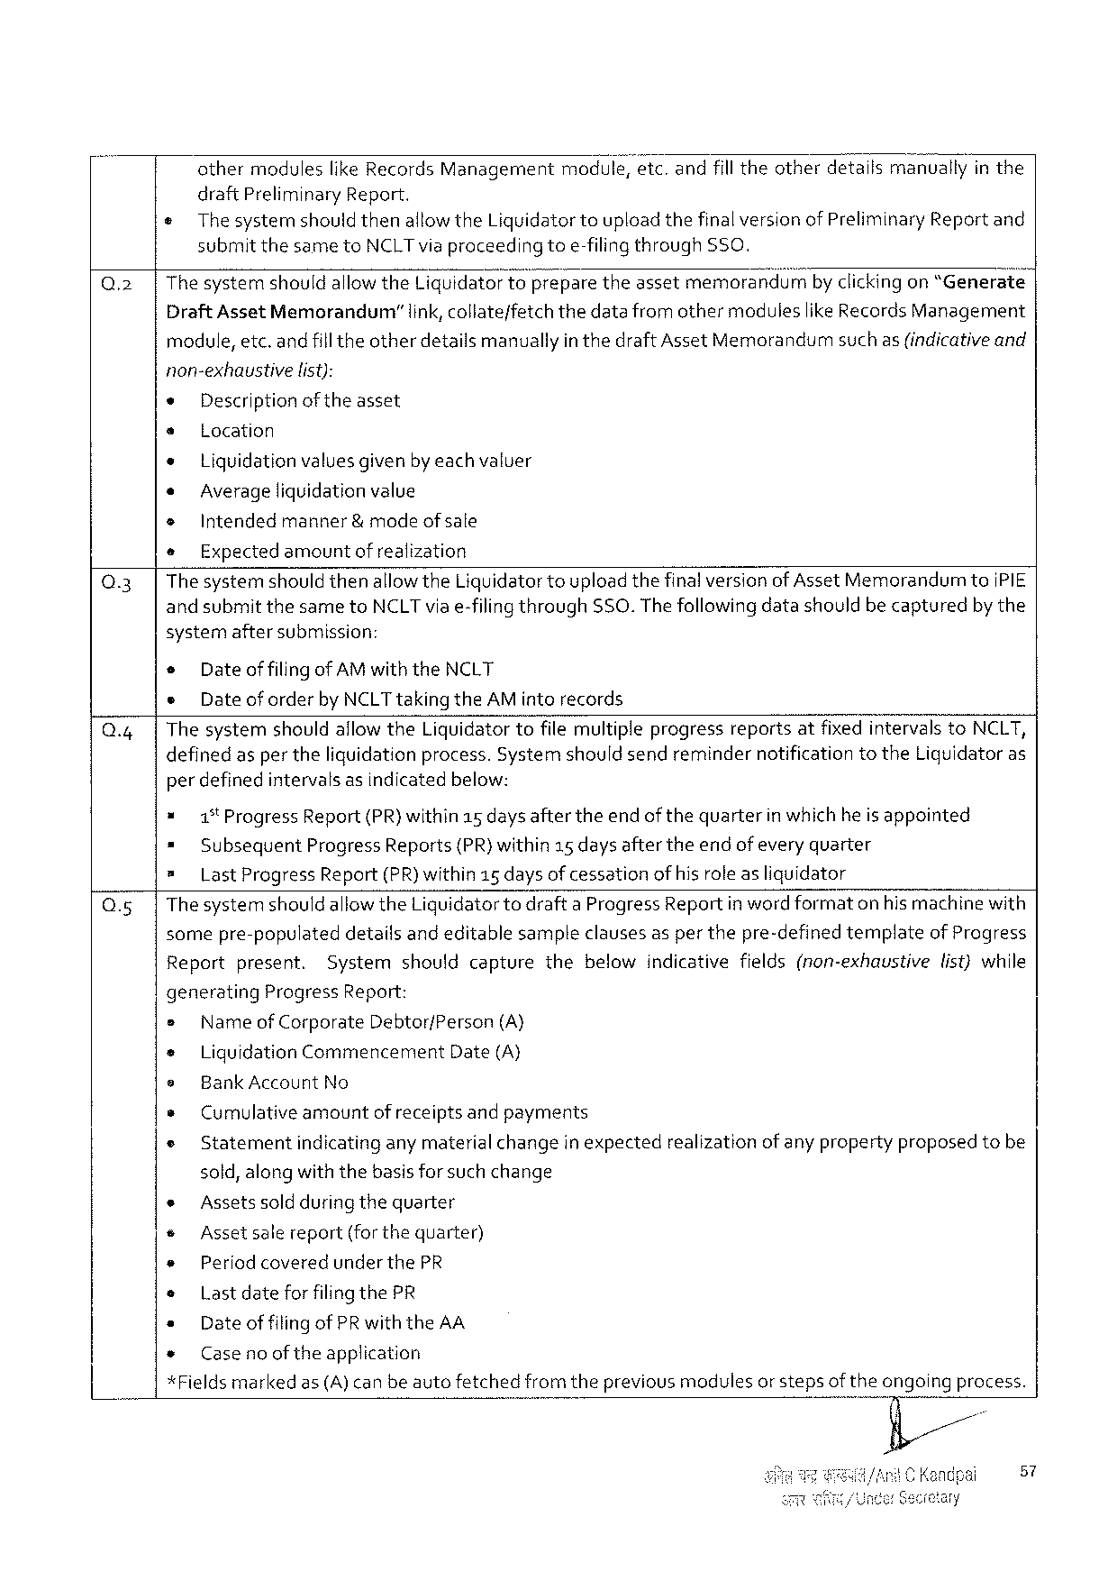

athermoduleslike Records Managementmodule, etc. andfilltheotherdetailsmanuallyin the

draft Preliminary Report.

¢ Thesystemshould thenallowthe Liquidatortoupload thefinalversionof Preliminary Report and

submit thesameto NCLT viaproceedingtoe-filingthrough$50.

|  |  |  |  |  |
| --- | --- | --- | --- | --- |
| Q.2 | Thesystemshouldallowthe Liquidatortoflpreparetheassetmemorandum | | | byclickingon“Generate |
| Draft Asset Memorandum” | link, collateffetch | thedatafromothermodulieslike Records Management | |

module, etc. andfill theotherdetailsmanuallyin thedraft Asset Memorandumsuch as(indicativeand

non-exhaustive list):

* Descriptionof theasset

s Location

» Liquidationvaluesgiven byeach valuer

* Averageliquidationvalue

» Intendedmanner& mode ofsale

e Expected amountof realization

Q.3| The systemshould thenallowthe Liquidatortoupload thefinalversionof Asset Memorandumto IPIE

and submitthesameto NCLT via e-filingthrough SSO. Thefollowingdatashouldbe capturedby the

systemaftersubmission:

o Dateof filingof AM with the NCLT

e Dateof orderby NCLT takingthe AM intorecords

Q.4| Thesystemshouldallow the Liquidator tofilemultipleprogressreportsatfixedintervals to NCLT,

definedasper theliquidationprocess. Systemshouldsendremindernotificationtothe Liguidatoras

perdefinedintervals asindicatedbelow:

* 1% Progress Report(PR) within 15 days aftertheendof thequarterin which he is appointed

= Subsequent Progress Reports(PR)within 15 daysaftertheendof everyquarter

= Last Progress Report(PR)within 15 daysofcessation ofhisroleasliquidator

Q.5|Thesystemshould allowthe Liquidatortodrafta Progress Reportinwordformaton hismachinewith

somepre-populateddetailsandeditablesampleclausesas per thepre-definedtemplateof Progress

Reportpresent. Systemshouldcapturethebelowindicativefields(non-exhaustivelist)while

generating Progress Report:

= Nameof Corporate Debtor/Person (A)

+ Liguidation Commencement Date(A}

e Bank Account No

» Cumulativeamountof receiptsandpayments

e Statement indicatinganymaterialchangeinexpected realization of anyproperty proposed tobe

sold, alongwiththebasisforsuchchange

|  |  |  |  |  |  |  |  |  |  |  |
| --- | --- | --- | --- | --- | --- | --- | --- | --- | --- | --- |
| * | | Assetssoldduring thequarter | | | | fromtheprevious | modules | orsteps | oftheongoing | process. |
| ¢ | Assetsale | | | report(forthequarter) | |
| e | Period coveredunder the PR | | | | |
| * | | Lastdateforfilingthe PR | | | |
| * | | Dateof filingof PR with the AA | | | |
| * | Caseno of theapplication | | | | |
| *Fields | | | marked | as(A)canbeauto | fetched |

57

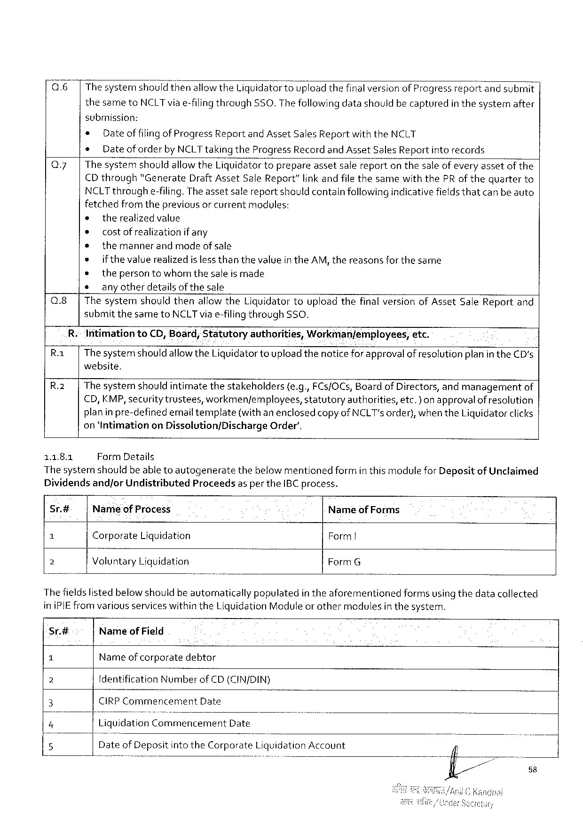

Q.6 |Thesystemshouldthenallowthe Liquidatortoupload thefinalversionof Progress reportandsubmit |

thesameto NCLT viae-filingthrough SSO. Thefollowingdatashouldbecapturedin thesystemafter

submission:

s Dateof filingof Progress Report and Asset Sales Reportwiththe NCLT

e Dateof orderby NCLT takingthe Progress Recordand Asset Sales Report into records

Q 7| Thesystemshouldallowthe Liquidatortoprepareassetsalereporton thesaleof everyassetof the

CD through“Generate Draft Asset Sale Report”linkandfile thesamewiththe PR of thequarterto

NCLT throughe-filing. Theassetsalereportshouldcontainfollowingindicativefieldsthatcanbe auto

fetchedfrom thepreviousor currentmodules:

¢ therealizedvalue

o costofrealization ifany

e themannerandmodeof sale

e ifthevalue realizedislessthanthevalue in the AM, thereasonsforthesame

* thepersontowhomthesaleis made

* _any otherdetailsofthesale

Q.8| Thesystemshouldthenallow the Liguidatortouploadthefinal versionof Asset Sale Reportand

submitthesameto NCLT viae-filingthrough SSO.

R.-Intimationto CD, Board; Statutoryauthorities, Workman/employees; etc.

R | Thesystemshould allowthe Liquidatortouploadthenoticeforapprovalof resolution planin the CD's

website.

R.2| The systemshouldintimatethestakeholders(e. g., FC s/OC s, Board of Directors, andmanagementof

€D, KMP, securitytrustees, workmen/employees, statutory authorities, etc.)on approvalof resolution

planin pre-definedemailtemplate(withan enclosedcopy of NCLT's order), when the Liquidatorclicks

on ‘Intimationon Dissolution/Discharge Order’.

11.8.1 Form Details

The systemshouldbeable toautogeneratethebelowmentionedformin thismodule for Depositof Unclaimed

Dividendsand/or Undistributed Proceedsas perthe IBC process.

|  |  |  |  |
| --- | --- | --- | --- |
| Sr.# | Nameof Process | | Nameof Forms |
| 1 | Corporate | Liquidation |
| Form |
| 3 | Voluntary Liquidation | |
| Form G |

Thefieldslistedbelow shouldbeautomaticallypopulatedin theaforementionedformsusingthedatacollected

ini PIE from variousserviceswithinthe Liquidation Moduleor othermodulesin thesystem.

Sr.# Nameof Field

1 Nameof corporatedebtor

2 fdentification Numberof CD (CIN/DIN)

3 CIRPC ommencement Date

4 Liquldat»on“Co I’r‘\mencemem Date

5 VD”at‘e‘of Depositintothe Corporate L’u; mdatlon Account

58

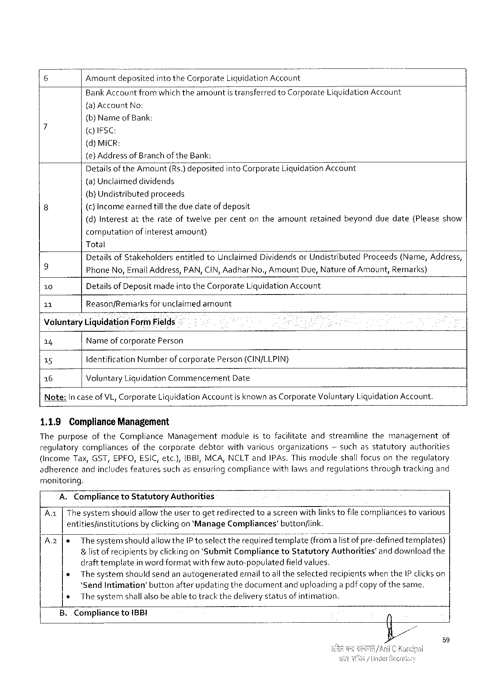

|  |  |  |  |  |  |
| --- | --- | --- | --- | --- | --- |
| Amountdeposited | | intothe Corporate | Liquidation Account | | Liquidation Account |
| Bank Accountfromwhichtheamount | | | istransferred | to Corporate |
| (a)Account | No: | |

(b)Nameof Bank:

()IFSC:

(d)MICR:

(e) Addressof Branchof the Bank:

|  |  |  |
| --- | --- | --- |
| Detailsofthe Amount(Rs.)deposited | into Corporate | Liquidation Account |

(a) Unclaimeddividends

|  |  |  |  |  |  |  |  |  |
| --- | --- | --- | --- | --- | --- | --- | --- | --- |
| (b}Undistributed | | proceeds | | retained | beyond | duedate | (Please | show |
| (c) Incomeearned | | tilltheduedateofdeposit | |
| (d)Interest | attherateoftwelve | | percentontheamount |

computationofinterestamount)

Total

|  |  |  |  |  |  |  |  |
| --- | --- | --- | --- | --- | --- | --- | --- |
| 9  10  11 | Detailsof Stakeholders | | entitied | to Unclaimed | Dividendsor Undistributed | Proceeds | (Name, Address, |
| Phone No, Email Address, PAN, CIN, Aadhar No., Amount Due, Natureof Amount, Remarks) Detailsof Depositmade intethe Corporate Liquidation Account | | | | | | |
| Reason/Remarks | forunclaimed | | amount | | | |

Voluntary Liquidation Form Fields

14 Nameofcorporate Person

15 Identification Numberof corporate Person(CIN/LLPIN}

16 Voluntary Liquidation Commencement Date

Note: In caseof VL, Corporate Liquidation Accountisknownas Corporate Voluntary Liguidation Account.

1.1.9 Compliance Management

Thepurposeofthe Compliance Managementmoduleistofacilitateandstreamlinethemanagement of

regulatory compliances ofthecorporate debtor withvarious organizations ~suchasstatutory authorities

(income Tax, GST, EPFO, ESIC, etc.), IBBI, MCA, NCLT and IPA s. Thismodule shallfocusontheregulatory

adherenceandincludesfeaturessuchasensuringcompliancewithlaws andregulationsthroughtrackingand

monitoring.

A. Complianceto Statutory Authorities

Aa|Thesystemshouldallowtheusertogetredirectedtoa screenwithlinkstofilecompliancestovarious

entities/institutionsby clickingon‘Manage Compliances’button/link.

|  |  |  |
| --- | --- | --- |
| A 2 | le | Thesyster'fids'l{o‘t‘,'ld'allowthe IP toselect therequiredteer Ié?: e(f}om alistofpre-definedtemplates) |

&list of recipientsby clickingon ‘Submit Complianceto Statutory Authorities’and downloadthe

draft templateinwordformatwithfew auto-populatedfieldvalues.

|  |  |  |  |
| --- | --- | --- | --- |
| o | Thesystemshouldsendanautogenerated | emailtoalltheselected | recipientswhenthe IP clickson |

‘Send Intimation’buttonafterupdatingthedocumentanduploadinga pdfcopyof the same.

o Thesystemshallalsobe able totrackthedeliverystatusof intimation.

B.. Compliance to 1 BBI

59

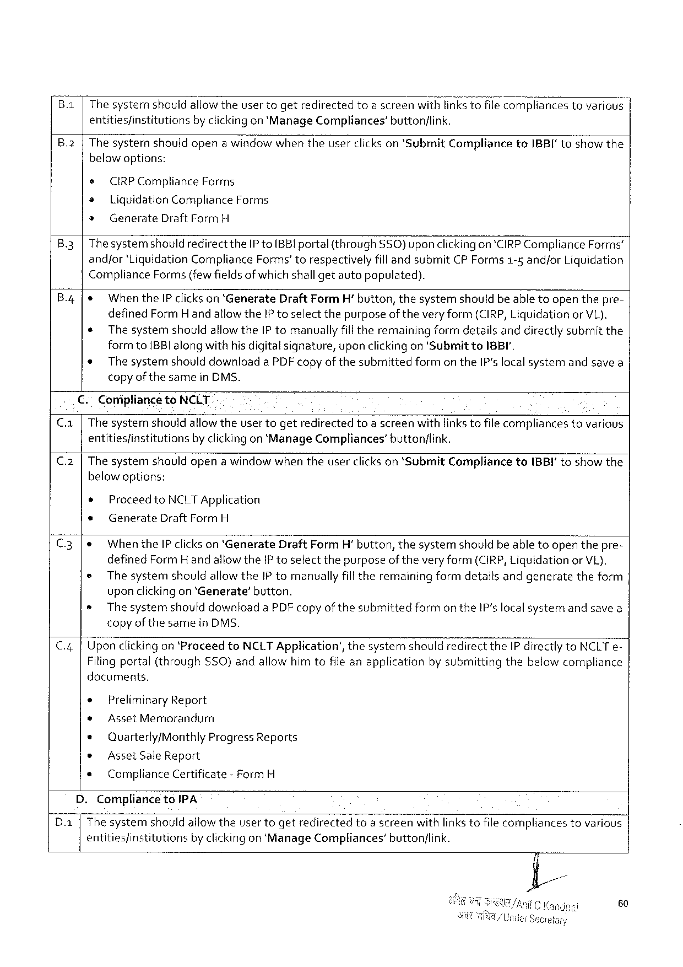

B.1|The systemshouldallowtheuser togetredirectedtoa screenwithlinkstofilecompliancestovarious | entities/institutionsby clickingon ‘Manage Compliances’buttonlink.

|  |  |  |  |  |  |
| --- | --- | --- | --- | --- | --- |
| B.2|Thesysternshouldopenawindowwhentheuserclickson‘Submit | | | | Compliance | to IBBI'toshowthe |
| below options: | | | |
| ¢ | CIRPC ompliance | | Forms |
| o | Liquidation Compliance Forms | | |
| » | Generate | Draft Form H | |

B.3|Thesystemshouldredirectthe[P to BB! portal(through SSO)upon clickingon*CIRPC ompliance Forms’andjor‘Liguidation Compliance Forms’torespectivelyfill andsubmit CP Forms 1-5 andfor Liquidation Compliance Forms{fewfieldsof whichshallgetautopopulated).

B.4|& When the IP clickson ‘Generate Draft Form H' button, thesystemshouldbe abletoopenthepre- defined Form Handallowthe IP toselectthepurposeoftheveryform(CIRP, Liquidationor VL). e The systemshouldallowthe IP tomanuallyfilltheremainingformdetailsanddirectlysubmitthe formto 1 BBI along withhisdigitalsignature, upon clickingon 'Submitto IBBI',   
 * Thesystemshould downloada PDF copyof thesubmittedformon the IP'slocalsystemandsavea copyof the samein DMS.

|  |  |  |
| --- | --- | --- |
| Ca | €. | Comiplianceto NCLT |
| The systemshouldallowtheuser togetredirectedtoa screenwithlinkstofilecompliancestovarious |
| entitiesfinstitutionsby clickingon ‘Manage Compliances’buttonflink. |

C.2|The systemn shouldopena windowwhen theuserclickson *Submit Complianceto IBBI' toshowthe below options:

® Proceed to NCLTA pplication

* Generate Draft Form H

C.3|e Whenthe IP clickson ‘Generate Draft Form H’button, thesystemshouldbeabletoopenthepre- defined Form H andallowthe IP toselectthepurposeof theveryform (CIRP, Liguidationor VL). s The systemshouldallowthe IP tomanuallyfilltheremainingformdetailsandgeneratetheform uponclickingon ‘Generate’button.

o The systemshoulddownloada PDF copy ofthesubmittedformon the IP‘slocalsystemandsavea copy of thesamein DMS.

C.4|Upon clickingon ‘Proceedto NCLT Application’, thesystemshouldredirectthe IP directlyto NCLT e-Filingportal(through SSO)andallowhimtofileanapplicationby submittingthebelowcompliance documents,

e Preliminary Report

* Asset Memorandum

s Quarterly/Monthly Progress Reports

* Asset Sale Report

s Compliance Certificate- Form H

D.‘Complianceto IPA

Da [ The systemshould allowtheuser togetredirectedtoa screenwithlinkstofilecompliancestovarious entities/institutions by clickingon‘Manage Compliances’ button/link.

60

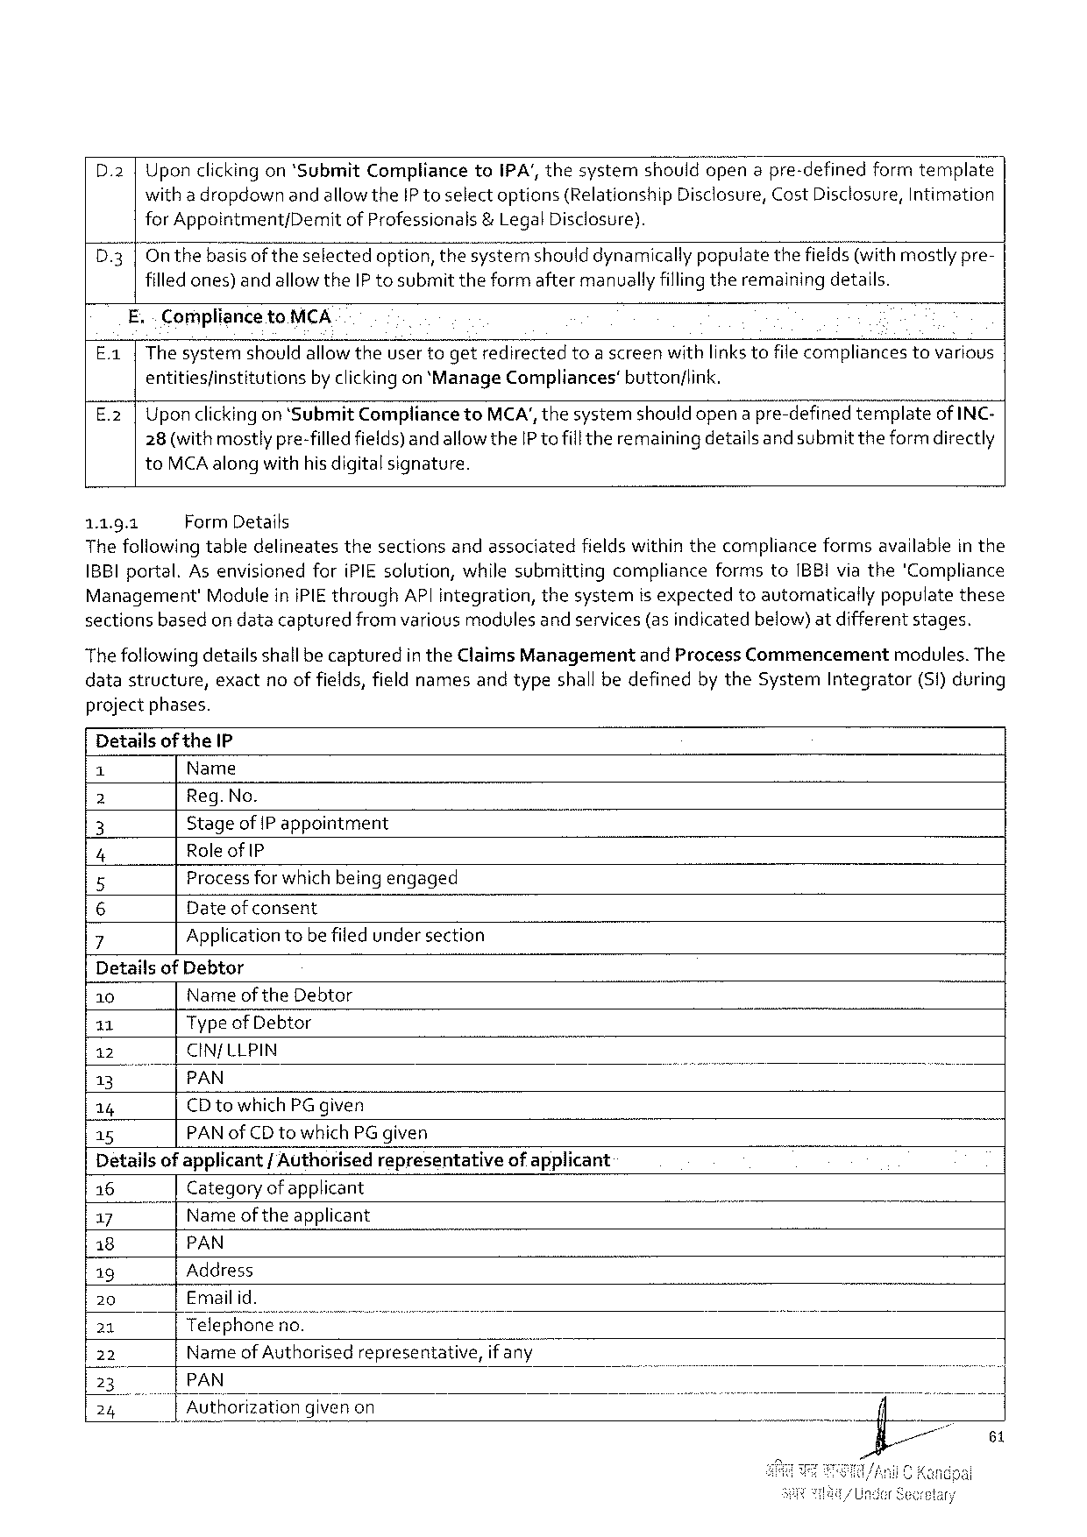

Uponclickingon*Submit Complianceto IPA’, thesystemshouldopena pre-definedformtemplate with a dropdownandallowthe IP toselectoptions(Relationship Disclosure, Cost Disclosure, Intimation

|  |  |  |  |
| --- | --- | --- | --- |
| D 3 | for Appointment/Demit | of Professionals | &Legal Disclosure). |
| Onthebasisof theselectedoption, thesystémshould dynamically populatethefields(withmostlypre-filledones) andallowthe IP tosubmittheformaftermanually fillingtheremainingdetalls. | | |

E. . Complianceto MCA

|  |  |  |  |
| --- | --- | --- | --- |
| E 1 | Thesystemshouldallowtheusertogetredirected | toascreenwithlinks tofile compliances | tovarious |

entitiesfinstitutionsby clickingon ‘Manage Compliances’button/link.

E.2 |Uponclickingon ‘Submit Complianceto MCA', thesystemshould opena pre-definedtemplateof INC-28(withmostlypre-filledfields)andallowthe IP tofillthe remainingdetailsand submit theformdirectly to MCA alongwithhis digitalsignature.

1.1.9.1 Form Details   
The following tabledelineatesthesectionsandassociatedfields withinthecomplianceformsavailablein the 1 BBI portal. As envisionedfori PIE solution, whilesubmittingcomplianceformsto IBBI viathe'‘Compliance Management'Modulein i PIE through AP| integration, thesystemisexpectedtoautomaticailypopulatethese sectionsbasedon datacapturedfrom variousmodulesand services(as indicatedbelow)atdifferentstages.

Thefollowingdetailsshallbe capturedin the Claims Managementand Process Commencement modules. The datastructure, exactnoof fields, fieldnamesandtypeshall bedefinedby the System Integrator(S 1)during projectphases.

Detailsof the IP

|  |  |
| --- | --- |
| e  (e  |  e | Name  Reg. No.  Stageof |Pappointment  Role of IP |

Process forwhich beingengaged   
o   
 Dateof consent

|  |  |
| --- | --- |
| ~Nov | Applicationtobe filed undersection |

Detailsof Debtor

|  |  |  |  |  |  |  |  |  |
| --- | --- | --- | --- | --- | --- | --- | --- | --- |
| 10 | Name of the Debtor | | | | | | [,1 | B |
| 11 | Typeof Debtor | | | | | |
| 12 | CIN/LLPIN | | | | | |
| 13 | |PAN | | | | | |
| 14 | CD towhich PG given | | | | | |
| 15 | PAN of CD towhich PG given | | | | | |
| Detailsof applicant | | | | / Authorisedrepresentative | | ofapplicant |
| 16 | Category ofapplicant | | | | | |
| 17 | " | | Nameoftheapplicant | | | |
| 18 | PAN | | | | | |
| ig | Address | | | | | |
| 20 | Emailid. | | | | | |
| 21 | |Telephoneno. | | | | | |
| 22 | Name of Authorisedrepresentative, ifan\/‘" | | | | | |
| I 3 | PAN | | | | | |
| 24 | B | Authorization | | | givenon | |

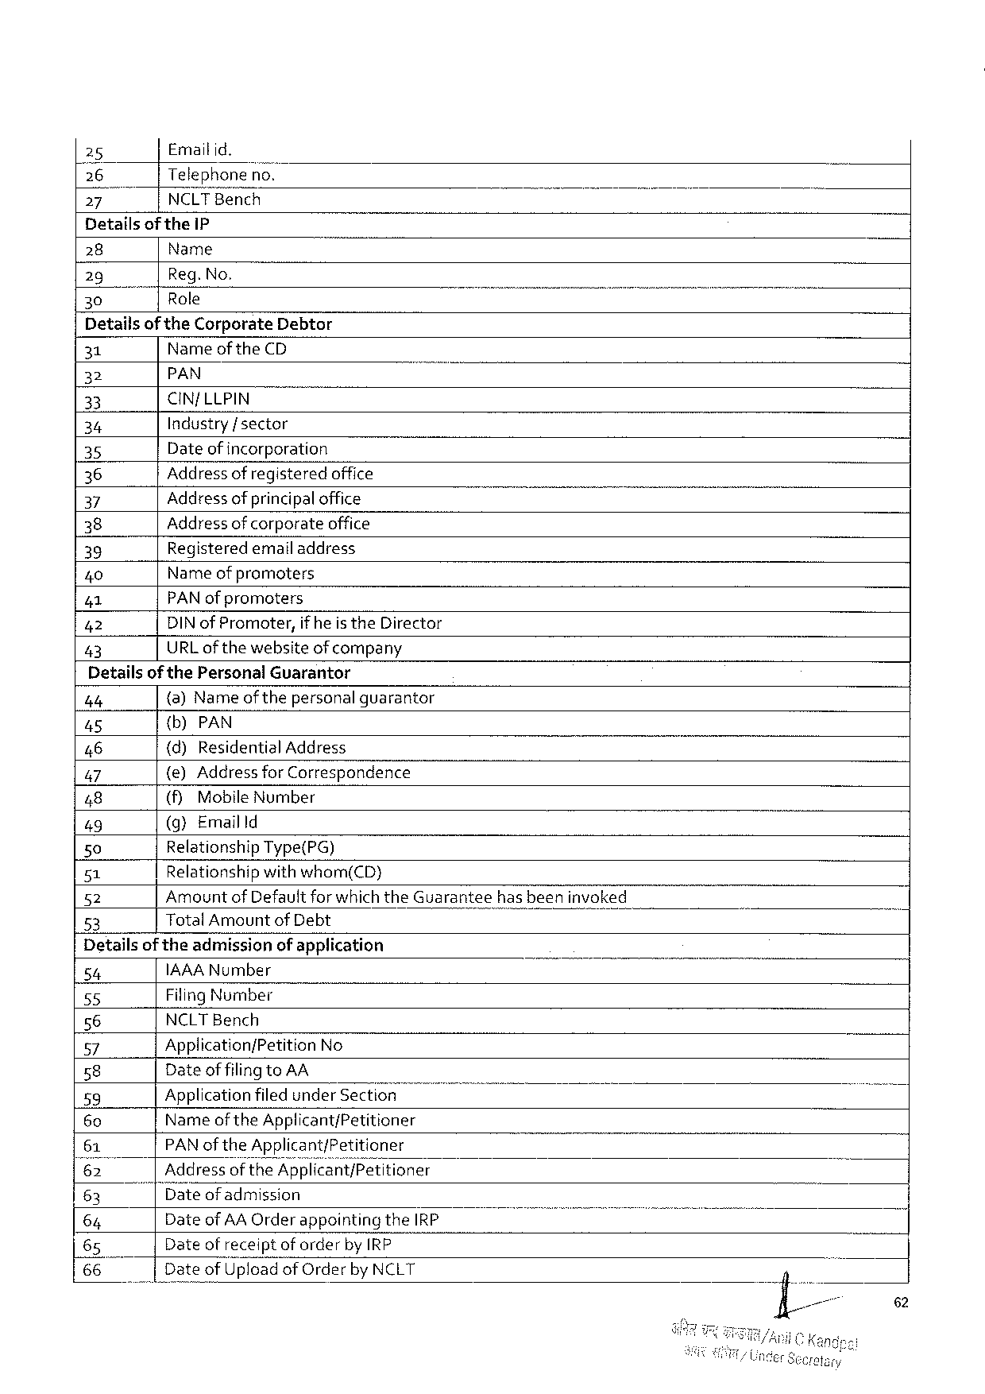

25 Emailid.

[26 Telephoneno.

27 NCLTB ench

Detailsof the IP

|  |  |  |  |
| --- | --- | --- | --- |
| 28 | Name | | /00 T |
| Reg. No. | |
| 29 |
| 30 | “TR ole | — |

Detailsof the Corporate Debtor

|  |  |  |  |
| --- | --- | --- | --- |
| 31 | Nameof the CD | | o |
| 32 | PAN | - |
| 33 | CIN/LLPIN | |
| 34 | Industry/ sector | |
| 35 |
| Dateof incorporation | |
| 36 | Address of registeredoffice | |
| 37 | Address of principaloffice | |
| 38 | Address ofcorporateoffice | |
| 39 | Registeredemail address | |
| 40 | Name of promoters | |
| 41 |
| PAN ofpromoters | |
| 42 | DIN of Promoter, if heis the Director | |
| 43 | URL of thewebsiteof company | |

Detailsof the Personal Guarantor

|  |  |  |  |  |  |  |
| --- | --- | --- | --- | --- | --- | --- |
| 44 | {a) Name of thepersonal guarantor | | | | hasbeeninvoked | ] |
| 45 | {b)PAN | | | |
| 46 | (d)Residential | | | Address |
| 47 | {e)Address for Correspondence | | | |
| 48 | (fy | Mobile | Number | |
| 49 | (g)Emailld | | | |
| 50 | Relationship Type(PG) | | | |
| 51 | Relationshipwithwhom(CD) | | | |
| 52 | Amountof Defaultforwhich the Guarantee | | | |
| 53 | Total Amountof Debt | | | |

Detailsoftheadmissionof application

|  |  |  |  |  |  |  |
| --- | --- | --- | --- | --- | --- | --- |
| 54 | IAAAN umber | | | T | . | - |
| 55 | Filing Number | | |
| 56 | NCLTB ench | | |
| 57 | Application/Petition No | | |
| 58 | Dateoffilingto AA | | |
| 59 |
| Applicationfiled under Section | | |
| 60 | Nameof the Applicant/Petitioner | | |
| 61 | PAN of the Applicant/Petitioner | | |
| 62 | ddressofthe Applwcant/P’e‘t\tioner | | |
| 63 | ateof admission | | |
| Dateof AA Orderappointing | | the IRP |
| 64 |
| 65 | Dateofreceiptof orderby IRP | | |
| 66 | Dateof Up Ioad | of Orderby NCLT | |

62

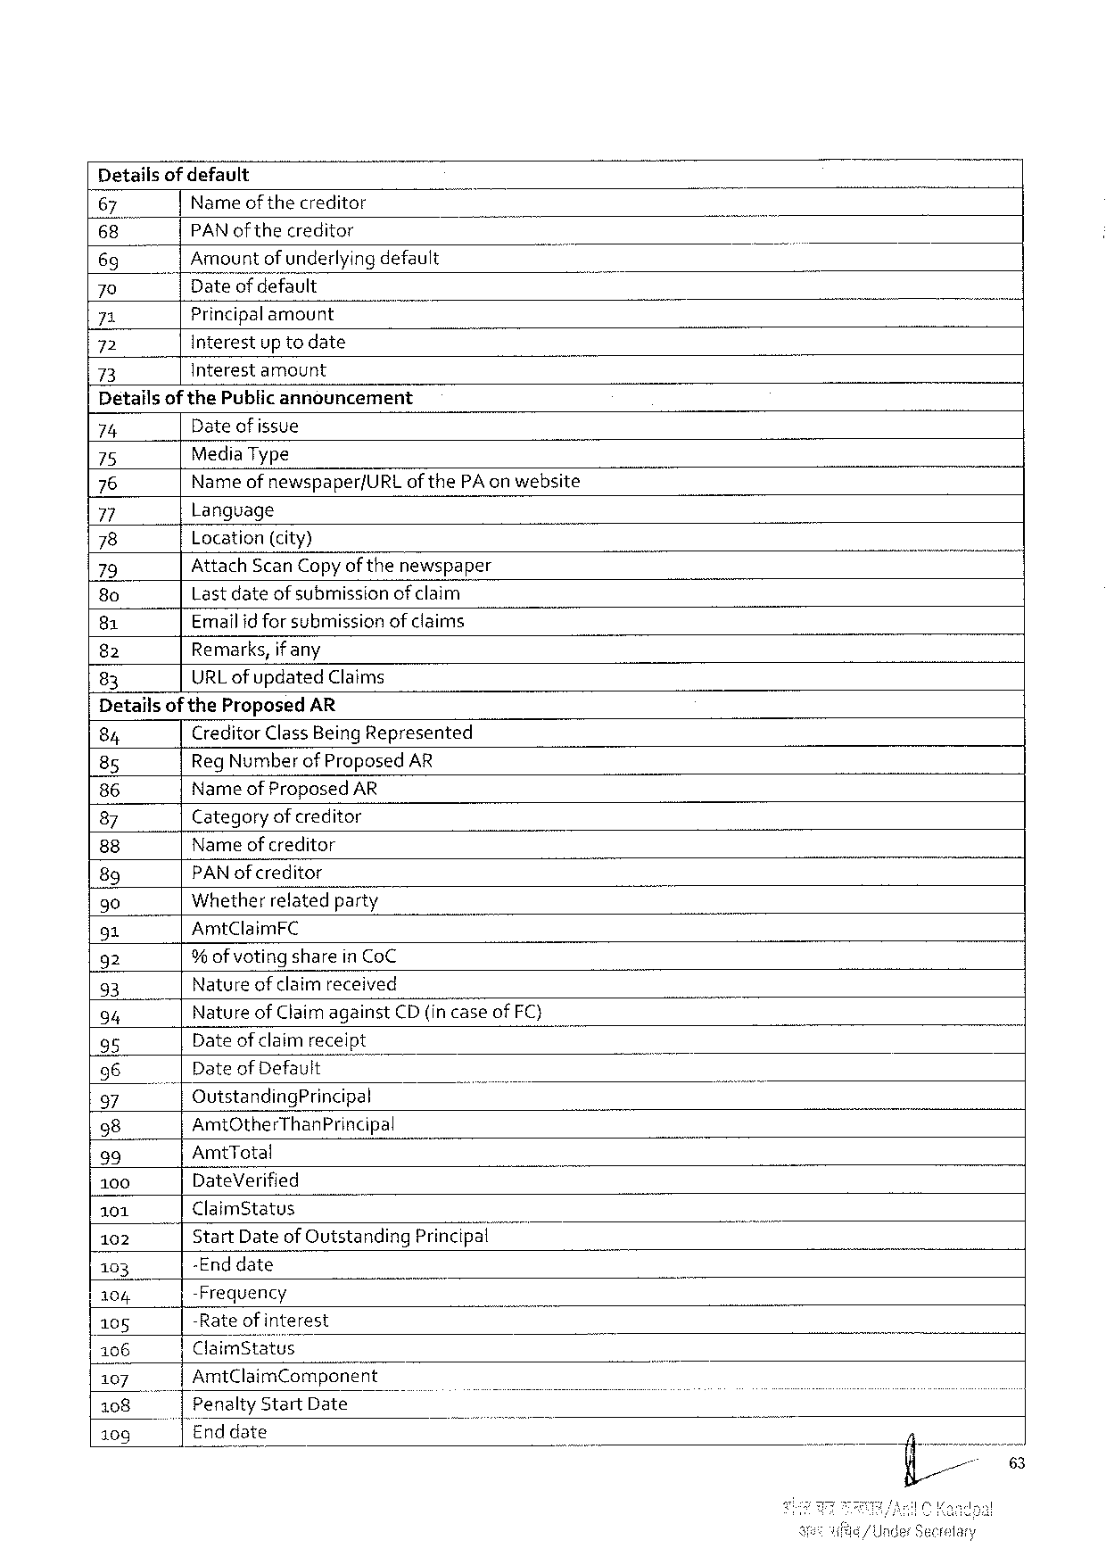

Detailsof default

|  |  |  |  |  |
| --- | --- | --- | --- | --- |
| 67 | Nameofthecreditor | i | o | - |
| 68 | PAN of the creditor |
| 69 | Amountof underlyingdefault |
| 70 | Dateofdefault |
| 71 | Principalamount |
| 72 | Interestup todate |
| 73 | Interestamount |

Detailsof the Public announcement

|  |  |  |  |
| --- | --- | --- | --- |
| 74 | Date of issue | | T |
| 75 | Media Type | |
| 76 | Name of newspaper/URL of the PA on website | |
| Language | |
| 77 |
| 78 | Location(city) | |
| 79 | Attach Scan Copyof thenewspaper | |
| 80 | Lastdateof submissionofclaim | |
| Emailid for submissionof claims | |
| 81 |
| Remarks, if any | |
| 82 |
| URL ofupdated | Claims |
| 83 |

Detailsofthe Proposed AR

|  |  |  |  |  |  |  |
| --- | --- | --- | --- | --- | --- | --- |
| 84 | Creditor Class Being Represented | | | ) | o | - |
| Reg Number of Proposed AR | | |
| 85 |
| Name of Proposed AR | | |
| 86 |
| Category of creditor | | |
| 87 |
| Name ofcreditor | | |
| 88 |
| PAN ofcreditor | | |
| 89 |
| Whetherrelatedparty | | |
| 90 |
| 91 | Amt Claim FC | | |
| 92 | % ofvoting sharein Co C | | |
| Nature of claimreceived | | |
| 93 |
| Nature of Claimagainst | | CD (in case of FC) |
| 94 |
| Dateof claimreceipt | | |
| 95 |
| 96 | Date of Default | | |
| Outstanding Principal | | ) |
| 97 |
| 98 | Amt Other Than Principal | | | o |
| 39 | Amt Total | | |
| 100 | Date Verified | | |
| 101 | Claim Status | | |
| 102 | Start Dateof Outstanding Princlpa{u | | |
| -Enddate | | |
| 103 |
| -Frequency | | |
| 104 |
| -Rateofinterest | | |
| 105 |
| Claim Status | | |
| 106 |
| 4107 | Amt Claim Component | | |
| Penalty | Start Date | ) |
| 108 |
| Enddate | | |
| 109 |

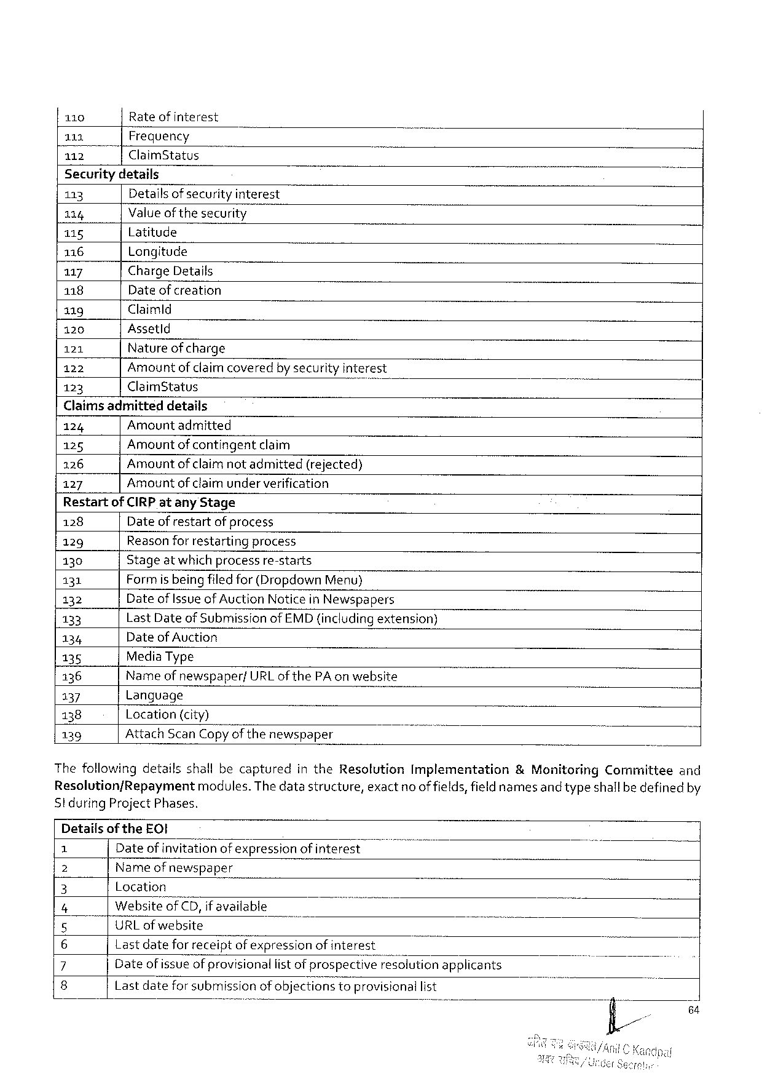

|  |  |  |  |  |  |  |
| --- | --- | --- | --- | --- | --- | --- |
| 110 | Rateofinterest | | o | i | o | ’ |
| 111 | Frequency | |
| 112 | Claim Status | |
| Securitydetails | | |
| 113 | Detailsofsecurity interest | |
| 114 | Valueof thesecurity | |
| 115 | Latitude | |
| 116 | Longitude | |
| 117 | Charge Details | |
| 118 | Date of creation | |
| 119 | Claimld | |
| 120 | Assetld | |
| 121 | Natureof charge | |
| 122 | Amountof claimcoveredby securityinterest | |
| 123 | Claim Status | ) |

Claims admitteddetails

124 Amountadmitted

125 Amountof contingentclaim

126 Amountofclaimnotadmitted (rejected)

127 Amountofclaimunderverification

Restartof CIRP atany Stage

128 Dateof restartofprocess

129 Reasonforrestarting process

130 Stageat which processre-starts

131 Formis being filedfor (Dropdown Menu)

132 Dateof Issue of Auction Notice in Newspapers

133 Last Dateof Submissionof EMD(includingextension)

134 Dateof Auction

135 Media Type

136 Nameof newspaper/URL of the PA on website i

137 Language

138 Location(city)

139 Attach Scan Copyofthenewspaper T B

Thefollowingdetailsshallbecapturedinthe Resolution Implementation &Monitoring Committee and

Resolution/Repayment modules. Thedatastructure, exact no of fields, fieldnamesand typeshallbedefinedby

Stduring Project Phases.

Detailsof the EOI

Dateofinvitation ofexpressionofinterest

Narne of newspaper

Wi Location

e Website’o‘f CD, if available

URL of website

|  |  |  |
| --- | --- | --- |
| o | Lastdatefor receiptofexpressionof interest | applicants |
| o~ | Dateof issueofprovisionallist ofprospectrv’e”feso! ution |
| Lastdateforsubmissionof objectionstoprovisionallist |

64

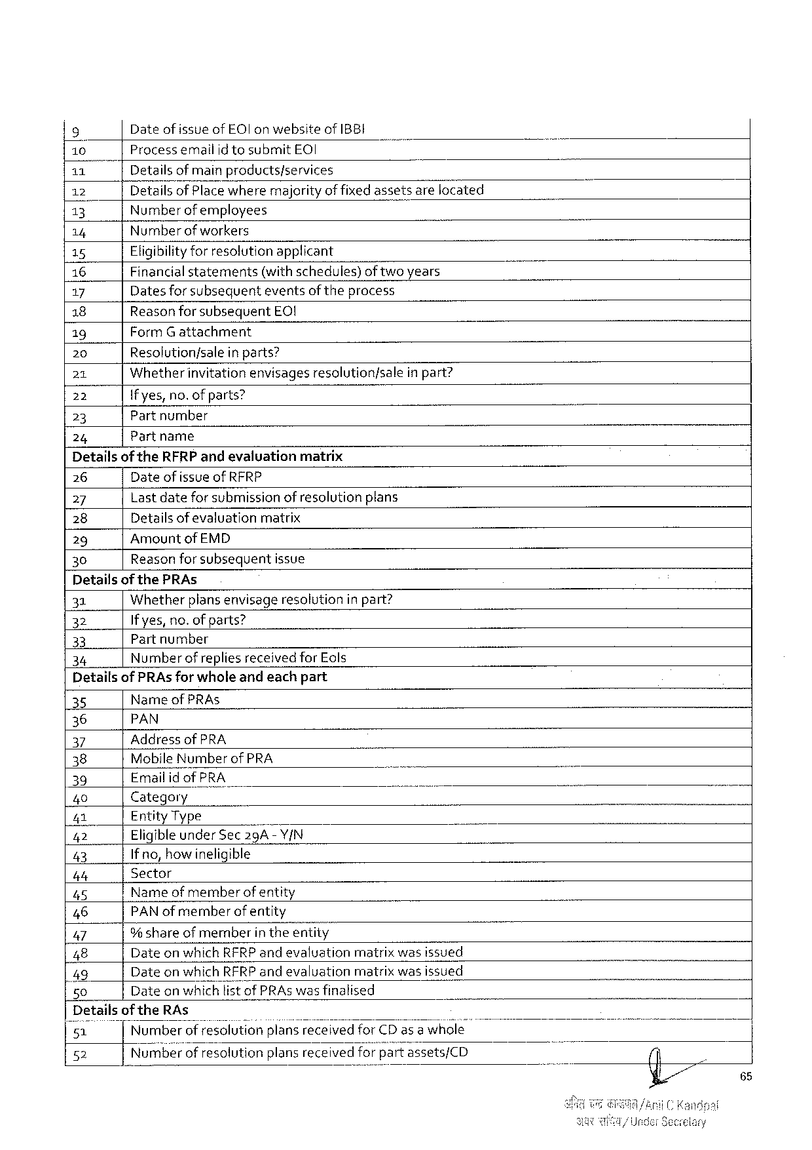

|  |  |  |  |  |  |  |
| --- | --- | --- | --- | --- | --- | --- |
| 9 | Dateofissueof EO l on websiteof IBBI | | | | | B |
| [10 | Processemailidtosubmit EOI | | | ) | |
| 11 | Detailsof main products/services | | | | |
| 12 | Detailsof Placewheremajorityof fixedassetsarelocated | | | | |
| 13 | Number ofemployees | | | | |
| 14 | Numberof workers | | | | |
| 15 | Eligibilityforresolutionapplicant | | | | |
| 16 | Financialstatements(withschedules)of twoyears | | | | |
| 17 | Dates for subsequenteventsof theprocess | | | | |
| 18 | Reasonforsubsequent | EQ! | | | |
| 19 | Form Gattachment | | | | |
| 20 | Resolution/salein parts? | | | | |
| 21 | Whetherinvitationenvisages | | resolution/sale | | inpart? |
| 22 | {fyes, no. of parts? | | | | |
| 23 | Partnumber | | | | |
| 24 | Partname | | | | |

Detailsof the RFRP andevaluationmatrix

26 Dateof issueof RFRP

27 Lastdateforsubmission of resolutionplans

28 Detailsof evaluation matrix

29 Amountof EMD

30 Reasonforsubsequentissue

Detailsof the PRA s

31 Whether plansenvisage resolution in pant?

32 If yes, no. of parts?

33 Partnumber

34 Number ofreplies receivedfor Eols

Detailsof PRA sfor wholeandeachpart

35 Nameof PRA s

36 PAN

37 Addressof PRA

38 Mobile Numberof PRA -~

39 Emailidof PRA e

40 Category

|42 Entity Type

42 Eligibleunder Sec 29 A-Y/N

43 Ifno, howineligible

b 4 Sector

45 Nameof memberof entity

46 PAN of memberofentity

47 9% shareof member intheentity

48 Dateonwhich RFRP andevaluation matrixwasissued

49 Dateonwhich RFRP andevaluation matrixwasissued

50 Date on whichlist of PRA s wasfinalised

Details of the RA s _

51 Numberofresolutionplansreceivedfor CD as a whole

52 Numberofresolution plansreceived for‘;; a‘v"tassets/CD

65

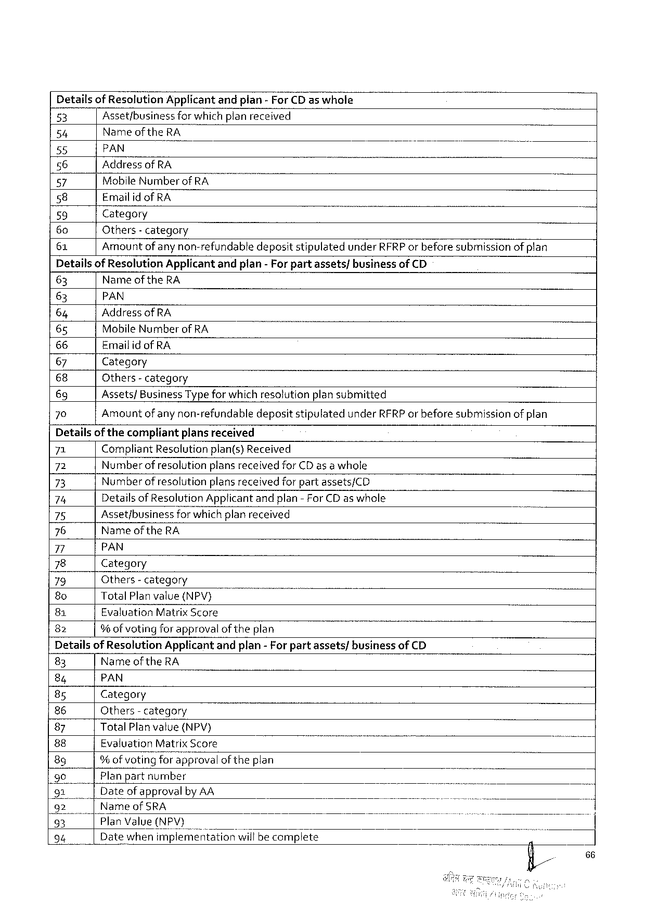

Detailsof Resolution Applicantandpian- For CD as whole

|  |  |  |  |  |
| --- | --- | --- | --- | --- |
| 53 | Asset/business | forwhichplanreceived | | ] |
| 54 | Name of the RA | | |
| 55 | PAN | ) | - |
| 56 |
| Addressof RA | | |
| 57 | Mobile Number of RA | | |
| 58 |
| Emailidof RA | | |
| 59 | Category | - | |
| 60 |
| Others- category | | |
| 61 |
| Amount ofany non-refundabledepositstipulatedunder RFRP or beforesubmissionof plan | | |

Detailsof Resolution Applicantandplan-For partassets/businessof CD

63 Name of the RA

63 PAN

64 Addressof RA

65 Mobile Number of RA

66 Emailid of RA

67 Category

68 Others- category

69 Assets/Business Typefor which resolutionplansubmitted

70 Amountof any non-refundabledepositstipulatedunder RFRP or beforesubmissionof plan

Detailsofthecompliantplansreceived

|  |  |  |  |  |
| --- | --- | --- | --- | --- |
| 71 | Compliant Resolutionplan(s)Received | | | - |
| 72 | Number ofresolutionplans receivedfor CD as awhole | | |
| 73 |
| Numberofresolution | | plansreceivedforpartassets/CD |
| 74 | Detailsof Resolution Applicantandplan-For CD aswhole | | |
| 75 | Asset/business | forwhichplanreceived | |
| 76 |
| Nameofthe RA | | |
| 7 |
| PAN | | |
| 78 | Category | | |
| 79 | Others- category | | |
| 8 o |
| Total Planvalue(NPV) | | T |
| 81 | Evaluation Matrix Score | | |
| 82 |
| %of voting forapprovalof theplan | | |

Detailsof Resolution Applicantandplan-For partassets/businessof CD

|  |  |  |  |  |  |
| --- | --- | --- | --- | --- | --- |
| 83 | Name of the RA | B | ) | - | - |
| 84 | PAN |
| 8 s | Category |
| 86 | Others- category |
| 87 | Total Planvalue{(NPV) |
| 88 | Evaluation Matrix Score |
| 8 g | % ofvoting forapprovalof theplan |
| 90 |
| Planpartnumber |
| 91  92| | Dateof approvalby AA  Nameof SRA |
| 95 | |Plan Value(NPV) |
| 94 | Datewhenxmplemé’ntationrwifibecomplete |

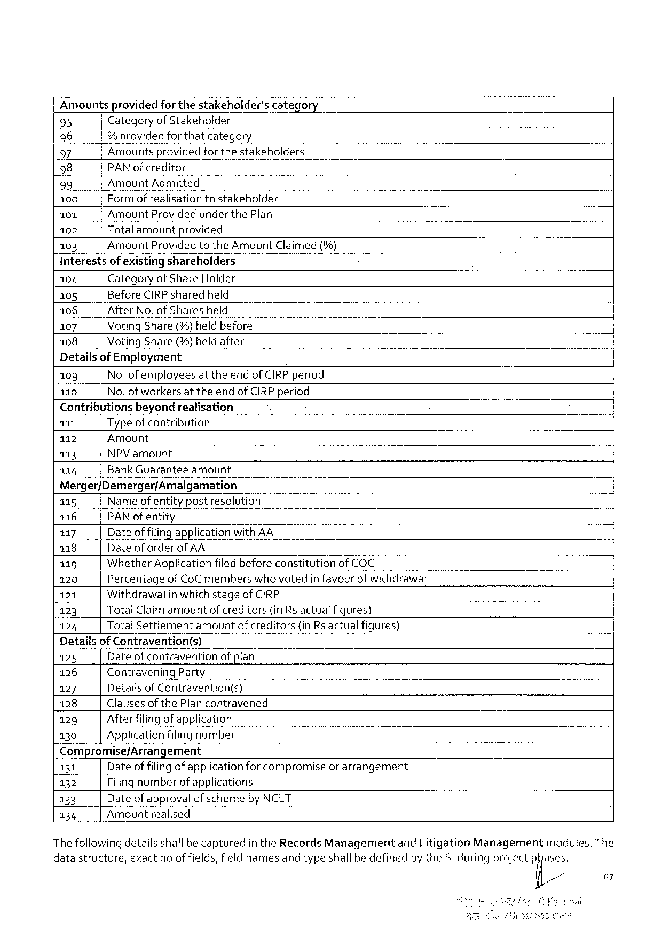

|  |  |  |  |  |  |  |  |  |  |
| --- | --- | --- | --- | --- | --- | --- | --- | --- | --- |
| Amountsprovidedfor thestakeholder's | | | | | | category | . | . | - |
| 95 | Categoryof Stakeholder | | | | | |
| 96 | | | | % providedforthatcategory | | | |
| 97 | Amountsprovidedforthestakeholders | | | | | | N |
| 98 | PAN ofcreditor | | | | B | - |
| 99 | Amount Admitted | | | | | |
| 100 | Formofrealisationtostakeholder | | | | | |
| 101 | Amount Providedunderthe Plan | | | | | |
| 102 | | Totalamountprovided | | | | |
| 103 | Amount | | | Providedtothe Amount Claimed(%) | | |

Interestsof existingshareholders

104 Categoryof Share Holder

105 Before CIRP sharedheld

106 After No. of Sharesheld

107 Voting Share (%)heldbefore

108 Voting Share(%)heldafter

Detailsof Employment

109 No. of employeesat theendof CIRP period

110 No. of workersat theendof CIRP period

Contributionsbeyondrealisation

111 Typeof contribution

112 Amount

113 NPV amount

114 Bank Guarantee amount

Merger/Demerger/Amalgamation

|  |  |  |  |  |
| --- | --- | --- | --- | --- |
| 115 | Nameof entitypostresolution | | | J |
| 116 | PAN ofentity | | |
| 117 | Dateof filingapplicationwith AA | | |
| 118 | Dateof orderof AA | | |
| 119 | Whether Applicationfiledbeforeconstitutionof COC | | |
| 120 | Percentageof Co C memberswhovotedin favourof withdrawal | | |
| 121 | Withdrawalin which stageof CIRP | | |
| 123 | Total Claimamount | | ofcreditors(in Rsactualfigures) |
| 124 | Total Settlement | amountofcreditors(in Rs actualfigures) | |

Detai! iofggtravention(s)

125 Dateof contravention of plan

126 Contravening Party

127 Detailsof Contravention(s)

128 Clauses of the Plancontravened

129 Afterfilingof application

130 Applicationfilingnumber

Compromise/Arrangement

|  |  |  |
| --- | --- | --- |
| 131| | Dateof filingofapplicationforcompromiseorarrangement | . |
| 132 | Filingnumberof applications |
| 133 | Dateof approvalofschemeby NCLT |
| 134 | Amountrealised |

Thefollowingdetailsshallbecapturedin the Records Managementand Litigation Managementmodules. The

datastructure, exact noof fields, field namesand typeshallbedefinedby the St duringprojectp@is,

67

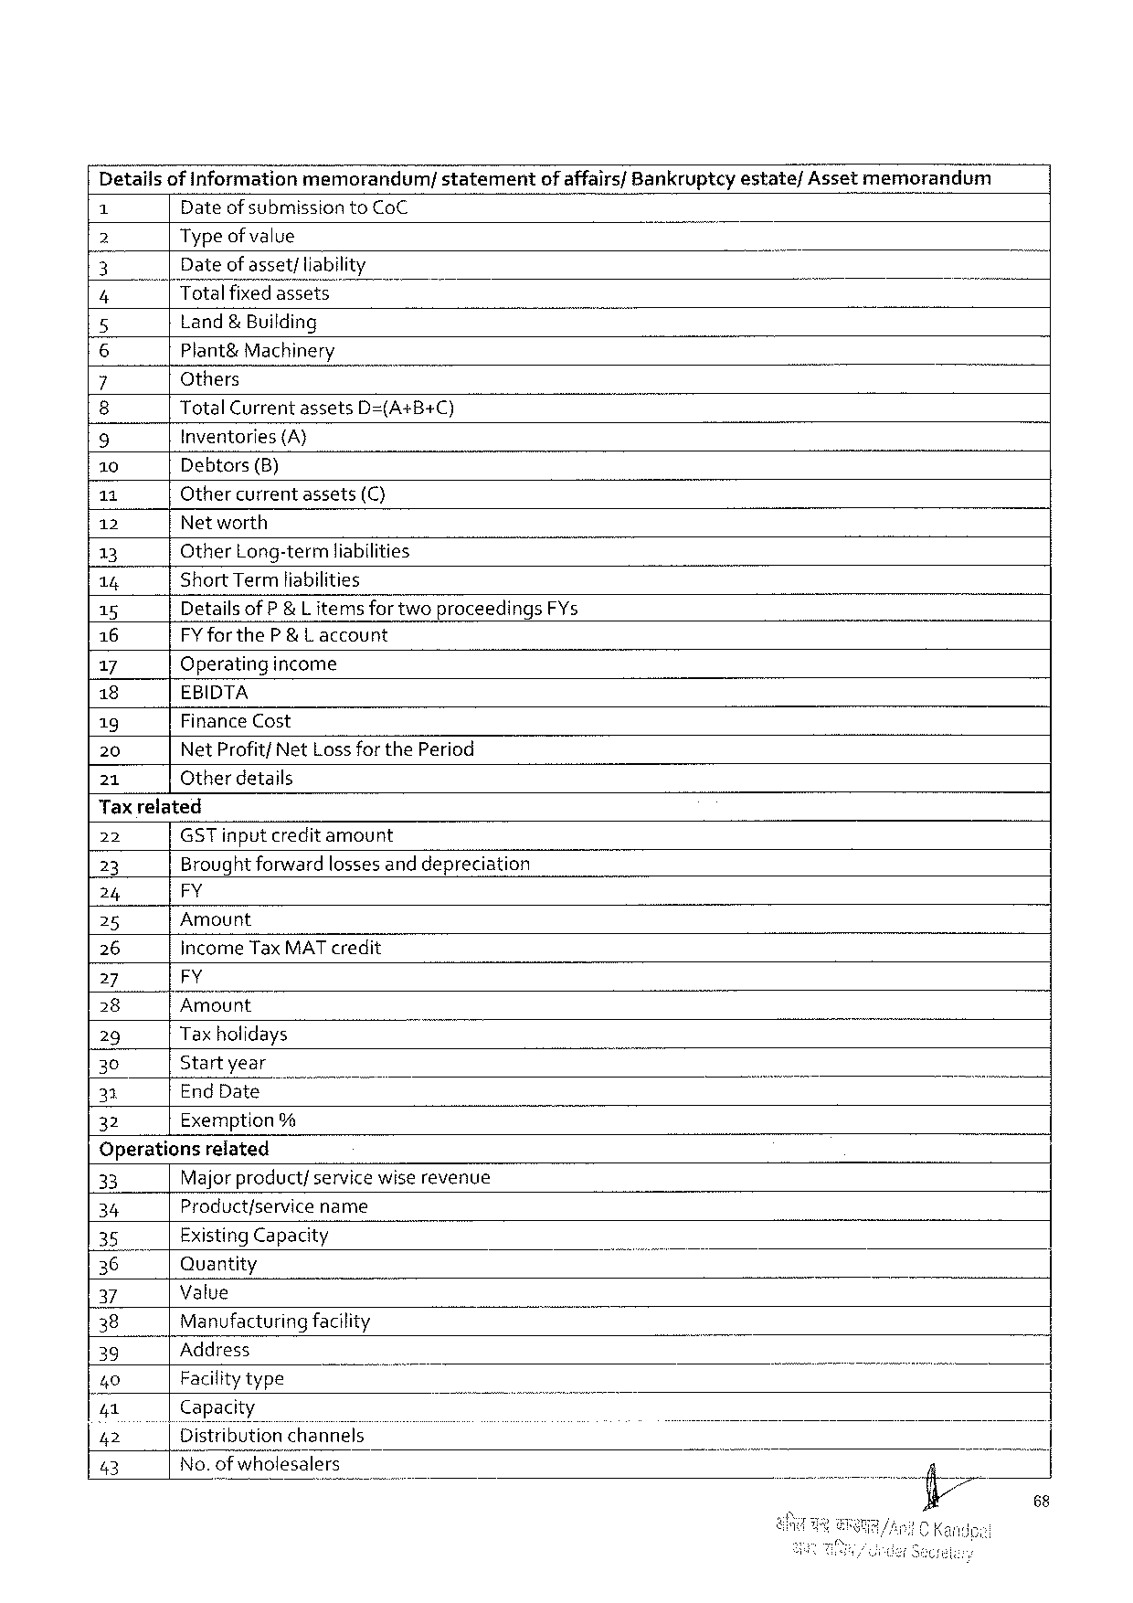

Detailsof informationmemorandum/ statement of affairs/Bankruptcyestate/Assetmemorandum

Dateof submission to Co C

2 Type of value

3 Dateof asset; liability } 7

4 Totalfixedassets -

5 Land& Building

6 Plant&Machinery

7 Others

8 Total Currentassets D=(A+B+C)

9 Inventories (A}

10 Debtors(B)

11 Othercurrentassets(C)

12 Networth

13 Other Long-termliabilities

14 Short Termliabilities

15 Detailsof P &L items for twoproceedings FY s

16 FY for the P&L account

17 Operatingincome

18 EBIDTA

19 Finance Cost

20 Net Profitf Net Lossforthe Period

21 Otherdetails

Tax related

|  |  |  |  |  |  |
| --- | --- | --- | --- | --- | --- |
| 22 | GST inputcredit amount | | - | . | - |
| 23 | Brought forwardlossesand depreciation | |
| 24 | e | |
| 25 | Amount | |
| 26 | Income Tax MAT credit | |
| 27 | FY | |
| 28 | Amount | |
| 29 | Taxholidays | |
| 30 | Startyear | |
| 33 | End Date | ) |
| 32 | Exemption% | |

Operations related

|  |  |  |  |  |  |  |
| --- | --- | --- | --- | --- | --- | --- |
| 33 | Majorproduct/servicewiserevenue | " | - | o | o | i |
| 34 | Productfservice name |
| 35 | Existing Capacity |
| 36 | Quantity |
| 37 | Value |
| 38 | Manufacturingfacility |
| 39 | Address |
| 40 | Facilitytype | T |
| Vz,1 | Capacity |
| Z, z | Distributionchannels |
| 43 | No. ofwholesalers |

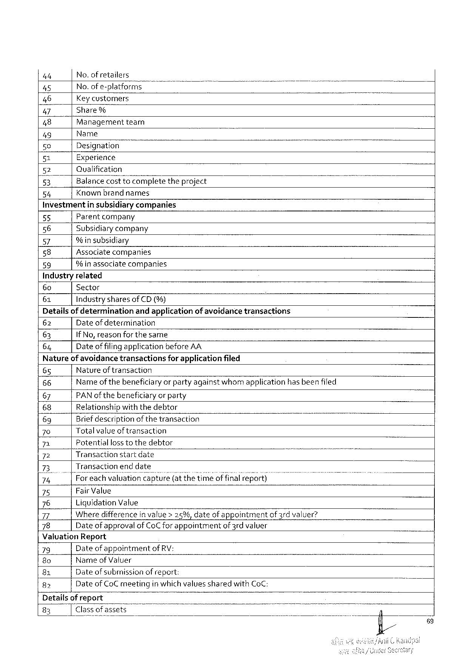

|  |  |  |  |  |
| --- | --- | --- | --- | --- |
| 4 t | No. ofretailers | " | B | - |
| 45 |
| No. ofe-platformsm |
| 46 | Key customers | theproject |
| 47 | Share% |
| 48 | Managementtearn |
| 49 | Name |
| 50 | Designation |
| 51 | Experience |
| 52 | Qualification |
| 5}, | Balancecosttocomplete |
| 54 | Knownbrandnarmes |

Investmentin subsidiarycompanies   
55 Parentcompany   
56 Subsidiarycompany   
57 % insubsidiary   
58   
 Associatecompanies 59 % inassociatecompanies   
Industryrelated

|  |  |  |  |  |  |  |  |  |  |
| --- | --- | --- | --- | --- | --- | --- | --- | --- | --- |
| 60 | Sector | | | | | | ) | B | I |
| 61 | Industrysharesof CD (%) | | | | | |
| Detailsof determination | | | andapplicationof avoidancetransactions | | | |
| 62 | Dateofdetermination | | | | | |
| 63 | If No, reasonforthesame | | | | | |
| 64 | Dateof filingapplicationbefore AA | | | | | |
| Natureof avoidancetransactions | | | | for applicationfiled | | |
| 65 | Natureof transaction | | | | | |
| 66 | Nameofthebeneficiaryorpartyagainstwhomapplication | | | | hasbeenfiled | |
| 67 | PAN of thebeneficiaryor party | | | | | |
| 68 | Relationshipwith thedebtor | | | | | |
| 69 | Briefdescriptionof thetransaction | | | | T | |
| 70 | Totalvalueof transaction | | | | | |
| 71 | Potential | losstothedebtor | | | | |
| 72 | Transactionstartdate | | | | - | T |
| 73 | Transactionend date | | | | | |
| 74 | |Foreachvaluation capture(at thetimeof final report) | | | | | |
| 75 | Fair Value | | | | | |
| 76 | Liquidation Value | | | | | |
| 77 | Wheredifferencein value> 25%, dateofappointmentof 3 rdvaluer? | | | | | |
| 78 | Dateof approvalof Co Cfor appointmentof 3 rdvaluer | | | | | |

Valuation Report

|  |  |  |  |  |
| --- | --- | --- | --- | --- |
| 79 | Dateof appointmentof RV: | | T | N |
| 8 o | Nameof Valuer | |
| 81 | Dateof subrnissionof report: | |
| 82 | Dateof Co Cmeeting | inwhichvaluessharedwith Co C: |

Detailsof report

|  |  |  |
| --- | --- | --- |
| 83 | Classof assets | 4 |

89

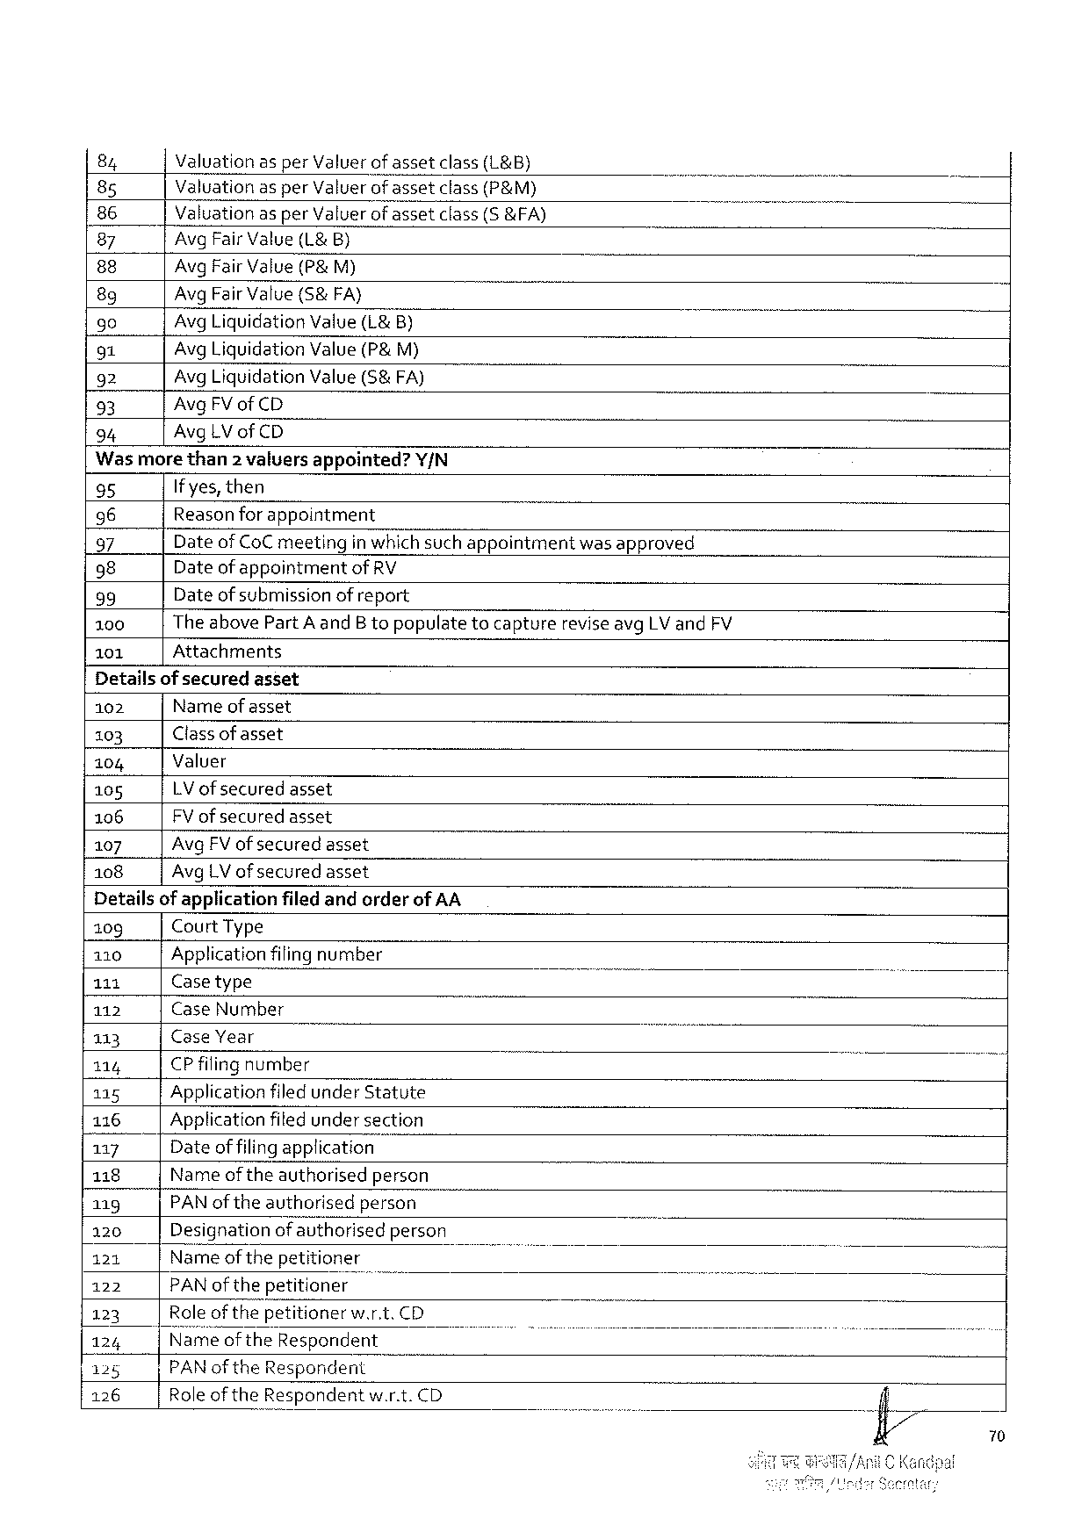

|  |  |  |  |  |  |
| --- | --- | --- | --- | --- | --- |
| 84 | Valuation | asper Valuer | ofasset | class(L&B) | B |
| 85 | Valuationasper Valuerofassetclass(P&M) | | | |
| 86 | Valuationas per Valuerofassetclass(S &FA) | | | |
| 87 | Avg Fair Value(L& B) | | | |
| 88 |
| Avg Fair Value(P& M) | | | |
| 89 | Avg Fair Value(S&FA} | | | |
| 90 | Avg Liquidation Value(L& B) | | | |
| 91 | Avg Liquidation Value(P& M) | | | |
| 92 | Avg Liquidation Value(5& FA) | | | |
| 93 |
| Avg FV of CD | | | |
| 94 |
| Avg LV of CD | | | |

Wasmorethan 2 valuersappointed? Y/N

|  |  |  |  |
| --- | --- | --- | --- |
| 95  96  97  98  99  100 101 | If yes, then  Reasonforappointment | | |
| Dateof Co C meeting | inwhichsuchappointment | wasapproved |
| Dateof appointmentof RV  Dateof submissionofreport  The above Part A and B topopulatetocapturereviseavg LV and FV Attachments | | |

Detailsof securedasset   
102 Nameof asset   
103 Classofasset   
104 Valuer   
105   
 LV of securedasset 106 FV of securedasset   
107 Avg FV ofsecuredasset   
108 Avg LV ofsecuredasset   
Detailsof applicationfiledandorderof AA

|  |  |  |  |  |  |  |  |
| --- | --- | --- | --- | --- | --- | --- | --- |
| 109 | Court Type | | | o | ) | o | ) |
| 110 | Applicationfilingnumber | | |
| 111 | Casetype | | |
| o |
| 112 | Case Number | | |
| 113 | Case Year | | |
| 114 | CP filing | number | |
| 115 | Applicationfiledunder Statute | | |
| 116 | Applicationfitedundersection | | |
| 117 | Dateoffilingapplication | | |
| 118 | Name oftheauthorisedperson | | |
| 119 | PAN oftheauthorisedperson | | |
| 120 | Designationof authorisedperson | | |
| 121 | Name of thepetitioner | | |
| 122 | PAN ofthepetitioner | | o |
| 123 | Roleof thepetitionerw. r. t. CD | | |
| 124 |
| Nameof the Respondent | | |
| 125 | PAN of the Respondent | | |
| 126 | Roleofthe Respondentw. r. t. CD | | |

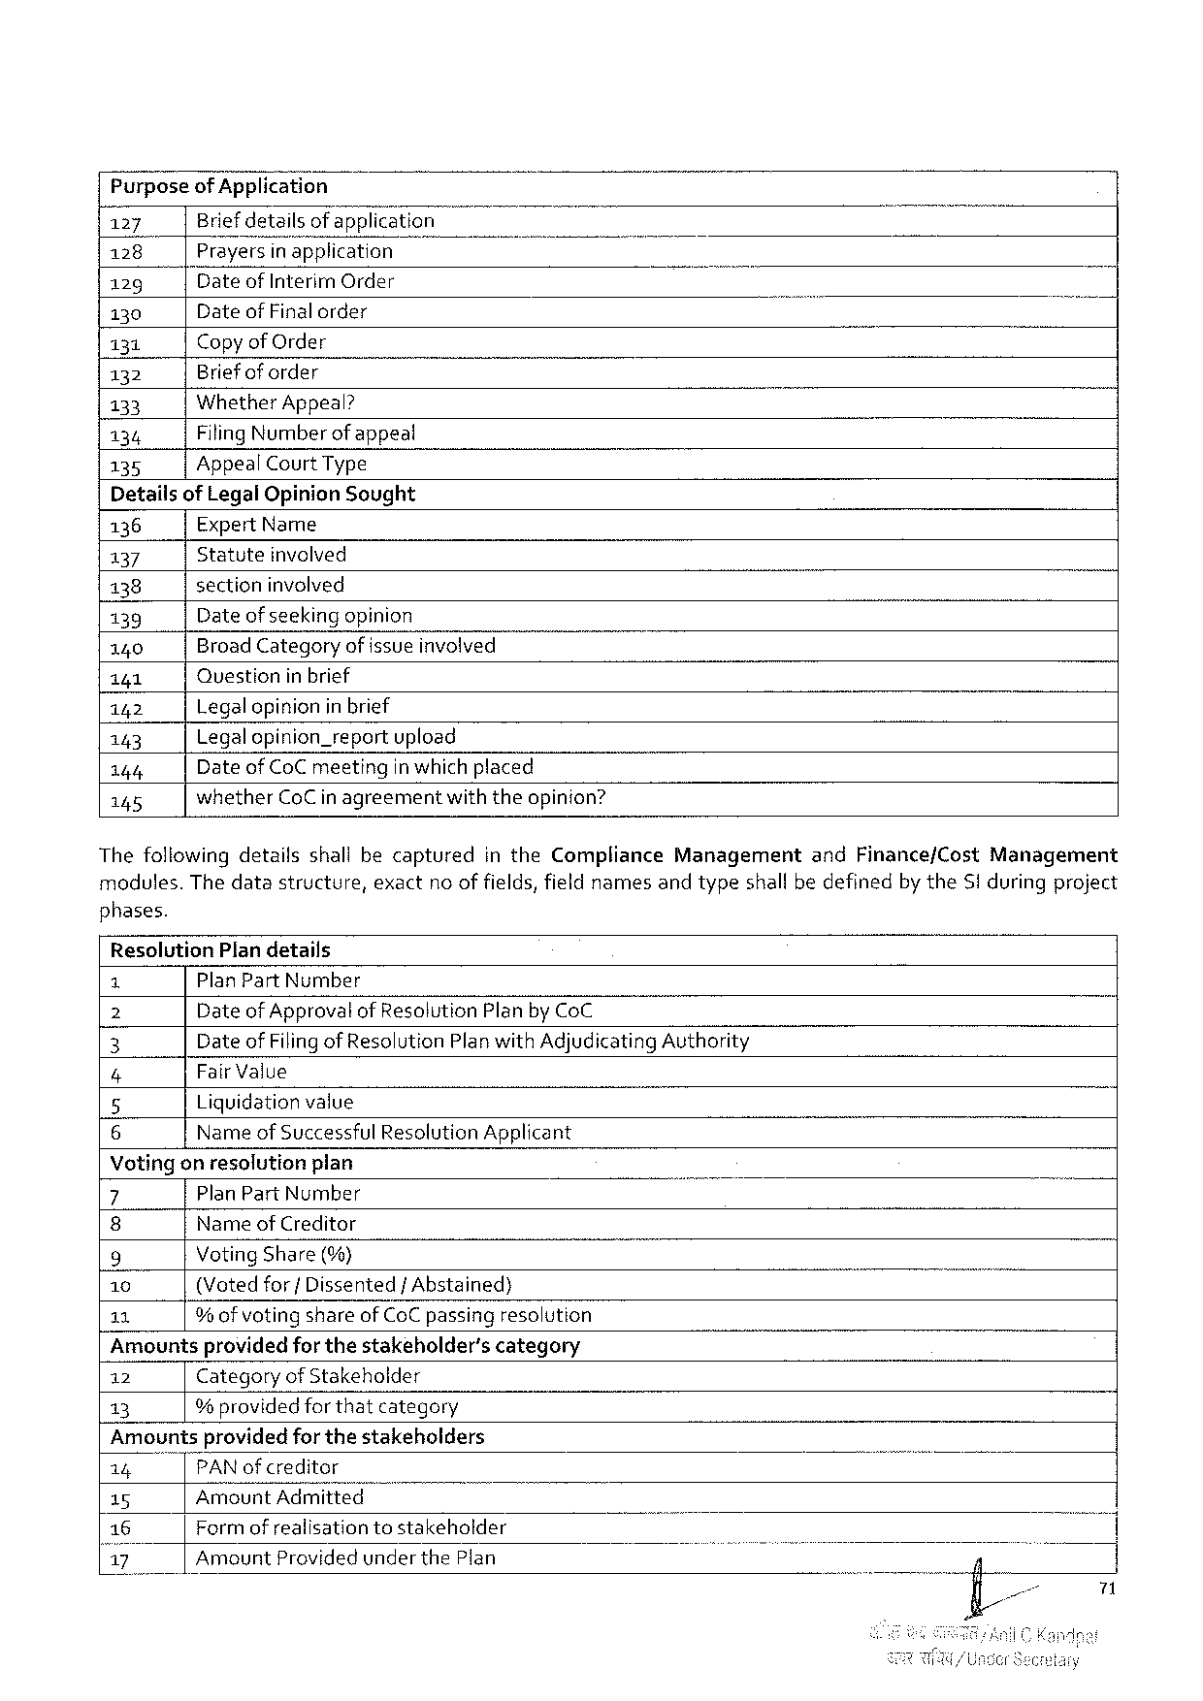

Purposeof Application

|  |  |  |  |  |  |
| --- | --- | --- | --- | --- | --- |
| 127 | Briefdetailsof application | ) | T | B | i |
| 128 | Prayers|r 7; pplicahon |
| 129 | Date of Interim Order |
| 130 | Date of Final order |
| 131 | Copyof Order |
| 132 | Briefof order |
| Whether Appeal? |
| 133 |
| Filing Number ofappeal |
| 134 |
| 135 | Appeal Court Type |

Detailsof Legal Opinion Sought

136 Expert Name

137 Statute involved

138 sectioninvolved

139 Dateof seekingopinion

140 Broad Categoryofissueinvolved

141 Question inbrief

142 Legalopinionin brief

143 Legalopinion_reportupload

144 Dateof Co Cmeetingin which placed

145 whether Co C in agreementwiththeopinion?

Thefollowingdetailsshallbecaptured in the Compliance Management and Finance/Cost Management

modules. Thedatastructure, exactno offields, fieldnamesandtypeshall bedefinedby the Siduringproject

phases.

Resolution Plandetails

1 Plan Part Number

Z Dateof Approvalof Resolution Plan by Co C

3 Date of Filing of Resolution Planwith Adjudicating Authority

4 Fair Value

5 Liquidationvalue

6 Name of Successful Resolution Applicant

Votingonresolutionplan

|  |  |  |  |  |
| --- | --- | --- | --- | --- |
| 7 | Plan Part Number | - | o | - |
| 8 | Nameof Creditor |
| 9 | Voting Share(%) |
| 10 | (Votedfor{ Dissented/Abstained) |
| 11 | % ofvotingshareof Co C passingresolution |

Amountsprovidedfor thestakeholder’scategory

12 Categoryof Stakeholder

13 %providedforthatcategory

Amountsprovidedfor thestakeholders

|  |  |  |  |
| --- | --- | --- | --- |
| 14 | "TPAN ofcreditor | - | o |
| 15 | Amount Admitted |
| 16 | Formofrealisationtostakeholder |
| 17 | Amount Providedunderthe Plan |

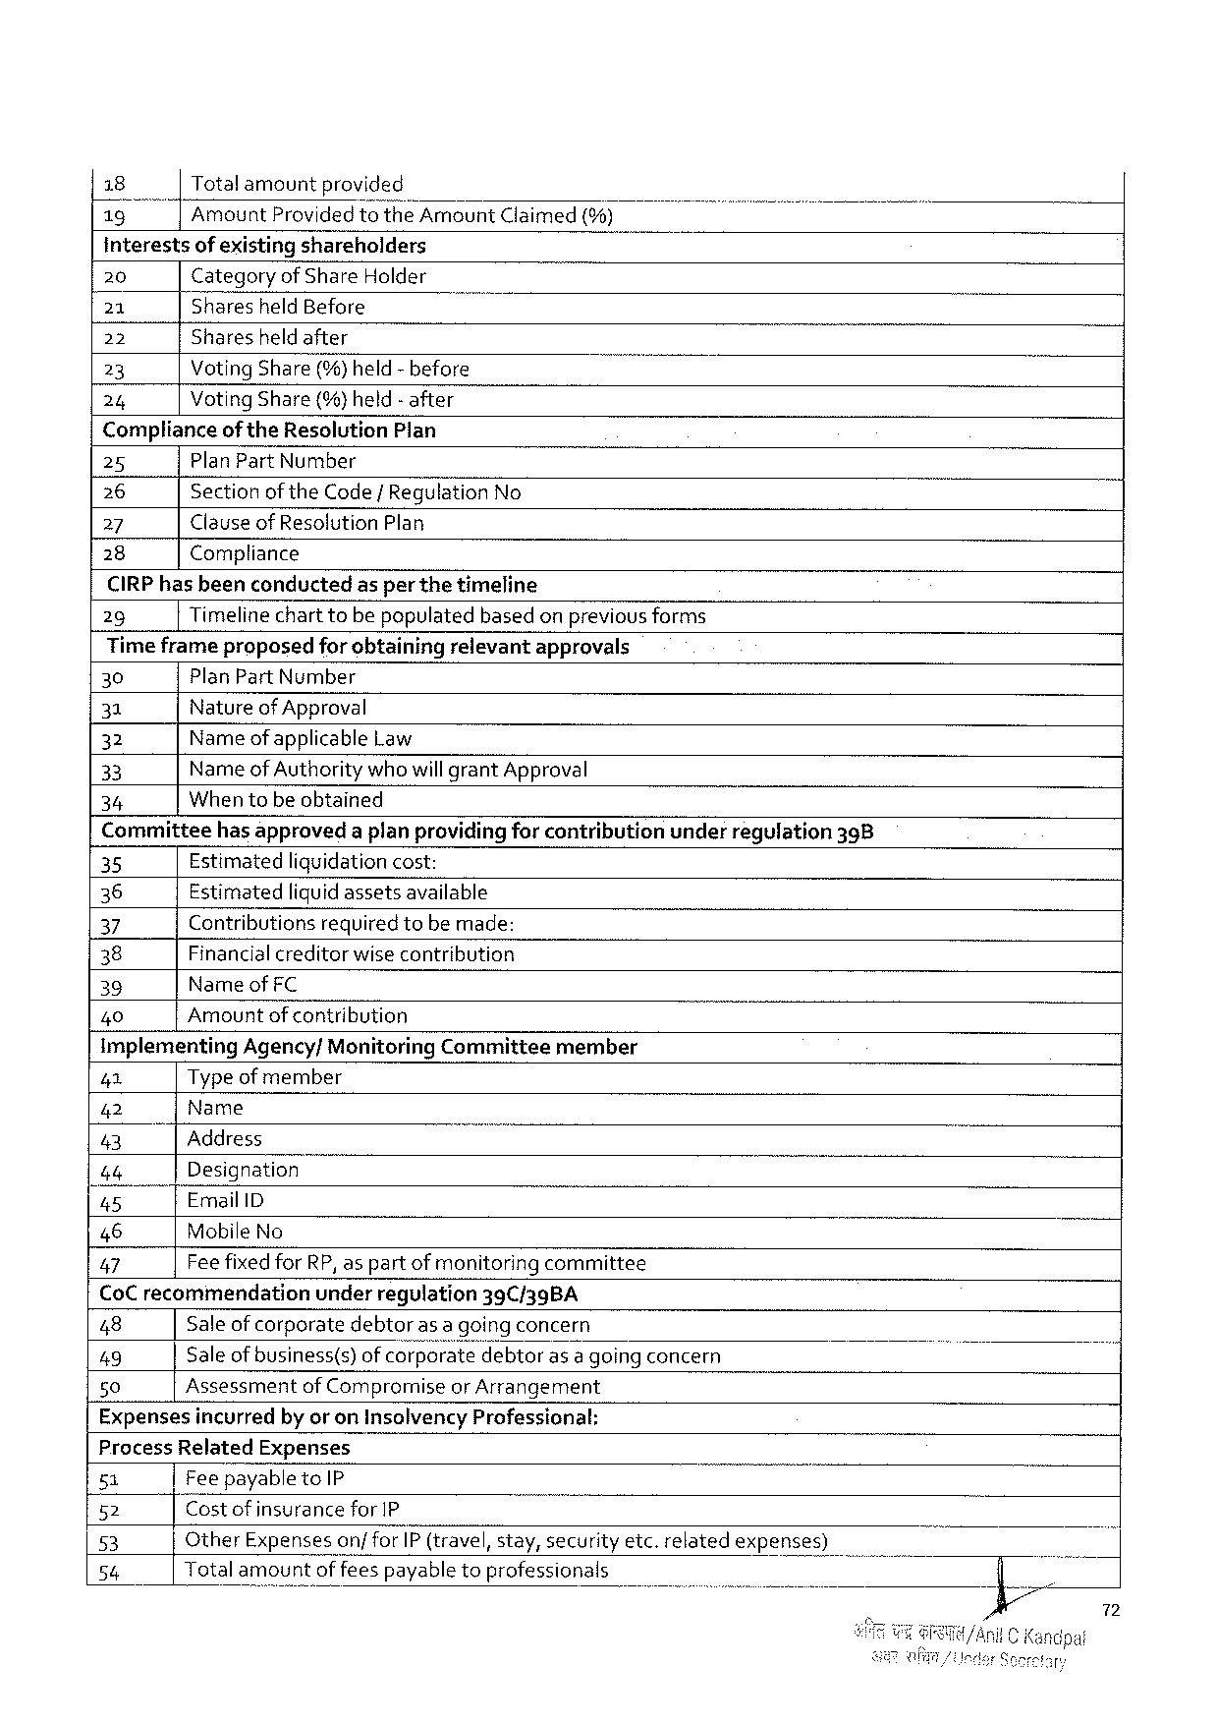

|  |  |  |  |  |  |
| --- | --- | --- | --- | --- | --- |
| 18 | Totalamountprovided | | Amount Claimed(%) | - | T |
| 13" |
| Amount Provided | to the |

interestsof existingshareholders

|  |  |  |  |
| --- | --- | --- | --- |
| 20 | Categoryof Share Holder | | - |
| 21 | Sharesheld Before | - |
| 22 |
| Sharesheldafter | |
| 23 | Voting Share(%)held-before | |
| 24 |
| Voting Share(%)held- after | |

Complianceof the Resolution Plan

25 Plan Part Number

26 Sectionof the Code/Regulation No

27 Clauseof Resolution Plan

28 Compliance

CIRP hasbeenconductedasper the timeline

29 Timelinechart tobepopulatedbasedon previousforms

Timeframeproposedfor obtainingrelevantapprovals

30 Plan Part Number

31 Natureof Approval

32 Name ofapplicable Law

33 Name of Authoritywhowill grant Approval

34 Whentobeobtained

Committeehasapproveda planprovidingfor contributionunderregulation 398

35 Estimatedliquidationcost:

36 Estimatedliquid assetsavailable

37 Contributionsrequiredtobe made:

38 Financialcreditorwise contribution

39 Nameof FC

40 Amountof contribution

Implementing Agency/Monitoring Committeemember

41 Type ofmember

42 Name

43 Address )

46 Designation

45 Email ID

46 Mobile No ]

47 Feefixedfor RP, as partof monitoringcommittee

Co Crecommendation underregulation 39 C/39 BA

48 Saleofcorporatedebtoras a goingconcern

49 Saleofbusiness(s)ofco’rpmjs;étedebtorasa going concern )

50 Assessmentof Compromiseor Arrangement

Expensesincurredby or on Insolvency Professional:

Process Related Expenses

51 Feepayableto IP

52 Costof insurance for IP

53 Other Expenseson/for IP (travel, stay, securityetc. relatedexpenses)

54 Totalamountoffeespayabletoprofessionals

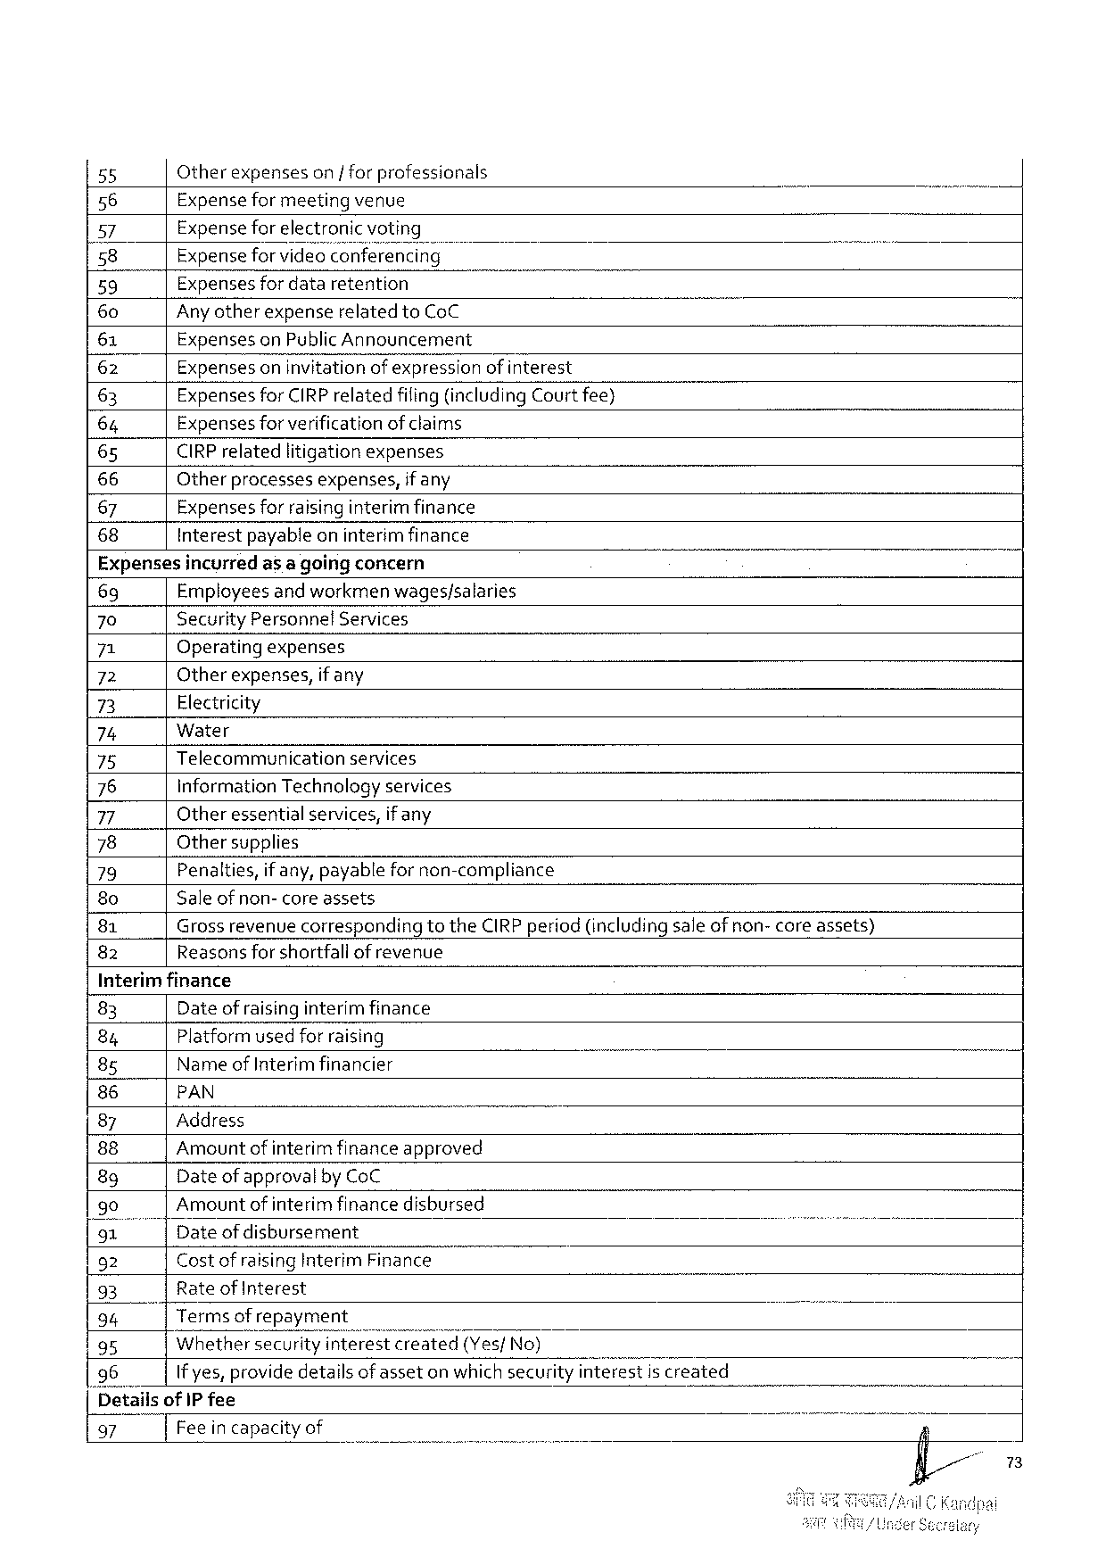

|  |  |  |  |  |  |  |
| --- | --- | --- | --- | --- | --- | --- |
| 55 | Otherexpenseson |forprofessionals | | | - | B | T |
| 56 | Expenseformeetingvenue | | |
| 57 | Expensefor electroni | | |
| 58 | Expenseforvideo 2 n‘fewrencing | | |
| 59 | Expensesfordataretention | o | |
| 60 | Anyotherexpenserelated to Co C | | |
| 61 | Expenseson Public Announcement | | |
| (62 | Expensesoninvitationof expression | | ofinterest |
| 63 | Expensesfor CIRP relatedfiling(including Court fee) | | |
| 64 | Expensesforverificationof claims | | |
| 65 | CIRP relatedlitigationexpenses | | |
| 66 | Otherprocessesexpenses, | ifany | |
| 67 |
| Expensesforraisinginterim finance | | |
| 68 | Interestpayableoninterimfinance | | |

Expensesincyrredas a goingconcern

69 Employees and workmenwages/salaries

70 Security Personnel Services

71 Operatingexpenses

72 Otherexpenses, if any

73 Electricity

74 Water

75 Telecommunication services

76 information Technologyservices

77 Otheressentialservices, ifany

78 Othersupplies

79 Penalties, if any, payablefornon-compliance

8 o Saleof non- core assets

81 Grossrevenue correspondingtothe CIRP period (includingsaleof non- core assets)

82 Reasonsforshortfallof revenue

Interimfinance

|  |  |  |  |  |  |  |
| --- | --- | --- | --- | --- | --- | --- |
| 83 | Dateofraisinginterim finance | | | T | T | i |
| 84 | Platformusedfor raising | | |
| 8 g | Name of Interimfinancier | | |
| 86 | PAN | | |
| 87 | Address | | - |
| 88 | Amountof interim financeapproved | | |
| 8 g | Date of approval by Co C | | |
| 90 | Amountof interim financedisbursed | | |
| 91"] | Dateof disbursement | | |
| } |
| 92 | Costofraising Interim Finance | | |
| 93 | Rate of Interest | | |
| 94 | | | Terms of repayment | | B |
| 95 | Whethersecurity‘? fi{érescreated(Yes/No) | | |
| 96 | If yes, providedetailsof asseton whichsecurity interestis created | | |
| [Detailsof IP fee | | | |
| 97 | Feeincapacityof | | |

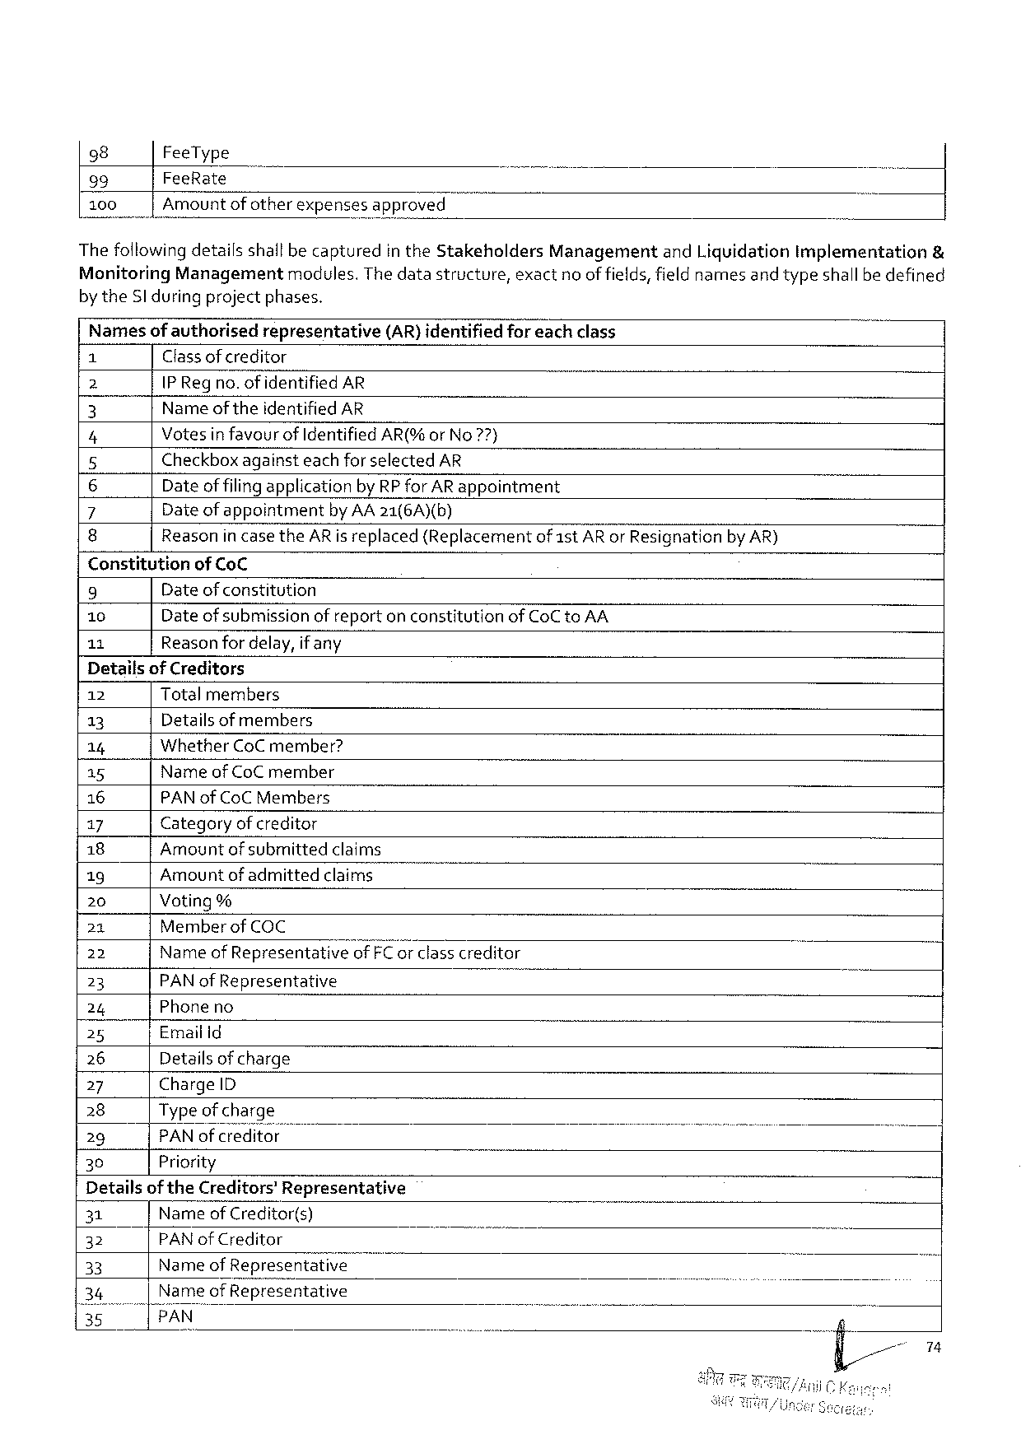

|  |  |  |  |
| --- | --- | --- | --- |
| 98 | Fee Type | Managementand Liquidationimplementation | & |
| 99 | Fee Rate |
| 100 | Amount of otherexpensesapproved |
| Thefollowingdetailsshallbecapturedin the Stakeholders | |

Monitoring Managementmodules. Thedatastructure, exactno of fields, fieldnamesand typeshallbedefined

by the Sl during projectphases.

|  |  |  |  |  |
| --- | --- | --- | --- | --- |
| Names | ofauthorised | representative | (AR)identified | foreachclass |

Classofcreditor

2 IP Regno. of identified AR

3 Name of theidentified AR

4 Votesinfavourof Identified AR(%or No 7?7}

5 Checkboxagainsteachforselected AR

6 Dateof filingapplicationby RP for AR appointment

7 Dateofappointment by AA 21(6 A)(b)

8 Reasonin case the AR is replaced(Replacementof 1 st AR or Resignationby AR)

Constitutionof Co C

9 Dateof constitution

10 Dateof submissionof reporton constitutionof Co Cto AA

11 Reasonfordelay, ifany

Detailsof Creditors

|  |  |  |  |  |  |
| --- | --- | --- | --- | --- | --- |
| 12 | Total members | | - | o | b |
| 13 |
| Detailsof members | |
| 14 | Whether Co C member? | |
| 15 |
| Nameof Co Cmember | |
| 16 | PAN of Co C Members | |
| 17 | Categoryofcreditor | |
| 18 |
| Amountofsubmitted | claims |
| 19 | Amountofadmitted | claims |
| 20 | Voting% | | classcreditor |
| 21 | Memberof COC | |
| 22 | Name of Representativegffi F‘Eg‘r | |
| 23 | PAN of Representative | |
| 24 |
| Phoneno | |
| 25 | Email Id | |
| 26 | Details of charge | |
| 27 | Charge ID | |
| 28 | Type ofcharge | |
| 29 | PAN ofcreditor | |
| 30 | Priority | |

Detailsof the Creditors’Representative

|  |  |  |  |  |  |  |  |
| --- | --- | --- | --- | --- | --- | --- | --- |
| 31 | Nameof Creditor(s) | | wwwww | o | ) | ) | - |
| 32 | PAN of Creditor | |
| 33 | Name | of Representati\); |
| of Representative | |

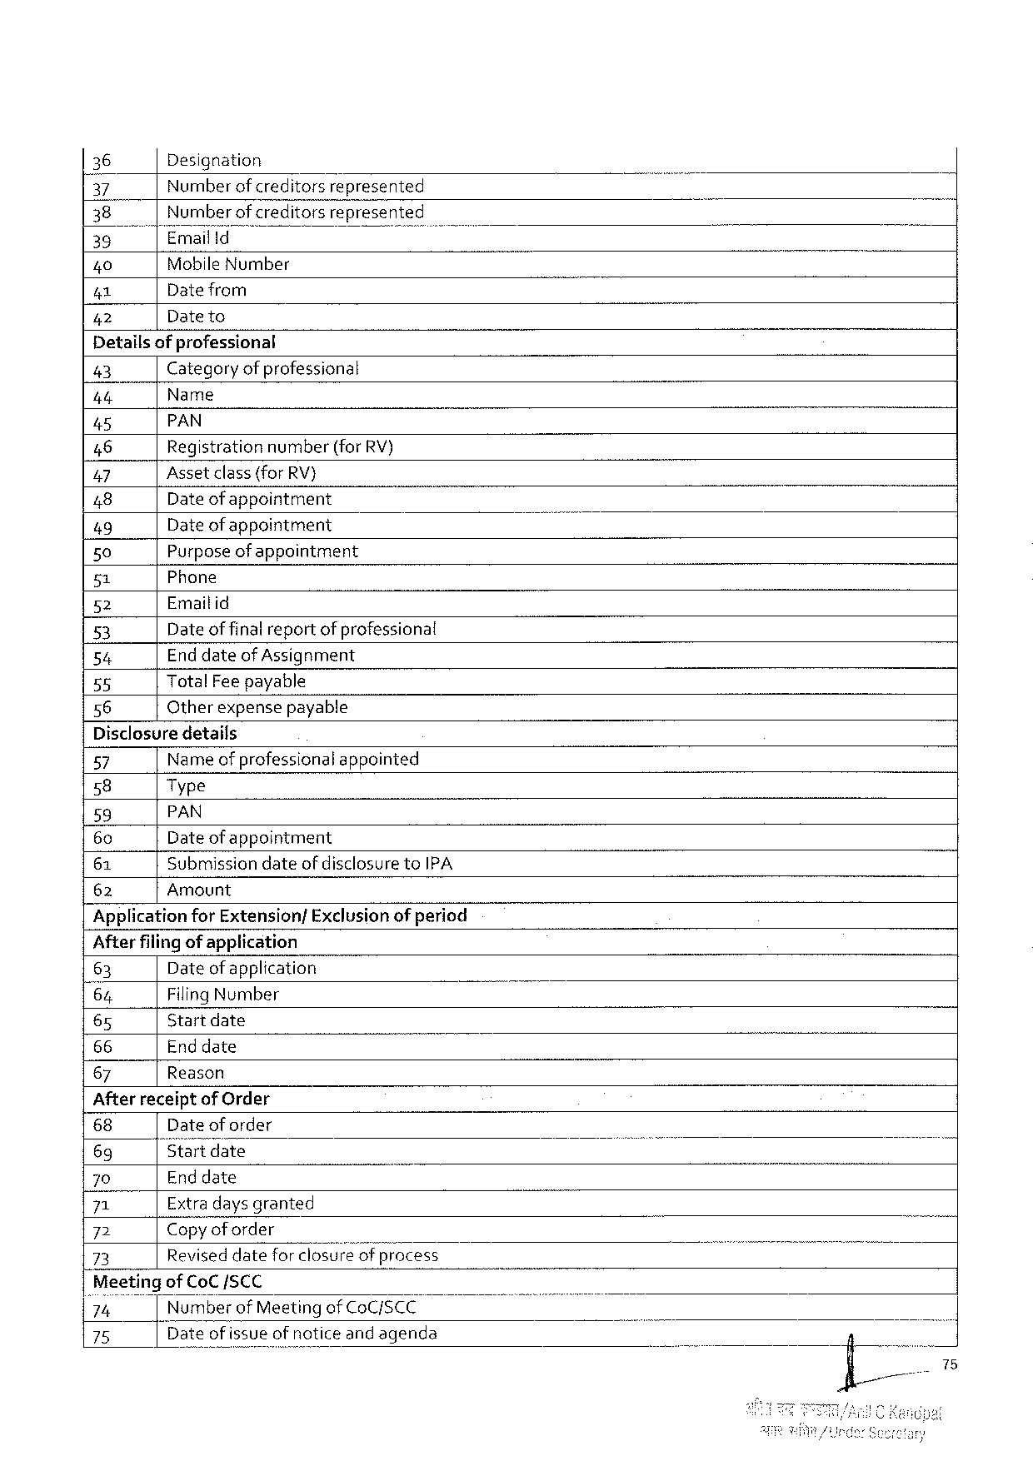

|  |  |  |  |  |
| --- | --- | --- | --- | --- |
| 36 | | | Designation | | B |
| 37 | Numberof creditors | represented |
| 38 | Number of creditorsrepresented | |
| 35 | Emailld | T |
| 40 | Mobile Number | |
| 41 | Datefrom | |
| Dateto | |
| 42 |

Detailsofprofessional

43 Categoryof professional

4 t Name

45 PAN

46 Registration number(for RV)

47 Assetclass(for RV}

48 Date ofappointment

49 Date ofappointment

50 Purposeof appointment

51 Phone

52 Emaitid

53 Date offinalreportof professional

54 End dateof Assignment

55 Total Feepayable

56 Otherexpensepayable

Disclosuredetails

57 Name of professionalappointed

58 Type

59 PAN

60 Date ofappointment

61 Submission dateofdisclosureto IPA

62 Amount

Applicationfor Extension/Exclusion ofperiod

Afterfilingof application

63 Dateof application

64 Filing Number

65 Start date

66 Enddate

67 Reason

Afterreceiptof Order

|  |  |  |  |  |  |
| --- | --- | --- | --- | --- | --- |
| 68 | Date oforder | " | T | i | 7 |
| 69 | Startdate |
| 70 | Enddate |
| 71 | Extradays granted |
| 72 | Copyof order |
| 73 | Reviseddateforclosur’eflgfwfirocess |

‘Meetingof Co CSCC

’72," Number of Meetingof Co C/SCC

75 Dateof issueofnoticeandagenda

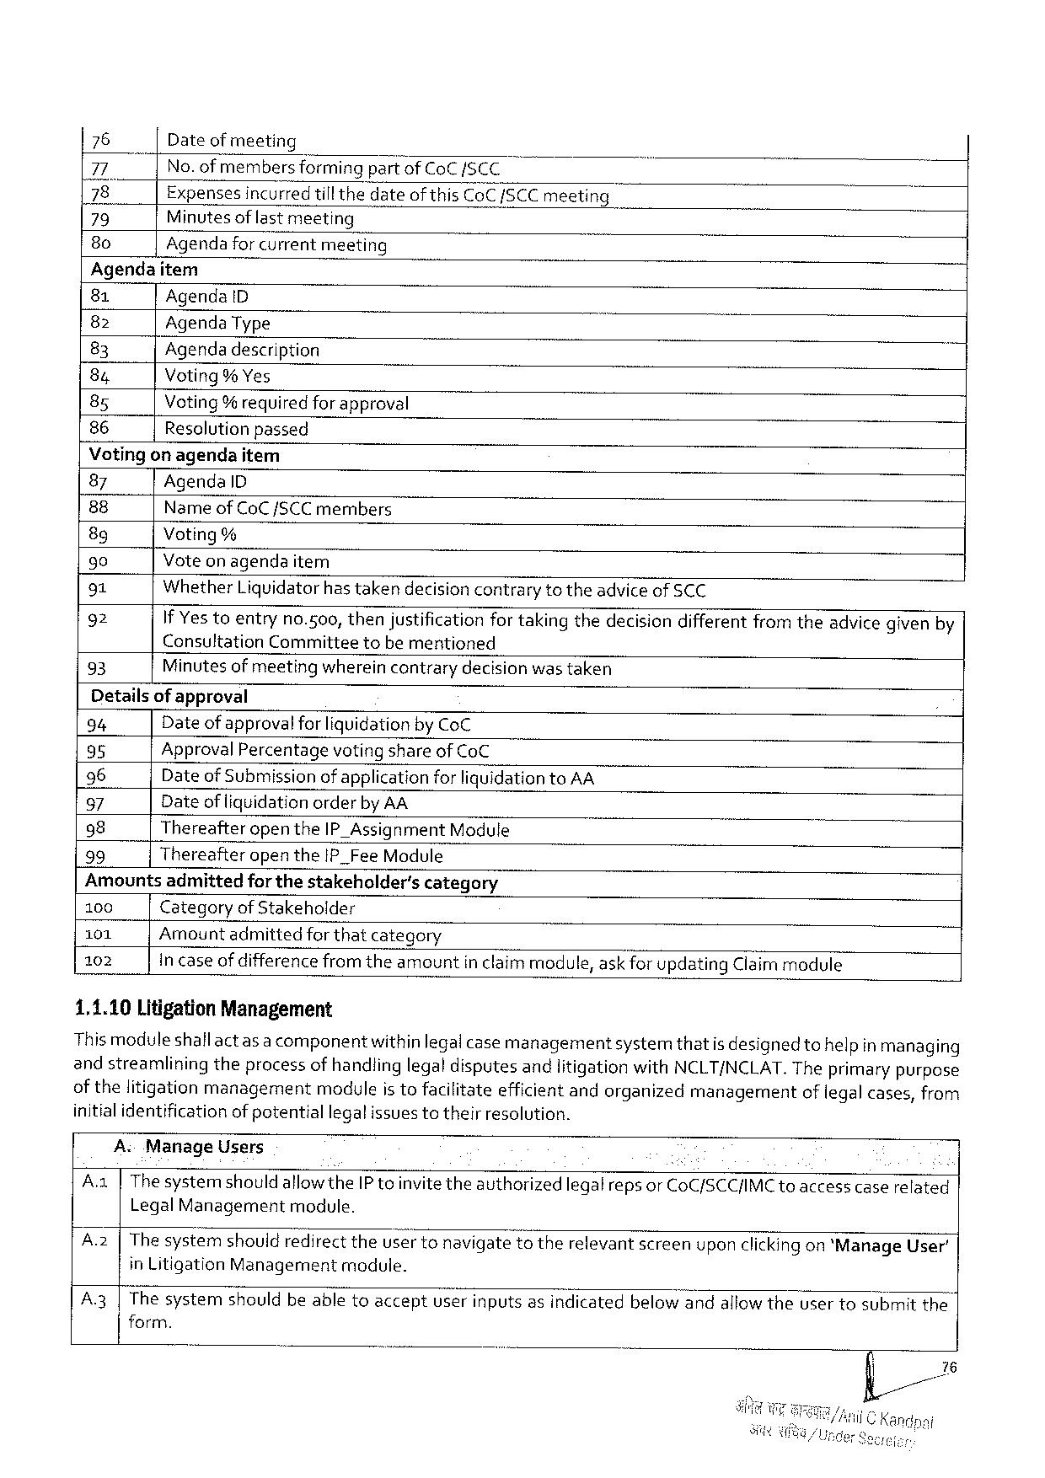

|  |  |
| --- | --- |
| 76  77  |78   79  8 o | Dateofmeeting  No. ofmembersformingpartof Co C/SCC  Expenses incurredtill thedateof this Co C/SCC meeting Minutesof last meeting  Agendaforcurrentmeeting |

Agendaitem

|  |  |  |
| --- | --- | --- |
| 81 | Agenda D | il |
| 82 | Agenda Type |
| 83 |
| Agendadescription |
| 84 |
| Voting% Yes |
| 85 |
| Voting% requiredforapproval |
| 86 |
| Resolutionpassed |

Votingon agendaitem

|  |  |
| --- | --- |
| 87  88  8 g  90  91  92  93 | Agenda ID  Name of Co C/SCC members  Voting%  Voteon agendaitem  Whether Liquidatorhastakendecisioncontrarytotheadviceof SCC  If Yestoentryno.500, thenjustificationfor takingthedecisiondifferentfromtheadvicegivenby Consultation Committeetobe mentioned  Minutes of meetingwhereincontrarydecision wastaken |

Detailsof approval

94 Date of approval for liquidationby Co C

95 Approval Percentagevoting shareof Co C

96 Dateof Submissionof applicationforliquidationto AA

97 Dateof liquidationorderby AA

98 Thereafteropenthe IP_Assignment Module

99 Thereafteropenthe IP_Fee Module

Amountsadmittedfor thestakeholder’scategory

100 Categoryof Stakeholder

101 Amountadmittedforthatcategory

102 Incaseof difference from theamountinclaimmodule, askfor updating Claimmodule

1,1.10 Litigation Management

This moduleshallactas a componentwithinlegalcase managementsystemthatis designedtohelpin managing

andstreamliningtheprocessofhandlinglegaldisputesandlitigationwith NCLT/NCLAT. Theprimarypurpose

of thelitigationmanagementmoduleis tofacilitateefficientandorganizedmanagementoflegal cases, from

initialidentificationofpotentiallegalissuestotheirresolution.

A Manage Users

A. a|Thesystemshould allowthe IP toinvitetheauthorizedlegalreps or Co C/SCC/IMC toaccess caserelated

Legal Management module.

A.2|Thesystem shouldredirecttheusertonavigatetotherelevantscreenuponclickingon*Manage User’

in Litigation Management module.

A 3|Thesystemshouldbeabletoacceptuserinputsasindicatedbelow andallowtheusertosubmitthe

form.

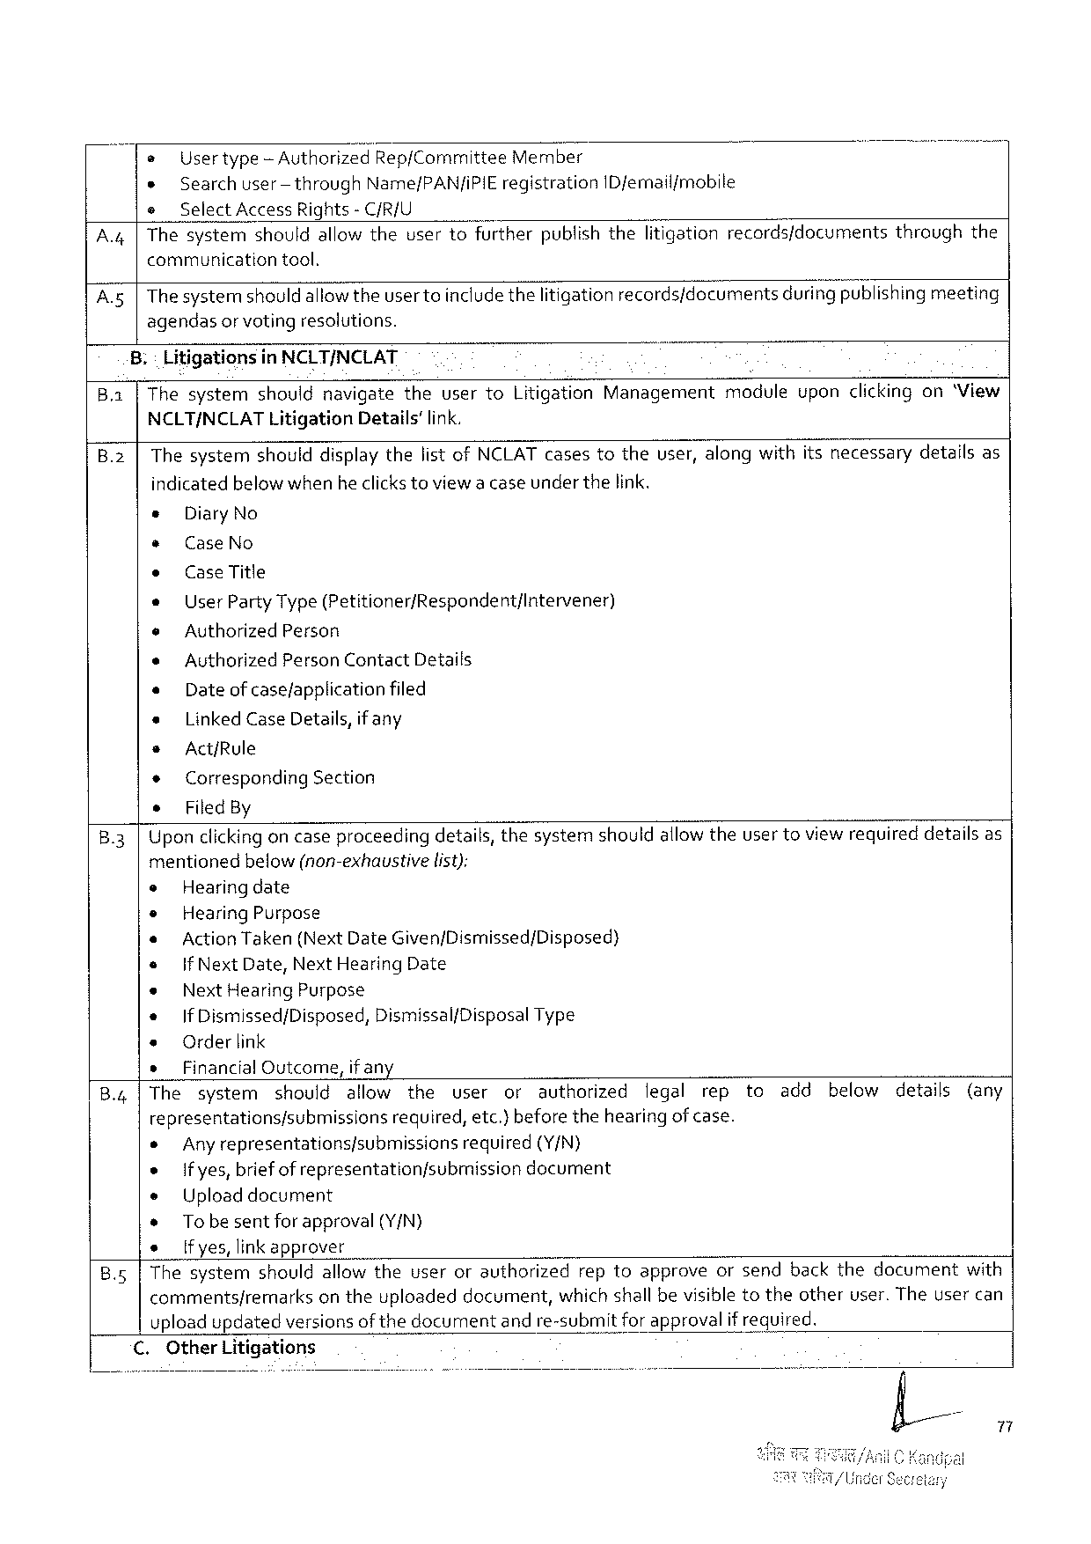

|  |  |  |  |  |  |
| --- | --- | --- | --- | --- | --- |
| A, | e | Usertype‘Authorizeg Rep/Comm\ttee | | Member | throughthe |
| » | Searchuser-through Name/PAN/IPIE registration ID femail/mobile | | |
| e | Select Access Rights- C/R/U | | |
| |Thesystemshouldallowtheusertofurtherpublishthelitigationrecords/documents | | | |
| communication | | tool. | |

A 5|Thesystemshould allowtheuser toincludethelitigationrecords/documentsduring publishing meeting

agendasor votingresolutions.

Litigationsin NCLT/NCLAT

B. a Thesystemshouldnavigatetheuserto Litigation Managementmoduleuponclickingon‘View

NCLT/NCLAT Litigation Details’ link.

B.2|Thesystemshoulddisplaythelistof NCLAT casestotheuser, alongwithitsnecessarydetailsas

indicatedbelow whenheclicks toviewa caseunderthelink.

s Diary No

* Case No

e Case Title

e User Party Type(Petitioner/Respondent/Intervener)

e Authorized Person

* Authorized Person Contact Details

« Dateof case/applicationfiled

« Linked Case Details, if any

s Act/Rule

* Corresponding Section

* Filed By

B.3|Upon clickingoncaseproceedingdetails, thesystemshouldallowtheuser toviewrequireddetailsas

mentioned below(non-exhaustive list):

e Hearingdate

e Hearing Purpose

e Action Taken(Next Date Given/Dismissed/Disposed)

e |f Next Date, Next Hearing Date

e Next Hearing Purpose

« If Dismissed/Disposed, Dismissal/Disposal Type

e Orderlink

» Financial Outcome, if any

B.4|The system should allow the user or authorized legal rep to add below details (any

representations/submissions required, etc.)beforethehearingof case.

e Anyrepresentations/submissions required (Y/N)

s Ifyes, briefof representationfsubmissiondocument

e Uploaddocument

* Tobesentforapproval(Y/N)

e [fyes, linkapprover

B.5|Thesystemshouldallowtheuserorauthorizedreptoapproveorsendbackthedocumentwith

commentsfremarksontheuploadeddocument, which shall bevisible totheotheruser. Theusercan

upload updatedversionsof thedocumentand re-submitfor approvalifrequired.

C. Other Litigations

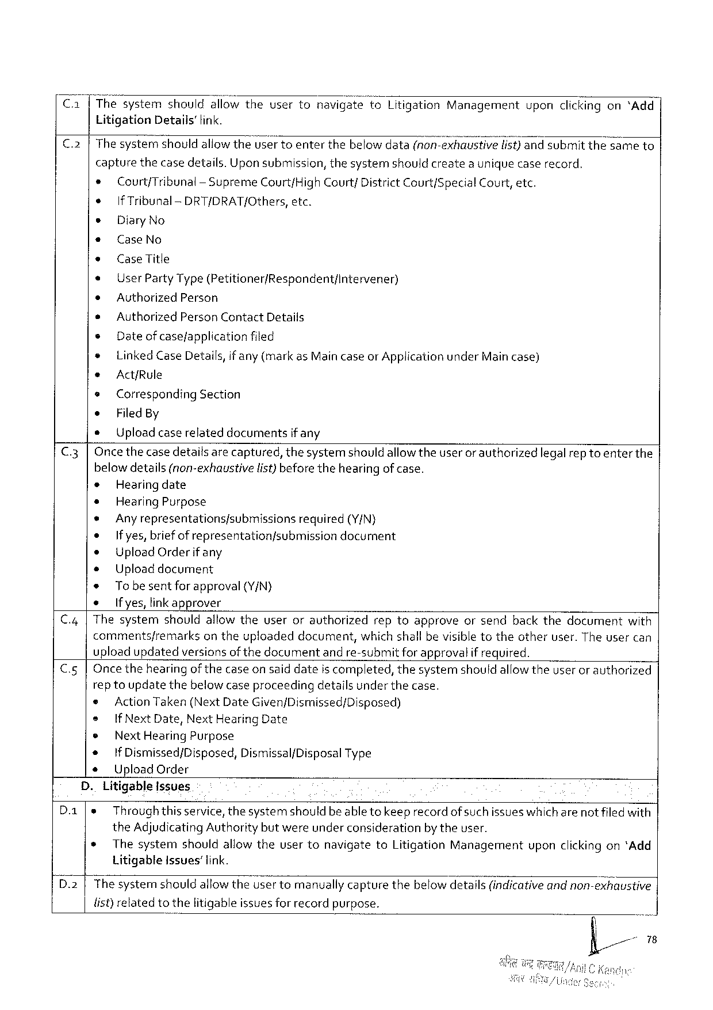

Ca[Thesystem should allowthe usertonavigate}o Litigation Management upon clickingon“Add

Litigation Details'fink.

C.2|Thesystemshouldallowthe Usertoenterthebelowdata(nonrekl; a’trs't? vglfl/‘s“t‘)kgr‘la submit thesame to|

capturethecasedetails. Uponsubmission, thesystemshouldcreateauniquecaserecord,

* Court/Tribunal-Supreme Court/High Court/ District Court/Special Court, etc.

e If Tribunal -DRT/DRAT/Others, etc.

e Diary No

e Case No

s Case Title

* User Party Type(Petitioner/Respondent/intervener)

e Authorized Person

s Authorized Person Contact Details

e Dateof casefapplicationfiled

* Linked Case Details, if any (markas Maincaseor Application under Main case)

s Act/Rule

* Corresponding Section

e Filed By

e Uploadcaserelateddocumentsif any

C.3|Oncethecase detailsare captured, thesystemshouldallow theuseror authorizedlegalrep toenter the

belowdetails(non-exhaustive list)beforethehearingof case.

* Hearingdate

* Hearing Purpose

* Anyrepresentationsfsubmissions required (Y/N)

o Ifyes, briefof representation/submissiondocument

® Upload Orderifany

+ Uploaddocument

* Tobe sentforapproval (Y/N)

s Ifyes, linkapprover

C.4|Thesystemshouldallowtheuserorauthorizedreptoapproveorsendbackthedocumentwith

comments/remarksontheuploadeddocument, whichshall bevisibletotheotheruser. The usercan

uploadupdatedversionsof thedocumentand re-submitfor approvalif required.

C.5|Oncethehearingofthecase on saiddateis completed, thesystemshouldallowtheuser or authorized

rep toupdatethebelow caseproceedingdetailsunder thecase.

© Action Taken(Next Date Given/Dismissed/Disposed)

® If Next Date, Next Hearing Date

|  |  |  |
| --- | --- | --- |
| ® | Next Hearing Purpose | Type |
| If Dismissed/Disposed, Dismissal/Disposal |

Upload Order

D. Litigable Issues

|  |  |  |  |  |  |  |
| --- | --- | --- | --- | --- | --- | --- |
| Da  D.2 | e | Throughthisservice, thesystemshouldbeabletokeeprecord of suchissueswhichare notfiledwith | | | | |
| the Adjudicating Authority butwereunderconsiderationby theuser. | | | | | |
| * | Thesystem | shouldallowtheusertonavigate | to Litigation | Management | uponclickingon*Add |
| Litigable Issues’ link.  The systernshouldallowtheuser tomanually capturethebelow details(indicativeand non-exhaustive | | | | | |

list)relatedtothelitigableissuesfor recordpurpose.

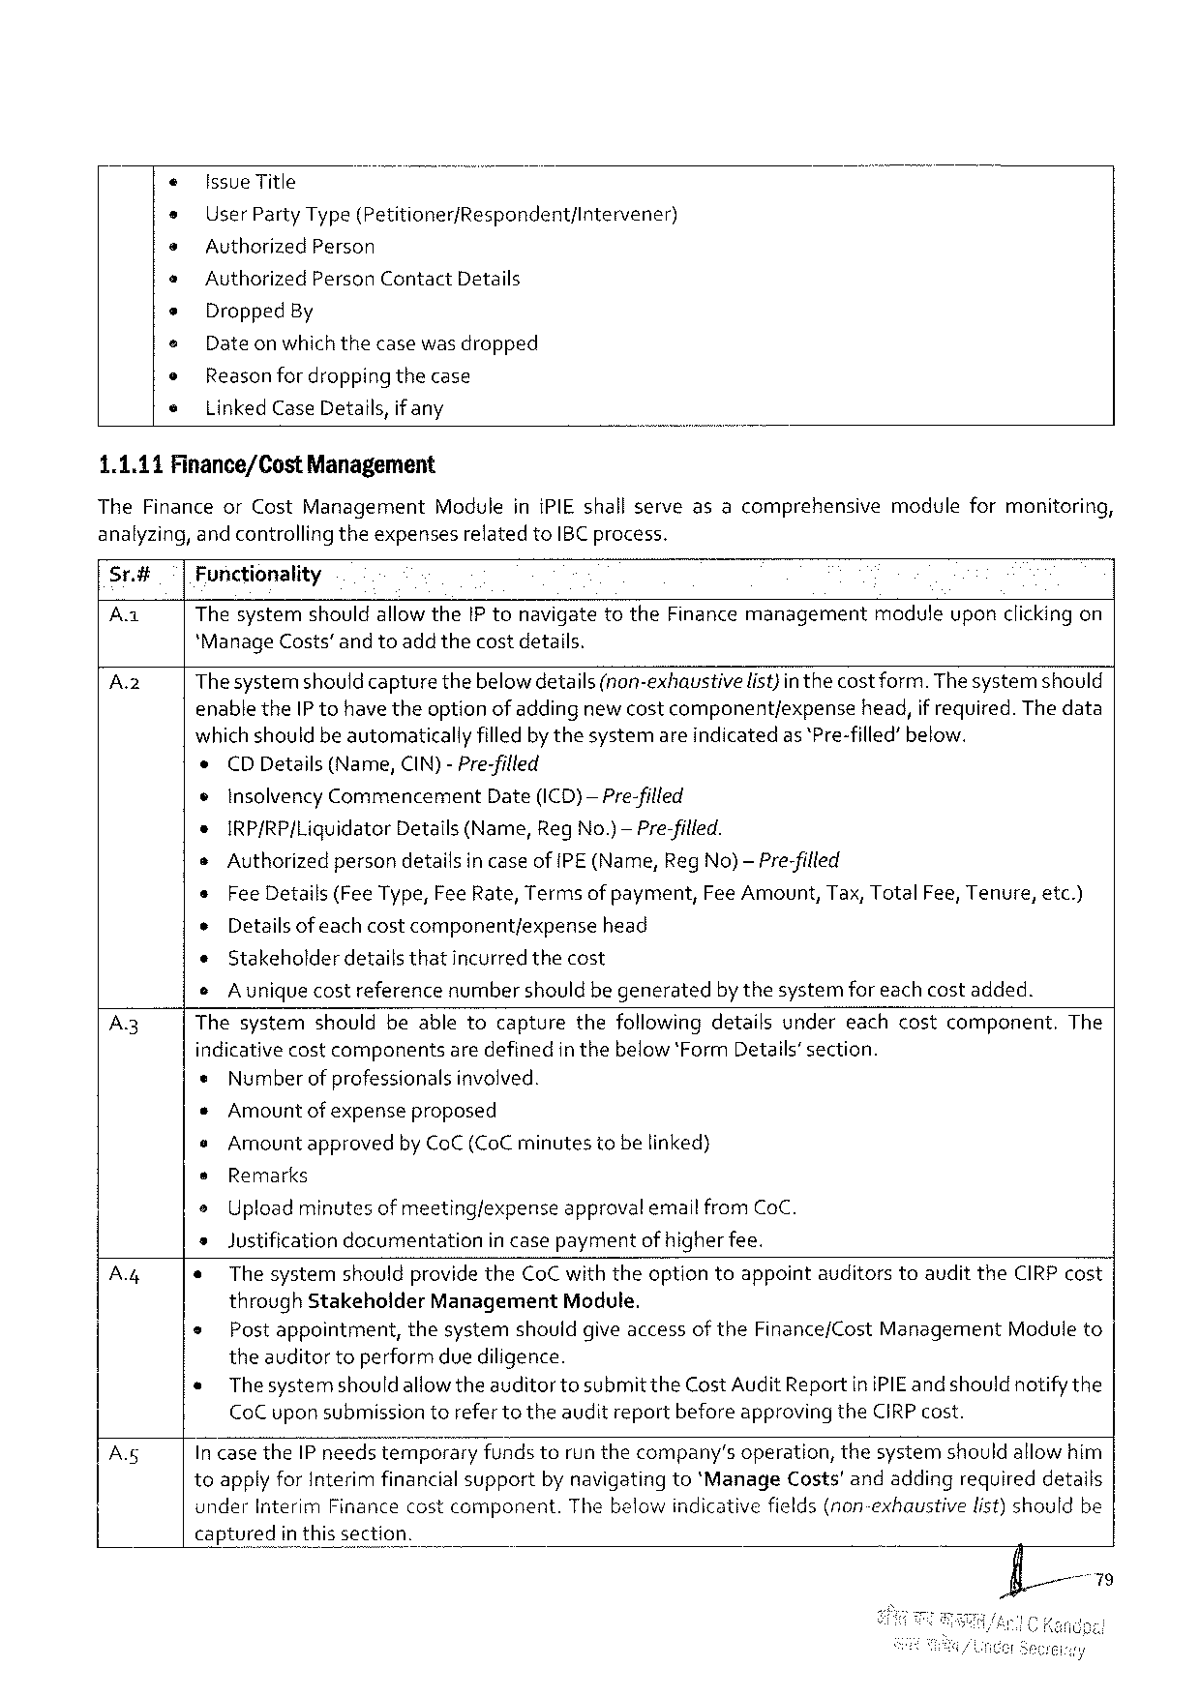

Issue Title

User Party Type(Petitioner/Respondent/Intervener)

Authorized Person

Authorized Person Contact Details

Dropped By

Dateonwhichthecasewasdropped

Reasonfor dropping thecase

Linked Case Details, if any

1.1.11 Finance/Cost Management

The Financeor Cost Management Moduleini PIE shallserveasacomprehensivemoduleformonitoring, analyzing, andcontrollingtheexpensesrelatedto IBC process.

Sr.# Fonctionality

Aa Thesystemshouldallowthe[P tonavigatetothe Finance managementmaduleuponclickingon *Manage Costs’andtoadd thecostdetails.

|  |  |  |
| --- | --- | --- |
| Az | Thesystemshould capturethebelowdetails(non-exhaustive | list)in thecostform. Thesystemshould |

enablethe IP tohave theoption of addingnew costcomponent/expensehead, if required. The data whichshouldbe automaticallyfilledbythesystemareindicatedas *Pre-filled’below.

e CDD etails(Name, CIN)-Pre-filled

¢ Insolvency Commencement Date(ICD)—Pre-filled

s IRP/RP[Liquidator Details(Name, Reg No.)— Pre-filled.

o Authorizedpersondetailsin caseof[PE(Name, Reg No)— Pre-filled

|  |  |  |
| --- | --- | --- |
| s | Fee Details(Fee Type, Fee Rate, Termsof payment, | Fee Amount, Tax, Total Fee, Tenure, etc.) |
| o | Details of eachcostcomponentjexpensehead |
| ¢ |
| Stakeholderdetailsthatincurredthecost |

o Auniquecostreferencenumbershould begeneratedbythesystemfor each costadded.

A 3 Thesystemshouldbeabletocapturethefollowingdetailsundereachcostcomponent. The indicativecostcomponentsaredefinedinthebelow‘Form Details’section.

« Number of professionalsinvolved.

¢Amountof expenseproposed

o Amountapprovedby Co C (Co C minutestobelinked)

s Remarks

o Uploadminutesof meeting/expenseapprovalemail from Co C.

»Justification documentation in casepaymentof higherfee.

Ay « The systemshouldprovidethe Co Cwiththeoptiontoappointauditorstoauditthe CIRP cost through Stakeholder Management Module.

e Post appointment, thesystemshouldgiveaccessof the Finance/Cost Management Moduleto theauditortoperformdue diligence.

« Thesystemshould allowtheauditortosubmitthe Cost Audit Reportini PIE and shouldnotifythe Co C uponsubmissiontorefertotheauditreportbeforeapprovingthe CIRP cost.

A Incasethe IP needstemporaryfundstorunthecompany’soperation, thesystemshouldallowhim toapplyfor Interim financial supportby navigatingto*Manage Costs'andaddingrequireddetails

|  |  |  |  |  |
| --- | --- | --- | --- | --- |
| {_ | | under Interim Financecostcomponent. | | Thebelowindicativefields(non-exhaustive | list)shouldbe |
| | capturedin | thissection. |

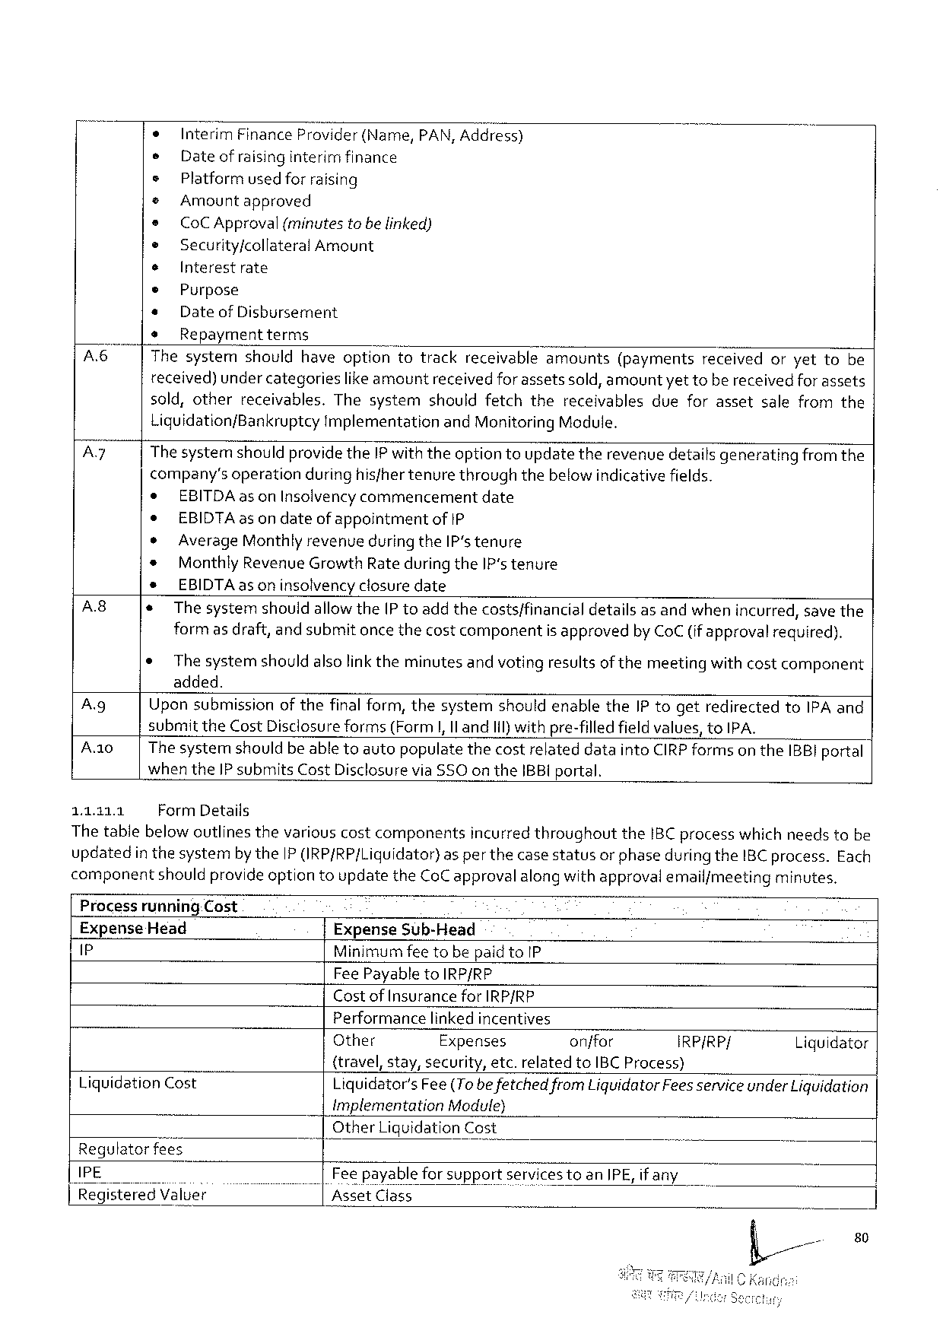

|  |  |  |  |  |  |  |  |  |  |  |  |  |  |  |
| --- | --- | --- | --- | --- | --- | --- | --- | --- | --- | --- | --- | --- | --- | --- |
| A  Ay | * | Interim | | Finance | Provider | (Name, | | PAN, Address) | | | | | | |
| s | Date of raisinginterirrifinance | | | | | | | | | | | | |
| s | Platformused for raising | | | | | | | | | | | | |
| © | | Amountapproved | | | | | | | | | | | |
| e | Co CA pproval(minutes tobe linked) | | | | | | | | | | | | |
| ® | | Security/collateral Amount | | | | | | | | | | | |
| s | Interestrate | | | | | | | | | | | | |
| © | Purpose | | | | | | | | | | | | |
| + | Date of Dishursement | | | | | | | | | | | | |
| * | Repaymentterms | | | | | | | | | | | | |
| Thesystem | | | should | haveoption | | totrack | | receivable | amounts | (payments | received | oryetto | be |
| received) under categorieslike amountreceived forassetssold, amountyet tobe receivedforassets sold, otherreceivables. Thesystemshouldfetchthereceivablesdueforassetsalefromthe Liquidation/Bankruptcyimplementationand Monitoring Module.  Thesystemshouldprovidethe IP withtheoption toupdatetherevenue detailsgeneratingfromthe company’s operationduringhisfhertenurethroughthebelowindicativefields. | | | | | | | | | | | | | |
| e | EBITDA as on Insolvencycommencementdate | | | | | | | | | | | | |
| e | EBIDTA as on dateofappointmentof 1 P | | | | | | | | | | | | |

Average Monthlyrevenueduring the IP stenure   
Monthly Revenue Growth Rate during the IP‘stenure   
EBIDTA as on insolvencyclosure date

|  |  |  |
| --- | --- | --- |
| A 8  Ag  A 0  11311 | * | Thesystemshouldallowthe IP toaddthecosts/financialdetailsas andwhenincurred, save the |
| formas draft, and submitonce thecostcomponentis approvedby Co C (ifapprovalrequired). | |
| ¢ | The systemshouldalsolinktheminutesand votingresultsof themeetingwithcostcomponent |
| added.  Upon submissionofthefinal form, thesystemshouldenablethe IP togetredirectedto IPA and submitthe Cost Disclosureforms(Form|, Il and Iil)withpre-filledfieldvalues, to IPA.  The systemshouldbe abletoautopopulatethecostrelateddatainto CIRP formson the IBBI portal when the IP submits Cost Disclosurevia SSO on the IBBI portal.  Form Details | |

Thetablebelow outlinesthevariouscostcomponentsincurred throughoutthe IBC processwhich needstobe updatedin thesystemby the IP IRP/RP/Liquidator)as perthecase statusor phaseduringthe IBC process. Each componentshouldprovide optiontoupdatethe Co Capprovalalong withapprovalemail/meetingminutes.

Processrunning. Cost   
Expense Head Expense Sub-Head   
P Minimumfeetobepaidto IP

Fee Payableto IRP/RP

Costof Insurance for IRP/RP   
Performancelinkedincentives

|  |  |  |  |  |  |
| --- | --- | --- | --- | --- | --- |
| Liquidation Cost | Other | Expenses | onffor | IRP/RP/ | Liguidator |
| {travel, stay, security, etc. relatedto IBCP rocess)  Liquidator's Fee(Tobe fetchedfrom Liquidator Fees serviceunder Liquidation Implementation Module) | | | | |

Other Liquidation Cost Regutatorfees

|  |  |  |
| --- | --- | --- |
| IPE | | | Fee payable for supportservicestoan IPE, if any |
| |fl Rieg|5 t; re'd"\'/a_IB e} | Asset Class |

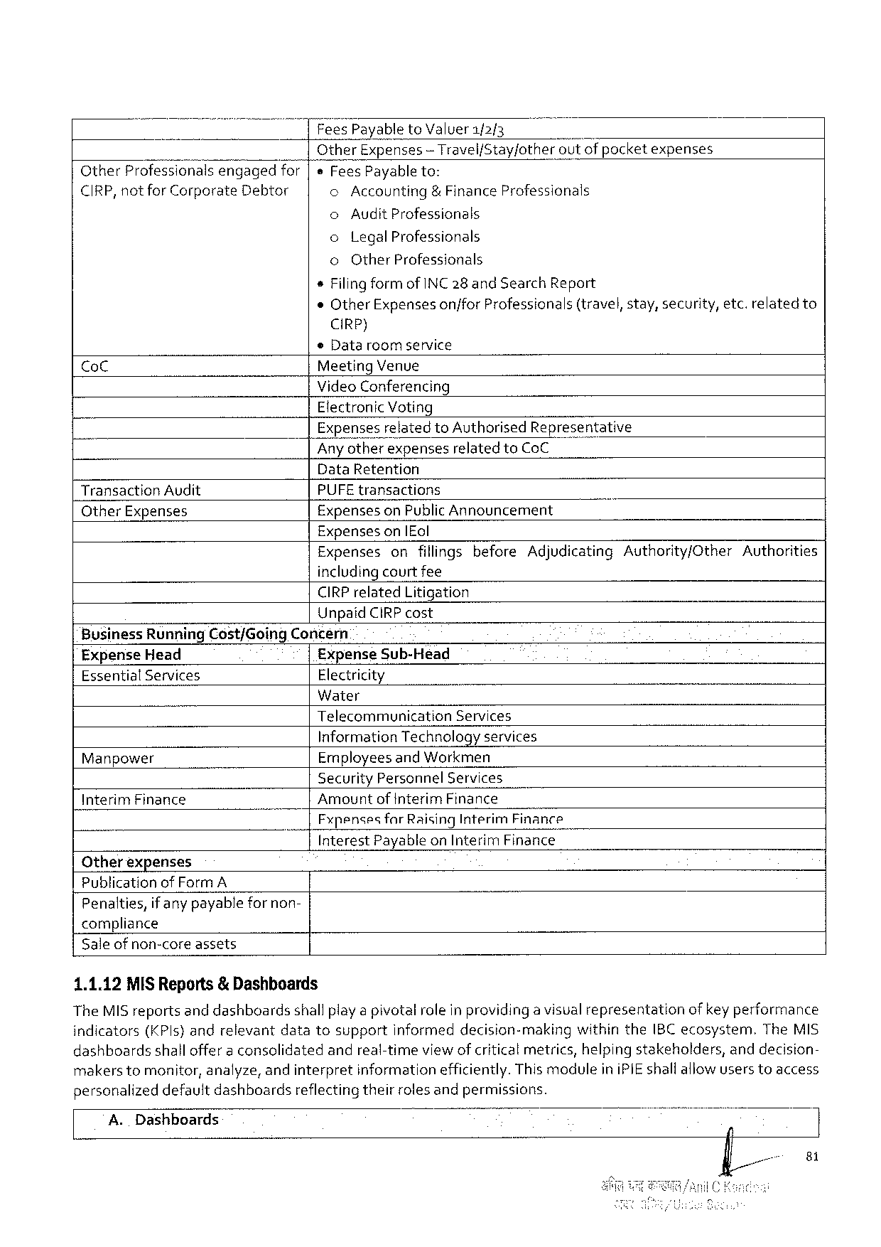

Fees Payable to Valuer 1/2{3

Other Expenses — Travel/Stay/other outof pocketexpenses

Other Professionalsengagedfor e Fees Payableto:

CIRP, notfor Corporate Debtor o Accounting & Finance Professionals

o Audit Professionals

o Legal Professionals

o Other Professionals

s Filing form of INC 28 and Search Report

«Other Expensesonjfor Professionals(travel, stay, security, etc. relatedto

CIRP)

© Data roomservice

Co C Meeting Venue

Video Conferencing

Electronic Voting

Expensesrelatedto Authorised Representative

Any otherexpensesrelated to Co C

Data Retention

Transaction Audit PUFE transactions

Other Expenses Expenseson Public Announcement

Expenseson|Eol

|  |  |  |
| --- | --- | --- |
| Expensesonfillingsbefore | Adjudicating Authority/Other | Authorities |

includingcourtfee

CIRP related Litigation

Unpaid CIRP cost

Business Running Cost/Going Concern

Expense Head Expense Sub-Head

Essential Services Electricity

Water

Telecommunication Services

Information Technologyservices

Manpower Employees and Workmen

Security Personnel Services

Interim Finance Amountof Interim Finance

Fxpenses far Raising Interim Finance

Interest Payableon Interim Finance

Otherexpenses

Publication of Form A

Penalties, if anypayablefor non-

compliance

Saleofnon-coreassets

1.1.12 MISR eports& Dashboards

The MIS reportsand dashboardsshallplaya pivotalroleinprovidinga visualrepresentationof keyperformance

indicators(KP ls}andrelevantdatatosupportinformeddecision-makingwithinthe IBC ecosystem. The MIS

dashboardsshalloffer a consolidatedandreal-timeviewof criticalmetrics, helping stakeholders, anddecision-

makers tomonitor, analyze, and interpretinformationefficiently. Thismoduleini PIE shallaliowusers toaccess

personalizeddefaultdashboardsreflecting theirrolesandpermissions.

A. Dashboards

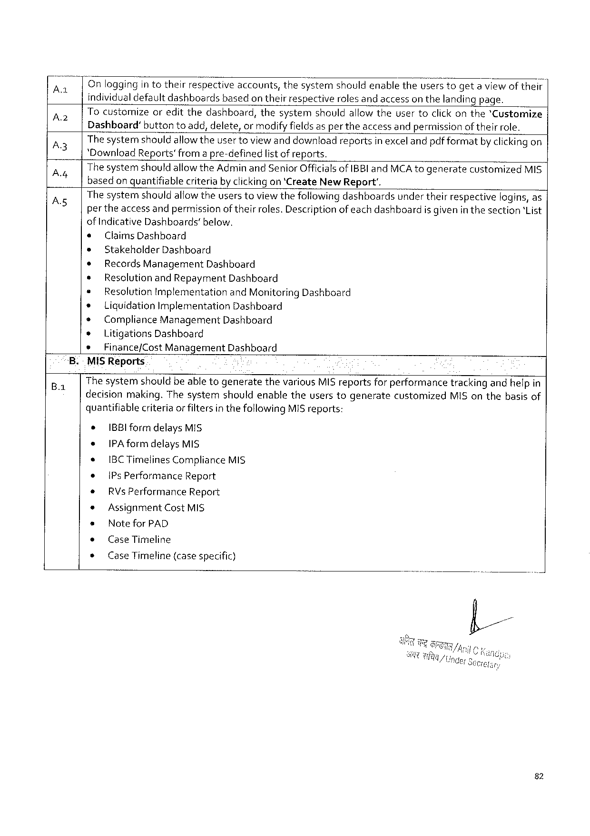

|  |  |  |  |
| --- | --- | --- | --- |
| A  A  A 3 A  As | on | loggingin totheirrespectiveaccounts, thesystemshouldenabletheuserstogeta viewof their | |
| individualdefaultdashboardsbasedon theirrespectiverolesand accesson thelandingpage. | | |
| |Tocustomize | | oreditthedashboard, thesystemshouldallow theusertoclickonthe'Customize |
| Dashboard”buttontoadd, delete, ormodifyfieldsasper theaccessandpermission oftheirrole. Thesystemshouldallowtheuser toviewand downloadreportsinexcelandpdfformatby clickingon‘Download Reports’from a pre-definedlist of reports.  Thesystemshould allowthe Adminand Senior Officialsof IBBI and MCA togeneratecustomized MIS basedon quantifiablecriteriaby clickingon ‘Create New Report'.  The systemshouldallowtheuserstoviewthefollowing dashboardsunder theirrespectivelogins, as per theaccessandpermissionof theirroles. Descriptionofeachdashboardis given in thesection‘List of Indicative Dashboards’below. | | |
| e | Claims Dashboard | |
| ® | Stakeholder Dashboard | |
| * | Records Management Dashboard | |
| ¢ | Resolutionand Repayment Dashboard | |
| * | Resolution Implementationand Monitoring Dashboard | |
| * | Liguidation Implementation Dashboard | |
| ¢ | Compliance Management Dashboard | |
| * | Litigations Dashboard | |
| s | Finance/Cost Management Dashboard | |

.-Mi SR eports

The systemshouldbeable togeneratethevarious MIS reportsfor performancetrackingandhelpin

decisionmaking. Thesystemshouldenabletheuserstogeneratecustomized MIS onthebasisof

quantifiablecriteria or filtersin thefollowing MIS reports:

¢ IBBI formdelays MIS

+ IPA formdelays MIS

* IBCT imelines Compliance MIS

e |Ps Performance Report

* RV s Performance Report

* Assignment Cost MIS

s Notefor PAD

¢ Case Timeline

s Case Timeline(casespecific)

82

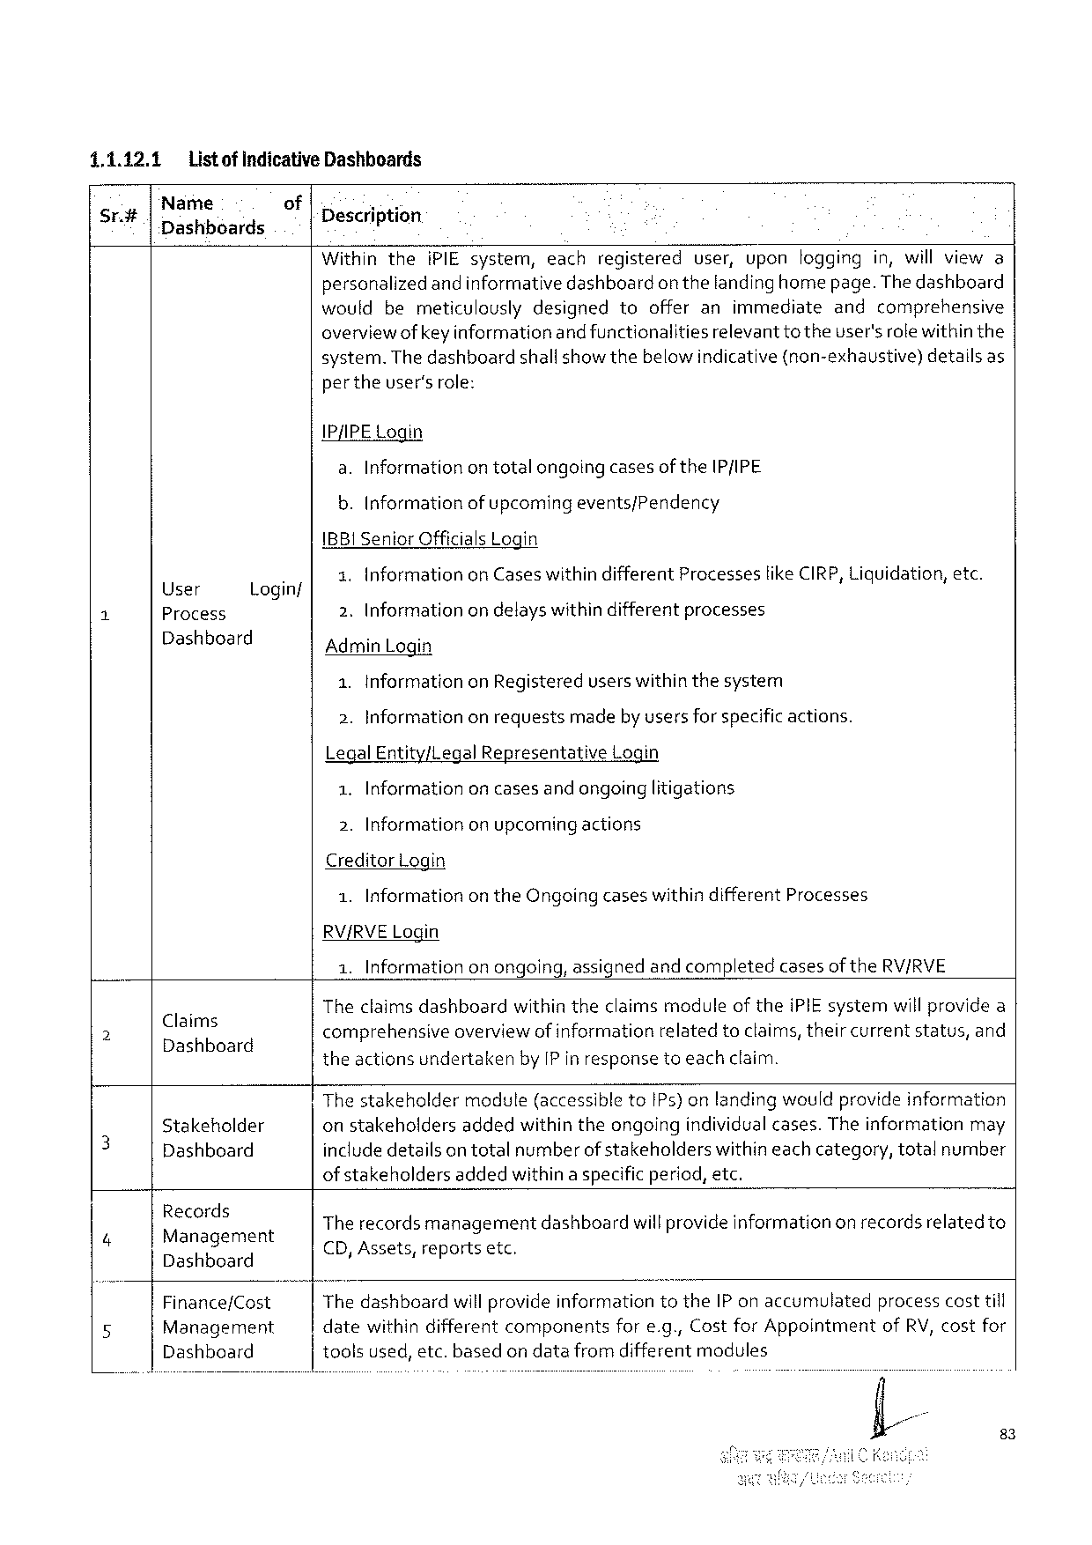

|  |  |  |  |  |  |  |  |  |  |  |  |
| --- | --- | --- | --- | --- | --- | --- | --- | --- | --- | --- | --- |
| 1.1.12.1 | Listof indicative Dashhoards | | | | i PIE system, | each | registered | user, | upon | logging | in, willviewa |
| Sr.# | Name | of | Description | |
| Dashboards |
| Within | | | the |

personalizedandinformativedashboardon thelandinghomepage. Thedashboard wouldbemeticulouslydesignedtoofferanimmediateandcomprehensive overviewofkeyinformationandfunctionalities relevantto theuser'srolewithinthe system. Thedashboard shallshowthebelowindicative(non-exhaustive) detailsas per theuser'srole:

IP/IPE Login   
 a. Informationontotalongoingcasesof the IP/IPE   
 b. Informationof upcomingevents/Pendency   
IBBI Senior Officials Login

|  |  |  |  |
| --- | --- | --- | --- |
| i | User | Login/ | 1. Informationon Caseswithindifferent Processeslike CIRP, Liquidation, etc. |
| 2. Informationon delayswithindifferentprocesses |
| Process |
| Dashboard | Admin Login |

1. Informationon Registereduserswithinthesystem   
2. Information onrequestsmadeby usersforspecificactions.

Legal Entity/Legal Representative Login

1. Information oncasesandongoinglitigations

2. Informationon upcoming actions   
Creditor Login

|  |  |  |
| --- | --- | --- |
| 1. Information | on the Ongoingcaseswithindifferent | Processes |

RV/RVEL ogin   
 1. Informationon ongoing, assignedand completedcasesof the RV/RVE

|  |  |  |
| --- | --- | --- |
| ) | p  Claims  DEER ba E | Theclaims dashboardwithintheclaimsmoduleof thei PIE systemwillprovidea  q i i . N h  comprehensive overviewof information relatedtoclaims, their current status, and |

theactionsundertakenby IP in responsetoeachclaim.

Thestakeholdermodule(accessibleto IP s) onlandingwouldprovideinformation

|  |  |  |  |  |  |  |  |
| --- | --- | --- | --- | --- | --- | --- | --- |
| 3 | Stakeholder | onstakeholdersaddedwithin theongoingindividualcases. Theinformationmay | | | | | |
| Dashboard | includedetailsontotalnumberofstakeholderswithineachcategory, totalnumber | | | | | |
| ofstakeholdersaddedwithinaspecificperiod, etc. | | | | | |
| Records |
| . P .  The recordsmanagementdashboardwill provideinformationon recordsrelatedto | | | | | |
| “ |
| Magagement Dashboard |
| CD, Assets, reportsetc ! A | | ) | | | |
| 5 | Thedashboard | will provideinformation | | | to the IP onaccumulated | processcosttill |
| Finance/Cost |
| Management | datewithindifferent | | components | fore. g., Costfor Appointment | | of RV, costfor |
| Dashboard | toolsused, etc. basedon datafromdifferentmodules | | | | | |

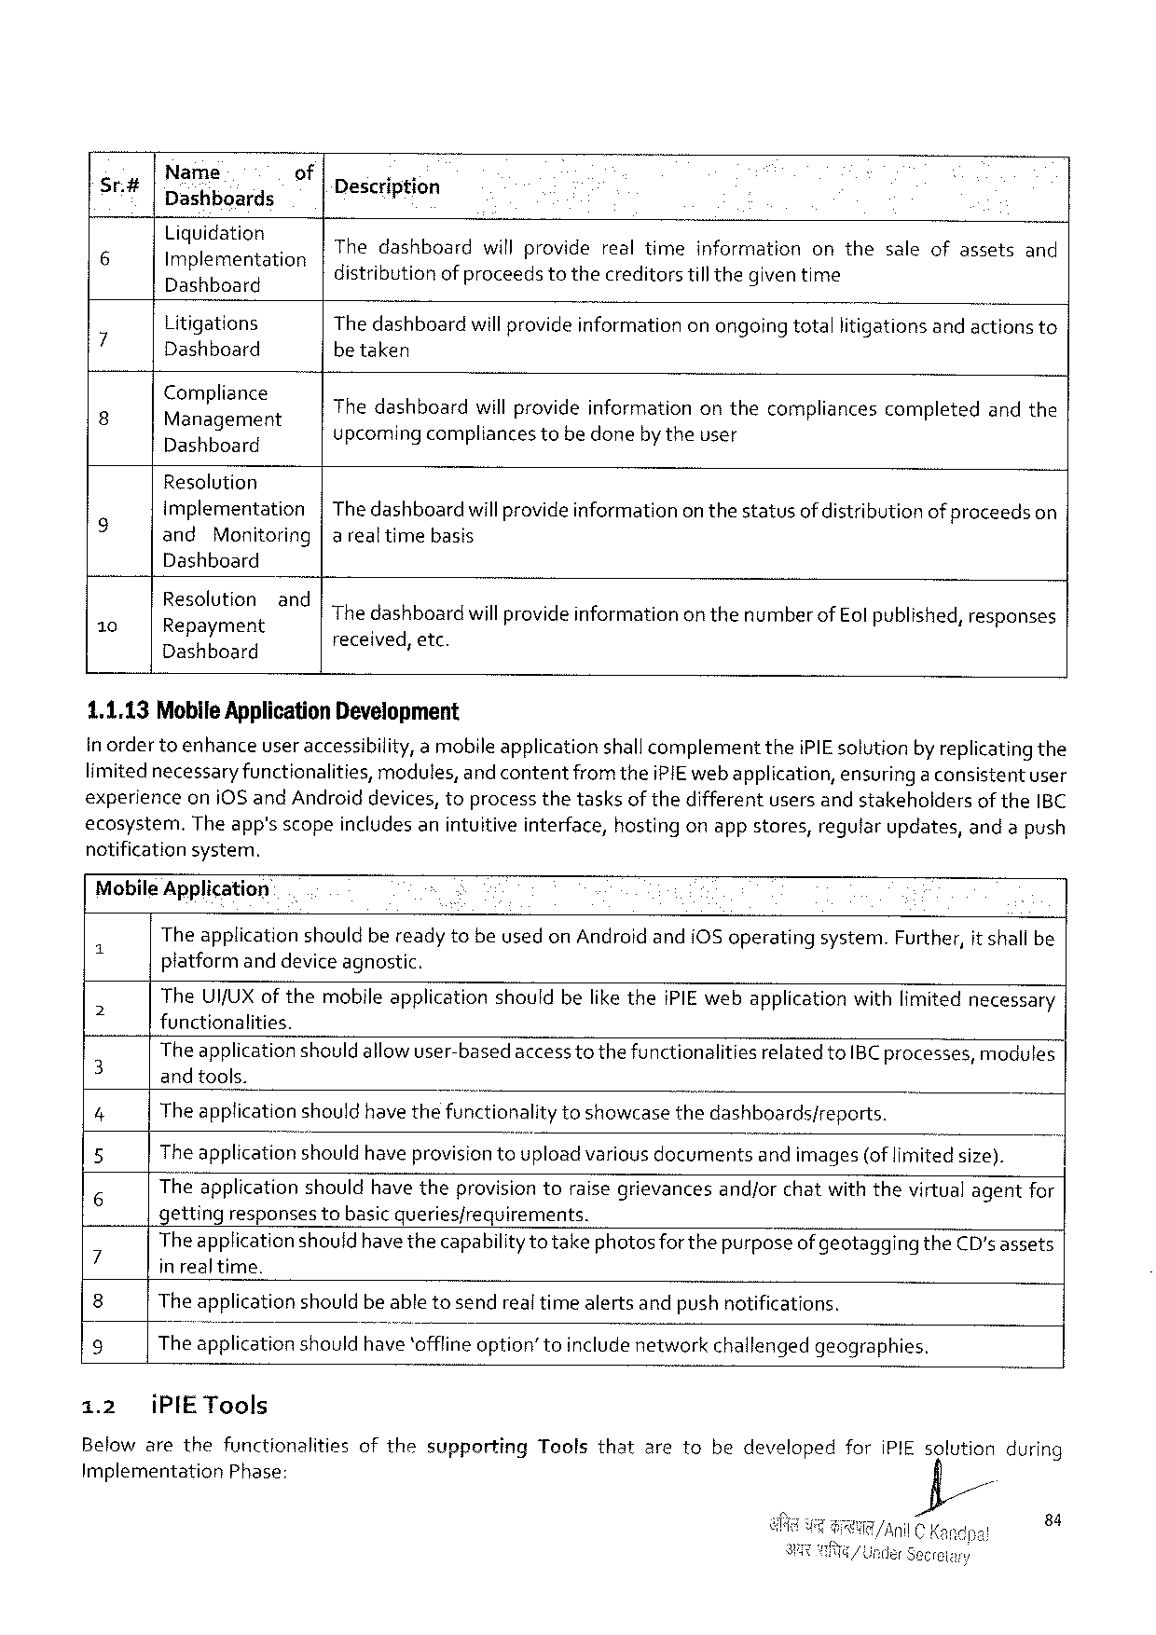

|  |  |  |  |  |
| --- | --- | --- | --- | --- |
| Sr# | Name  Dashboards | of | Description | |
| 6 | Liquidationg Implementation | |
| Thedashboard distributionof proceedstothecreditorstillthegiventime . willproviderealtimeinformationonthesaleofassets A s | and |
| Dashboard | |
| 7 | Litigations | | The dashboardwill provideinformationonongoingtotallitigationsand actionsto | |
| Dashboard | | betaken | |
| P | :\: A‘)a:]: g: rr:: nt | |
| Thedashboardwillprovideinformationonthecompliancescompletedandthe | |
| Dashboard | | upcomingcompliances tobe donebytheuser | |

Resalution

|  |  |  |  |
| --- | --- | --- | --- |
| g | Implementation | | |Thedashboardwillprovideinformationon thestatusof distributionofproceedson |
| and | Monitoring|arealtime basis | |

Dashboard

|  |  |  |
| --- | --- | --- |
| 10 | E: S(; Iu: nigzt Bnd The dashboardwillprovide informationonthenumberof Eol published, responses | |
| pay  Dashboard | received, etc. |

1.1.13 Mobile Application Development

In ordertoenhanceuser accessibility, amobileapplicationshallcomplementthei PIE solutionby replicating the

limitednecessary functionalities, modules, and contentfromthei PIE web application, ensuring a consistentuser

experienceoni 0 Sand Androiddevices, toprocessthetasksof thedifferentusersandstakeholdersof the IBC

ecosystem. Theapp’sscopeincludesanintuitiveinterface, hostingonappstores, regularupdates, andapush

notificationsystem.

Mobile Application:

Theapplicationshouldbereadytobeusedon Androidandi OS operatingsystem. Further, it shall be

platformand deviceagnostic.

The UI/UX of themobileapplicationshouldbelikethei PIE webapplicationwithlimitednecessary

a functionalities.

The application should allowuser-basedaccesstothefunctionalitiesrelated to IBC processes, modules

3 and tools. 5

4 The applicationshould have thefunctionalitytoshowcasethedashboards/reports.

5 The applicationshould haveprovisiontoupload variousdocumentsand images(oflimited size).

6 Theapplicationshouldhave theprovisiontoraisegrievancesand/orchatwiththevirtualagentfor

getting responses tobasicqueries/requirements.

7 Theapplication shouldhavethecapabilityto takephotosfor the purposeof geotaggingthe CD'sassets . *

in realtime.

8 The applicationshouldbe abletosendrealtimealertsandpush notifications.

9 The applicationshouldhave‘offfineoption”toincludenetworkchallengedgeographies.

1.2 i PIET ools

Belowarethefunctionalities of the supporting Tools that aretobedeveloped for i PIE solution during

Implementation Phase: =

84

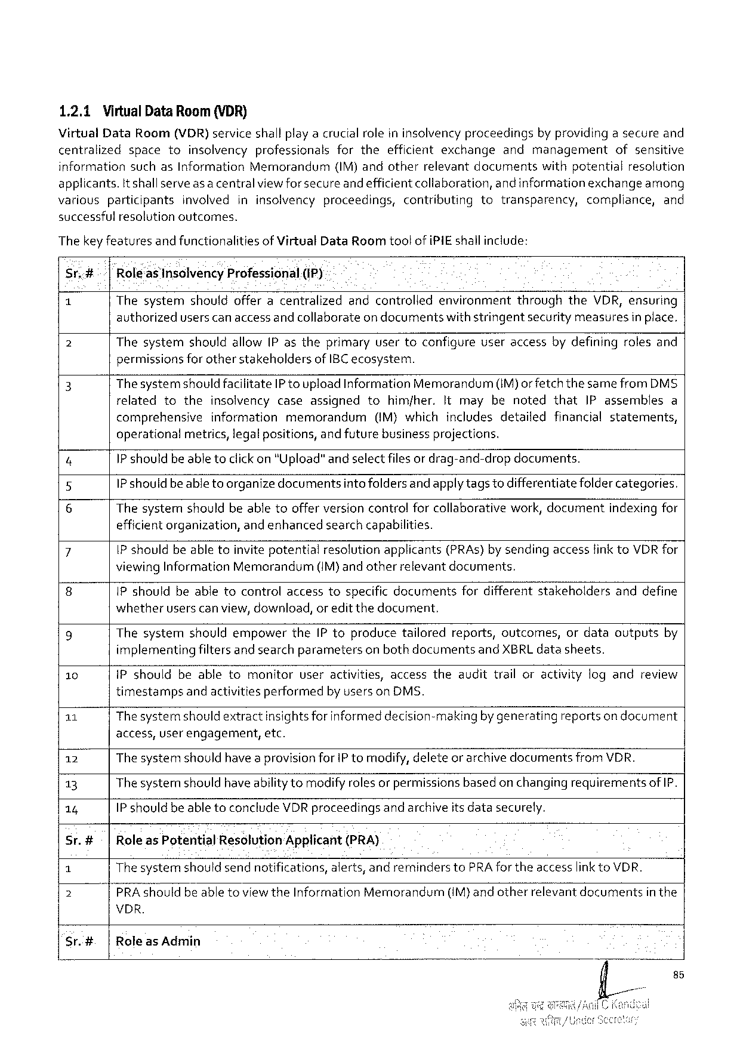

1.2.1 Virtual Data Room (VDR)

Virtual Data Room(VDR) serviceshallplayacrucialroleininsolvencyproceedings byprovidingasecureand

centralized space to insolvency professionals for the efficient exchange and management ofsensitive

information suchas Information Memorandum (IM)andotherrelevant documents withpotential resolution

applicants. Itshallserveas a centralviewforsecureandefficientcollaboration, andinformationexchange among

various participants involved ininsolvency proceedings, contributing to transparency, compliance, and

successful resolutionoutcomes.

Thekey featuresand functionalitiesof Virtual Data Room too! of i PIE shallinclude:

Sr.# ‘Rkoleas Insolvency Professional.(IP)

1 Thesystemshouldofferacentralizedandcontrolledenvironmentthroughthe VDR, ensuring

authorizeduserscan access andcollaborateon documentswithstringentsecurity measuresin place,

2 Thesystemshouldallow(P astheprimaryusertoconfigureuseraccessbydefiningrolesand

permissionsforother stakeholdersof IBC ecosystem.

3 Thesystemshouldfacilitate IP to upload Information Memorandum(IM)or fetch thesamefrom DMS

relatedtotheinsolvencycaseassignedtohimjher. Itmaybenotedthat IP assemblesa

comprehensive information memorandum (IM)which includes detailed financial statements,

operational metrics, legalpositions, andfuturebusinessprojections.

4 1 Pshouldbeable toclick on "Upload"andselectfilesor drag-and-dropdocuments.

5 1 P should beable to organizedocumentsintofoldersandapplytagstodifferentiatefoldercategories.

6 Thesystemshouldbeabletoofferversioncontrolforcollaborativework, documentindexing for

efficientorganization, andenhancedsearchcapabilities.

7 IP shouldbeabletoinvite potentialresolutionapplicants(PRA s)bysendingaccessfink to VDR for

viewing Information Memorandum (IM)andotherrelevantdocuments.

8 IP shouldbeabletocontrolaccesstospecificdocumentsfordifferentstakeholdersanddefine

whetheruserscanview, download, or editthedocument.

9 Thesystemshouldempowerthe IP toproducetailoredreports, outcomes, ordataoutputsby

implementingfiltersand searchparametersonbothdocumentsand XBRL datasheets.

10 i Pshouldbeabletomonitoruseractivities, accesstheaudittrailoractivitylogandreview

timestamps andactivitiesperformed by userson DMS.

11 Thesystemshould extractinsightsfor informeddecision-makingby generatingreportson document

access, user engagement, etc.

12 The systemshouldhave aprovisionfor IP tomodify, deleteor archivedocumentsfrom VDR.

13 Thesysternshouldhave abilitytomodifyrolesor permissionsbasedon changingrequirementsof IP.

14 1 P shouldbe able toconclude VDR proceedingsand archiveits datasecurely.

Sr.#- |Roleas Potential Resolution‘Applicant (PRA)

1 Thesystemshouldsendnotifications, alerts, andremindersto PRA fortheaccesslink to VDR.

2 PRA shouldbeabletoviewthe Information Memorandurm (IM)andotherrelevantdocuments in the

VDR.

Sr.#. |Role as Admin

fi/ss

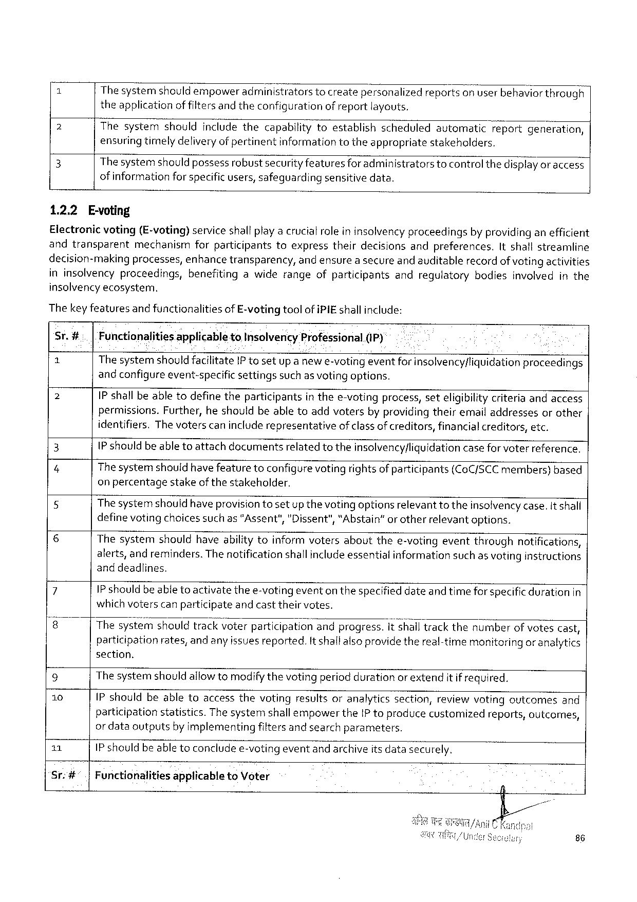

Thesystemshouldempower administrators tocreatepersonalized reportson userbehavior through

theapplicationof filtersand theconfigurationof reportlayouts.

2 Thesystemshouldincludethecapabilitytoestablishscheduledautomaticreportgeneration, ensuring timelydeliveryof pertinentinformation totheappropriatestakeholders.

3 Thesystemshould possessrobustsecurity featuresforadministratorstocontrol thedisplay or access

of information forspecificusers, safeguardingsensitivedata.

1.2.2 E-voting

Electronicvoting(E-voting) serviceshallplayacrucialrole ininsolvencyproceedingsby providing anefficient andtransparent mechanismforparticipantstoexpresstheirdecisionsandpreferences, Itshallstreamline

decision-makingprocesses, enhancetransparency, andensurea secureand auditablerecordof votingactivities ininsolvencyproceedings, benefitingawiderangeofparticipantsandregulatorybodiesinvolvedinthe

insolvencyecosysterm.

The keyfeaturesand functionalitiesof E-vetingtoolof i PIE shallinclude:

Sr.#.. |Functionalitiesapplicableto Insolvency Professional(i P)

|  |  |  |  |  |  |  |
| --- | --- | --- | --- | --- | --- | --- |
| 2  2  3  4  5  6  7  8  9  10  11 | The systemshould facilitate IP tosetupanewe-votingeventforinsolvency/liquidationproceedings | | | | | |
| andconfigureevent-specific | | | settings | suchas votingoptions. | |
| IP shallbeabletodefinetheparticipantsin thee-votingprocess, seteligibilitycriteriaandaccess permissions. Further, heshouldbeabletoaddvotersbyproviding theiremailaddressesorother identifiers. Thevoterscanincluderepresentative ofclassof creditors, financialcreditors, etc.  IP shouldbe able toattachdocumentsrelated totheinsolvency/liquidation case for voterreference.  Thesystemshouldhave featuretoconfigure voting rightsof participants(Co C/SCC members)based on percentagestakeofthestakeholder.  Thesystemshouldhaveprovisiontosetup thevotingoptionsrelevant totheinsolvencycase. It shall definevotingchoicessuchas"Assent","Dissent",“Abstain”orotherrelevantoptions.  Thesystemshouldhaveabilitytoinformvotersaboutthee-votingeventthroughnotifications, alerts, andreminders. The notificationshallincludeessentialinformationsuch as votinginstructions and deadlines,  IP should beable toactivatethee-votingeventonthespecified dateand timefor specificdurationin | | | | | |
| whichvoterscanparticipate | | | andcasttheirvotes. | | |
| Thesystgfi'}shouldtrackvoterparticlpahon‘andprogress. it shalltrackthenumberof votescast, participationrates, and any issues reported. It shallalso providethereal-timemonitoringor analytics section.  The systemshouldallowtomodifythevotingperiod durationorextendit if required.  IP shouldbeabletoaccessthevotingresultsoranalyticssection, reviewvotingoutcomesand | | | | | |
| participation | statistics. | Thesystemshallempowerthe IP toproducecustomized | | | reports, outcomes, |
| or dataoutputsby implementingfiltersand searchparameters.  IP should beable toconcludee-votingevent andarchiveits datasecurely. | | | | | |

Sr:#°.|Functionalitiesapplicableto Voter

86

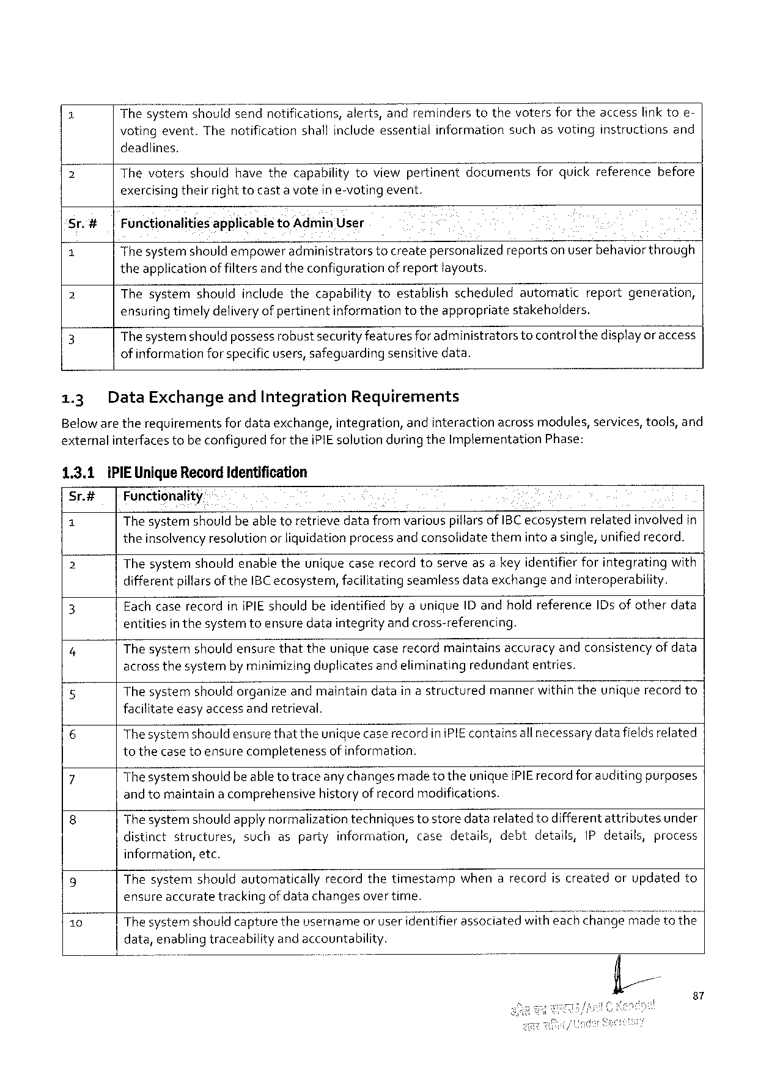

1 Thesy: mshouldsendnotifications, alerts, andreminderstothevotersfortheaccesslinktoe-

votingevent. Thenotification shallincludeessential information suchasvoting instructions and

deadlines.

2 Thevotersshouldhavethecapabilitytoviewpertinentdocumentsforquickreferencebefore exercisingtheirrighttocasta voteine-votingevent.

|  |  |  |  |
| --- | --- | --- | --- |
| Sr.# | | | Functionalitiesapplicableto Admin'User | |
| 1 | The systemshould empoweradministratorstocreatepersonalizedreportson userbehavior through | |
| 2 | theapplication | of filtersand theconfigurationof reportlayouts. |
| Thesystemshouldincludethecapabilitytoestablishscheduledautomaticreportgeneration, | |
| 3 | ensuring timelydeliveryof pertinentinformationtotheappropriatestakeholders. | |
| Thesystemshould possessrobustsecurityfeaturesforadministratorstocontrolthedisplayor access | |

of informationforspecificusers, safeguardingsensitivedata.

|  |  |  |  |
| --- | --- | --- | --- |
| 1.3 | Data Exchange | and Integration | Requirements |

Belowaretherequirementsfor dataexchange, integration, andinteractionacrossmodules, services, tools, and externalinterfacestobeconfiguredforthei PIE solution during the Implementation Phase:

|  |  |
| --- | --- |
| 1.3.1 Sr.#  1  2 | i PIE Unique Record Identification   Functionality-  The systemshouldbeable toretrievedatafrom variouspiflarsof IBC ecosystemrelatedinvolved in theinsolvencyresolution orliquidationprocessand consolidatethemintoa single, unifiedrecord.  Thesystemshouldenabletheuniquecaserecordtoserveasa keyidentifierforintegratingwith |

differentpillarsofthe IBC ecosystem, facilitatingseamlessdataexchangeand interoperability.

|  |  |
| --- | --- |
| 3  4 | Eachcaserecordin IPIE shouldbeidentifiedby aunique ID andholdreference ID s ofotherdata entitiesin thesystemtoensuredataintegrityand cross-referencing.  Thesystemshouldensurethattheunique caserecordmaintainsaccuracy andconsistencyofdata |

acrossthesystembyminimizingduplicatesand eliminatingredundantentries.

5 Thesystemshouldorganizeandmaintaindatain astructuredmannerwithintheuniquerecordto facilitateeasyaccessandretrieval.

6 Thesystemshould ensurethattheuniquecase recordini PIE containsall necessarydata fieldsrelated tothecase toensurecompletenessof information.

|  |  |  |  |
| --- | --- | --- | --- |
| 7  8 | Thesystemshouldbeabletotraceany changesmade to theuniquei PIE recordforauditing purposes and tomaintaina comprehensivehistoryof recordmodifications.  Thesystemshould apply normalizationtechniquestostoredatarelatedtodifferentattributesunder | | |
| distinctstructures, | suchaspartyinformation, casedetails, debt | details, IP details, process |

information, etc.

|  |  |  |
| --- | --- | --- |
| g  10 | Thesystemshouldautomaticallyrecordthetimestampwhenarecordiscreatedorupdatedto ensureaccuratetrackingofdatachangesover time. | |
| Thesystemshould capturetheusernameor useridentifier associatedwithea Ek"w’EH;@e | madetothe |

data, enablingtraceabilityandaccountability.

87

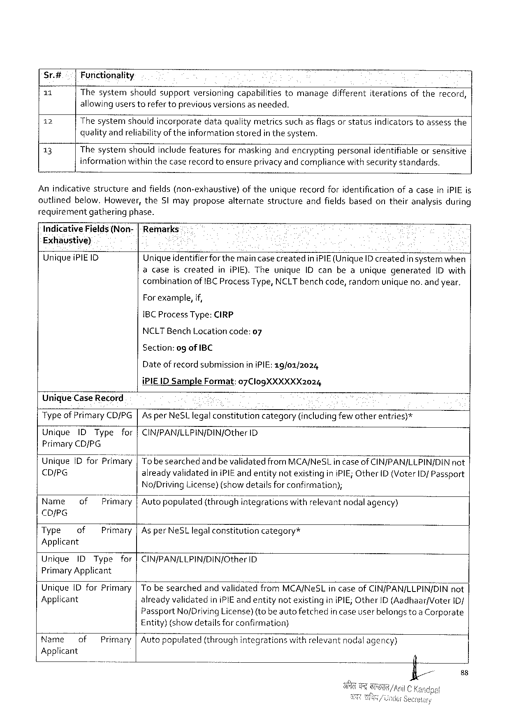

Sr.4# Functionality

11 Thesystem shouldsupport versioning capabilities tomanage different iterations oftherecord,

allowinguserstorefertopreviousversionsasneeded.

12 Thesystemshouldincorporatedataqualitymetricssuchasflagsor statusindicatorstoassessthe

qualityandreliabilityof theinformationstoredin thesystem.

13 Thesystemshouldincludefeaturesformaskingandencryptingpersonalidentifiableorsensitive

informationwithinthecaserecord toensureprivacyand compliancewith security standards.

Anindicativestructure andfields(non-exhaustive) oftheuniquerecordforidentification ofacaseini PIE is

outlinedbelow, However, the SI mayproposealternatestructureandfieldsbasedontheiranalysisduring

requirementgatheringphase.

Indicative Fields(Non-|Remarks

Exhaustive) ¢

Uniquei PIEID Uniqueidentifierforthemaincase createdini PIE(Unique ID createdin systemwhen

acaseiscreatedini PIE). Theunique ID canbeauniquegenerated ID with

combinationof IBC Process Type, NCLT benchcode, randomunigueno. and year.

For example, if,

1 BCP rocess Type: CIRP

NCLTB ench Locationcode:07

Section: ogof IBC

Dateofrecordsubmission ini PIE:19/01/2024

Unique Case Record

i PIE 1 DS ample Format:07 Clog XXXXXX 2024

Typeof Primary CD/PG As per Ne SL legalconstitutioncategory(includingfewotherentries)*

Unique IDT ype for CIN/PAN/LLPIN/DIN/Other 1 D

Primary CD/PG

Unigue ID for Prirfiéw

CD/PG alreadyvalidatedin i PIE and entitynot existingini PIE; Other ID (Voter 1 D/Passport

No/Driving License)(showdetailsforconfirmation);

|  |  |  |  |  |  |
| --- | --- | --- | --- | --- | --- |
| Name | of | Prfljfiary | Autopopulated | (thr OCQ hintegrations | withrelevantnodalagency) |

CDIPG

|  |  |  |  |
| --- | --- | --- | --- |
| Type | of | Primary|Asper Ne SL legalconstitution | category* |

Applicant

|  |  |  |  |  |
| --- | --- | --- | --- | --- |
| Unique | IDT ype | for | CIN/PAN/LLPIN/DIN/Other | ID |

Primary Applicant

|  |  |
| --- | --- |
| Unique 1 D for Primary Applicant | To besearchedandvalidatedfrom MCA/Ne SL in caseof CIN/PAN/LLPIN/DIN not alreadyvalidatedini PIE and entitynotexistingini PIE; Other ID(Aadhaar/Voter i D/ |

Passport No/Driving License)(tobeautofetched

Entity)(showdetailsforconfirmation)

incaseuserbelongstoa Corporate

|  |  |  |  |
| --- | --- | --- | --- |
| Name | of | Primary | Auto populated(throughintegrationswithrelevantnodal agency) |

Applicant

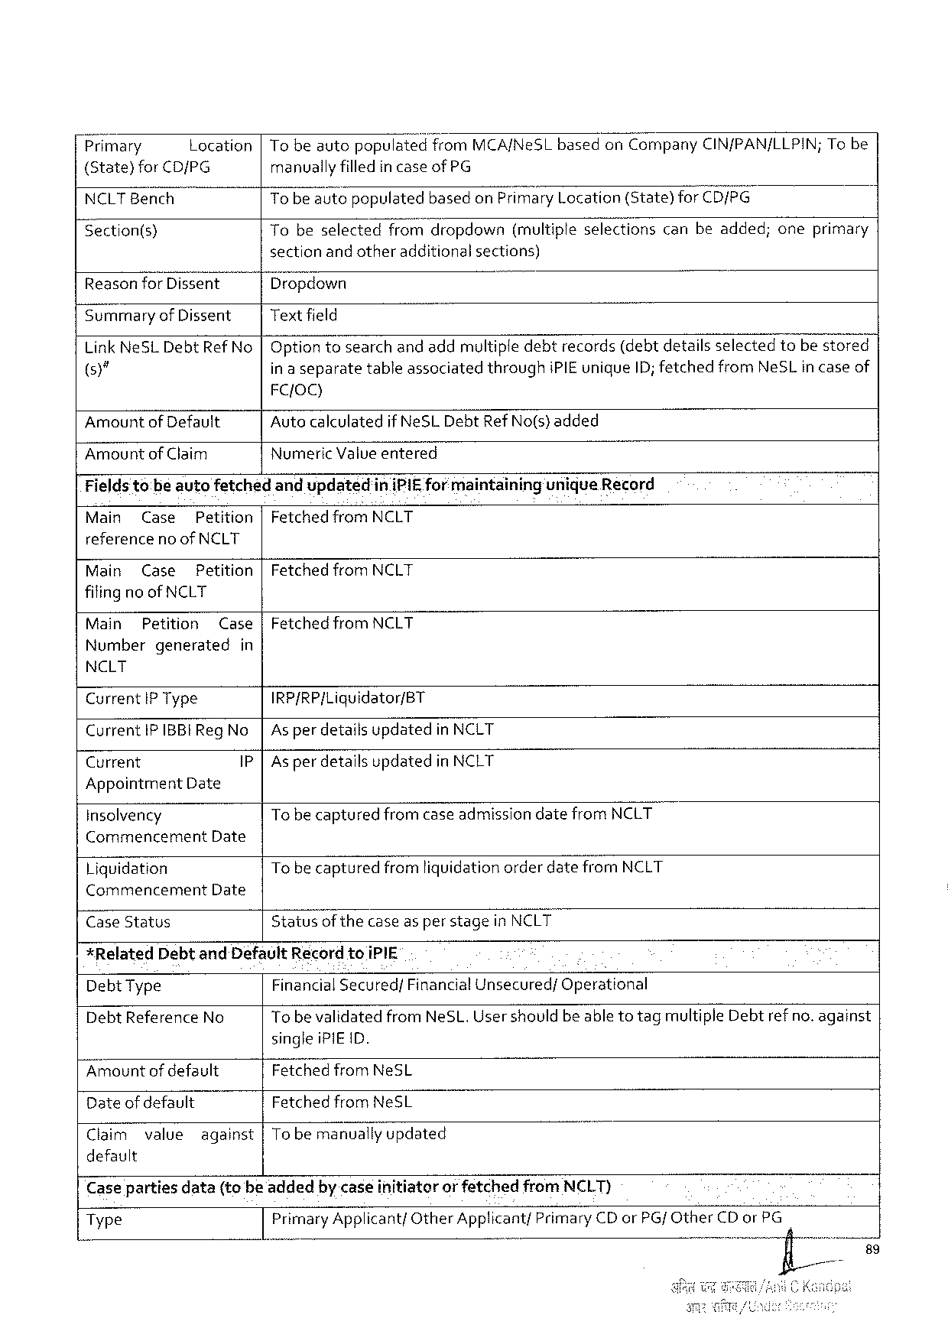

7 Primary Location|Tobeautopopu\atea? rom MCA/Ne SL basedon Company CIN/PAN/LLPIN; Tobe

(State)for CD/PG manuallyfilledincaseof PG

NCLTB ench To beautopopulatedbasedon Pr; n“ary Location(State)for CD/PG

[Section(s) Tobeselected fromdropdown (multiple selections canbeadded; oneprimary

sectionandotheradditionalsections)

|  |  |
| --- | --- |
| Reason for Dissent  Summary of Dissent  Link Ne SLD ebt Ref No )"  Amountof Default Amountof Claim | Dropdown  Textfield  Optiontosearchand addmultipledebtrecords(debtdetailsselectedtobestored in a separatetableassociatedthroughi PIE unique ID; fetchedfrom Ne SL in caseof FC{OQ)  Auto calculatedif Ne SLD ebt Ref No(s) added  Numeric Valueentered |

Fields tobeauiofetched andupdatedini PIE formaintainingunique Record

|  |  |  |  |
| --- | --- | --- | --- |
| Main | Case | Petition | Fetched frorfi NCLT |

referenceno of NCLT

|  |  |  |
| --- | --- | --- |
| Main | Case | Petition|Fetched from NCLT |

filingno of NCLT

Main Petition Case|Fetched from NCLT

Numbergenerated in

NCLT

Current IP Type IRP/RP/Liquidator/BT

Current IPIBBI Reg No As perdetailsupdatedin NCLT

Current P As perdetailsupdatedin NCLT

Appointment Date

insolvency Tobe capturedfromcaseadmissiondatefrom NCLT

Commencement Date

Liquidation Tobecapturedfromliquidationorderdatefrom NCLT

Commencement Date

Case Status Statusof the caseas per stagein NCLT

*Related Debtand Default Record toi PIE

Debt Type Financial Secured/Financial Unsecured/Operational

Debt Reference No Tobevalidatedfrom Ne SL. User shouldbe able totagmultiple Debtrefno. against

singlei PIE ID.

Amountofdefault Fetchedfrom Ne SL

Dateof default Fetchedfrom Ne SL

Claim value against|To bemanually updated

default

Caseparties data(tobeadded bycaseinitiator orfetched from NCLT)

Type Primary Applicant/Other Applicant/Primary CD or PG/ Other CD or PG

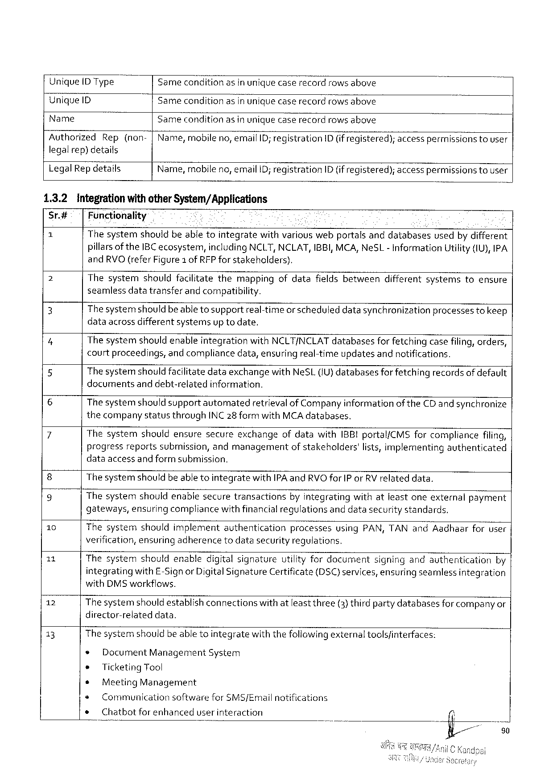

Unique DT ype Samecondition asinuniquecaserecordrowsabove

Unique ID Samecondition asinuniguecaserecordrowsabove

Name Sameconditionasin uniquecaserecordrowsabove

Authorized Rep(non-|Name, mobileno, email ID; registration ID (if registered); accesspermissions tousar

legalrep)details

Legal Rep details Name, mobileno, email ID; registration ID (if registered); access permissionstouser

1.3.2 integrationwithother System/Applications

Sr.# | Functionality

2 l Thesystemshouldbeabletointegratewithvariouswebportalsanddatabasesusedby different

pillarsof the 1 BC ecosystem, including NCLT, NCLAT, IBBI, MCA, Ne SL- Information Utility(1 U), IPA

and RVO(refer Figure 1 of RFP forstakeholders).

|  |  |  |  |  |  |  |  |  |
| --- | --- | --- | --- | --- | --- | --- | --- | --- |
| 2  3  4  5  6  7  8  9  10  11  12  13 | Thesystemshouldfacilitatethemappingofdatafieldsbetweendifferentsystemstoensure seamlessdatatransferand compatibility.  Thesystemshould beabletosupportreal-timeor scheduleddatasynchronizationprocessestokeep dataacrossdifferentsystemsup todate.  Thesystemshouldenableintegrationwith NCLT/NCLAT databasesfor fetchingcasefiling, orders, courtproceedings, andcompliancedata, ensuringreal-timeupdatesandnotifications.  Thesystemshould facilitatedataexchangewith Ne SL(U} databasesforfetchingrecordsofdefault documentsanddebt-relatedinformation.  The systemshould supportautomatedretrievalof Companyinformationof the CD andsynchronize thecompanystatusthrough INC 28 formwith MCA databases.  Thesystemshouldensuresecureexchangeofdatawith IBBI portal/CMS forcompliancefiling, progressreportssubmission, andmanagementof stakeholders'lists, implementingauthenticated dataaccessand formsubmission.  The systemshouldbeabletointegratewith IPA and RVO for IP or RV relateddata. | | | | | | | |
| Thesystem | | shouldenablesecuretransactions | | | byintegrating | withatleastoneexternal | payment |
| gateways, ensuringcompliancewithfinancial requlationsanddatasecuritystandards. | | | | | | | |
| Thesystemshouldimplementauthentication | | | | | processesusing PAN, TAN and Aadhaarforuser | | |
| verification, ensuringadherencetodatasecurity regulations.  Thesystemshouldenabledigitalsignatureutilityfordocumentsigningandauthenticationby | | | | | | | |
| integrating | | with£-Signor Digital Signature Certificate(DSC) services, ensuringseamlessintegration | | | | | |
| with DMS workffows.  The systemshouldestablishconnectionswithatleast three(3) thirdpartydatabasesforcompanyor director-relateddata.  The systemshouldbeabletointegratewiththefollowingexternaltoolsfinterfaces: | | | | | | | |
| ¢ | Document Management System | | | | | | |
| * | Ticketing Tool | | | | | | |
| ¢ | Meeting Management | | | | | | |
| s | Communication | | softwarefor SMS/Emailnotifications | | | | |
| ¢ | Chatbotforenhanced | | | userinteraction | | | |

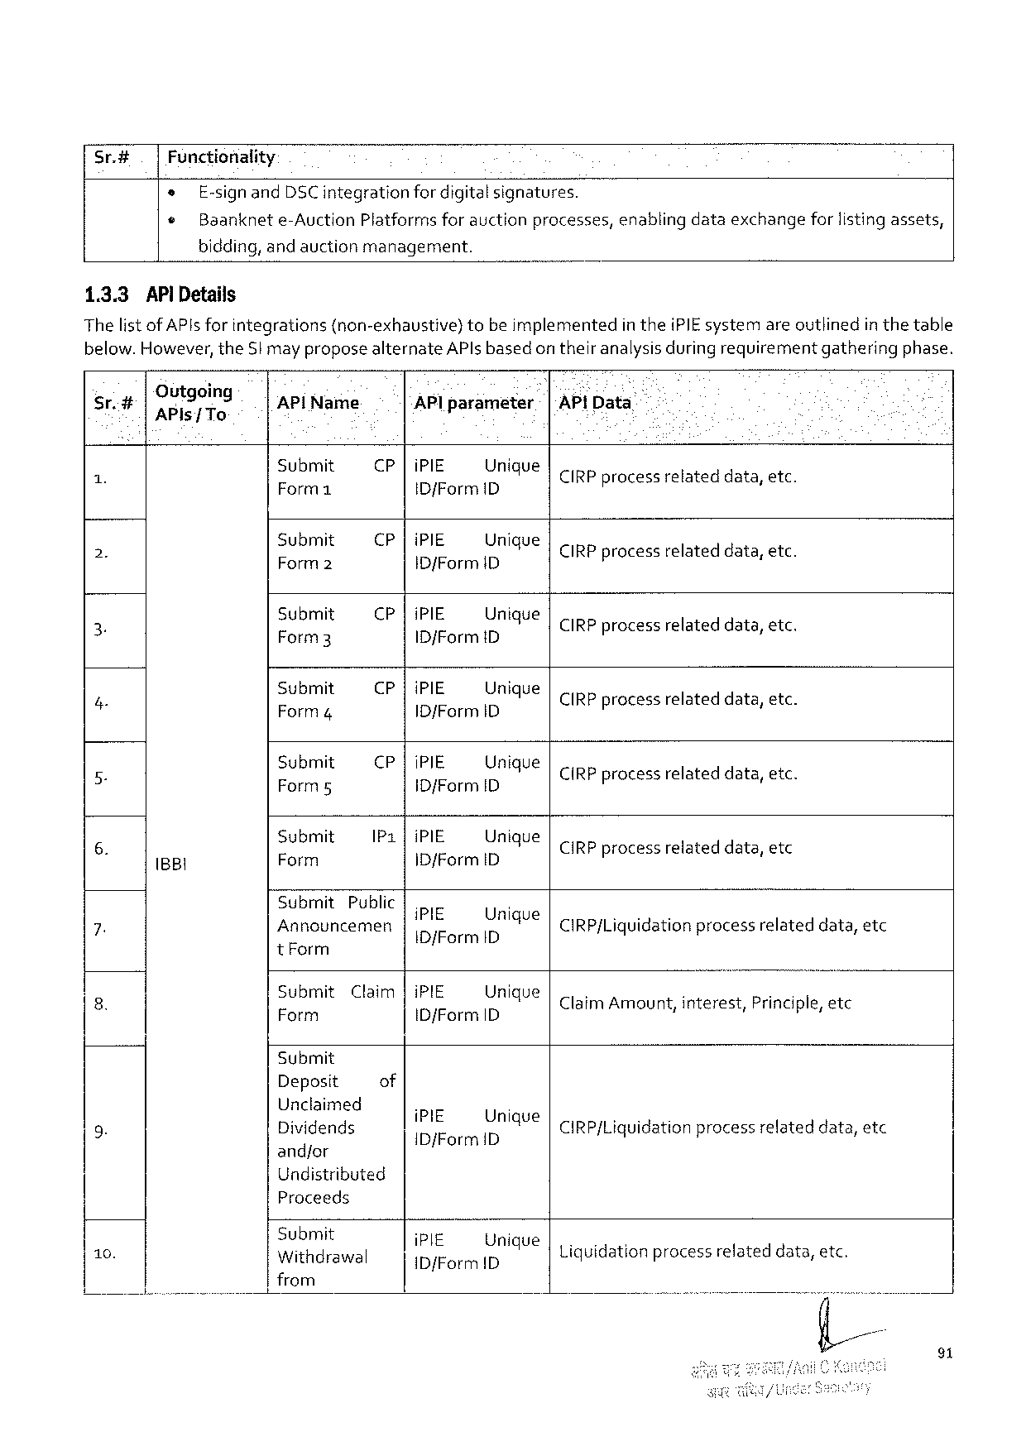

|  |  |  |  |  |  |  |  |
| --- | --- | --- | --- | --- | --- | --- | --- |
| Sr.# | Functionality | | | | | enablingdataexchange | forlistingassets, |
| e | E-signand DSC integration | | | fordigitalsignatures. |
| © | Baanknet | e-Auction | Platformsforauctionprocesses, | |

bidding, andauctionmanagement.

1.3.3 AP Details

Thelist of API sfor integrations(non-exhaustive)tobeimplementedinthei PIE systemareoutlinedin thetable below. However, the Stmay proposealternate AP lsbasedon theiranalysisduringrequirementgatheringphase.

|  |  |  |  |  |  |  |  |  |  |  |  |  |
| --- | --- | --- | --- | --- | --- | --- | --- | --- | --- | --- | --- | --- |
| Sr.# | | Outgoing AP ls/ To | AP! Name | AP lparameter | | | | e | & - [AP]Data | | | |
| 1 X | | B 8 l | Submit [— | CP |i PIE Unigue  ID/Form ID | | | | | | CIRP processrelated lateddata, data, | | etc. etc |
| Submit  R & | CP |i PIE Unique  ID f Form ID 4 | | | | | | CIRP processrelateddata, etc. | | |
| 2. | |
| Submit Form 3 | CP |i PIE Unique  ID/Formi D | | | | | | CIRP processrelateddata, etc. | | |
| 3 | |
| Submit  Form 4 | CP| | | i PIE Unique  |D/Form ID | | | CIRP processrelated | | data, etc data, etc. | |
| 4 | 3 |
| Submit Form 5 | CP |i PIE Unique  ID/Form ID | | | | | | CIRP processrelated lateddata, data, etc etc. | | |
| 5 B | |
| Submit [y | IP 1|i PIE Unique  ID/Form ID | | | | | | CIRP processrelateddata, etc | | |
| 6. | |
| Submit | Public | PIE | | Urigoa | | | | | |
| 7. | |
| Annocuncemen | | | IDJF orm ID 4 | | | CIRP/Liquidationprocessrelateddata, etc | | | |

t Form

|  |  |  |  |
| --- | --- | --- | --- |
| 8. | Submit  5 T | Claim|i PIE Unique  ID/Form ID. | : s i  Claim Amount, interest, Principle, etc |

Submit

|  |  |  |  |  |
| --- | --- | --- | --- | --- |
| 9. | Deposit | of | i PIE Unique  ID f Form D | CIRP/Liquidationprocessrelateddata, etc |
| Unclaimed  Dividends |

and/or   
Undistributed   
Proceeds

|  |  |  |
| --- | --- | --- |
| 10. | Submit  Withdrawal | i  ; Efiorm Ilémque Liquidation processrelateddata, etc. |

from

91

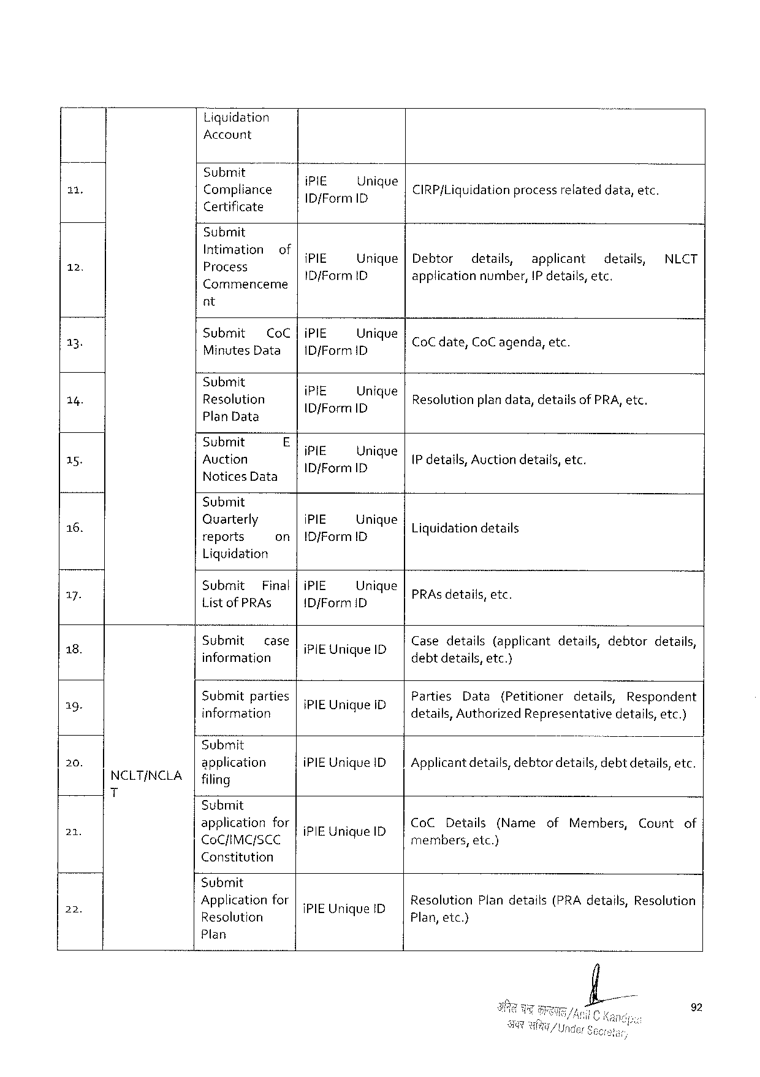

Liquidation

Account

|  |  |  |  |
| --- | --- | --- | --- |
| 11 | Submit | - | . |
| Compliance | :! I;‘/EF orm IL[})nlque CIRP{Liquidationprocessrelateddata, etc. | |

Certificate

Submit   
Intimati

|  |  |  |  |  |  |  |  |  |  |
| --- | --- | --- | --- | --- | --- | --- | --- | --- | --- |
| T | ) | ;: OIZB: SIOH of | i PIE | Unique|Debtor | | details, | applicant | details, | NLCT |
| Commenceme | ID{Form ID | | applicationnumber, IP details, etc. | | | |

nt

|  |  |  |  |  |  |  |
| --- | --- | --- | --- | --- | --- | --- |
| 13.  14. | Submit Co C |i PIE Unique  Minutes Data | ID/Form ID | | | Co Cdate, | Co C agenda, | etc. |
| Submit | i | - | | | |
| Resolution | : FI; I/iorrn ILIJ)mque Resolutionplandata, detailsof PRA, etc. | | | | |

Plan Data

|  |  |  |  |  |  |
| --- | --- | --- | --- | --- | --- |
| 15. | Submit | E | i | Unique | IP details, Auctiondetails, etc. |
| Auction |
| Notices Data | B/Ferl R |

Submit

|  |  |  |  |
| --- | --- | --- | --- |
| 1 6. | Quarterly  reports | on|10/Form 1 D i PIE Unique| | . . . .  Liquidationdetails |

Liquidation

|  |  |  |  |  |  |  |  |  |
| --- | --- | --- | --- | --- | --- | --- | --- | --- |
| g 4 | Submit Final|i PIE Unique  Listof PRA s | ID j Form ID | | | .  PRA s details, etc. | | | | |
| 8.  b | Submit case|. .  F :  information RIEUR iquel D | | | Casedetails(applicantdetails, debtordetails, d ! : debtdetails, etc.) | | | | |
| B 3 | Submit | parties| | |
| Parties | Data | (Petitioner | details, | Respondent |
| information | | IPIEUR ique, i D | details, Authorized Representativedetails, etc.) | | | | |

“Submit

|  |  |  |  |  |
| --- | --- | --- | --- | --- |
| 20. | NCLT/NCLA T | application | i PIEU nique ID| | Applicantdetails, debtordetails, debtdetails, etc. |
| filing |

Submit

|  |  |  |  |
| --- | --- | --- | --- |
| 2 | applicationfor|. . Co CD etails(Name  cocnmersce |PBUMQUEID o bers, etc) | of Members, | Countof |

Constitution

Submit

|  |  |  |  |  |
| --- | --- | --- | --- | --- |
| 2 | ) | Applicationfor | {PIE Unique ID | Resolution Plandetails(PRA details, Resolution |
| Resolution | 4 | Plan, etc.) |

Plan

92

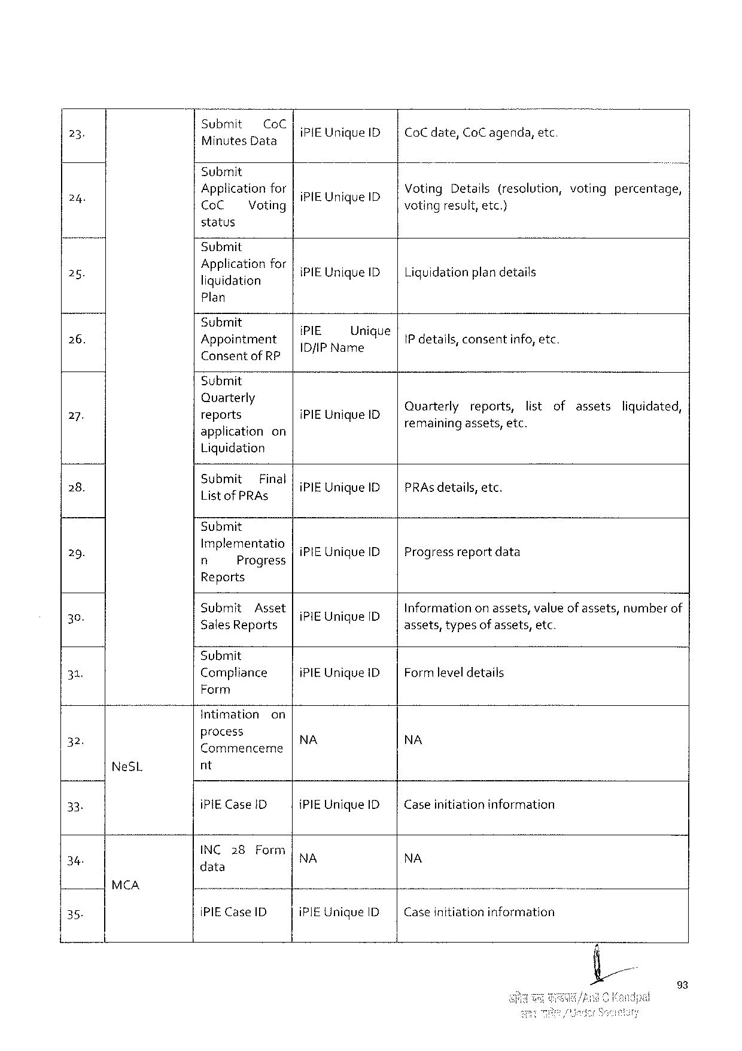

|  |  |  |  |  |
| --- | --- | --- | --- | --- |
| 23 | Submit Co C  NETEID a TS | i PIEU nique ID| | Co C date, Co C agenda, | etc |

Submit

|  |  |  |  |  |  |  |  |  |
| --- | --- | --- | --- | --- | --- | --- | --- | --- |
| 24 | Applicationfor|. | | | N | ID | Voting Details(resolution, votingpercentage, | | |
| Co C | Voting | i PIEU nique | | voting | result, | etc.) |

status

Submit

|  |  |  |  |
| --- | --- | --- | --- |
| 28. | Application  liquidation | for|.  i PIEU nique ID| | i = g  Liquidationplandetails |

Plan

|  |  |  |  |  |
| --- | --- | --- | --- | --- |
| 26. | Submit | . | . | IP details, consentinfo, etc. |
| Appointment | :; I; IEP Nan: Jnlq Ue | |
| Consentof RP | € | |

Submit

|  |  |  |  |  |  |  |  |  |
| --- | --- | --- | --- | --- | --- | --- | --- | --- |
| 2. | Quarterly  reports | IPIEU nique I | Ouarte‘rly | reports, | i  list | of | assets | ol  liquidated, |
| applicationon . | remainingassets, etc. | | |

Liquidation

|  |  |  |
| --- | --- | --- |
| 28. | Submit Final|. :  Listof PRAS i PIEU nique ID| | 8  PRA s details, etc. |

Submit

|  |  |  |
| --- | --- | --- |
| 29. | Implementatio|. .  n Progress i PIEU nique ID | Progressreportdata |

Reports

|  |  |  |  |  |
| --- | --- | --- | --- | --- |
| o | Submit | Asset | {PIEU nique ID | Informationonassets, valueof assets, numberof |
| 30 | Sales Reports | | q | assets, typesof assets, etc. |

Submit

|  |  |  |  |
| --- | --- | --- | --- |
| 31, | Compliance | i PIEU nique ID| | Formleveldetails |

Form

|  |  |  |  |  |
| --- | --- | --- | --- | --- |
| = | Intimation | on | NA | NA |
| process |

Commenceme

|  |  |  |  |  |  |  |
| --- | --- | --- | --- | --- | --- | --- |
| 33 | Ne SL | nt | | i PIEU nique ID| | Caseinitiationinformation | . |
| i PIEC ase 1 D | |
| 34 | MCA | INC 28 | Form | NA | NA |
| data | |
| —— | | U |
| 35. | i PIEC ase ID | | i PIEU nique ID | Caseinitiationinformation |

23

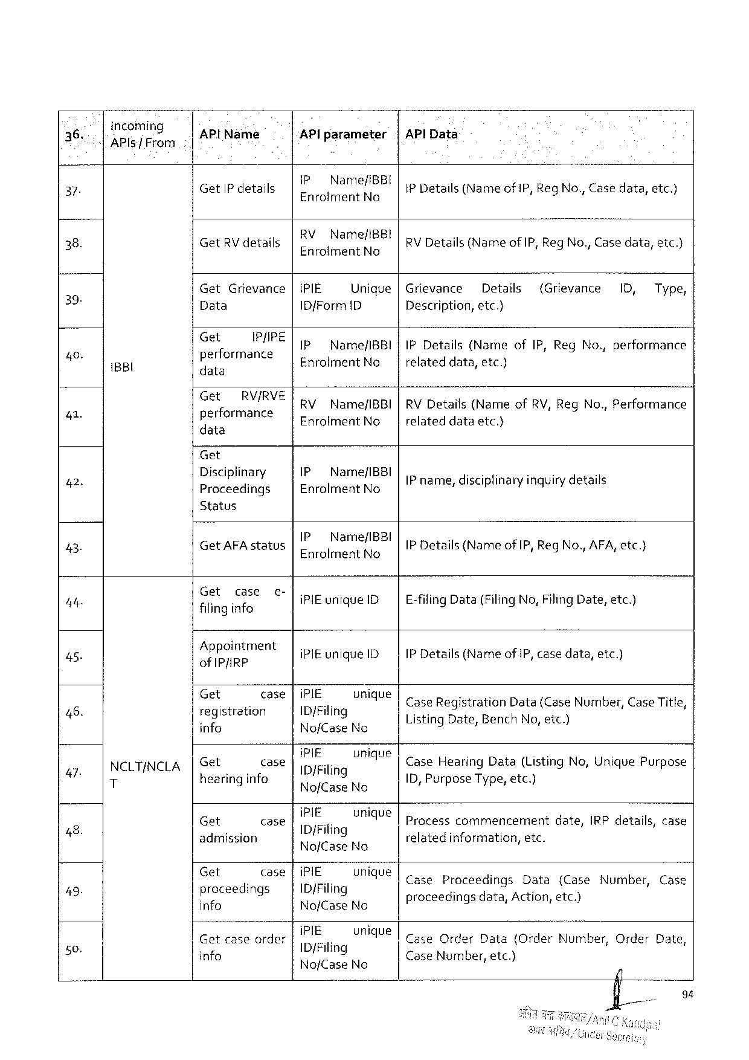

|  |  |  |  |  |  |  |  |  |  |  |  |  |
| --- | --- | --- | --- | --- | --- | --- | --- | --- | --- | --- | --- | --- |
| 36, | incoming  API s f From | AP l Name | | AP lparameter | | |AP l Data | | | | | | |
| 37. | i BBI | Get IP details | | IP Name/IBBI  Enrolment No | | IP Details(Name of IP, Reg No., Casedata, etc.) | | | | | | |
| .  Get RV details | | RVN ame/IBB! Enrdimena Ne | | | ;  RV Details(Nameof IP, Reg No., Casedata, etc.} | | | | | |
| 38. |
| Get | Grievance|i PIE | | Unique|Grievance | | | Details | | (Grievance | 1 D, | Type, |
| 39 |
| Data | | ID f Form D | | Description, etc.) | | | | | | |
| Get | IR/IRE | IP | Name/IBBI|IPD etails(Name | | | | of IP, Reg No., performance | | | |
| 4 |
| performance data | | Enrolment No | | relateddata, etc.) (s | | | | | | |
| 41 | Get RV/RVERV Name/IBBI|RVD etails(Nameof RV, Reg No., Performance  performance Enrolment No relateddataetc.)  data | | | | | | | | | | |

Get

|  |  |  |  |
| --- | --- | --- | --- |
| 42. | Disciplinary  Proceedings | IP Name/IBBI  ERFGIFER t NG | IP name, disciplinaryinquirydetails AN [ . I |

Status

|  |  |  |  |  |  |  |  |  |  |  |  |  |  |  |  |  |  |  |  |  |  |  |  |
| --- | --- | --- | --- | --- | --- | --- | --- | --- | --- | --- | --- | --- | --- | --- | --- | --- | --- | --- | --- | --- | --- | --- | --- |
| 43. | NCLTINCLA T | Get AFA status | | | | 1 P Name/IBBI  Enrolment No | | | s  IP Details{(Nameof IP, Reg No., AFA, etc.) | | | | | | | | | | | | | | |
| 4 ty | f G”?,: gi\:?; e | | | & | lireunique 1 D | | E-filing Data(Filing No, Filing Date, etc.) | | | | | | | | | | | | | | | |
| 7 | Appointment of IPJIRP | | | | [.  i PIE unique ID | | .  IP Details(Nameof IP, casedata, etc.) | | | | | | | | | | | | | | | |
| 46. | et | oeoe | | | IP}E_ | UMV | ]case Registration | | | | | | | | Data(Case Number, Case Title, | | | | | | | |
| registration info | | | | ID j Filing  Nof Case No | | Listing Date, Bench No, etc.)  9 < = | | | | | | | | | | | | | | | |
| 47 | Get | case | | | hi E | unique | Case | | | Hearing | | | Data | | (Listing | | | No, Unique | | | Purpose | |
| hearinginfo 9 | | | | Df Filing  Noj/Case No | | 1 D, Pur s | | | | | ose'lg' e, etc.)  PUTP ype, etc. | | | | | 9 T | | § | | | i |
| 48. | Get   o  admission | | case | | i PIE  ID/Filing | vnique | Process commencement  .  relatedinformation, etc. | | | | | | | | | date, IRP details, | | | | | | case |
| No/Case No | |
| 49- | Gt | o S 28 | | | IPIE_ | UMV | Case | | | | Proceedings | | | | Data | (Case | | | Number, | | | Case |
| proceedings info | | | | ID/Filing  Nof Case No | | p | | roceedingsdata, 9 | | | | | ! | Action, | etc.)  A | | | | | | |
| 59 | i 5 IE_UMAU e | | |coce | | | Order | | | Data | | {Order Number, | | | | | Order | | Date, |
| Getcaseorder | | | |
| info | | | | ID/Filing  Nof Case No | | Case Number, etc.)   L | | | | | | | | | | | | | | | |

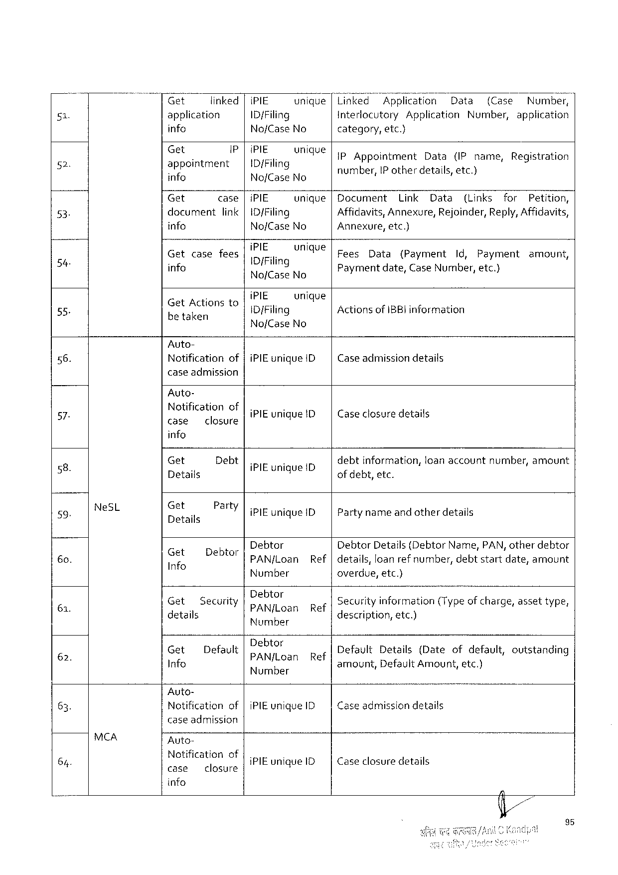

|  |  |  |  |  |  |  |  |  |  |  |  |  |  |  |  |  |  |  |  |  |  |  |  |  |
| --- | --- | --- | --- | --- | --- | --- | --- | --- | --- | --- | --- | --- | --- | --- | --- | --- | --- | --- | --- | --- | --- | --- | --- | --- |
| 51  2  53.  54  55. | Get | | | linked| | | | | | i PIE | unique|Linked | | | | TA pp Iication | | | | | Data | | (Case | | Numbe?, | |
| application | | | | | | | | ID/Filing | | Interlocutory | | | | | Application | | | | Number, | | | application | |
| info | | | | | | | | No/Case No | | category, | | | etc.) | | | | | | | | | | |
| Gt | s | | | | i | | | (PIE. ounique | | | Appointment | | | | | Data | | (IP name, | | | | Registration | |
| appointment info | | | | | | | | | ID/Filing  No/Case No | | number, IP otherdetails, etc.) E === | | | | | | | | | | | | | |
| Get | | | | case|i PIE | | | | | unique|Document | | | | Link | | | Data | | (Links | | | for | | Petition, |
| docurnent | | | | | | link |ID/Filing | | | | Affidavits, Annexure, | | | | | | | Rejoinder, Reply, Affidavits, | | | | | | |
| info | | | | | | | | No/Case No | | Annexure, etc.) | | | | | | | | | | | | | |
| Get | | case | | | fees | | | IPIE,. | UMAY€|Fees | | | Data | | (Payment | | | | Id, | Payment | | | amount, | |
| info | | | | | | | | [Di Filing  No/f Case No | | Paymentdate, Case Number, etc.)  Y/ £ L | | | | | | | | | | | | | |
| . | | | | | | | | i PIE | unique | | | | | | | | | | | | | | |
| Get Actionsto betaken | | | | | | | | 1 D{Filing | | Actionsof IBBI information | | | | | | | | | | | | | |
| Nof Case | No |

Auto-

|  |  |  |
| --- | --- | --- |
| 56. | Notificationof |i PIE unique ID| | Caseadmissiondetails |

case admission

Auto-

|  |  |  |  |  |  |  |  |  |  |  |
| --- | --- | --- | --- | --- | --- | --- | --- | --- | --- | --- |
| 57 | Ne SL | Notificationof case closure | | i PIE unique ID | | Caseclosure details | | | | |
| g | info | | | | | | | | |
| Get | Debt | i PIE unique ID | | debtinformation, | | loanaccount | | number, amount |
| 2 | Details | | q | | of debt, etc. | | | | |
| 59. | Get  Details | Party|. .  i PIE unique ID | | | i Partynameandotherdetails | | | | |
| 6 o. | Gif | ID ab E | Debtor | | Debtor Details(Debtor Name, PAN, otherdebtor | | | | |
| Info | = | PAN/f Loan | Ref |details, loanref number, | | | | debtstartdate, amount | |
| 61. | Number | | | | overdue, etc.) | | | | |
| Get   3 details | Security Debtor   PAN/j Loan | | Ref | Securityinformation(Typeof charge, assettype, e  description, etc.) | | | | |
| 62. | Number | |
| Get | Default | D   ebtos  PAN/Loan | Ref | 5 s  Default Details(Dateofdefault, outstanding | | | | |
| Info | amount, | Default Amount, etc.) | | | |
| Number |

Auto-

|  |  |  |
| --- | --- | --- |
| 63. | Notificationof |i PIE unique ID | Case admissiondetails |

case admission

|  |  |  |  |  |
| --- | --- | --- | --- | --- |
| 64. | MCA | Auto- | i PIE unigue 1 D | Caseclosuredetails |
| Notification of  case closure |

info

95

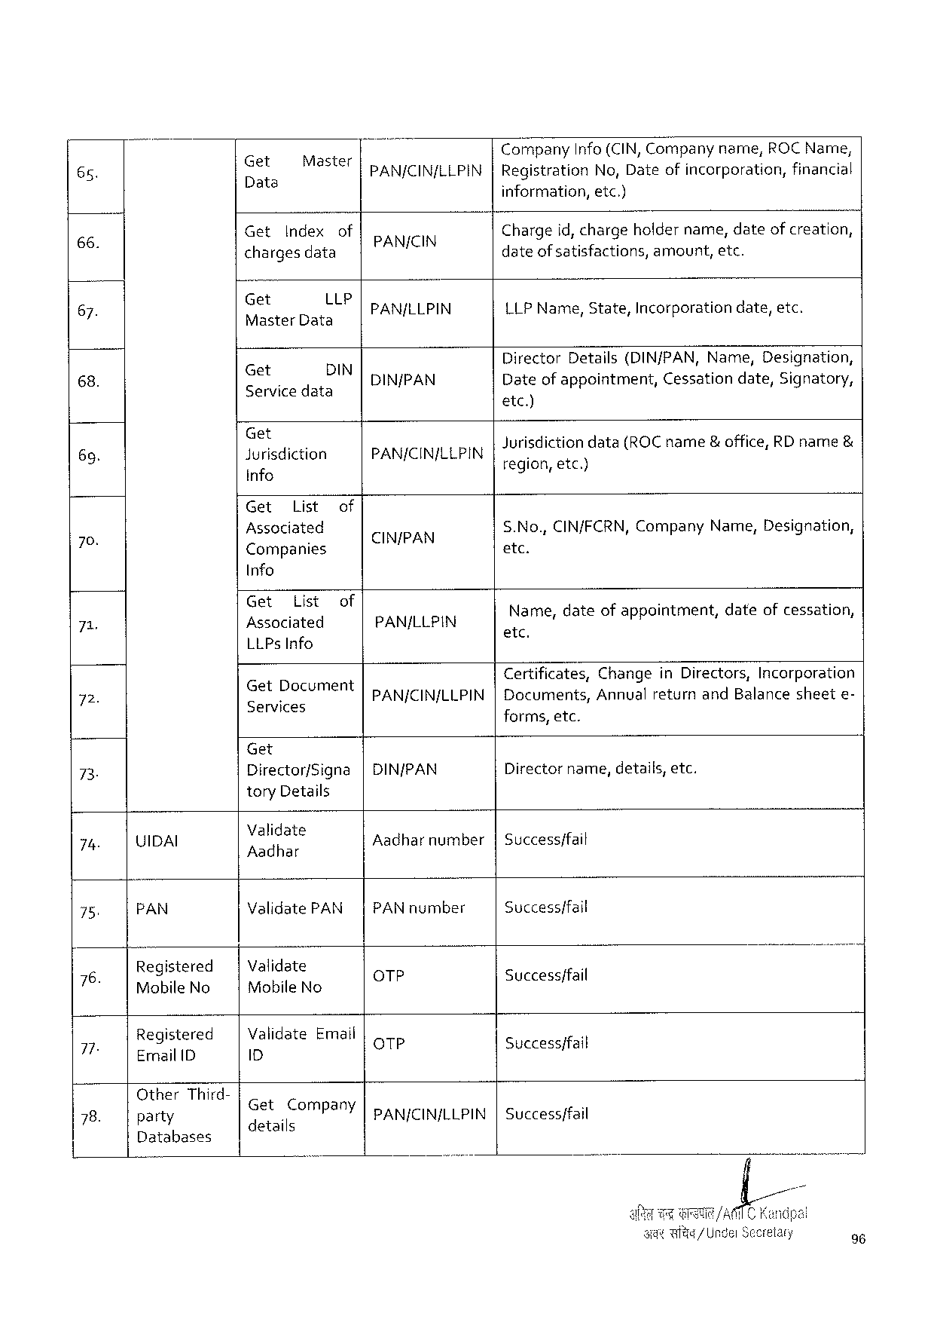

|  |  |  |  |  |  |  |  |  |  |  |  |  |
| --- | --- | --- | --- | --- | --- | --- | --- | --- | --- | --- | --- | --- |
| 65. | Get  e | Master | | PAN/CIN/LLPIN | Company | Info(CIN, Companyname, ROCN ame, | | | | | | |
| Registration | | No, Dateofincorporation, | | | | | financial |
| el | information, | | etc.) | | | | | |
| Get | Index | of |
| 66: | Chargeid, chargeholdername, dateofcreation, | | | | | | | |
| chargesdata | | | dateof satisfactions, amount, etc. | | | | | | | |
| Get LLP  Master Data | | | PAN/LLPIN | {LPN ame, State, | | | " Incorporation | | date, etc. | | |
| 67. |
| DIN/PAN | Director | Details(DIN/PAN, Name, | | | | | Designation, | |
| Get | DIN | |
| 68. |
| Servicedata | | | Dateofappointment, | | | | Cessation | date, Signatory, | | |

etc)

|  |  |  |  |  |  |  |  |
| --- | --- | --- | --- | --- | --- | --- | --- |
| 69. | Get  Jurisdiction | | of | PAN/CIN/LLPIN | Jurisdictiondata(ROC name& office, RD name& 3 ‘  region, etc.) | | |
| info | |
| 70. | Get | List | CIN/PAN | S. No., CIN/FCRN, Company | Name, | Designation, |
| Assoclat. ed | |
| Companies | | etc. | | |

Info

|  |  |  |  |  |  |  |  |  |
| --- | --- | --- | --- | --- | --- | --- | --- | --- |
| 7 | Get — | List | of | PAN/LLPIN | .  el: came, dateofappointment, | | date | .  ofcessation, |
| ) | | | | |
| LLP s Info | | |
| 72 | Get Document | | | Certificates, Changein Directors, Incorporation | | | | |
| .  Services | | | PAN/CIN/LLPIN|Documents, | | Annualreturnand Balancesheete- | | |
| forms, etc. | | | | |

Get

|  |  |  |  |
| --- | --- | --- | --- |
| 73 | Director/Signa | |DIN/PAN | Directorname, details, etc. |

tory Details

|  |  |  |  |  |  |  |
| --- | --- | --- | --- | --- | --- | --- |
| 74 | UIDAI | | Validate  P | | Aadharnumber|Successffail | |
| Validate PAN| | | PAN number | Success/fail |
| 75. | PAN | |
| Validate Mobile No | | Qo TP | i  Successffail |
| Registered Mobile No | |
| 76. |
| Validate Emaii D | | QTP | .  Success/fail |
| Registered Ermail 1 D | |
| 77- |
| PANJCIN/LLPIN | | Successffail |
| Other | Third- | GEEIGOB a T | |
| 78. |
| party | | 5 details | pany |
| Databases | |

96

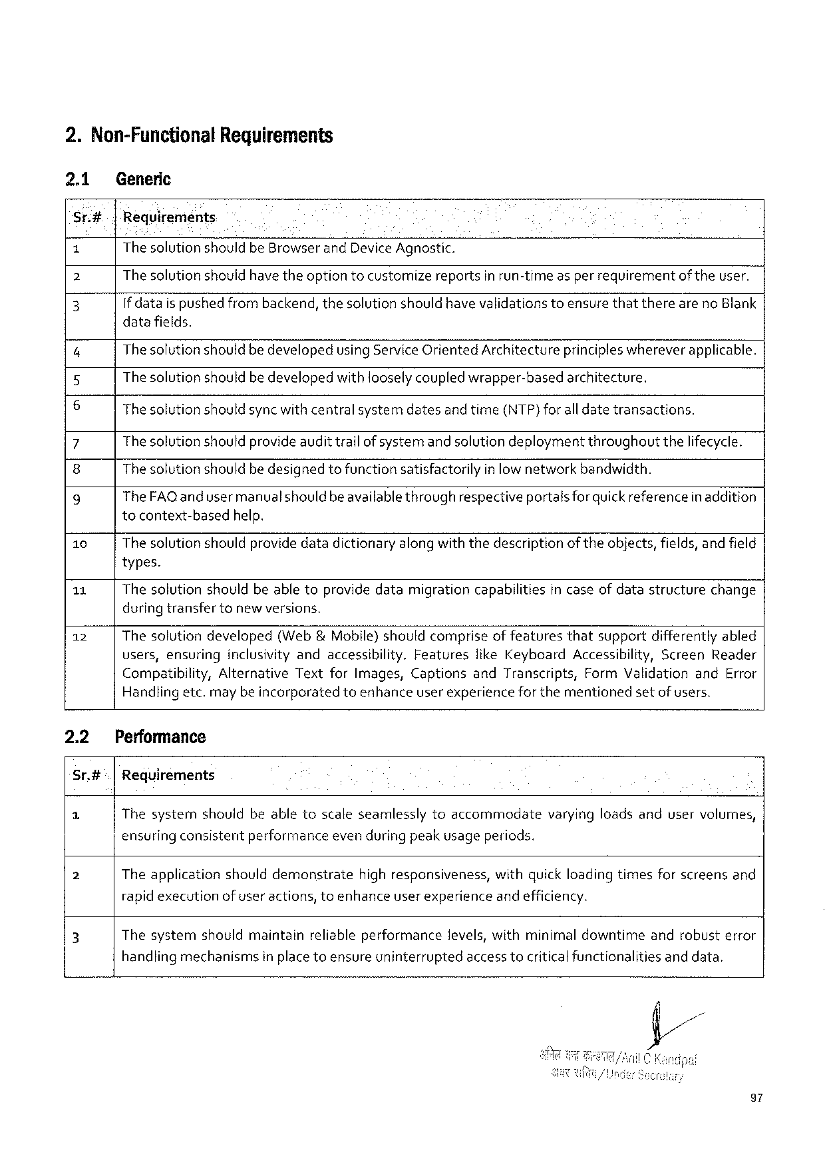

2. Non-Functional Requirements

2.1 Generic

Sr.#- |Requirements. .

1 The solutionshould be Browserand Device Agnostic.

2 The solutionshould have theoption tocustomizereportsin run-time asper requirementof theuser.

3 If dataispushedfrombackend, thesolutionshouldhavevalidationstoensurethatthereareno Blank

datafields.

4 Thesolutionshouldbe developedusing Service Oriented Architectureprincipleswhereverapplicable.

Thesolutionshould bedevelopedwithlooselycoupled wrapper-basedarchitecture,

6 Thesolutionshouldsyncwithcentralsystemdatesandtime(NTP)foralldatetransactions.

7 Thesolutionshouldprovideaudittrailof systemand solutiondeploymentthroughoutthelifecycle.

8 Thesolutionshouldbedesignedtofunctionsatisfactorilyinlow networkbandwidth.

9 The FAQ and usermanualshould beavailablethroughrespectiveportalsforquickreferencein addition

tocontext-basedhelp.

10 Thesolutionshouldprovide datadictionaryalong withthedescriptionof theobjects, fields, and field

types.

11 Thesolutionshouldbeabletoprovidedatamigrationcapabilitiesin caseof datastructurechange

during transfertonewversions,

12 Thesolutiondeveloped(Web &Mobile)shouldcompriseof featuresthatsupportdifferentlyabled

users, ensuring inclusivityandaccessibility. Features like Keyboard Accessibility, Screen Reader

Compatibility, Alternative Textfor Images, Captionsand Transcripts, Form Validationand Error

Handlingetc. may be incorporatedtoenhanceuserexperiencefor thementionedsetofusers,

|  |  |  |
| --- | --- | --- |
| 2.2 | Performance | varyingloadsanduservolumes, |
| Sr.#| | Requirements |
| a | Thesystemshouldbeabletoscaleseamlesslytoaccommodate |

ensuringconsistentperformanceeven during peakusageperiods.

|  |  |  |
| --- | --- | --- |
| 2 | Theapplicationshoulddemonstrate | highresponsiveness, withquick loadingtimesforscreensand |

rapidexecutionof useractions, toenhanceuser experienceand efficiency.

|  |  |  |  |  |  |
| --- | --- | --- | --- | --- | --- |
| 3 | Thesystem | shouldmaintain | reliableperformance | levels, withminimaldowntime | androbusterror |

handlingmechanismsinplacetoensureuninterruptedaccess tocriticalfunctionalitiesand data.

97

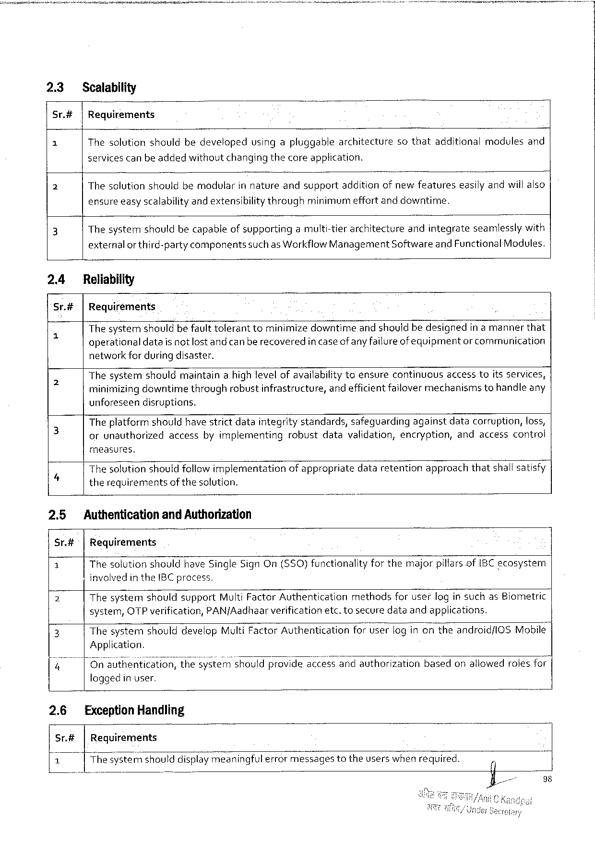

23 Scalability

Sr.#|Requirements

1 Thesolutionshouldbedevelopedusingapluggablearchitecturesothatadditionalmodulesand

servicescanbe addedwithoutchangingthecore application.

2 Thesolutionshouldbemodvlarinnature andsupport additionofnewfeatures easilyandwiilalso

ensureeasyscalabilityandextensibilitythrough minimurm effortanddowntime.

3 Thesystemshouldbecapableof supportingamuiti-tierarchitectureandintegrateseamlesslywith

externalor third-partycomponentssuchas Workflow Management Softwareand Functional Modules.

24 Reliability

Sr.#|Requirements

|  |  |  |
| --- | --- | --- |
| 5 | The systemshouldbe faulttoleranttominimizedowntimeand shouldbedesignedin amannerthat | |
| operationaldatais not lostand canberecoveredin caseof anyfailureof equipment | or communication |

network for during disaster.

|  |  |
| --- | --- |
| 2 | Thesystemshouldmaintainahighlevelofavailabilitytoensurecontinuousaccesstoitsservices, minimizingdowntimethroughrobustinfrastructure, andefficientfailover mechanismstohandleany |

unforeseendisruptions.

|  |  |
| --- | --- |
| 3 | Theplatformshouldhave strictdataintegritystandards, safeguardingagainstdatacorruption, loss, orunauthorizedaccessbyimplementingrobustdatavalidation, encryption, andaccesscontrot |

measures.

Thesolutionshouldfollowimplementationofappropriatedataretentionapproachthatshallsatisfy

4 therequirementsofthesolution.

2.5 Authenticationand Authorization

Sr.#t|Requirements

|  |  |
| --- | --- |
| £  2  3 | The solutionshouldhave Single Sign On($50)functionalityforthemajorpillarsof IBC ecosystem involvedin the IBC process.  Thesystemshouldsupport Multi Factor Authenticationmethodsforuserlogin suchas Biometric system, OTP verification, PAN/Aadhaarverificationetc. tosecuredataandapplications.  Thesystemshoulddevelop Multi Factor Authenticationforuserlog inontheandroid/l OSM obile| |

Application.

|  |  |  |
| --- | --- | --- |
| 4 | On authentication, | thesy's’tye’m’shomdprovideaccessandauthorizationbasedonallowedrolesfor| |

loggedin user.

2.6 Exception Handling

Sr.#|Requirements

|  |  |  |  |
| --- | --- | --- | --- |
| 1 | Thesysterfishoulddisplayme_aningful errormessages | totheuserswhenrequired. | 0 |

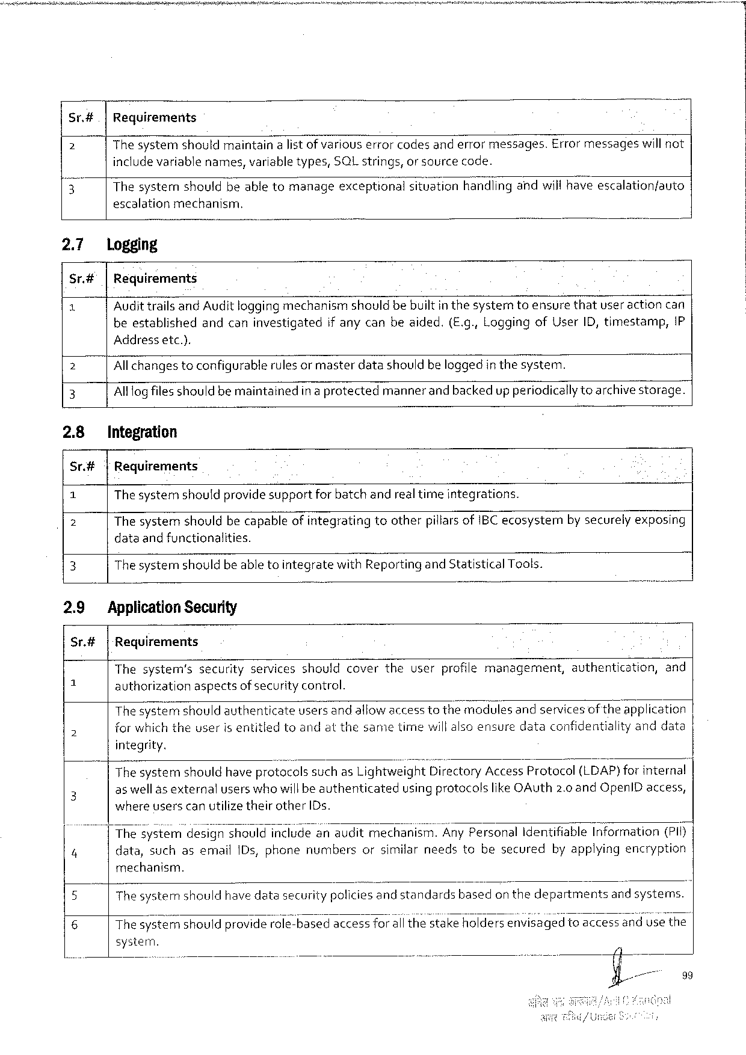

Sr.#|Requirements

2 The systemshouldmaintainalistof variouserrorcodesand errormessages. Errormessageswill not

includevariablenames, variabletypes, SQL strings, orsourcecode.

? Thesysternshouldbeable tomanageexceptionalsituationhandiingandwillhaveescalation/auto

escalationmechanism.

|  |  |  |
| --- | --- | --- |
| 2.7  Sr# e | logging  |Requirements | |
| Audittrails and Audit loggingmechanismshouldbe builtin thesyster | toensurethatuser action can |
| beestablishedandcaninvestigatedif anycanbeaided.(E. g., Loggingof User ID, timestamp,{P | |

Addressetc.).

2 Allchangestoconfigurablerulesor masterdatashouldbe loggedinthesystem. ~

3 Alllogfilesshould bemaintainedin a protectedmannerand backedup periodicallytoarchivestorage.

2.8 Integration

Sr.#| Requirements

1 Thesystemshouldprovidesupportfor batchandrealtimeintegrations.

2 Thesystemshouldbecapableofintegratingtootherpillarsof IBC ecosystemnby securelyexposing

dataand functionalities.

3 Thesystemshouldbe abletointegratewith Reporting and Statistical Tools.

2.9 Application Security

Sr.#|Requirements

|  |  |  |  |
| --- | --- | --- | --- |
| =  5 | Thesystem’ssecurityservicesshouldcovertheuserprofilemanagement, | authentication, | and |
| authorizationaspectsof security control.  Thesystemshouldauthenticateusersandallowaccesstothemodules andservicesof theapplication for which theuser Isentitledtoandatthesametimewillalsoensuredataconfidentialityanddata | | |

integrity.

|  |  |  |
| --- | --- | --- |
| 3  4 | Thesystemshouldhave protocolssuchas Lightweight Directory Access Protocol(LDAP)for internal | |
| as well as externalusers whowill beauthenticated | usingprotocolslike OA uth 2.0 and Openl Daccess, |
| where userscanutilizetheirother ID s.  Thes’yst’em'desrlgnshouldincludeanauditmechanism. Any Personal Identifiable Information(PI f) data, suchasemail 1 Ds, phonenumbersorsimilarneedstobesecuredbyapplyingencryption | |

mechanism.

5 Thesystemnshouldhavedatasecuritypoliciesandstandards basedon thedepartments andsystems.

6 Thesy EFémshouldproviderole-basedaccessfor all thestakeholdersey’wi’s’ége‘d’toaccessandusethe

system.

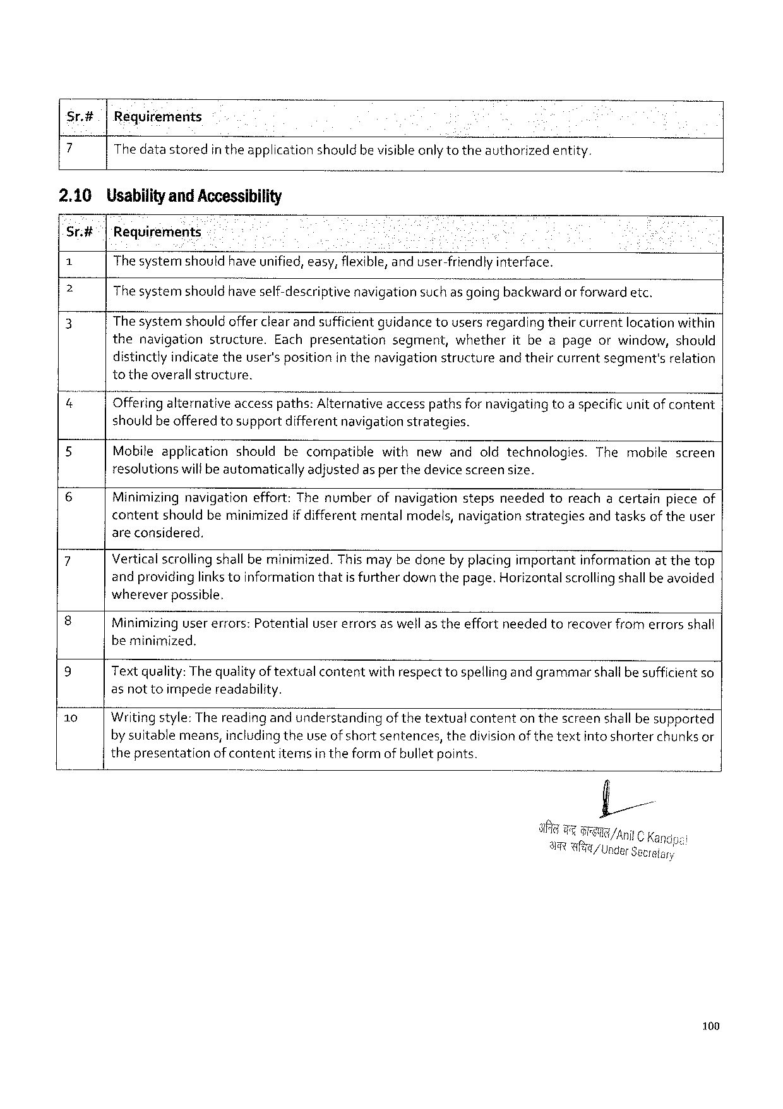

Sr.#|Reguirements

7 Thedatastoredin theapplication shouldbevisibleonly totheauthorizedentity.

2.10 Usabilityand Accessibility

Sr.#| 'Requirements

1 Thesystemshouldhaveunified, easy, flexible, anduser-friendly interface.

e Thesystemshouldhave self-descriptive navigationsuch as going backwardor forwardetc.

3 The systemshouldofferclear andsufficientquidancetousersregardingtheircurrentlocationwithin

the navigation structure. Eachpresentation segment, whether itbeapage orwindow, should

distinctlyindicate theuser'spositionin thenavigationstructureand theircurrentsegment'srelation

totheoverallstructure.

|  |  |  |  |
| --- | --- | --- | --- |
| &  5 | Offering alternativeaccesspaths: Alternativeaccesspathsfor navigatingtoaspecificunit of content shouldbeofferedtosupportdifferentnavigationstrategies. | | |
| Mobileapplicationshouldbecompatible | withnewandoldtechnologies. | Themobilescreen |

resolutionswilfbeautomaticallyadjustedasper thedevice screensize.

6 Minimizing navigationeffort: Thenumberofnavigationstepsneededtoreachacertainpieceof

contentshouldbeminimizedif differentmentalmodels, navigationstrategiesandtasksof theuser

areconsidered.

|  |  |
| --- | --- |
| 7  8  9 | Verticalscrollingshall beminimized. Thismay bedoneby placingimportantinformationatthetop andprovidinglinks toinformationthatis furtherdown thepage. Horizontalscrollingshallbe avoided whereverpossible.  Minimizingusererrors: Potentialusererrorsaswellas theeffortneededtorecover fromerrorsshall beminimized.  Text quality: The qualityof textualcontentwithrespecttospellingandgrammarshallbesufficient so |

as nottoimpedereadability.

10 Writingstyle: Thereading andunderstandingof thetextualcontenton thescreen shall besupported

by suitablemeans, includingtheuseof short sentences, thedivisionof the textintoshorterchunks or

thepresentationof contentitemsin theform of bulletpoints.

6 t /Anil C Ka

AT Wl/Ungar Setrelary

100

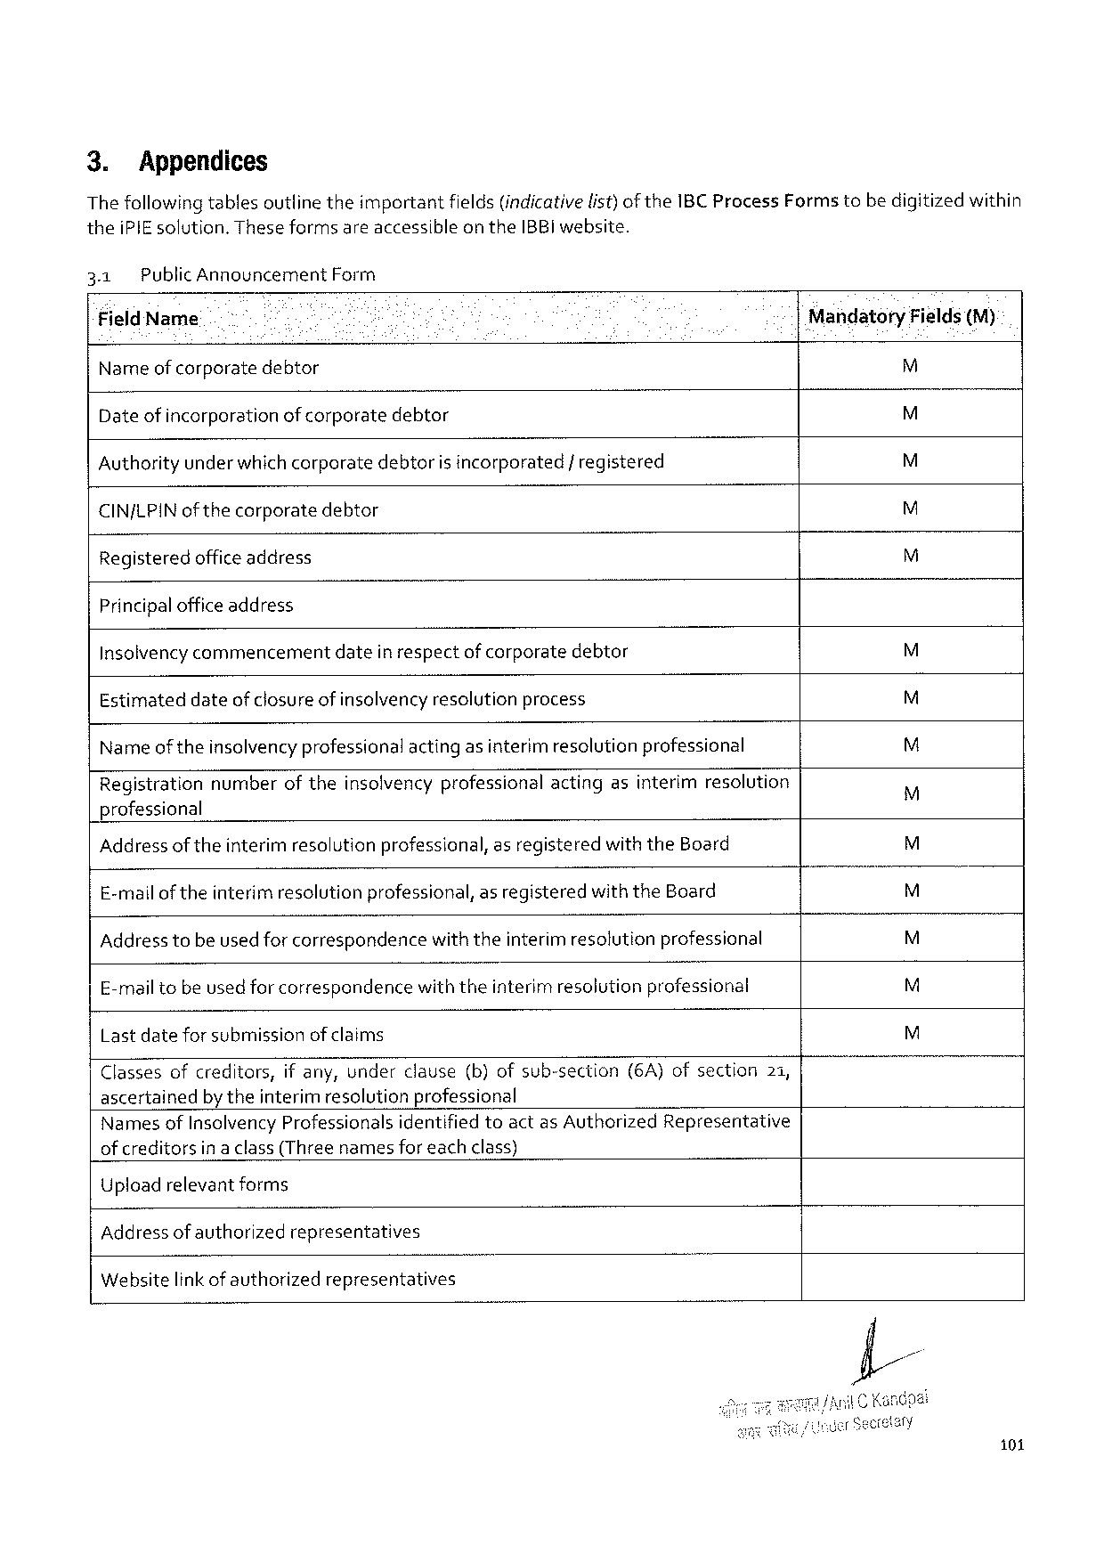

3. Appendices   
The followingtablesoutline theimportantfields(indicativelist)of the 1 BCP rocess Formstebe digitizedwithin thei PIE solution. Theseformsareaccessibleonthe IBBI website.

|  |  |  |  |  |
| --- | --- | --- | --- | --- |
| 3.1 | Public Announcement Form | | Mandatory | Fields(M) |
| Field Name | | |
| M |
| Nameof corporatedebtor | | |
| M |
| Date of incorporationofcorporatedebtor | | |
| M |
| Authorityunder whichcorporatedebtoris incorporated/ registered | | |
| M |
| CINJLPIN ofthecorporate | | debtor |
| M |
| Registeredofficeaddress | | |

Principalofficeaddress   
Insolvencycommencementdatein respectof corporatedebtor M Estimateddateof closure of insclvency resolutionprocess M Nameoftheinsolvencyprofessionalacting asinterim resolutionprofessional M Registrationnumberoftheinsolvencyprofessionalactingasinterimresolution   
 M professional

|  |  |  |  |  |  |  |  |  |
| --- | --- | --- | --- | --- | --- | --- | --- | --- |
| Address of theinterimresolutionprofessional, asregisteredwiththe Board E-malloftheinterim resolutionprofessional, as registeredwiththe Board Address tobe used for correspondencewiththeinterim resolutionprofessional E-mailtobeused forcorrespondencewiththeinterim resolutionprofessional Lastdatefor submissionof claims | | | | | | | | M  M  M  M  M |
| Classesofcreditors, | | ifany, underclause | | (b)ofsub-section | (6 A)ofsection | | 21, |
| ascertainedby theinterim resolutionprofessional | | | | | | | |
| Namesof Insolvency Professionals | | | identifiedtoactas Authorized | | | Representative | |
| of creditors | inaclass(Threenamesforeachclass) | | | | | | |

Upload relevantforms   
Address of authorizedrepresentatives   
Websitelink of authorizedrepresentatives

101

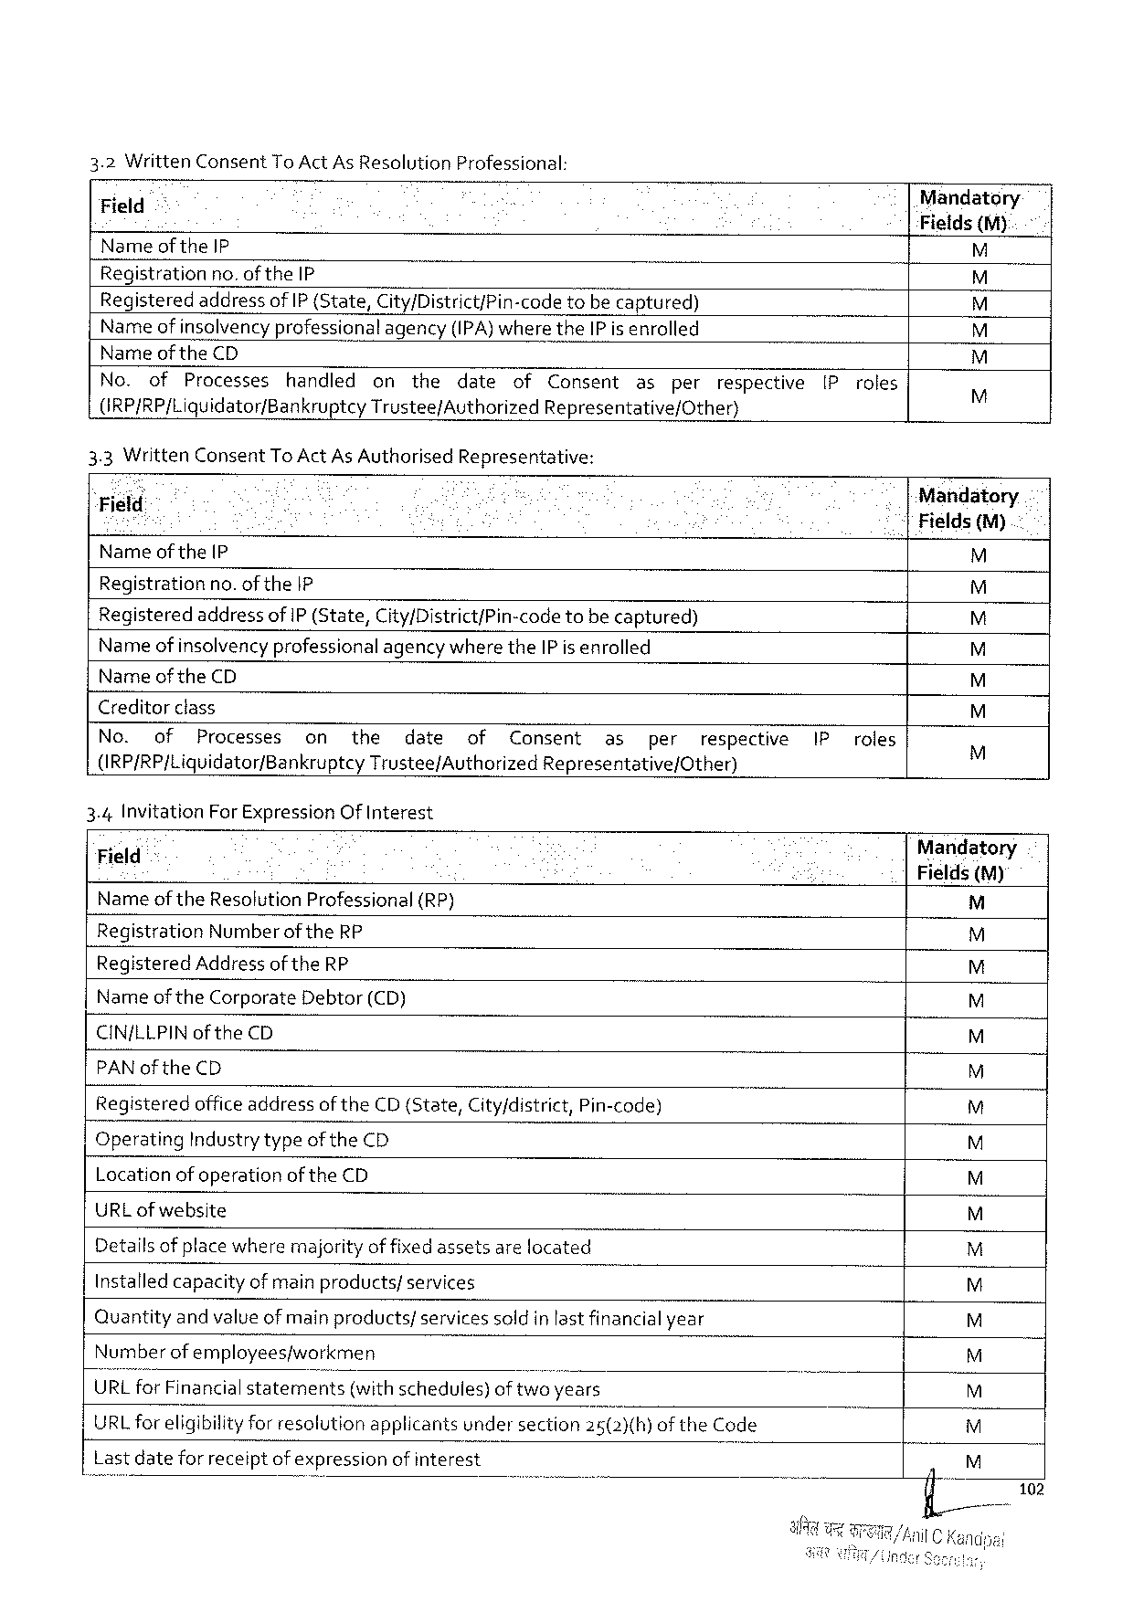

|  |  |  |
| --- | --- | --- |
| 3.2 Written Consent To Act As Resolution | Professional: | Mandatory |
| Field |
| Fields (M) |
| Nameof the IP |

Registrationno. of the IP

|  |  |  |  |  |  |  |  |  |  |  |  |  |  |
| --- | --- | --- | --- | --- | --- | --- | --- | --- | --- | --- | --- | --- | --- |
| Registered | | addressof IP {State, City/District/Pin-code | | | | | | tobecaptured) | | | | [Proles | EE 4 E 4 E 4 E 4 ES |
| Nameof insolvencyprofessionalagency(IPA)where the IP is enrolled | | | | | | | | | | | |
| Nameof the CD | | | | | | | | | | | |
| No. | of | Processes | handled | on | the | date | of | Consent | as | per | respective |
| (RP/RP/Liquidator/Bankruptcy Trustee/Authorized Representative/Other) | | | | | | | | | | | |
| 3.3 Written Consent To Act As Authorised | | | | | | Representative: | | | | | | Mandatory.  |Fields (M) |
| “Field | | | | | | | | | | | |
| Nameof the(P | | | | | | | | | | | | M |

Regjistrationno. of the|P

|  |  |  |
| --- | --- | --- |
| Registeredaddressof IP (State, City/District/Pin-code | tobe captured) | 4 |

Nameof insolvencyprofessionalagency wherethe IP is enrolled

Nameof the CD

Creditorclass

|  |  |  |  |  |  |  |  |  |  |  |  |  |  |
| --- | --- | --- | --- | --- | --- | --- | --- | --- | --- | --- | --- | --- | --- |
| No. | of | Processes | on | the | date | of | Consent | as | per | respective | IP | roles | EEYE 4 E 4 |
| (IRP/RP/Liquidator/Bankruptcy | | | | Trustee/Authorized Representative/Other) | | | | | | |

3.4 Invitation For Expression Of Interest

|  |  |  |  |
| --- | --- | --- | --- |
| Field | " | (RP) | Mandatory |
| Fields(M) |
| Nameofthe Resolution Professional | |

Registration Numberofthe RP

Registered Address of the RP

Nameof the Corporate Debtor(CD)

CIN/LLPIN of the CD

PAN of the CD

Registeredofficeaddressof the CD(State, City/district, Pin-code)

Operating Industrytypeofthe CD

Locationof operationof the CD |z|z|glg|g 2 ig|g|

URL ofwebsite

Detailsof placewheremajorityof fixedassetsare located

Installed capacityof main products/services

|2 z Quantityandvalueofmain products/servicessold inlastfinancialyear

|  |  |  |
| --- | --- | --- |
| Numberofemployeesjworkmen | | |I 2 |
| URL for Financialstatements | (withschedules)oftwoyears |

URL foreligibilityfor resolutionapplicantsundersection 25(2)(h)of the Code

Lastdatefor receiptof expressionof interest gz

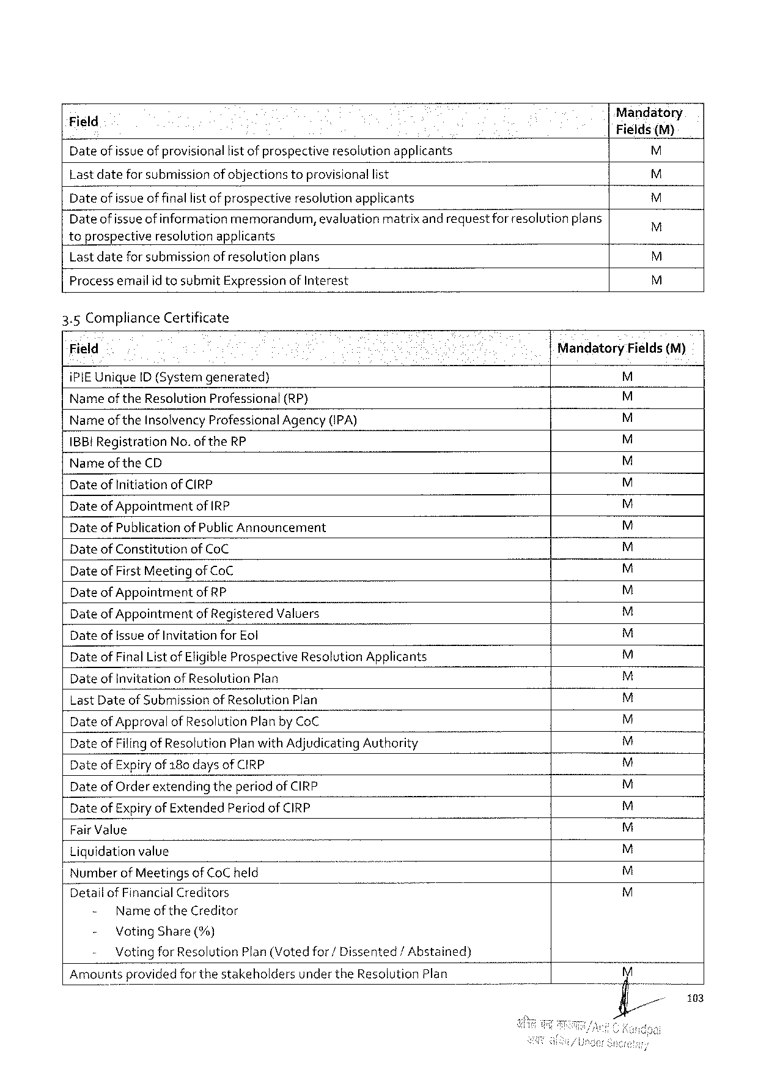

Date of issueof provisionallist of prospectiveresolutionapplicants [\

Lastdateforsubmission of objectionstoprovisionallist

Date of issueof finallist of prospectiveresolution applicants M Dateof issueof information memorandum, evaluationmatrixand requestforresolution plans M toprospectiveresolutionapplicants   
Lastdateforsubmissionof resolutionplans M

Processemailid tosubmit Expressionof Interest M

3.5 Compliance Certificate

|  |  |  |  |  |
| --- | --- | --- | --- | --- |
| Field | | | Mandatory | Fields(M) |
| i PIEU nique ID (Systemgenerated) | | | = |
| Nameof the Resolution Professional | | (RP) | 4 TS |
| Nameof the Insolvency Professional Agency (IPA) | | |
| IBB! Registration | No. of the RP | | 44 |
| Narme of the CD | | |

Date of Initiationof CIRP   
Dateof Appointmentof IRP   
Date of Publicationof Public Announcement E 4 ESES

Date of Constitutionof Co C 4

Date of First Meetingof Co C   
Date of Appointmentof RP   
Date of Appointmentof Registered Valuers   
Date of Issueof Invitationfor Eol   
Date of Final List of Eligible Prospective Resolution Applicants   
Dateof Invitationof Resolution Plan   
Last Dateof Submissionof Resolution Plan   
Date of Approvalof Resolution Planby Co C   
Date of Filing of Resolution Planwith Adjudicating Authority   
Date of Expiry of 180 days of CIRP   
Date of Orderextendingtheperiod of CIRP   
Date of Expiryof Extended Periodof CIRP   
Fair Value   
Liquidationvalue   
Numberof Meetingsof Co C held   
Detallof Financial Creditors EHE 4 E 4 E 4 E 4 E 4 Ed E<SE d E 4 ESESESESESEY

- Name of the Creditor  
 - Voting Share(%)   
 Votingfor Resolution Plan(Votedfor/Dissented/Abstained) Amountsprovidedforthestakeholdersunder the Resolution Plan

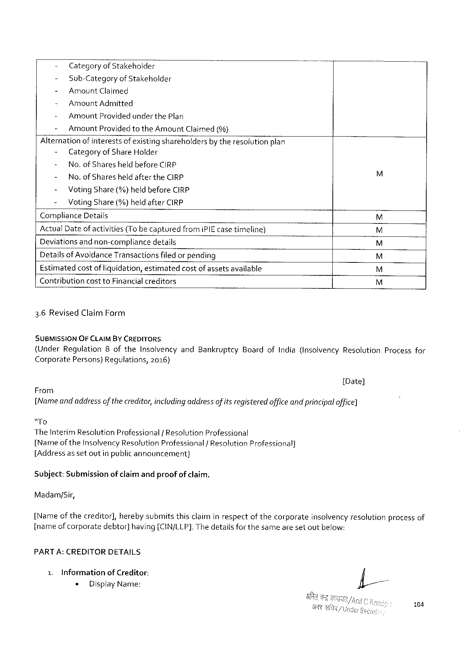

- Categoryof Stakeholder-

- Sub-Categoryof Stakeholder

- Amount Claimed

- Amount Admitted

- Amount Providedunder the Plan

- Amount Providedtothe Amount Claimed(%)

Alternationof interestsofexisting shareholdersby theresolutionplan

|  |  |  |  |
| --- | --- | --- | --- |
| - | Categoryof Share Holder | | ES  R  ES  R |
| - | No. of Sharesheld before CIRP | |
| - | No. of Sharesheldafterthe CIRP | |
| - | Voting Share (%)heldbefore CIRP | |
| - | Voting Share (%)heldafter CIRP | |
| Compliance Details | | |
| Actual Dateofactivities(To becaptured | | fromi PIE casetimeline) |
| Deviationsand non-compliancedetails  Detailsof Avoidance Transactionsfiledorpending | | |

Estimatedcostof liquidation, estimatedcostofassetsavailable

Contributioncostto Financialcreditors EHEY

3.6 Revised Claim Form

SUBMISSION OFCLAIMBY CREDITORS

(Under Regulation 8 of the Insolvencyand Bankruptcy Boardof India(Insolvency Resolution Processfor

Corporate Persons)Regulations, 2016)

[Date]

From

[Nameandaddressof thecreditor, includingaddressofitsregisteredoffice andprincipaloffice]

“To

The Interim Resolution Professional/Resolution Professional

[Nameofthe Insolvency Resolution Professional/Resolution Professional]

[Addressassetoutinpublicannouncement}

Subject: Submissionof claimandproofof claim.

Madam/Sir,

[Name of thecreditor], herebysubmitsthisclaiminrespectof thecorporateinsolvencyresolutionprocessof

[nameofcorporate debtor] having[CIN/LLP]. Thedetailsforthesamearesetoutbelow:

PART A: CREDITORDETAILS

1. Informationof Creditor:

« Display Name:

104

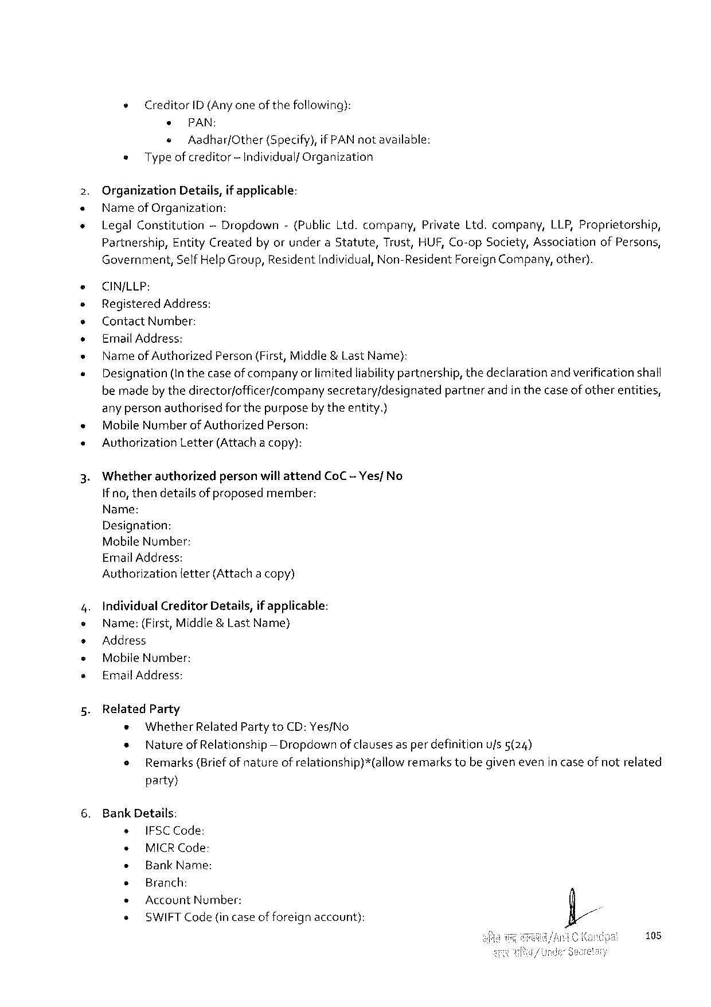

» Creditor ID (Any oneofthefollowing):

* PAN:  
 « Aadhar/Other (Specify), if PAN notavailable: = Typeof creditor-Individualf Organization

Organization Details, if applicable:   
Nameof Organization:

|  |  |  |  |  |
| --- | --- | --- | --- | --- |
| Legal Constitution | — Dropdown | -(Public Lid. company, | Private Ltd. company, | LLP, Proprietorship, |

Partnership, Entity Createdby orundera Statute, Trust, HUF, Co-op Society, Associationof Persons, Government, Self Help Group, Residentndividual, Non-Resident Foreign Company, other).

CIN/LLP:   
Registered Address:   
Contact Number:   
Ermnail Address:   
Nameof Authorized Person(First, Middle&Last Name):   
Designation(In thecaseof companyor limited liabilitypartnership, thedeclarationand verificationshalf bemadeby thedirector/officer/companysecretary/designatedpartnerandin thecase of otherentities, any personauthorisedfor thepurposeby theentity.)   
Mobile Number of Authorized Person:   
Auvthorization Letter(Attachacopy):

Whetherauthorizedpersonwillattend Co C -Yes/ No Ifno, thendetailsof proposedmember:   
Name:   
Designation:   
Mobile Number:   
Email Address:   
Authorization fetter(Attachacopy)

Individual Creditor Details, if applicable:   
Name:(First, Middle&Last Name)   
Address   
Mobile Number:   
Email Address:

Related Party   
 * Whether Related Partyto CD: Yes/No   
 * Natureof Relationship — Dropdown of clausesas per definitionufs 5(24)   
 o Remarks(Briefof natureof relationship)*(allowremarkstebe given evenin caseof notrelated

party}

Bank Details:

|  |  |  |  |
| --- | --- | --- | --- |
| s | IFSCC ode: | account): | . |
| ¢ |
| MICRC ode: |
| » |
| Bank Name: |
| * |
| Branch: |
| Account Number: |
| * |
| + | SWIFTC ode(incaseofforeign |

108

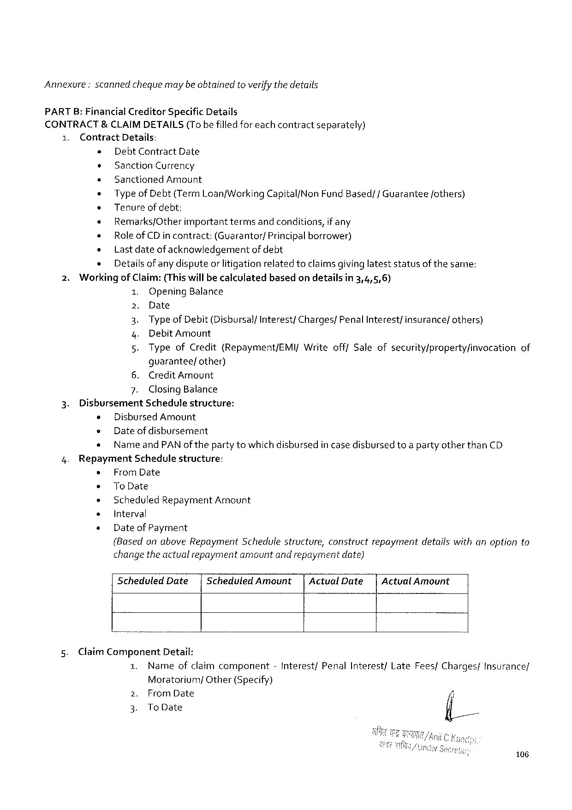

Annexure: scannedchequemaybeobtained toverify the details

PARTB: Financial Creditor Specific Details

CONTRACT&CLAIMDETAILS (Tobefilledforeachcontract separately)

1. Contract Details:

» Debt Contract Date

¢ Sanction Currency

+ Sanctioned Amount

s Type of Debt(Term Loan/Working Capital/Non Fund Based/f Guarantee fothers)

* Tenureofdebt:

« Remarks/Other important termsandconditions, if any

« Roleof CD incontract: (Guarantor/ Principalborrower)

o Lastdateof acknowledgement of debt

s Detailsofany disputeorlitigationrelatedtoclaimsgivinglateststatusofthe same:

2. Workingof Claim:(Thiswillbe calculatedbasedon detailsin 3,4,5,6)

1. Opening Balance

2. Date

3. Typeof Debit(Disbursalf Interest/Charges/Penal Interest/insurance/others)

4. Debit Amount

5. Typeof Credit(Repayment/EMI/Writeofff Saleofsecurity/property/invocation of

guarantee/other)

6. Credit Amount

7. Closing Balance

3. Disbursement Schedulestructure:

¢ Disbursed Amount

e Dateofdisbursement

¢ Nameand PAN of the party towhichdishbursedin case disbursedtoa partyotherthan CD

4. Repayment Schedulestructure:

« From Date

s To Date

» Scheduled Repayment Amount

s Interval

« Date of Payment

(Basedon above Repayment Schedulestructure, constructrepaymentdetailswithanoptionto

change the actualrepaymentamountand repaymentdate}

|  |  |  |  |  |
| --- | --- | --- | --- | --- |
| 5. | Scheduled Date| | Scheduled Amount| | Actual Date| | Actual Amount |
| Claim Component Detail: |

|  |  |  |  |  |  |  |
| --- | --- | --- | --- | --- | --- | --- |
| 1. | Nameofclaimcomponent | | -Interest/ | Penal Interest/ | Late Fees/Charges/ | Insurance/ |
| 2. | Moratorium/ | Other(Specify) |
| From Date | |
| 3. | To Date | |

106

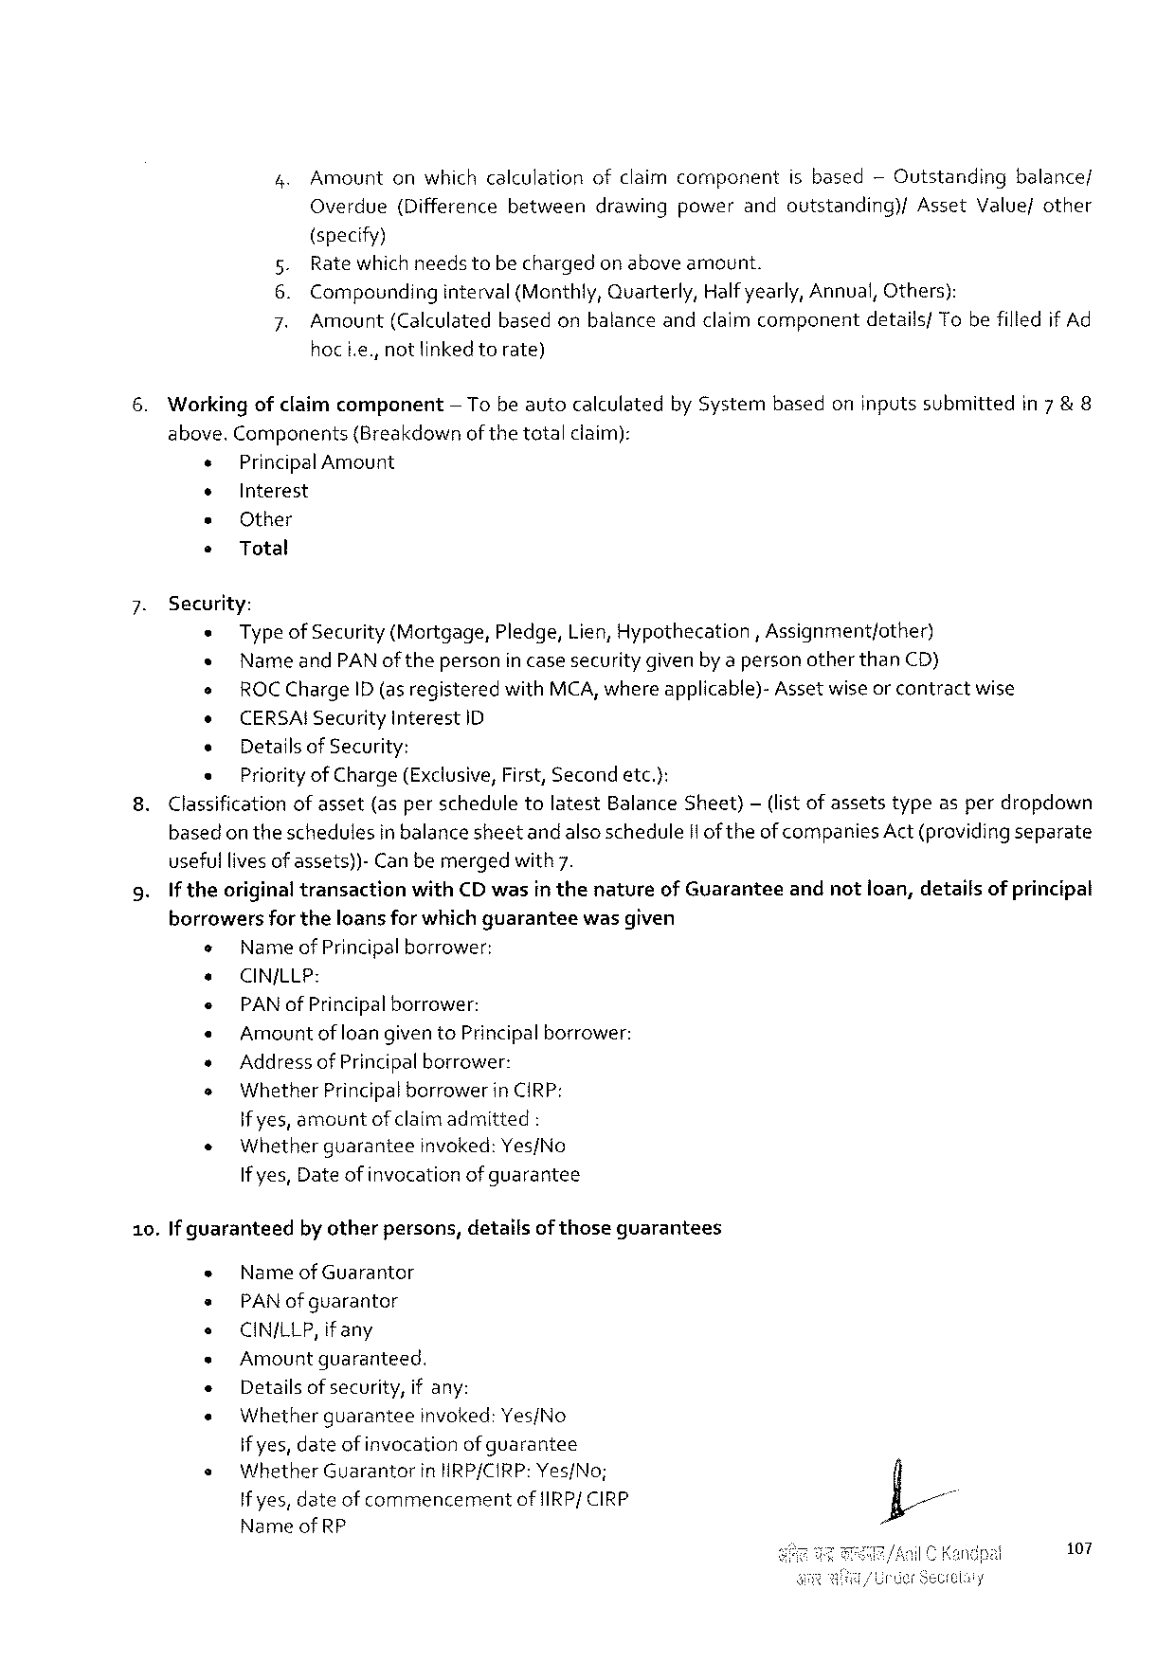

4. Amountonwhichcalculationofclaimcomponentisbased— Outstandingbalance/

|  |  |  |  |  |  |  |
| --- | --- | --- | --- | --- | --- | --- |
| Overdue | (Difference | between | drawing | power | andoutstanding)/ | Asset Value/other |

(specify)

5. Rate whichneedstobe chargedon aboveamount.

6. Compounding interval(Monthly, Quarterly, Halfyearly, Annual, Others):

7. Amount (Calculated basedonbalanceandclaimcomponent details/ Tobefilledif Ad

hoci. e., notlinkedtorate)

6. Workingofclaimcomponent — Tobe autocalculatedby Systembasedoninputssubmittedin 7 & 8

above. Components {Breakdownof thetotalclaim):

« Principal Amount

¢ Interest

* Other

* Total

7. Security:

« Typeof Security(Mortgage, Pledge, Lien, Hypothecation, Assignment/other)

« Nameand PAN oftheperson incasesecuritygivenby apersonotherthan CD)

o ROCC harge ID (asregisteredwith MCA, whereapplicable)-Asset wiseor contractwise

o CERSAIS ecurity Interest ID

« Detailsof Security:

« Priority of Charge(Exclusive, First, Secondetc.):

8. Classificationof asset(asperscheduletolatest Balance Sheet)— (listof assetstypeasperdropdown

basedon theschedulesin balancesheetandalsoschedule Ilof theofcompanies Act(providingseparate

usefullivesof assets))-Canbemergedwith 7.

9. If theoriginaltransactionwith CD wasin thenatureof Guaranteeandnotioan, detailsof principal

borrowersfor theloansfor which guarantee wasgiven

o Nameof Principalborrower:

e CINJLLP:

e PAN of Principalborrower:

« Amount of loangivento Principalborrower:

» Addressof Principalborrower:

s Whether Principalborrower in CIRP:

if yes, amountof claimadmitted:

|  |  |  |
| --- | --- | --- |
| « | Whetherguarantee | invoked: Yes/No |

If yes, Date of invocationof guarantee

10. If guaranteed by otherpersons, detailsof thoseguarantees

« Nameof Guarantor

= PAN of guarantor

o CIN/LLP, ifany

« Amountguaranteed.

« Detailsofsecurity, ifany:

« Whetherguarantee invoked: Yes/No

if yes, dateof invocationof guarantee

|  |  |  |
| --- | --- | --- |
| s | Whether Guarantor | in HRP/CIRP: Yes/No; |

If yes, dateof commencementof{IRP/ CIRP

|  |  |
| --- | --- |
| Nameof RP | 107 |

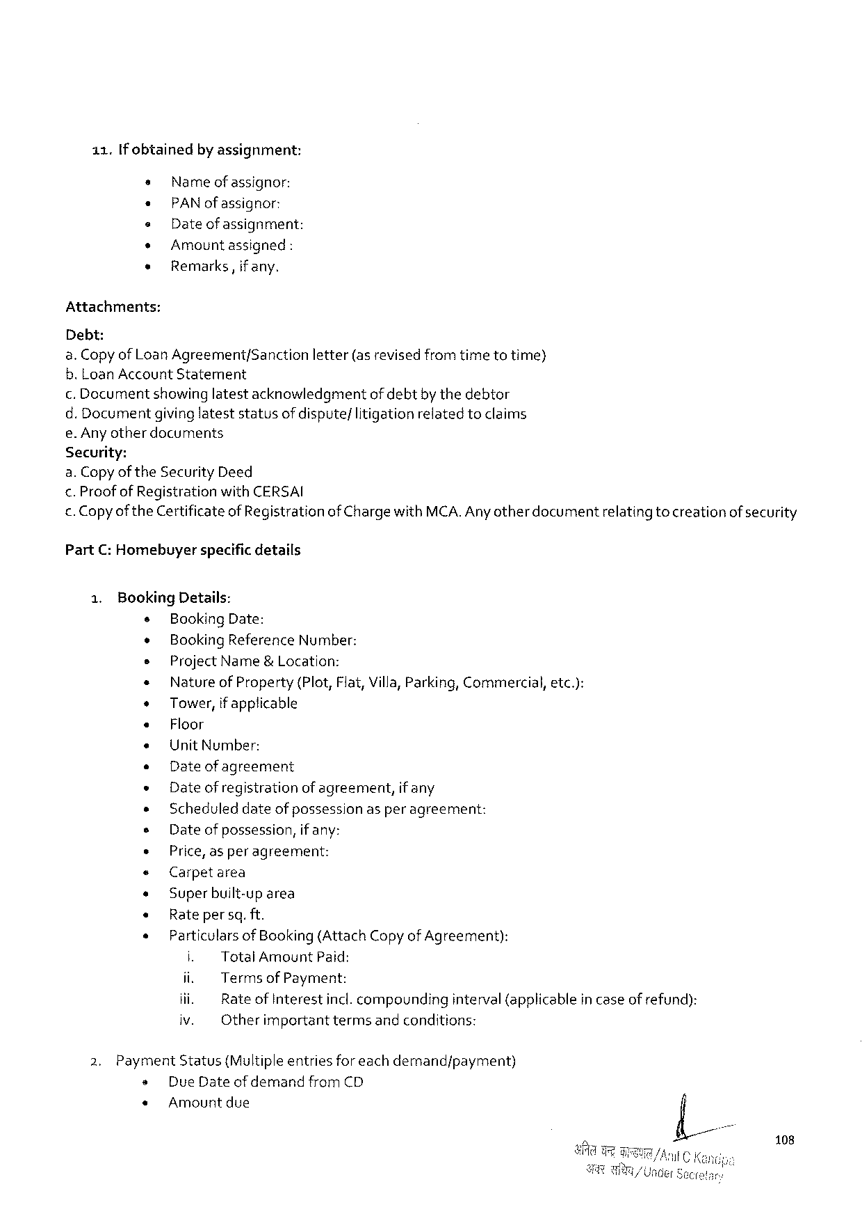

11.[f obtained by assignment:

s Name ofassignor:

* PAN of assignor:

e Dateof assignment:

+ Amountassigned :

e Remarks, if any.

Attachments:

Debt:

a. Copyof Loan Agreement/Sanctionletter(asrevised fromtimetotime)

b. Loan Account Statement

. Documentshowinglatestacknowledgmentof debtby thedebtor

d. Documentgivinglateststatusof dispute/litigationrelatedtoclaims

e. Anyother documents

Security:

a. Copyof the Security Deed

<. Proof of Registrationwith CERSAI

. Copyofthe Certificateof Registrationof Charge with MCA. Any otherdocumentrelating tocreationof security

Part C: Homebuyerspacific details

15 Booking Details:

s Booking Date:

¢ Booking Reference Number:

s Project Name&Location:

+ Natureof Property (Plot, Flat, Villa, Parking, Commercial, etc.):

* Tower, if applicable

« Floor

e Unit Number:

e Dateof agreement

« Date of registrationof agreement, if any

» Scheduleddateof possessionasper agreement:

s Dateofpossession, if any:

+ Price, asperagreement:

« Carpetarea

¢ Superbuilt-up area

« Rate persq. ft.

« Particulars of Booking(Attach Copyof Agreement):

i. Total Amount Paid:

ii. Terms of Payment:

iii. Rateof Interestincl. compoundinginterval(applicablein caseofrefund):

iv. Otherimportanttermsandconditions:

2. Payment Status(Multipleentriesforeachdemand/payment)

s Due Dateof demand from CD

* Amountdue

108

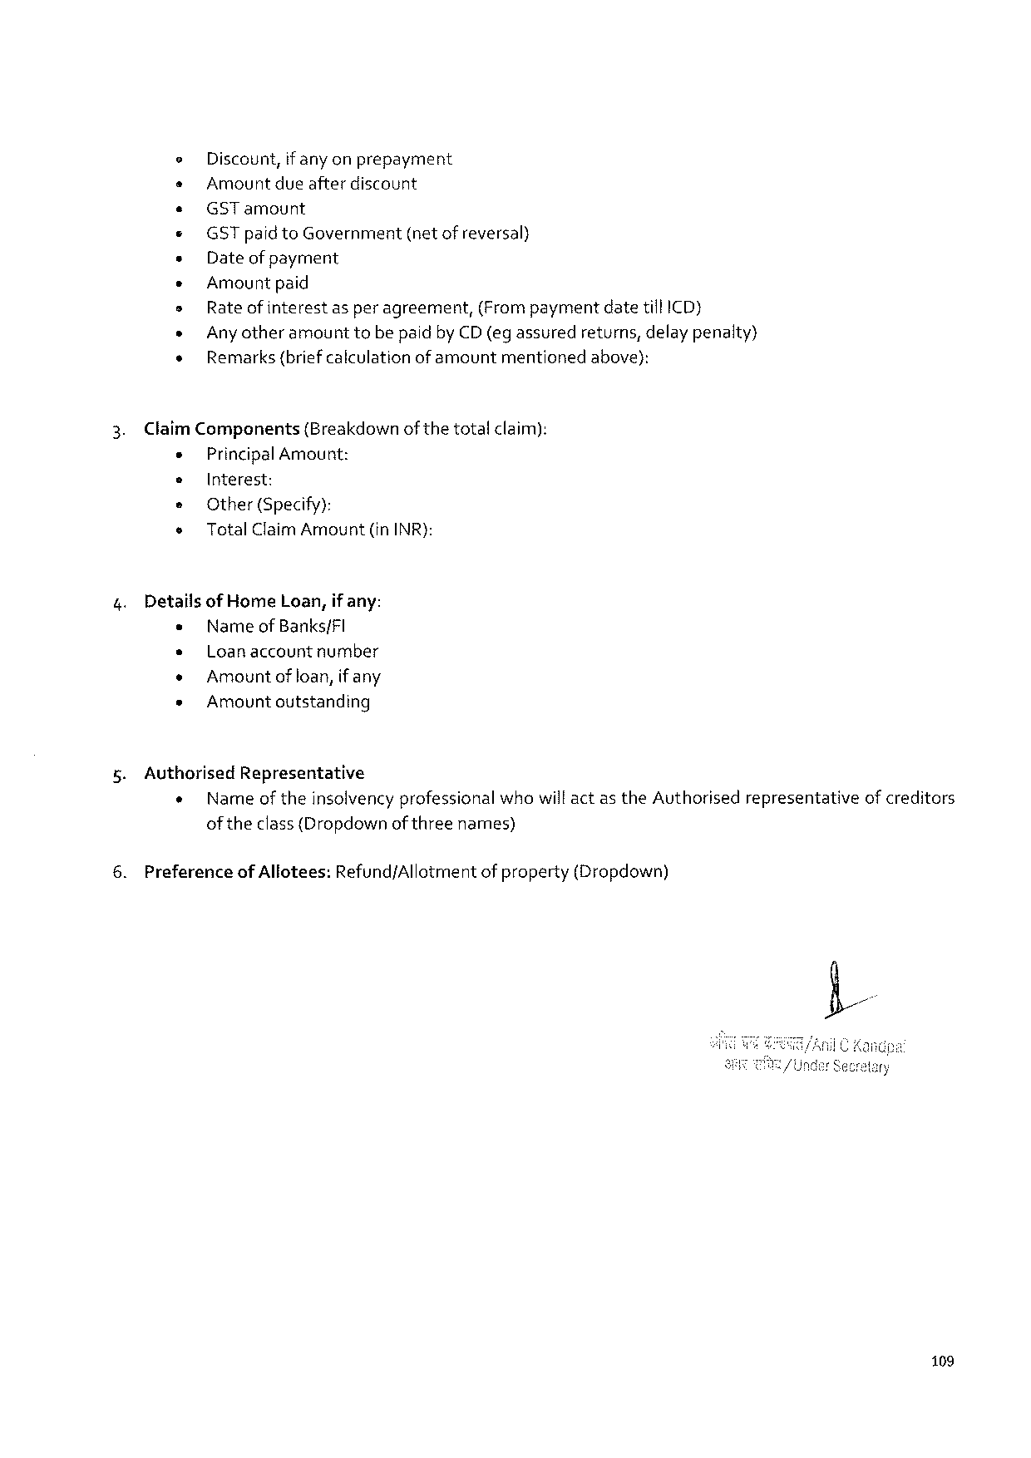

e Discount, if anyonprepayment

s Amountdueafterdiscount

e« GST amount

« GST paidto Government (netofreversal)

« Dateofpayment

e Amount paid

s Rate ofinterestas per agreement,(Frompaymentdatetill ICD)

» Any otheramounttobepaidby CD(egassured returns, delaypenalty)

s Remarks(briefcalculationofamount mentioned above):

Claim Components (Breakdownof thetotalclaim):

« Principal Amount:

e Interest:

e Other(Specify):

o Total Claim Amount (in INR):

Detailsof Home Loan, if any:

e Nameof Banks/FI

» Loanaccountnumber

« Amountof loan, if any

* Amount outstanding

Authorised Representative

« Nameof theinsolvencyprofessionalwhowill actas the Authorisedrepresentativeof creditors

oftheclass{Dropdownof threenames)

Preferenceof Allotees: Refund/Allotmentof property(Dropdown)

109

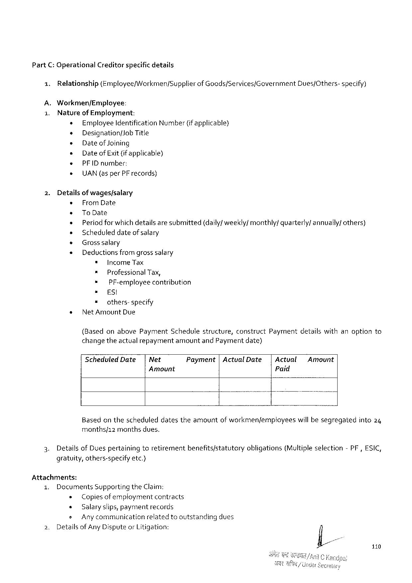

Part C: Operational Creditorspecific details

1. Relationship(Employee/Workmen/Supplierof Goods/Services/Government Dues/Others-specify)

A. Workmen/Employee:

1. Natureof Employment:

+ Employee Identification Number(if applicable)

o Designationf Job Title

» Dateof Joining

» Dateof Exit (if applicable)

e PFID number:

» UAN(asper PF records)

2. Detailsof wages/salary

« From Date

+ To Date

+ Period forwhichdetailsaresubmitted(daily/weekly/ monthly/quarterly/annually/ others)

» Scheduleddateofsalary

* Grosssalary

« Deductions from grosssalary

" Income Tax

= Professional Tax,

= PF-employeecontribution

= ES!

» others-specify

* Net Amount Due

(Basedonabove Payment Schedulestructure, construct Paymentdetailswithanoptionto

changetheactualrepaymentamountand Paymentdate)

Scheduled Date| Net Payment|Actual Date|Actval Amount

Amount Paid

Basedon thescheduleddatestheamountof workmen/employees willbesegregatedinto 24

months/12 monthsdues.

3. Details of Duespertainingtoretirementbenefits/statutoryobligations(Multipleselection-PF, ESIC,

gratuity, others-specifyetc.)

Attachments:

|  |  |  |  |  |  |
| --- | --- | --- | --- | --- | --- |
| 1. | Documents Supportingthe Claim; | | | | dues |
| 2. | » | | Copiesofemploymentcontracts | |
| « | | Salaryslips, paymentrecords | |
| s | Anycommunication | | relatedtooutstanding |
| Detailsof Any Disputeor Litigation: | | | |

110

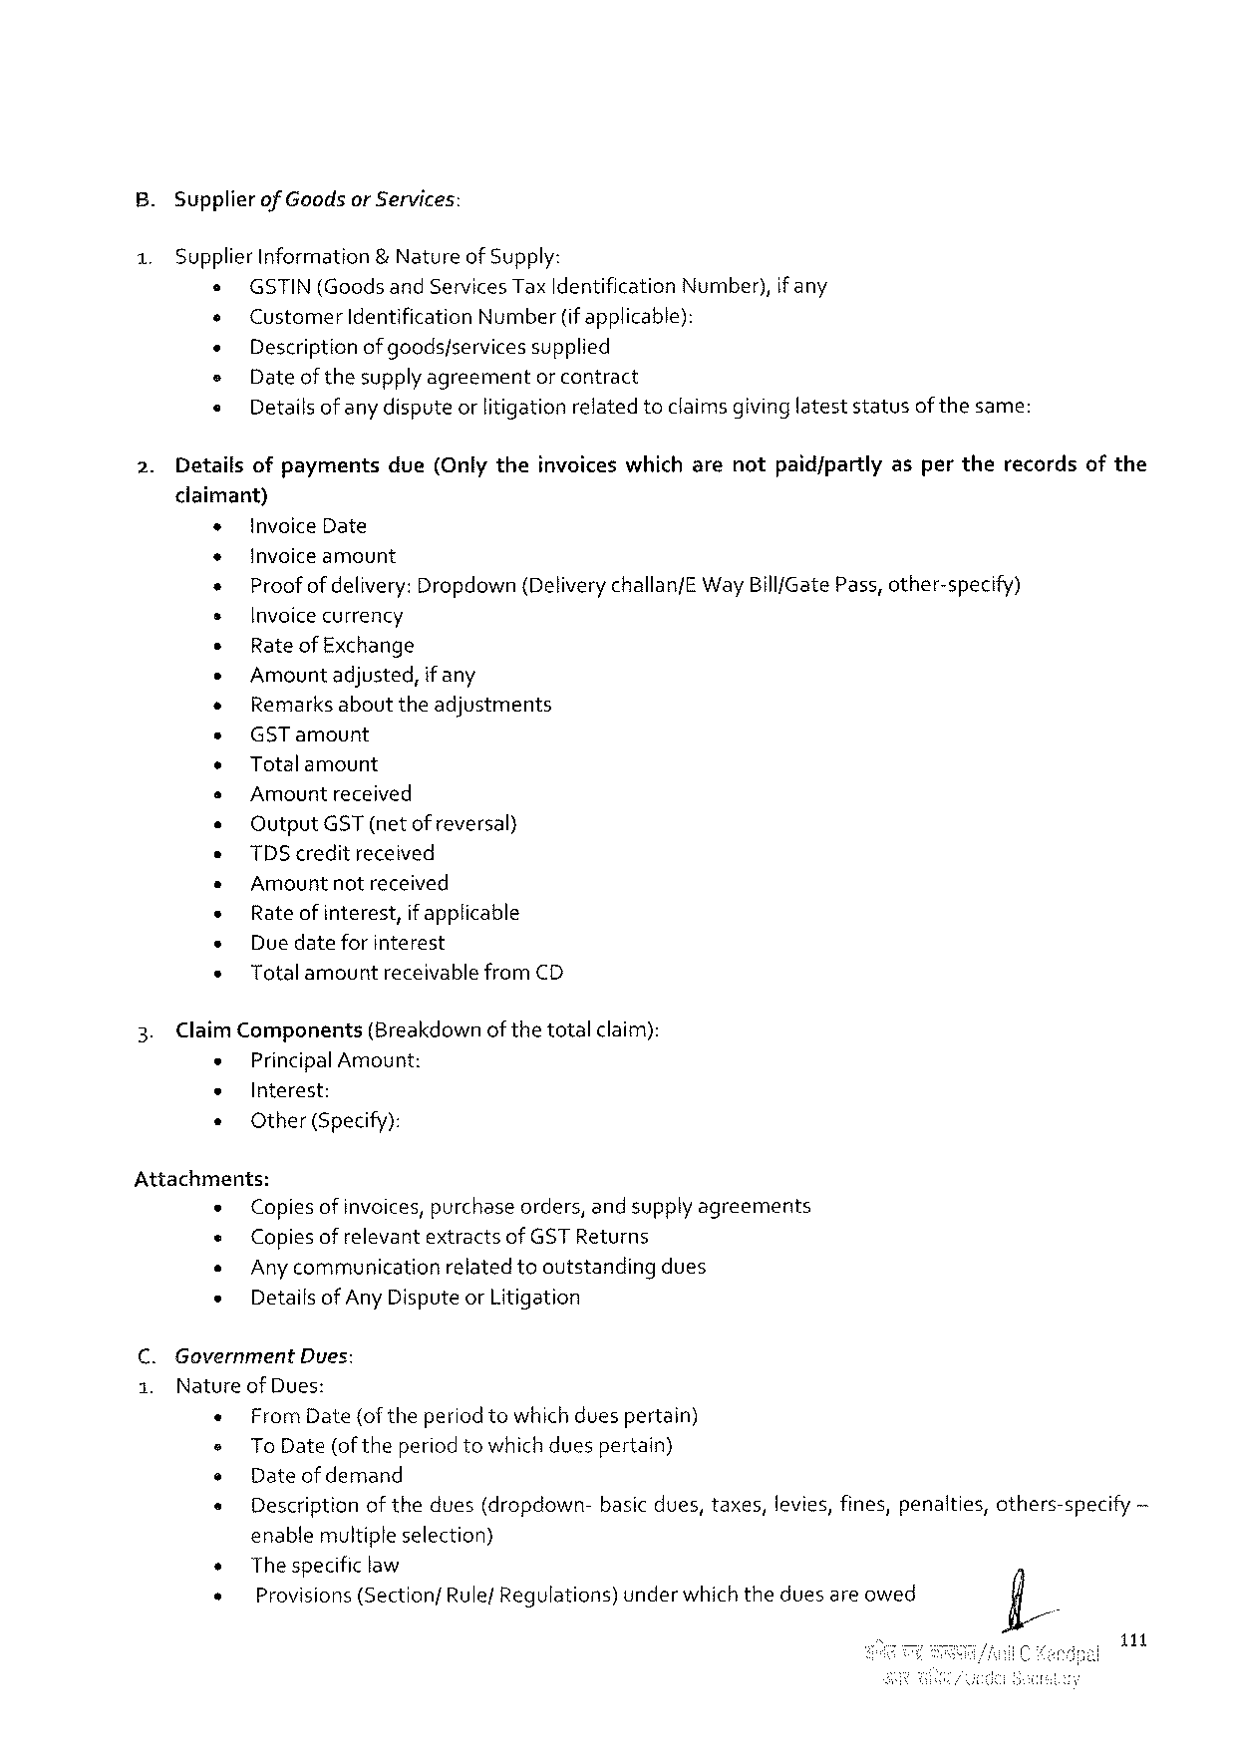

B. Supplier of Goodsor Services:

1. Supplier Information& Natureof Supply:

o GSTIN(Goodsand Services Tax Identification Number), if any

e Customer Identification Number(if applicable):

« Descriptionofgoods/services supplied

= Dateof thesupplyagreementor contract

« Details of any disputeor litigationrelatedtoclaimsgivinglateststatusof thesame:

2. Detailsofpayments due(Onlytheinvoiceswhicharenotpaid/partlyaspertherecordsofthe

claimant)

|  |  |  |  |  |  |  |  |  |  |
| --- | --- | --- | --- | --- | --- | --- | --- | --- | --- |
| + | | invoice Date | | | | | | | ~ |
| + | | Invoiceamount | | | | | | |
| + | | | Proof ofdelivery: Dropdown {Deliverychallan/EW ay Bill/Gate Pass, other-specify) | | | | | |
| s | | Invoicecurrency | | | | | | |
| * | | Rateof Exchange | | | | | | |
| * | | Amountadjusted, if any | | | | | | |
| * | | Remarksabouttheadjustments | | | | | | |
| + | | GST amount | | | | | | |
| » | | Totalamount | | | | | | |
| s | | Amountreceived | | | | | | |
| o | | Output GST(netof reversal) | | | | | | |
| e | | TDS creditreceived | | | | | | |
| * | | Amountnotreceived | | | | | | |
| « | | Rateofinterest, | | | | if applicable | | |
| « | | Duedateforinterest | | | | | | |
| « | | Totalamount | | | receivablefrom CD | | | |
| 3. | Claim Components(Breakdown of thetotalclaim): | | | | | | | |
| * | | Principal Amount: | | | | | | |
| e | | Interest: | | | | | | |
| « | | Other(Specify): | | | | | | |
| Attachments: | | | | | | | | |
| « | | Copiesof invoices, purchaseorders, and supplyagreements | | | | | | |
| « | | Copies of relevantextractsof GST Returns | | | | | | |
| « | | Any communicationrelatedtooutstandingdues | | | | | | |
| « | | Detaifsof Any Disputeor Litigation | | | | | | |
| C. Government | | | | Dues: | | | | |
| 1. | Natureof Dues: | | | | | | | |
| « | | From Date{of theperiodtowhichduespertain) | | | | | | |
| = | | | To Date (of the periodtowhichduespertain) | | | | | |
| o | | Dateof demand | | | | | | |
| s | | Descriptionofthedues(dropdown- | | | | | basicdues, taxes, levies, fines, penalties, | others-specify |

enablemultipleselection)

|  |  |  |  |
| --- | --- | --- | --- |
| s | Thespecific law | underwhichtheduesareowed | fi/ |
| « |
| Provisions(Sectionf Rule/Regulations) |

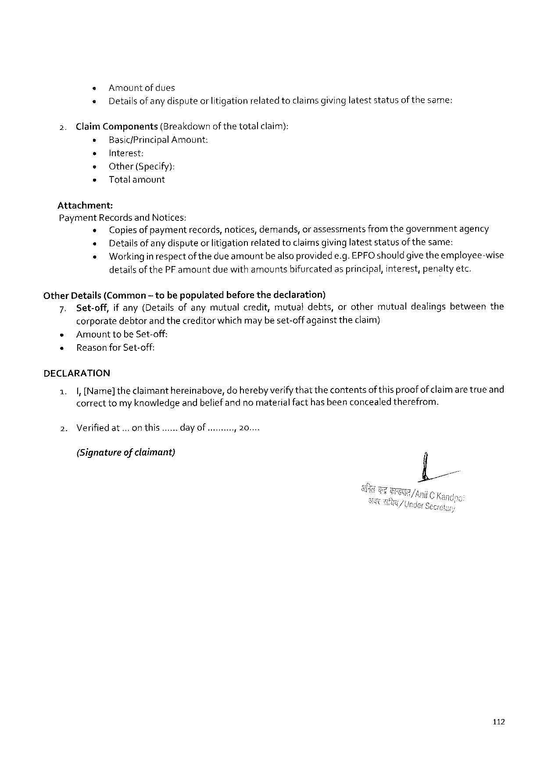

« Amountofdues

« Details ofanydisputeorlitigationrelatedtoclaimsgivinglateststatusofthesame:

2. Claim Components(Breakdown of thetotalclaim):   
 e Basic/Principal Amount:

e Interest:   
e Other (Specify):  
» Totalamount

Attachment:   
Payment Recordsand Notices:  
 « Copiesof paymentrecords, notices, demands, or assessmentsfromthegovernmentagency « Detailsof any disputeor litigationrelatedtoclaimsgivinglateststatusofthesame:  
 « Working inrespectof thedue amountbealsoprovidede. g. EPFO should givetheemployee-wise detailsof the PF amountduewith amountsbifurcatedasprincipal, interest, penaltyetc.

Other Details(Common~ tobepopulatedbeforethedeclaration)   
 7. Set-off, if any(Detailsofanymutualcredit, mutualdebts, orothermutualdealingsbetweenthe corporatedebtorand thecreditorwhich may be set-offagainst theclaim)  
 « Amount tobe Set-off:  
 « Reasonfor Set-off:

DECLARATION

|  |  |  |  |
| --- | --- | --- | --- |
| 1.  2. | |,[Name]theclaimanthereinabove, do herebyverifythatthecontentsofthis proofof claimare trueand correcttomy knowledgeand beliefandno materialfacthasbeenconcealedtherefrom. | | |
| Verifiedat... on this... | day of . oy | 2000 |

(Signatureof claimant)

112



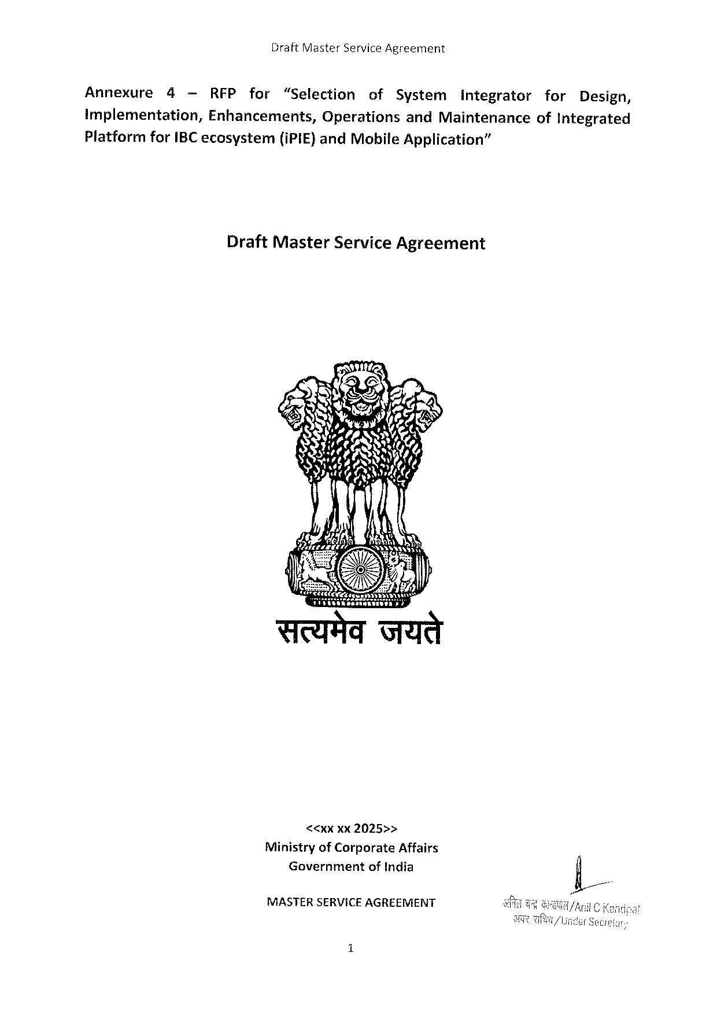

Draft Master Service Agreement

Annexure 4 —RFP for “Selection of System integrator for Design,

Implementation, Enhancements, Operationsand Maintenanceof Integrated

Platform for IBC ecosystem (i PIE}and Mobile Application”

Draft Master Service Agreement

74

Sty 57< & N««A

Sy o S AR,

SN-~

MASTERSERVICE AGREEMENT

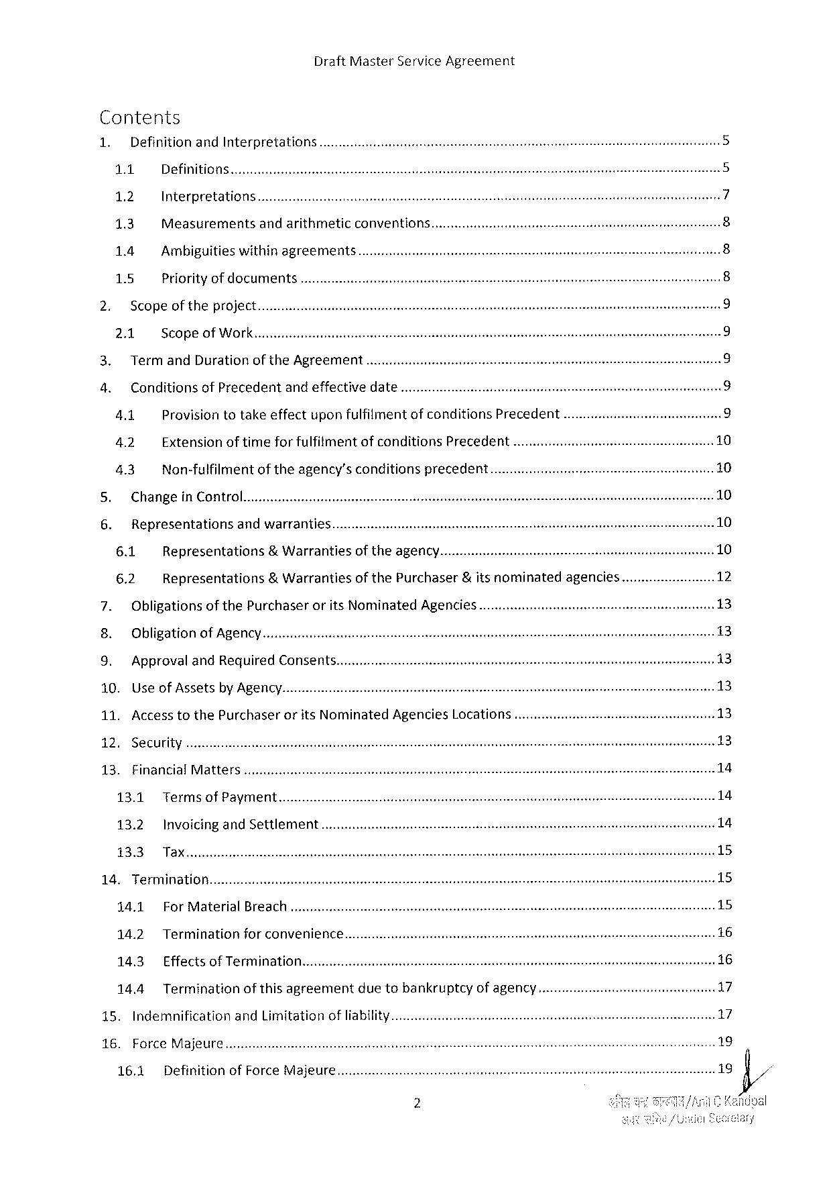

Draft Master Service Agreement

Contents

|  |  |  |  |  |  |  |  |  |  |  |
| --- | --- | --- | --- | --- | --- | --- | --- | --- | --- | --- |
| 1. | Definitionand Interpretations............. | | | | | | | | ... | U |
| U |
| 1.1 | Definitions | | | | | | |
| 1.2 | Interpretations | | | | | | | N |
| 13 | Measurements | andarithmetic | | | conventions............ | | | e |
| ~ |
| 1.4 | Ambiguitieswithinagreements........ | | | | | | | G |
| 1.5 | Priorityof documents | | | .... | | | | ® |
| Scopeoftheproject........... | | | | | | | |
| W |
| 2.1 | Scopeof Work | | | | | | | O |
| Termand Durationofthe Agreement | | | | | | | | © |
| Conditionsof Precedent | | | andeffectivedate... | | | | |
| 4.1 | Provisiontotakeeffectuponfulfilimentofconditions | | | | | Precedent | |
| 4.2 | Extensionoftimefor fulfitment | | | | ofconditions Precedent | | ..... |
| 4.3 | Non-fulfilmentof theagency’sconditionsprecedent.... | | | | | | |

Changein Control

|  |  |  |  |  |  |  |
| --- | --- | --- | --- | --- | --- | --- |
| LR y Representations | | andwarranties.. | | of theagency. | &itsnominated | agencies...... |
| 6.1 | Representations | | &Warranties |
| of the Purchaser |
| 6.2 | Representations | | &Warranties |

Obligationsof the Purchaserorits Nominated Agencies.............

Obligationof Agency

Approvaland Required Consents....

10. Useof Assetsby Agency.

11. Accesstothe Purchaserorits Nominated Agencies Locations.

12. Security

13. Financial Matters...

13.1 Terms of Payment

13.2 Invoicingand Settlement.

14. Termination........

14.1 For Material Breach

14.2 Terminationforconvenience.....

14.3 Effectsof Termination

14.4 Termination of thisagreement duetobankruptcy of agency....

15. Indemnification and Limitationofliability..............

16. Force Majeure

16.1 Definition of Force Majeure...

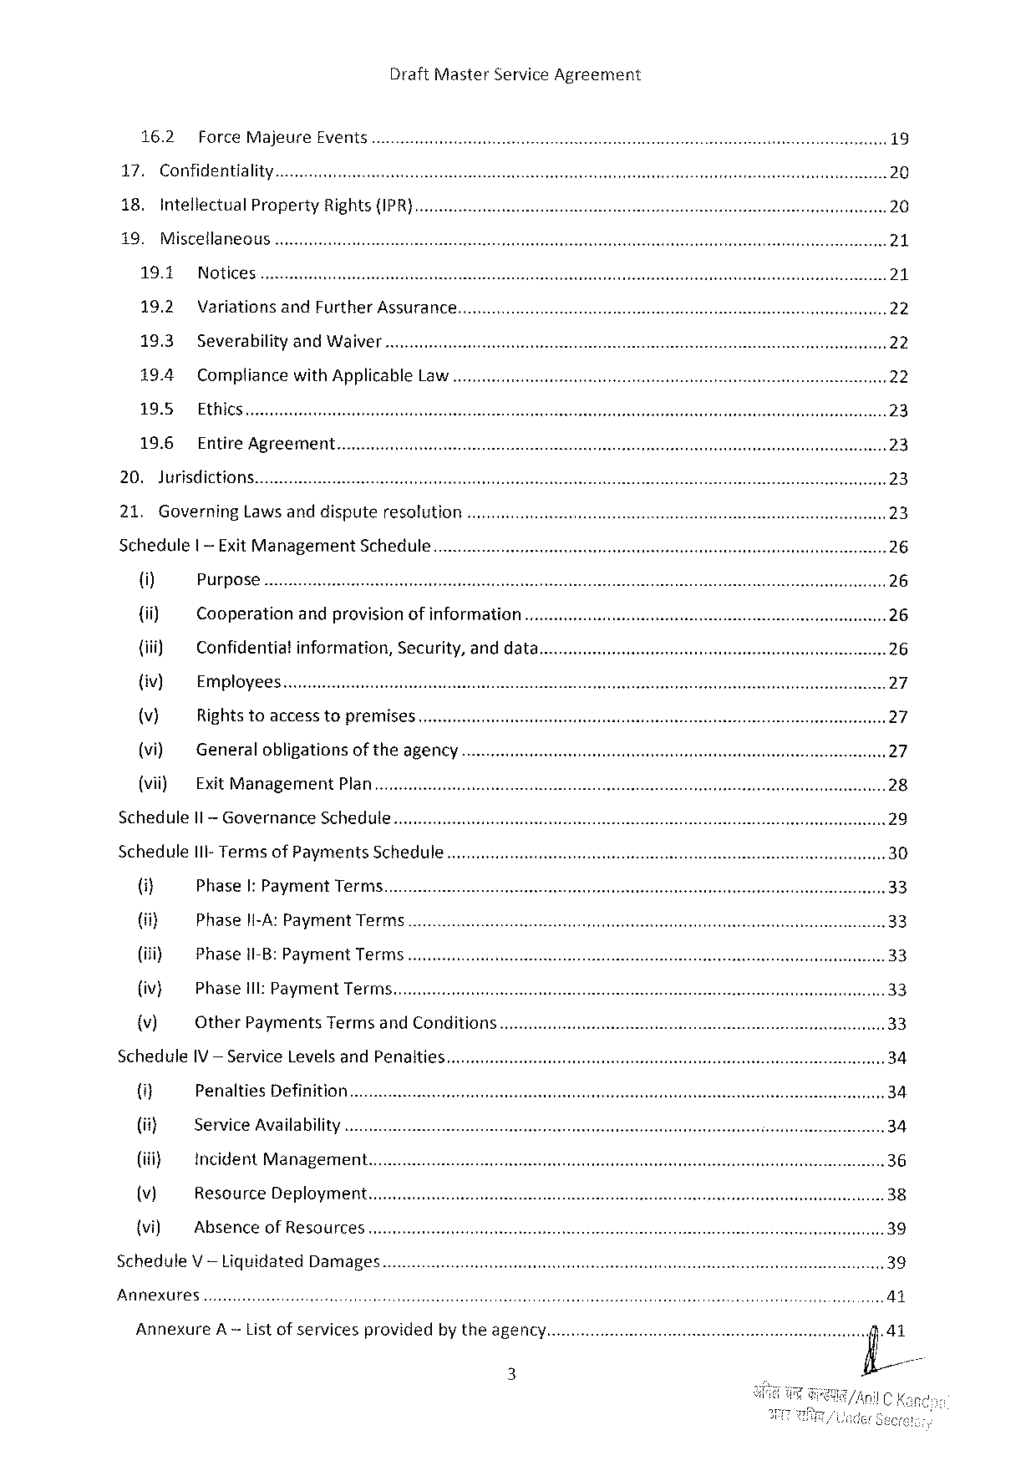

16.2 Force Majeure Events

17. Confidentiality

18. Intellectual Property Rights {IPR}

19. Miscellaneous

19.1 Notices

19.2 Variationsand Further Assurance

19.3 Severabilityand Waiver

19.4 Compliancewith Applicable Law

19.5 Ethics........

19.6 Entire Agreement

20. Jurisdictions.

21. Governing Laws anddispute resolution

Schedule | -Exit Management Schedule

{i) Purpose

{ii) Cooperation andprovisionofinformation

{iii) Confidentia! information, Security, anddata....

{iv) Employees

(v) Rights toaccesstopremises

(vi) Generalobligationsoftheagency

(vii) Exit Management Plan

Schedule Il-Governance Schedule

Schedule I 1 I-Termsof Payments Schedule..........

(i} Phase I: Payment Terms.

(ii} Phaseli-A: Payment Terms........... c.....

(iii) Phase 1 I-B: Payment Terms.

{iv} Phase 1 I: Payment Terms

{v) Other Payments Termsand Conditions........

Schedule IV — Service Levelsand Penalties

4] Penalties Definition

(it} Service Availability

(i} incident Management.

(v) Resource Deployment...........

{vi) Absenceof Resources

Schedule V— Liquidated Damages

Annexures



Draft Master Service Agreement

Annexure B — Required Deliverablesand Associated Timelines.

Annexure€— Non-Disclosure Agreement

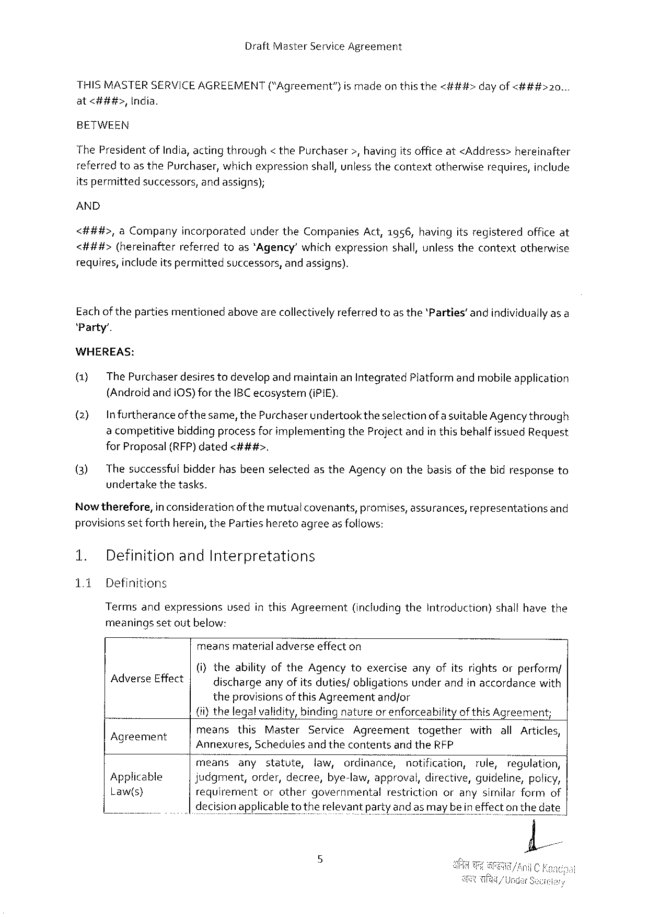

Draft Master Service Agreement

|  |  |  |  |  |  |  |
| --- | --- | --- | --- | --- | --- | --- |
| THISMASTERSERVICEAGREEMENT | | (“Agreement”} | ismade | onthisthe | <###> | dayof<###>20... |
| at<###>, | India. |

BETWEEN

The Presidentof India, acting through< the Purchaser>, havingitsofficeat<Address>hereinafter

|  |  |  |  |  |  |  |  |
| --- | --- | --- | --- | --- | --- | --- | --- |
| referredtoasthe Purchaser, | | | whichexpression | shall, unlessthecontext | otherwise | requires, | include |
| itspermitted | successors, | andassigns); | |

AND

<##4#>, a Companyincorporatedunderthe Companies Act,1956, havingitsregisteredofficeat <###t#>(hereinafterreferredtoas‘Agency’ whichexpressionshall, unlessthecontextotherwise

|  |  |  |
| --- | --- | --- |
| requires, includeitspermitted | successors, | andassigns). |

Eachof thepartiesmentionedabovearecollectivelyreferred toas the'Parties’andindividuallyas a‘Party’.

WHEREAS:

(1) The Purchaser desirestodevelopand maintainan Integrated Platformand mobileapplication (Androidandi 0 S)for the IBC ecosystem (i Pi E).

(2) Infurtheranceof thesame, the Purchaserundertook theselectionofa suitable Agencythrough a competitivebiddingprocessfor implementingthe Projectandin this behalfissued Request for Proposal(RFP)dated<###>.

(3) Thesuccessfulbidderhasbeenselectedasthe Agencyon thebasisofthebidresponseto undertakethetasks.

Nowtherefore, in considerationofthemutual covenants, promises, assurances, representationsand provisionsset forthherein, the Partiesheretoagreeasfollows:

1. Definitionand Interpretations

1.1 Definitions

Termsandexpressionsvsedinthis Agreement(includingthe Introduction)shallhavethe meaningssetoutbelow:

meansmaterialadverseeffecton

|  |  |  |
| --- | --- | --- |
| Adverse Effect | (i)theabilityofthe Agencytoexerciseanyofitsrightsorperform/ dischargeanyofits duties/obligationsunderandinaccordancewith | |
| theprovisionsof this Agreement | andfor |

(ii)thelegalvalidity, binding natureor enforceabilityof this Agreement;

|  |  |  |  |  |  |  |  |  |  |  |  |  |  |  |  |
| --- | --- | --- | --- | --- | --- | --- | --- | --- | --- | --- | --- | --- | --- | --- | --- |
| Agreement g  Applicable  Law(s} | means | this | Master | | Service Agreement | | | | together | | withall Articles, | | | | |
| Annexures, | | Schedules | | andthecontents | | and the RFP | | | | | | | | |
| means | any | statute, | | law, | ordinance, | | notification, | | | | rule, | | regulation, | |
| judgment, order, decree, bye-law, approval, directive, guideline, policy, | | | | | | | | | | | | | | |
| requirement | | or | other | governmental | | restriction | | | orany | | | similar | form | of |

decisionapplicabletotherelevantparty and as maybeineffecton thedate

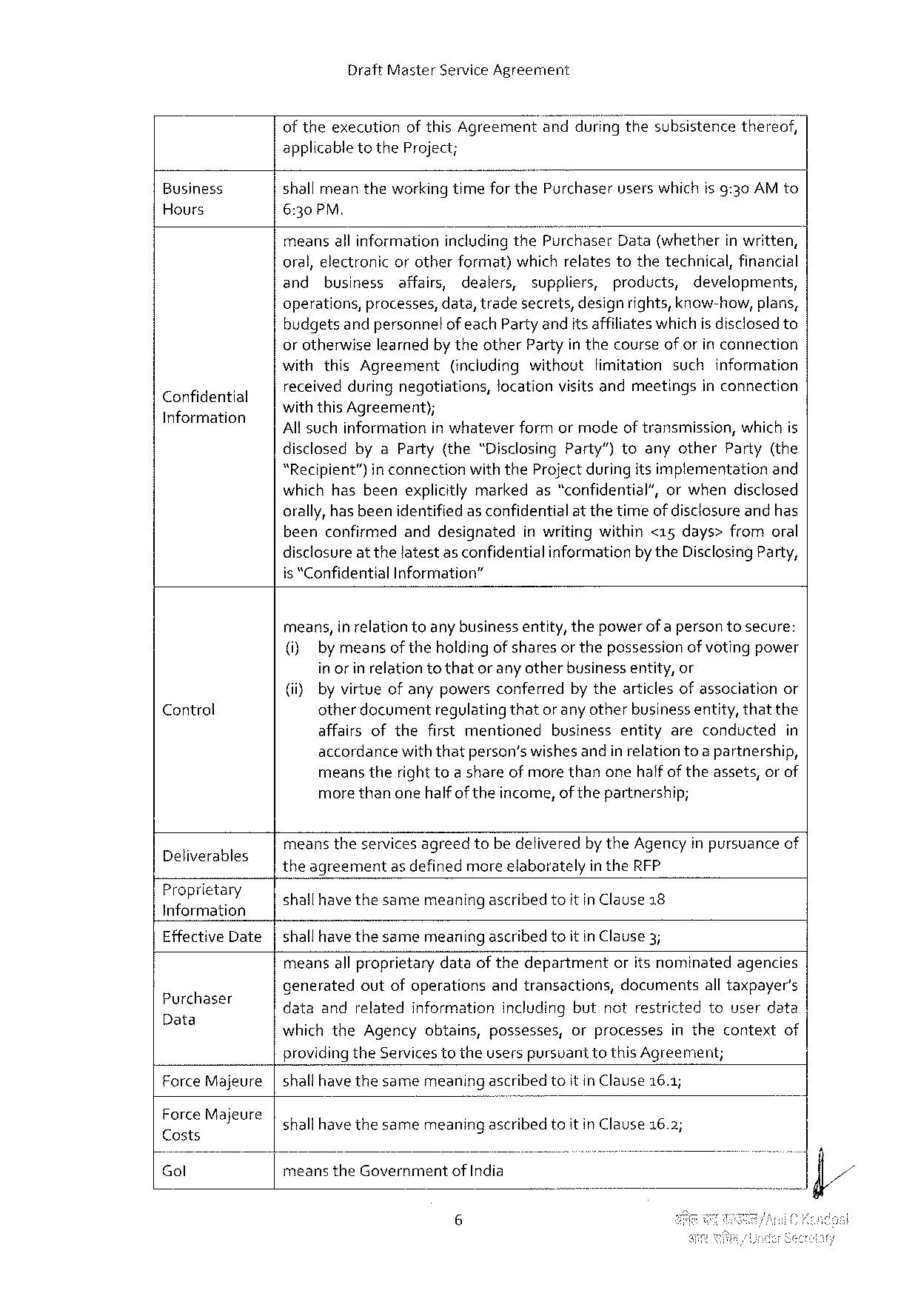

Draft Master Service Agreement

of theexecutionofthis Agreementand"duringthesubsistencethereof, applicable to the Project;

Business shall meantheworkingtimefor the Purchaseruserswhichisg:30 AM to Hours 6:30 PM,

meansall informationincludingthe Purchaser Data(whetherin written, oral, electronic orotherformat) whichrelatestothetechnical, financial

and business affairs, dealers, suppliers, products, developments,

operations, processes, data, tradesecrets, designrights, know-how, plans, budgetsandpersonnelof each Partyandits affiliates whichisdisclosedto or otherwiselearnedby theother Partyin thecourseof orin connection

|  |  |  |  |  |  |
| --- | --- | --- | --- | --- | --- |
| Confidential Information | withthis Agreement | | (includingwithoutfimitationsuchinformation | | |
| received | duringnegotiations, | | locationvisitsandmeetings | inconnection |
| withthis Agreement);  All suchinformationin whateverformormodeof transmission, which is | | | | |

disclosedbya Party{the“Disclosing Party”)toanyother Party(the“Recipient”)in connectionwith the Project during itsimptementationand whichhasbeenexplicitlymarkedas“confidential’, orwhendisclosed orally, has beenidentified as confidentialat thetimeof disclosureandhas beenconfirmedanddesignated inwritingwithin<15 days>fromoral disclosure at thelatestas confidentialinformationbythe Disclosing Party, is “Confidential Information”

means, in relationtoany businessentity, thepowerofa person tosecure: (i) by meansoftheholdingof sharesor thepossessionof votingpower in or in relationtothator any otherbusinessentity, or

|  |  |  |  |  |
| --- | --- | --- | --- | --- |
| Control | (i} | by virtueofanypowersconferredby thearticlesofassociationor | | |
| otherdocumentregulatingthatorany otherbusiness entity, thatthe | | |
| affairsofthefirstmentioned | businessentityareconducted | in |

accordancewiththatperson’swishesandin relationtoa partnership, meanstherighttoa shareofmorethanonehalfof theassets, orof morethanonehalfof theincome, of thepartnership;

|  |  |
| --- | --- |
| Deliverables  Proprietary  Information  Effective Date | meanstheservicesagreedtobedeliveredby the Agencyin pursuanceof theagreementas definedmoreelaboratelyin the RFP  shallhave thesamemeaning ascribedtoitin Clause 18  shallhave thesamemeaning ascribedtoitin Clause 3; |

meansall proprietarydataofthedepartmentoritsnominatedagencies

|  |  |
| --- | --- |
| Purchaser Data | generatedoutofoperationsandtransactions, documentsall taxpayer's dataandrelatedinformationincludingbutnotrestrictedtouserdata whichthe Agencyobtains, possesses, orprocessesinthecontextof |

providingthe Servicestotheuserspursuanttothis Agreement;

|  |  |  |
| --- | --- | --- |
| Force Majeure Force Majeure Costs  Gol | shallhave thesamemeaning ascribedtoit in Clause 16.1; shallhave thesamemeaning ascribedtoit in Clause 16.2; | |
| meansthe Government | of India |

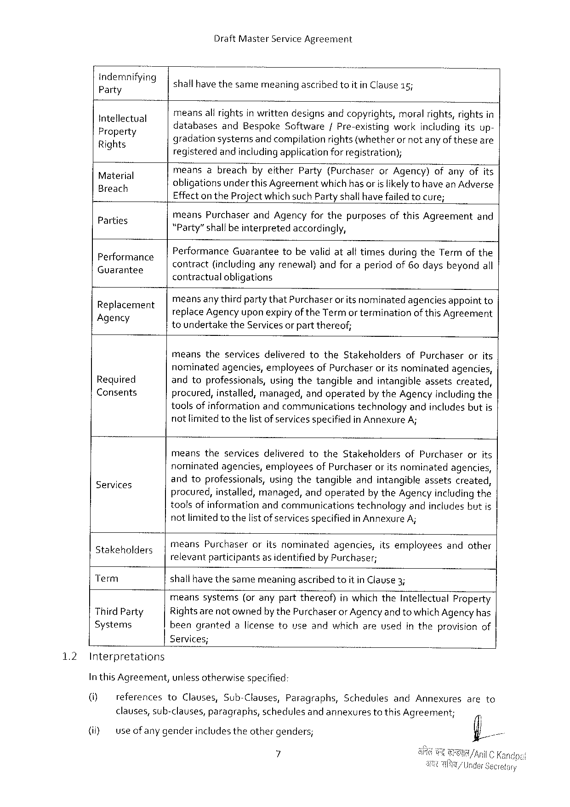

Draft Master Service Agreement

|  |  |  |  |  |
| --- | --- | --- | --- | --- |
| gfii; flmfi/mg  Intellectual Propert  Ri Ets¥  9  3  Material —  Parties q  GCU a Ta TTES Performance  Replacement Agency  Required  Consents  Services  atakeholders  Term  Third Party Systems | shallhavethesamemeaningascribedtoit in Clause 15;  meansall rightsin writtendesignsandcopyrights, moralrights, rightsin  databases and Bespoke Software/Pre-existingworkincludingitsup- S ) ==  gradationsystemsand compilationrights (whetheror not anyof theseare  registeredandincludingapplication for registration);  meansabreachbyeither Party(Purchaseror Agency)ofanyofits  . A : A  obligationsunder this Agreementwhich hasorisiikely tohavean Adverse  Effectonthe Projectwhichsuch Partyshallhave failed tocure;  -means Purchaserand Agencyforthepurposesofthis Agreementand  Party”shallbeinterpretedaccordingly, 3 3 3  contract(includinganyrenewal)andforaperiodof 60 daysbeyondall Performance Guaranteetobevalid atalftimesduringthe Termofthe . s 3  contractualobligations | | | |
| meansanythirdpartythat Purchaser | oritsnominated | agencies | appointto |
| replace Agency upon expiryof the Termorterminationof this Agreement toundertakethe Servicesor partthereof;  meanstheservicesdeliveredtothe Stakeholdersof Purchaserorits nominatedagencies, employeesof Purchaseroritsnominatedagencies, andtoprofessionals, usingthetangibleandintangibleassetscreated, procured, installed, managed, andoperatedbythe Agencyincludingthe toolsof informationandcommunicationstechnologyandincludesbutis not limitedtothelist of services specifiedin Annexure A;  meanstheservicesdeliveredtothe Stakeholdersof Purchaserorits nominatedagencies, employeesof Purchaseroritsnominatedagencies, andtoprofessionals, usingthetangibleandintangibleassetscreated, procured, installed, managed, andoperatedby the Agencyincludingthe toolsofinformationandcommunicationstechnologyandincludesbutis notlimitedtothelistof services specifiedin Annexure A;  means Purchaseroritsnominatedagencies, itsemployeesandother relevantparticipantsas identifiedby Purchaser;  shallhavethesamemeaningascribedtoit in Clause 3;  meanssystems(oranypartthereof)inwhichthe Intellectual Property Rightsarenot ownedby the Purchaseror Agency and to which Agencyhas beengrantedalicensetouseandwhichareusedintheprovisionof | | | |

Services;

1.2 Interpretations

In this Agreement, unlessotherwisespecified:

|  |  |  |  |  |  |  |  |  |  |  |  |  |  |
| --- | --- | --- | --- | --- | --- | --- | --- | --- | --- | --- | --- | --- | --- |
| [G] | references | to | Clauses, | | Sub-Clauses, | | Paragraphs, | | Schedules | | and | Annexures | areto |
| (i) | clauses, sub-clauses, | | | paragraphs, | | schedules | | andannexures | | to this Agreement; | | |
| useofany genderincludestheothergenders; | | | | | | | | | | | |

7

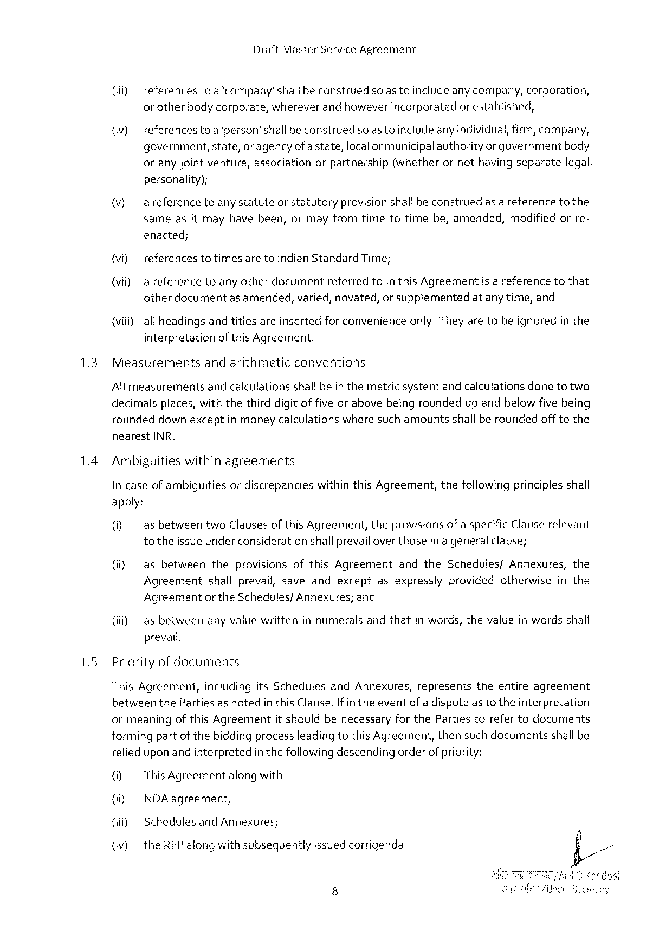

Draft Master Service Agreement

(iiy referencesto a'company’shall beconstrued soastoincludeanycompany, corporation,

or otherbodycorporate, whereverandhoweverincorporated or established;

(iv) referencestoa‘person’shallbeconstruedsoas toincludeanyindividual, firm, company,

government, state, or agencyofa state, localor municipalauthority orgovernmentbody

oranyjointventure, association orpartnership (whether ornothavingseparate legal

personality);

|  |  |  |  |
| --- | --- | --- | --- |
| (v) | areferencetoanystatuteorstatutory | provisionshallbeconstrued | asareferencetothe |

sameasitmayhavebeen, ormayfromtimetotimebe, amended, modifiedorre-

enacted;

|  |  |  |  |  |
| --- | --- | --- | --- | --- |
| (vi) | referencestotimes areto Indian Standard Time; | | isareference | tothat |
| (vii) | a referencetoanyotherdocument | referredtointhis Agreement |

otherdocumentas amended, varied, novated, or supplementedatanytime; and

(viii)all headingsandtitlesareinsertedfor convenienceonly. They aretobeignoredin the

interpretationof this Agreement.

|  |  |  |
| --- | --- | --- |
| 13 | Measurements | andarithmeticconventions |

Allmeasurementsandcalculationsshalfbein themetricsystemand calculationsdonetotwo

decimalsplaces, withthethirddigitof five orabovebeingroundedupandbelowfive being

roundeddown exceptin moneycalculationswheresuch amountsshallberoundedofftothe

nearest INR.

14 Ambiguitieswithinagreements

In caseof ambiguitiesordiscrepancieswithinthis Agreement, thefollowingprinciples shall

apply:

|  |  |  |  |
| --- | --- | --- | --- |
| (i) | asbetween | two Clausesof this Agreement, | theprovisionsofaspecific Clauserelevant |

to theissue underconsiderationshallprevail overthosein a generalclause;

(i} as betweentheprovisionsofthis Agreementandthe Schedules/Annexures, the

Agreementshallprevail, saveandexceptasexpresslyprovidedotherwiseinthe

Agreementor the Schedulesf Annexures; and

|  |  |  |  |  |  |
| --- | --- | --- | --- | --- | --- |
| (i) | as between | anyvaluewritten | innumerals | andthat | inwords, thevalueinwordsshall |

prevail.

|  |  |  |  |  |  |  |  |
| --- | --- | --- | --- | --- | --- | --- | --- |
| 15 | Priorityof documents | | its Schedules | and Annexures, | represents | theentire | agreement |
| This Agreement, | including |

betweenthe Partiesas notedin this Clause. If in theeventof adispute as totheinterpretation

ormeaningof this Agreementit shouldbenecessaryforthe Partiestorefertodocuments

formingpartof thebiddingprocessleadingtothis Agreement, thensuch documentsshallbe

relied upon and interpretedin thefollowingdescendingorderofpriority:

[0} This Agreement alongwith

(i) NDA agreement,

{iiiy Schedulesand Annexures;

(iv) the RFP along withsubsequentlyissuedcorrigenda

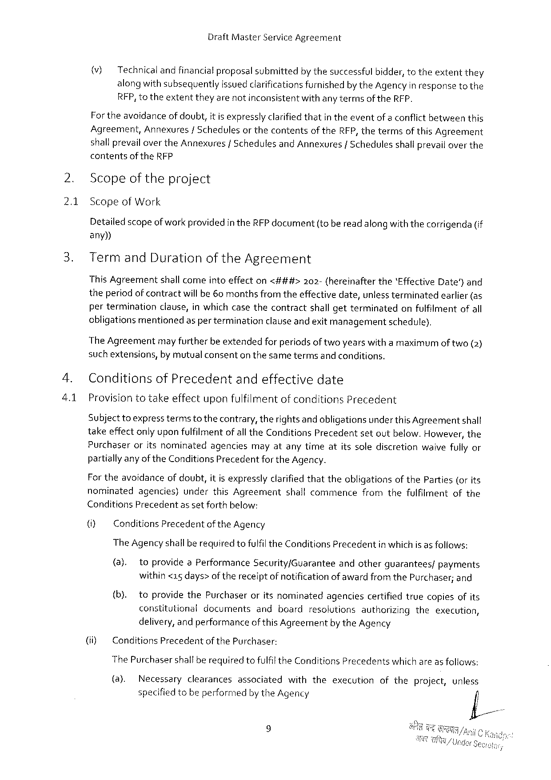

Draft Master Service Agreement

(v) Technicalandfinancial proposalsubmittedbythesuccessfulbidder, totheextentthey alongwith subsequentlyissuedclarificationsfurnishedbythe Agencyin responseto the RFP, totheextenttheyarenotinconsistentwithanytermsof the RFP.

For theavoidanceof doubt, it is expresslyclarifiedthatin theeventof a conflictbetweenthis Agreement, Annexures/Schedulesor thecontentsof the RFP, thetermsof this Agreement shallprevailoverthe Annexures |Schedulesand Annexures | Schedules shallprevailoverthe

contentsof the RFP

Scopeof theproject

2.1 Scopeof Work

Detailed scopeofworkprovidedin the RFP document(oberead along withthecorrigenda(if any))

Termand Durationofthe Agreement

This Agreement shallcomeintoeffecton<###> 202-(hereinafter the‘Effective Date) and

theperiod ofcontractwillbe 60 monthsfromtheeffectivedate, unlessterminatedearlier (as perterminationclause, inwhichcasethecontractshall getterminatedonfulfilmentofall obligationsmentionedas per terminationclause andexitmanagementschedule),

The Agreementmay furtherbe extendedfor periodsof twoyearswitha maximumof two(2) suchextensions, by mutualconsenton thesametermsand conditions.

Conditionsof Precedentandeffectivedate

Provisiontotakeeffectuponfulfilmentof conditions Precedent

Subject toexpress termsto thecontrary, therights andobligationsunder this Agreementshall takeeffectonly uponfulfilmentof all the Conditions Precedentsetoutbelow. However, the Purchaseroritsnominatedagenciesmayatanytimeatitssolediscretionwaivefully or partiallyany of the Conditions Precedentforthe Agency.

For theavoidanceofdoubt, it isexpresslyclarifiedthattheobligationsof the Parties(or its nominatedagencies)underthis Agreement shallcommencefromthefulfilmentofthe Conditions Precedentas setforthbelow:

(i) Conditions Precedentof the Agency

The Agency shallbe requiredtofulfil the Conditions Precedentinwhich is as foliows:

|  |  |  |  |  |  |  |  |  |  |  |
| --- | --- | --- | --- | --- | --- | --- | --- | --- | --- | --- |
| (ii) | (a). | toprovidea Performance | | | Security/Guarantee | andother | | guarantees/ | | payments |
| within<15 days> of thereceiptof notificationofawardfromthe Purchaser; and | | | | | | | | | |
| (b). | | toprovidethe Purchaser | | oritsnominated | agencies | certified | | truecopiesofits | |
| constitutional | | | documents | andboardresolutionsautherizingtheexecution, | | | | | |
| delivery, andperformanceof this Agreementby the Agency | | | | | | | | | |
| Conditions Precedent | | | of the Purchaser: | | | | | | |

The Purchasershallberequiredtofulfil the Conditions Precedentswhich areas follows:

|  |  |  |  |  |  |  |  |  |  |
| --- | --- | --- | --- | --- | --- | --- | --- | --- | --- |
| (8). | Necessary | clearances | associated | with | the | execution | of the | project, | unless |
| specified tobe performedby the Agency | | | |

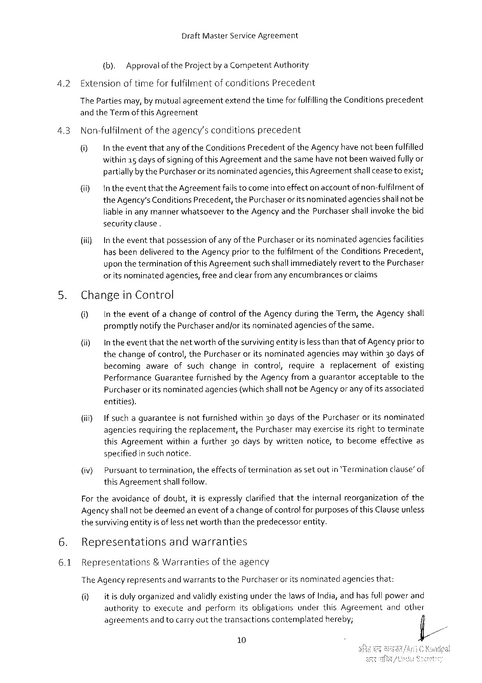

Draft Master Service Agreement

|  |  |  |  |  |
| --- | --- | --- | --- | --- |
| 4.2 | (b). | Approvalofthe Projectby a Competent Authority | | precedent |
| Extensionoftimeforfulfilmentofconditions Precedent | | |
| The Partiesmay, by mutualagreement | | extendthetimeforfulfillingthe Conditions |

and the Termof this Agreement

4.3 Non-fulfilmentoftheagency’sconditionsprecedent

(i) Intheeventthatanyofthe Conditions Precedent of the Agencyhavenotbeenfulfilled

within 15 days of signingof this Agreementandthesamehave notbeenwaived fullyor partiallybythe Purchaseror itsnominatedagencies, this Agreementshall ceaseteexist;

(il Intheeventthatthe Agreementfails tocomeinto effectonaccountof non-fulfilmentof the Agency's Conditions Precedent, the Purchaserorits nominatedagenciesshallnotbe liablein any mannerwhatsoevertothe Agency and the Purchasershallinvokethebid securityclause.

|  |  |  |  |
| --- | --- | --- | --- |
| {iil) | In theeventthatpossession | ofanyofthe Purchaseroritsnominated | agenciesfacilities |

hasbeendeliveredtothe Agencypriortothefuifilmentof the Conditions Precedent, upon theterminationof this Agreementsuch shailimmediatelyreverttothe Purchaser or itsnominatedagencies, freeand clearfromany encumbrancesor claims

5. Changein Control

() In theeventofachangeofcontrolof the Agencyduringthe Term, the Agencyshall promptlynotifythe Purchaserandjorits nominatedagenciesof thesame.

(i) Intheeventthatthenetworthof thesurvivingentityisless thanthatof Agencypriorto thechangeof control, the Purchaseror itsnominatedagenciesmay within 30 daysof

|  |  |  |  |
| --- | --- | --- | --- |
| becomingawareofsuchchange | incontrol, | requireareplacement | ofexisting |

Performance Guaranteefurnishedby the Agencyfromaguarantoracceptabletothe

|  |  |  |
| --- | --- | --- |
| Purchaser | oritsnominated | agencies(whichshallnotbe Agencyor anyofitsassociated |

entities).

|  |  |  |  |  |
| --- | --- | --- | --- | --- |
| (i) | Ifsuchaguarantee | isnotfurnished | within 30 daysofthe Purchaser | oritsnominated |

agencesrequiringthereplacement, the Purchasermay exerciseitsright toterminate this Agreementwithinafurther 30 daysbywrittennotice, tobecomeeffectiveas specifiedin such notice.

|  |  |  |  |  |
| --- | --- | --- | --- | --- |
| (iv) | Pursuanttotermination, | theeffectsof termination | assetoutin‘Termination | clause’of |

this Agreementshallfollow.

Fortheavoidanceofdoubt, it is expresslyclarifiedthattheinternalreorganizationofthe Agencyshallnot bedeemedaneventof a changeof controlfor purposesofthis Clauseunless thesurvivingentityis of lessnetworththanthepredecessorentity.

6. Representations andwarranties

6.1 Representations & Warranties oftheagency

The Agencyrepresents andwarrantstothe Purchaser oritsnominated agenciesthat:

(i) itisdulyorganizedandvalidlyexistingunderthetaws of India, andhas fullpowerand

authority toexecute andperform itsobligations under this Agreement andother

agreementsand tocarryoutthetransactionscontemplatedhereby; fil/

10

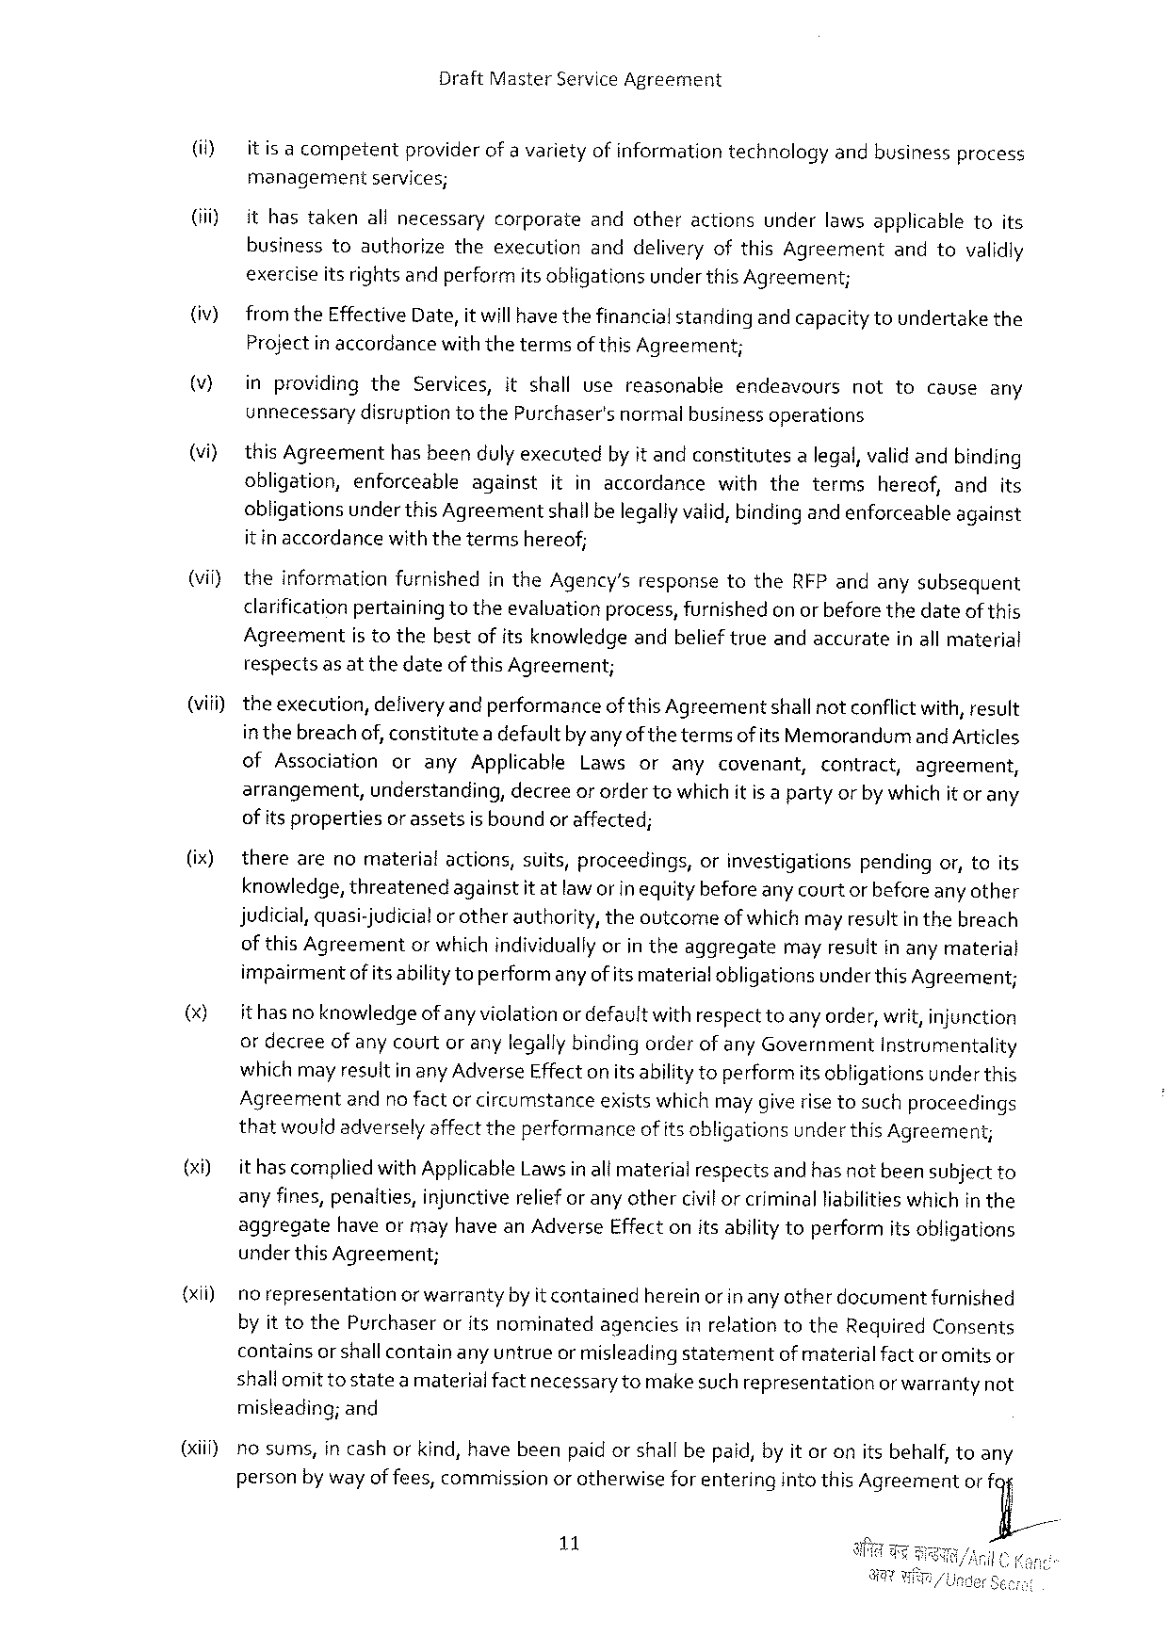

Draft Master Service Agreement

|  |  |  |  |  |  |  |  |  |
| --- | --- | --- | --- | --- | --- | --- | --- | --- |
| (i)  (i)  (iv)  (V)  (vi)  (vii) | itisacompetent | providerofavarietyofinformation | | | technology | andbusiness | | process |
| managementseivices;  ithastakenallnecessarycorporateandotheractionsunderlawsapplicabletoits businesstoauthorizetheexecutionanddeliveryofthis Agreementandtovalidly exerciseitsrights andperformits obligationsunder this Agreement;  from the Effective Date, it willhavethefinancialstandingandcapacity toundertakethe Projectin accordancewiththetermsof this Agreement; | | | | | | | |
| inprovidingthe Services, itshallusereasonable | | | | endeavours | nottocauseany | | |
| unnecessarydisruptiontothe Purchaser'snormalbusinessoperations  this Agreementhasbeendulyexecutedby it andconstitutesa legal, validandbinding | | | | | | | |
| obligation, enforceable | | against | itinaccordancewiththeterms | | | hereof, andits | |
| obligationsunder this Agreementshallbelegallyvalid, bindingand enforceableagainst itinaccordancewiththetermshereof;  theinformationfurnishedin the Agency’sresponsetothe RFP andanysubsequent clarification pertainingtotheevalvationprocess, furnishedon or beforethedateofthis Agreementistothebestof itsknowledgeandbelieftrueandaccurateinall material | | | | | | | |

respectsas at thedateofthis Agreement;

(viii)- theexecution, defiveryandperformanceof this Agreementshallnotconflictwith, result inthebreach of, constitutea defaultby anyofthe termsof its Memorandumand Articles of Associationorany Applicable Lawsoranycovenant, contract, agreement, arrangement, understanding, decreeor ordertowhich it is a partyorby whichit or any of its propertiesor assetsis boundor affected;

(ix) therearenomaterial actions, suits, proceedings, orinvestigations pendingor, toits knowledge, threatenedagainstitatlaw orin equitybefore any courtor before any other judicial, quasi-judicialor otherauthority, theoutcomeofwhich mayresultin thebreach of this Agreementor whichindividuallyorin theaggregatemay resultin any material impairmentof its abilitytoperformanyofits materialobligationsunder this Agreement;

() ithasno knowledge ofanyviclationordefaultwithrespecttoanyorder, writ, injunction or decreeof anycourtor anylegallybindingorderof any Government Instrumentality which may resultinany Adverse Effecton itsabilitytoperformitsobligationsunderthis

|  |  |  |  |  |  |  |  |  |  |  |  |
| --- | --- | --- | --- | --- | --- | --- | --- | --- | --- | --- | --- |
| (xi)  {xii)  (il | Agreement | andnofactorcircumstance | | | | existswhichmaygiverisetosuchproceedings | | | | | |
| thatwouldadversely affecttheperformanceof its obligationsunderthis Agreemen;  ithascomplied with Applicable Lawsinall materialrespectsand hasnot beensubject to any fines, penalties, injunctivereliefor any othercivilor criminalliabilitieswhichin the aggregatehaveor mayhavean Adverse Effect onitsabilitytoperformitsobligations underthis Agreement; | | | | | | | | | | |
| norepresentation | | orwarranty | byitcontained | | | hereinor inanyotherdocument | | | furnished | |
| by it to the Purchaseroritsnominatedagenciesin relationtothe Required Consents | | | | | | | | | | |
| containsor shallcontainany untrueor misleadingstatement | | | | | | | | ofmaterialfactor omitsor | | |
| shallomit tostatea materialfactnecessary tomake such representationor warrantynot misleading; and  nosums, in cashor kind, havebeenpaid orshall bepaid, by it oronitsbehalf, toany | | | | | | | | | | |
| personby wayof fees, commission | | | | orotherwise | | | forenteringintothis Agreement | | | orfy/ |

11

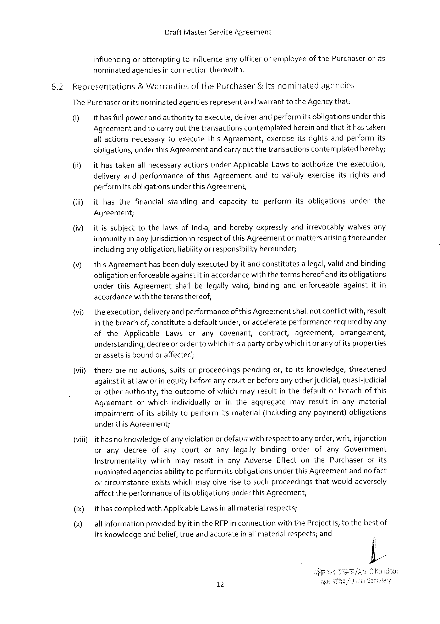

Draft Master Service Agreement

influencing orattemptingtoinfluence anyofficer oremployeeof the Purchaserorits nominatedagenciesin connectiontherewith.

|  |  |  |  |  |  |
| --- | --- | --- | --- | --- | --- |
| 6.2 | Representations | & Warranties | of the Purchaser | &itsnominated | agencies |

The Purchaseror itsnominatedagenciesrepresentand warranttothe Agencythat:

() ithasfull powerandauthoritytoexecute, deliverandperformitsobligationsunderthis

Agreement andtocarryoutthetransactions contemplated hereinandthatithastaken

allactionsnecessarytoexecutethis Agreement, exerciseitsrightsandperformits obligations, under this Agreementandcarryoutthetransactionscontemplatedhereby;

(i) ithastakenallnecessaryactionsunder Applicable Laws toauthorizetheexecution, deliveryandperformanceofthis Agreementandtovalidlyexerciseitsrightsand performitsobligationsunderthis Agreement;

(iiiy ithasthefinancialstandingandcapacitytoperformitsobligationsunderthe

Agreement;

(iv) itissubjecttothelawsof India, andherebyexpresslyandirrevocablywaivesany immunityinanyjurisdiction in respectofthis Agreementormattersarisingthereunder includingany obligation, liabilityor responsibility hereunder;

|  |  |
| --- | --- |
| (v) | this Agreementhasbeendulyexecutedby itandconstitutesa legal, validandbinding obligationenforceableagainstitin accordancewiththetermshereofandits obligations |

underthis Agreementshallbelegallyvalid, bindingandenforceableagainstitin accordancewiththetermsthereof;

|  |  |  |  |  |  |  |  |  |  |  |  |  |  |
| --- | --- | --- | --- | --- | --- | --- | --- | --- | --- | --- | --- | --- | --- |
| (vi) | theexecution, | | | deliveryandperformance | | | | | of this Agreement | | | shallnotconflictwith, result | |
| in thebreachof, constitutea defaultunder, or accelerateperformancerequiredby any | | | | | | | | | | | | |
| of | the | Applicable | | Laws | or | any | covenant, | | contract, | agreement, | | arrangement, |

understanding, decreeor orderto whichit is a partyorby whichitoranyof itsproperties orassetsisboundor affected;

(vii) therearenoactions, suitsorproceedingspendingor, toitsknowledge, threatened againstitatlawor in equitybeforeanycourtorbeforeany otherjudicial, quasi-judicial orotherauthority, theoutcomeof whichmayresultin thedefaultorbreachof this

|  |  |  |
| --- | --- | --- |
| Agreement | orwhichindividuallyorintheaggregate | mayresultinanymaterial |

impairmentofitsability toperformitsmaterial(includinganypayment)obligations

under this Agreement;

(viii)ithasno knowledgeof anyviolation ordefaultwithrespectto any order, writ, injunction oranydecree ofanycourtoranylegallybindingorderofany Government Instrumentalitywhichmayresultinany Adverse Effectonthe Purchaserorits nominatedagenciesabilitytoperformitsobligationsunder this Agreementandno fact orcircumstanceexistswhichmaygiverise tosuchproceedingsthatwouldadversely affect theperformanceof itsobligationsunderthis Agreement;

(ix) it hascompliedwith Applicable Lawsinall materialrespects;

() allinformationprovidedby itin the RFP in connectionwiththe Projectis, tothebestof

itsknowledge andbelief, trueandaccurate inallmaterial respects; and

12

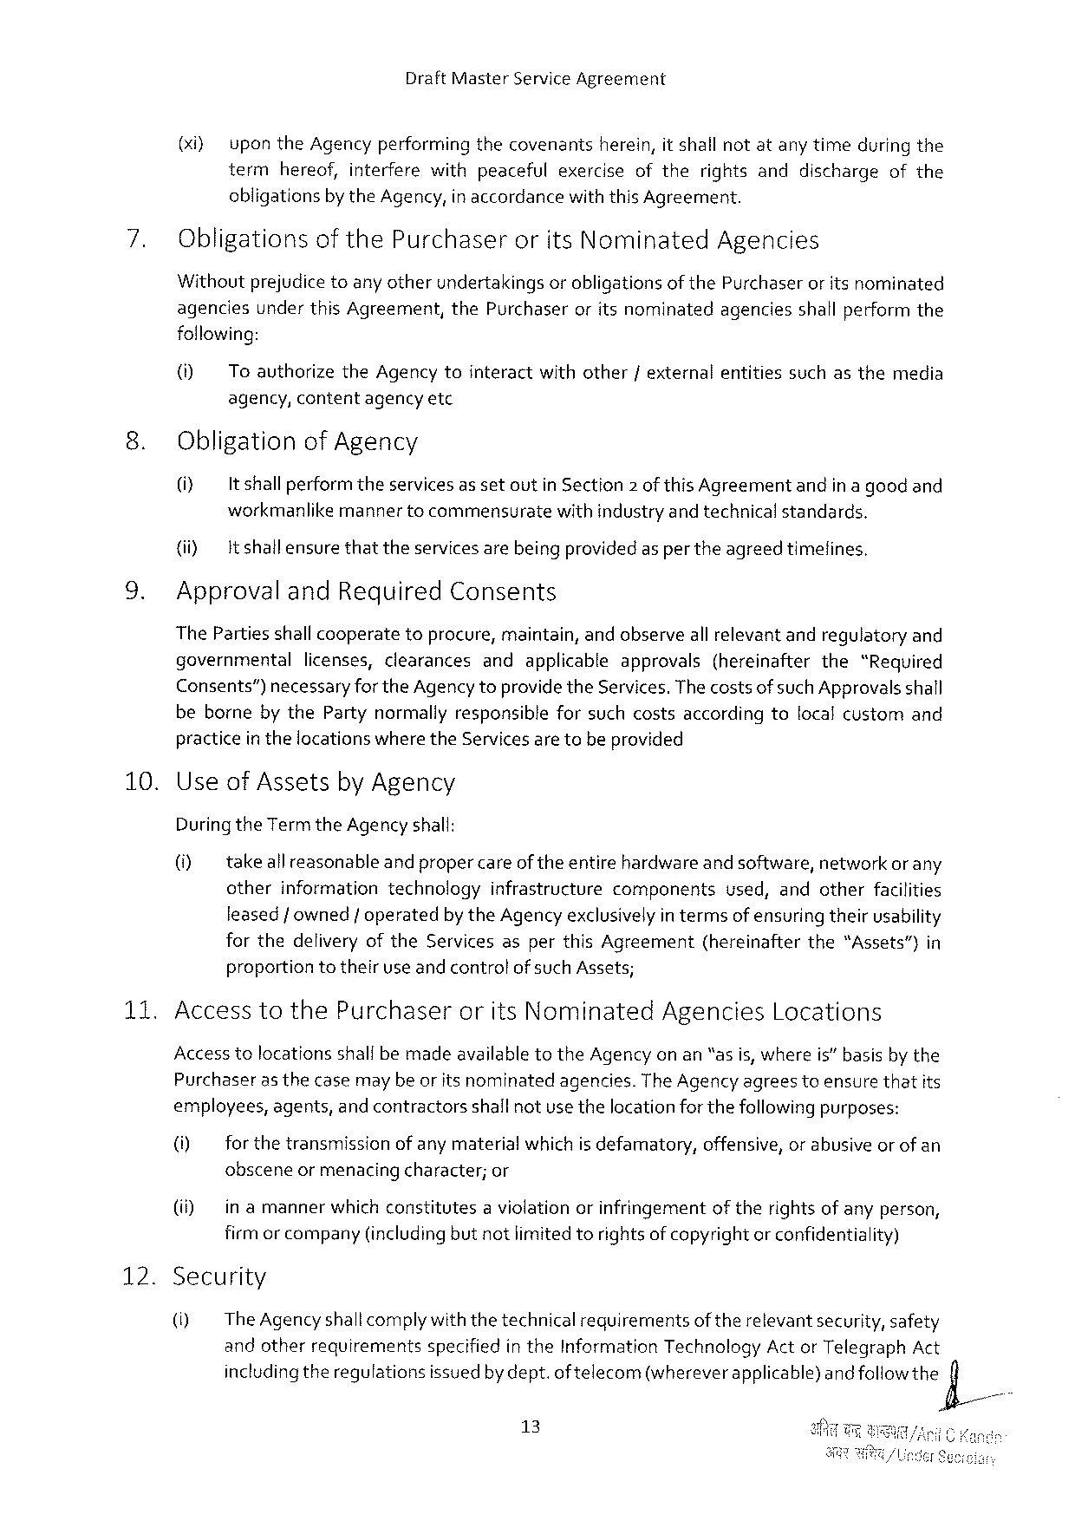

Draft Master Service Agreement

(xi} uponthe Agencyperforming thecovenants herein, itshallnotatanytimeduringthe term hereof, interferewithpeacefulexerciseoftherightsanddischargeofthe

obligations by the Agency, in accordance withthis Agreement.

Obligationsofthe Purchaser orits Nominated Agencies

Withoutprejudice toany otherundertakingsorobligationsof the Purchaseror itsnominated agenciesunderthis Agreement, the Purchaseroritsnominatedagenciesshallperformthe following:

(i) Toauthorizethe Agencytointeractwithother/externalentitiessuchasthemedia agency, contentagencyetc

Obligationof Agency

|  |  |  |
| --- | --- | --- |
| (i) | It shallperformtheservicesassetoutin Section 2 ofthis Agreement | andinagoodand |

workmanlikemannertocommensuratewith industryand technicalstandards.

(i) It shallensurethattheservicesarebeingprovidedas per theagreedtimefines,

Approvaland Required Consents

The Partiesshallcooperatetoprocure, maintain, andobserveall relevantandregulatoryand

|  |  |  |
| --- | --- | --- |
| governmental | licenses, clearances | andapplicableapprovals(hereinafterthe“Required |

Consents”) necessaryforthe Agencytoprovidethe Services. Thecostsofsuch Approvalsshall bebornebythe Partynormallyresponsibleforsuchcostsaccordingtolocalcustomand practicein thelocationswhere the Servicesaretobeprovided

10. Useof Assetsby Agency

Duringthe Term the Agency shall:

0] takeallreasonable andpropercareoftheentirehardwareandsoftware, networkorany

otherinformationtechnologyinfrastructurecomponents used, andotherfacilities leasedf owned/ operatedby the Agency exclusivelyin termsofensuring theirusability forthedeliveryofthe Servicesasperthis Agreement(hereinafterthe“Assets”)in proportiontotheiruse andcontrolof such Assets;

|  |  |  |  |
| --- | --- | --- | --- |
| 135 | Accesstothe Purchaser | orits Nominated | Agencies Locations |

Accesstolocationsshallbemadeavailabletothe Agency on an“as is, whereis” basisby the

|  |  |  |  |
| --- | --- | --- | --- |
| Purchaser | as thecasemaybeoritsnominated | agencies. | The Agencyagreestoensurethatits |

employees, agents, and contractorsshallnotusethelocationforthefollowingpurposes:

(i) for thetransmissionof anymaterialwhichis defamatory, offensive, or abusiveor of an obsceneormenacing character; or

(i) in amannerwhichconstitutesa violationorinfringementoftherightsofanyperson, firmor company(includingbut notlimitedtorights ofcopyrightor confidentiality)

12. Security

() The Agencyshallcomplywiththetechnicalrequirementsof therelevantsecurity, safety andotherrequirementsspecifiedin the Information Technology Act or Telegraph Act includingtheregulationsissuedby dept. oftelecom(whereverapplicable)andfo Howthe)X/

13

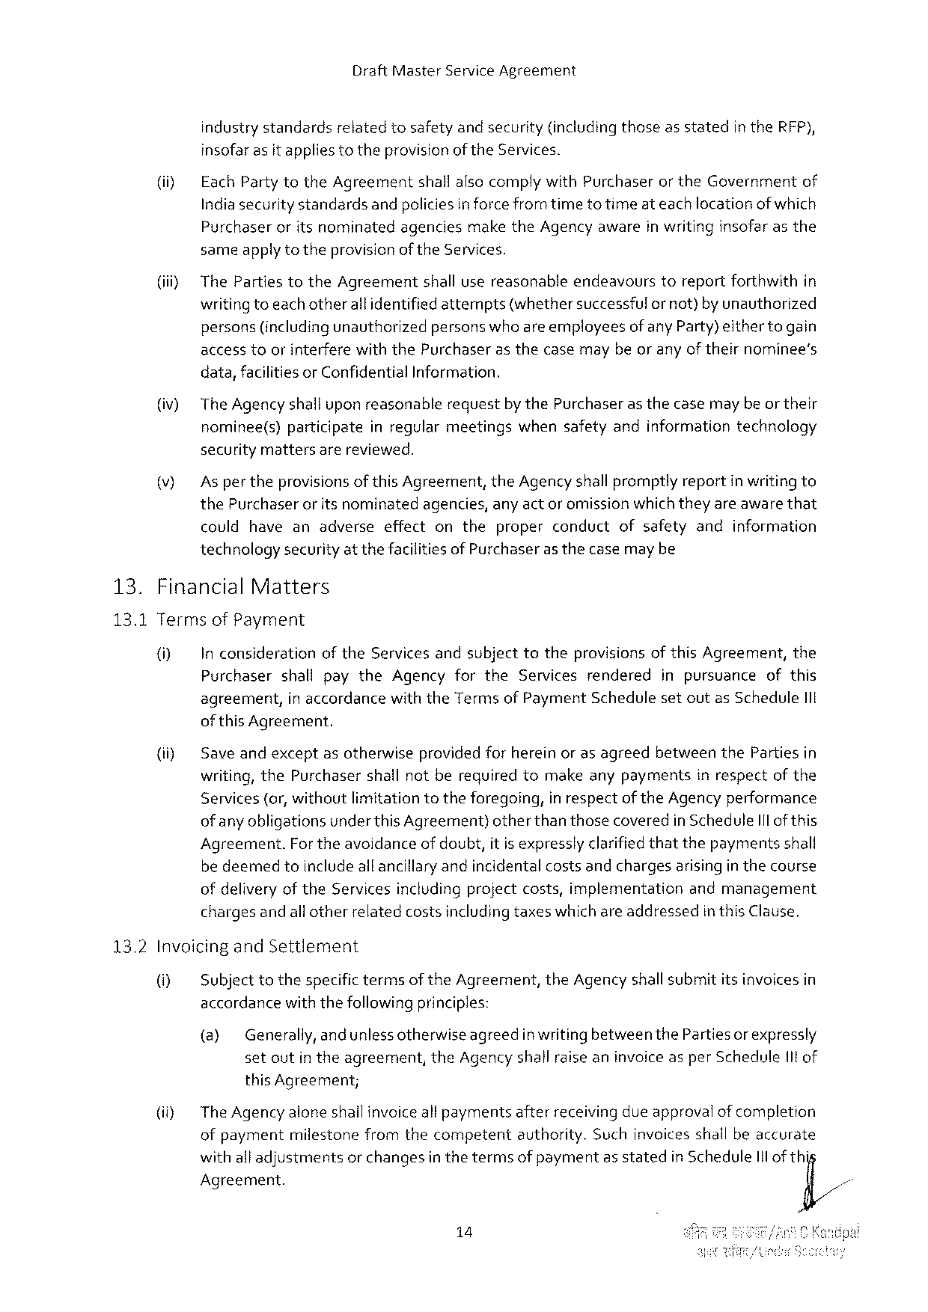

Draft Master Service Agreement

industry standardsrelatedtosafetyand security(includingthoseas statedin the RFP), insofarasit appliestotheprovisionofthe Services.

|  |  |  |  |  |
| --- | --- | --- | --- | --- |
| (ii) | Each Partytothe Agreementshall alsocomply with Purchaseror the Governmentof Indiasecurity standardsandpoliciesin forcefromtimeto timeat eachlocationofwhich | | | |
| Purchaser | oritsnominated | agencies | makethe Agencyawareinwritinginsofarasthe |

sameapplyto theprovisionof the Services.

(jii} The Partiestothe Agreementshall usereasonableendeavourstoreportforthwithin writingtoeach otherall identified attempts(whethersuccessful ornot)by unauthorized persons(includingunauthorizedpersonswho are employeesofany Party)eithertogain accesstoorinterferewiththe Purchaserasthecasemaybeor anyof theirnominee’s

|  |  |  |
| --- | --- | --- |
| (iv) | data, facilitiesor Confidential | Information. |
| The Agency shalluponreasonablerequestby the Purchaseras thecasemay be ortheir nominee(s)participateinregularmeetingswhensafetyandinformationtechnology | |

securitymattersarereviewed.

Asper theprovisionsof this Agreement, the Agencyshall promptlyreportin writing to the Purchaseroritsnominated agencies, anyactor omissionwhichtheyareawarethat couldhaveanadverseeffectontheproperconductofsafetyandinformation technologysecurityat thefacilitiesof Purchaserasthecasemay be

|  |  |  |
| --- | --- | --- |
| 13. | Financial | Matters |

13.1 Termsof Payment

0] In considerationof the Services andsubjecttotheprovisions of this Agreement, the Purchasershallpaythe Agencyforthe Servicesrendered inpursuanceofthis agreement, in accordancewiththe Termsof Payment Schedulesetoutas Schedule 11 t of this Agreement.

|  |  |  |
| --- | --- | --- |
| (i) | Saveandexceptasotherwiseprovidedfor hereinoras agreedbetweenthe Partiesin writing, the Purchasershallnotberequiredtomakeanypaymentsinrespectofthe | |
| Services(or, withoutlimitationtotheforegoing, | in respectofthe Agencyperformance |

ofany obligationsunderthis Agreement)otherthanthosecoveredin Schedule I 1 l of this Agreement. For theavoidanceof doubt, it is expresslyclarifiedthatthepaymentsshall be deemedtoincludealtancillaryandincidentalcostsandchargesarisingin thecourse ofdelivery of the Servicesincludingprojectcosts, implementationandmanagement chargesandallotherrelatedcostsincludingtaxeswhichareaddressedin this Clause,

13.2 Invoicingand Settlement

@ Subjecttothespecifictermsof the Agreement, the Agencyshallsubmititsinvoicesin accerdancewiththefollowing principles:

(@ Generally, and unlessotherwiseagreedin writing betweenthe Partiesor expressly setoutin theagreement, the Agency shall raise aninvoiceasper Scheduleitof this Agreement;

iy The Agency aloneshailinvoiceall paymentsafterreceiving dueapprovalof completion ofpaymentmilestonefromthecompetentauthority. Suchinvoicesshallbeaccurate withall adjustmentsor changesin thetermsof paymentas statedin Schedule 1 lof thi Agreement.

14

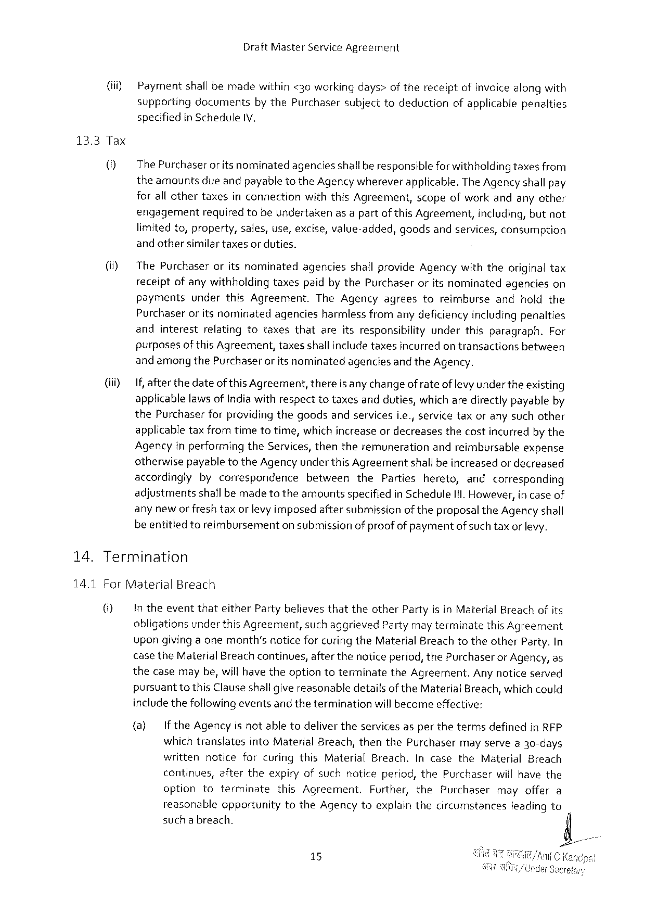

Draft Master Service Agreement

|  |  |
| --- | --- |
| (iii) | Paymentshall bemadewithin <30 workingdays>of thereceiptofinvoicealongwith supportingdocumentsby the Purchasersubjecttodeductionofapplicablepenalties specifiedin Schedule IV, |

13.3 Tax

|  |  |  |
| --- | --- | --- |
| U} | The Purchaseror itsnominatedagenciesshallberesponsible forwithholding taxesfrom theamountsdue andpayabletothe Agencywhereverapplicable. The Agency shallpay forall othertaxesinconnectionwiththis Agreement, scopeofworkandanyother | |
| engagement | requiredtobeundertakenasa partofthis Agreement, including, butnot |

limitedto, property, sales, use, excise, value-added,

and othersimilartaxesor duties.

goodsandservices, consumption

|  |  |  |
| --- | --- | --- |
| (i) | The Purchaseroritsnominatedagenciesshallprovide Agencywiththeoriginaltax receiptofanywithholdingtaxespaidby the Purchaseroritsnominatedagencieson | |
| payments | underthis Agreement. The Agencyagreestoreimburseandholdthe |
| Purchaseroritsnominatedagenciesharmlessfromany deficiencyincludingpenalties | |

andinterestrelatingtotaxesthatareitsresponsibilityunderthisparagraph. For purposesofthis Agreement, taxesshallincludetaxesincurred ontransactionsbetween

|  |  |  |
| --- | --- | --- |
| (iiiy | andamongthe Purchaserorits nominated | agenciesandthe Agency. |
| If, after thedateof this Agreement, there is any changeof rateof levyunder theexisting applicablelaws of Indiawithrespecttotaxesandduties, which aredirectlypayableby the Purchaserforproviding thegoodsandservicesi. e., servicetaxoranysuchother | |

applicabletaxfromtimetotime, whichincreaseor decreasesthecostincurredby the Agencyin performingthe Services, thentheremunerationandreimbursableexpense otherwisepayable to the Agency underthis Agreementshallbeincreasedor decreased

|  |  |  |  |  |  |  |
| --- | --- | --- | --- | --- | --- | --- |
| 14. | accordinglybycorrespondence | | between | the | Partieshereto, | andcorresponding |
| adjustmentsshallbemadetotheamountsspecifiedin Schedule Ill. However, in caseof | | | | | |
| anynewor fresh | taxorlevy imposedaftersubmissionoftheproposalthe Agency shall | | | | |
| be entitledtoreimbursementon submissionof proofof paymentofsuch taxor levy. Termination | | | | | |

14.1 For Material Breach

|  |  |
| --- | --- |
| 0} | In theeventthateither Partybelievesthattheother Partyisin Material Breachofits obligationsunder this Agreement, such aggrieved Partymayterminatethis Agreement upongivingaonemonth’snoticefor curing the Material Breach totheother Party. In |

case the Material Breachcontinues, afterthenoticeperiod, the Purchaseror Agency, as thecasemaybe, willhavetheoptiontoterminatethe Agreement. Anynoticeserved pursuanttothis Clauseshallgivereasonabledetailsof the Material Breach, whichcould includethefollowingeventsand theterminationwill becomeeffective:

|  |  |  |  |  |  |  |  |  |  |  |
| --- | --- | --- | --- | --- | --- | --- | --- | --- | --- | --- |
| (@) | If the Agencyisnotabletodelivertheservicesasperthetermsdefinedin RFP | | | | | | | | | Can |
| whichtranslates | | | into Material Breach, thenthe Purchaser | | | mayservea 30-days | | |
| writtennoticeforcuringthis Material Breach. Incasethe Material Breach | | | | | | | | |
| continues, aftertheexpiryofsuchnoticeperiod, the Purchaserwillhavethe | | | | | | | | |
| option | toterminate | | | this Agreement, | Further, the Purchasermayoffera | | | |
| reasonable | | opportunity | | to the Agencytoexplainthecircumstances | | | leadingto | |
| such a breach. | | | | | | | | |
| 15 | | | | | /i | | | C |

nder Sec

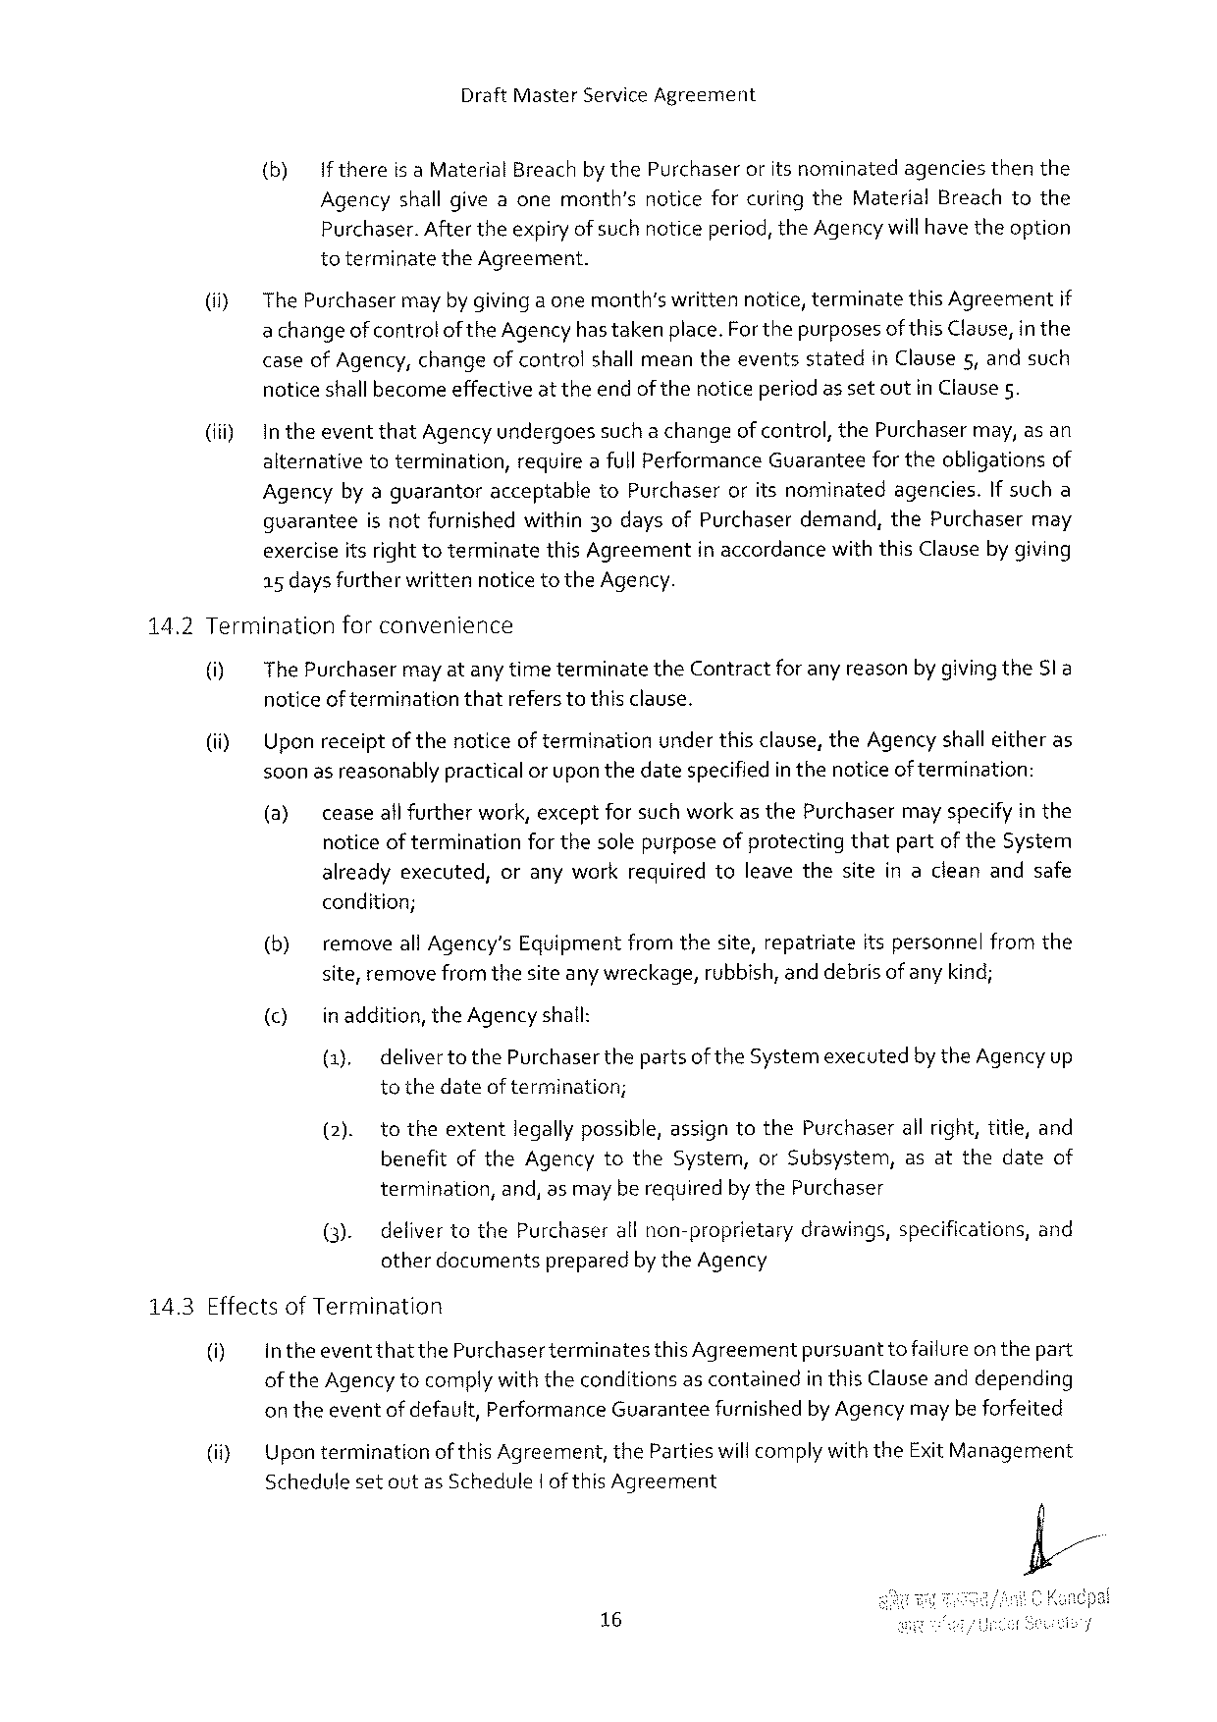

Draft Master Service Agreement

{(b) Ifthereisa Material Breach by the Purchaseroritsnominatedagenciesthenthe Agencyshall giveaonemonth’snoticeforcuringthe Material Breachtothe Purchaser. Aftertheexpiryofsuchnoticeperiod, the Agency willhave theoption toterminatethe Agreement.

|  |  |  |  |  |
| --- | --- | --- | --- | --- |
| (i) | The Purchaser | mayby givingaonemonth’swrittennotice, terminate | this Agreement | if |
| achangeofcontrolofthe Agency hastaken place. Forthepurposesofthis Clause, in the | | | |

caseof Agency, changeofcontrolshall meantheeventsstatedin Clause 5, andsuch noticeshallbecomeeffectiveatthe endof thenoticeperiod as setoutin Clause 5.

(iii) Intheeventthat Agencyundergoessuch a changeofcontrol, the Purchasermay, asan alternativetotermination, requireafull Performance Guaranteefor theobligationsof Agencyby aguarantoracceptableto Purchaseroritsnominatedagencies. If sucha guaranteeisnotfurnishedwithin 30 daysof Purchaserdemand, the Purchasermay exerciseitsrighttoterminatethis Agreementin accordancewiththis Clauseby giving a 5 days furtherwrittennoticeto the Agency.

14.2 Terminationforconvenience

|  |  |  |
| --- | --- | --- |
| 0]  (i) | The Purchasermayat any timeterminatethe Contractforany reasonbygivingthe Sl a noticeof terminationthatrefers to this clause.  Upon receiptofthenoticeof terminationunderthisclause, the Agency shall eitheras soonas reasonablypractical or upon thedatespecifiedin thenoticeoftermination: | |
| (@) | ceaseall furtherwork, exceptforsuch workas the Purchasermay specifyin the |

noticeof terminationfor thesolepurposeof protectingthatpartof the System alreadyexecuted, oranyworkrequiredtoleavethesiteinacleanandsafe

condition;

(b) removeall Agency’s Equipmentfromthesite, repatriateitspersonnelfromthe site, remove fromthesiteanywreckage, rubbish, and debrisofany kind;

() inaddition, the Agency shall:

(1), delivertothe Purchaser thepartsof the Systemexecutedby the Agencyup tothedateof termination;

(2). totheextentlegally possible, assigntothe Purchaserall right, title, and benefitofthe Agencytothe System, or Subsystem, asatthedateof

termination, and, asmayberequiredby the Purchaser

(3). defivertothe Purchaserall non-proprietarydrawings, specifications, and otherdocumentspreparedby the Agency

14.3 Effectsof Termination

|  |  |  |  |
| --- | --- | --- | --- |
| 0] | intheeventthatthe Purchaserterminates | this Agreement | pursuanttofailureon thepart |
| of the Agency tocomplywith theconditionsascontainedin this Clauseanddepending | | |

on theeventofdefault, Performance Guaranteefurnishedby Agency maybeforfeited

(i}   
 Schedulesetoutas Schedule|of this Agreement

16

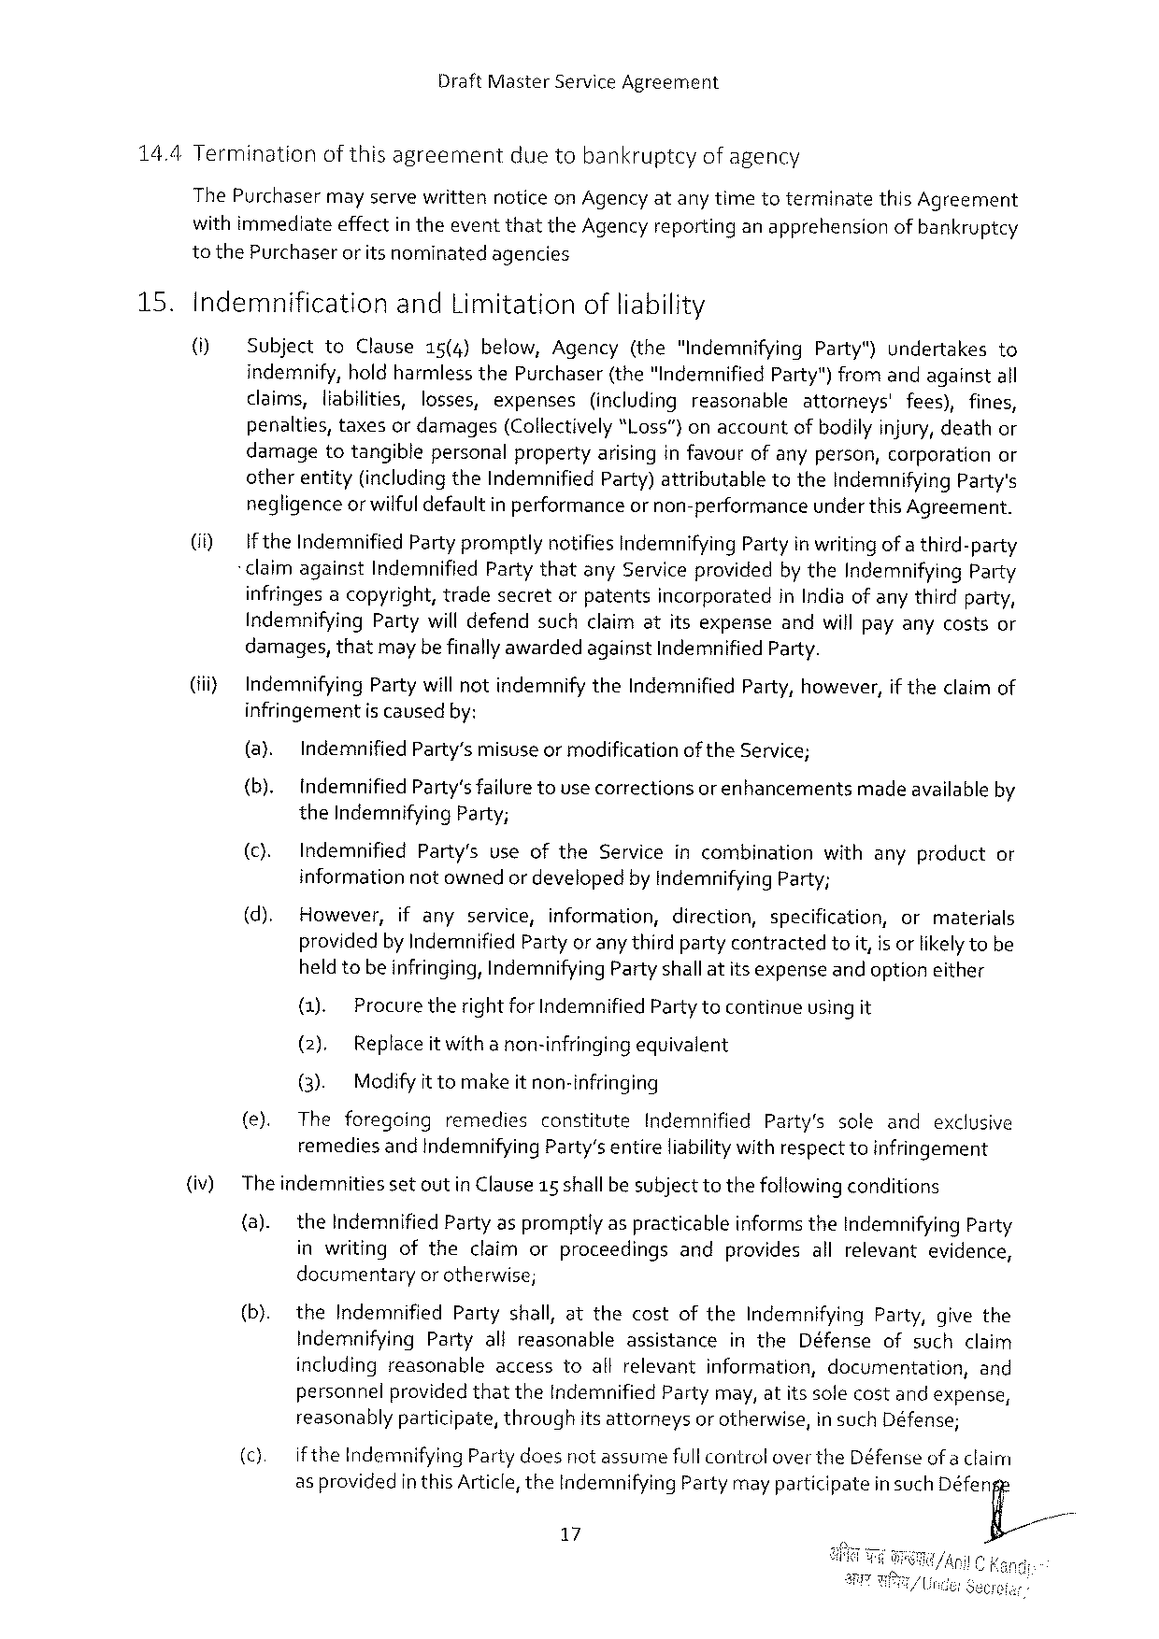

Draft Master Service Agreement

14.4 Terminationofthisagreement duetobankruptcyofagency

The Purchaser mayservewritten noticeon Agencyatanytimetoterminate this Agreement

withimmediateeffectin theeventthatthe Agencyreportinganapprehensionofbankruptcy

to the Purchaseror itsnominatedagencies

|  |  |  |  |  |  |  |  |  |  |  |  |  |  |  |  |  |  |  |  |  |  |
| --- | --- | --- | --- | --- | --- | --- | --- | --- | --- | --- | --- | --- | --- | --- | --- | --- | --- | --- | --- | --- | --- |
| 15. | Indemnification | | | | | and Limitationofliability | | | | | | | | | | | | | | | |
| () | Subjectto Clause 15(4)below, Agency(the"Indemnifying Party")undertakesto | | | | | | | | | | | | | | | | | | | |
| indemnify, holdharmlessthe Purchaser(the“Indemnified Party")fromandagainstall | | | | | | | | | | | | | | | | | | | | |
| claims, liabilities, losses, expenses | | | | | | | | | (includingreasonable | | | | | attorneys' | | | fees), fines, | | | |
| penalties, taxesor damages(Collectively“l. oss”)onaccountofbodily injury, deathor damagetotangiblepersonalpropertyarisinginfavourofanyperson, corporationor otherentity(includingthe Indemnified Party)attributabletothe Indemnifying Party's negligenceor wilful defaultin performanceor non-performanceunder this Agreement. | | | | | | | | | | | | | | | | | | | | |
| (i) | Ifthe Indemnified Party promptlynotifies Indemnifying Partyin writing of a third-party | | | | | | | | | | | | | | | | | | | |
| -claimagainst Indemnified Partythatany Serviceprovidedbythe Indemnifying Party infringes acopyright, tradesecretorpatentsincorporatedin Indiaof anythirdparty, Indemnifying Partywill defendsuchclaimatitsexpenseandwill payanycostsor damages, thatmaybefinallyawardedagainst Indemnified Party. | | | | | | | | | | | | | | | | | | | | |
| (i) | Indemnifying Party willnotindemnifythe Indemnified Party, however, if theclaimof | | | | | | | | | | | | | | | | | | | |
| infringementis causedby: | | | | | | | | | | | | | | | | | | | | |
| (@) | | Indemnified | | | Party’smisuseormodification | | | | | | of the Service; | | | | | | | | | |
| (b). | | Indemnified Party'sfailuretousecorrectionsor enhancementsmadeavailable by | | | | | | | | | | | | | | | | | | |
| the Indemnifying Party; | | | | | | | | | | | | | | | | | | | | |
| (). | | Indemnified | | | Party's | | useofthe | | Service | | incombination | | | with | | anyproduct | | | | or |
| informationnot ownedor developedby Indemnifying Party; | | | | | | | | | | | | | | | | | | | | |
| (d). | | However, | | | ifany | | service, | information, | | | direction, | | specification, | | | or | | | materials | |
| providedby Indemnified Partyor anythird partycontractedtoiit, is orlikelytobe heldtobeinfringing, Indemnifying Party shallatitsexpenseand optioneither | | | | | | | | | | | | | | | | | | | | |
| (). | | | Procuretheright for Indemnified Partytocontinueusing it | | | | | | | | | | | | | | | | | |
| (2). | | | Replaceit witha non-infringingequivalent | | | | | | | | | | | | | | | | | |
| (3). | | | Modifyit tomakeitnon-infringing | | | | | | | | | | | | | | | | | |
| (e). | | The | foregoing | | | remedies | | constitute | | Indemnified | | | Party's | | sole | and | | exclusive | | |
| remediesand indemnifying Party’sentireliabilitywithrespecttoinfringement | | | | | | | | | | | | | | | | | | | | |
| (iv) | Theindemnitiessetoutin Clause 15 shallbe subjecttothefollowingconditions | | | | | | | | | | | | | | | | | | | |
| (a). | | the Indemnified Partyaspromptlyas practicableinformsthe Indemnifying Party | | | | | | | | | | | | | | | | | | |
| inwritingoftheclaimorproceedingsandprovidesallrelevantevidence, documentaryorotherwise; | | | | | | | | | | | | | | | | | | | | |
| (b). | | the Indemnified Partyshall, atthecostofthe Indemnifying Party, givethe | | | | | | | | | | | | | | | | | | |
| Indemnifying Partyalireasonable | | | | | | | | | | assistance | | in the Défenseofsuchclaim | | | | | | | | |
| includingreasonableaccesstoallrelevantinformation, documentation, | | | | | | | | | | | | | | | | | | | | and |
| personnel | | | | providedthatthe Indemnified | | | | | | | Partymay, atitssolecostandexpense, | | | | | | | | | |
| reasonablyparticipate, throughitsattorneysor otherwise, in such Défense; | | | | | | | | | | | | | | | | | | | | |
| (c). | | ifthe Indemnifying | | | | | Partydoesnotassumefull controloverthe Défenseofa claim | | | | | | | | | | | | | |
| as providedin this Article, the Indemnifying Partymayparticipatein such Déferfi | | | | | | | | | | | | | | | | | | | | |

=

17

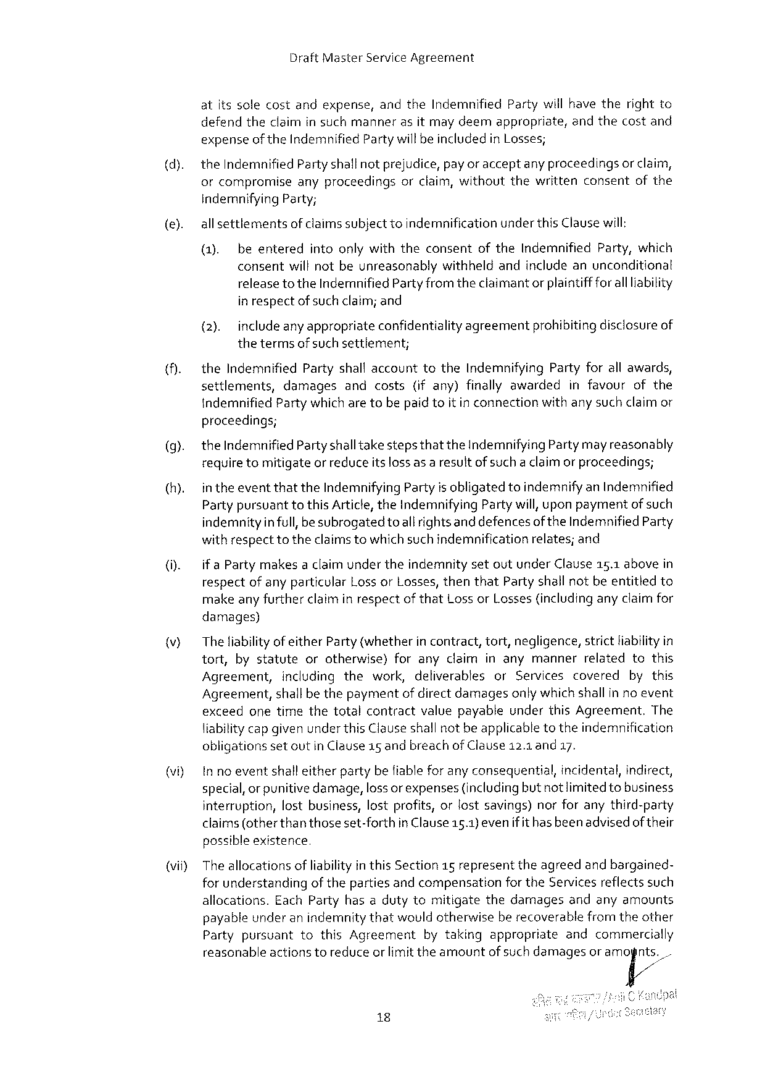

Draft Master Service Agreement

atitssolecostandexpense, and the Indemnified Partywill havetherightto defendtheclaimin suchmannerasitmay deemappropriate, andthecostand expenseof the Indemnified Partywillbeincludedin Losses;

the Indemnified Partyshallnotprejudice, payor acceptany proceedingsor claim,

|  |  |  |  |  |  |
| --- | --- | --- | --- | --- | --- |
| orcompromise | anyproceedings | orclaim, without | thewritten | consent | of the |

indemnifying Party;

|  |  |  |  |
| --- | --- | --- | --- |
| (e). | all settlements | | of claimssubject toindemnificationunderthis Clausewill: |
| (1). | beenteredintoonlywiththeconsentofthe Indemnified Party, which | |
| consentwill notbeunreasonablywithheldandincludeanunconditional | | |

releasetothe Indemnified Partyfromtheclaimant or plaintiffforall liability in respectof such claim; and

{2). includeanyappropriateconfidentiality agreementprohibiting disclosureof

thetermsof suchsettlement;

|  |  |  |  |  |  |  |  |  |
| --- | --- | --- | --- | --- | --- | --- | --- | --- |
| (). | the Indemnified Partyshall accounttothe Indemnifying Partyforall awards, | | | | | | | |
| settlements, | damages | and | costs | (ifany) | finallyawarded | infavour | of the |

indemnified Partywhicharetobepaidtoitin connectionwithany such claimor proceedings;

|  |  |
| --- | --- |
| (9).  (h). | the Indemnified Partyshalltakestepsthatthe Indemnifying Partymayreasonably requiretomitigateor reduceitslossas a resultofsuch a claimor proceedings;  in theeventthatthe Indemnifying Partyis obligatedtoindemnify an Indemnified Partypursuanttothis Article, the Indemnifying Partywill, uponpaymentof such |

indemnityinfull, besubrogatedtoall rights anddefencesof the Indemnified Party withrespecttotheclaimstowhichsuch indemnificationrelates; and

(). if a Partymakesaclaimundertheindemnitysetoutunder Clause 15.1 abovein respectofanyparticular Loss or Losses, thenthat Partyshall notbeentitledto makeany furtherclaim in respectof that Lossor Losses(includinganyclaimfor

damages)

|  |  |  |  |  |  |  |  |  |
| --- | --- | --- | --- | --- | --- | --- | --- | --- |
| v) | Theliabilityof either Party(whether | | | | in contract, | tort, negligence, | strictliabilityin | |
| tort, | bystatute | | orotherwise)foranyclaiminanymannerrelatedtothis | | | | |
| Agreement, | | includingthework, deliverables | | | or Servicescovered | | bythis |
| Agreement, shallbe thepaymentof directdamagesonlywhich shallin no event | | | | | | | |

exceedonetimethetotalcontractvaluepayableunderthis Agreement. The liabilitycapgivenunder this Clauseshallnotbe applicabletotheindemnification

|  |  |  |  |  |
| --- | --- | --- | --- | --- |
| (vi) | obligations | setoutin Clause 15 andbreachof Clause 12.1 and 17. | | |
| In noeventshalleitherpartybefiableforanyconsequential, | | incidental, | indirect, |
| special, orpunitivedamage, loss orexpenses(includingbut notlimitedtobusiness interruption, lostbusiness, lostprofits, orlostsavings)norforanythird-party | | | |

claims(otherthanthoseset-forth possible existence

in Clause 15.1)evenifit hasbeenadvisedof their

(vii) The allocationsofliabilityinthis Section 15 representtheagreedand bargained-

for understandingof thepartiesandcompensationforthe Services reflectssuch

allocations. Each Partyhasadutytomitigatethedamagesandanyamounts

payableunderanindemnitythatwouldotherwiseberecoverablefromtheother

Party pursuant to this Agreement bytaking appropriate and commercially

reasonableactionstoreduceor limittheamountof such damagesor am(]n/ts‘/.

18

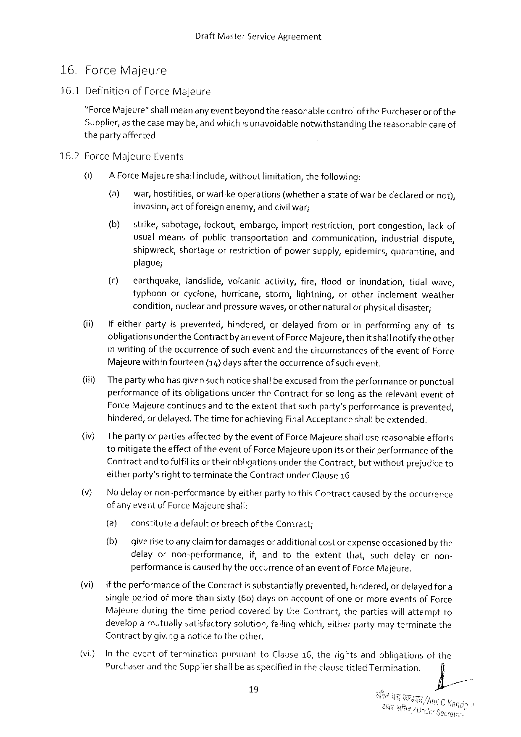

Draft Master Service Agreement

|  |  |  |
| --- | --- | --- |
| 16. | Force | Majeure |

16.1 Definitionof Force Majeure

“Force Majeure”shall meananyeventbeyond thereasonablecontrolofthe Purchaser or of the Supplier, as thecasemaybe, and which is unavoidablenotwithstandingthereasonablecare of thepartyaffected,

|  |  |  |  |  |  |  |
| --- | --- | --- | --- | --- | --- | --- |
| 16.2 | Force Majeure | | | Events | | ornot), |
| () | A Force Majeureshallinclude, withoutlimitation, thefollowing: | | | |
| (a) | | war, hostifities, orwarlikeoperations | | (whetherastateofwarbedeclared |

invasion, actofforeign enemy, andcivilwar;

|  |  |  |
| --- | --- | --- |
| (b) | strike, sabotage, tockout, embargo, importrestriction, portcongestion, lack of | |
| usualmeansofpublictransportation | andcommunication, industrialdispute, |
| shipwreck, shortageorrestrictionofpowersupply, epidemics, quarantine, and | |

plague;

|  |  |  |  |  |  |  |  |  |  |
| --- | --- | --- | --- | --- | --- | --- | --- | --- | --- |
| (i)  (i)  (iv)  )  vi) | (c) | earthquake, landslide, volcanicactivity, fire, floodorinundation, tidalwave, | | | | | | | |
| typhoonorcyclone, hurricane, storm, lightning, orotherinclementweather condition, nuclear and pressurewaves, orothernaturalor physicaldisaster; | | | | | | | | |
| If eitherpartyisprevented, | | | | | hindered, ordelayedfromorinperforminganyofits | | | |
| obligationsunderthe Contractby aneventof Force Majeure, thenitshallnotifytheother in writingof theoccurrenceof sucheventandthecircumstancesoftheeventof Force | | | | | | | | |
| Majeurewithinfourteen | | | | (14) daysaftertheoccurrence | | | | ofsuchevent. |
| The partywho hasgivensuch noticeshallbe excusedfrom theperformanceor punctual performanceofits obligationsunderthe Contractforso longas therelevanteventof Force Majeurecontinuesand totheextentthatsuchparty’sperformanceisprevented, hindered, or delayed. Thetimefor achieving Final Acceptanceshallbeextended.  Thepartyor partiesaffectedby theeventof Force Majeureshallusereasonableefforts tomitigatetheeffectoftheevent of Force Majeureuponitsor theirperformanceof the Contractand tofulfil itsor their obligationsunder the Contract, butwithoutprejudiceto eitherparty’srighttoterminatethe Contractunder Clause 16.  Nodelay or non-performanceby eitherpartytothis Contractcausedby theoccurrence of anyevent of Force Majeureshall: | | | | | | | | |
| (3) | constitutea defaultorbreachofthe Contract; | | | | | | | |
| (b) giverise | | toany claimfordamagesor additionalcostor expenseoccasionedbythe | | | | | | |
| delayornon-performance, | | | | | | if, andtotheextentthat, suchdelayornon- | | |
| performance | | | is caused | | by theoccurrence | | of aneventof Force Majeure. | |
| iftheperformanceofthe Contractis substantiallyprevented, hindered, or delayed for a singleperiodofmorethansixty(60} daysonaccountof oneormoreeventsof Force Majeureduring thetimeperiodcoveredby the Contract, thepartieswillattemptto developamutuallysatisfactorysolution, failingwhich, eitherpartymay terminatethe | | | | | | | | |

Contractby givinganoticetotheother,

|  |  |  |  |  |  |
| --- | --- | --- | --- | --- | --- |
| (vil) | Intheevent | oftermination | pursuant | to Clause 16, therightsandobligations | of the |
| Purchaserand the Suppliershallbeas specifiedintheclausetitled Termination. | | | |
| fi/ |

19

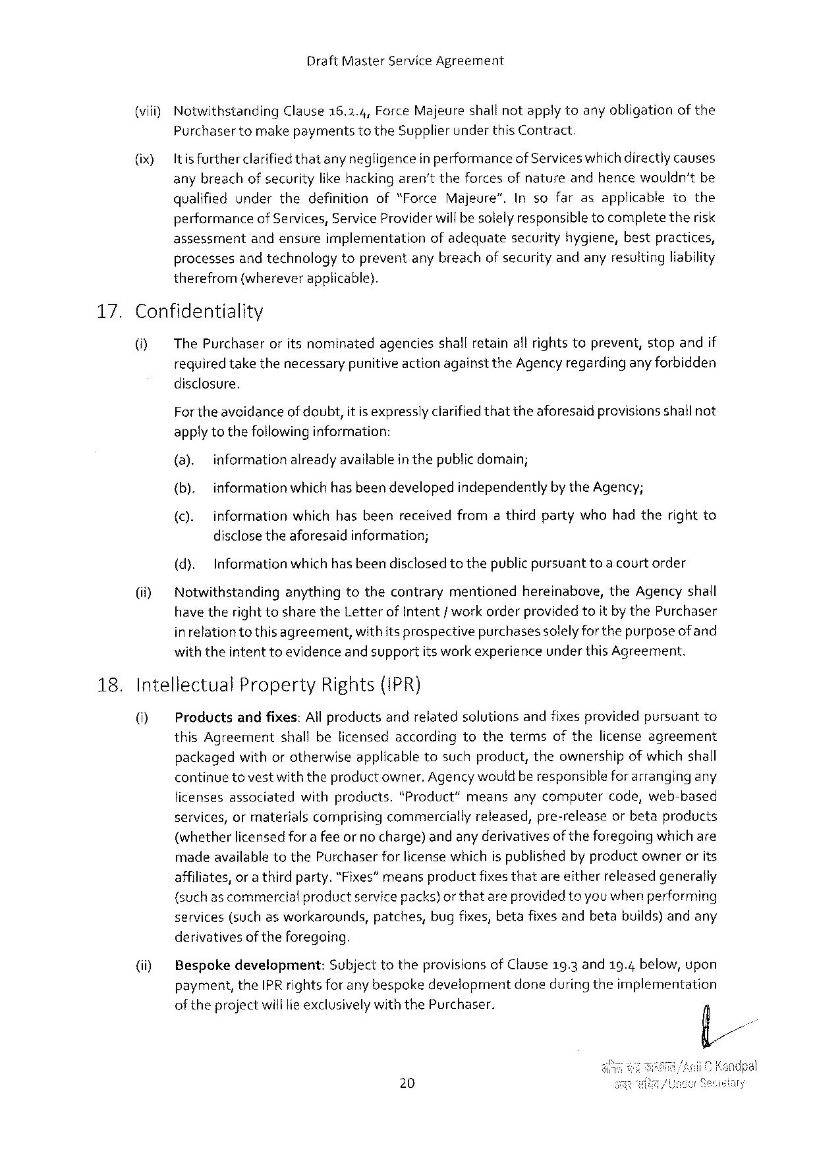

Draft Master Service Agreement

|  |  |  |  |
| --- | --- | --- | --- |
| (viii) | Notwithstanding | Clause 16.2.4, Force Majeureshallnotapplytoanyobligation | of the |

Purchasertomake paymentstothe Supplierunder this Contract.

|  |  |
| --- | --- |
| (ix) | it is furtherclarifiedthatany negligencein performanceof Serviceswhichdirectlycauses anybreachof securitylikehacking aren'ttheforcesofnatureandhencewouldn’tbe |

qualifiedunderthedefinitionof“Force Majeure”. Insofarasapplicabletothe performanceof Services, Service Providerwillbe solelyresponsibletocompletetherisk assessmentandensureimplementationofadequatesecurityhygiene, bestpractices, processesand technologytopreventany breachofsecurityandanyresultingliability therefrom(whereverapplicable).

|  |  |  |
| --- | --- | --- |
| 17. | Confidentiality | |
| O] | The Purchaseroritsnominatedagenciesshallretainall rightstoprevent, stopandif |
| requiredtakethenecessarypunitive actionagainstthe Agency regardinganyforbidden | |

disclosure,

Fortheavoidanceof doubt, itisexpresslyclarifiedthattheaforesaidprovisionsshallnot applytothefollowinginformation:

(a). informationalreadyavailableinthepublicdomain;

(b). informationwhich hasbeen developedindependentlyby the Agency;

{c). information whichhasbeenreceived fromathirdpartywhohadtherightto

disclosetheaforesaidinformation;

|  |  |  |  |
| --- | --- | --- | --- |
| (i) | (d). | Informationwhichhasbeendisclosedtothepublicpursuant | toa courtorder |
| Notwithstandinganythingtothecontrarymentionedhereinabove, the Agencyshall have therighttosharethe Letterof Intent/ workorderprovided toitby the Purchaser | | |

inrelationtothis agreement, withitsprospectivepurchasessolelyforthepurposeof and withtheintent toevidenceand supportits workexperienceunder this Agreement.

18. Intellectual Property Rights(IPR)

0] Productsandfixes: All productsandrelatedsolutionsandfixes providedpursuantto this Agreementshallbelicensedaccordingtothetermsofthelicenseagreement packagedwithorotherwiseapplicabletosuchproduct, theownershipofwhichshall continue tovestwiththeproductowner. Agencywouldberesponsible forarrangingany licensesassociatedwithproducts."Product”meansanycomputercode, web-based services, ormaterialscomprisingcommerciallyreleased, pre-releaseorbetaproducts (whetherlicensedfor a feeor no charge) andany derivativesof theforegoingwhichare madeavailabletothe Purchaserforlicense whichispublishedby productownerorits affiliates, or a thirdparty.“Fixes”meansproductfixesthatareeitherreleasedgenerally (suchascommercial productservicepacks)orthatareprovidedtoyouwhenperforming services(such as workarounds, patches, bugfixes, betafixes andbetabuilds)andany derivativesof theforegeing.

|  |  |  |
| --- | --- | --- |
| (i) | Bespokedevelopment: | Subject totheprovisions of Clause 19.3 and 19.4 below, upon |
| payment, the IPR rights for any bespokedevelopmentdoneduringtheimplementation | |

of theprojectwill lieexclusivelywiththe Purchaser.

20

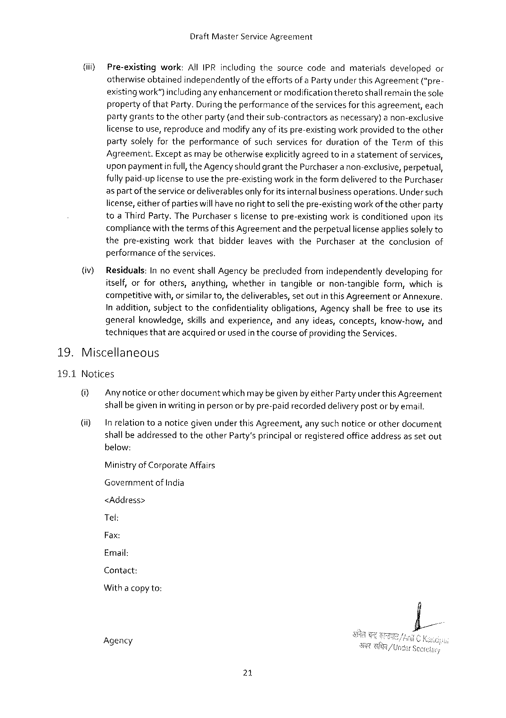

Draft Master Service Agreement

|  |  |  |  |
| --- | --- | --- | --- |
| (iif) | Pre-existing | work: All IPR includingthesourcecodeandmaterialsdeveloped | or |
| otherwiseobtainedindependentlyof theeffortsofa Party underthis Agreement(“pre- | | |

existingwork")includinganyenhancementormodificationtheretoshallremain thesole propertyofthat Party. Duringtheperformanceof theservices forthisagreement, each partygrantstotheotherparty(andtheirsub-contractorsasnecessary)a non-exclusive licensetouse, reproduceandmodifyany of itspre-existingworkprovidedtotheother partysolelyfortheperformanceofsuchservicesfordurationofthe Termofthis Agreement. Exceptasmaybe otherwiseexplicitlyagreedtoin a statementof services, upon paymentinfull, the Agencyshould grantthe Purchaseranon-exclusive, perpetual, fullypaid-uplicensetousethepre-existingworkin theformdeliveredtothe Purchaser aspartof theserviceordeliverablesonly for itsinternalbusinessoperations. Under such license, eitherof partieswillhave no righttosellthepre-existingwork oftheotherparty toa Third Party. The Purchaserslicensetopre-existingworkisconditioneduponits compliancewiththetermsofthis Agreementand theperpetuallicenseapplies solelyto thepre-existingworkthatbidderleaveswiththe Purchaserattheconclusionof performanceof theservices.

(iv) Residuals: In noeventshall Agencybeprecludedfromindependentlydevelopingfor itself, orforothers, anything, whetherintangibleornon-tangibleform, which is competitivewith, or similarto, thedeliverables, setoutin this Agreementor Annexure. Inaddition, subjecttotheconfidentialityobligations, Agencyshallbefreetouseits generalknowledge, skills andexperience, andanyideas, concepts, know-how, and techniquesthatareacquired or usedin thecourseofprovidingthe Services.

19. Miscellaneous

19.1 Notices

(i) Any noticeorotherdocumentwhichmaybe givenby either Partyunder this Agreement shallbegivenin writingin personor by pre-paidrecordeddelivery postor by email.

(i) In relationtoa noticegivenunderthis Agreement, any suchnoticeorotherdocument shall beaddressedtotheother Partysprincipalor registeredofficeaddressassetout below:

Ministryof Corporate Affairs

Government of India

<Address>

Tel:

Fax:

Email:

Contact:

Witha copyto:

Agency

21

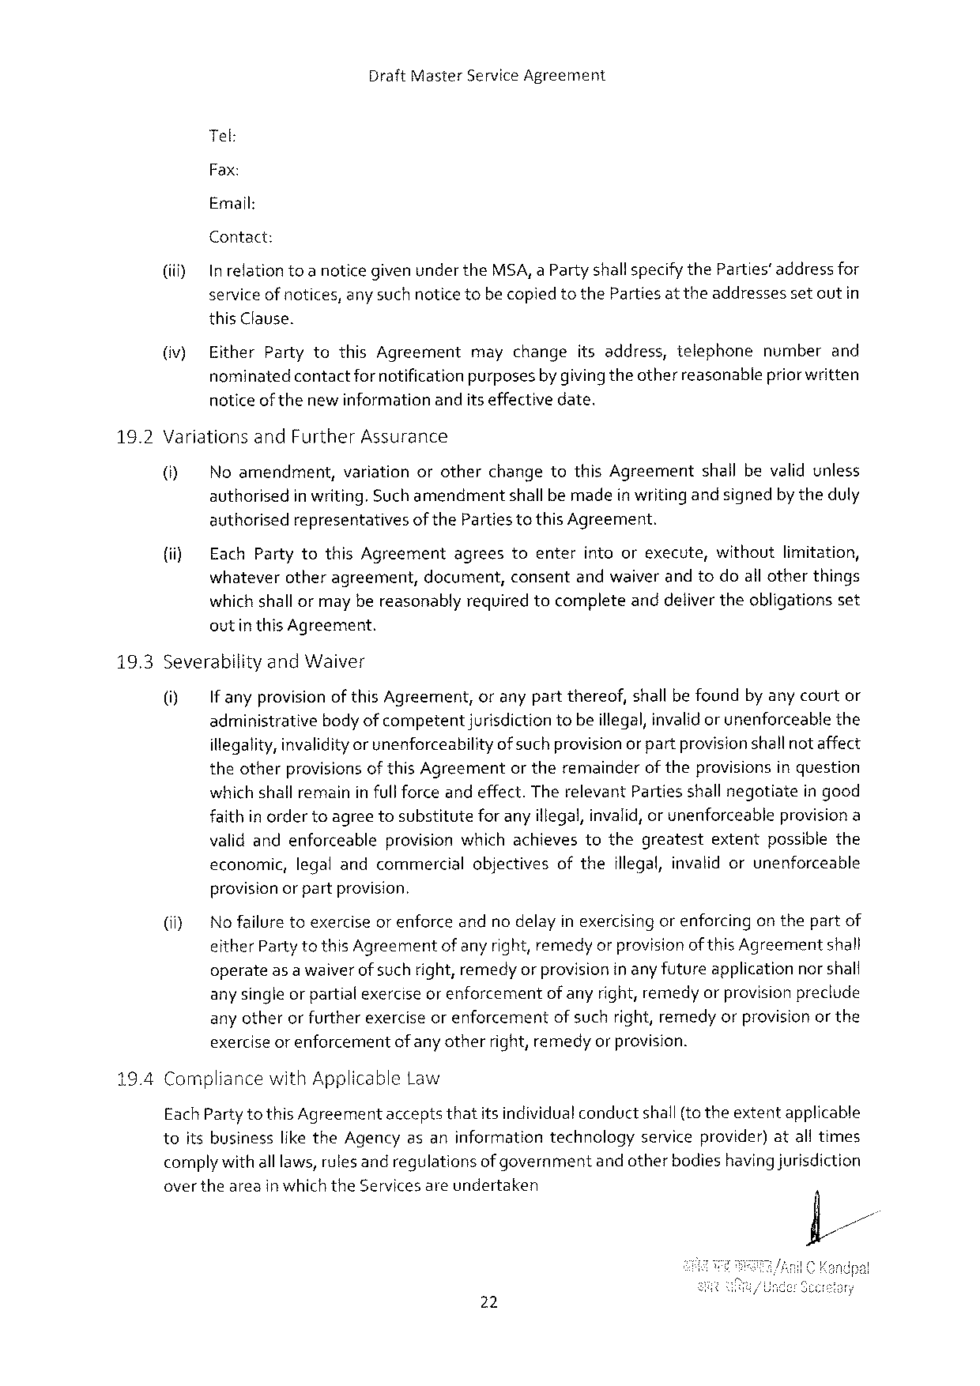

Draft Master Service Agreement

Tel:

Fax:

Email:

Contact:

(iiiy In relationtoa noticegiven under the MSA, a Partyshallspecifythe Parties’addressfor service ofnotices, any suchnotice tobecopiedtothe Parties at theaddressesset outin this Clause.

|  |  |  |  |
| --- | --- | --- | --- |
| (iv) | Either Partytothis Agreement | maychangeitsaddress, telephone | numberand |
| nominatedcontactfornotificationpurposesby givingtheotherreascnablepriorwritten | | |

notice of thenewinformationanditseffectivedate.

|  |  |  |  |
| --- | --- | --- | --- |
| 16.2 | Variationsand Further Assurance | | |
| ® | Noamendment, | variationorotherchangetothis Agreementshallbevalidunless |
| authorisedin writing. Suchamendmentshallbemadein writing andsignedby theduly | | |

authorisedrepresentativesofthe Partiestothis Agreement.

|  |  |  |  |  |  |  |
| --- | --- | --- | --- | --- | --- | --- |
| (ii) | Each Partytothis Agreement | agrees | toenter | intoorexecute, | without | limitation, |
| whateverotheragreement, document, consentandwaiver andtodoall otherthings | | | | | |

which shallormay bereasonablyrequiredtocompleteanddeliver theobligationsset outinthis Agreement.

|  |  |  |
| --- | --- | --- |
| 19.3 | Severabilityand Waiver | |
| 0] | If anyprovisionof this Agreement, oranypartthereof, shall be foundby any courtor |
| administrativebodyofcompetent jurisdictiontobeillegal, invalid or unenforceablethe | |

illegality, invalidityor unenforceabilityof suchprovisionor partprovisionshallnot affect theotherprovisions of this Agreementor theremainderof theprovisions inquestion which shall remaininfull forceand effect. Therelevant Partiesshall negotiatein good faithin ordertoagreetosubstitutefor anyillegal, invalid, or unenforceableprovisiona validandenforceableprovisionwhichachievestothegreatest extentpossiblethe

economic, legalandcommercial objectives of the illegal, invalidorunenforceable

provisionorpartprovision.

|  |  |  |  |
| --- | --- | --- | --- |
| (i) | Nofailuretoexerciseorenforce | andnodelayinexercisingorenforcing | onthepartof |
| either Partytothis Agreementof any right, remedyor provisionof this Agreementshall | | |

operateas a waiverof suchright, remedyor provisioninanyfutureapplicationnorshall any single or partialexercise or enforcementof anyright, remedyor provisionpreclude any otherorfurtherexerciseorenforcementof suchright, remedyorprovisionor the exercise or enforcementofany otherright, remedyor provision.

Compliancewith Applicable Law

Each Partytothis Agreementacceptsthatitsindividualconductshall{to theextentapplicable

|  |  |  |  |
| --- | --- | --- | --- |
| toitsbusiness | likethe Agencyasaninformation | technology | serviceprovider)atalltimes |

complywith alllaws, rulesandregulationsof governmentandotherbodieshavingjurisdiction overtheareainwhichthe Servicesareundertaken

22

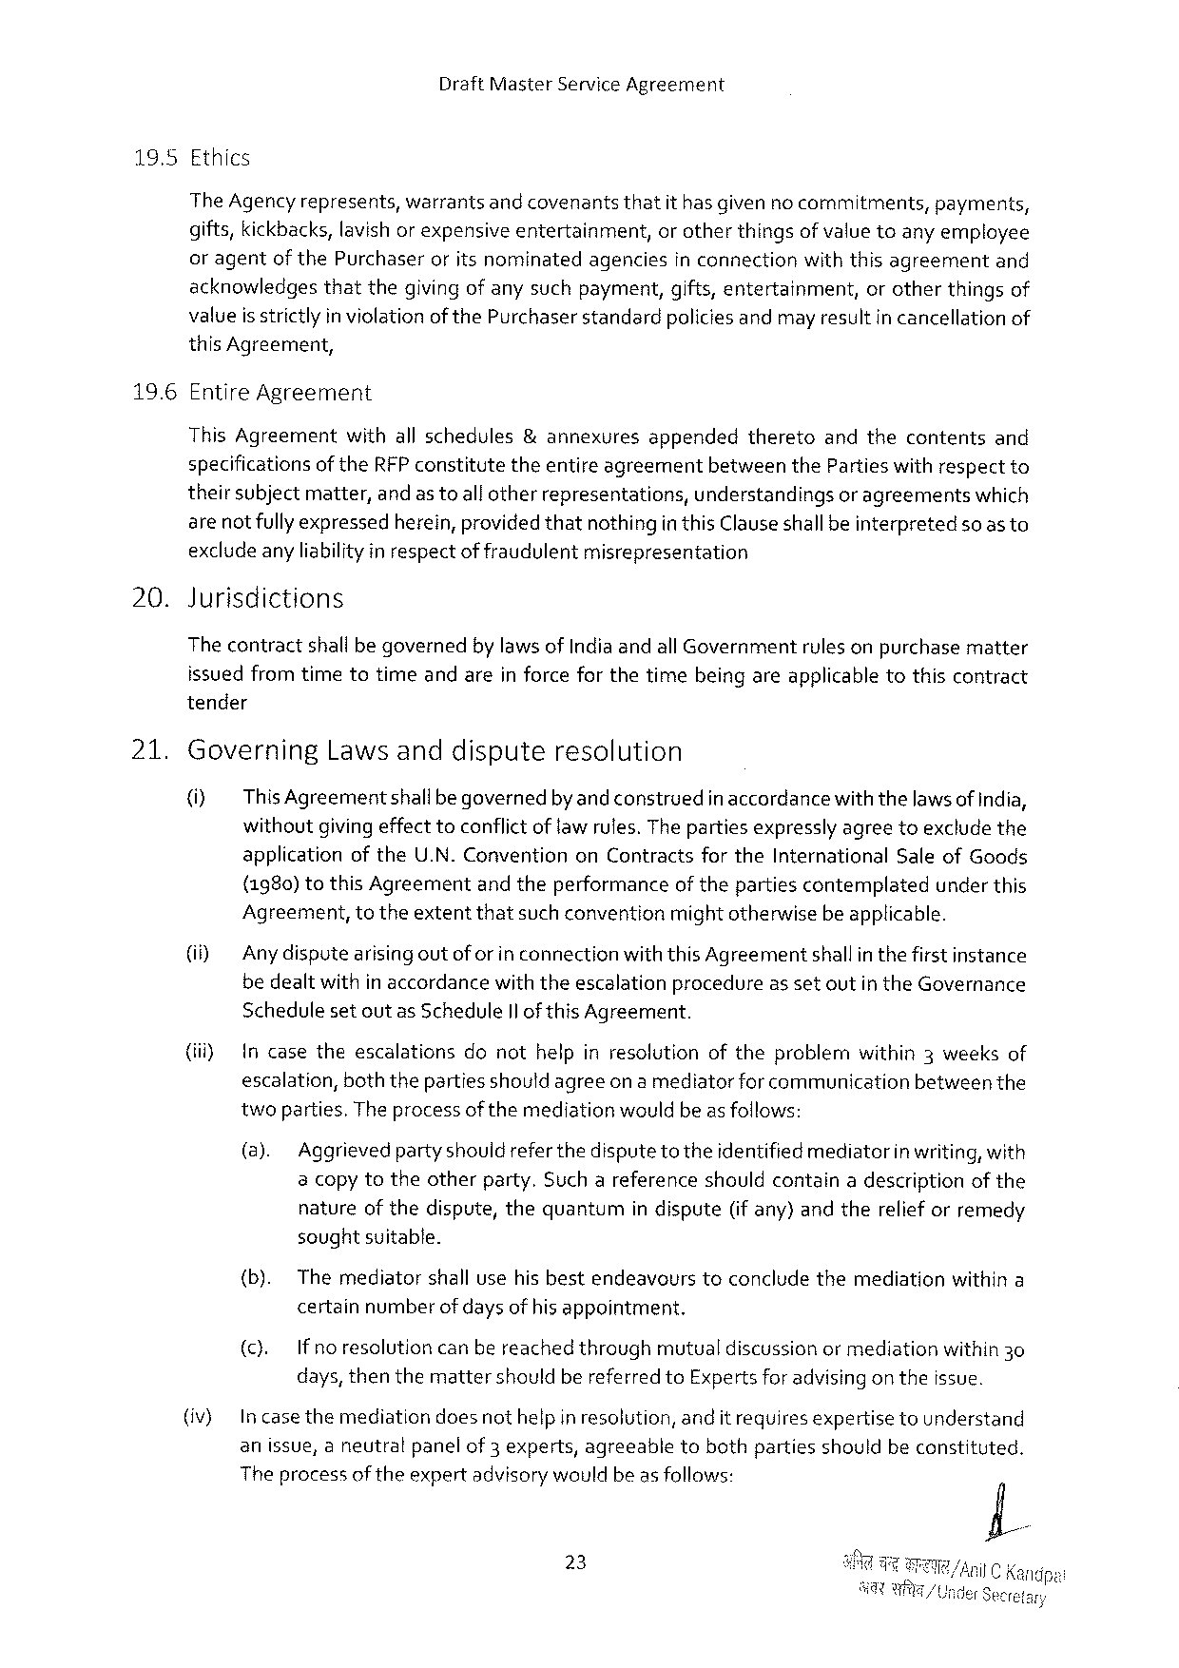

Draft Master Service Agreement

|  |  |  |  |  |  |  |
| --- | --- | --- | --- | --- | --- | --- |
| 19.5 | Ethics | | | | | |
| The Agencyrepresents, | warrantsandcovenants | thatit hasgivenno commitments, | | | payments, |
| gifts, kickbacks, lavishor expensiveentertainment, | | | or otherthingsofvalue toany employee | | |
| or agentof the Purchaseroritsnominatedagenciesin connectionwiththisagreementand | | | | | |
| acknowledgesthatthegivingof anysuchpayment, gifts, entertainment, | | | | orotherthingsof | |

valueis strictly in violation of the Purchaserstandardpoliciesandmayresultin cancellationof this Agreement,

196 Entire Agreement

This Agreementwithallschedules&annexuresappendedtheretoandthecontentsand specificationsof the RFP constitutetheentireagreementbetweenthe Parties withrespectto theirsubjectmatter, andastoall otherrepresentations, understandingsor agreementswhich are notfully expressedherein, providedthatnothingin this Clauseshallbeinterpretedsoasto exclude anyliabilityin respectof fraudulentmisrepresentation

20. Jurisdictions

The contractshallbe governedby lawsof Indiaandall Governmentrulesonpurchasematter issuedfromtimetotimeandareinforceforthetimebeingareapplicabletothiscontract tender

21. Governing Lawsanddispute resolution

(i) This Agreementshallbegovernedby and construedin accordancewiththelawsof India, withoutgivingeffect toconflict of law rules. The partiesexpresslyagreetoexclude the applicationofthe U. N. Conventionon Contractsforthe International Saleof Goods {1980) to this Agreementandtheperformanceof thepartiescontemplatedunderthis Agreement, totheextentthatsuch conventionmightotherwisebe applicable.

(i) Anydisputearisingoutoforin connectionwiththis Agreementshallinthe firstinstance bedealtwithin accordancewiththeescalationprocedureas setoutin the Governance Schedulesetoutas Schedule Il of this Agreement.

|  |  |  |  |  |  |
| --- | --- | --- | --- | --- | --- |
| (ii) | Incasetheescalations | donothelpinresolution | oftheproblem | within 3 weeks | of |

escalation, boththepartiesshould agreeon a mediatorforcommunicationbetweenthe twoparties. The process ofthemediationwouldbe asfollows:

(a). Aggrievedpartyshould refer thedispute to theidentified mediatorinwriting, with a copytotheotherparty. Suchareferenceshouldcontaina descriptionof the natureofthedispute, thequantumin dispute(if any)andtherelief orremedy soughtsuitable.

|  |  |  |  |  |
| --- | --- | --- | --- | --- |
| {b). | Themediator | shallusehisbestendeavours | toconcludethemediation | withina |

certainnumberofdays of hisappointment.

|  |  |  |  |  |
| --- | --- | --- | --- | --- |
| (). | Ifnoresolution | canbereachedthrough | mutualdiscussionormediation | within 30 |

days, thenthemattershouldbereferred to Expertsforadvisingon theissue.

(iv) In casethemediationdoesnothelpin resolution, andit requires expertisetounderstand

anissue, aneutralpanelof 3 experts, agreeable tobothpartiesshouldbeconstituted.

Theprocessoftheexpertadvisorywouldbeas follows:

23

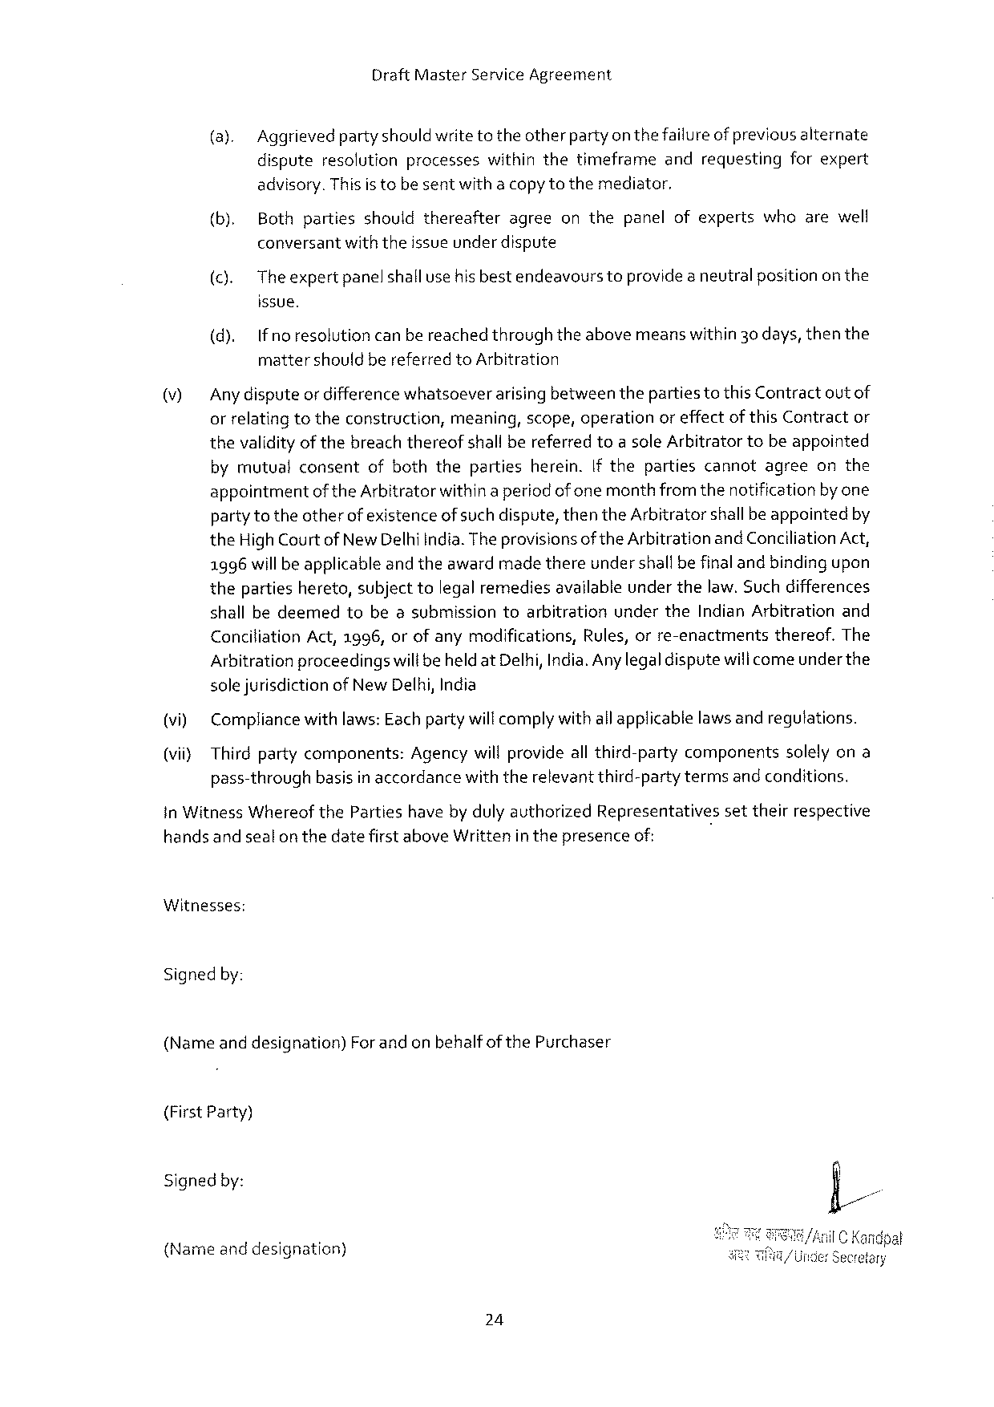

Draft Master Service Agreement

(a). Aggrievedpartyshouldwrite totheotherparty on thefailureof previousalternate dispute resolution processes withinthe timeframe and requesting forexpert

advisory. Thisis tobe sentwitha copytothemediator,

|  |  |  |
| --- | --- | --- |
| (b). | Bothpartiesshouldthereafter | agreeonthepanelofexpertswhoarewell |

conversantwiththeissueunderdispute

(c). Theexpertpanelshallusehisbestendeavourstoprovidea neutralpositionon the

issue.

(d). Ifnoresolutioncan bereachedthroughtheabovemeanswithin 30 days, thenthe mattershouldbereferred to Arbitration

|  |  |
| --- | --- |
| \7] | Any disputeordifferencewhatsoeverarising betweentheparties to this Contractoutof orrelatingtotheconstruction, meaning, scope, operationoreffectof this Contractor |

thevalidityof thebreachthereofshall bereferredtoa sole Arbitratortobeappointed bymutualconsentofboththepartiesherein. If thepartiescannotagreeonthe appointmentof the Arbitratorwithina periodof one monthfromthenotificationby one party totheotherof existenceof such dispute, thenthe Arbitratorshallbeappointedby the High Court of New Delhi India. Theprovisionsof the Arbitration and Conciliation Act, 1996 will be applicableandtheawardmadethereunder shallbefinaland bindingupon thepartieshereto, subjecttolegal remediesavailableunderthelaw. Suchdifferences shallbedeemedtobeasubmissiontoarbitrationunderthe Indian Arbitrationand

|  |  |  |  |  |
| --- | --- | --- | --- | --- |
| Conciliation | Act,1996, orofanymodifications, | Rules, orre-enactments | thereof. | The |

Arbitrationproceedingswili beheldat Delhi, India. Any legaldisputewili comeunder the solejurisdictionof New Delhi, India

(vi) Compliancewithlaws: Eachpartywill complywith allapplicablelawsand regutations.

(vii} Thirdpartycomponents: Agencywill provideall third-partycomponentssolelyona pass-throughbasisin accordancewith therelevantthird-partytermsand conditions.

in Witness Whereofthe Partieshave by dulyauthorized Representativessettheirrespective handsand sealon thedatefirst above Writtenin thepresenceof:

Witnesses:

Signedby:

(Nameanddesignation) Forandonbehalfofthe Purchaser

(First Party)

Signedby:

{Nameanddesignation)

24



Draft Master Service Agreement

Agency

(Second Party)

(Name anddesignation)For andon behalfof Agency Signedby:

25

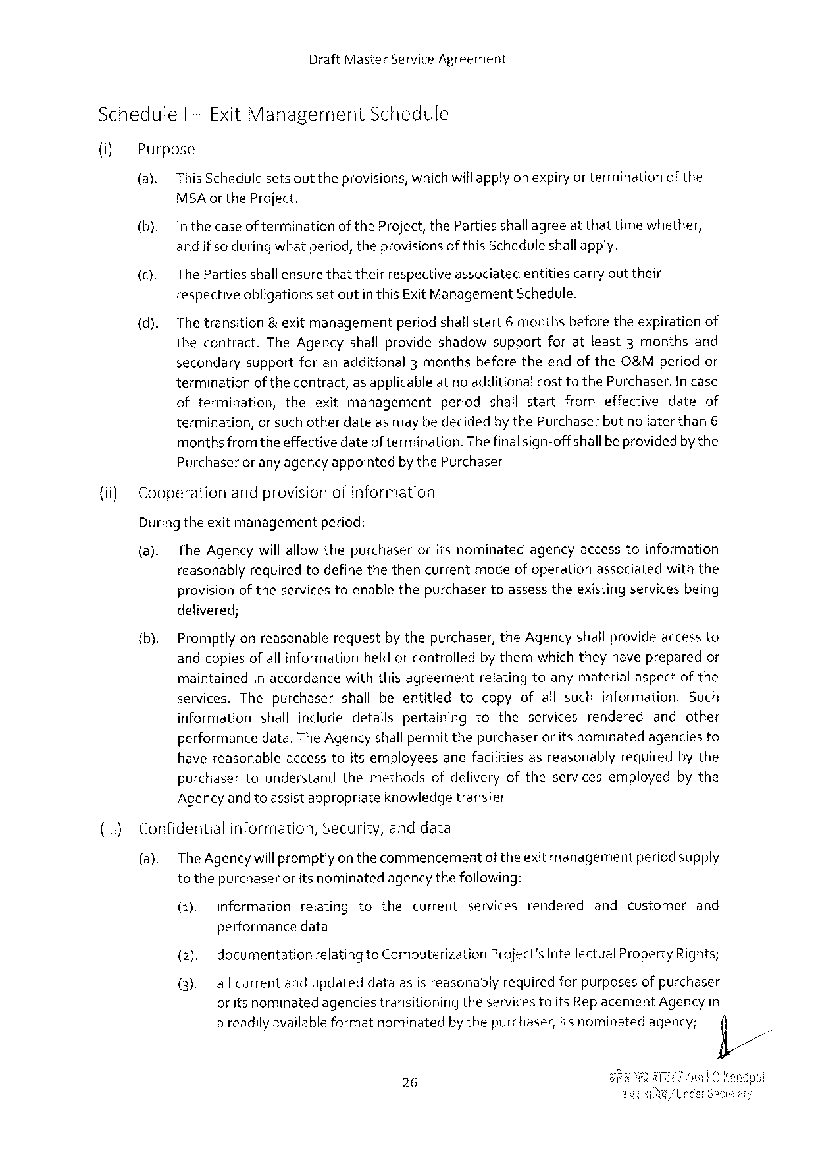

Draft Master Service Agreement

Schedule | -Exit Management Schedule

(i) Purpose

(a). This Schedulesetsouttheprovisions, whichwillapply on expiryor terminationofthe

MSA or the Project.

(b). Inthecaseof terminationofthe Project, the Partiesshallagreeat thattimewhether,

and ifso during whatperiod, theprovisionsof this Scheduleshall apply.

(c). The Partiesshall ensurethattheirrespectiveassociatedentitiescarryout their

respectiveobligationssetoutin this Exit Management Schedule.

|  |  |  |
| --- | --- | --- |
| (d). | The transition& exitmanagementperiodshallstart | 6 monthsbeforetheexpirationof |

thecontract. The Agencyshallprovideshadowsupportforatleast 3 monthsand

secondarysupportforanadditional 3 monthsbeforetheendofthe O&Mperiodor

terminationof thecontract, as applicableat no additionalcosttothe Purchaser. Incase

|  |  |  |
| --- | --- | --- |
| oftermination, | theexitmanagement | periodshallstartfromeffectivedateof |

termination, or such otherdateasmay be decidedby the Purchaserbutno laterthan 6

monthsfromtheeffectivedateof termination. The finalsign-offshallbeprovidedby the

Purchaserorany agencyappointedbythe Purchaser

{(ii)Cooperationandprovisionofinformation

Duringtheexitmanagement period:

(8). The Agencywillallow thepurchaseroritsnominatedagencyaccesstoinformation

reasonablyrequiredtodefinethethencurrentmodeof operationassociatedwiththe

provisionof theservicestoenablethepurchasertoassesstheexistingservicesbeing

delivered;

(b). Promptlyonreasonablerequestby thepurchaser, the Agencyshall provideaccessto

andcopiesofall informationheldor controlledby themwhich theyhave preparedor

maintained inaccordance withthisagreement relatingtoanymaterial aspect of the

services. Thepurchasershallbeentitled tocopyofallsuchinformation. Such

information shallincludedetailspertaining totheservicesrendered andother

performancedata. The Agency shallpermitthepurchaseror its nominatedagenciesto

|  |  |  |  |
| --- | --- | --- | --- |
| havereasonable | accesstoitsemployees | andfacilitiesasreasonably | requiredbythe |

purchasertounderstandthemethodsofdeliveryoftheservicesemployedbythe

Agencyandtoassistappropriate knowledge transfer.

{iii) Confidential information, Security, anddata

(a). The Agencywillpromptlyon thecommencementofthe exitmanagementperiodsupply

tothepurchaser oritsnominatedagencythefollowing:

|  |  |  |  |  |  |  |  |  |  |  |
| --- | --- | --- | --- | --- | --- | --- | --- | --- | --- | --- |
| (1). | information | relating | to | the | current | services | rendered | and | customer | and |

performancedata

(2). documentation relatingto Computerization Project’s Intellectual Property Rights;

(3). allcurrentandupdateddataasisreasonablyrequiredforpurposesof purchaser

oritsnominated agenciestransitioning theservicestoits Replacement Agencyin

areadilyavailableformatnominatedby thepurchaser, itsnominatedagency; fi/

~

26

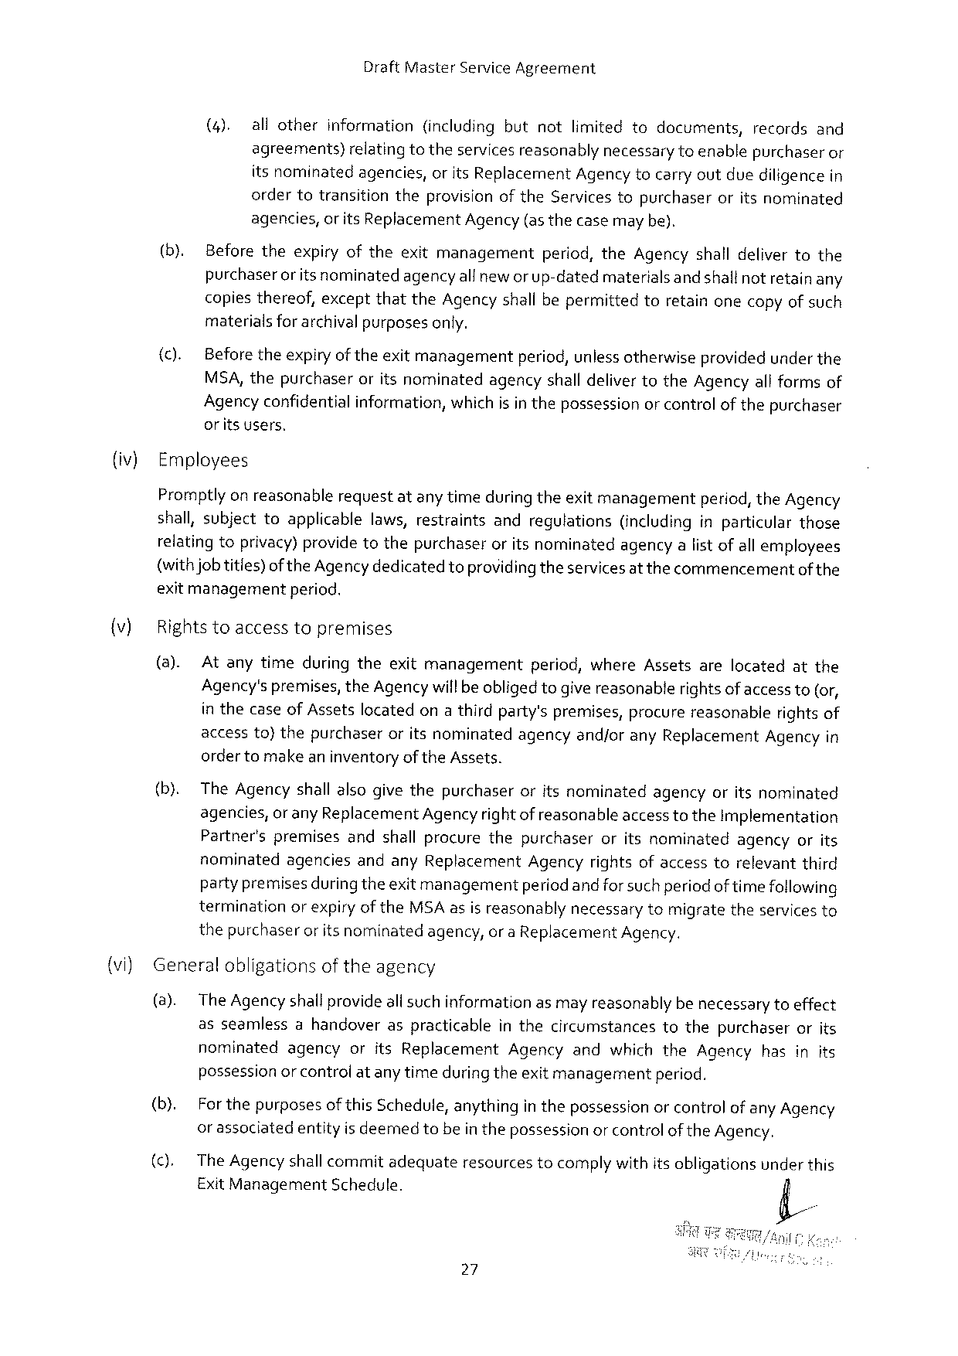

Draft Master Service Agreement

|  |  |  |  |  |  |  |  |  |  |  |  |  |  |  |  |  |  |  |  |  |  |  |  |  |
| --- | --- | --- | --- | --- | --- | --- | --- | --- | --- | --- | --- | --- | --- | --- | --- | --- | --- | --- | --- | --- | --- | --- | --- | --- |
| (iv)  )  {vi) | (4). | | | allother | | | information | | | (including | | | | but | | not | | limited | to | documents, | | records | | and |
| agreements)relatingtotheservices reasonablynecessary toenablepurchaseror itsnominatedagencies, or its Replacement Agency tocarry outduediligencein | | | | | | | | | | | | | | | | | | | | | | | |
| ordertotransition | | | | | | | | theprovision | | | | of the Servicestopurchaser | | | | | | | | oritsnominated | | | |
| agencies, or its Replacement Agency (asthecase may be). | | | | | | | | | | | | | | | | | | | | | | | |
| (b). | | Beforetheexpiryoftheexitmanagement | | | | | | | | | | | | | | period, the Agencyshalldelivertothe | | | | | | | |
| purchaserorits nominatedagencyallneworup-datedmaterialsandshallnotretain any copiesthereof, exceptthatthe Agencyshall bepermittedtoretainonecopyofsuch materialsforarchivalpurposesonly. | | | | | | | | | | | | | | | | | | | | | | | |
| (c). | Before theexpiryof theexitmanagement | | | | | | | | | | | | | period, unlessotherwiseprovidedunderthe | | | | | | | | | |
| MSA, thepurchaseroritsnominatedagencyshalldelivertothe Agencyall formsof Agency confidentialinformation, which is in thepossessionor controlof thepurchaser oritsusers,  Employees  Promptlyon reasonablerequestatany timeduring theexitmanagementperiod, the Agency shall, subjecttoapplicablelaws, restraintsandregulations(includinginparticularthose relatingtoprivacy)providetothepurchaseroritsnominatedagencyalist ofallemployees | | | | | | | | | | | | | | | | | | | | | | | |
| (withjob titles)of the Agencydedicatedtoprovidingtheservices atthecommencement | | | | | | | | | | | | | | | | | | | | | | of the | |
| exitmanagementperiod. | | | | | | | | | | | | | | | | | | | | | | | |
| Rightstoaccess | | | | | topremises | | | | | | | | | | | | | | | | | | |
| (a). | Atanytimeduringtheexitmanagement | | | | | | | | | | | | | | period, where Assetsarelocatedatthe | | | | | | | | |
| Agency'spremises, the Agencywill beobliged togive reasonablerights of accessto(or, in thecaseof Assetslocatedona thirdparty'spremises, procurereasonablerightsof accessto)thepurchaseroritsnominatedagencyandjorany Replacement Agencyin orderto makean inventoryof the Assets. | | | | | | | | | | | | | | | | | | | | | | | |
| (b). | The Agencyshallalsogivethepurchaser | | | | | | | | | | | | oritsnominated | | | | | | agency | oritsnominated | | | |
| agencies, | | | | or any Replacement | | | | | | Agencyrightofreasonable | | | | | | | | accesstothe Implementation | | | | | |
| Partner'spremisesandshallprocurethepurchaseroritsnominatedagencyorits nominatedagenciesandany Replacement Agencyrightsofaccesstorelevantthird partypremises duringtheexitmanagementperiodandforsuch periodof timefollowing terminationor expiryof the MSA asis reasonablynecessarytomigratetheservicesto thepurchaseror itsnominatedagency, or a Replacement Agency.  Generalobligationsoftheagency | | | | | | | | | | | | | | | | | | | | | | | |
| (a). | The Agency shallprovideall suchinformationasmay reasonablybe necessarytoeffect | | | | | | | | | | | | | | | | | | | | | | |
| asseamlessahandoveraspracticableinthecircumstancestothepurchaserorits nominatedagencyorits Replacement Agencyandwhichthe Agencyhasinits possessionor control atany timeduring theexitmanagementperiod. | | | | | | | | | | | | | | | | | | | | | | | |
| (b). | For thepurposesofthis Schedule, anythingin thepossessionor controlof any Agency | | | | | | | | | | | | | | | | | | | | | | |
| or assoclatedentityis deemedtobe inthepossessionor controlof the Agency. | | | | | | | | | | | | | | | | | | | | | | | |
| The Agencyshallcommitadequate | | | | | | | | | | | resources | | | | tocomplywithitsobligations | | | | | | underthis | | |
| Exit Management | | | | | | | Schedule. | | | | | | | | | | | | | | | | |

27

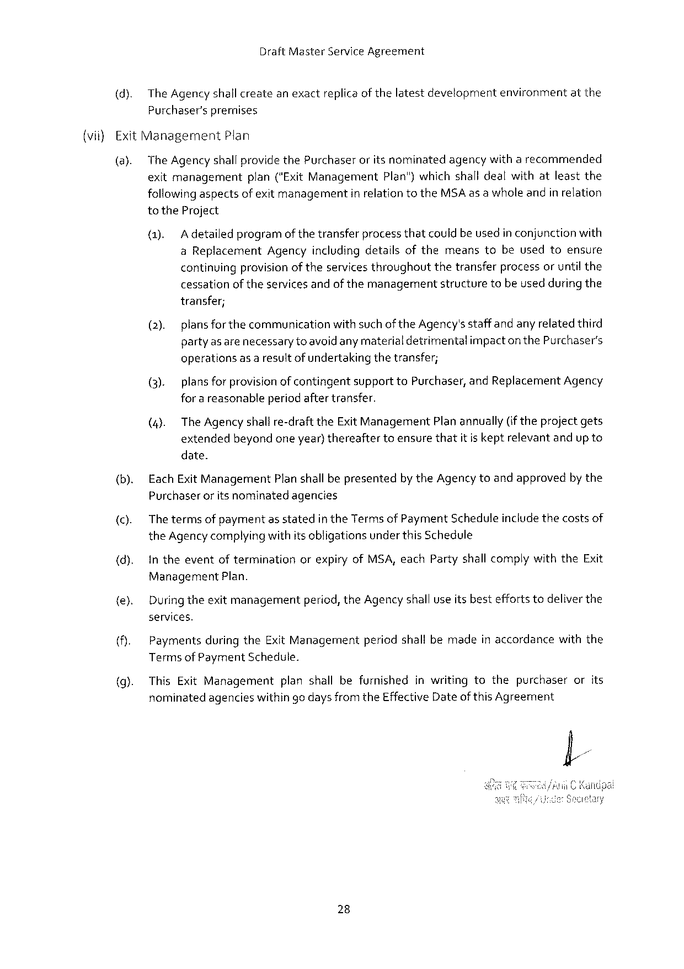

Draft Master Service Agreement

(dy. The Agency shallcreatean exactreplicaof thelatestdevelopmentenvironmentatthe Purchaser’spremises

(vii}Exit Management Plan

(a). The Agencyshallprovidethe Purchaser oritsnominated agencywitharecommended

exitmanagement plan("Exit Management Plan")whichshall dealwithatleastthe followingaspectsof exit managementin relationtothe MSA as a whole andin relation to the Project

(1). Adetailedprogramof thetransferprocessthatcouldbe usedin conjunctionwith a Replacement Agencyincludingdetailsofthemeanstobeusedtoensure continuingprovisionof theservices throughoutthetransferprocessoruntil the cessationoftheservicesandofthemanagementstructuretobeused during the transfer;

(2). plansforthe communicationwithsuchofthe Agency'sstaffandany relatedthird partyas arenecessary to avoidany materialdetrimentalimpactonthe Purchaser's operationsas a resultof undertakingthetransfer;

|  |  |  |  |  |
| --- | --- | --- | --- | --- |
| (3). | plansforprovisionofcontingent | supportto Purchaser, | and Replacement | Agency |

for a reasonableperiodaftertransfer.

(4). The Agency shalire-draftthe Exit Management Plan annually(iftheprojectgets extendedbeyondoneyear) thereaftertoensurethatitis keptrelevantandup to date.

(b). Each Exit Management Planshall bepresentedby the Agency toandapprovedbythe Purchaseroritsnominatedagencies

(). Thetermsof paymentas statedinthe Terms of Payment Scheduleincludethecostsof the Agencycomplying withitsobligationsunder this Schedule

{d). In theeventofterminationorexpiryof MSA, each Partyshall complywiththe Exit

Management Plan.

{e). Duringtheexitmanagementperiod, the Agency shall useits besteffortstodeliverthe services.

Paymentsduringthe Exit Managementperiodshallbemadein accordancewiththe Terms of Payment Schedute.

This Exit Management planshallbefurnishedinwritingtothepurchaserorits nominatedagencieswithin go days from the Effective Dateof this Agreement

28

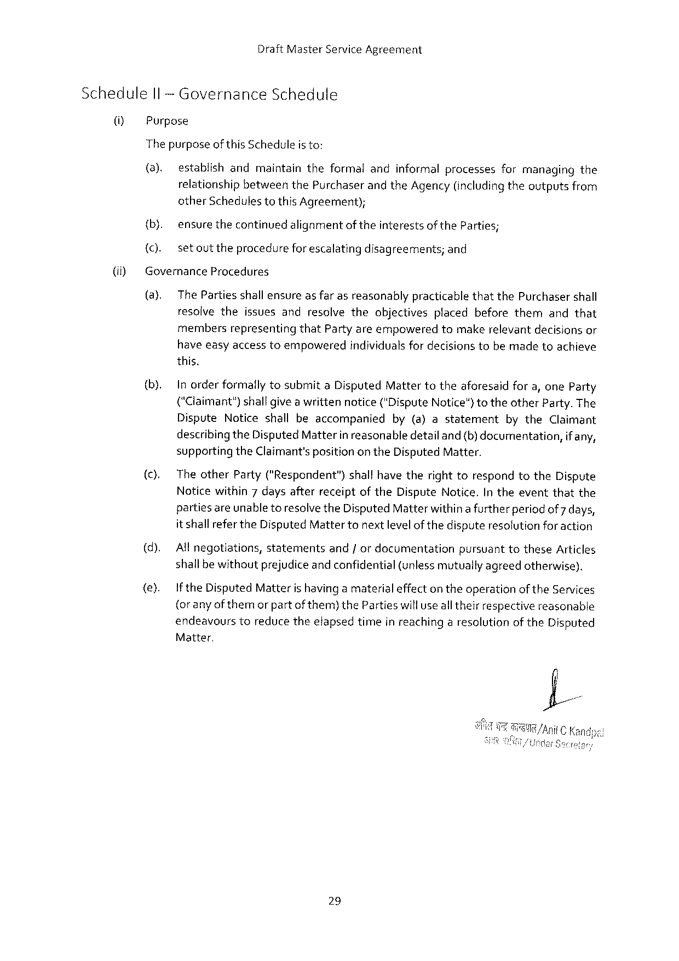

Draft Master Service Agreement

Schedule Il -Governance Schedule

(i Purpose

The purposeof this Scheduleis to:

(a). establishandmaintaintheformalandinformalprocessesformanagingthe relationshipbetweenthe Purchaserand the Agency (includingtheoutputsfrom other Schedulestothis Agreement);

|  |  |  |
| --- | --- | --- |
| (if) | {b). | ensurethecontinuedalignmentoftheinterestsofthe Parties; |
| {C). | setouttheprocedureforescalatingdisagreements; and |
| Governance Procedures | |
| (a). | The Partiesshall ensureas farasreasonablypracticablethatthe Purchasershall |
| resolvetheissuesandresolvetheobjectivesplacedbeforethemandthat | |

membersrepresentingthat Partyareempoweredtomakerelevantdecisionsor have easyaccesstoempoweredindividualsfor decisionstobemadetoachieve this.

(b). Inorderformallytosubmita Disputed Mattertotheaforesaidfora, one Party (“Claimant")shallgivea writtennotice("Dispute Notice")totheother Party. The

|  |  |  |  |  |
| --- | --- | --- | --- | --- |
| (c). | Dispute Noticeshallbeaccompanied | by(a)astatement | bythe Claimant | |
| describingthe Disputed Matterin reasonabledetail and{b) documentation, | | | if any, |
| supportingthe Claimant'sposition on the Disputed Matter.  Theother Party("Respondent”)shallhavetherighttorespondtothe Dispute Noticewithin 7 daysafterreceiptofthe Dispute Notice. Intheeventthatthe | | | |

partiesareunabletoresolvethe Disputed Matterwithina furtherperiodof 7 days, it shallreferthe Disputed Mattertonextlevelof thedisputeresolution for action

|  |  |  |  |  |
| --- | --- | --- | --- | --- |
| (d).  (e). | All negotiations, statementsand/ordocumentationpursuanttothese Articles | | | |
| shallbewithoutprejudiceandconfidential | | (unlessmutuallyagreedotherwise). | |
| If the Disputed Matterishavinga materialeffectontheoperationof the Services | | | |
| (or anyofthemorpart | ofthem)the Partieswillusealltheirrespective | | reasonable |
| endeavourstoreducetheefapsedtimeinreachinga resolutionof the Disputed | | | |

Matter,

29

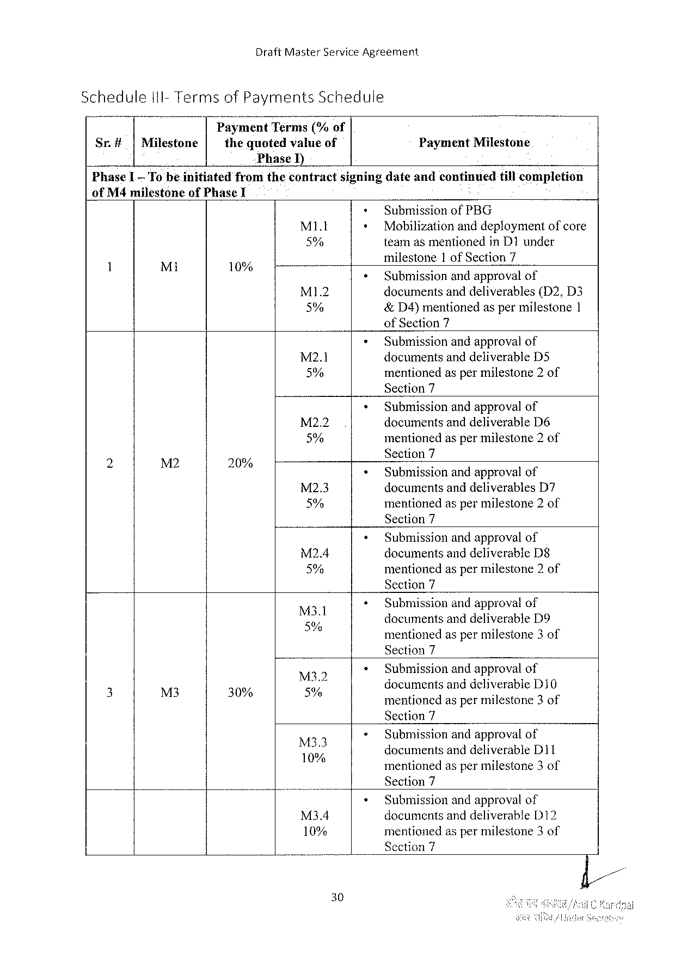

Draft Master Service Agreement

|  |  |  |  |  |  |
| --- | --- | --- | --- | --- | --- |
| Schedule | | l 1 I-Terms | of Payments | Schedule | Payment Milestone |
| Sr.# | |Milestone | | Payment Terms(%of | |
| thequotedvalueof | |

Phase I)

|  |  |  |  |  |
| --- | --- | --- | --- | --- |
| Phase L | Tobe. initiated | fromthecontract | signingdateandcontinued | tillcompletion |

of M 4 milestoneof Phase I   
 Submissionof PBG

|  |  |  |  |  |  |
| --- | --- | --- | --- | --- | --- |
| 1 | Mi | 10% | MI. t | Mobilizationanddeploymentofcore | |
| 5% | teamasmentionedin D 1 under | |
| milestone | 1 of Section 7 |
| ° | MI 1.2 | Submissionandapproval of | |
| documentsanddeliverables(D 2, D 3 | |
| 5% | &D 4)mentionedaspermilestone 1 | |

of Section 7

Submissionandapprovalof M 2.1 documentsanddeliverable D 5 5% mentionedaspermilestone 2 of Section 7

Submissionandapprovalof

|  |  |  |  |  |  |
| --- | --- | --- | --- | --- | --- |
| e | M 2 | o | M 22 | documentsanddeliverable D 6 | |
| 5% | mentionedaspermilestone 2 of | |
| Section 7 | |
| 20% | M 2.3 | Submissionandapprovalof | |
| documentsanddeliverables | D 7 |
| 5% | mentionedaspermilestone 2 of | |

Section 7

Submissionandapprovalof

|  |  |
| --- | --- |
| M 2.4  5% | documentsanddeliverable D§mentionedasper milestone 2 of |

Section 7

|  |  |
| --- | --- |
| M 3 l  5% g | Submissionandapprovalof  documentsanddeliverable D 9 " X )  mentionedaspermilestone 3 of |

Section 7

Submissionandapprovalof

|  |  |  |  |  |  |  |
| --- | --- | --- | --- | --- | --- | --- |
| 3 | = | o | MZ'Z | documents | anddeliverable | D 10 |
| M 3 | 30% | % | mentionedaspermilestone 3 of | | |

Section 7

Submissionandapprovalof Mo 10% documemsand and deliverable D 11 mentionedaspermilestone 3 of Section 7

Submissionandapprovalof M 34 documentsanddeliverable 312 10% mentionedaspermilestone 3 of Section 7

30

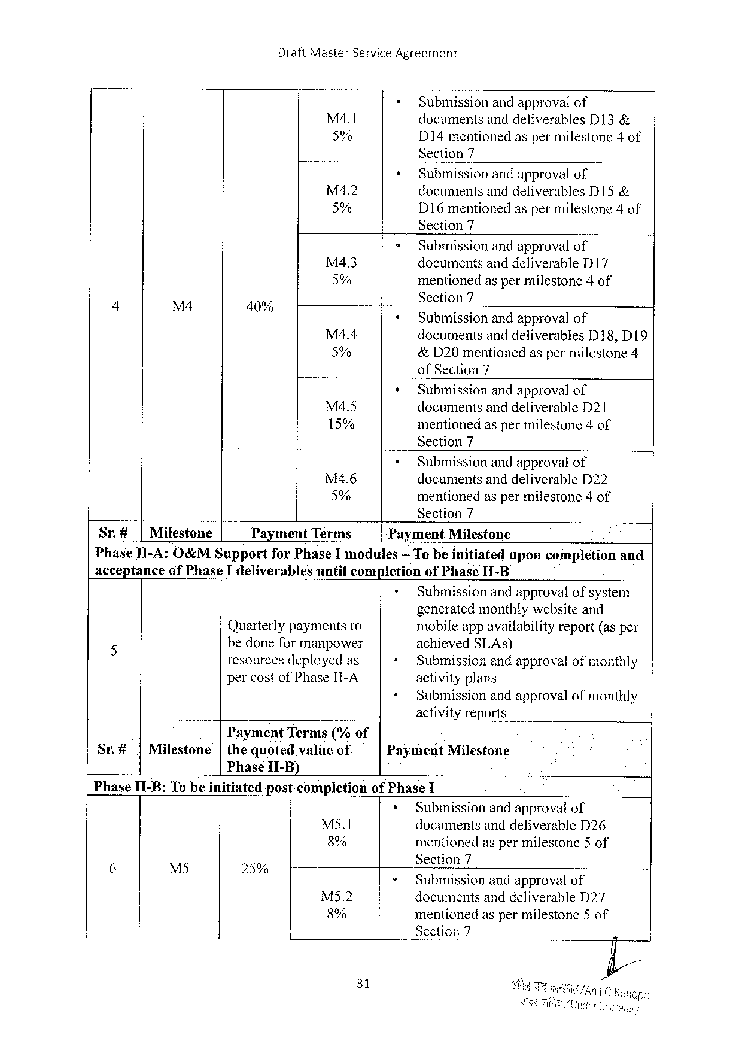

Draft Master Service Agreement

|  |  |  |  |
| --- | --- | --- | --- |
| M 4 l | = | Submissionandapprovalof | |
| documentsanddeliverables | D 13& |
| 5% | D 14 mentionedaspermilestone 4 of | |

Section 7

|  |  |  |  |
| --- | --- | --- | --- |
| M 4.2 | * | Submissionandapprovalof | |
| documentsanddeliverables | D 15& |
| 5% |
| D 16 mentionedaspermilestone 4 of | |

Section 7

|  |  |  |  |  |  |
| --- | --- | --- | --- | --- | --- |
| 4 | M 4 | 40% | M 43 | » | Submissionandapprovalof |
| documentsanddeliverable D 17 |
| 5% | « | mentioned aspermilestone 4 of |
| Sectl({n 7 |
| Submissionand approval of |
| M 4.4 | + | documentsanddeliverables D 18, D 19 |
| 5% | &D 20 mentionedaspermilestone 4 |
| of Section 7 |
| Submissionandapprovalof |
| M 4.5 | documentsanddeliverable D 21 |
| 15% | mentionedaspermilestone 4 of |

Section 7

|  |  |  |
| --- | --- | --- |
| M 4.6 | + | Submissionandapprovalof |
| documentsanddeliverable D 22 |
| 5% |
| mentionedaspermilestone 4 of |

Section 7

|  |  |  |  |  |  |
| --- | --- | --- | --- | --- | --- |
| Sr.#| | Miléstone | Payment | Terms | Payment | Milestone |

Phase II-A: O&MS upportfor Phase Imodules— Te be initiateduponcompletionand acceptanceof Phase Ideliverablesuntilcompletionof Phase II-B

|  |  |  |  |
| --- | --- | --- | --- |
| 5 | Quarterlypaymentsto | + | Submissionandapprovalofsystem |
| generatedmonthlywebsiteand |
| mobileappavailabilityreport(as per |
| bedoneformanpower | « | achieved SLA s) |
| resourcesdeployedas | Submissionandapprovalofmonthly |
| percostof Phase II-A. | + | activityplans |
| Submissionandapprovalofmonthly |

activityreports

B Payment Terms("/; of

Sr.#|Milestone|thequotedvalueof Phase 1 I-B)

Payment Milestone

Phase I 1-B: Tobeinitiatedpostcompletionof Phase I

|  |  |  |  |  |  |  |
| --- | --- | --- | --- | --- | --- | --- |
| S | e | o | 1 | Ms 5.1 | + | Submissionandapproval of |
| documentsanddeliverable D 26 |
| 8% | mentionedaspermilestone 5 of |
| Section 7 |
| 254 | M 52 | * |
| Submissionandapprovalof |
| documentsanddeliverable D 27 |
| 8% | mentionedaspermilestone 5 of |
| _Scction 7 |

31

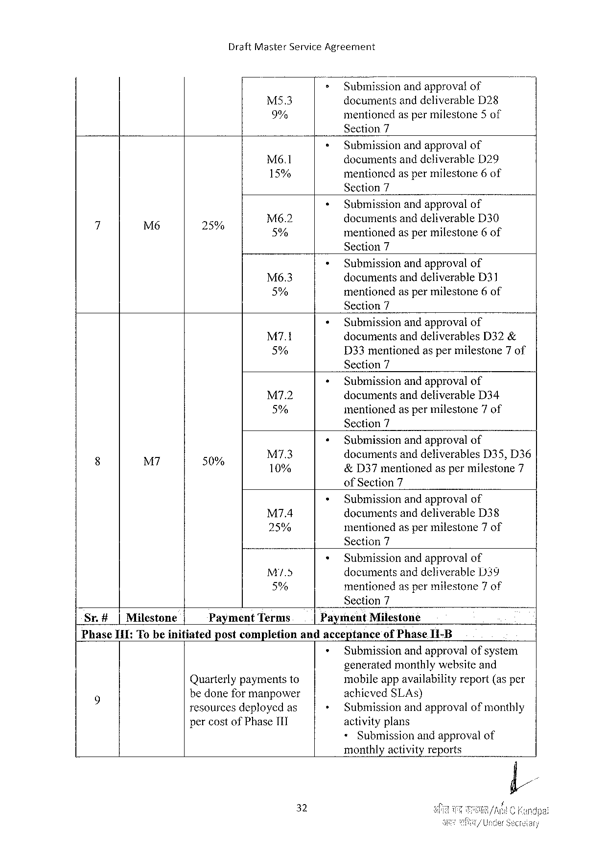

Draft Master Service Agreement

|  |  |  |
| --- | --- | --- |
| M 5.3 | > | Submissionand approvalof |
| documentsanddeliverable D 28 |
| 9% | mentionedaspermilestone 5 of |

Section 7

|  |  |  |
| --- | --- | --- |
| Mé6.1 | * | Submissionandapprovalof |
| documentsanddeliverable D 29 |
| 15% | mentionedaspermilestone 6 of |

Section 7

|  |  |  |  |  |  |
| --- | --- | --- | --- | --- | --- |
| 4 | L | S | M 6.2 | * | Submissionandapprovalof |
| documentsanddeliverable D 30 |
| 2% | 5% | mentionedaspermilestone 6 of |

Section 7

|  |  |  |
| --- | --- | --- |
| Mé6.3 | » | Submissionandapprovalof |
| documentsanddeliverable D 31 |
| 5% | mentionedaspermilestone 6 of |

Section 7

|  |  |  |
| --- | --- | --- |
| M 7.1 | * | Submissionandapprovalof |
| documentsanddeliverables D 32& |
| 5% | D 33 mentionedaspermilestone 7 of |

Section 7

|  |  |  |
| --- | --- | --- |
| M 7.2 | « | Submissionandapprovalof |
| documentsanddeliverable D 34 |
| 5% | mentionedaspermilestone 7 of |

Section 7

|  |  |  |  |  |  |
| --- | --- | --- | --- | --- | --- |
| 8 | M | o | M 7.3 | « | Submissionandapprovalof |
| documentsanddeliverables D 35, D 36 |
| 50% | 10% | &D 37 mentionedaspermilestone 7 |

of Section 7

|  |  |  |
| --- | --- | --- |
| M 7.4 | * | Submissionandapprovalof |
| documentsanddeliverable D 38 |
| 25% | mentionedaspermilestone 7 of |

Section 7

|  |  |  |
| --- | --- | --- |
| M 5 | « | Submissionandapprovalof |
| documentsanddeliverable 1339 |
| 5% | mentionedas permilestone 7 of |

Section 7

|  |  |  |  |  |
| --- | --- | --- | --- | --- |
| Sr.# | |Milestone | Payment Terms | Payment Milestone | |
| Phase I 1 I: Tobeinitiated | | postcompletion | andacceptance | of Phase I 1-B |

Submissionandapprovalofsystem   
generatedmonthlywebsiteand

Quarterlypaymentsto   
bedoneformanpower   
resourcesdeployedas

mobileappavailabilityreport(asper achicved SLAS)   
Submissionandapprovalofmonthly

percostof Phase I 1 I activityplans

<Submissionandapprovalof

monthlyactivity reports

32

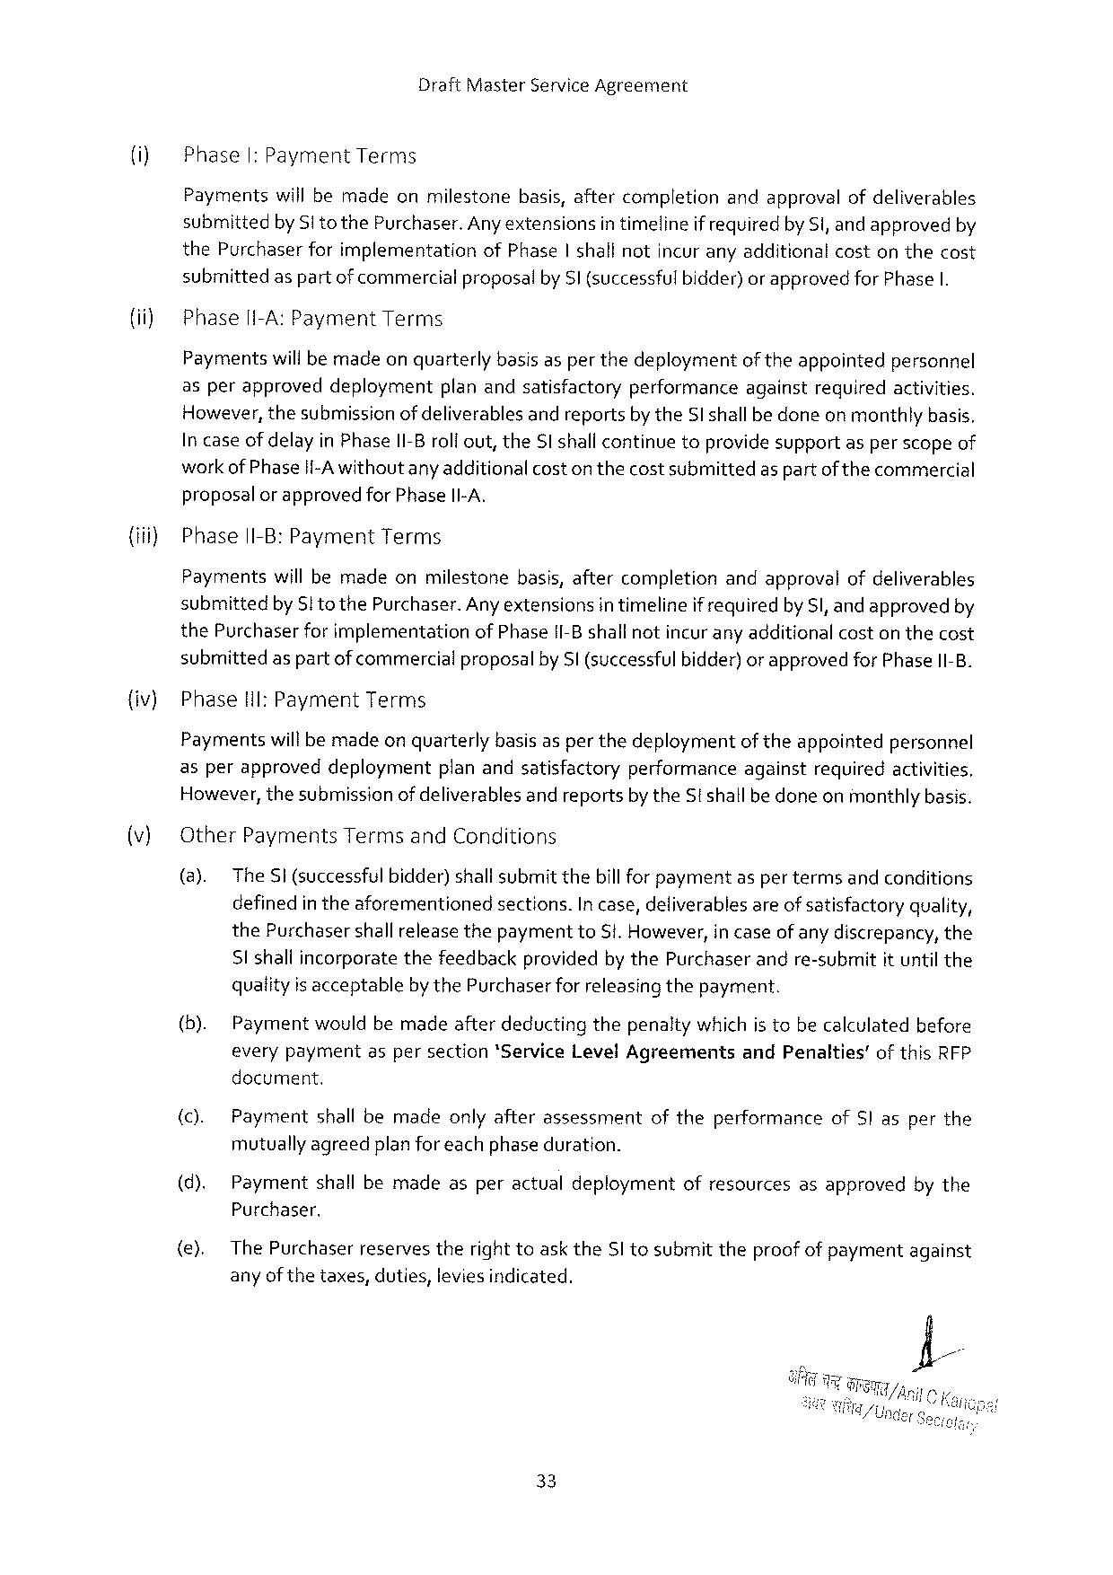

Draft Master Service Agreement

(i) Phase I: Payment Terms

Paymentswill bemadeonmilestonebasis, aftercompletionandapprovalofdeliverables submittedby Sito the Purchaser. Any extensionsin timelineif requiredby Si, and approvedby the Purchaserforimplementationof Phase|shall notincuranyadditionalcostonthecost submittedas partofcommercialproposalby Sl (successfulbidder)orapprovedfor Phase I.

Phasel I-A: Payment Terms

Paymentswillbemadeon quarterlybasis asper thedeploymentoftheappointedpersonnel

|  |  |  |  |  |  |  |
| --- | --- | --- | --- | --- | --- | --- |
| asperapproved | deployment | planandsatisfactory | performance | against | required | activities. |

However, thesubmissionofdeliverablesand reportsby the Sl shallbe doneon monthlybasis. In caseof delayin Phase I 1-Broli out, the Sl shallcontinuetoprovidesupportasper scopeof workof Phasei{-A withoutany additional coston thecostsubmittedas partof the commercial proposal or approvedfor Phase II-A.

{iii) Phase II-B: Payment Terms

Paymentswill bemadeonmilestonebasis, aftercompletionandapprovalofdeliverables submittedby Sto the Purchaser. Anyextensionsin timelineif requiredby S, and approvedby the Purchaserfor implementationof Phase II-Bshallnotincurany additionalcoston thecost submittedas partofcommercialproposalby Sl (successful bidder) or approvedfor Phase II-B.

|  |  |  |
| --- | --- | --- |
| {iv) | Phase | Hil: Payment Terms |

Paymentswillbemadeon quarterlybasis asper thedeploymentof theappointedpersonnel asperapproveddeploymentplanandsatisfactoryperformanceagainstrequiredactivities. However, thesubmissionofdeliverablesand reportsby the St shallbedoneonmonthlybasis.

(v) Other Payments Termsand Conditions

(@). The Si (successful bidder)shallsubmitthebill for paymentas per termsand conditions definedin theaforementionedsections. In case, deliverablesareof satisfactoryquality, the Purchasershallreleasethepaymentto Si. However, in caseof any discrepancy, the Sl shaliincorporatethefeedbackprovidedby the Purchaserandre-submitit until the qualityis acceptablebythe Purchaserforreleasingthepayment.

(b). Paymentwouldbemadeafterdeductingthepenaltywhichis tobecalculatedbefore everypaymentaspersection*Service Level Agreements and Penalties’of this RFP docurment.

|  |  |  |  |  |  |
| --- | --- | --- | --- | --- | --- |
| (c). | Payment | shallbemade | onlyafterassessment | oftheperformance | of S|asperthe |

mutuallyagreedplanforeach phaseduration.

(d). Paymentshallbemadeasperactualdeploymentofresourcesasapprovedbythe Purchaser,

(e). The Purchaserreservestheright toaskthe SI tosubmittheproofof paymentagainst anyof thetaxes, duties, leviesindicated.

33

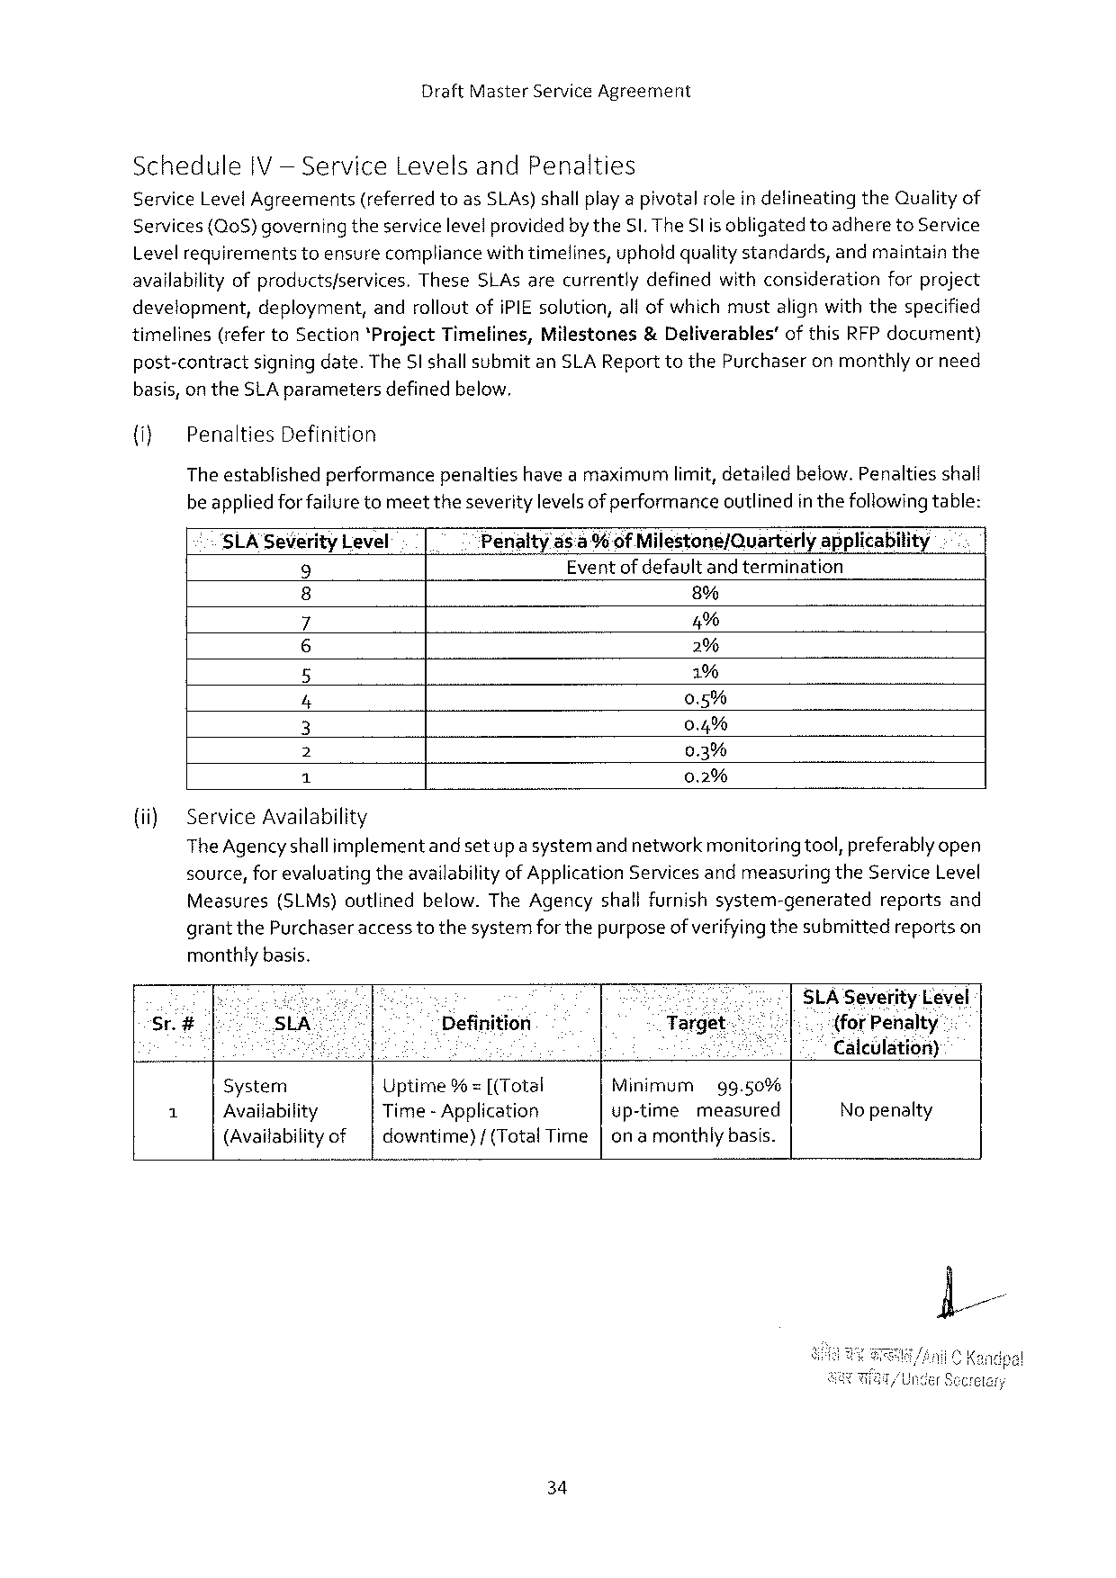

Draft Master Service Agreement

Schedule IV— Service Levelsand Penalties

Service Level Agreements (referred toas SLA s) shallplayapivotalrolein defineating the Qualityof Services(Q 0 S)governingtheservicelevelprovidedby the SI. The Sl is obligatedtoadhereto Service

|  |  |  |
| --- | --- | --- |
| Levelrequirements | toensurecompliancewithtimelines, upholdqualitystandards, | andmaintainthe |

availabilityofproductsfservices. These SLA sarecurrentlydefinedwithconsiderationforproject development, deployment, androlloutofi PIE solution, all ofwhich mustalign withthespecified

|  |  |  |  |  |
| --- | --- | --- | --- | --- |
| timelines | (referto Section*Project Timelines, | Milestones | &Deliverables’ | ofthis RFP document) |

post-contractsigning date. The Sl shallsubmitan SLA Report to the Purchaseronmonthlyor need basis, on the SLA parametersdefinedbelow.

{i} Penalties Definition

Theestablishedperformancepenaltieshave amaximumlimit, detailedbelow. Penaltiesshall beappliedforfailuretomeettheseveritylevelsof performanceoutlinedin thefollowingtable:

|  |  |  |  |
| --- | --- | --- | --- |
| SLA Severity Level | Penalty | ds: a % of Milestone/Quarterly | applicability |
| Eventofdefaultandtermination | |
| 9 |
| 8% | |
| o |

5%

o~ 2%   
 1%   
 0.5%   
 0.4%   
 0.3%

|  |  |  |
| --- | --- | --- |
| {i) | BN l | 0.2% |
| Service Availability |

The Agencyshallimplementandsetup a systemand networkmenitoringtool, preferably open source, for evaluatingtheavailabilityof Application Servicesandmeasuring the Service Level Measures(SLM s)outlinedbelow. The Agencyshallfurnishsystem-generated reportsand grantthe Purchaseraccess tothesystemforthepurposeof verifyingthesubmittedreportson monthlybasis.

|  |  |  |  |  |  |  |  |  |  |
| --- | --- | --- | --- | --- | --- | --- | --- | --- | --- |
| Sr.# | . | e | % | | CU erl | | | e | SLA Severity Level |
| SLA | | Definition | | Target- | | | " | {for Penalty |
| S | | : | ; | K | | | | Calculation) |
| A | System | | Uptime% = [(Total | | Minimum | | gg.50% | |
| No penalty |
| Availability | | Time -Application | | up-time | measured | | |
| (Availabilityof | | downtime}/(Total Time|onamonthlybasis. | | | | | |

34

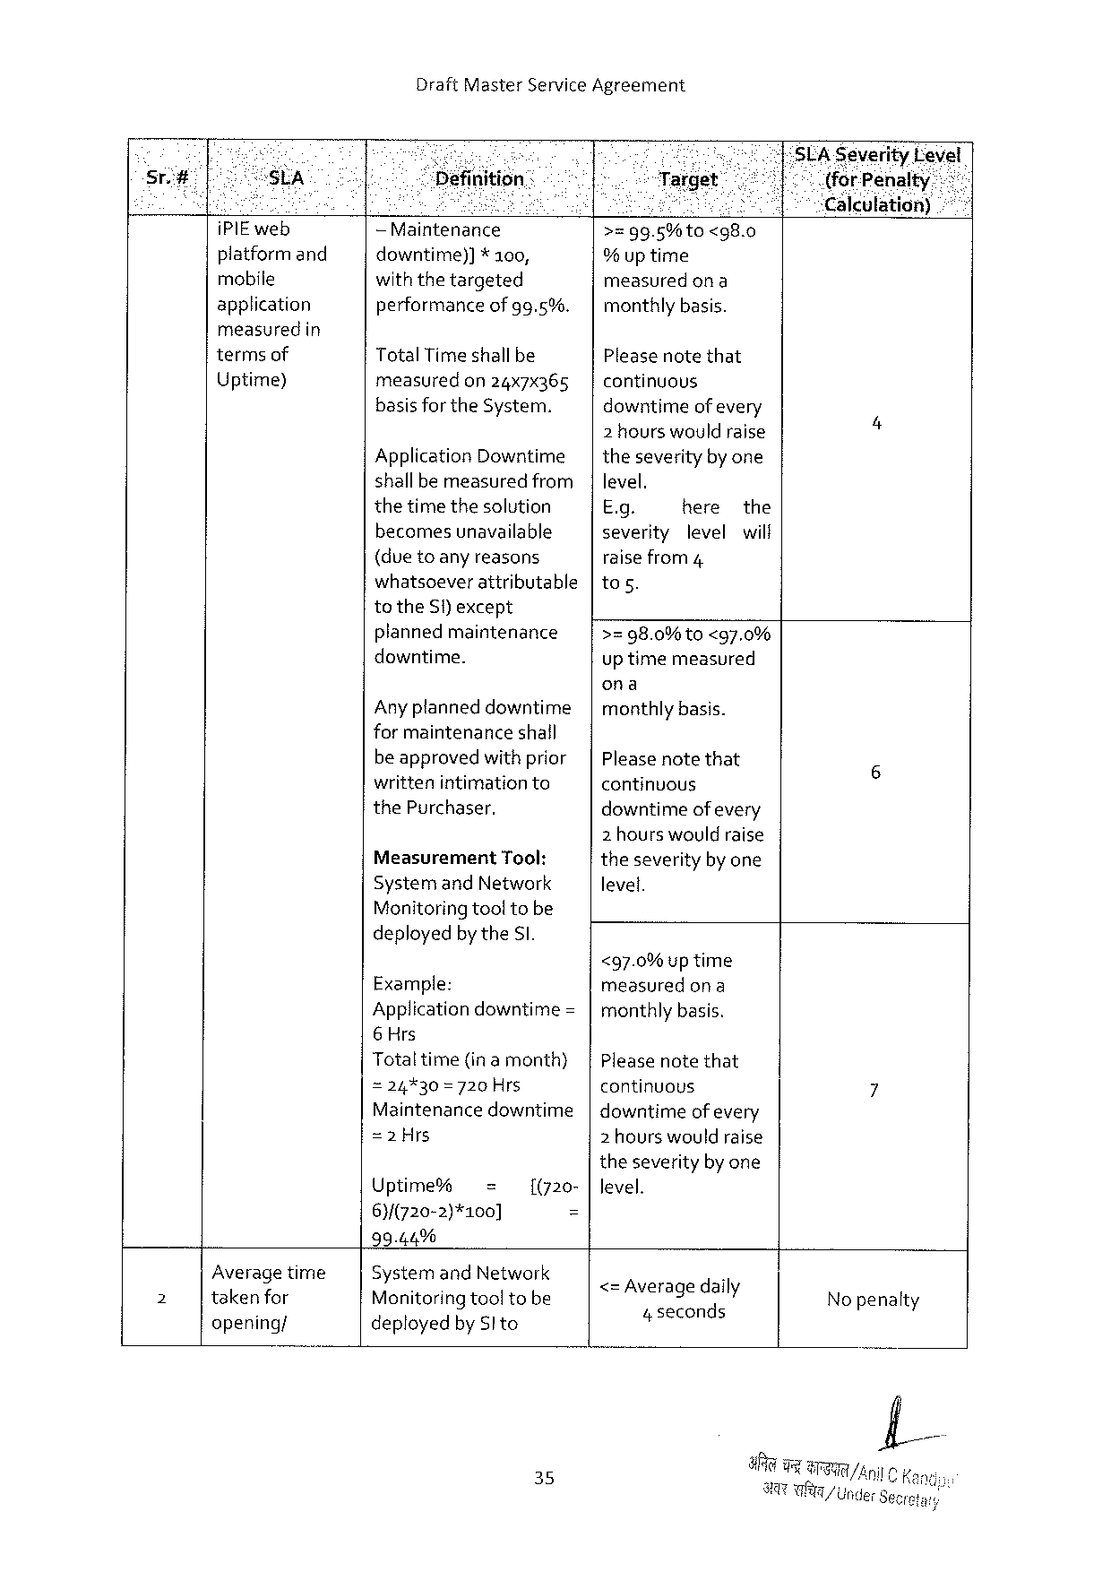

Draft Master Service Agreement

|  |  |  |  |  |  |  |  |  |  |
| --- | --- | --- | --- | --- | --- | --- | --- | --- | --- |
| ! | s | i | S | | Gl | | o SLAS everity Devel | | |
| Sr. i# | “HSLA | Définition | | | Target” | | | 71}" | (for Penalty |
| ] | ; | i | | | o | e | ee | | ‘Calculation) |
| i PIE web | —Maintenance | | | >z 9 g.5%to | <g 8.0 | | | |
| platformand | downtime)] | * 100, | |
| % uptime | | | | |
| mobile |
| withthetargeted | | | measured | ona | | | |
| application | performance | | of 9 g.5%. |
| monthlybasis. | | | | |
| measuredin | Total Timeshallbe | | |
| Pleasenotethat | | | | |
| termsof |
| Uptime) | measured | on 24 x 7 x 365 | | continuous | | | | |

basisforthe System.

Application Downtime|

downtimeof every   
2 hourswouldraise 4 theseverityby one

|  |  |  |  |
| --- | --- | --- | --- |
| shallbe measuredfrom| | level. | here | the |
| thetimethesolution | E. g. |

becomesunavailable   
(duetoany reasons

severity levelwilf

raise from 4

whatsoeverattributable|tos.   
to the S)except

plannedmaintenance   
downtime.

Any planneddowntime   
for maintenanceshail

>=98.0%10<g 7.0%   
uptimemeasured

ona   
|monthlybasis.

|  |  |  |
| --- | --- | --- |
| beapprovedwith prior|Pleasenotethat | | 6 |
| writtenintimationto | continuous |
| the Purchaser. | downtimeof every |

Measurement Tool:

2 hours wouldraise   
theseverityby one

|  |  |
| --- | --- |
| Systemand Network Monitoringtooltobe | level. |

deployedbythe SI.

|  |  |
| --- | --- |
| Example: | <97.0%uptime  measuredon a |

Application downtime=|monthlybasis.   
6 Hrs

|  |  |  |  |  |  |  |
| --- | --- | --- | --- | --- | --- | --- |
| Totaltime | (inamonth) | | | | | Pleasenotethat | 7 |
| =24%30=720 Hrs | | | continuous | | |
| Maintenancedowntime|downtimeofevery | | | | | |
| =2 Hrs | | | 2 hourswouldraise | | |
| theseverityby one | | | | | |
| Uptime% | | = | [(720- |level. | | |
| 6)/(720-2)*100] | | | £ | | |

99.44%

|  |  |  |  |  |
| --- | --- | --- | --- | --- |
| p 3 | Average time | Systemand Network | <= Average daily | No penalty |
| takenfor | Monitoringtooltobe |
| 4 seconds |
| opening/ | deployedby Slto |

35

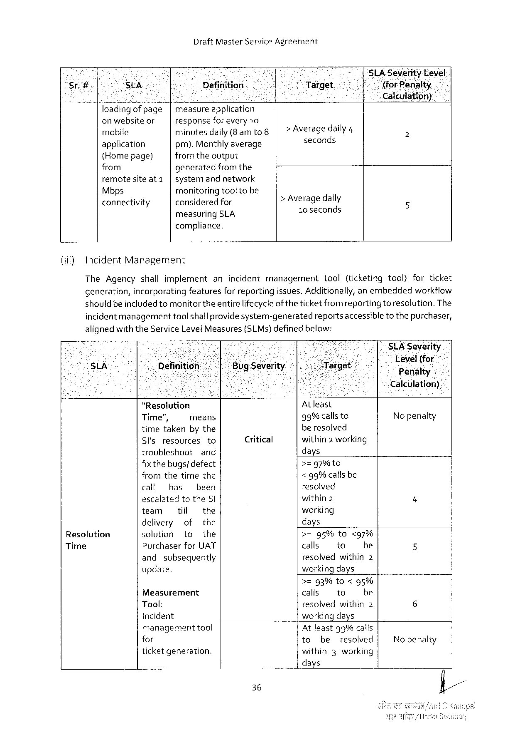

Draft Master Service Agreement

|  |  |  |  |  |  |  |  |
| --- | --- | --- | --- | --- | --- | --- | --- |
| Srg. | St A | Definition | | 8 | *1 Target | | | SLA-Severity Level |
| h ‘(for‘Piefliilkt\yi |
| caleulation) |
| loadingofpage | measureapplication | |
| > Average daily 4 |
| onwebsiteor | responseforevery 10 | |
| rnobile | minutesdaily(8 amto | |
| seconds |
| application | pm). Monthlyaverage | |
| {Homepage) | from theoutput | | > Average daily |
| from | generatedfromthe | |
| remotesiteat 1 | systemandnetwork | |
| Mbps | monitoring tooltobe | |
| connectivity | consideredfor | |
| 10 seconds |
| measuring | SLA |

compliance.

{iif) Incident Management

|  |  |  |  |
| --- | --- | --- | --- |
| The Agencyshallimplement | anincidentmanagement | tool | (ticketingtool)forticket |

generation, incorporatingfeaturesfor reportingissues. Additionally, anembeddedworkflow

should be includedtomonitor theentire lifecycleof theticket fromreportingtoresolution. The

incidentmanagementtool shallprovidesystem-generatedreportsaccessibleto thepurchaser,

alignedwiththe Service Level Measures

{(SLM s)definedbelow:

|  |  |  |  |  |  |  |  |  |  |  |
| --- | --- | --- | --- | --- | --- | --- | --- | --- | --- | --- |
| - | “Resolution | | | | Critical | At least | | | Level(for | - |
| s LA | Penalty |
| Calculation) |
| Resolution | Time”, | | means | | 99%callsto | | | Nopenalty |
| timetakenby the | | | | beresolved | | |
| Sl'sresources | | | to | within 2 working | | |
| troubleshoot | | and | | days | | |
| fixthe bugs/defect | | | | >zg 7%to | | | 4 |
| fromthetimethe | | | | < 99%callsbe | | |
| call | has | been | | resolved | | |
| escalatedtothe Sl | | | | within 2 | | |
| team | till | | the | working | | |
| delivery | | of | the | days | | |
| solution | | to | the | >=95%to<97% | | |
| Purchaserfor UAT | | | | calls | to | be | 5 |
| Time |
| and | subsequently | | | resolvedwithin 2 | | |
| update. | | | | workingdays | | |

>=93%to<95%

|  |  |  |  |  |  |  |
| --- | --- | --- | --- | --- | --- | --- |
| Measurement | | calis | | to | be | 6 |
| Tool: | | resolvedwithin 2 | | | |
| Incident | | workingdays | | | | No penalty |
| management | toot | Atleast 9 g%calls | | | |
| for | | to | be | resolved | |
| ticketgeneration. | | within | | 3 working | |

days

36

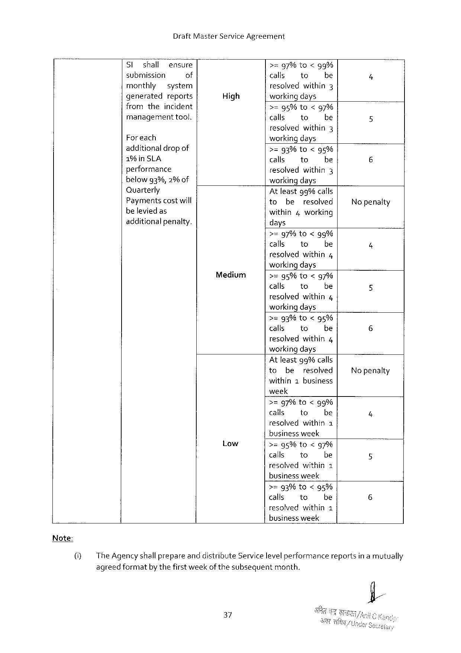

Draft Master Service Agreement

|  |  |  |  |  |  |  |
| --- | --- | --- | --- | --- | --- | --- |
| Sl | shall | ensure | High | >=97%to<gg% | | |
| submission | | of | calls | to | be |
| monthly | | system | resolvedwithin 3 | | |
| generated | | reports | workingdays | | |

fromtheincident   
managementtool.

Foreach   
additionaldropof

1%in SLA   
performance   
belowg 3%,2%of

>=95%to<97%

|  |  |  |
| --- | --- | --- |
| calls | to | be |
| resolved | within | 3 |

workingdays

>=g 3%to<g 5%

|  |  |  |
| --- | --- | --- |
| calls | to | be |

resolvedwithin 3   
workingdays

|  |  |  |  |  |
| --- | --- | --- | --- | --- |
| Quarterly | At leastgg% calls | | | No penaity |
| Paymentscostwill |
| to | be | resolved |
| beleviedas | within 4 working | | |
| additionalpenalty. |
| days | | |

>=97%to<95%

|  |  |  |
| --- | --- | --- |
| calls | 1 o | be |
| resolved | within | 4 |

workingdays

Medium >=95%to<g 7%

calls to be

resolved within 4

workingdays

>=93%to<g 5%

|  |  |  |
| --- | --- | --- |
| calls | to | be |
| resolved | within | 4 |

workingdays

Atleastg% calls

to be resolved Nopenalty

within 1 business

week

>=g 7%to<9%

|  |  |  |
| --- | --- | --- |
| calls | to | be |

resolvedwithin 1

businessweek

Low >=95%to<g 7%

calls to be

resolved within 1

businessweek

>=93% to<95%

calls to be

resolvedwithin 1

business week

(i} The Agencyshallprepareanddistribute Servicelevelperformancereportsin a mutually

agreedformatby thefirstweek of thesubsequentmonth.

37

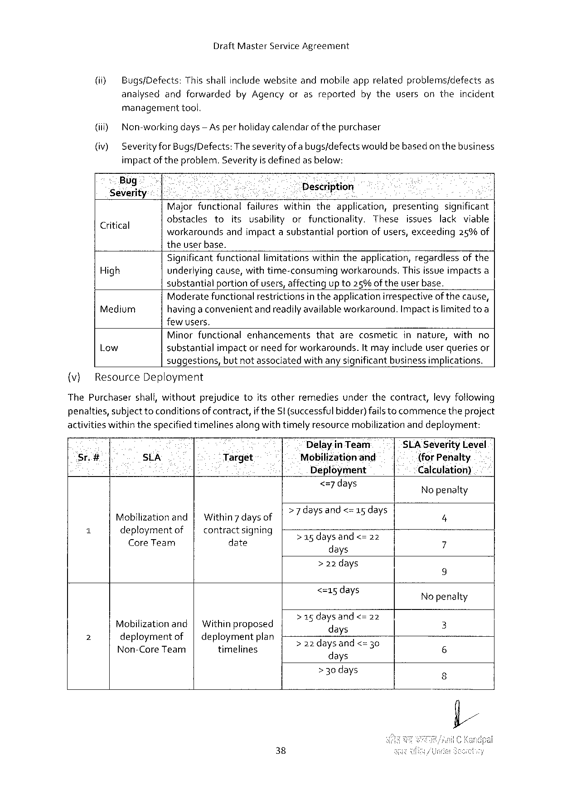

Draft Master Service Agreement

(i) Bugs/Defects: Thisshallinclude websiteandmobileapprelatedproblems/defectsas

analysedandforwarded by Agencyorasreported bytheusersontheincident

managementtool.

(i) Non-working days— As perholidaycalendarofthepurchaser

(iv) Severityfor Bugs/Defects: Theseverityofa bugs/defectswouldbebasedon thebusiness

impact of theproblem. Severityis definedas below:

|  |  |  |  |  |  |  |
| --- | --- | --- | --- | --- | --- | --- |
| Bug -  ;  Severity  Critical | B | | et | Description   il o | | |
| Majorfunctionalfailureswithintheapplication, presentingsignificant | | | | | |
| obstacles | to | itsusabilityorfunctionality. | | These | issueslackviable |

workaroundsandimpactasubstantialportionofusers, exceeding 25%of

theuserbase.

Significant functionallimitationswithintheapplication, regardlessof the

High underlyingcause, with time-consumingworkarounds. Thisissue impactsa

substantialportion of users, affectingup to 25%oftheuserbase.

Moderatefunctionalrestrictionsintheapplicationirrespectiveof thecause,

Medium havinga convenientandreadilyavailable workaround. Impact islimitedtoa

few users,

Minorfunctionalenhancements thatarecosmeticinnature, withno

Low substantialimpactor need forworkarounds. It mayinclude userqueriesor

suggestions, but notassociatedwithany significantbusinessimplications.

(v} Resource Deployment

The Purchasershall, withoutprejudicetoitsotherremediesunderthecontract, levy fotlowing

penatties, subject toconditionsof contract, if the SI (successfulbidder)fails tocommencetheproject

activitieswithinthespecifiedtimelines alongwithtimelyresource mobilization anddeployment:

Delayin Team SLA Severity Level

Sr.# . SLA Target {for Penalty.

Deployment Calculation)

<=7 days No penalty

d d <=15 days

Mobilizationand| Within 7 daysof e YEIANCS 8 5 IC a Y] 4

i deploymentof contractsigning Sasdaysandes o 3

Core Team date 7

days

>22 days

i 9

<=15 days Nopenalty

> 15 daysand<=

Mobilizationand| Withinproposed 2 \f: la " 2 3

2 deploymentof| deploymentplan e E ynd T

Non-Core Team timelines 220 ay Es =3 6

days

> 30 days 3

38

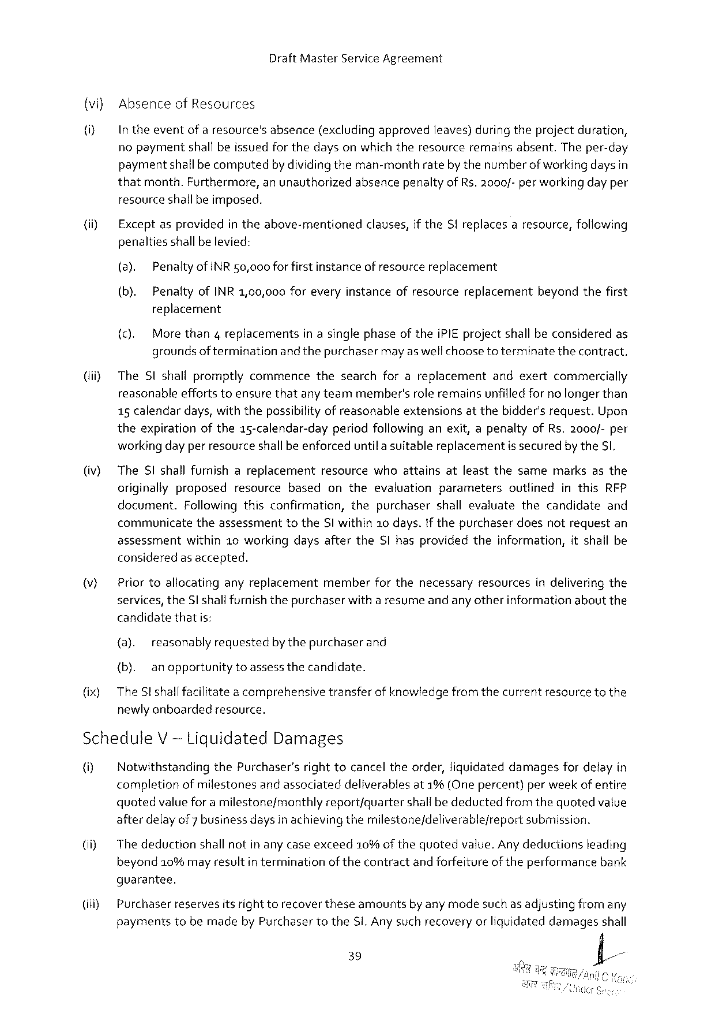

Draft Master Service Agreement

(vi) Absenceof Resources

Intheeventofaresource's absence (excludingapproved leaves)duringtheprojectduration,

nopayment shallbeissuedforthedaysonwhichtheresource remainsabsent. Theper-day paymentshallbe computedby dividingtheman-monthrateby thenumberofworkingdays in thatmonth. Furthermore, anunauthorizedabsencepenaltyof Rs. 2000/- per workingday per resourceshallbe imposed.

|  |  |  |  |  |  |  |  |  |
| --- | --- | --- | --- | --- | --- | --- | --- | --- |
| (i) | Exceptasprovided | | | intheabove-mentioned | clauses, | if the SI replaces | aresource, | following |
| penaltiesshallbe levied: | | | | | | | |
| (a). | Penaltyof INR 50,000 forfirstinstanceofresourcereplacement | | | | | | |
| (b). | | Penaltyof INR 1,00,000 foreveryinstanceofresourcereplacementbeyondthefirst | | | | | |

replacement

(c). More than 4 replacementsin asinglephaseof thei PIE projectshall beconsideredas groundsof terminationand thepurchasermayaswelfchooseto terminatethecontract.

(iii) The SI shallpromptlycommencethesearchforareplacementandexertcommercially reasonableeffortstoensurethatanyteammember'srole remainsunfilledfor no longerthan 15 calendardays, withthepossibilityof reasonableextensionsatthebidder'srequest. Upon theexpirationof the 15-calendar-dayperiodfollowing anexit, apenaltyof Rs.2000/-per workingday per resourceshallbe enforceduntila suitablereplacementissecuredby the S,

(v} The SI shallfurnishareplacementresourcewhoattainsatleastthesamemarksasthe originallyproposedresourcebasedontheevaluationparameters outlinedinthis RFP document. Followingthisconfirmation, thepurchasershallevaluatethecandidate and communicatetheassessmenttothe SI within 2 o days. If thepurchaserdoesnotrequestan assessment within 10 workingdaysafterthe Slhasprovidedtheinformation, itshallbe consideredas accepted.

|  |  |  |  |  |  |  |  |
| --- | --- | --- | --- | --- | --- | --- | --- |
| v) | Priortoallocating | anyreplacement | member | forthenecessary | resources | indelivering | the |

services, the Sl shallfurnish thepurchaserwitha resumeand any otherinformationaboutthe candidatethatis:

{a). reasonablyrequestedby thepurchaserand

{b). anopportunity toassessthecandidate.

(ix) The St shallfacilitatea comprehensivetransferof knowledge fromthecurrentresourcetothe newlyanboardedresource.

Schedule V -tiguidated Damages

U] Notwithstandingthe Purchaser’srighttocanceltheorder, liquidateddamagesfordelayin completionofmilestonesand associateddeliverablesat 1%(One percent)per weekof entire quotedvaluefor a milestone/monthlyreport/quartershallbedeductedfromthequotedvalue afterdelay of 7 business daysin achieving themilestone/deliverablejreportsubmission.

(ii) Thedeductionshall notin any caseexceed 10%of thequotedvalue. Anydeductionsleading beyond 10%mayresultin terminationof thecontractand forfeitureoftheperformancebank

guarantee.

(iii) Purchaserreservesitsrighttorecover theseamountsby any modesuch as adjustingfromany paymentstobemadeby Purchasertothe Si. Anysuchrecoveryor liquidateddamagesshall

39



Draft Master Service Agreement

notin any wayrelievethe Si fromany of itsobligationstocomplete Workor fromany other

obligationsand liabilities under the Contract.

|  |  |  |  |  |  |  |  |  |  |  |  |  |
| --- | --- | --- | --- | --- | --- | --- | --- | --- | --- | --- | --- | --- |
| (iv) | Delaysnotattributable | | | to Si shaltbeconsidered | | | | forexclusionforthepurposeofcomputing | | | | |
| liquidateddamages. | | | is | the | amount | of | payment | due | against | a | particular |
| Note: | Quoted | valve |
| milestone/month/quarter | | | asper paymentschedule. | | | | | | | | |

40

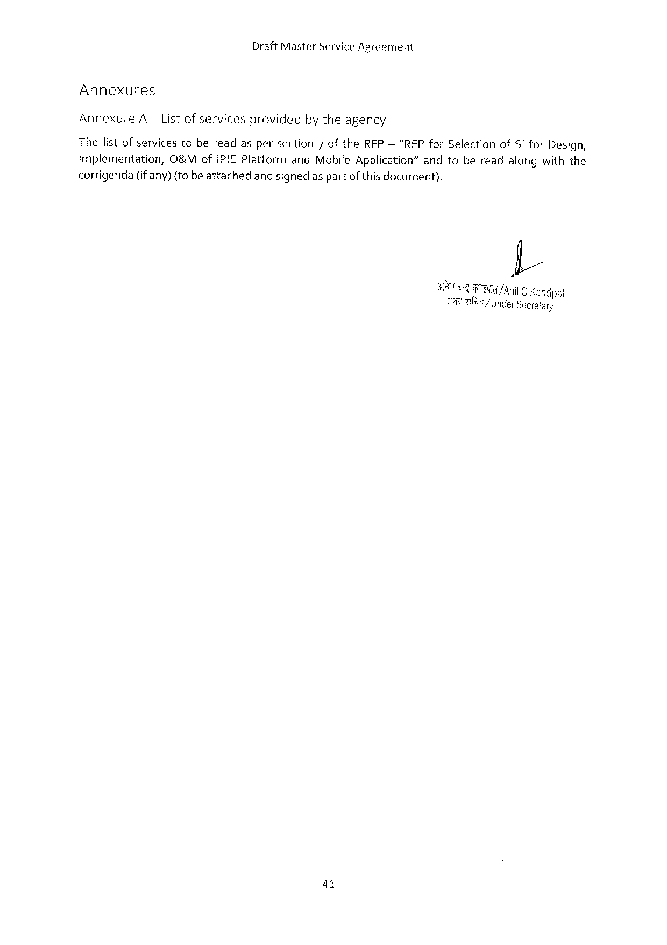

Draft Master Service Agreement

Annexures

Annexure A— Listofservicesprovidedbytheagency

Thelist ofservicestobereadaspersection 7 of the RFP— “RFP for Selectionof St for Design,

Implementation, O&Mofi PIEP latformand Mobile Application”andtobereadalongwiththe

corrigenda(if any)(to beattachedandsignedas partof this document).

I

GG Anit Kandpai

a 3 9/ Under Secretary

41

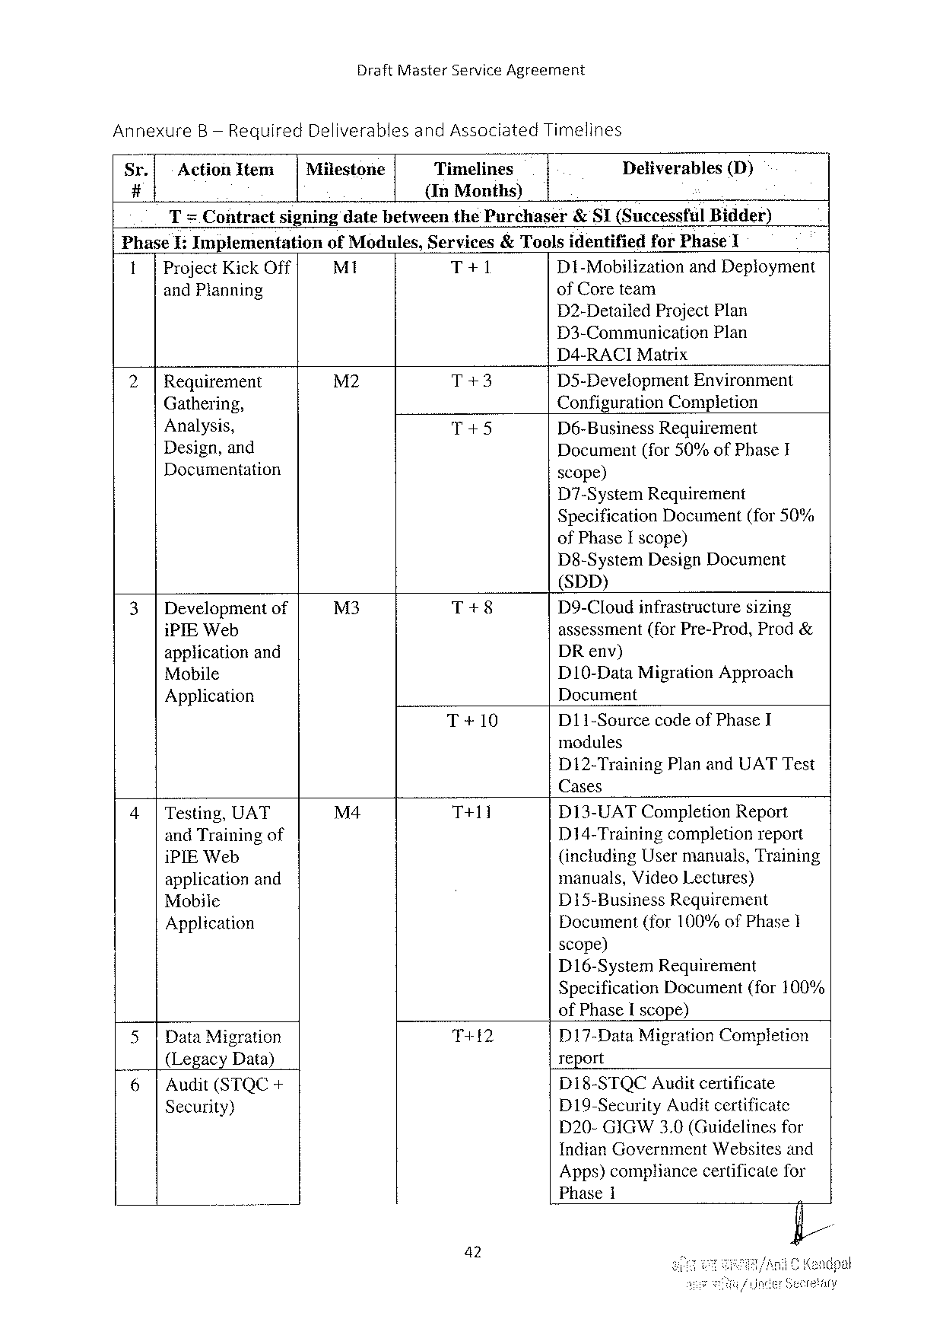

Draft Master Service Agreement

Annexure B— Required Deliverablesand Associated Timelines

|  |  |  |  |  |  |
| --- | --- | --- | --- | --- | --- |
| Sr. | Action Item | Milestone | Timelines | Deliverables | (D) |
| # | {In Months) |

T= Contractsigningdatebetweenthe Purchaser& SI(Successful Bidder)

Phase I: Implementation of Modules, Services& Toolsidentifiedfor Phase 1

1|Project Kick Off M 1 T+1 D 1-Mobilization and Deployment

and Planning of Coreteam

D 2-Detailed Project Plan

D 3-Communication Plan

D 4-RACIM atrix

|  |  |  |  |  |
| --- | --- | --- | --- | --- |
| 2| | Requirement | M 2 | T+3 | D 35-Development Environment |
| Gathering, | T+5 | Configuration Completion |
| Analysis, | D 6-Business Requirement |

Design, and   
Documentation

Document(for 50%of Phase I scope)

D 7-System Requirement   
Specification Document(for 50% of Phase I scope)   
D 8-System Design Document   
(SDD)

|  |  |  |  |
| --- | --- | --- | --- |
| 3|Development of | M 3 | T+8 | D 9-Cloudinfrastructure sizing |
| i PIEW eb | T+10 | assessment(for Pre-Prod, Prod& |
| applicationand | DR env) |
| Mobile | D 10-Data Migration Approach |
| Application | Document |
| D 11-Sourcecodeof Phase I |

modules   
D 12-Training Planand UATT est   
Cases

|  |  |  |  |
| --- | --- | --- | --- |
| 4|Testing, UAT | M 4 | T+11 | D 13-UATC ompletion Report |
| and Trainingof | D 14-Trainingcompletionreport |
| i PIEW eb | (including Usermanuals, Training |
| applicationand | manuals, Video Lectures) |
| D 15-Business Requirement |
| Mobile |
| Document(for 100%of Phase I |
| Application |

scope)   
D 16-System Requirement   
Specification Document(for 100%   
of Phase Iscope)

|  |  |  |  |  |  |
| --- | --- | --- | --- | --- | --- |
| L. | 5|Data Migration | | T+12 | D 17-Data Migration Completion | |
| report | |
| (Legacy Data) | |
| D 18-STQCA uditcertificate | |
| 6| | Audit(STQC+ |
| D 19-Security Auditcertificate | |
| Security) | |
| D 20-GIGW 3.0(Guidelinesfor | |
| Indian Government | Websitesand |

Apps)compliancecertificatefor   
Phase 1

42

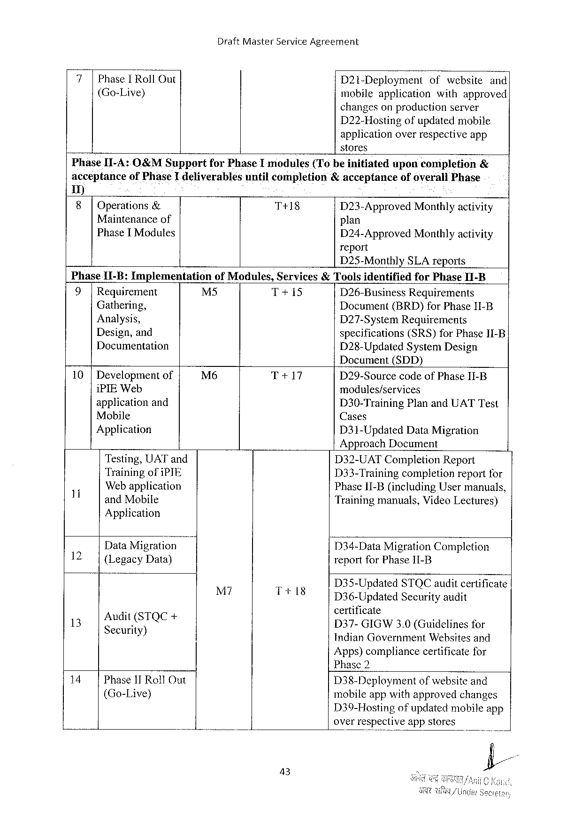

Draft Master Service Agreement

|  |  |  |  |
| --- | --- | --- | --- |
| Phase I Roll Out  (Go-Live) | D 21 i-Deployment | ofwebsite | and |
| mobileapplication | withapproved | |
| changesonproductionserver | | |

D 22-Hostingofupdatedmobile

applicationoverrespectiveapp

stores

Phase II-A: O&MS upport for Phase Imodules(Tobeinitiated uponcompletion &

acceptanceof Phase I deliverablesuntilcompletion&acceptanceofoverall Phase

1)

8 Operations & T+18 D 23-Approved Monthlyactivity

Maintenance of plan

Phase I Modules

D 24-Approved Monthlyactivity report

D 25-Monthly SLA reports

|  |  |  |  |  |
| --- | --- | --- | --- | --- |
| Phase 11-B: Implementation  9|Requirement  Gathering,  Analysis,  Design, and  Documentation | of Modules, Services&Toolsidentified | | | for Phase I 1-B |
| M 5 | T+15 | D 26-Business | Requirements |
| Document(BRD)for Phase II-B D 27-System Requirements  specifications(SRS)for Phase 11-B D 28-Updated System Design | | | |

Document(SDD)

|  |  |  |  |
| --- | --- | --- | --- |
| 10 |Development of | M 6 | T+17 | D 29-Sourcecode of Phase II-B |
| i PIEW eb | modules/services |
| applicationand |
| D 30-Training Planand UATT est |
| Mobile |
| Cases |
| Application | D 31-Updated Data Migration |

Approach Document

|  |  |  |  |  |  |
| --- | --- | --- | --- | --- | --- |
| 1 | Testing, UAT and | M 7 | . | D 32-UATC ompletion Report | |
| Trainingofi PYE | D 33-Trainingcompletionreportfor | |
| Web application | Phase II-B(including Usermanuals, | |
| and Mobile | Trainingmanuals, Video Lectures) | |
| 12 | Application | D 34-Data Migration Completion | |
| Data Migration |
| {Legacy Data) | reportfor Phase I 11-B | |
| D 35-Updated | STQC auditcertificate |
| 13 | :  ? e“ci‘; is)TQ e+ | T+18 | D 36-Updated Securityaudit | |
| certificate  D 37-GIGW 3.0 (Guidelines for | |
| Indian Government Websitesand | |

Apps)compliancecertificatefor   
Phase 2

|  |  |  |  |
| --- | --- | --- | --- |
| 14 | Phase 1 T Roll Out | D 38-Deployment | ofwebsiteand |
| (Go-Live) | mobileappwithapprovedchanges | |
| D 39-Hostingofupdatedmobileapp | |

overrespective app stores

43

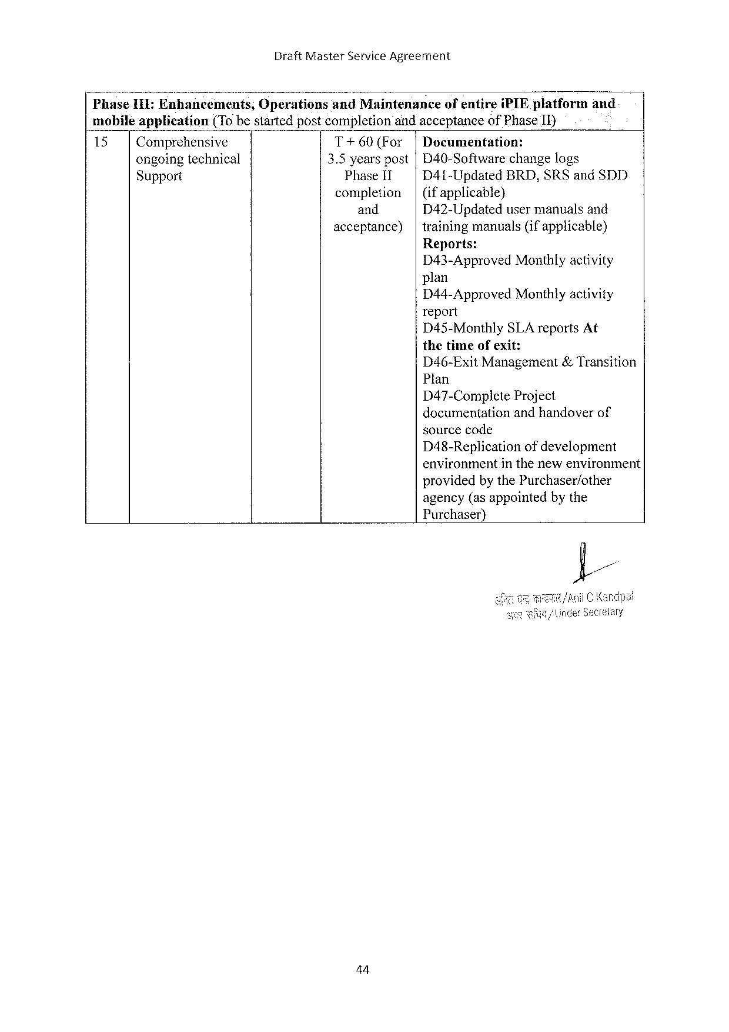

Draft Master Service Agreement

NP hase 1118]Enhancem; n; s, Oper:;; ions‘;;; i Maintenance ofentirei PIE platform and

mobiléapplication (To bestartedpostcompletionandacceptanceof Phase II)

15 Comprehensive T+60(For Documentation:

ongoingtechnical 3.5 yearspost D 40-Softwarechangelogs

Support Phase 11 D 41-Updated BRD, SRS and SDD

completion (ifapplicable)}

and D 42-Updatedusermanualsand

acceptance) trainingmanuals(ifapplicable)

Reports:

D 43-Approved Monthlyactivity

plan

D 44-Approved Monthlyactivity

report

D 45-Monthly SLA reports At

thetimeofexit:

D 46-Exit Management&Transition

Plan

D 47-Complete Project

documentationandhandoverof

sourcecode

D 48-Replication ofdevelopment

environmentinthenewenvironment

providedby the Purchaser/other

agency(asappointedbythe

Purchaser)}

44

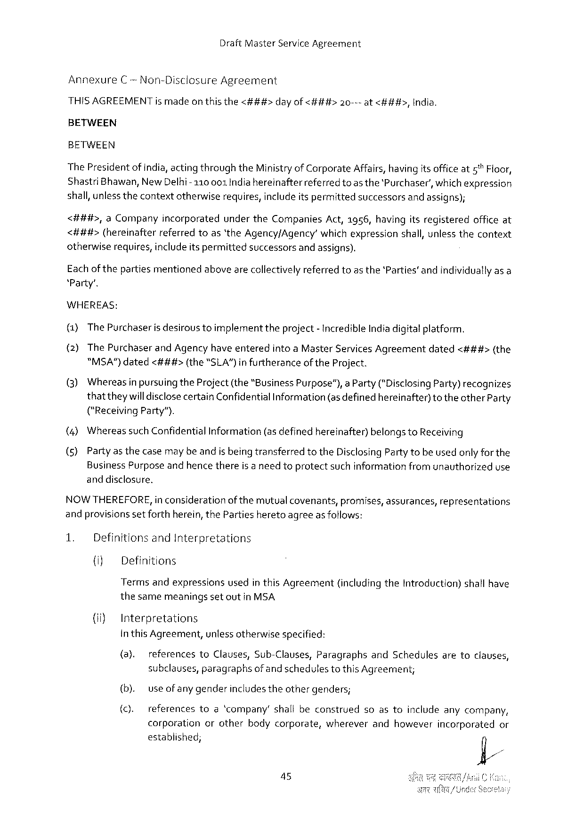

Draft Master Service Agreement

Annexure C -Non-Disclosure Agreement

|  |  |  |  |
| --- | --- | --- | --- |
| HISAGREEMENT ismadeon thisthe<###> | dayof<###> | 20---at<###>, | India. |

BETWEEN

BETWEEN

The Presidentof India, acting throughthe Ministryof Corporate Affairs, havingits officeat 5™Floor,

Shastri Bhawan, New Delhi-110001 Indiahereinafter referredtoas the‘Purchaser’, whichexpression

shall, unlessthecontextotherwiserequires, includeitspermittedsuccessorsand assigns);

<##4#>, a Company incorporated underthe Companies Act,1956, havingitsregistered officeat

<###>(hereinafterreferredtoas‘the Agency/Agency’whichexpressionshall, unlessthecontext

otherwiserequires, includeitspermittedsuccessorsand assigns).

Eachofthepartiesmentionedabovearecollectivelyreferredtoas the‘Parties’andindividuallyasa

‘Party’.

WHEREAS:

(1)The Purchaseris desiroustoimplementtheproject- incredible Indiadigitatplatform.

(2)The Purchaserand Agencyhave enteredintoa Master Services Agreementdated<###>(the

"MSA”)dated<###> (the“SLA")infurtherance of the Project.

(3) Whereas inpursuingthe Project(the“Business Purpose”), a Party(*Disclosing Party)recognizes

thattheywilldisclosecertain Confidential Information (asdefinedhereinafter) totheother Party

("Receiving Party”).

|  |  |  |  |  |  |
| --- | --- | --- | --- | --- | --- |
| (4) | Whereas | such Confidential | Information | (asdefinedhereinafter) | belongsto Receiving |

(5)Partyas thecasemaybeandis being transferredtothe Disclosing Partytobeusedonly for the

Business Purposeandhencethereis a needtoprotectsuchinformationfromunauthorizeduse

anddisclosure.

NOWTHEREFORE, in considerationof themutual covenants, promises, assurances, representations

andprovisionssetforthherein, the Partiesheretoagreeasfollows:

|  |  |  |  |  |  |
| --- | --- | --- | --- | --- | --- |
| 1. | Definitionsand Interpretations | | | (includingthe Introduction) | shallhave |
| (iy | Definitions | |
| Termsandexpressions | | usedin this Agreement |

thesamemeaningsset outin MSA

(i} Interpretations

in this Agreement, unlessotherwisespecified:

(a). referencesto Clauses, Sub-Clauses, Paragraphsand Schedulesaretoclauses,

subclauses, paragraphsofand schedulestothis Agreement;

|  |  |  |  |  |  |  |  |  |  |
| --- | --- | --- | --- | --- | --- | --- | --- | --- | --- |
| (b). | use ofany genderincludestheothergenders; | | | | | | soastoincludeanycompany, | | |
| (c). |
| references | toa‘company’ | | | shallbeconstrued | |
| corporation | | orother | bodycorporate, | | wherever | andhowever | incorporated | or |

established;

45

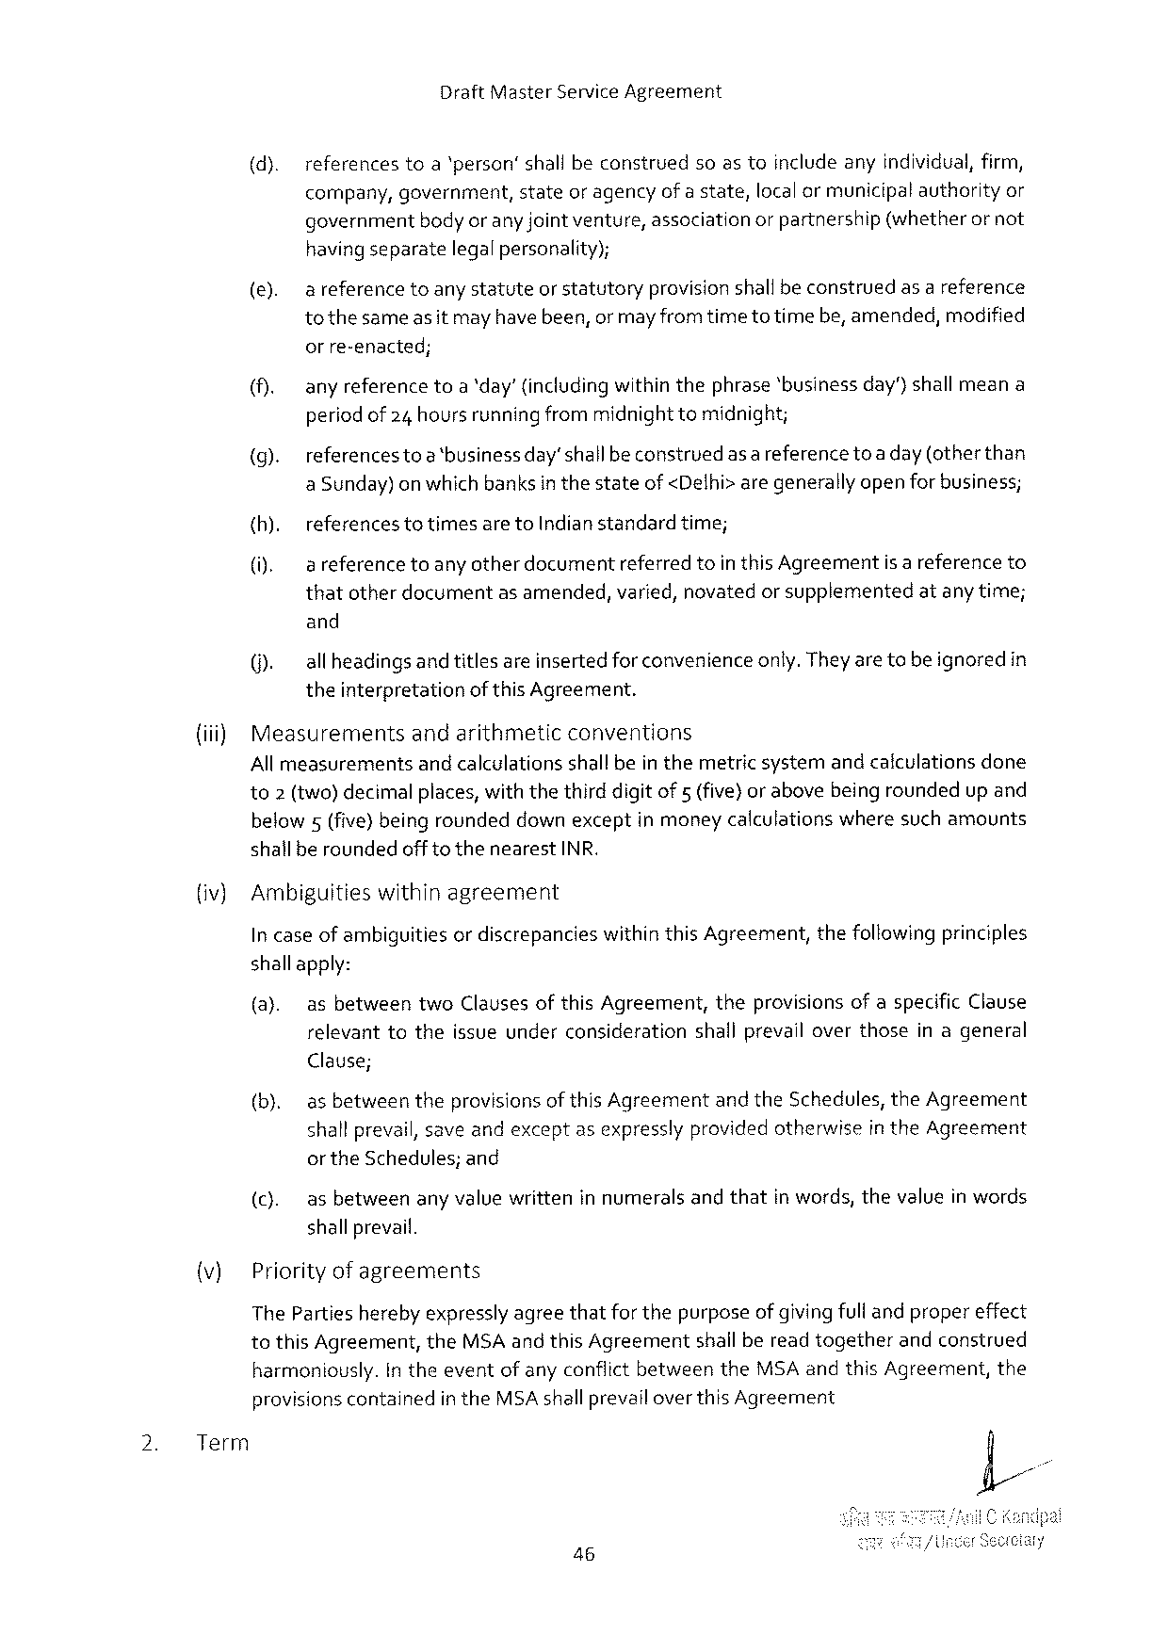

Draft Master Service Agreement

|  |  |  |  |  |  |  |  |
| --- | --- | --- | --- | --- | --- | --- | --- |
| (d). | references | toa‘person’shallbeconstrued | | soastoincludeanyindividual, firm, | | | |
| company, | government, | stateoragencyofastate, | | localormunicipal | | authorityor |
| bodyoranyjointventure, association | | | orpartnership | (whetherornot | |
| government |

havingseparatelegalpersonality);

(e). areferencetoanystatuteorstatutoryprovisionshallbe construedasa reference tothesameas it mayhave been, or mayfromtime totimebe, amended, modified

orre-enacted;

(). anyreferencetoa‘day’ (includingwithinthephrase‘businessday’)shall meana periodof 24 hoursrunningfrommidnighttomidnight;

(g). referencestoa‘businessday’shall beconstruedas a referencetoa day (otherthan a Sunday)on which banksin thestateof <Delhi>aregenerally openfor business;

|  |  |  |  |  |
| --- | --- | --- | --- | --- |
| {h). | referencestotimesareto Indianstandardtime; | | isareference | to |
| (i). | areference | toanyotherdocumentreferredtointhis Agreement |

thatotherdocumentasamended, varied, novatedor supplementedatanytime;

and

(). allheadingsand titlesareinsertedforconvenienceonly. Theyare tobe ignoredin theinterpretationof this Agreement.

|  |  |  |
| --- | --- | --- |
| (iii) | Measurements | andarithmeticconventions |

All measurementsand calculationsshallbein themetric systemandcalculationsdone to 2 (two)decimalplaces, withthethird digitof 5 (five}or abovebeingroundedup and

|  |  |  |
| --- | --- | --- |
| below 5(five) beingrounded | downexceptinmoneycalculations | wheresuchamounts |

shallberoundedofftothenearest INR.

(iv) Ambiguitieswithinagreement

In caseof ambiguitiesordiscrepancieswithin this Agreement, thefollowingprinciples

shallapply:

(a). asbetweentwo Clausesofthis Agreement, theprovisions ofaspecific Clause relevanttotheissueunderconsiderationshallprevailoverthoseinageneral

Clause;

(b). as betweentheprovisionsof this Agreementandthe Schedules, the Agreement shallprevail, saveandexceptasexpresslyprovidedotherwisein the Agreement

|  |  |  |  |  |  |
| --- | --- | --- | --- | --- | --- |
| (c). | orthe Schedules; | | and | andthat | inwords, thevalueinwords |
| asbetween | anyvaluewritteninnumerals | |

shallprevail.

(v) Priorityof agreements

The Partiesherebyexpresslyagreethatfor thepurposeofgivingfulland propereffect to this Agreement, the MSA and this Agreementshallbereadtogetherandconstrued

|  |  |  |  |  |  |  |  |
| --- | --- | --- | --- | --- | --- | --- | --- |
| 2. | Term | harmoniously. | In theeventofanyconflictbetween | | | the MSA andthis Agreement, | the |
| provisionscontained | | in the MSA shallprevail | overthis Agreement | |

46

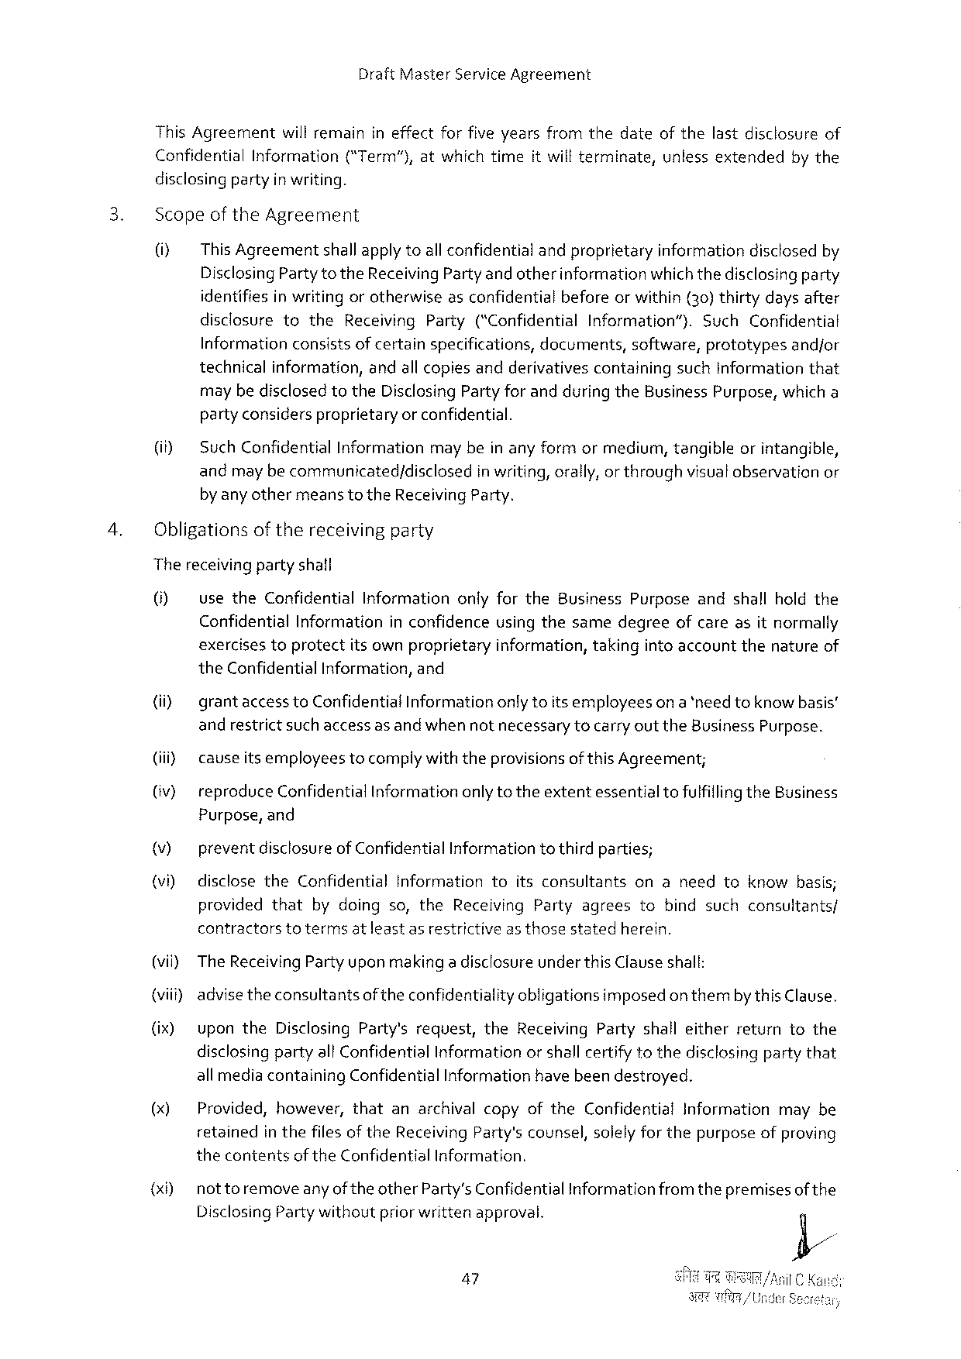

Draft Master Service Agreement

This Agreementwillremainineffectforfiveyearsfromthedateofthelastdisclosureof

|  |  |  |  |  |  |  |  |  |
| --- | --- | --- | --- | --- | --- | --- | --- | --- |
| Confidential | Information | (“Term"), | atwhich | time | itwillterminate, | unless | extended | bythe |

disclosingpartyin writing.

Scopeof the Agreement

0] This Agreementshallapplytoall confidentialandproprietaryinformationdisclosedby Disclosing Partytothe Receiving Partyand otherinformationwhichthedisclosingparty identifiesin writing orotherwiseasconfidentialbeforeorwithin (30)thirtydaysafter

|  |  |  |  |  |  |  |  |  |
| --- | --- | --- | --- | --- | --- | --- | --- | --- |
| disclosure | to | the | Receiving | Party | (“Confidential | Information”). | Such | Confidential |

Informationconsistsof certainspecifications, documents, software, prototypesandjor technicalinformation, andallcopiesandderivativescontainingsuch Informationthat maybedisclosed to the Disclosing Partyfor andduring the Business Purpose, which a partyconsidersproprietaryor confidential.

(i Such Confidential Informationmay bein anyformormediurm, tangibleorintangible, andmay becommunicated/disclosed in writing, orally, or throughvisualobservationor by anyothermeanstothe Receiving Party.

Obligationsofthereceivingparty

Thereceivingpartyshall

0] usethe Confidential Informationonlyforthe Business Purposeandshallholdthe Confidential Informationin confidenceusingthesamedegreeofcareasitnormally

|  |  |  |  |  |  |  |
| --- | --- | --- | --- | --- | --- | --- |
| exercises | toprotect | itsownproprietary | information, | taking | intoaccountthenature | of |

the Confidential Information, and

(i) grantaccess to Confidential Informationonlytoitsemployeeson a *need toknow basis’ andrestrictsuch access as andwhen notnecessarytocarryout the Business Purpose.

(iii cavseitsemployeestocomplywiththeprovisionsof this Agreement;

(v} reproduce Confidential Informationonly totheextentessentialtofulfillingthe Business Purpose, and

v) preventdisclosureof Confidential Informationto thirdparties;

(i) disclosethe Confidential Informationtoitsconsultantsonaneedtoknowbasis; providedthat bydoingso, the Receiving Partyagreestobindsuchconsultants/ contractorstotermsatleast asrestrictiveas thosestatedherein.

(vii) The Receiving Party upon makinga disclosureunderthis Clauseshall:

{viii) advisetheconsultantsoftheconfidentialityobligationsimposedon thembythis Clause.

(ix) uponthe Disclosing Party'srequest, the Receiving Partyshalleitherreturntothe disclosingpartyall Confidential Informationorshall certifytothedisclosingpartythat all mediacontaining Confidential Informationhave beendestroyed.

() Provided, however, thatanarchivalcopyofthe Confidential Informationmaybe retainedin thefiles of the Receiving Party'scounsel, solelyfor thepurposeofproving thecontentsof the Confidential Information.

(x 0) nottoremoveanyof theother Party’s Confidential Informationfromthepremisesof the Disclosing Partywithoutpriorwrittenapproval.

47

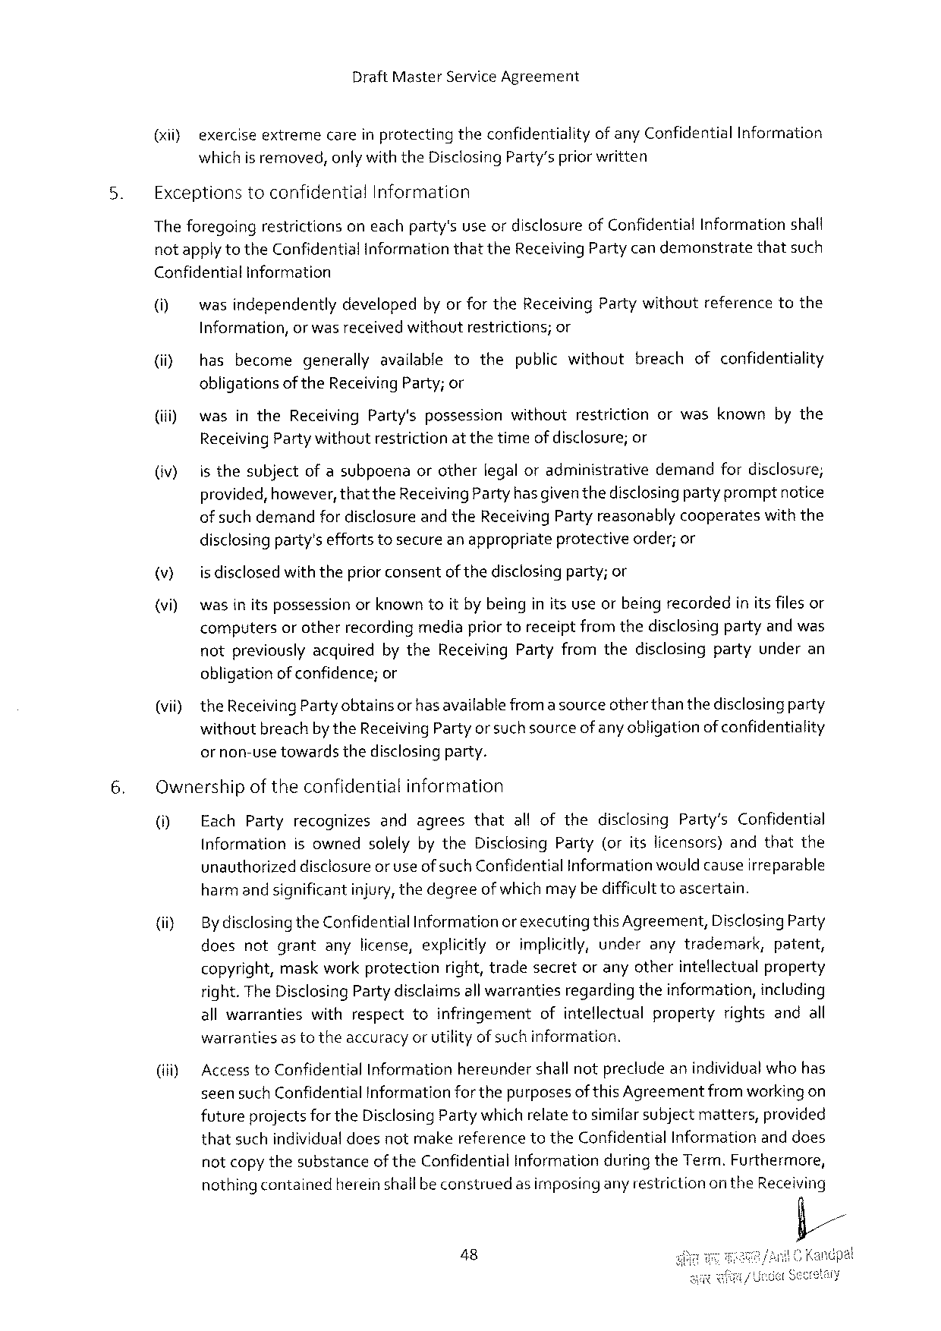

Draft Master Service Agreement

(it} exerciseextremecareinprotectingtheconfidentialityof any Confidential Information which is removed, onlywiththe Disclosing Party’spriorwritten

Exceptionstoconfidential Information

Theforegoingrestrictionsoneachparty'suseordisclosureof Confidential Informationshall notapplytothe Confidential Informationthatthe Receiving Party candemonstratethatsuch

Confidential Information

|  |  |  |  |  |  |
| --- | --- | --- | --- | --- | --- |
| (M  (iiy  (iii)  (v} | wasindependentlydevelopedbyor for the Receiving Partywithoutreferencetothe | | | | |
| Information, | orwas receivedwithoutrestrictions; | | | or |
| hasbecome | | generallyavailabletothepublicwithoutbreachofconfidentiality | | |
| obligations | of the Receiving Party; or | | | |
| wasinthe Receiving Party'spossessionwithoutrestrictionorwasknownbythe | | | | |
| Receiving Partywithoutrestrictionat thetime | | | of disclosure; or | |
| isthesubjectofasubpoenaorotherlegaloradminisirativedemandfordisclosure; provided, however, thatthe Receiving Party hasgiventhedisclosingparty promptnotice | | | | |

of such demandfor disclosureandthe Receiving Partyreasonablycooperateswith the

|  |  |  |  |
| --- | --- | --- | --- |
| v)  (vi) | disclosingparty'seffortstosecureanappropriate | protective | order; or |
| is disclosedwiththepriorconsentof thedisclosingparty; or  wasin itspossessionorknown toit by beinginits useorbeingrecordedinitsfilesor computersor otherrecordingmediapriortoreceiptfromthedisclosingpartyandwas | | |

notpreviouslyacquiredbythe Receiving Partyfromthedisclosingpartyunderan obligationof confidence; or

(vii) the Receiving Partyobtainsor has availablefroma sourceotherthan thedisclosingparty withoutbreachbythe Receiving Party orsuchsourceof anyobligationofconfidentiality

ornon-usetowardsthedisclosingparty.

Ownershipoftheconfidentialinformation

|  |  |
| --- | --- |
| 0] | Each Partyrecognizesandagreesthatallofthedisclosing Party’s Confidential Informationisownedsolelybythe Disclosing Party(oritslicensors)andthatthe |

unauthorizeddisclosureor useof such Confidential Information wouldcauseirreparable harmand significantinjury, thedegreeof whichmay be difficulttoascertain.

|  |  |  |
| --- | --- | --- |
| (iiy | By disclosingthe Confidential Informationor executingthis Agreement, Disclosing Party | |
| doesnotgrantanylicense, explicitlyorimplicitly, underanytrademark, | patent, |

copyright, maskworkprotectionright, tradesecretoranyotherintellectualproperty right. The Disclosing Partydisclaims allwarrantiesregardingtheinformation, including allwarrantieswithrespecttoinfringementofintellectualpropertyrightsandall warrantiesas totheaccuracyor utilityof suchinformation.

(iiiy Accessto Confidential Informationhereundershall notprecludeanindividualwho has seensuch Confidential Informationfor thepurposesof this Agreementfrom workingon futureprojects for the Disclosing Party which relatetosimilarsubjectmatters, provided thatsuchindividualdoesnotmakereferencetothe Confidential Informationand does notcopy thesubstanceof the Confidential Informationduring the Term. Furthermore, nothingcontainedherein shallbeconstruedas imposingany restrictionon the Receiving

48

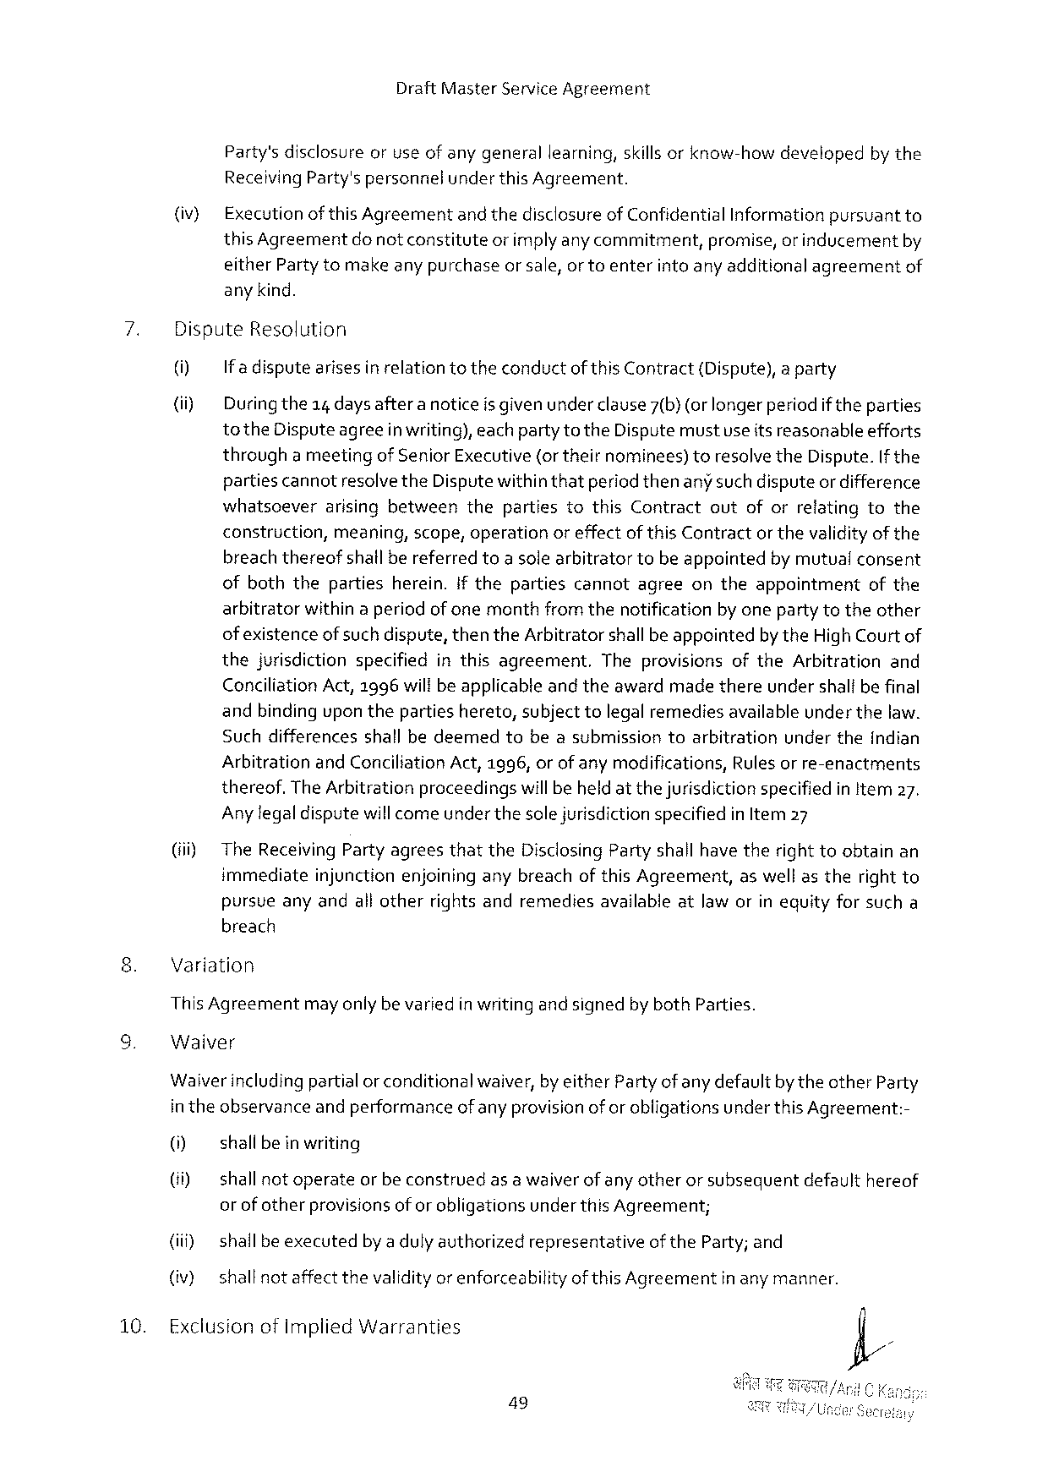

Draft Master Service Agreement

Party'sdisclosureoruseof anygenerallearning, skills orknow-howdevelopedby the Receiving Party'spersonnielunderthis Agreement.

(iv} Executionofthis Agreementand thedisclosureof Confidential Informationpursuantto this Agreement donotconstitute orimplyanycommitment, promise, or inducement by

either Partytomakeany purchaseor sale, or toenterinto any additionalagreementof any kind.

7. Dispute Resolution

0] If adisputearises in relationtotheconductof this Contract{Dispute), a party

(ii) Duringthe 14 days aftera noticeis given under clause 7(b) (orlonger periodif theparties to the Disputeagreein writing), eachparty to the Disputemustuseitsreasonableefforts througha meetingof Senior Executive(ortheirnominees)toresclve the Dispute. If the partiescannotresolvethe Disputewithinthatperiodthenany such disputeor difference whatsceverarisingbetweenthepartiestothis Contractoutoforrelatingtothe construction, meaning, scope, operationoreffectofthis Contractorthevalidityof the breachthereofshallbereferredtoa solearbitratortobeappointedby mutualconsent ofboththepartiesherein. if thepartiescannotagreeontheappointment of the arbitratorwithin aperiodof onemonthfrom thenotificationby onepartytotheother of existenceofsuch dispute, thenthe Arbitratorshallbeappointedbythe High Court of thejurisdictionspecifiedinthisagreement. Theprovisionsofthe Arbitrationand Conciliation Act,1996 wiltbe applicabteand theawardmadethereundershalibefinal andbindingupon thepartieshereto, subjecttolegalremediesavailableunder thelaw. Suchdifferencesshallbedeemedtobeasubmissiontoarbitrationundertheindian Arbitrationand Conciliation Act,1996, orof anymodifications, Rulesor re-enactments thereof. The Arbitrationproceedingswill beheldat thejurisdictionspecifiedin ltem 27.

Anylegaldisputewillcomeunder thesole jurisdictionspecifiedin Item 27

(i) The Receiving Partyagreesthatthe Disclosing Partyshallhave therighttoobtainan immediateinjunctionenjoininganybreachofthis Agreement, as wellastherightto pursueanyandall otherrightsandremediesavailableatlaw orin equityforsucha breach

Variation

This Agreementmayonlybevariedin writing and signedbyboth Parties.

Waiver

Waiverincludingpartialorconditionalwaiver, by either Partyof any defaultby theother Party in theobservanceand performanceof anyprovisionof or obligationsunderthis Agreement:-

0] shallbe in writing

(ii) shallnotoperateor beconstruedas awaiverof any otheror subsequentdefaulthereof or ofotherprovisionsof or obligationsunderthis Agreement;

(iii) shallbeexecutedby adulyauthorizedrepresentativeofthe Party; and

(iv) shallnotaffect thevalidityorenforceabilityof this Agreementinany manner.

10. Exclusionof Implied Warranties

49

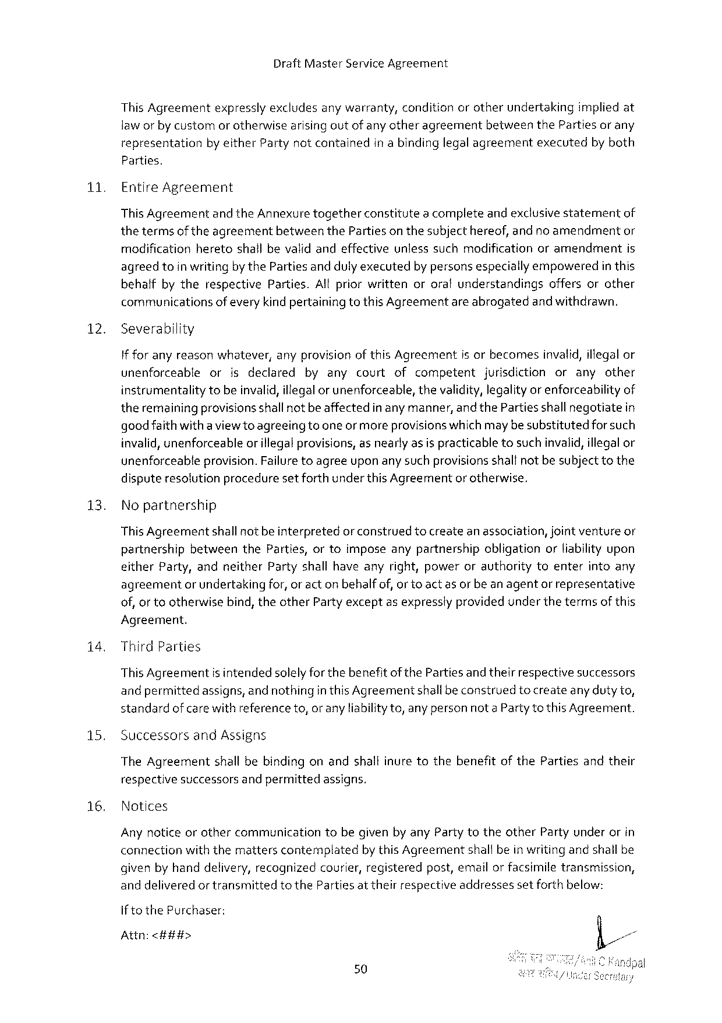

Draft Master Service Agreement

This Agreement expresslyexcludesanywarranty, condition orotherundertaking impliedat

laworby customorotherwise arisingoutofanyotheragreement between the Partiesorany

representation by either Partynotcontained inabindinglegalagreement executed byboth

Parties.

11 Entire Agreement

This Agreementand the Annexuretogetherconstitutea completeandexclusivestatementof thetermsof theagreementbetweenthe Parties on thesubjecthereof, and no amendmentor modificationheretoshallbevalidandeffectiveunlesssuchmodificationoramendmentis agreedtoin writingby the Parties andduly executedby personsespeciallyempoweredin this behaifbytherespective Parties. All priorwrittenororalunderstandingsoffersorother communicationsofevery kindpertainingtothis Agreementare abrogatedand withdrawn.

12. Severability

If foranyreasonwhatever, anyprovision of this Agreementisorbecomesinvalid, illegalor

|  |  |  |  |  |  |  |
| --- | --- | --- | --- | --- | --- | --- |
| unenforceable | or | isdeclared | byanycourtof | competent | jurisdiction | oranyother |

instrumentalitytobeinvalid, illegalor unenforceable, thevalidity, legalityor enforceabilityof theremainingprovisionsshallnot beaffectedin any manner, and the Partiesshallnegotiatein goodfaith withaviewtoagreeingtooneormoreprovisionswhichmaybesubstitutedforsuch invalid, unenforceableor illegalprovisions, as nearly asis practicabletosuchinvalid, illegalor unenforceableprovision. Failuretoagreeuponany suchprovisionsshalfnot besubjecttothe disputeresolutionproceduresetforthunderthis Agreementor otherwise,

|  |  |  |  |  |  |  |
| --- | --- | --- | --- | --- | --- | --- |
| 13. | Nopartnership | shallnotbeinterpreted | orconstrued | tocreateanassociation, | jointventure | or |
| This Agreement |

partnershipbetweenthe Parties, ortoimposeanypartnershipobligationorliabilityupon either Party, andneither Partyshallhaveanyright, powerorauthoritytoenterintoany agreementor undertakingfor, or act on behalfof, orto act as or beanagentor representative of, or tootherwisebind, theother Partyexceptas expresslyprovidedunderthetermsof this

Agreement.

i 4. Third Parties

This Agreementis intendedsolelyfor thebenefitof the Partiesand theirrespectivesuccessors andpermittedassigns, and nothingin this Agreementshallbeconstruedtocreateanyduty to, standardof care withreference to, oranyliability to, anypersonnota Partyto this Agreement.

|  |  |  |
| --- | --- | --- |
| 15. | Successors | and Assigns |

The Agreementshallbebindingonandshallinuretothebenefitofthe Partiesandtheir

|  |  |  |  |  |
| --- | --- | --- | --- | --- |
| 16. | respective | successors | andpermitted | assigns. |
| Notices |

Any noticeorothercommunicationtobegivenby any Party totheother Partyunderorin connectionwiththemattersconternplatedbythis Agreementshallbein writing andshall be givenbyhanddelivery, recognizedcourier, registeredpost, emailor facsimiletransmission, anddeliveredor transmittedtothe Parties at theirrespectiveaddressessetforthbelow:

if to the Purchaser:

Attn:<###>

50

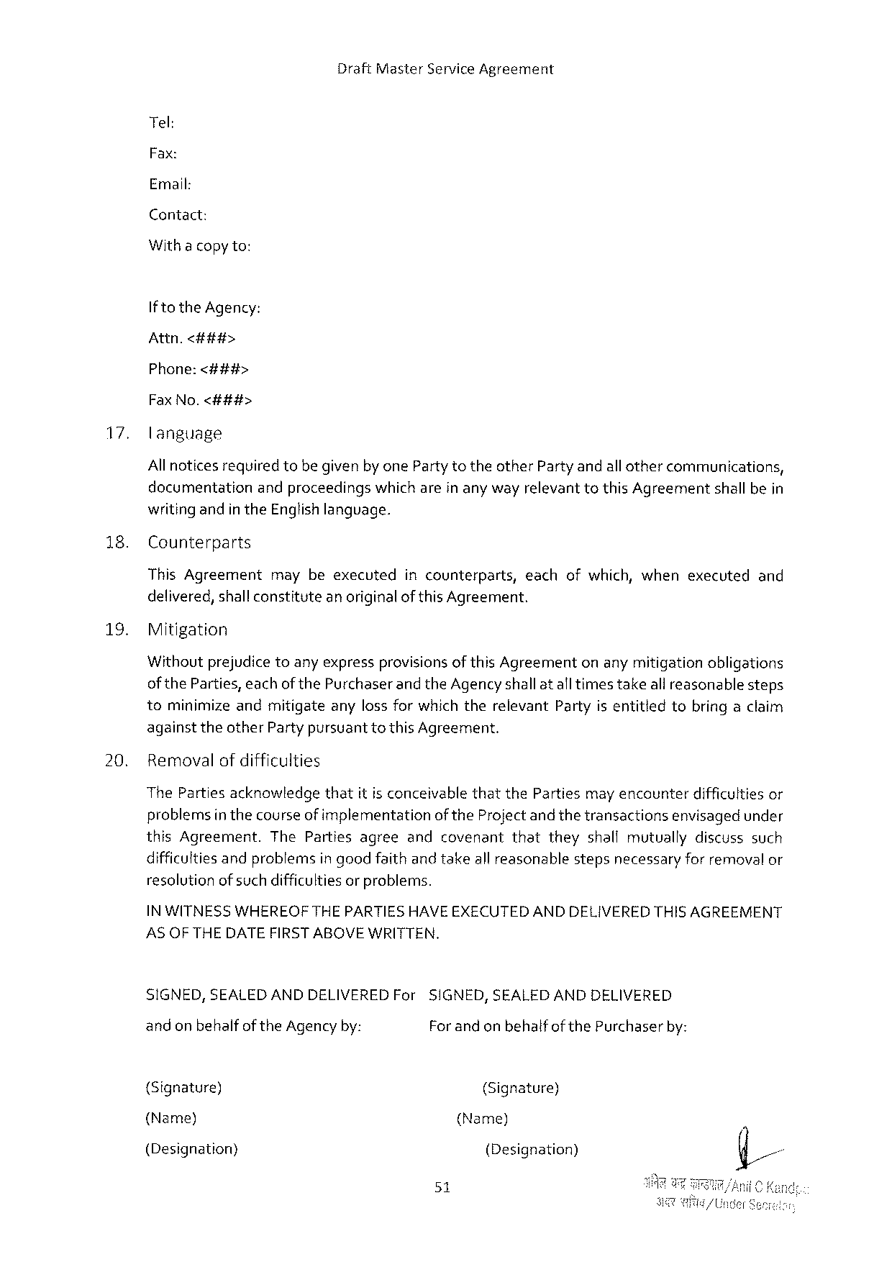

Draft Master Service Agreement

Tel:

Fax:

Email:

Contact:

Withacopyto:

Ifto the Agency:

Attn.<##i#>

Phone:<###>

Fax No.<###>

17. language

Allnoticesrequiredtobe givenby one Partytotheother Party andallothercommunications, documentationandproceedingswhich arein any wayrelevanttothis Agreementshall bein writing andin the Englishlanguage.

|  |  |  |  |  |
| --- | --- | --- | --- | --- |
| 18. | Counterparts | maybeexecuted | incounterparts, | eachofwhich, whenexecutedand |
| This Agreement |

delivered, shallconstitutean originalof this Agreement.

19. Mitigation

Withoutprejudicetoanyexpressprovisionsof this Agreementonanymitigationobligations of the Parties, eachofthe Purchaserandthe Agencyshallat altimestakeall reasonablesteps tominimizeandmitigateanylossfor whichtherelevant Partyis entitledtobringaclaim againsttheother Partypursuanttothis Agreement.

20. Removalof difficulties

The Partiesacknowledgethatit isconceivablethatthe Partiesmay encounterdifficulties or problemsin thecourseof implementationof the Project and thetransactionsenvisagedunder this Agreement. The Partiesagreeandcovenantthattheyshallmutuallydiscusssuch difficultiesandproblemsin goodfaithand takeallreasonablestepsnecessaryforremoval or resolutionofsuch difficultiesor problems.

IN WITNESSWHEREOFTHEPARTIESHAVEEXECUTEDAND DELIVEREDTHISAGREEMENT ASOFTHE DATE FIRSTABOVE WRITTEN.

SIGNED, SEALEDANDDELIVEREDF or andonbehalf of the Agency by:

SIGNED, SEALEDANDDELIVERED For and on behalfof the Purchaserby:

{Signature) (Signature)

(Name) (Name)

(Designation) (Designation)

51



Draft Master Service Agreement

|  |  |  |
| --- | --- | --- |
| (Address) | (Fax No.) | (Address) |
| (Fax No.) | (Signature) |
| (Signature) |

Inthepresenceof:

I

2.

52